AWS IAM User and Group Management

Create IAM Users
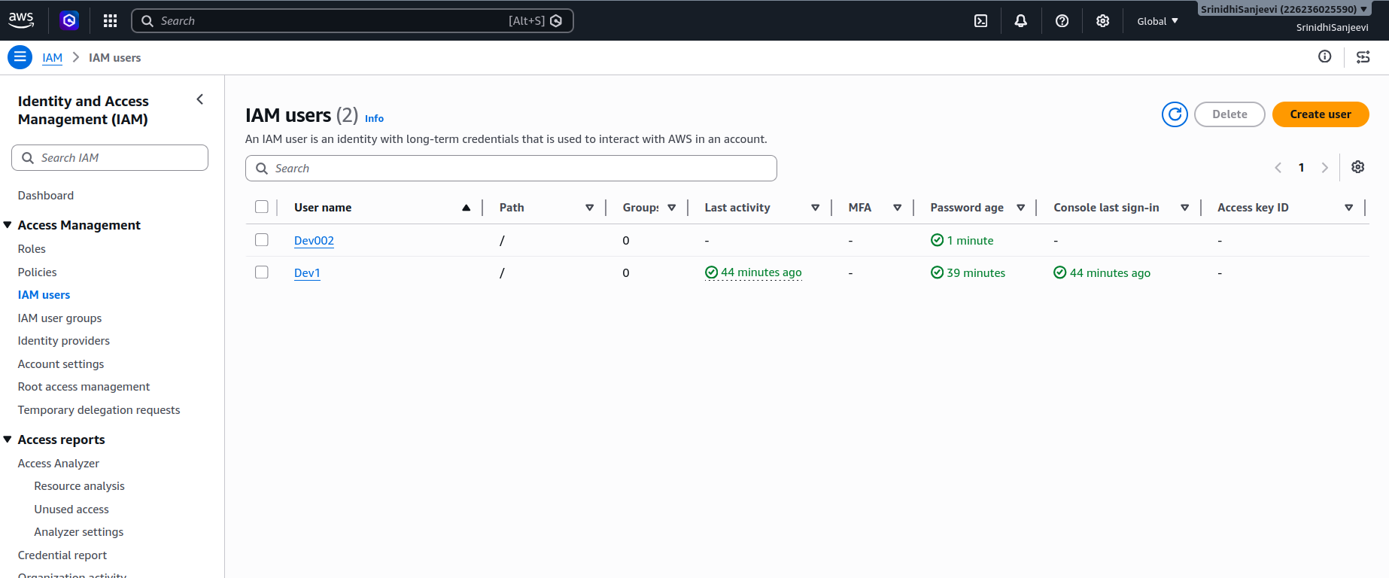
Created two IAM users:
- Dev1
- Dev002

Create IAM User Group
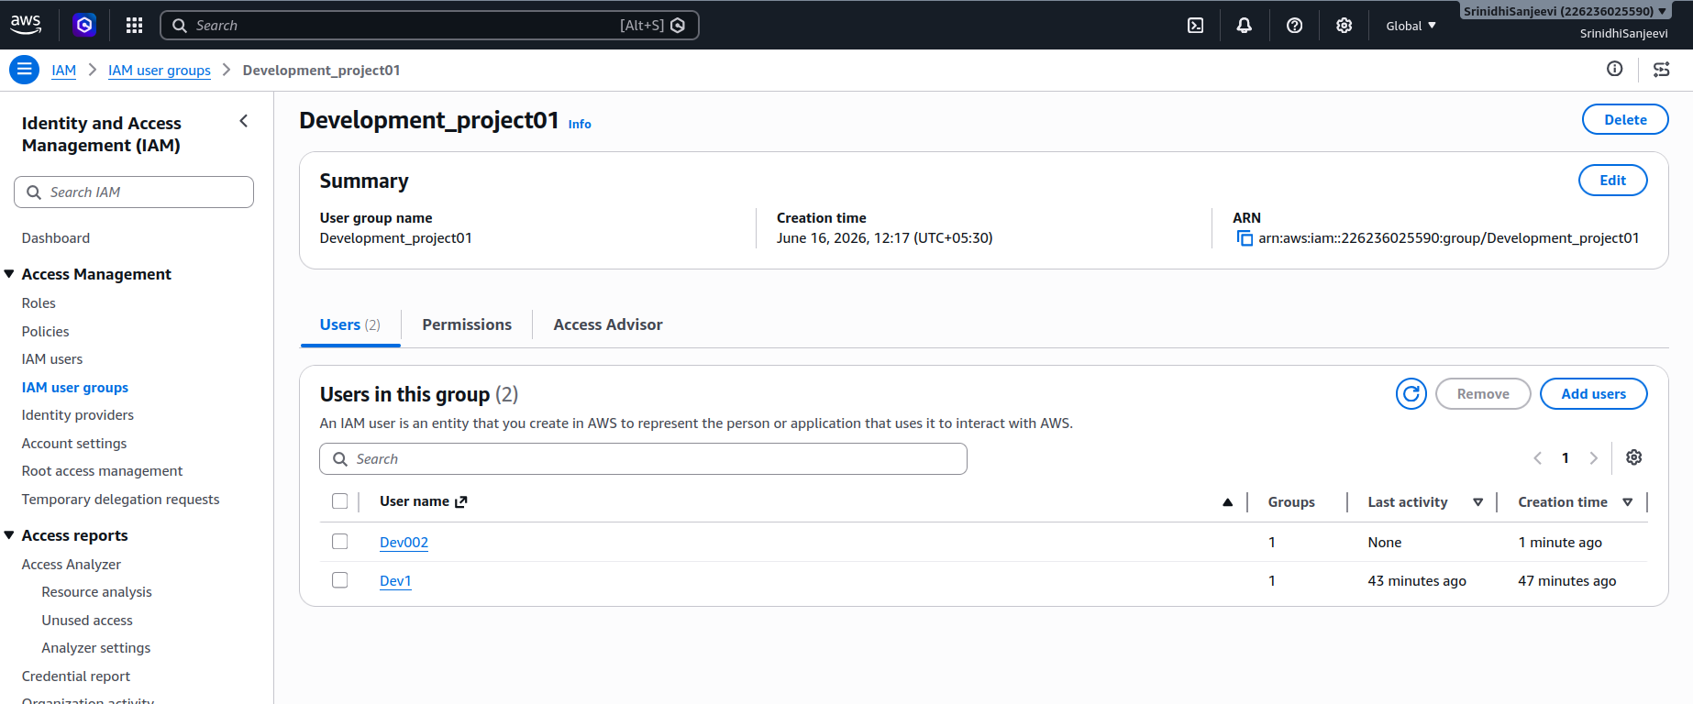
Created an IAM user group named Development_project01 to manage permissions centrally for development team members.

Add Users to IAM Group
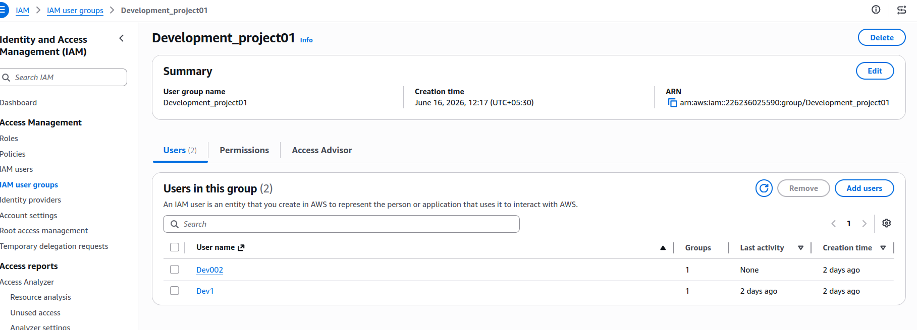
Added Dev1 and Dev002 users to the Development_project01 group so that permissions can be inherited through the group.

Create IAM User Login Credentials
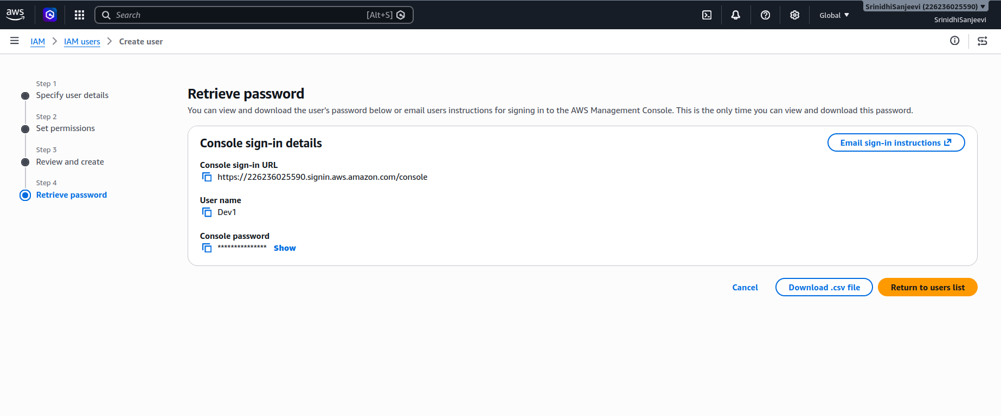
Generated AWS Management Console login credentials for IAM users and provided secure console access.
The following were configured:
- User Name
- Console Sign-In URL
- Temporary Password

Permission Restrictions
Attempted to access Amazon S3 resources using an IAM user without any policies attached.
Result:
- Access Denied error was displayed.
- User could not list S3 resources.
- AWS returned an authorization failure due to missing permissions.
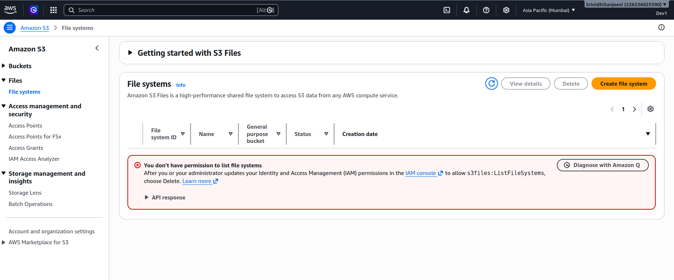

AWS EC2, ECR, S3 Bucket and CloudWatch Implementation

1. Amazon EC2 Setup

Launching EC2 Instance
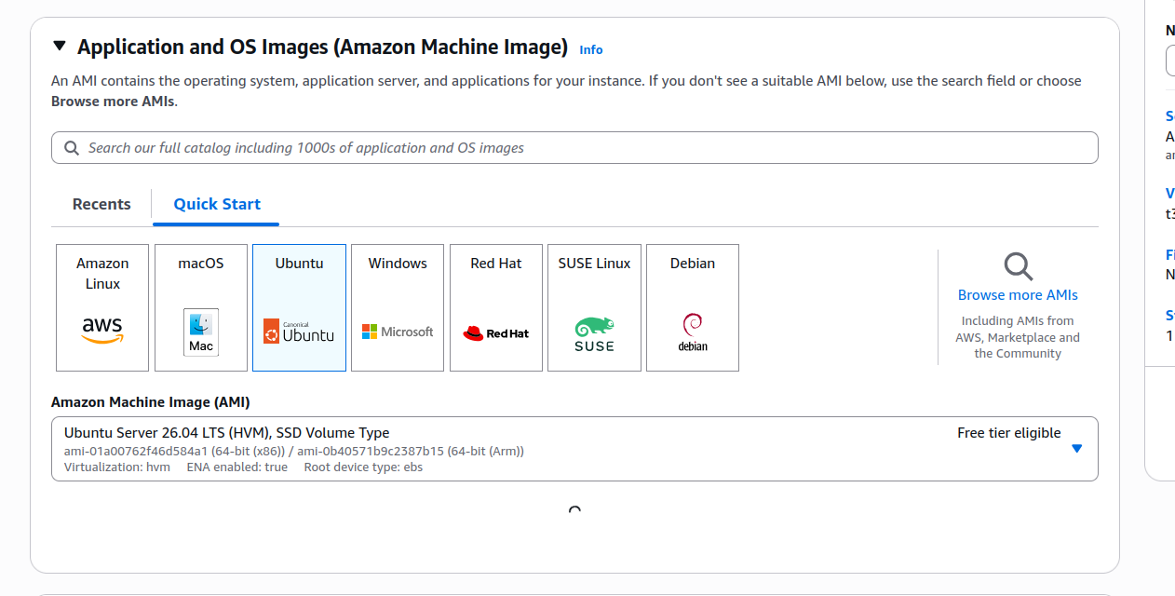

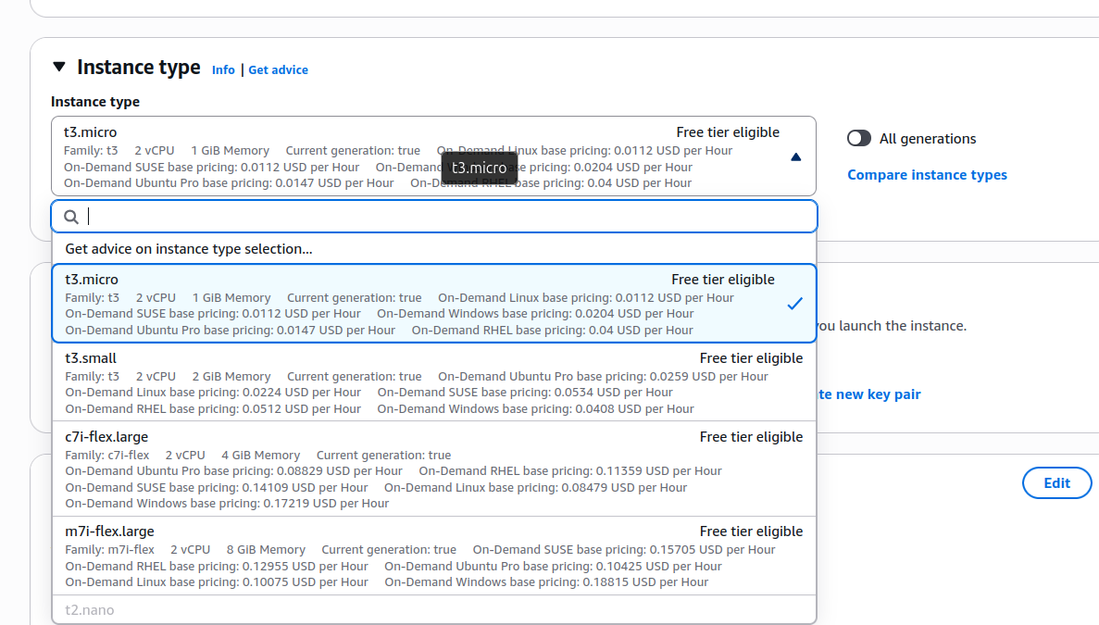
Selected Ubuntu Server 26.04 LTS AMI while launching the EC2 instance. This operating system was chosen as the deployment environment for the application and Docker containers.
Selected instance type which describes the size of cpu and ram.

EC2 Instance Creation Summary
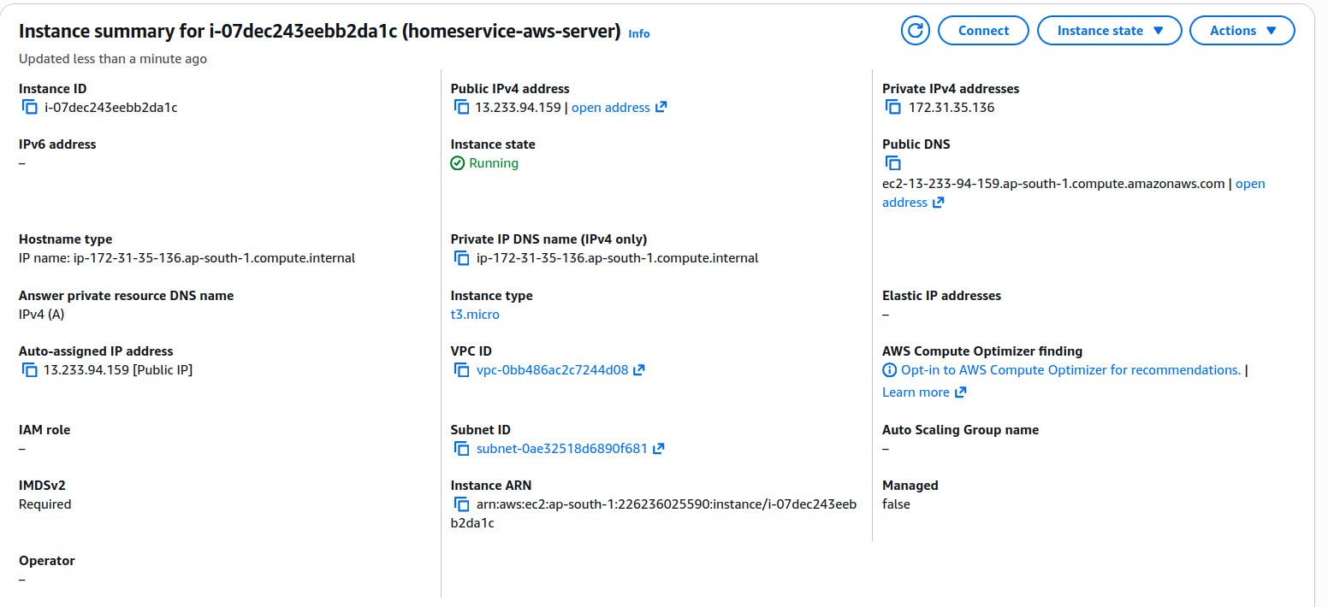
Created an EC2 t3.micro instance and verified instance details including public IP address, private IP address, VPC, subnet, and instance state.

Configure Security Group Rules
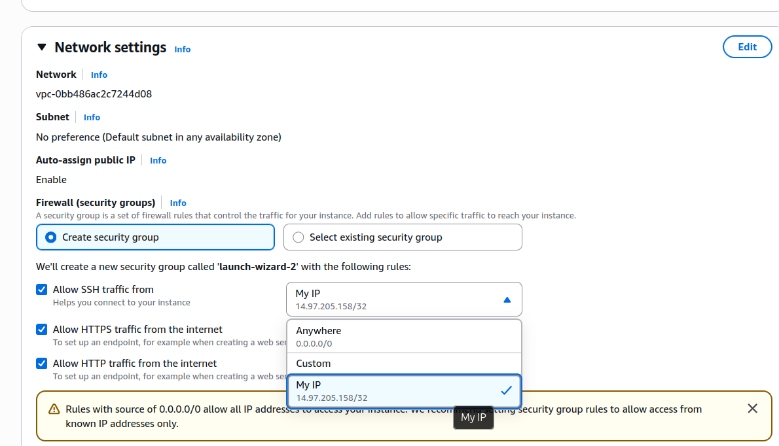
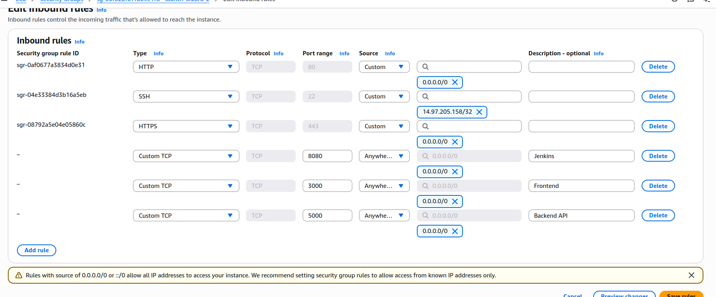
Configured inbound security group rules to allow access to application services running on different ports.
Ports Opened:
- 22 – SSH
- 80 – HTTP
- 443 – HTTPS
- 3000 – Frontend
- 5000 – Backend API
- 8080 – Jenkins
Added a custom TCP rule for port 8080 to enable Jenkins access through the browser.

Create SSH Connection
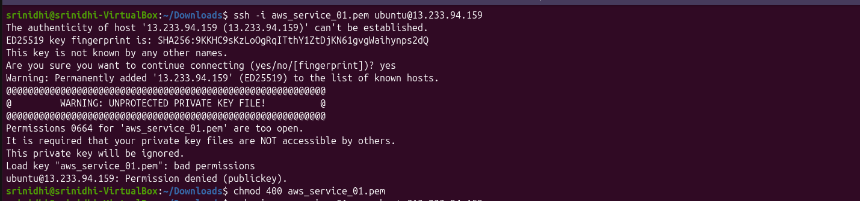
Configured PEM file permissions using chmod 400 and established a secure SSH connection to the EC2 instance.

2. IAM Role Configuration

Create IAM Role for EC2
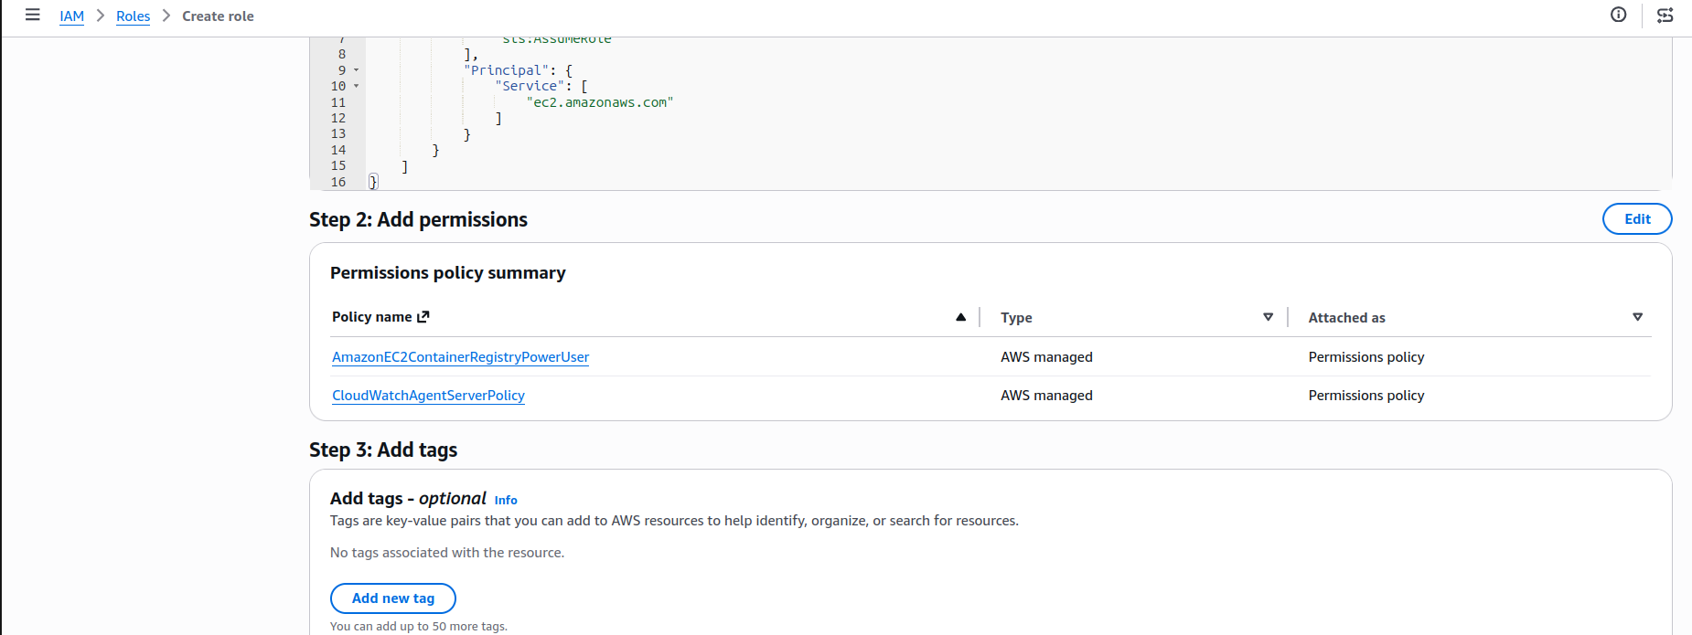
Created an IAM role and attached AmazonEC2ContainerRegistryPowerUser policy to allow EC2 access to Amazon ECR repositories.

Attach CloudWatch Permissions
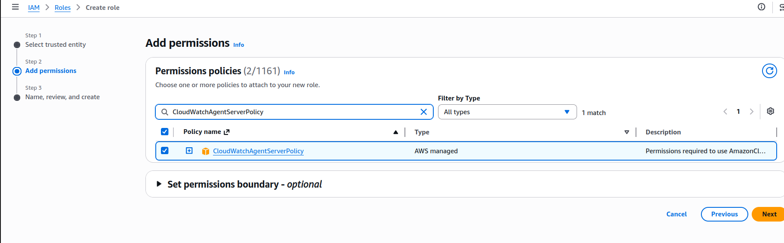

Attached CloudWatchAgentServerPolicy to enable CloudWatch monitoring and metric collection from the EC2 instance.

Attach IAM Role to EC2
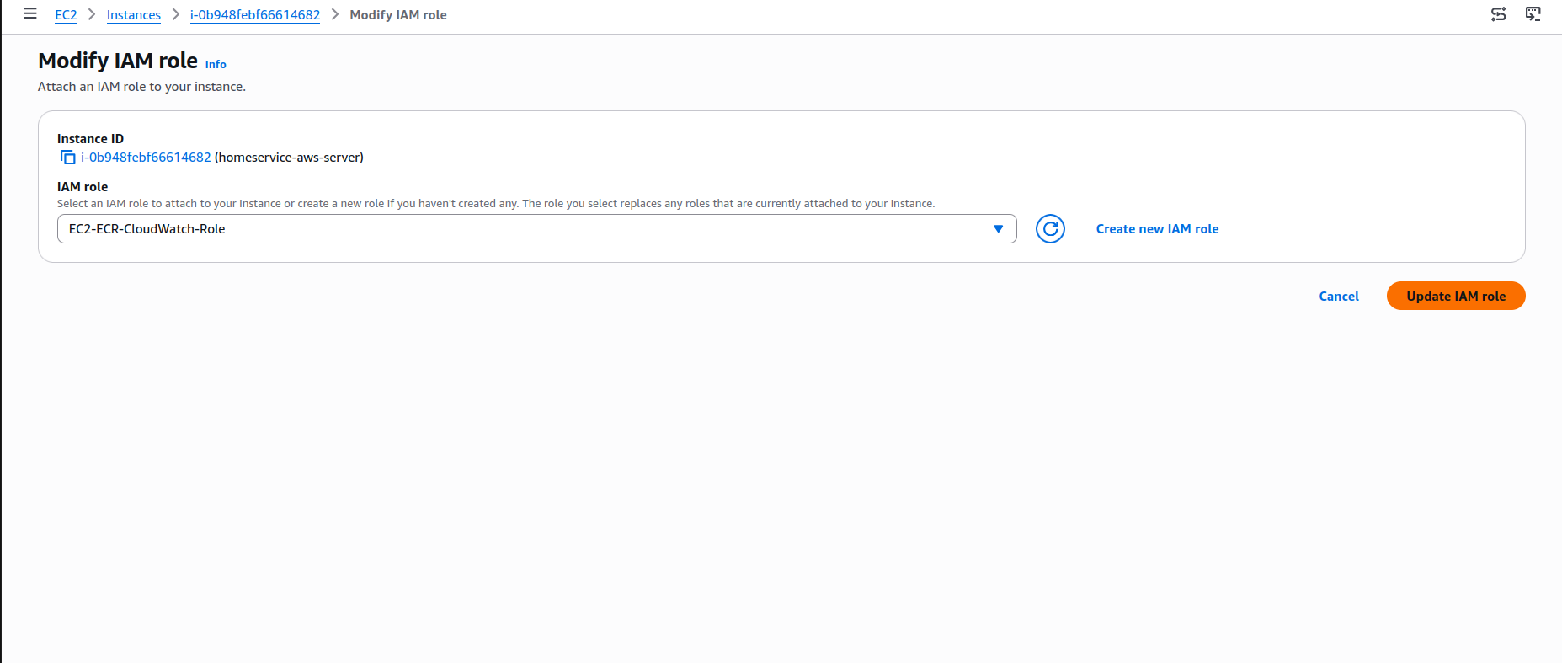
Associated the newly created IAM role with the EC2 instance to provide access to ECR and CloudWatch services without storing credentials.

3. Amazon Elastic Container Registry (ECR)

Create ECR Repository
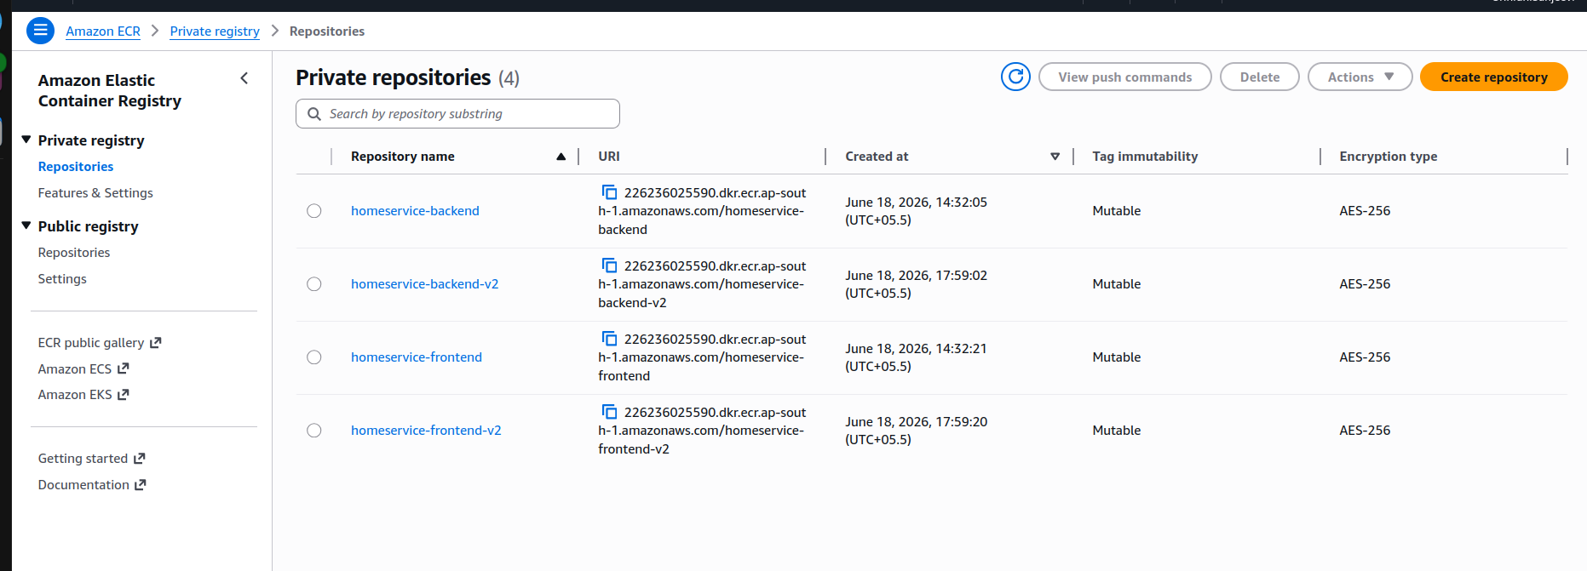
Created a private Amazon ECR repository named homeservice-backend to store Docker container images securely

Verify IAM Role Access
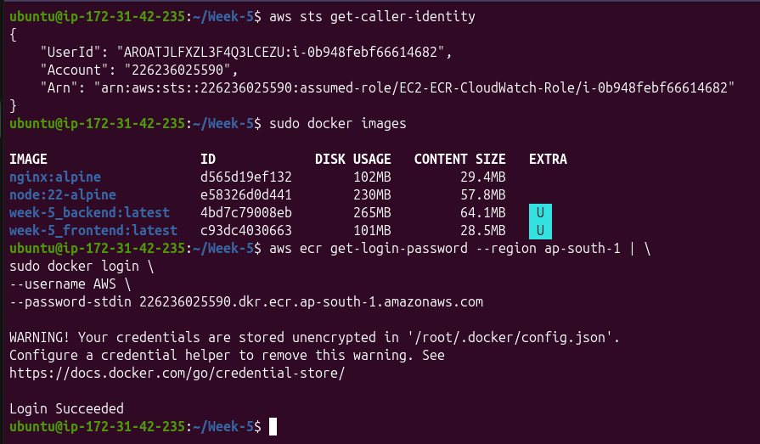
Verified IAM role attachment using AWS STS and authenticated Docker with Amazon ECR using AWS CLI login commands.
Validation:
- IAM Role Verified
- AWS Account Verified
- ECR Login Successful

Push Backend Image to ECR
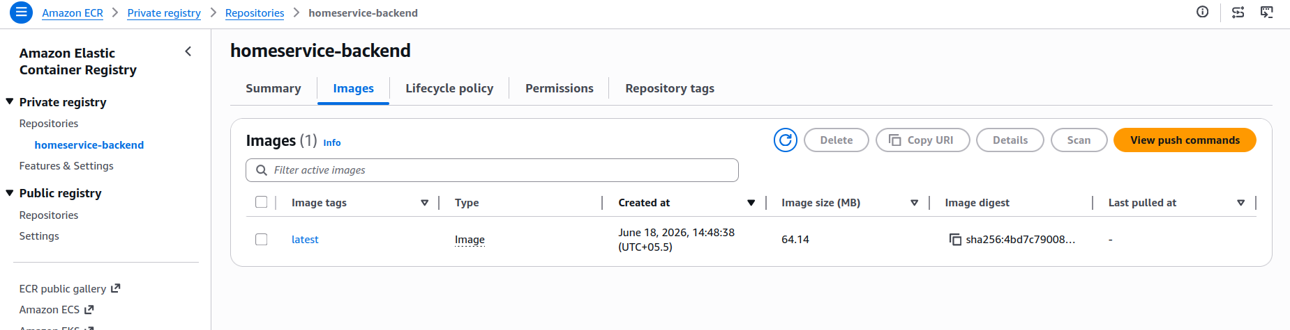
Successfully pushed the backend Docker image to the ECR repository and verified image availability.

4. Docker Container Deployment

Pull Docker Images from ECR
Screenshot: (Docker Pull Screenshot)
Pulled application images from ECR to the EC2 instance using Docker commands.

Start Backend Container
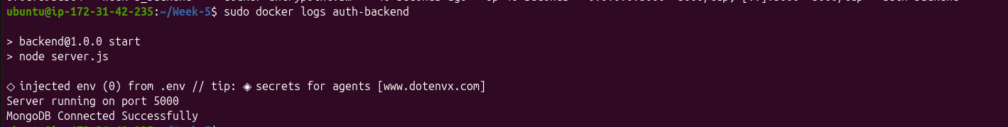
Started the backend container and verified successful application startup through Docker logs.
Validation Output:
- Server running on Port 5000
- MongoDB Connected Successfully

Verify Backend Application
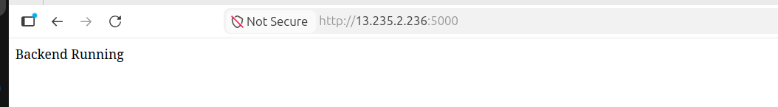 Accessed the backend application using the EC2 public IP and verified that the service was running successfully.
URL Format:
http://Public-IP:5000

5. Amazon CloudWatch Monitoring

Configure CloudWatch Metrics
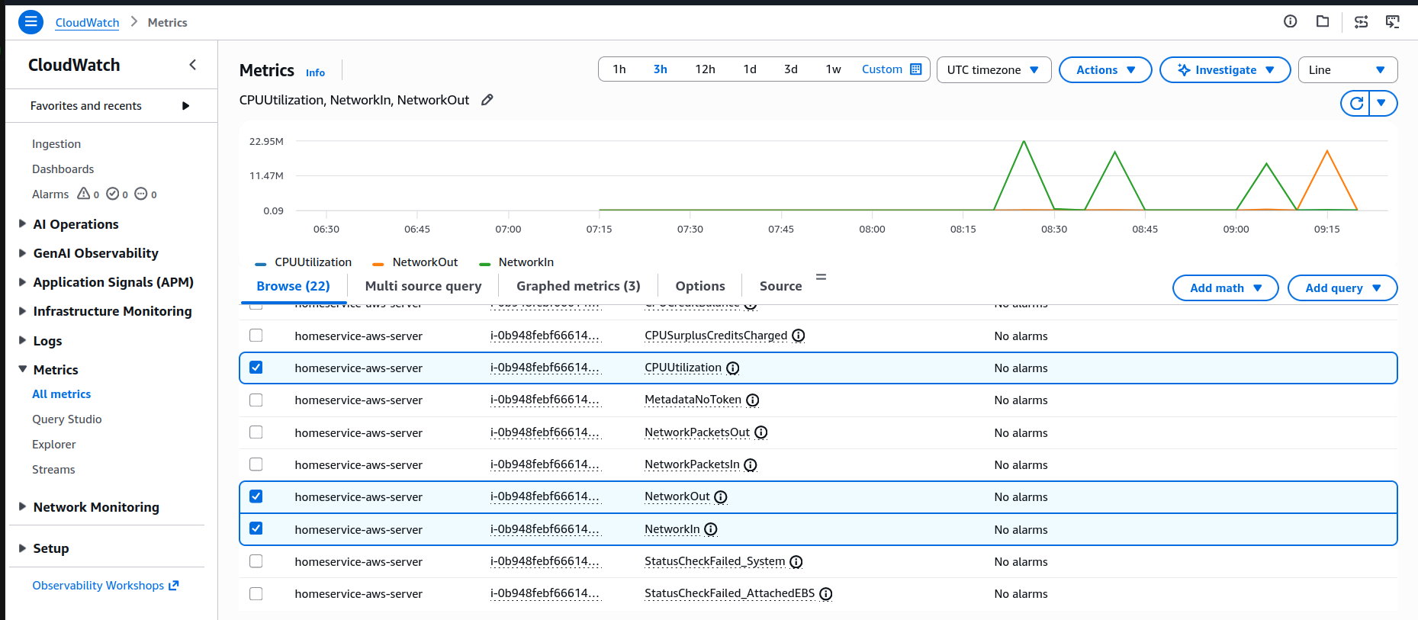
Selected key EC2 monitoring metrics including CPU Utilization, Network In, and Network Out for performance monitoring.

Monitor Resource Usage
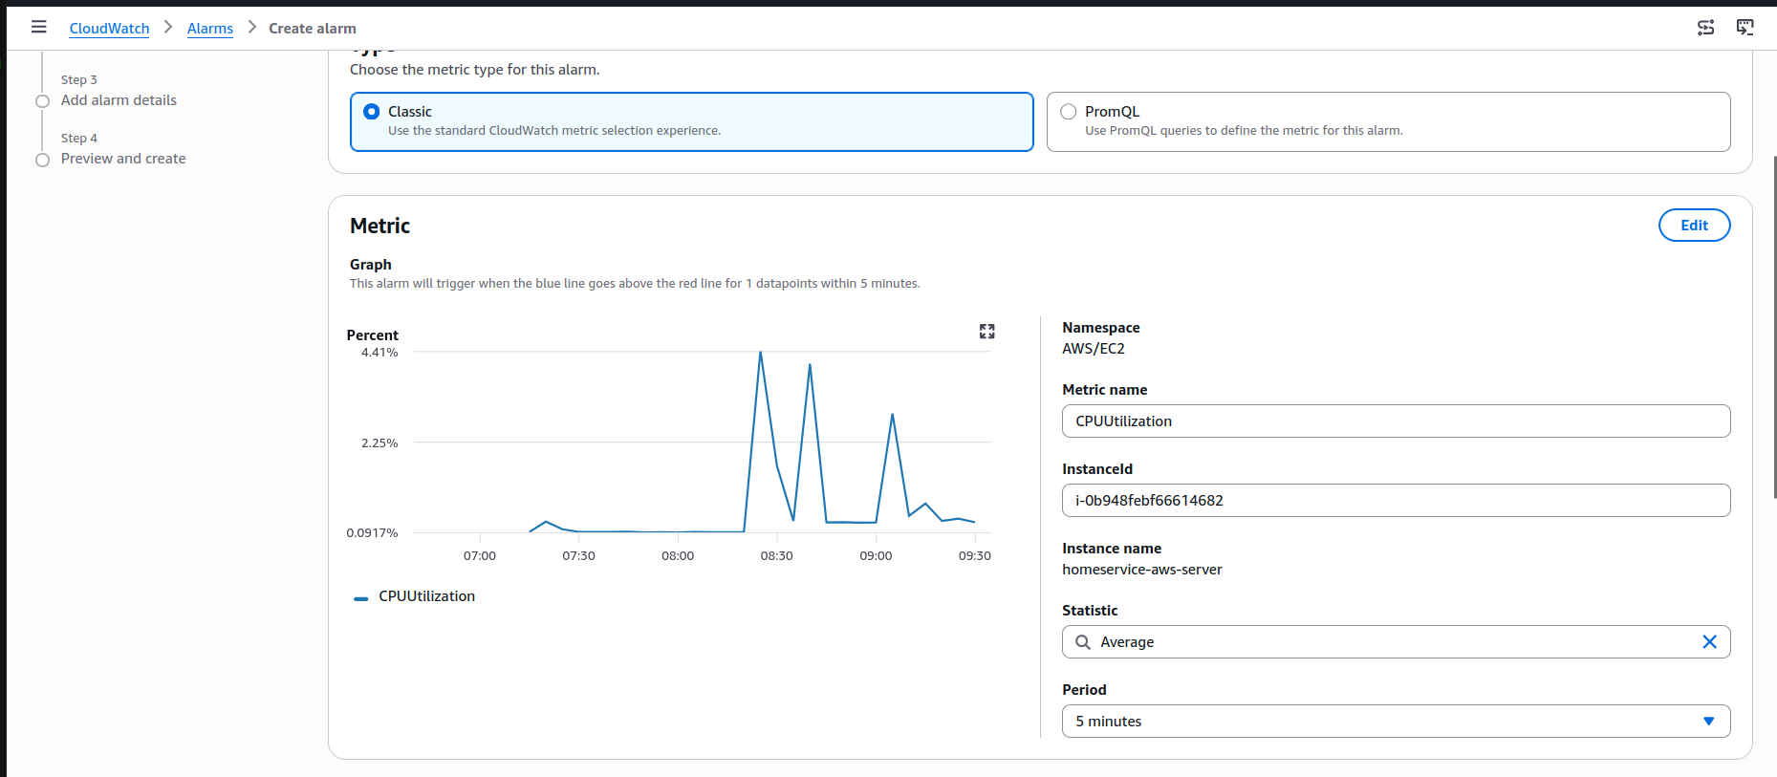
Observed real-time metric graphs to analyze CPU consumption and network traffic generated by the deployed application.

6. CloudWatch Alarm Configuration

Select CPU Utilization Metric
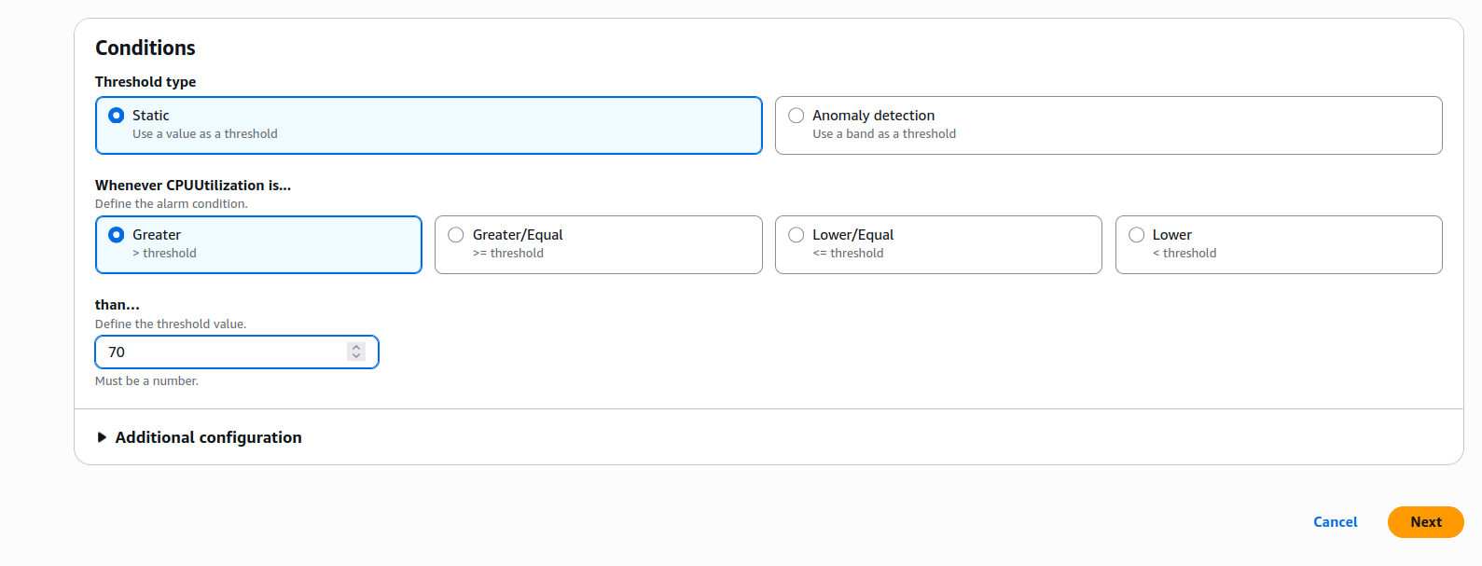
Configured CloudWatch alarm using the CPUUtilization metric from the EC2 instance.
Configuration:
- Namespace: AWS/EC2
- Metric: CPUUtilization
- Statistic: Average
- Period: 5 Minutes

Configure Alarm Threshold
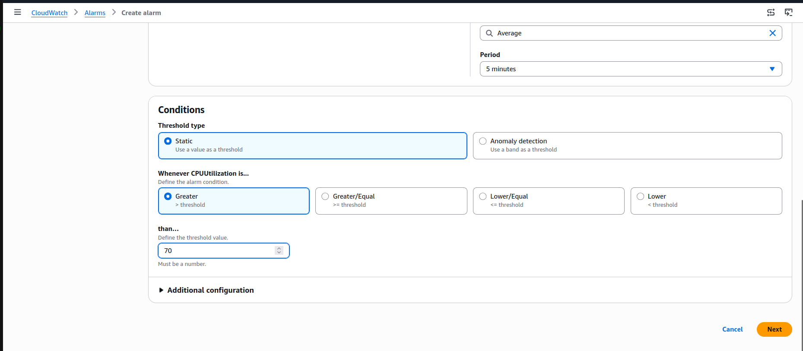
Configured a static threshold condition to trigger an alert when CPU utilization exceeds the defined limit.
Threshold Settings:
- Condition: Greater Than
- Threshold: 70%
- Evaluation Period: 5 Minutes

Create CloudWatch Alarm
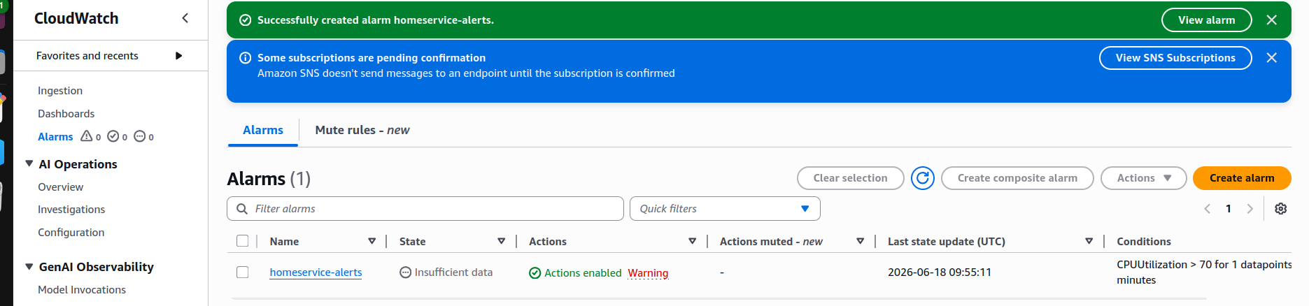
Successfully created the CloudWatch alarm named homeservice-alerts to monitor EC2 CPU utilization and trigger notifications when thresholds are breached.
Alarm Details:
- Alarm Name: homeservice-alerts
- Metric: CPUUtilization
- Threshold: 70%
- SNS Notification Enabled

Create S3Bucket
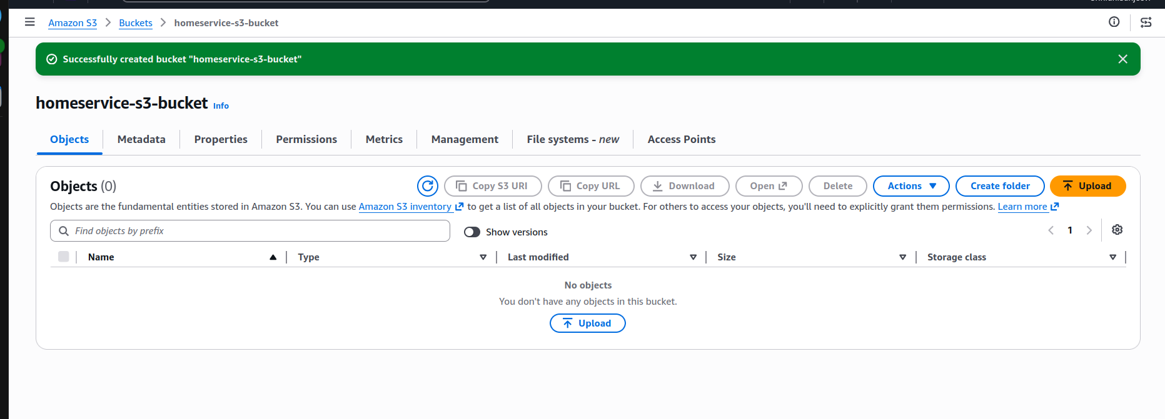

Created S3 Bucket where we can upload all the files and folders required

