**CHAPTER – 3**

**SYSTEM DESIGN**

**3.1 INTRODUCTION**

We design the system for the crime scene prediction, the following parameters that are taken into consideration are: evidences, witnesses, method of killing, motive of the murder, weapons used, number of murder attacks in particular area, month, year, time, using explosive devices. Then we analyze it with history of previous records to predict jewel theft murder. Jewel theft murder crime characteristic the first step of identification with the quality of previous datasets and apply the machine learning techniques. More specifically we use the classification and clustering based models, that helps to identify the crime and criminal pattern scene. The project intends to develop an automated tool with help of machine learning using machine learning techniques and strategies to predict the jewel theft murder in much lesser time. In this chapter, system design is reflected with the illustration of various diagrams like system architecture, process flow, use case, activity and data flow diagrams.

**3.2 SYSTEM ARCHITECTURE**

The goal of the architecture design is to establish the overall structure. Crime data is analyzed which is stored in the database. In the figure 3.1 represents the crime scene prediction using history of data system architecture. System will group crime and clustering will be done based on places where crime occurred, gang who involved in crime and the timing crime took place. This will help to predict crime which will occur in future. The subsystems are the working module in the process the testing and the training model and the implementation data preprocessing which controls and develop the definite data records for the system the system is the predicting model. This processing of the system is represented in the system architecture shown below.

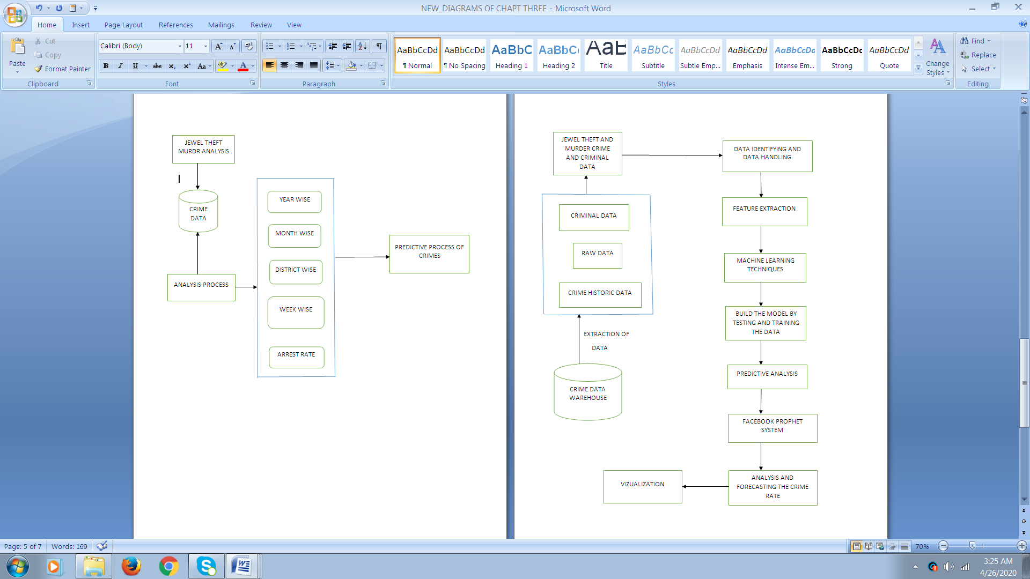

***Figure 3.1 System Architecture***

The systems architecture process is where the concepts that will be the backbone of the actual system are developed. It is a conceptual model that describes the structure and behavior of the proposed system or of an existing system.

* 1. **PROCESS FLOW**

The process explains the systematic flow of predictive analytics process, of crime scene prediction of jewel theft and murder using historic data. In the figure 3.2 represents the process flow of our project work crime scene prediction. It starts with data collection from various data sources. The data are crime records, historic crime data, criminal data. The data collected is subjected to pre-processing where the data is made ready for analysis on various parameters. Preprocessing step helps the model for processing the analyzing the crime rate. Modeling is an important step in the process flow where the actual model is built and made to fit the trained data. The data which are preprocessed are taken for the testing and training the model, so that the predictive analysis is analyzed and found and the model is also build. The predictive analysis is based on the trained data which gives the actual and predicted values. The forecasted crime rate values are made to plot in the form of graph for visualization purpose, which forms the final step in the predictive analytics process.

The process flow includes the following steps, they are:

* Data source
* Data collection
* Data pre-processing
* Data analysis
* Modeling
* Predictive analysis
* Visualization

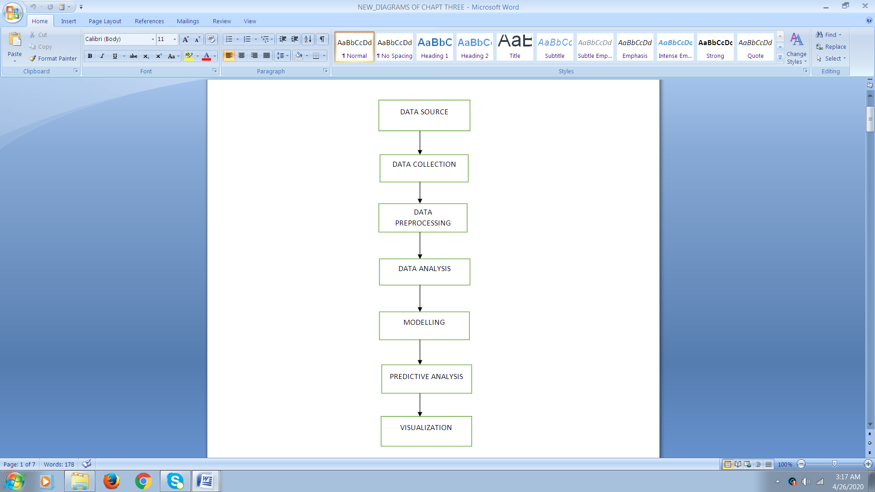

***Figure 3.2 Process Flow diagram***

* 1. **DATA FLOW DIAGRAM**

The below represented diagrams are the data flow diagrams which explains our work.

**3.4.1 DFD LEVEL 0**

In the level 0 of data flow diagram explains the basic flow of the project. The input data contains the crime database and the final result is the output data. The process between them involves analyzing and prediction.

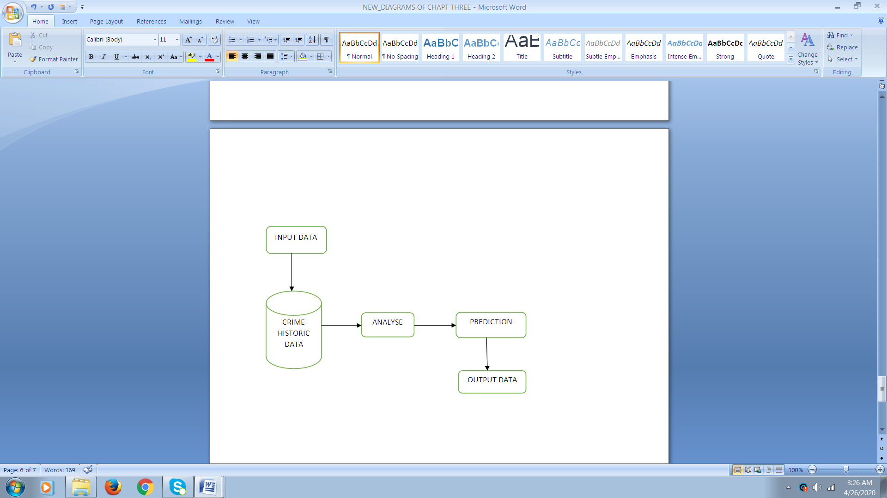

***Figure 3.3 DFD Level 0***

**3.4.2 DFD LEVEL 1**

In the below figure 3.4 It highlights the main functions carried out by the system. Crime database contains all the crime record. The necessary crime data is collected and the data is subjected to pre-processing. After pre-processing stage, the data will be cleaned from unwanted values. The cleaned data will be used for analysis process. Then a detailed analysis on Jewel theft murder crimes will be made on various parameters. Then forecasting made on the analysis will give the statistics about the crime rate and its future. The statistics will be represented in a graphical form and it shows the actual trend, monthly and weekly trends.

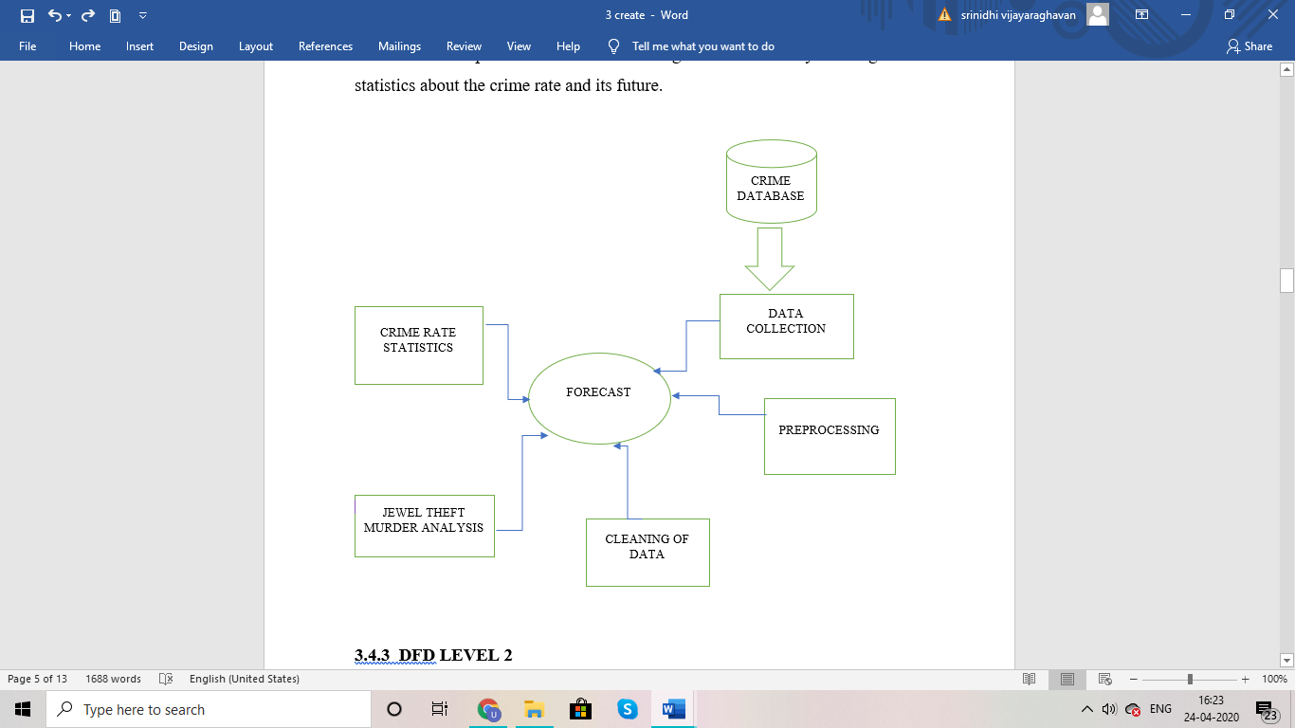

***Figure 3.4 DFD Level 1***

**3.4.3 DFD LEVEL 2**

. In the below figure 3.5 represents the DFD level 2. All crime records are collected for various resources which contains raw data. The raw data contains huge amount of unclassified records. The unclassified raw data is classified and segregated into the required crime data, history of crime and criminal data which combined to form the first step in the process of data collection.

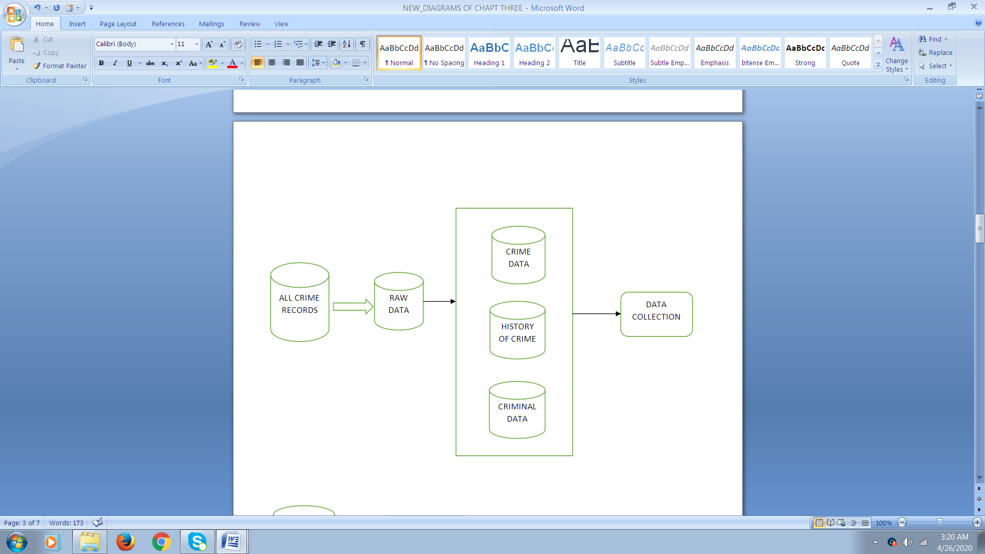

***Figure 3.5 DFD Level 2***

In DFD level 2, the next step after data collection is data pre-processing. Data pre-processing is a machine learning technique which is used to transform the raw data. The below figure 3.6 represents the collected crime records contain many missing and noisy values. Missing and noisy values are a common problem in real time data. The lost data can cause bias in the estimation of parameters. They provide with incorrect values which may lead to poor efficiency of the model. These values should be removed so that data is made suitable for analysis and prediction models.

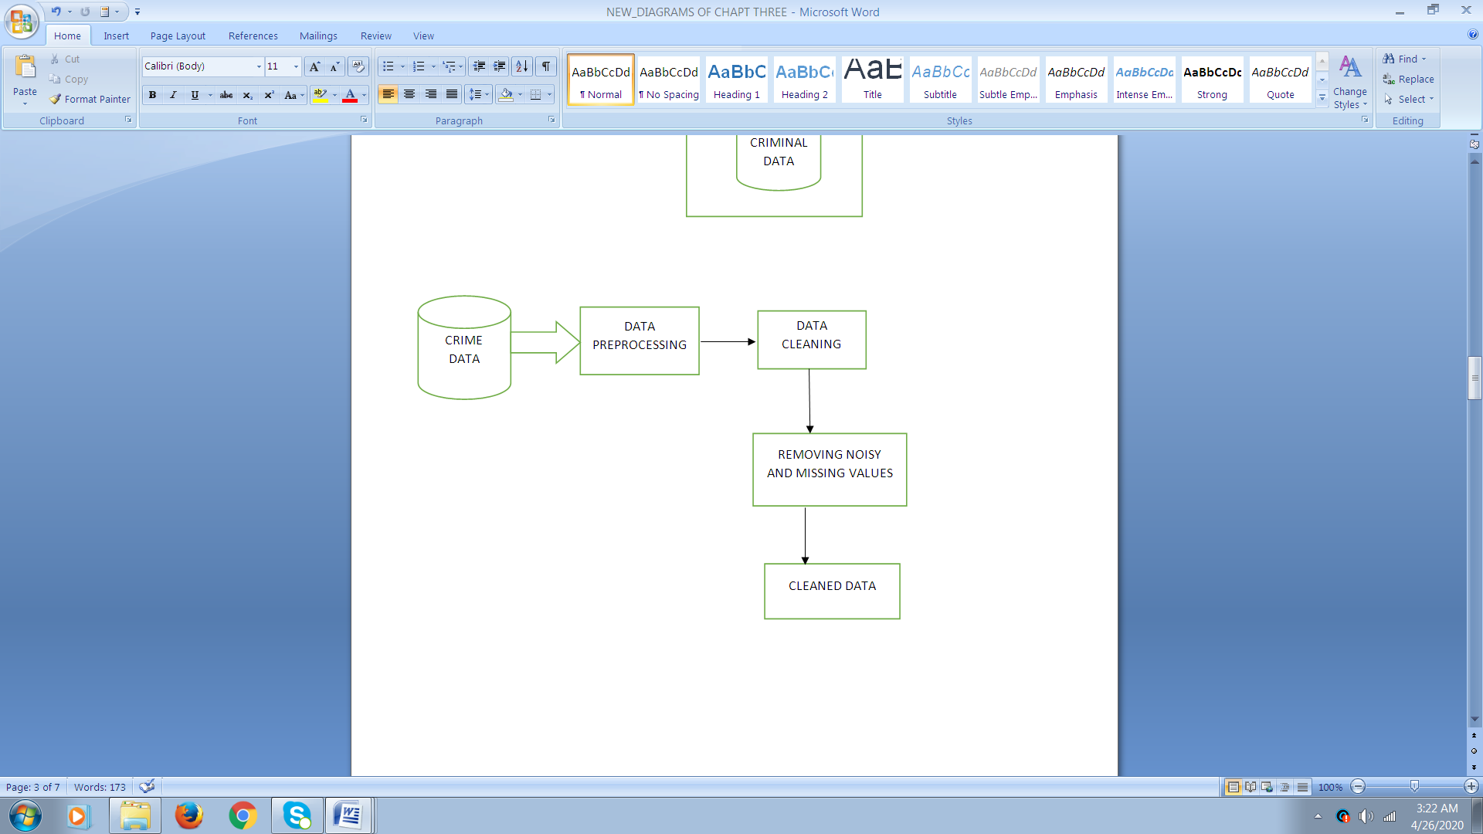

***Figure 3.6 DFD Level 2***

In DFD level 2, the below figure 3.7 shows the brief analysis of Jewel theft murder. It includes all the process till analysis. After the data is cleaned, we classify crime types according to their crime count values. Based on the analysis, we found that the Jewel theft murder crimes are the highest among other crimes. So a predictive analysis is made on it.

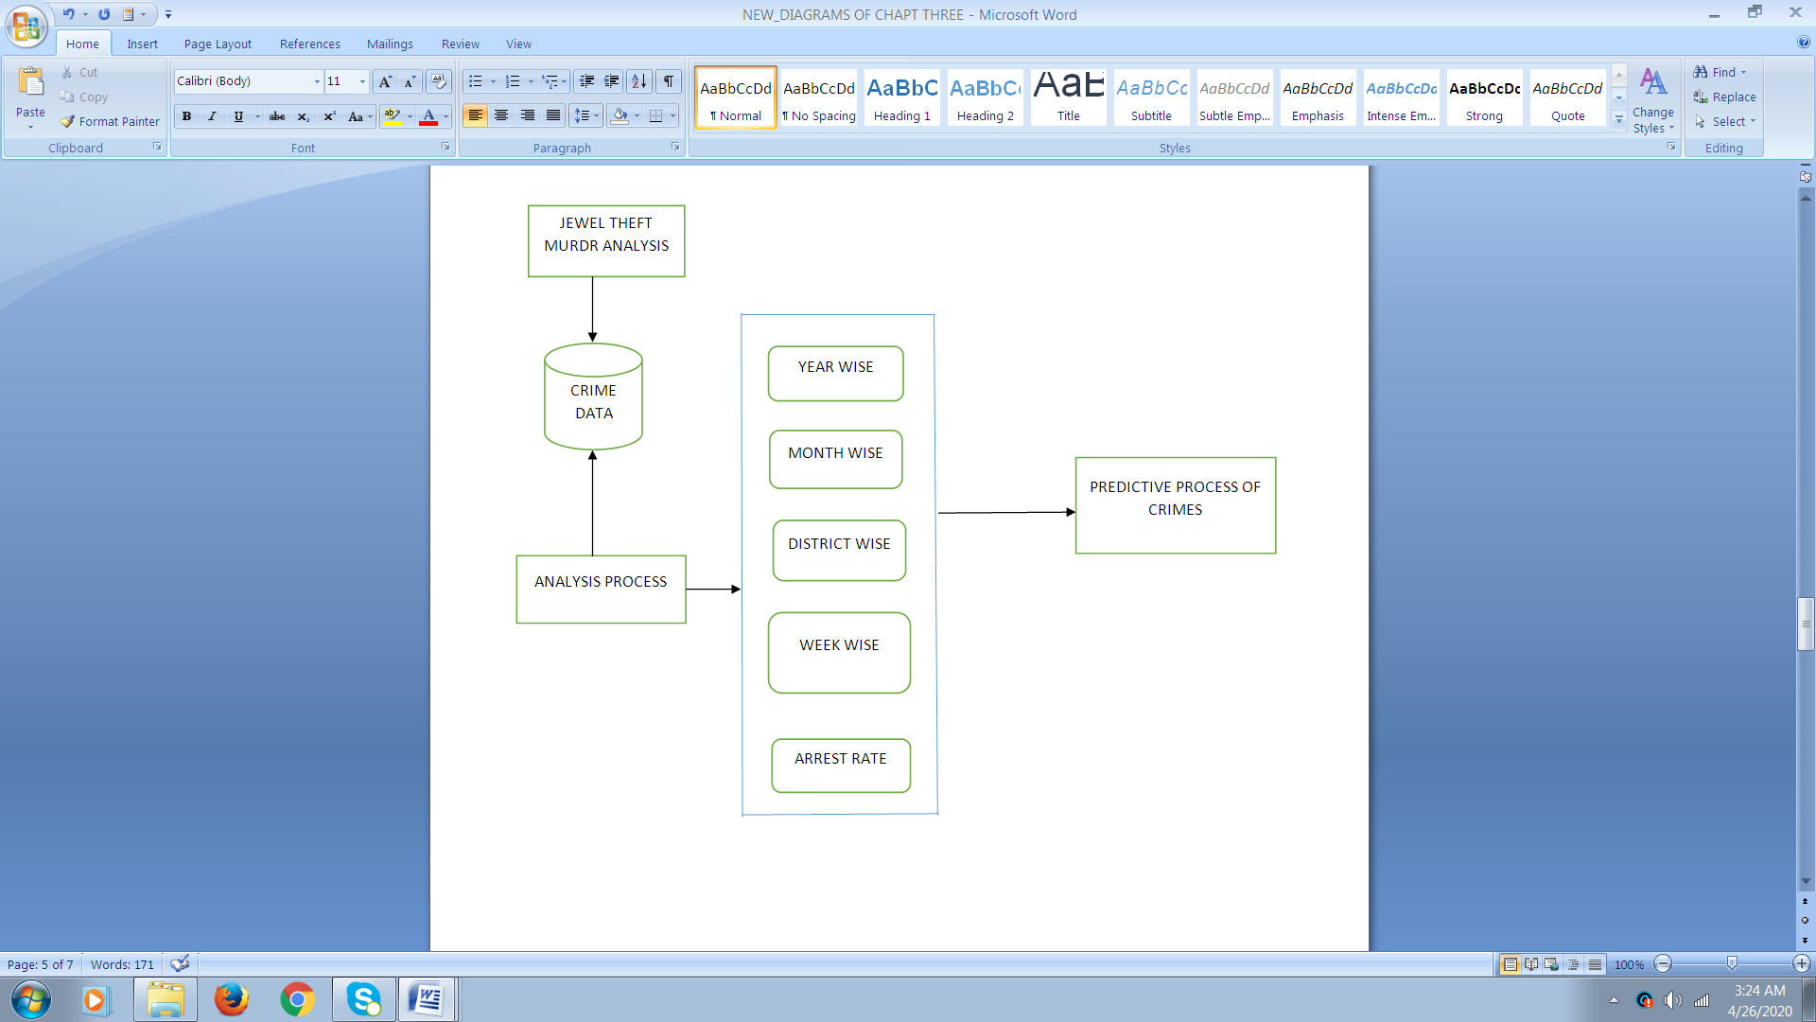

***Figure 3.7 DFD Level 2***

First we analysis the Jewel theft murder crimes on their week wise, month, year wise and district wise counts. Arrest rate analysis is also being done which shows the districts wise arrest statistics. This will be useful for police officials

to detect the pattern of the criminal and locate the districts where more concentration is needed. A graphical representation is made based on the statistics. These classified records will be the base for the predictive analysis and forecasting of model.

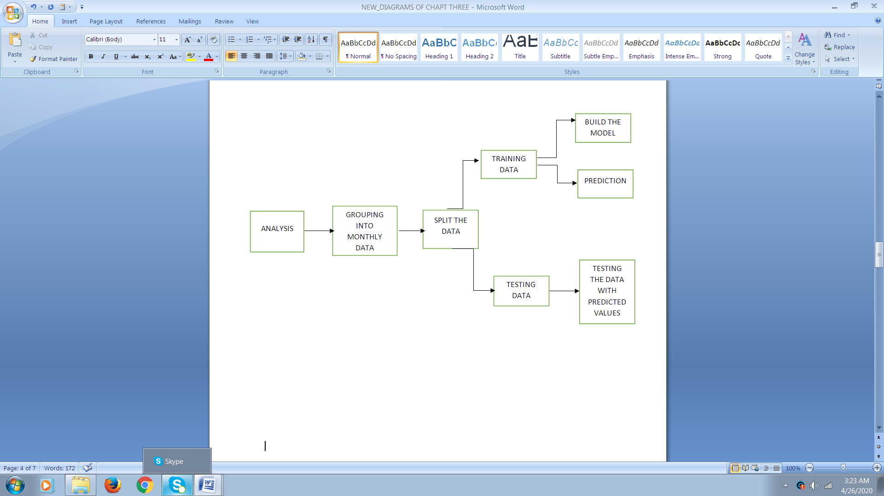

***Figure 3.8 DFD Level 2***

In DFD level 2 above figure3.8 represents, shows a detailed view on building of model for forecasting. After the jewel theft murder data are analyzed, they are grouped into monthly records. The monthly data made ready will be split into training data and testing data. The training data contains 80% of the data and testing data contains 20% of the data. A model is built and made to fit on the training data. The predictions are made for the future. Then test the data with predicted values using the testing data which shows the accuracy of the model built.

* 1. **UML DIAGRAMS**

The following UML diagrams are required for the project, they are:

* Use case diagram
* Activity diagram
* Class diagram

**3.5.1 USE CASE DIAGRAM**

There are four actors involved in the use case diagram are admin, criminal, police official and data analyst as showed in the figure 3.9. The use cases associated with admin are data source, data collections and classification, analyze and prediction. The use cases associated with criminal are property stolen, jewels and arrest rate. The use cases associated with police officials are investigate the case, to find the evidence, to maintain the record, book the case and arrest the case. The use case involved with data analyst are making week wise prediction, month wise prediction, district wise prediction and forecasting crime rate. The actor admin collects the data sources and process the crime and criminal data. The next actor criminal in which specifies the criminal behavior those are the type of the crime the criminal commits, time, date, the jewel and property. The next actor is the police officials where the crime and the criminal data are filed and reordered. The next actor is data analyst, forecasts the crime attempted by the criminal month, week, year, district wise and also forecasts the crime rate.

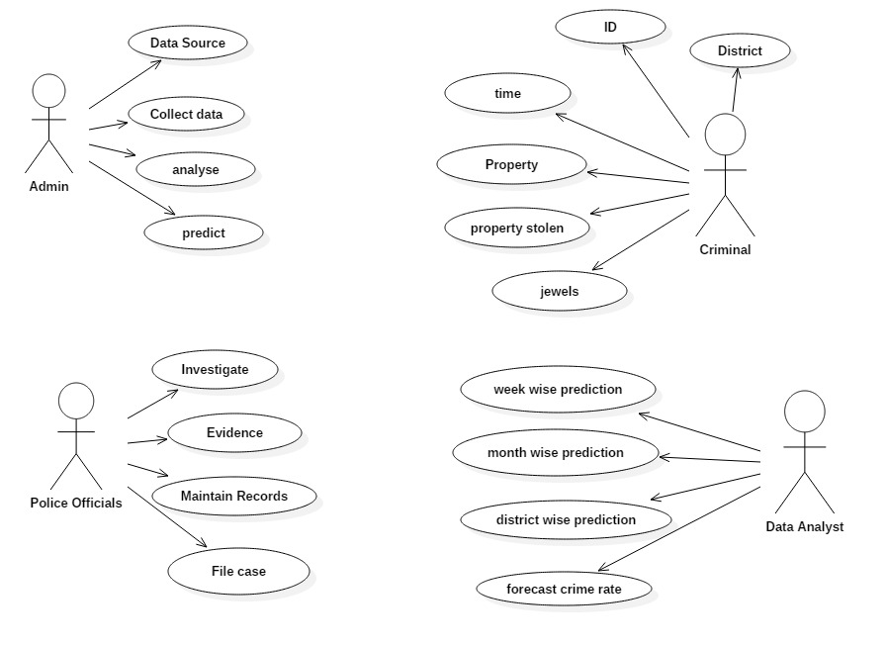

***Figure 3.9 Use case diagram***

**3.5.2 ACTIVITY DIAGRAM**

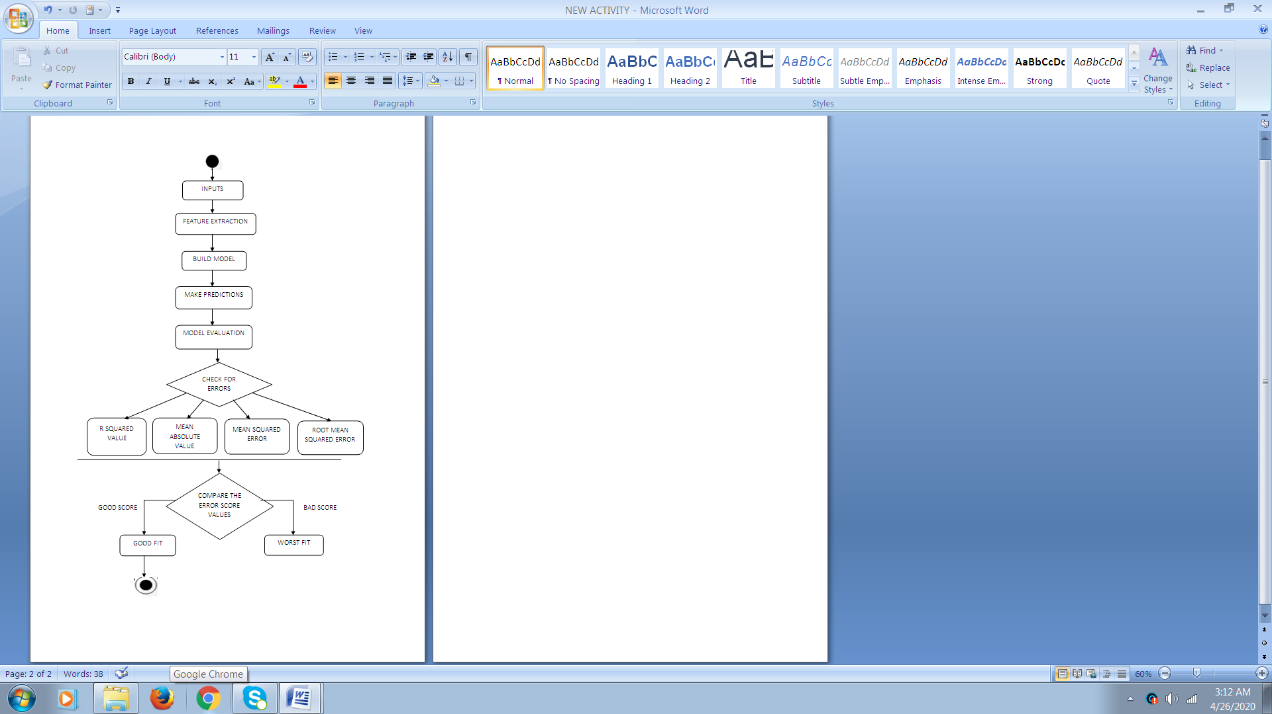

***Figure 3.10 Activity diagram***

Activity diagram is a flowchart to represent the flow from one activity to another activity as showed in figure 3.10. The process flow starts with input data that contains jewel theft murder crimes, where the required features are extracted for effective modelling.

Based on this data, a predictive model is built for making predictions and forecasting future values. Once the predictions are made, the model is evaluated for errors. The model evaluation includes four metrics namely r-squared value, mean squared error, mean absolute value and root mean squared error which will be used to evaluate the model. Based on the error score, we can conclude whether the model built is a good fit or a bad fit.

**3.6 PROCESS WORK FLOW**

Initialize

Outputs

Predicted values

Inputs

Date

Actual values

Start

Model=Prophet ()

Model. fit (actual values)

Forecast=model. predict (future)

Display predicted values

root square error=r2_score (actual values, predicted values)

display root square error

mse = mean_ squared_ error (actual values, predicted values)

display mse

mav=mean_ absolute_ error (actual values, predicted values)

display mav

End

**3.7 SUMMARY**

This chapter helps in making the system design for the crime prediction and also in understanding the process of the crime analysing and forecasting the system. Also it briefs about the system in various perspectives like, as an actor’s role, data flow and their activities, as the flow of the process step by step and the basic structure architecture of the system. With this system design and the proposed system structure and the process flow, the diagrams explains the data collection and segregation and the several stages of pre-processing, analysis, detection, prediction of the crime scene system.