Ex:1

**package** javalab1;

**public** **class** javalab1

{

**public** **static** **void** main(String args[])

{

System.***out***.println("hello java");

}

}

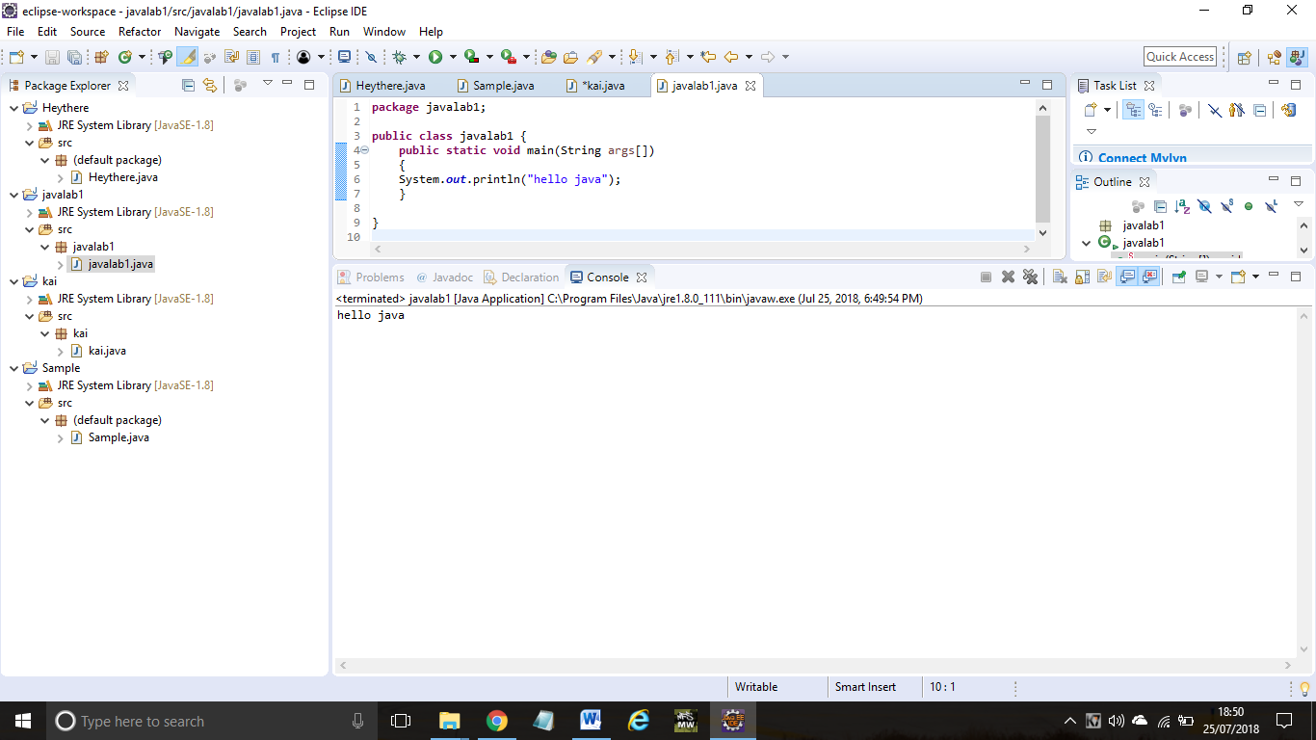

Ex:2

**package** javalab2;

**public** **class** javalab2

{

**int** id;

String name;

**public** **static** **void** main(String args[])

{

javalab2 s1=**new** javalab2();

System.***out***.println(s1.id);

System.***out***.println(s1.name);

}

}

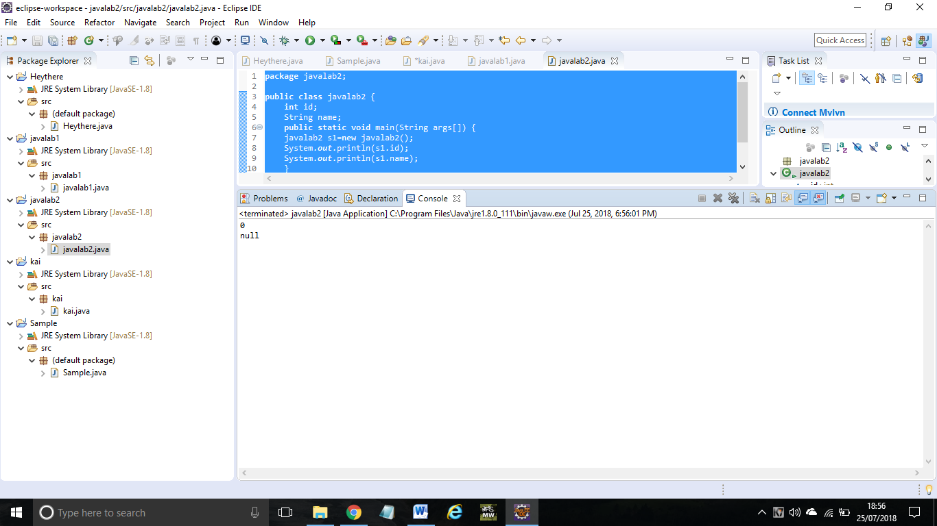

Ex:3

**package** javalab3;

**public** **class** javalab3

{

**int** rollno;

String name;

**void** insertRecord(**int** r, String n)

{

rollno=r;

name=n;

}

**void** displayInformation(){System.***out***.println(rollno+" "+name);

}

**public** **static** **void** main(String args[])

{

javalab3 s1=**new** javalab3();

javalab3 s2=**new** javalab3();

s1.insertRecord(111,"srinidhi");

s2.insertRecord(222,"deepikha");

s1.displayInformation();

s2.displayInformation();

}

}

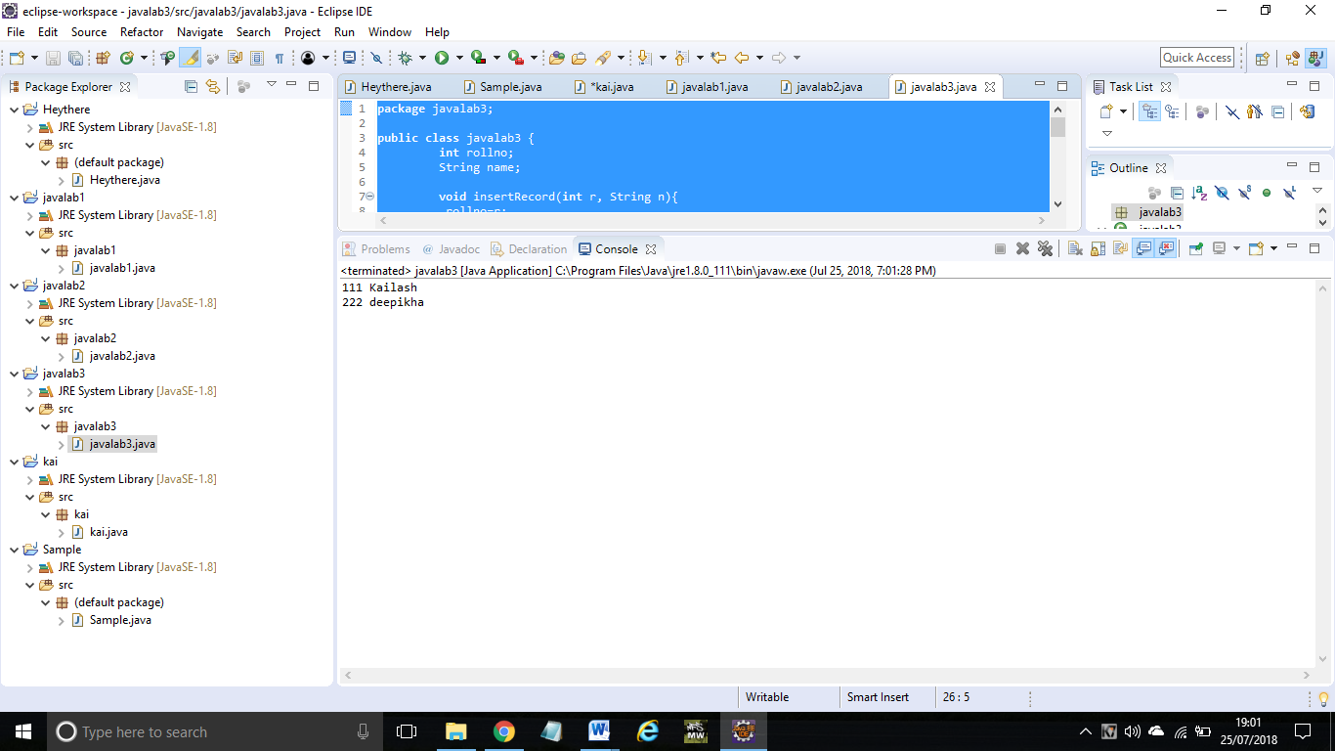

Ex:4

**package** javalab4;

**public** **class** javalab4

{

**int** length;

**int** width;

**void** insert(**int** l,**int** w)

{

length=l;

width=w;

}

**void** calculateAreaofRECTANGLE(){System.***out***.println(length*width);

}

**public** **static** **void** main(String args[]){

javalab4 r1=**new** javalab4();

javalab4 r2=**new** javalab4();

r1.insert(11,5);

r2.insert(3,15);

r1.calculateAreaofRECTANGLE();

r2.calculateAreaofRECTANGLE();

}}

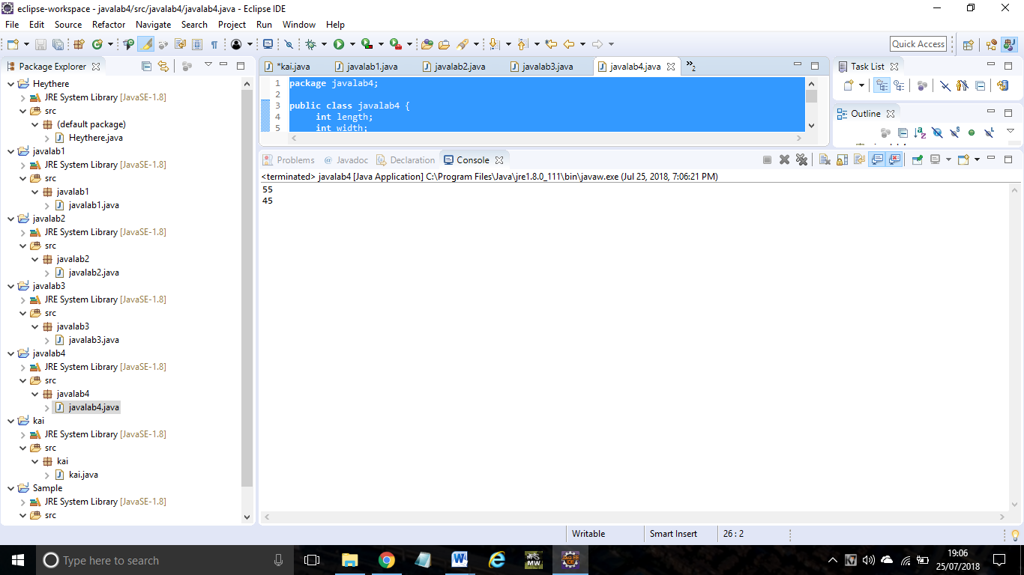

Ex:5

**package** javalab5;

**public** **class** javalab5

{

**void** fact(**int** n)

{

**int** fact=1;

**for**(**int** i=1;i<=n;i++)

{

fact=fact*i;

}

System.***out***.println("factorial is "+fact);

}

**public** **static** **void** main(String args[])

{

**new** javalab5().fact(5);

}

}

Output:

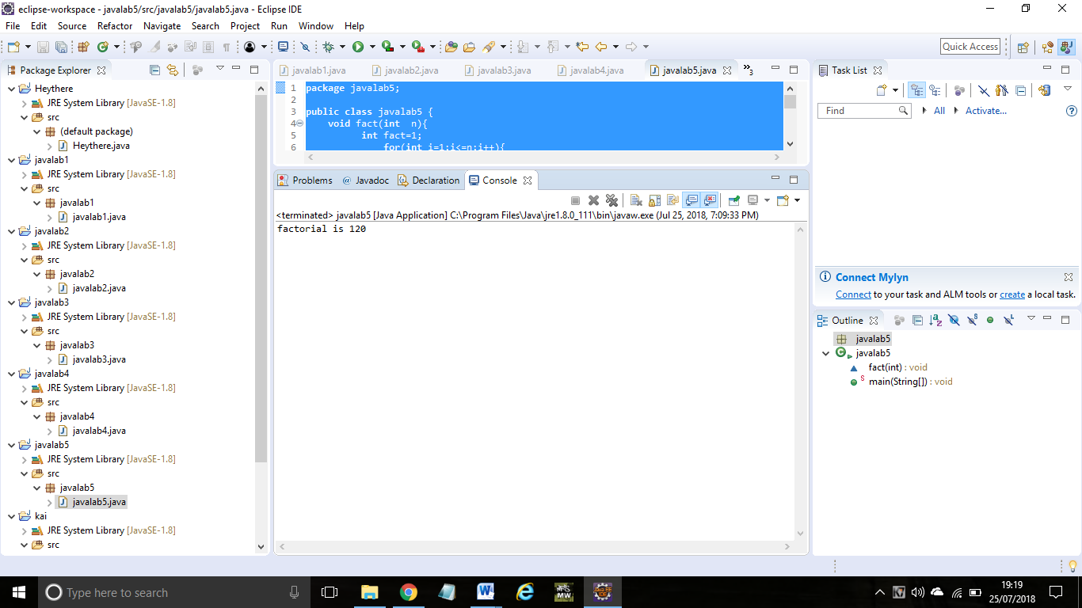

Ex:6

package javalab6;

public class javalab6 {

int length;

int width;

void insert(int l,int w){

length=l;

width=w;

}

void calculateArea(){System.out.println(length*width);}

public static void main(String args[]){

javalab6 r1=new javalab6(),r2=new javalab6();

r1.insert(11,5);

r2.insert(3,15);

r1.calculateArea();

r2.calculateArea();

}

output:

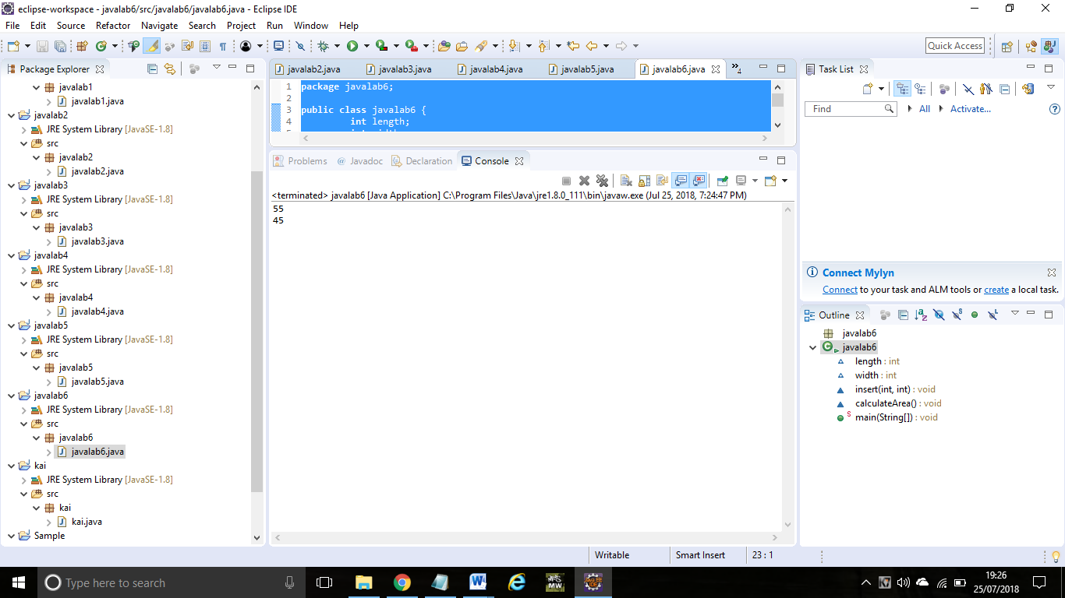

Ex:7

**package** javalab7;

**public** **class** javalab7 {

**void** sum(**int** a,**int** b){System.***out***.println(a+b);}

**void** sum(**int** a,**int** b,**int** c){System.***out***.println(a+b+c);}

**public** **static** **void** main(String args[]){

javalab7 obj=**new** javalab7();

obj.sum(10,10,10);

obj.sum(20,20);

}

}

Output:

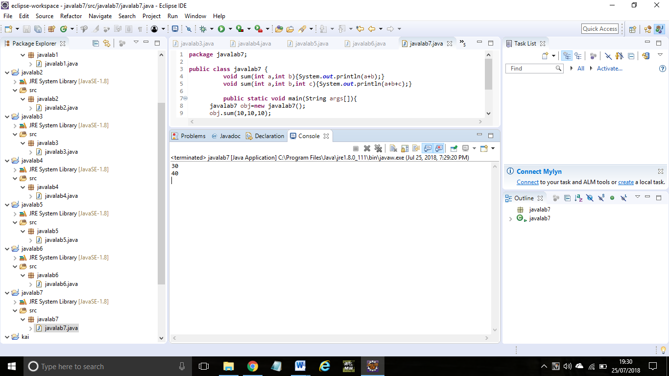

Ex:8:

**package** javalab8;

**public** **class** javalab8 {

**void** sum(**int** a,**int** b){System.***out***.println(a+b);}

**void** sum(**double** a,**double** b){System.***out***.println(a+b);}

**public** **static** **void** main(String args[]){

javalab8 obj=**new** javalab8();

obj.sum(10.5,10.5);

obj.sum(20,20);

}

}

Output:

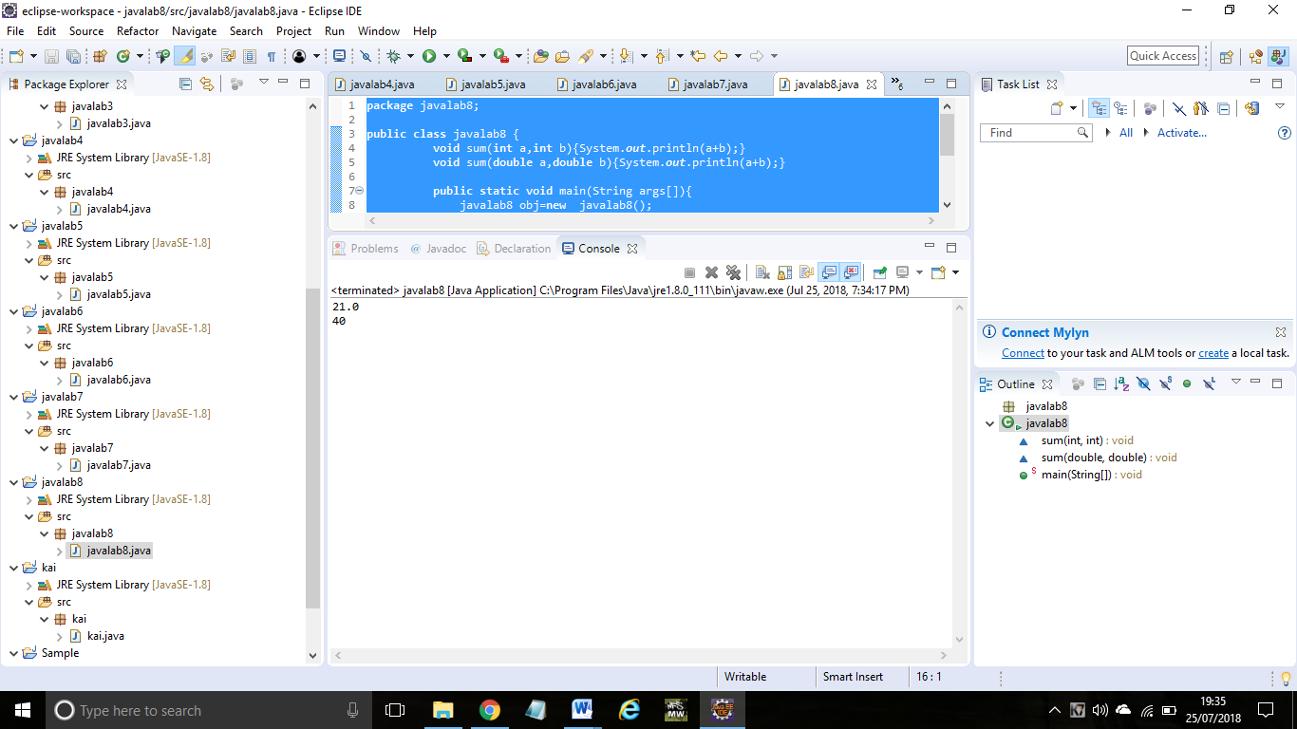

Ex:9

**package** javalab9;

**public** **class** javalab9 {

**public** **static** **void** main(**int** a){

System.***out***.println(a);

}

**public** **static** **void** main(String args[]){

System.***out***.println("main() method invoked");

*main*(10);

}

}

Output:

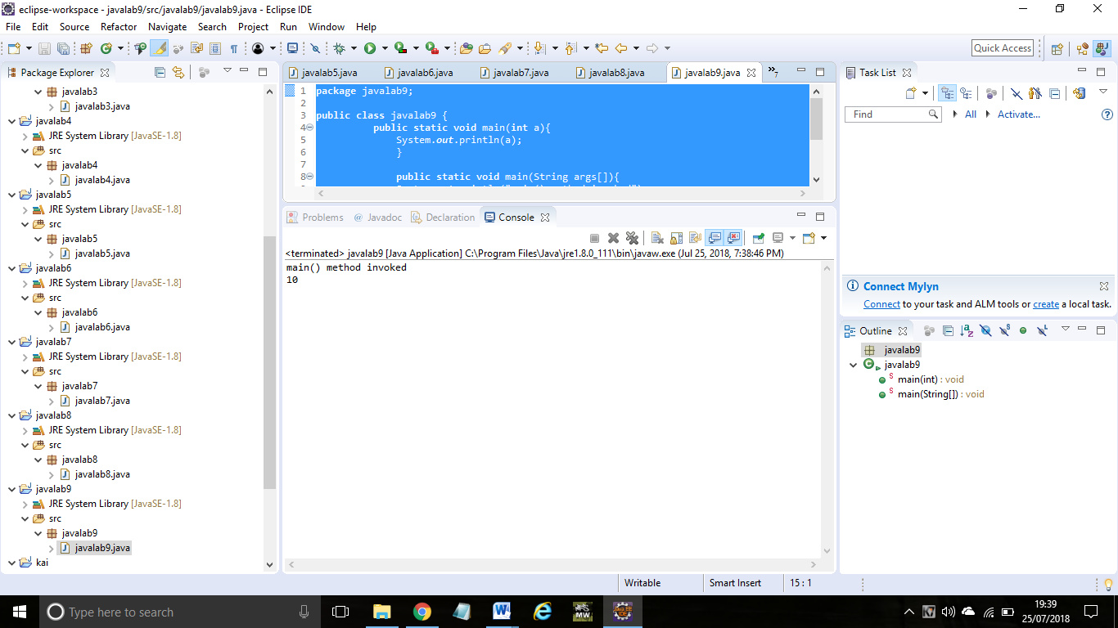

Ex:10

**package** javalab10;

**public** **class** javalab10 {

**void** sum(**int** a,**long** b){System.***out***.println(a+b);}

**void** sum(**int** a,**int** b,**int** c){System.***out***.println(a+b+c);}

**public** **static** **void** main(String args[]){

javalab10 obj=**new** javalab10();

obj.sum(20,20);

obj.sum(20,20,20);

}

}

Output:

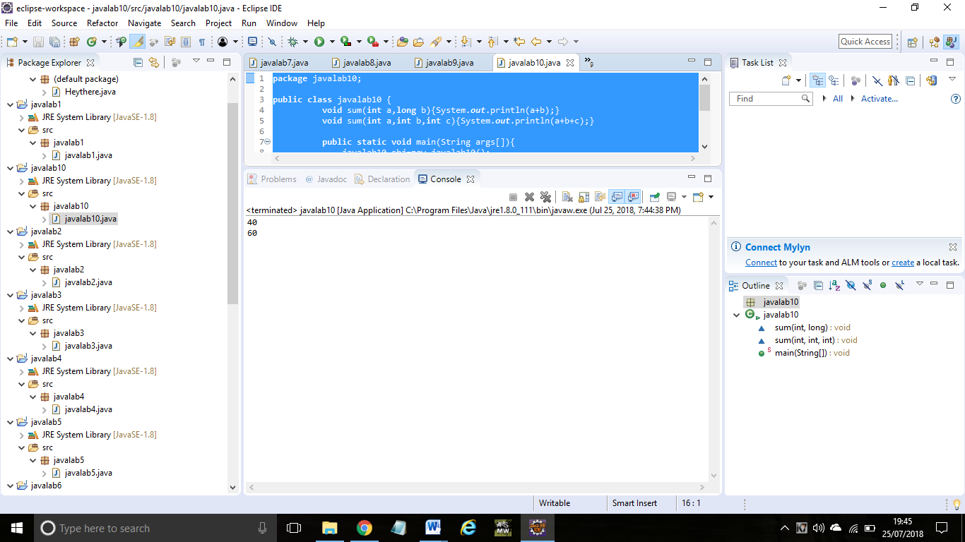

Ex:11

**package** javalab11;

**public** **class** javalab11 {

javalab11(){System.***out***.println("Bike is created");}

**public** **static** **void** main(String args[]){

javalab11 b=**new** javalab11();

}

}

Output:

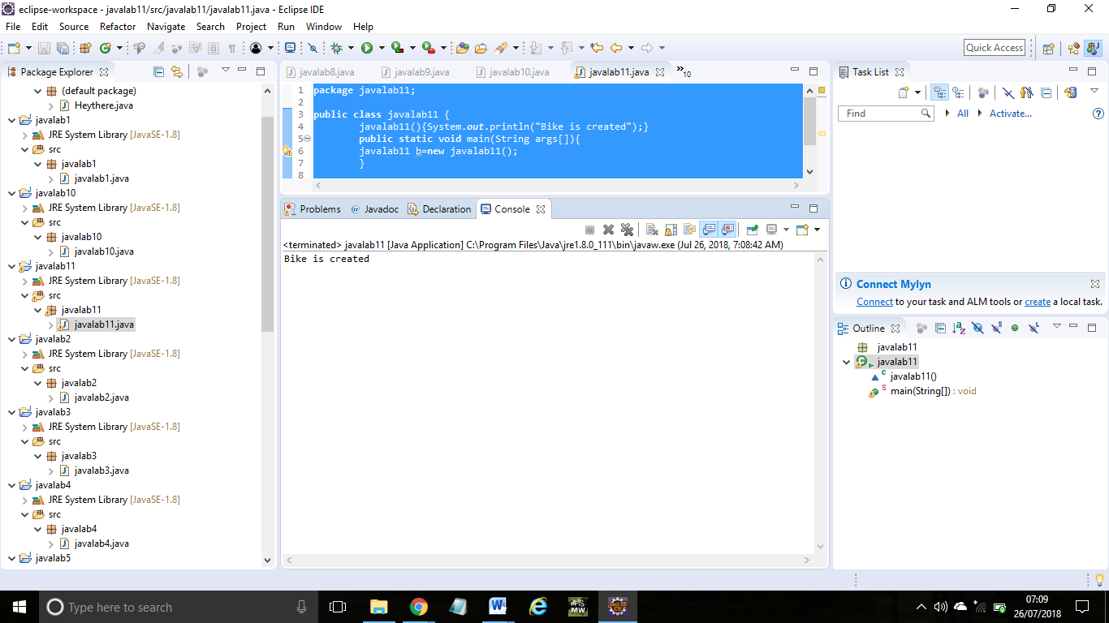

Ex:12

**package** javalab12;

**public** **class** javalab12 {

**int** id;

String name;

**void** display(){System.***out***.println(id+" "+name);}

**public** **static** **void** main(String args[]){

javalab12 s1=**new** javalab12();

javalab12 s2=**new** javalab12();

s1.display();

s2.display();

}

}

Output:

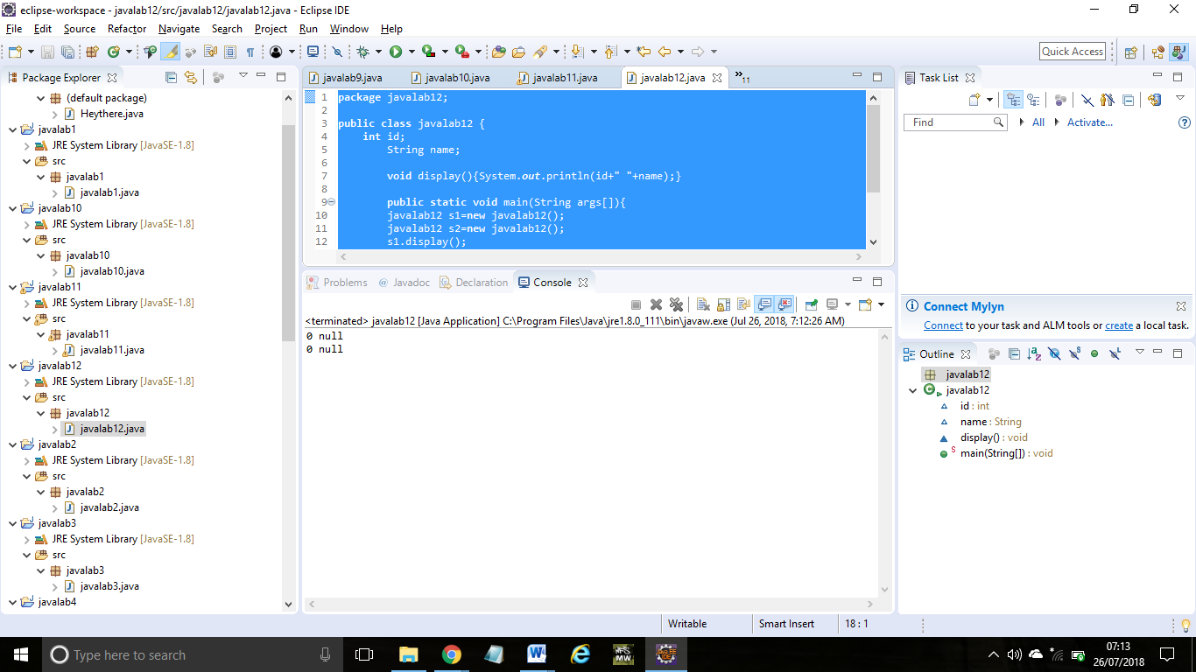

Ex:13

**package** javalab13;

**public** **class** javalab13 {

**int** id;

String name;

javalab13(**int** i,String n){

id = i;

name = n;

}

**void** display(){System.***out***.println(id+" "+name);}

**public** **static** **void** main(String args[]){

javalab13 s1 = **new** javalab13(111,"manisha");

javalab13 s2 = **new** javalab13(222,"eswari");

s1.display();

s2.display();

}

}

Output:

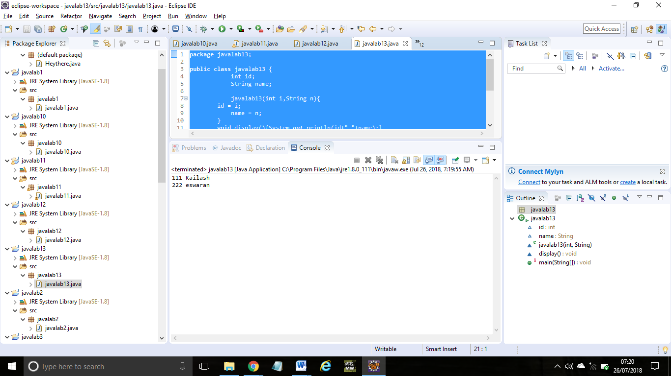

Ex:14

**package** javalab14;

**public** **class** javalab14 {

**int** id;

String name;

**int** age;

javalab14(**int** i,String n){

id = i;

name = n;

}

javalab14(**int** i,String n,**int** a){

id = i;

name = n;

age=a;

}

**void** display(){System.***out***.println(id+" "+name+" "+age);}

**public** **static** **void** main(String args[]){

javalab14 s1 = **new** javalab14(111,"kaliaya",19);

javalab14 s2 = **new** javalab14(222,"vinoth",19);

s1.display();

s2.display();

}

}

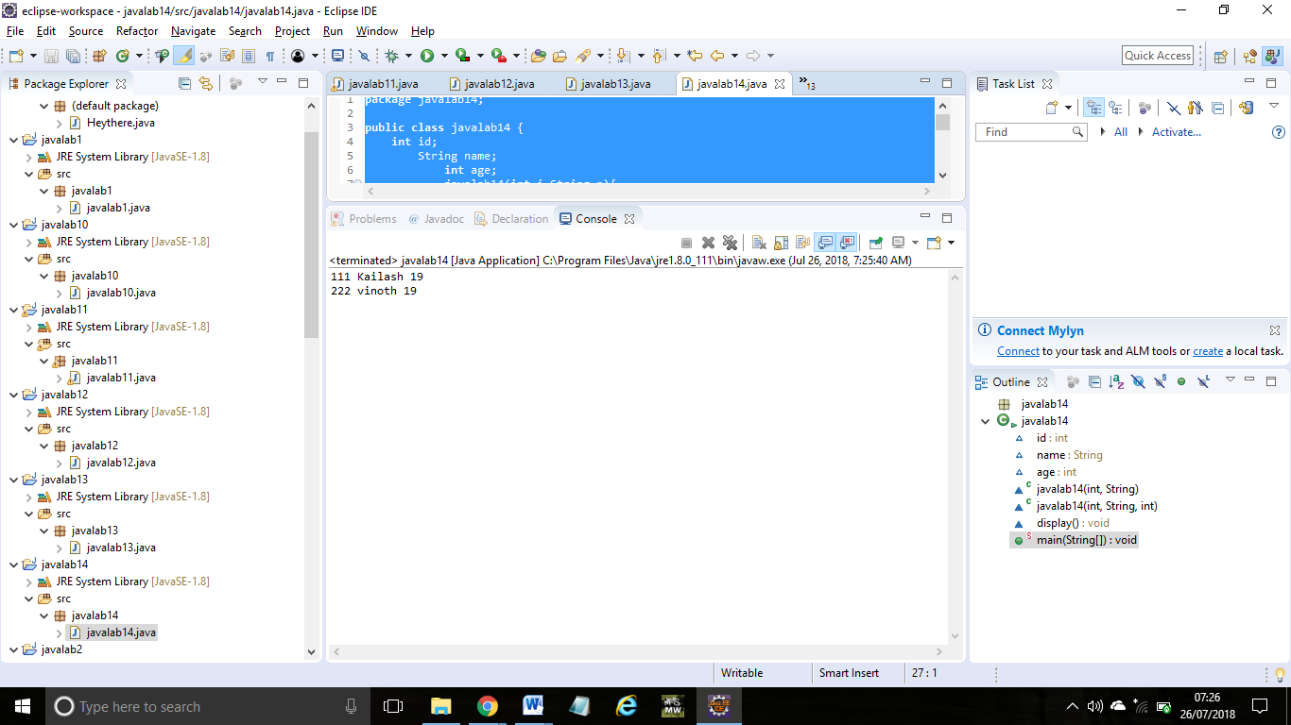

Ex:15

**public** **class** javalab15 {

**int** id;

String name;

javalab15(**int** i,String n){

id = i;

name = n;

}

javalab15(javalab15 s){

id = s.id;

name =s.name;

}

**void** display(){System.***out***.println(id+" "+name);}

**public** **static** **void** main(String args[]){

javalab15 s1 = **new** javalab15(111,"srinidhi");

javalab15 s2 = **new** javalab15(s1);

s1.display();

s2.display();

}

}

Output:

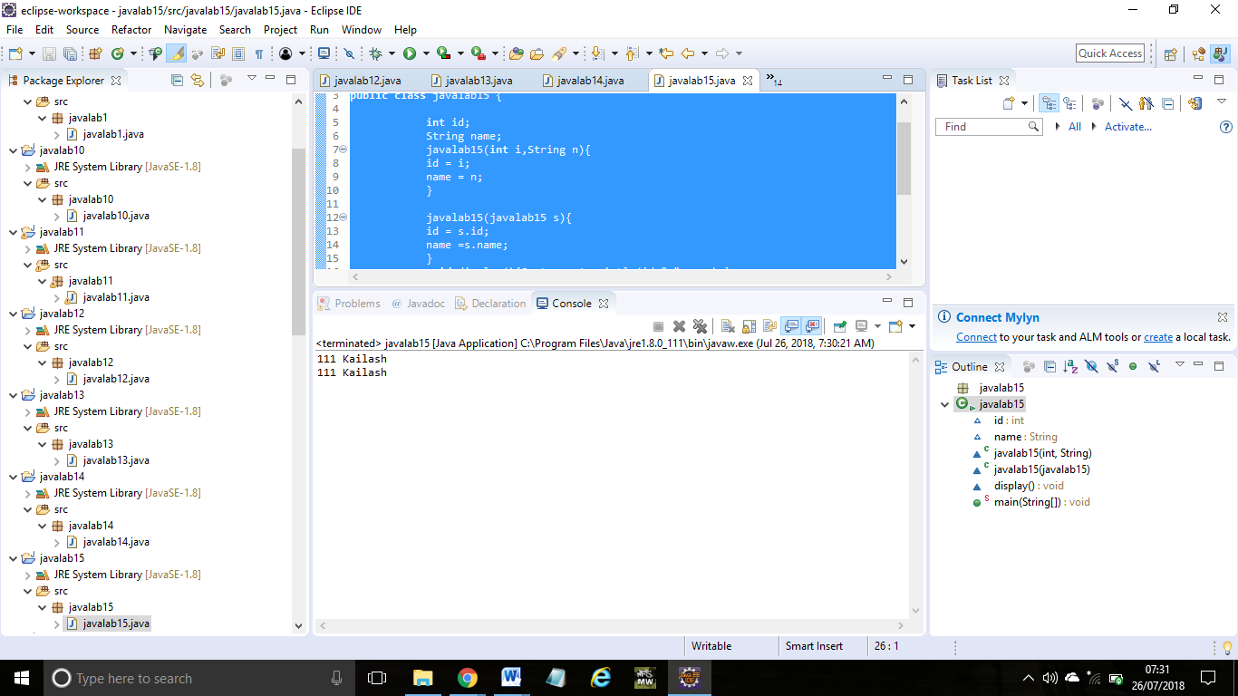

Ex:16

**package** javalab16;

**public** **class** javalab16 {

**int** count=0;

javalab16(){

count++;

System.***out***.println(count);

}

**public** **static** **void** main(String args[]){

javalab16 c1=**new** javalab16();

javalab16 c2=**new** javalab16();

javalab16 c3=**new** javalab16();

}

}

Output:

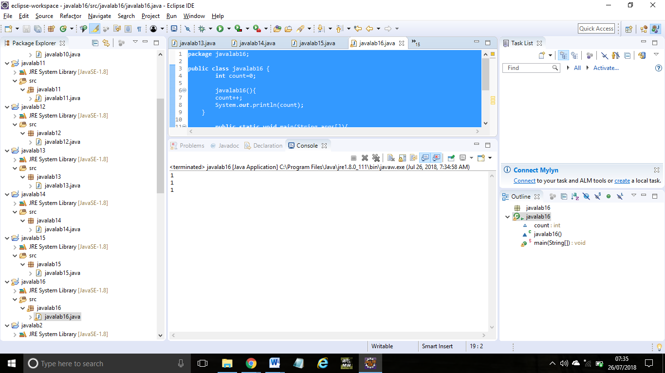

Ex:17

**package** javalab17;

**public** **class** javalab17 {

**static** **int** *count*=0;

javalab17(){

*count*++;

System.***out***.println(*count*);

}

**public** **static** **void** main(String args[]){

javalab17 c1=**new** javalab17();

javalab17 c2=**new** javalab17();

javalab17 c3=**new** javalab17();

}

}

Output:

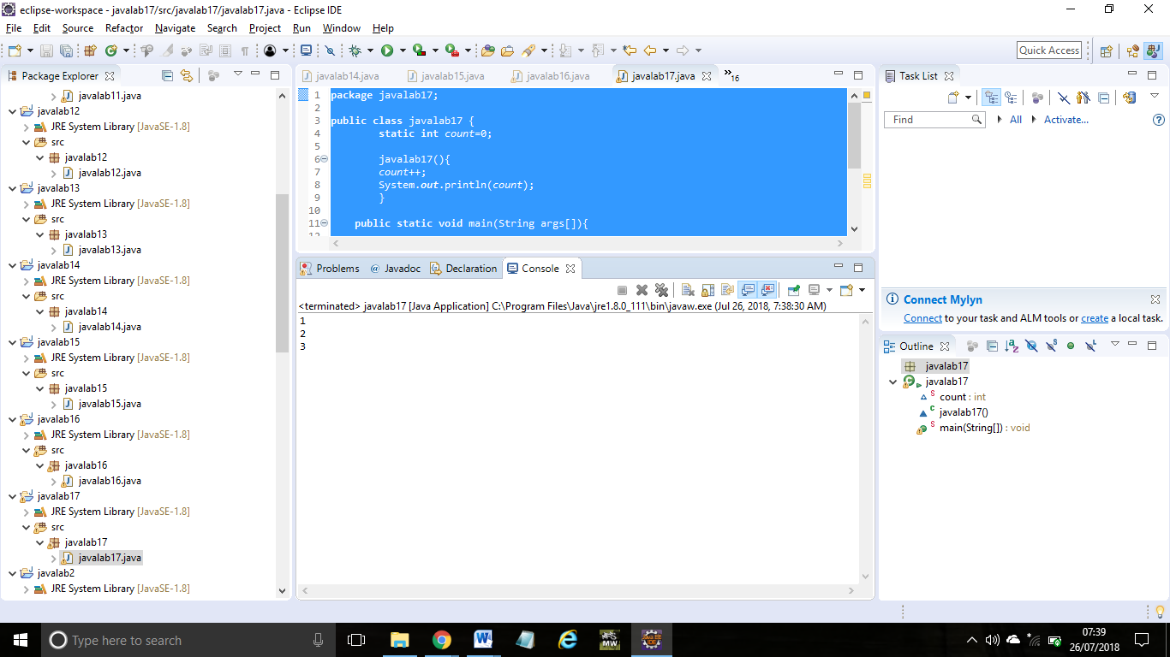

Ex:18

**package** javalab18;

**public** **class** javalab18 {

**int** rollno;

String name;

**static** String *college* = "ITS";

**static** **void** change(){

*college* = "RIT"; }

javalab18(**int** r, String n){

rollno = r;

name = n;

}

**void** display (){System.***out***.println(rollno+" "+name+" "+*college*);}

**public** **static** **void** main(String args[]){

javalab18.*change*();

javalab18 s1 = **new** javalab18 (111,"srinidhi");

javalab18 s2 = **new** javalab18 (222,"vinoth");

javalab18 s3 = **new** javalab18 (333,"deepikha");

s1.display();

s2.display();

s3.display();

}

}

Output:

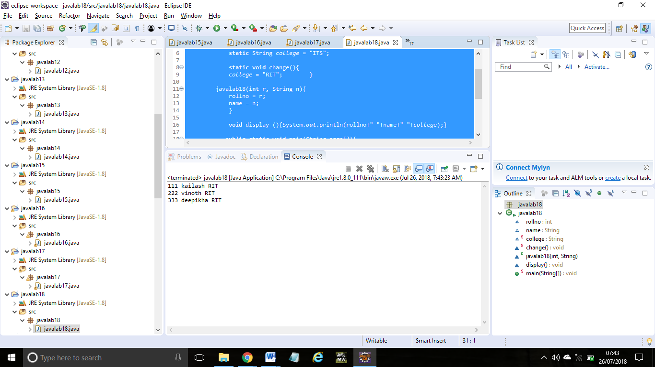

Ex:19

**package** javalab19;

**public** **class** javalab19 {

**int** id;

String name;

javalab19(**int** id,String name){

**this**.id = id;

**this**.name = name;

}

**void** display(){System.***out***.println(id+" "+name);}

**public** **static** **void** main(String args[]){

javalab19 s1 = **new** javalab19(011,"srinidhi");

javalab19 s2 = **new** javalab19(004,"deepikha");

s1.display();

s2.display();

}

}

Output:

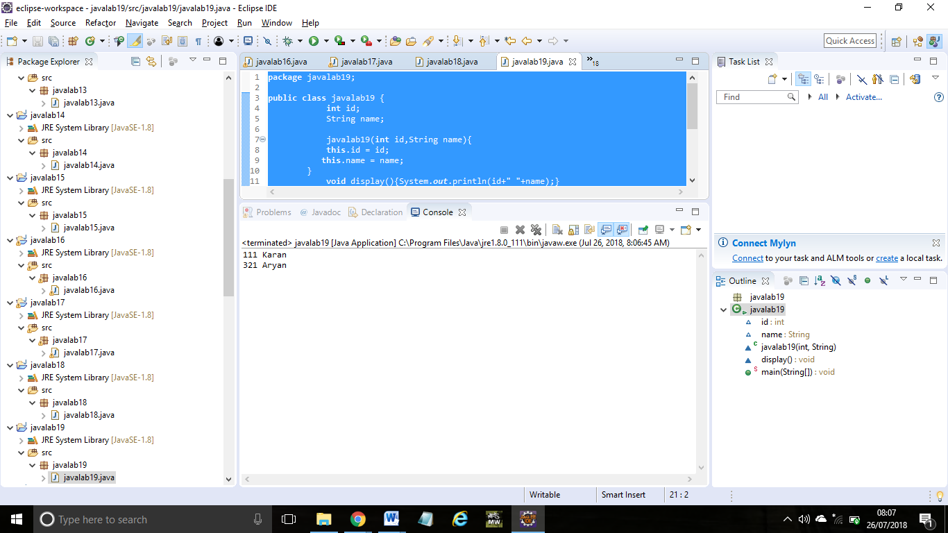

Ex:20

**package** javalab20;

**public** **class** javalab20 {

**int** id;

String name;

javalab20(){System.***out***.println("default constructor is invoked");}

javalab20(**int** id,String name){

**this** ();//it is used to invoked current class constructor.

**this**.id = id;

**this**.name = name;

}

**void** display(){System.***out***.println(id+" "+name);}

**public** **static** **void** main(String args[]){

javalab20 e1 = **new** javalab20(111,"shivani");

javalab20 e2 = **new** javalab20(222,"yashika");

e1.display();

e2.display();

}

}

Output:

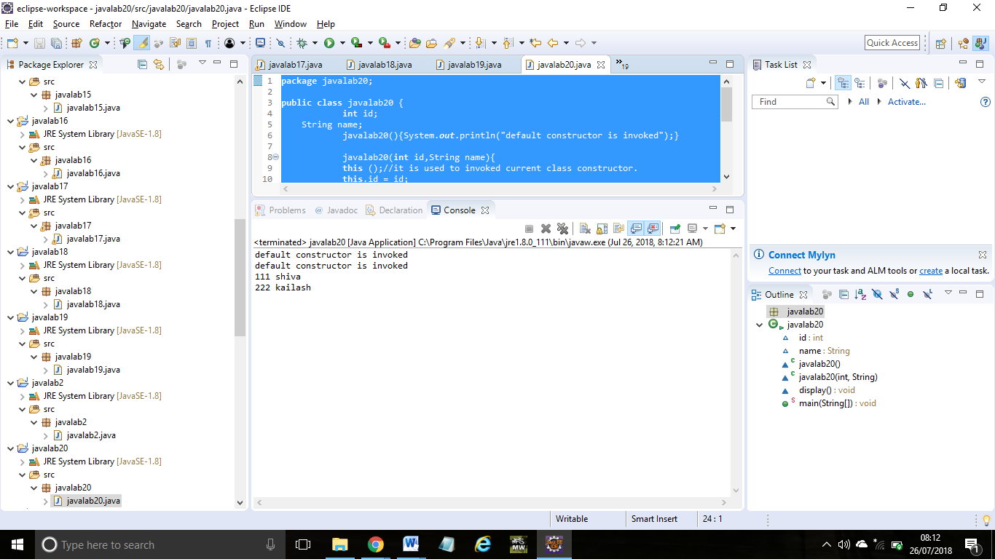

Ex:21

**package** javalab21;

**public** **class** javalab21 {

**int** id;

String name;

String city;

javalab21(**int** id,String name){

**this**.id = id;

**this**.name = name;

}

javalab21(**int** id,String name,String city){

**this**(id,name);//now no need to initialize id and name

**this**.city=city;

}

**void** display(){System.***out***.println(id+" "+name+" "+city);}

**public** **static** **void** main(String args[]){

javalab21 e1 = **new** javalab21(111,"srinidhi","tambaram");

javalab21 e2 = **new** javalab21(222,"deepikha","kk nagar");

e1.display();

e2.display();

}

}

Output:

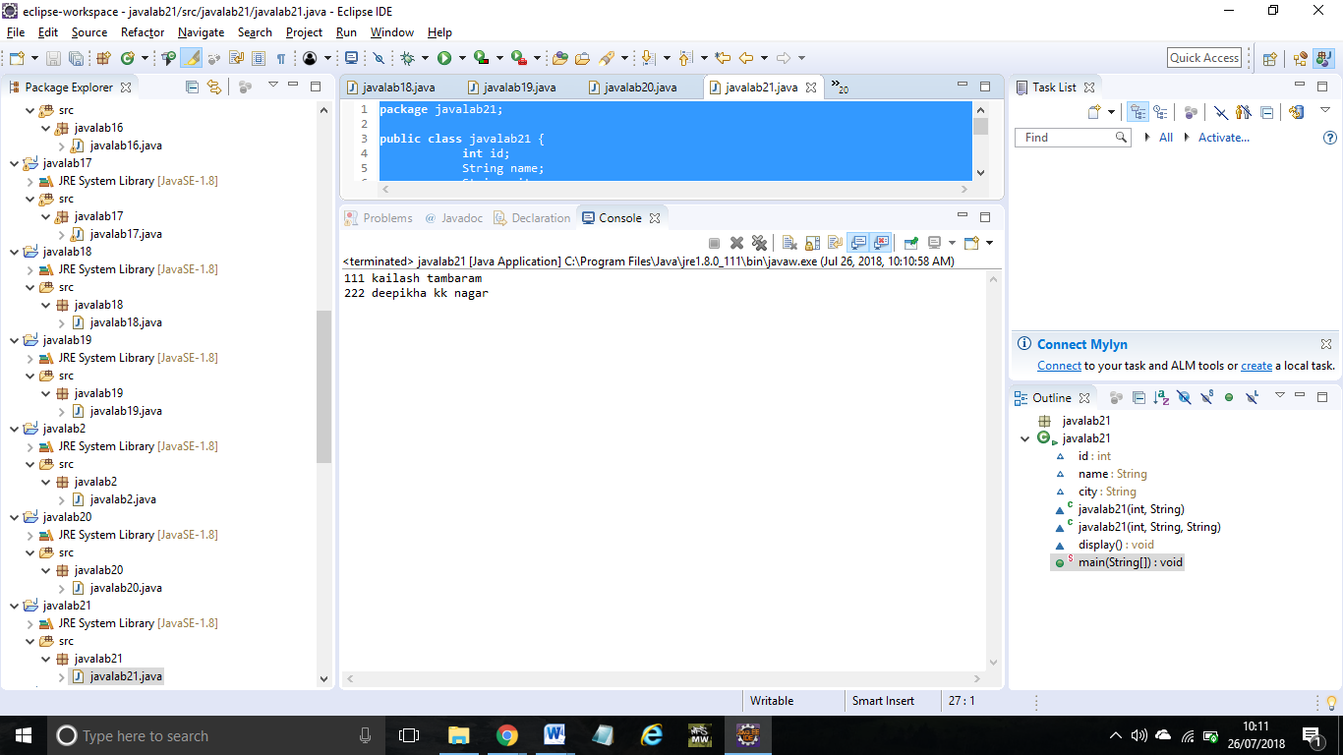

Ex:22

**package** javalab22;

**public** **class** javalab22 {

**void** m(){

System.***out***.println("method is invoked");

}

**void** n(){

**this**.m();

}

**void** p(){

n();

}

**public** **static** **void** main(String args[]){

javalab22 s1 = **new** javalab22();

s1.p();

}

}

Output:

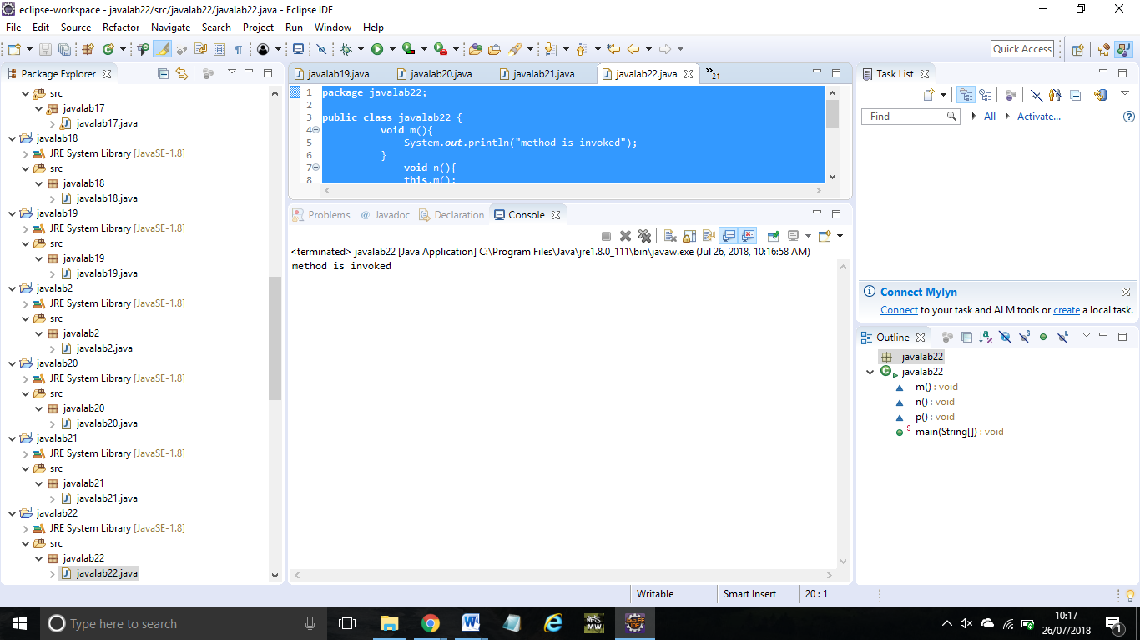

Ex:23

**package** javalab23;

**public** **class** javalab23 {

**void** m(javalab23 obj){

System.***out***.println("method is invoked");

}

**void** p(){

m(**this**);

}

**public** **static** **void** main(String args[]){

javalab23 s1 = **new** javalab23();

s1.p();

}

}

Output:

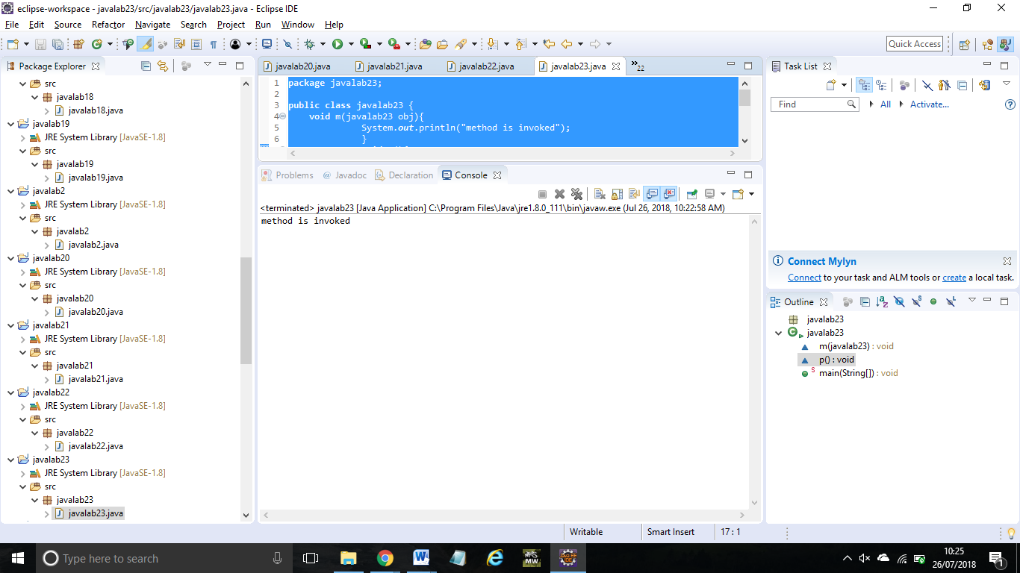

Ex:24

**package** javalab24;

**public** **class** javalab24 {

A4 obj;

javalab24(A4 obj){

**this**.obj=obj;

}

**void** display(){

System.***out***.println(obj.data);

}

}

**class** A4{

**int** data=10;

A4(){

javalab24 b=**new** javalab24(**this**);

b.display();

}

**public** **static** **void** main(String args[]){

A4 a=**new** A4();

}

}

Output:

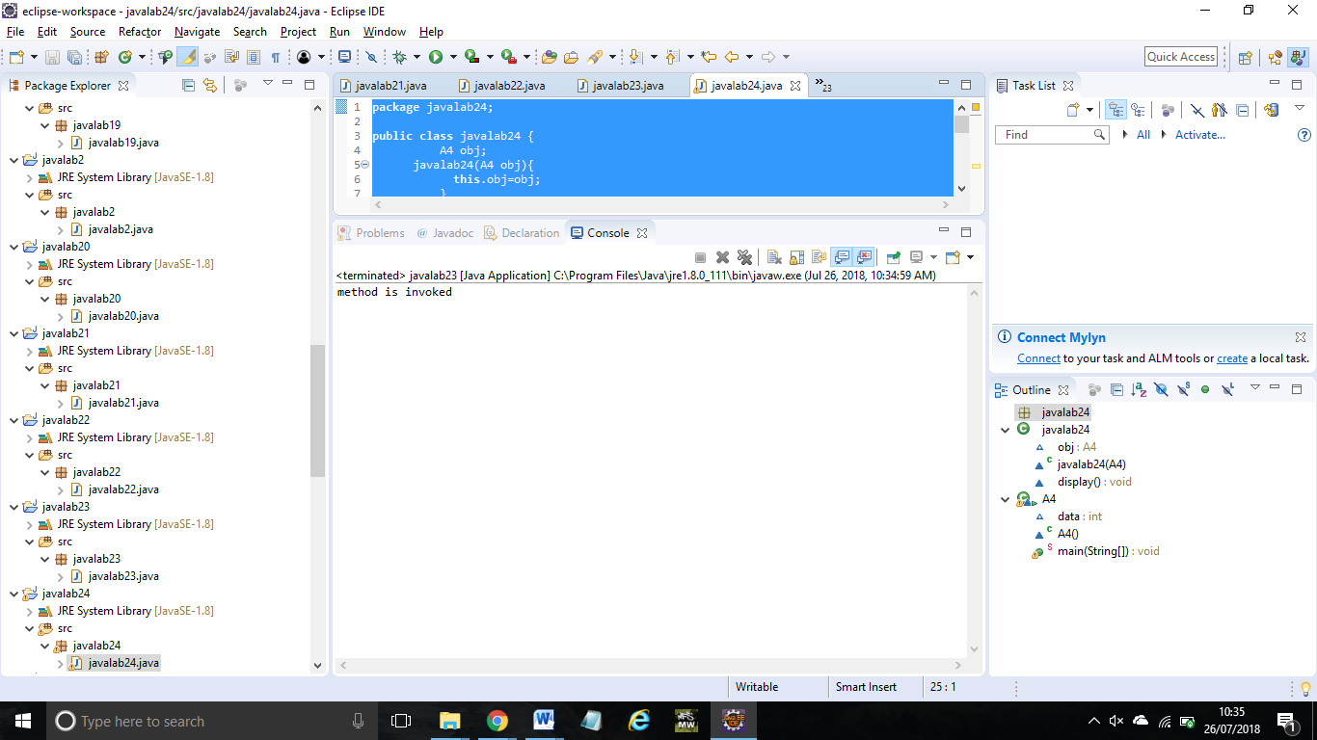

Ex:25

**package** javalab25;

**public** **class** javalab25 {

javalab25 getA(){

**return** **this**;

}

**void** msg(){System.***out***.println("Hello java");}

}

**class** Test1{

**public** **static** **void** main(String args[]){

**new** javalab25().getA().msg();

}

}

Output:

