AI ASSISTED CODING
ASSIGNMENT – 7.3
Name:E.Srinidhi Reddy
Hall Ticket No: 2303A51566
Batch: 09
-------------------------------------------------------------------------------------------------------------Task-01:
Prompt:
def add(a,b)
return a + b
#Find errors and correct them
Code:
def add(a, b):
return a + b
#The error was that there was no colon at the end of the function definition line. I have added the colon to correct the error.
#Sample input
print(add(5, 3)) # This should output 8
Output:
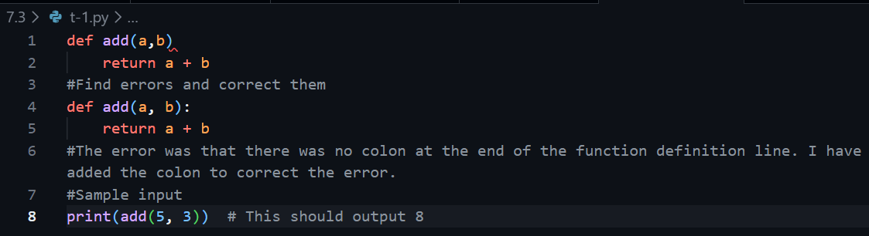

Explanation:
There was a syntax error because the function definition was missing a colon at the end. Python requires a colon to start the function body. After adding it, the function worked correctly.

Task-02:
Prompt:
def count_down(n):
while n>=0:
print(n)
n+=1
#Find errors and correct them
Code:
def count_down(n):
while n >= 0:
print(n)
n -= 1
#The error was that the loop was incrementing n instead of decrementing it. I have changed n+=1 to n-=1 to correct the error.
#Sample input
count_down(5) # This should print 5, 4, 3, 2, 1, 0 on separate lines
Output:
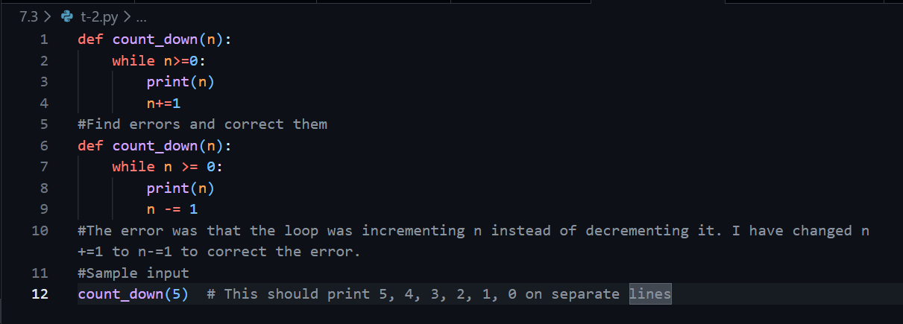
Explanation:
The loop was increasing the value instead of decreasing it, which caused it to run forever. Since the condition always stayed true, it became an infinite loop. Changing it to decrement fixed the problem.

Task-03:
Prompt:
def divide(a,b):
return a / b
print(divide(10,0))
#Find errors and correct them
Code:
def divide(a, b):
if b == 0:
return "Error: Division by zero is not allowed."
return a / b
#The error was that the original code did not handle the case where b is zero, which would cause a division by zero error. I have added a check to return an error message if b is zero.
#Sample input
print(divide(10, 0)) # This should output "Error: Division by zero is not allowed."
Output:
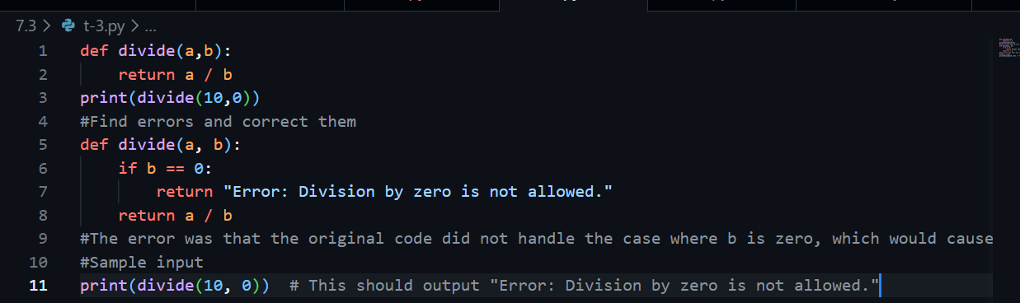
Explanation:
The program tried to divide by zero, which causes a runtime error in Python. Added a check to handle this situation safely. Now the program shows an error message instead of crashing.

Task-04:
Prompt:
class Rectangle:
def __init__(length,width):
self.length=length
self.width=width
#find errors and correct them
Code:
class Rectangle:
def __init__(self, length, width):
self.length = length
self.width = width
#The error was that there was a missing space between 'def' and '__init__', and the parameters were not defined correctly. I have added the space and defined the parameters properly.
#Sample input
rect = Rectangle(5, 3) # This should create a Rectangle object with length 5 and width 3

Output:
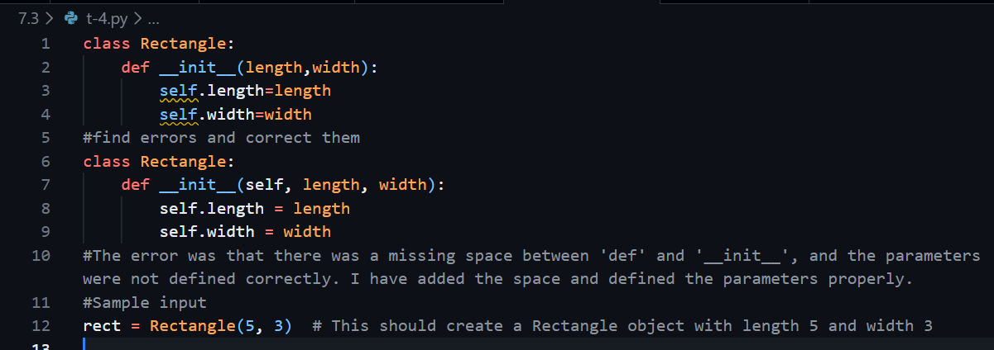
Explanation:
The class constructor was missing the required object reference parameter. Without it, the object cannot store its own data. After fixing it, the class works properly.
Task-05:
Prompt:
numbers=[1,2,3]
print(numbers[5])
#Find errors and correct them
Code:
numbers = [1, 2, 3]
try:
print(numbers[5])
except IndexError:
print("Index out of range. Please provide a valid index.")
#The error was that the code was trying to access an index that does not exist in the list. I have added a try-except block to catch the IndexError and print a user-friendly message instead.
#Sample input
# This will attempt to access an index that is out of range, and the error handling will print a message instead of crashing the program.
Output:
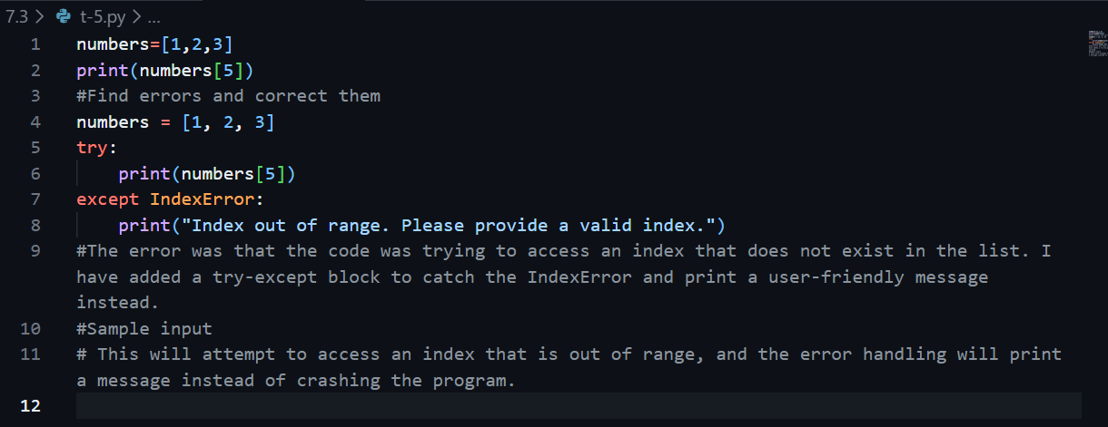
Explanation:
The program tried to access a list index that doesn’t exist. This caused an index error so it is handled safely so the program doesn’t crash and instead shows a proper message.

