AI ASSISTED CODING
ASSIGNMENT-01
NAME:SRINIDHI REDDY
HT NO:2303A51566
BATCH:09
---------------------------------------------------------------------------------
#TASK-01
PROMPT:
#write a program to check whether the given number is prime or not without using functions
CODE:
num = int(input("Enter a number: "))
if num > 1:
for i in range(2, int(num**0.5) + 1):
if (num % i) == 0:
print(num, "is not a prime number")
break
else:
print(num, "is a prime number")
else:
print(num, "is not a prime number"
OUTPUT:
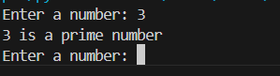

EXPLANATION:
No function used
Input is taken directly
Simple and direct
Good for small programs

#TASK-02
PROMPT:
#generate optimized version of code to check whether the given number is prime or not using functions
CODE:
def is_prime(n):
if n <= 1:
return False
for i in range(2, int(n**0.5) + 1):
if n % i == 0:
return False
return True
number = int(input("Enter a number: "))
if is_prime(number):
print(number, "is a prime number")
else:
print(number, "is not a prime number")
OUTPUT:
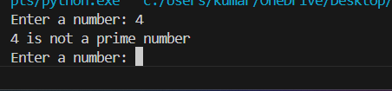

EXPLANATION:
Uses a function
Code is clean
Reusable
Good for big programs and repeated codes
DIFFERENCE BETWEEN TASK-01 AND TASK-02
Task 1: checks directly
Task 2: uses functions
Task 1: used for small programs
Task 2: Repeated & large use
#TASK-01
#generate fibonocci series using iterative functions in a given range
CODE:
def fibonacci_iterative(n):
seq = []
a, b = 0, 1
for _ in range(n):
seq.append(a)
a, b = b, a + b
return seq
terms_iterative = int(input("Enter the number of terms for Fibonacci series (iterative): "))
print("Fibonacci series (iterative):", fibonacci_iterative(terms_iterative))
OUTPUT:
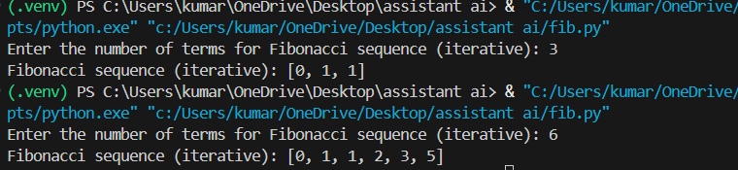

#TASK-02K-
#generate fibonocci series using recursive functions in a given range
CODE:
def fibonacci_recursive(n):
if n <= 0:
return []
elif n == 1:
return [0]
elif n == 2:
return [0, 1]
else:
seq = fibonacci_recursive(n - 1)
seq.append(seq[-1] + seq[-2])
return seq
terms_recursive = int(input("Enter the number of terms for Fibonacci series (recursive): "))
print("Fibonacci series (recursive):", fibonacci_recursive(terms_recursive))
OUTPUT:
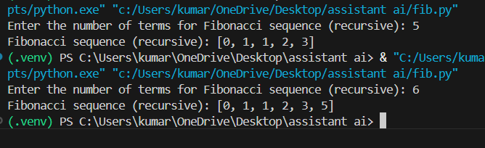
EXPLANATION– Task 1
- Uses a loop to generate the series
- Faster execution
- Uses less memory
- Suitable for large number of terms
EXPLANATION– Task 2
- Uses function calling itself
- Code is easy to understand
- Slower execution
- Uses more memory due to recursion
Difference between Task 1 and Task 2
- Task 1 uses loop, Task 2 uses recursion
- Task 1 is fast, Task 2 is slow
- Task 1 is memory efficient, Task 2 uses more memory

