AI ASSISTED CODING
ASSIGNMENT – 11.3
Name:E.Srinidhi Reddy
Hallticket No: 2303A51566
Batch – 09
-------------------------------------------------------------------------------------------------------------
Task-01:
Prompt:
# Create Python implementations of a Contact Manager using arrays (lists) and linked lists with operations to add, search, and delete contacts, and compare their performance.
Code:
import time
# Contact represented as a dictionary
# {'name': str, 'phone': str}
class ContactManagerList:
def __init__(self):
self.contacts = []
def add(self, name, phone):
self.contacts.append({'name': name, 'phone': phone})
def search(self, name):
for contact in self.contacts:
if contact['name'] == name:
return contact
return None
def delete(self, name):
for i, contact in enumerate(self.contacts):
if contact['name'] == name:
del self.contacts[i]
return True
return False
class Node:
def __init__(self, data):
self.data = data
self.next = None
class ContactManagerLinkedList:
def __init__(self):
self.head = None
def add(self, name, phone):
new_node = Node({'name': name, 'phone': phone})
if not self.head:
self.head = new_node
else:
current = self.head
while current.next:
current = current.next
current.next = new_node
def search(self, name):
current = self.head
while current:
if current.data['name'] == name:
return current.data
current = current.next
return None
def delete(self, name):
if not self.head:
return False
if self.head.data['name'] == name:
self.head = self.head.next
return True
current = self.head
while current.next:
if current.next.data['name'] == name:
current.next = current.next.next
return True
current = current.next
return False
# Performance comparison
def compare_performance():
num_operations = 1000
# List-based
cm_list = ContactManagerList()
start = time.time()
for i in range(num_operations):
cm_list.add(f'name{i}', f'phone{i}')
for i in range(num_operations):
cm_list.search(f'name{i}')
for i in range(num_operations):
cm_list.delete(f'name{i}')
list_time = time.time() - start
# Linked List-based
cm_ll = ContactManagerLinkedList()
start = time.time()
for i in range(num_operations):
cm_ll.add(f'name{i}', f'phone{i}')
for i in range(num_operations):
cm_ll.search(f'name{i}')
for i in range(num_operations):
cm_ll.delete(f'name{i}')
ll_time = time.time() - start
print(f"List-based time: {list_time:.4f} seconds")
print(f"Linked List-based time: {ll_time:.4f} seconds")
print(f"Linked List is {'faster' if ll_time < list_time else 'slower'} by {abs(ll_time - list_time):.4f} seconds")
def user_interface():
print("Choose implementation:")
print("1. List-based Contact Manager")
print("2. Linked List-based Contact Manager")
choice = input("Enter choice (1 or 2): ").strip()
if choice == '1':
cm = ContactManagerList()
impl = "List-based"
elif choice == '2':
cm = ContactManagerLinkedList()
impl = "Linked List-based"
else:
print("Invalid choice")
return
print(f"\nUsing {impl} Contact Manager")
while True:
print("\nOperations:")
print("1. Add contact")
print("2. Search contact")
print("3. Delete contact")
print("4. Exit")
op = input("Choose operation (1-4): ").strip()
if op == '1':
name = input("Enter name: ").strip()
phone = input("Enter phone: ").strip()
cm.add(name, phone)
print("Contact added successfully")
elif op == '2':
name = input("Enter name to search: ").strip()
contact = cm.search(name)
if contact:
print(f"Found: Name: {contact['name']}, Phone: {contact['phone']}")
else:
print("Contact not found")
elif op == '3':
name = input("Enter name to delete: ").strip()
if cm.delete(name):
print("Contact deleted successfully")
else:
print("Contact not found")
elif op == '4':
break
else:
print("Invalid operation")
if __name__ == "__main__":
print("Choose mode:")
print("1. Performance comparison")
print("2. Interactive user interface")
mode = input("Enter choice (1 or 2): ").strip()
if mode == '1':
compare_performance()
elif mode == '2':
user_interface()
else:
print("Invalid choice")
Output:
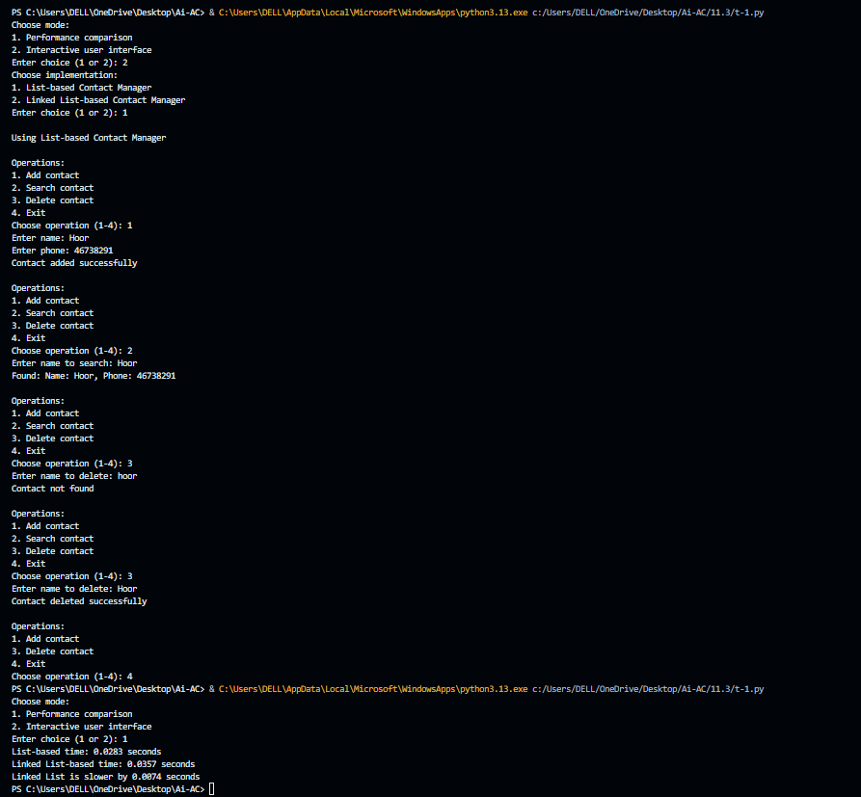
Explanation:
This program implements a Contact Manager using two data structures: a list (array) and a linked list. Each contact stores a name and phone number. It supports adding, searching, and deleting contacts in both implementations. The program also measures the execution time of operations to compare the performance of list-based and linked-list-based approaches. Lists provide simple storage, while linked lists allow dynamic memory allocation.
Task-02:
Prompt:
# Create a Python program implementing a Queue and a Priority Queue to manage book requests, prioritizing faculty requests over student requests.
Code:
import heapq
from collections import deque
class BookRequest:
def __init__(self, requester_type, requester_name, book_title):
self.requester_type = requester_type # 'faculty' or 'student'
self.requester_name = requester_name
self.book_title = book_title
def __str__(self):
return f"{self.requester_type.capitalize()}: {self.requester_name} - {self.book_title}"
class Queue:
def __init__(self):
self.requests = deque()
def enqueue(self, request):
self.requests.append(request)
def dequeue(self):
if self.requests:
return self.requests.popleft()
return None
def is_empty(self):
return len(self.requests) == 0
def size(self):
return len(self.requests)
class PriorityQueue:
def __init__(self):
self.requests = []
self.counter = 0 # To handle ties
def enqueue(self, request):
# Priority: faculty (0) > student (1)
priority = 0 if request.requester_type == 'faculty' else 1
heapq.heappush(self.requests, (priority, self.counter, request))
self.counter += 1
def dequeue(self):
if self.requests:
return heapq.heappop(self.requests)[2]
return None
def is_empty(self):
return len(self.requests) == 0
def size(self):
return len(self.requests)
# Demo
def demo():
print("Regular Queue:")
q = Queue()
q.enqueue(BookRequest('student', 'Alice', 'Book A'))
q.enqueue(BookRequest('faculty', 'Dr. Smith', 'Book B'))
q.enqueue(BookRequest('student', 'Bob', 'Book C'))
while not q.is_empty():
print(q.dequeue())
print("\nPriority Queue (Faculty first):")
pq = PriorityQueue()
pq.enqueue(BookRequest('student', 'Alice', 'Book A'))
pq.enqueue(BookRequest('faculty', 'Dr. Smith', 'Book B'))
pq.enqueue(BookRequest('student', 'Bob', 'Book C'))
pq.enqueue(BookRequest('faculty', 'Prof. Johnson', 'Book D'))
while not pq.is_empty():
print(pq.dequeue())
if __name__ == "__main__":
demo()
Output:
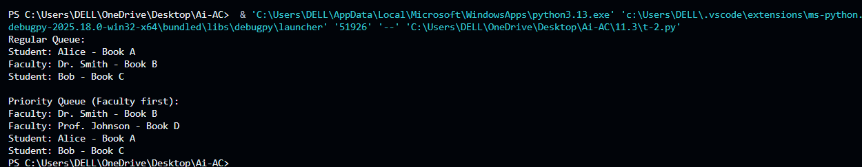
Explanation:
The normal queue follows the FIFO (First-In, First-Out) rule, requests are processed in the order they are received. The priority queue gives higher priority to faculty requests over student requests using the heapq module. This ensures faculty members receive books before students when requests are processed.
Task-03:
Prompt:
#create Python stack implementation for managing help desk tickets with push, pop, peek, and checks for empty or full stack.
Code:
# Stack implementation for SR University IT Help Desk
class HelpDeskStack:
def __init__(self, capacity):
# maximum number of tickets allowed
self.capacity = capacity
# list used to store stack elements
self.stack = []
# check if stack is empty
def is_empty(self):
return len(self.stack) == 0
# check if stack is full
def is_full(self):
return len(self.stack) == self.capacity
# push operation -> add a new ticket
def push(self, ticket):
if self.is_full():
print("Stack is full. Cannot add more tickets.")
else:
self.stack.append(ticket)
print(f"Ticket added: {ticket}")
# pop operation -> resolve the latest ticket
def pop(self):
if self.is_empty():
print("No tickets to resolve.")
else:
ticket = self.stack.pop()
print(f"Ticket resolved: {ticket}")
return ticket
# peek operation -> view latest ticket without removing
def peek(self):
if self.is_empty():
print("No tickets available.")
else:
print("Latest Ticket:", self.stack[-1])
# ---- Simulation of Help Desk Tickets ----
# create stack with capacity 10
helpdesk = HelpDeskStack(10)
# 5 tickets raised
helpdesk.push("WiFi not working")
helpdesk.push("Laptop not starting")
helpdesk.push("Email login problem")
helpdesk.push("Printer not responding")
helpdesk.push("Software installation issue")
print("\nCurrent Top Ticket:")
helpdesk.peek()
print("\nResolving Tickets (LIFO order):")
helpdesk.pop()
helpdesk.pop()
helpdesk.pop()
helpdesk.pop()
helpdesk.pop()
print("\nIs stack empty?", helpdesk.is_empty())
Output:
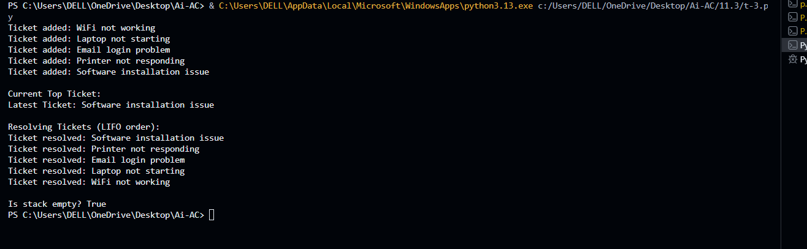

Explanation:
Stack is used here and it follows the LIFO (Last-In, First-Out) principle: most recently raised ticket is resolved first. The program includes operations such as push (add ticket), pop (resolve ticket), and peek (view latest ticket). It also checks whether the stack is empty or full.
Task-04:
Prompt:
#Generate a Python hash table with insert, search, and delete operations using collision handling with chaining.
Code:
class HashTable:
def __init__(self, size=10):
self.size = size
self.table = [[] for _ in range(size)]
def _hash(self, key):
return hash(key) % self.size
def insert(self, key, value):
index = self._hash(key)
for i, (k, v) in enumerate(self.table[index]):
if k == key:
self.table[index][i] = (key, value)
print(f"Updated: {key} -> {value}")
return
self.table[index].append((key, value))
print(f"Inserted: {key} -> {value}")
def search(self, key):
index = self._hash(key)
for k, v in self.table[index]:
if k == key:
print(f"Found: {key} -> {v}")
return v
print(f"Not found: {key}")
return None
def delete(self, key):
index = self._hash(key)
for i, (k, v) in enumerate(self.table[index]):
if k == key:
self.table[index].pop(i)
print(f"Deleted: {key}")
return True
print(f"Not found: {key}")
return False
def display(self):
for i, bucket in enumerate(self.table):
print(f"Index {i}: {bucket}")
if __name__ == "__main__":
ht = HashTable(5)
while True:
print("\n1. Insert 2. Search 3. Delete 4. Display 5. Exit")
choice = input("Enter choice: ").strip()
if choice == '1':
key = input("Enter key: ").strip()
value = input("Enter value: ").strip()
ht.insert(key, value)
elif choice == '2':
key = input("Enter key: ").strip()
ht.search(key)
elif choice == '3':
key = input("Enter key: ").strip()
ht.delete(key)
elif choice == '4':
ht.display()
elif choice == '5':
break
else:
print("Invalid choice!")
Output:
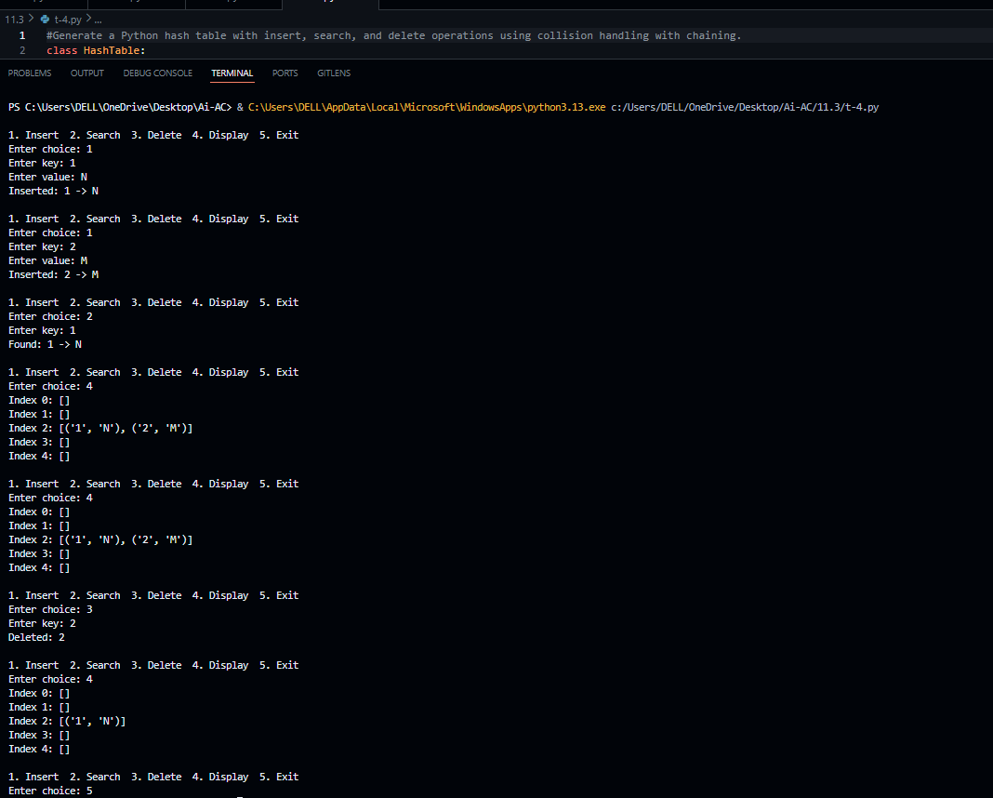
Explanation:
implements a Hash Table with operations for insert, search, and delete. It uses chaining to handle collisions, multiple key-value pairs can be stored in the same index using a list. A hash function determines the index where the key should be stored. This structure allows fast data retrieval and efficient storage.
Task-05:
Prompt:
#Choose a suitable data structures for campus management features and implement one feature in Python using the chosen data structure. Take user input
Code:
class CampusManagement:
def __init__(self):
# Dictionary for students: {student_id: {name, email, courses}}
self.students = {}
# Dictionary for courses: {course_id: {name, instructor, capacity, enrolled}}
self.courses = {}
# List for logs
self.logs = []
def enroll_student(self):
"""Feature: Enroll a student in a course"""
print("\n--- Student Enrollment ---")
student_id = input("Enter Student ID: ").strip()
if student_id not in self.students:
name = input("Enter Student Name: ").strip()
email = input("Enter Email: ").strip()
self.students[student_id] = {
'name': name,
'email': email,
'courses': []
}
print(f"Student {name} registered successfully!")

print("\nAvailable Courses:")
if not self.courses:
print("No courses available.")
return

for cid, course in self.courses.items():
print(f"{cid}: {course['name']} (Enrolled: {len(course['enrolled'])}/{course['capacity']})")

course_id = input("Enter Course ID to enroll: ").strip()

if course_id not in self.courses:
print("Invalid course ID!")
return

course = self.courses[course_id]
if len(course['enrolled']) >= course['capacity']:
print("Course is full!")
return
if course_id in self.students[student_id]['courses']:
print("Student already enrolled in this course!")
return
course['enrolled'].append(student_id)
self.students[student_id]['courses'].append(course_id)
print(f"Student enrolled in {course['name']}!")
self.logs.append(f"Student {student_id} enrolled in {course_id}")
def add_course(self):
"""Add a new course"""
course_id = input("Enter Course ID: ").strip()
if course_id in self.courses:
print("Course already exists!")
return
name = input("Enter Course Name: ").strip()
instructor = input("Enter Instructor Name: ").strip()
capacity = int(input("Enter Course Capacity: "))
self.courses[course_id] = {
'name': name,
'instructor': instructor,
'capacity': capacity,
'enrolled': []
}
print(f"Course {name} added successfully!")
def view_student_courses(self):
"""View courses enrolled by a student"""
student_id = input("Enter Student ID: ").strip()
if student_id not in self.students:
print("Student not found!")
return
student = self.students[student_id]
print(f"\nStudent: {student['name']}")
print("Enrolled Courses:")
if not student['courses']:
print("No courses enrolled.")
else:
for cid in student['courses']:
print(f" - {self.courses[cid]['name']}")

def main_menu(self):
"""Main menu"""
while True:
print("\n=== Campus Management System ===")
print("1. Add Course")
print("2. Enroll Student in Course")
print("3. View Student's Courses")
print("4. Exit")
choice = input("Enter your choice (1-4): ").strip()
if choice == '1':
self.add_course()
elif choice == '2':
self.enroll_student()
elif choice == '3':
self.view_student_courses()
elif choice == '4':
print("Exiting system...")
break
else:
print("Invalid choice! Try again.")
# Run the program
if __name__ == "__main__":
system = CampusManagement()
system.main_menu()
# Data Structures Used:
# 1. Dictionary (Hash Table) – Used to store students and courses with unique IDs as keys.
# This allows fast lookup, insertion, and deletion (average O(1) time complexity).
# 2. List (Dynamic Array) – Used to store:
# - Courses enrolled by each student
# - Students enrolled in each course
# - System logs
# Lists allow easy addition of new elements and maintain order.
# The combination of dictionaries and lists helps efficiently manage student records, course details, and enrollments in the Campus Management System.
Ouput:
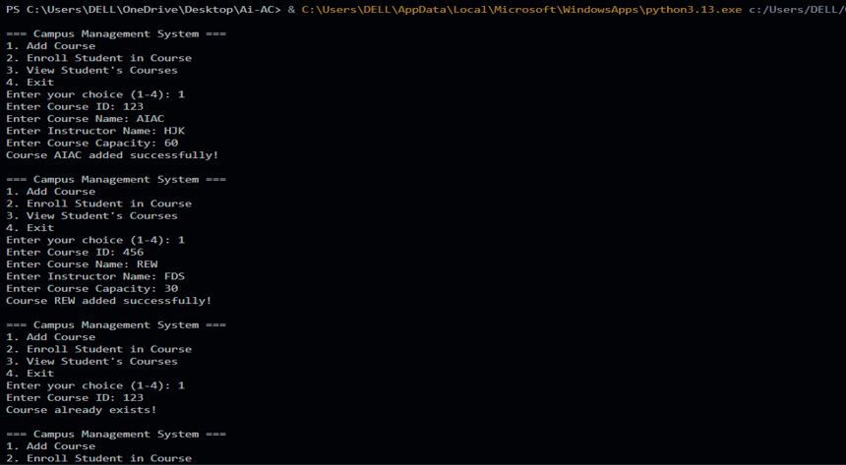
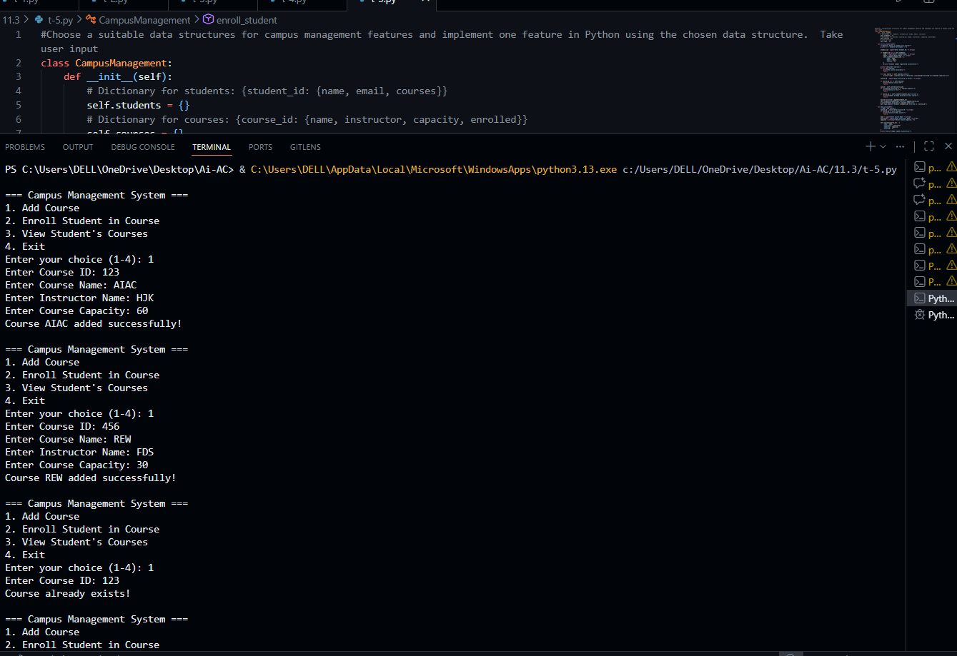
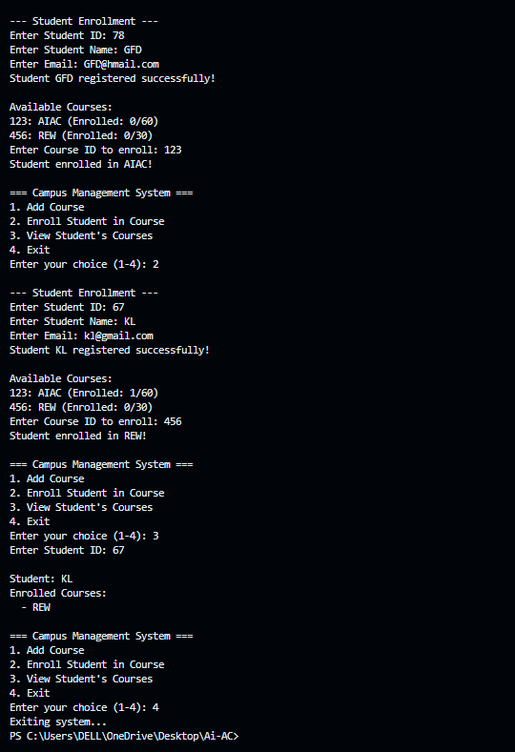
Explanation:
Program uses a dictionary (hash table) to store student and course information for fast access using unique IDs. Lists are used to maintain enrolled courses and logs. The system allows users to add courses, enroll students, and view student course details, demonstrating practical use of data structures in real-time applications.

