AI ASSISTED CODING
ASSIGNMENT-8.3
NAME:SRINIDHI REDDY
ROLL NUMBER:2303A51566
BATCH:09
Task 1: Email Validation using TDD
PROMPT:
#write a python program to develop a user registration system that requires reliable email input validation
CODE:
#write a python program to develop a user registration system that requires reliable email input validation
import re
class UserRegistration:
def __init__(self, name, email):
self.name = name
self.email = email
def validate_email(self):
pattern = r'^[a-zA-Z0-9._%+-]+@[a-zA-Z0-9.-]+\.[a-zA-Z]{2,}$'
if re.match(pattern, self.email):
return True
else:
return False
def display(self):
print(f"Name: {self.name}")
print(f"Email: {self.email}")
if self.validate_email():
print("Email is valid.")
else:
print("Email is invalid.")
# Test Cases
user1 = UserRegistration("Alice", "alice@example.com")
user2 = UserRegistration("Bob", "bob@example")
user1.display()
user2.display()
OUTPUT:
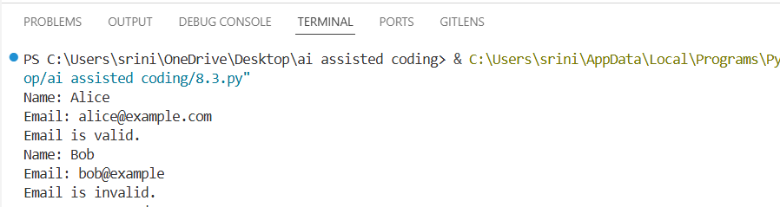

EXPLANATION:
This program creates a user registration system and checks whether the email format is correct using regex pattern. It prints user details and shows if the email is valid or invalid.

Task 2: Grade Assignment using Loops
PROMPT:
#TASK-2:write a python program to bulid an automated grading system for an online examination platform using loops and aslo include invalid input like -5,eighty
CODE:
#TASK-2:write a python program to bulid an automated grading system for an online examination platform using loops and aslo include invalid input like -5,eighty

def calculate_grade(score):
if score < 0 or score > 100:
return "Invalid input"
elif score >= 90:
return "Grade: A"
elif score >= 80:
return "Grade: B"
elif score >= 70:
return "Grade: C"
elif score >= 60:
return "Grade: D"
else:
return "Grade: F"
# Test Cases
scores = [95, 85, 75, 65, 55, -5
, "eighty"]
for s in scores:
if isinstance(s, int):
print(f"Score: {s} - {calculate_grade(s)}")
else:
print(f"Score: {s} - Invalid input")
OUTPUT:
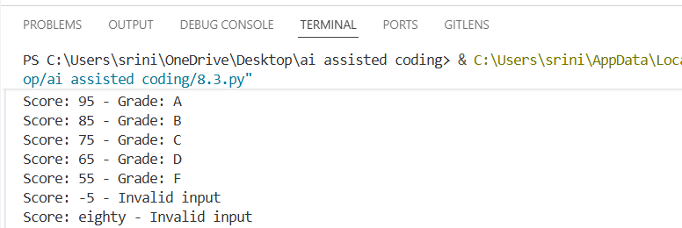
EXPLANATION:
This program assigns grades based on exam scores using conditions and loops. It also handles invalid inputs like negative numbers or non-numeric values.

Task 3: Sentence Palindrome Checker
PROMPT:
#TASK-3:write a python program to check sentence palindrome checker to develop a text-processing utility to analyze sentences
CODE:
#TASK-3:write a python program to check sentence palindrome checker to develop a text-processing utility to analyze sentences
def is_palindrome(sentence):
cleaned = ''.join(sentence.lower().split())
return cleaned == cleaned[::-1]
# Test Cases
sentences = ["Madam In Eden Im Adam",
"Hello World","A man a plan a canal Panama"]
for s in sentences:
if is_palindrome(s):
print(f'"{s}" is a palindrome.')
else:
print(f'"{s}" is not a palindrome.')

OUTPUT:
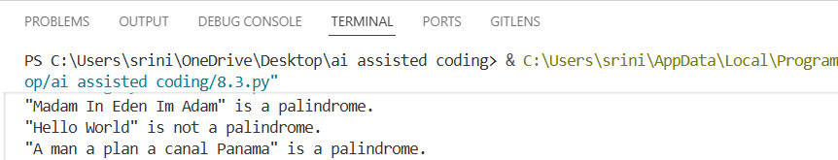
EXPLANATION:
This program checks whether a sentence reads the same forward and backward after removing spaces and converting to lowercase. It prints whether each sentence is palindrome or not.

Task 4: Shopping Cart Class
PROMPT:
#TASK-4:Write a python program to design a basic shopping cart module for an e-commerce application.add item and remove item and total cost
CODE:
#TASK-4:Write a python program to design a basic shopping cart module for an e-commerce application.add item and remove item and total cost
class ShoppingCart:
def __init__(self):
self.cart = {}
def add_item(self, item, price):
self.cart[item] = price
print(f"Added {item} to cart at ₹{price}")
def remove_item(self, item):
if item in self.cart:
del self.cart[item]
print(f"Removed {item} from cart")
else:
print(f"{item} not found in cart")
def total_cost(self):
return sum(self.cart.values())
# Test Cases
cart = ShoppingCart()
cart.add_item("Laptop", 50000)
cart.add_item("Headphones", 2000)
cart.add_item("Mouse", 500)
print("Total Cost: ₹", cart.total_cost())
cart.remove_item("Headphones")
print("Total Cost after removal: ₹", cart.total_cost())
OUTPUT:
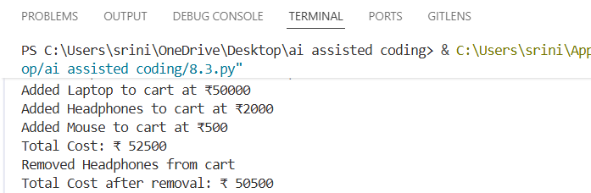
EXPLANATION:
This program creates a shopping cart where items can be added or removed. It calculates and displays the total cost of items in the cart.

Task 5: Date Format Conversion
PROMPT:
#TASK-5:write a python program to create a utility function to convert date formats for reports
CODE:
#TASK-5:write a python program to create a utility function to convert date formats for reports

from datetime import datetime
def convert_date_format(date_str, current_format, desired_format):
try:
date_obj = datetime.strptime(date_str, current_format)
return date_obj.strftime(desired_format)
except ValueError:
return "Invalid date format"
# Test Cases
dates = [("2024-06-15", "%Y-%m-%d", "%d/%m/%Y"),
("15/06/2024", "%d/%m/%Y", "%Y-%m-%d"),
("06-15-2024", "%m-%d-%Y", "%Y/%m/%d"),
("invalid-date", "%Y-%m-%d", "%d/%m/%Y")]
for date_str, current_fmt, desired_fmt in dates:
print(f"Original: {date_str} - Converted: {convert_date_format(date_str, current_fmt, desired_fmt)}")
OUTPUT:
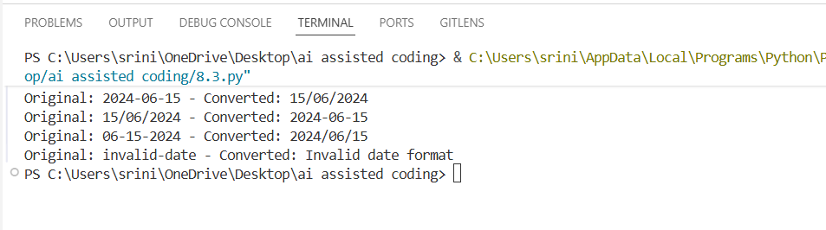
EXPLANATION:
This program converts dates from one format to another using the datetime module. It also handles invalid date inputs safely.

