AI ASSISTED CODING

ASSIGNMENT-4.3

NAME:SRINIDHI REDDY

ROLL NUMBER:2303A51566

BATCH:09

-------------------------------------------------------------------------------------------------------------------

Task 1: Zero-Shot Prompting – Leap Year Check

PROMPT:
generate a Python program whether the year is leap year using function

CODE:
def is_leap_year(year):
if (year % 4 == 0 and year % 100 != 0) or (year % 400 == 0):
return True else:
return False # Example usage
year = int(input("Enter a year to check if it's a leap year: "))

if is_leap_year(year): print(f"{year} is a leap year.")
else:
print(f"{year} is not a leap year.")

OUTPUT:
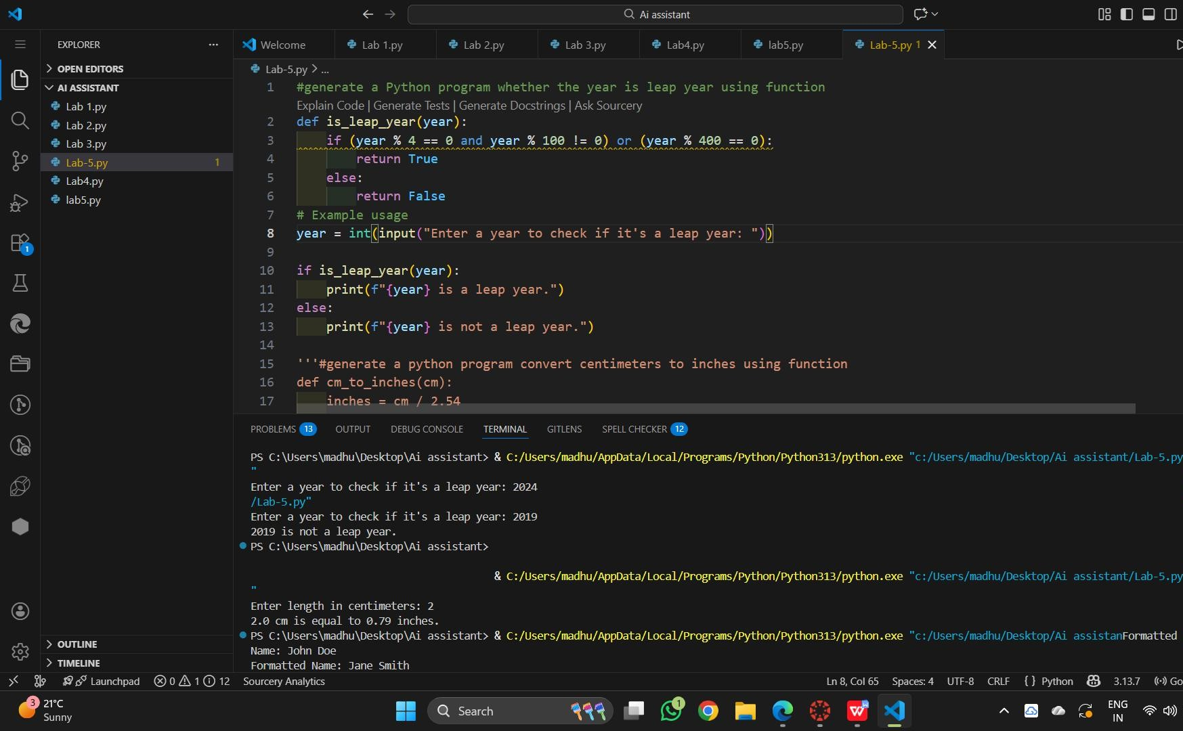

EXPLANATION:
This program determines whether a given year is a leap year using a function.
The function applies standard leap year rules and returns True or False.
The user inputs a year, which is checked by the function
The result is printed as either a leap year or not.

Task 2: One-Shot Prompting – Centimeters to Inches Conversion

PROMPT:
generate a python program convert centimeters to inches using function

CODE:

def cm_to_inches(cm): inches = cm / 2.54 return inches
# Example usage
cm_value = float(input("Enter length in centimeters: ")) inches_value = cm_to_inches(cm_value)
print(f"{cm_value} cm is equal to {inches_value:.2f} inches.")

OUTPUT:
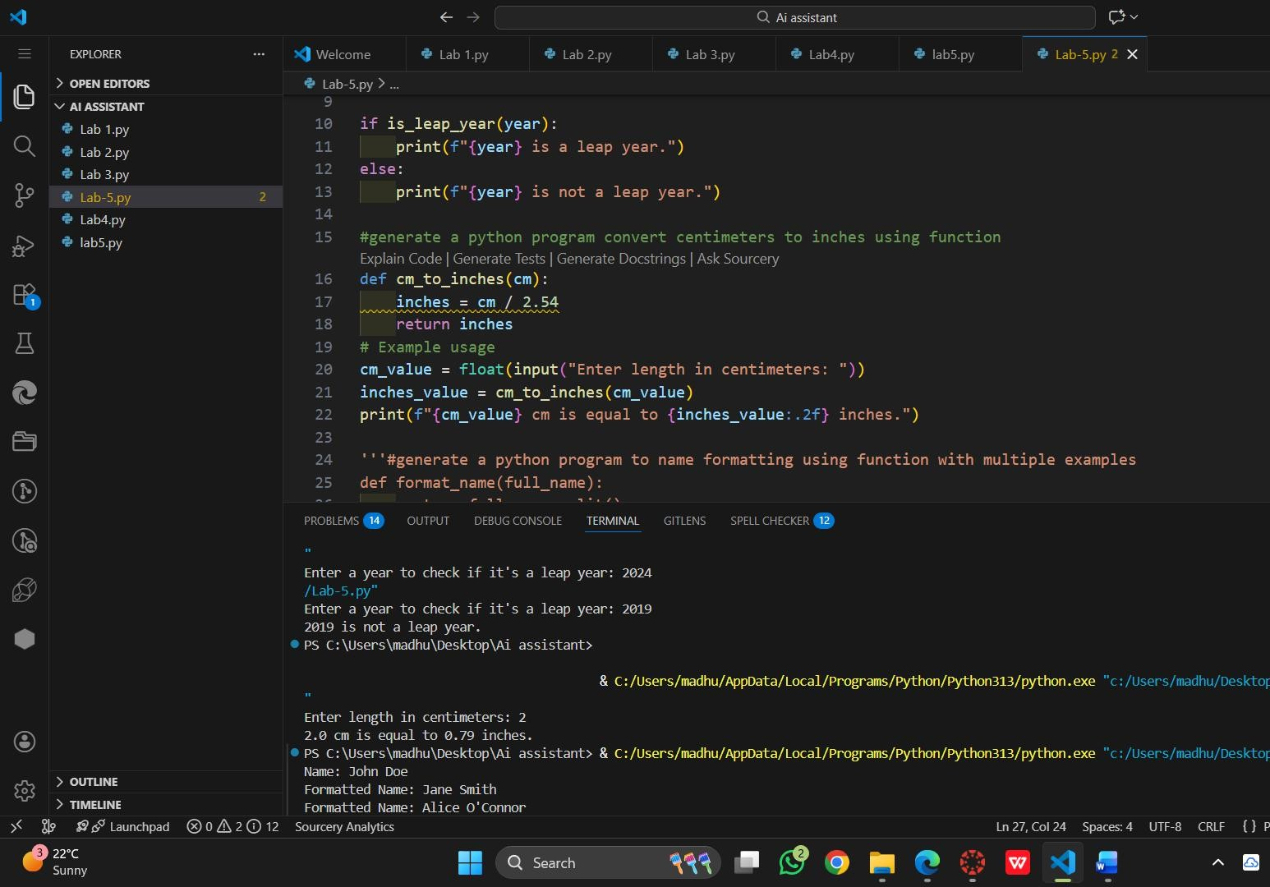

EXPLANATION:

This program converts a length from centimeters to inches using the correct mathematical formula.

A function performs the conversion by dividing the value by 2.54.

The user enters a value in centimeters, which is passed to the function.
The converted result is displayed in inches.
Task 3: Few-Shot Prompting – Name Formatting

PROMPT:

#generate a python program to name formatting using function with multiple examples

CODE:
def format_name(full_name): parts = full_name.split()
if len(parts) >= 2: first_name = parts[0] last_name = parts[-1]
return f"{last_name}, {first_name}" else:
return full_name # Return as is if not enough parts # Example usage
test_names = [ "John Smith", "Anita Rao", "Alice Johnson", "Bob"

]
for name in test_names:

formatted_name = format_name(name)
print(f"Original: {name} | Formatted: {formatted_name}")

OUTPUT:

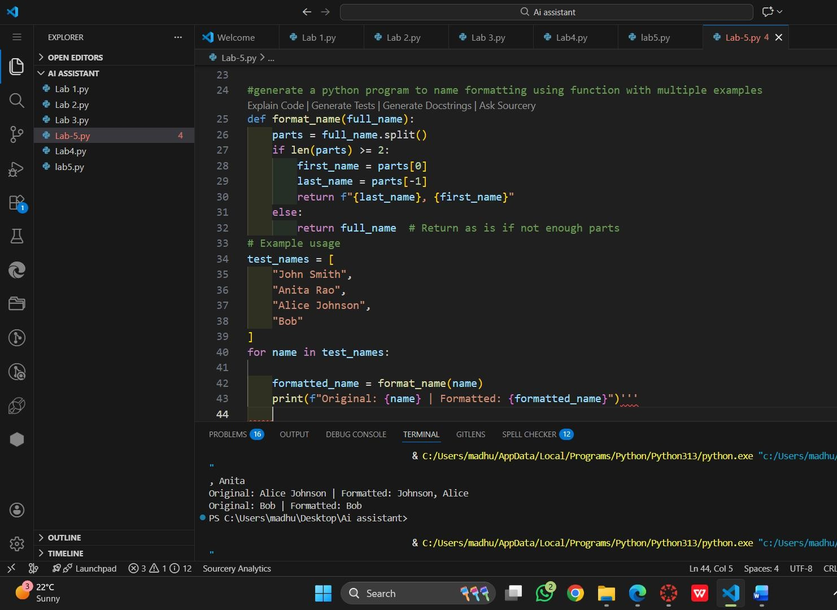

EXPLANATION:

This program formats a full name entered as first name and last name.

The input is split and validated to ensure the correct format.

Each part of the name is cleaned and capitalized.

The formatted full name is then displayed.

Task 4: Comparative Analysis – Zero-Shot vs Few-Shot
PROMPT:
#generate a python code using function that counts vowels in a string

CODE:

def count_vowels(input_string): vowels = "aeiouAEIOU"
count = sum(1 for char in input_string if char in vowels)
return count
# Example usage
test_string = "Hello World"
vowel_count = count_vowels(test_string)
print(f"The number of vowels in '{test_string}' is: {vowel_count}")

OUTPUT:
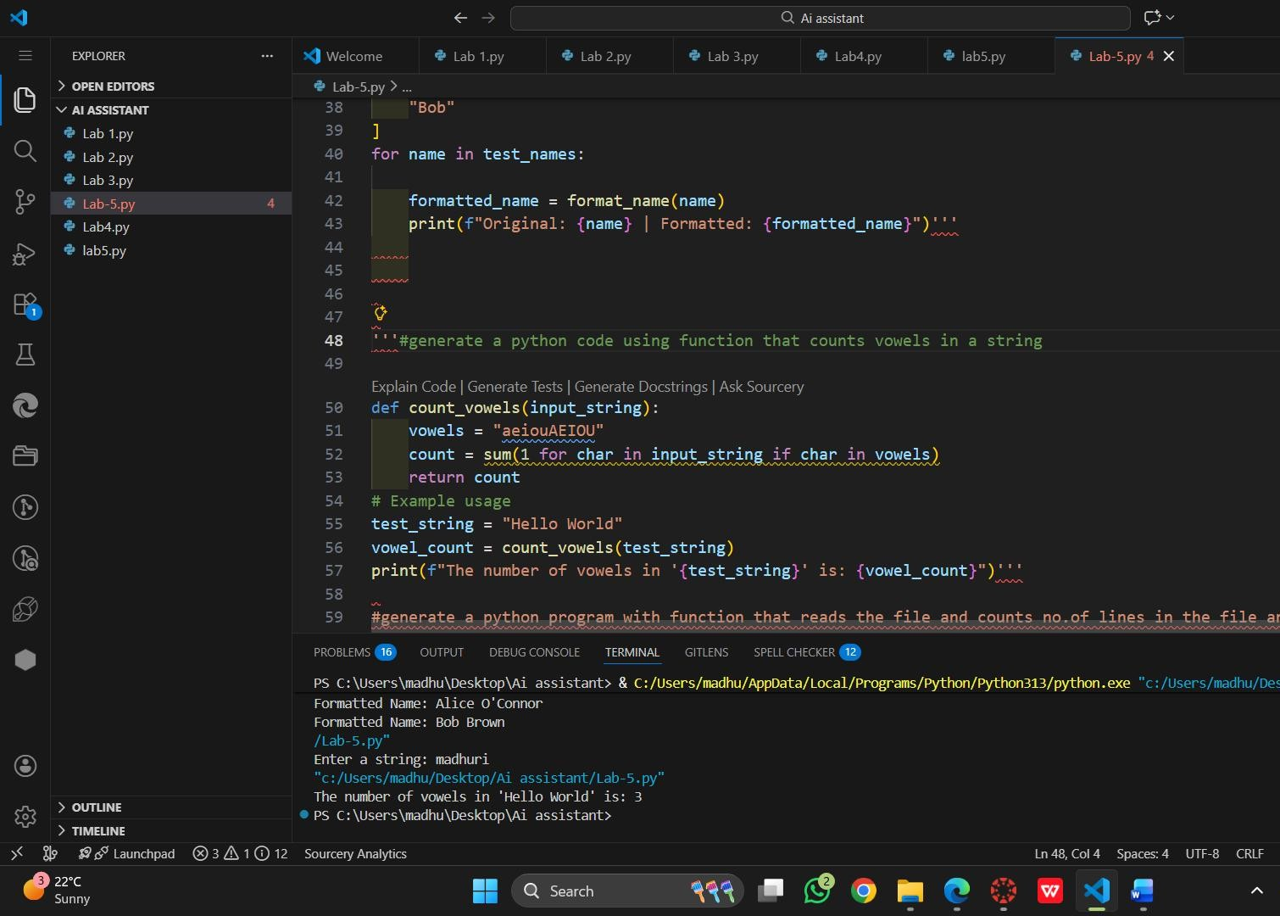

EXPLANATION:

The function counts vowels in a given string using a direct logic approach

Zero-shot prompting applies the logic without examples.

Few-shot prompting helps by showing patterns before execution.

The function returns the total number of vowels in the input string.

Task 5: Few-Shot Prompting – File Handling

PROMPT:
#generate a python program with function that reads the file and counts no.of lines in the file and return the line count
CODE:
def count_lines_in_file(file_path): try:
with open(file_path, 'r') as file: lines = file.readlines() return len(lines)
except FileNotFoundError:
print(f"Error: The file '{file_path}' was not found.") return None
# Example usage
file_path = input("Enter the file path to count lines: ") line_count = count_lines_in_file(file_path)

if line_count is not None:
print(f"The number of lines in the file '{file_path}' is: {line_count}")

OUTPUT:
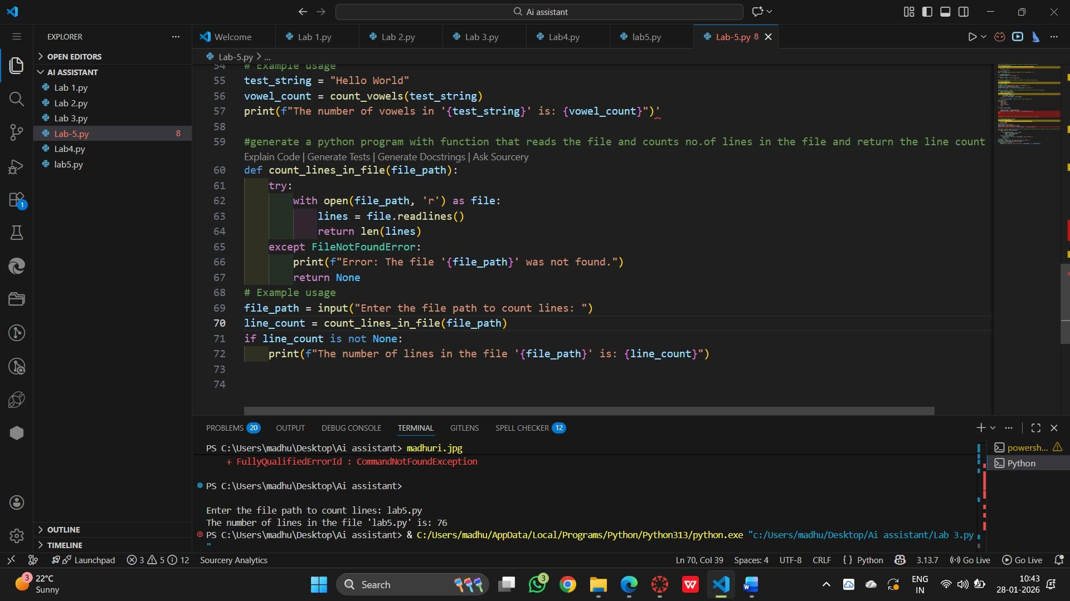

EXPLANATION:

This program reads a text file and counts the number of lines.
A function opens the file safely and calculates the line count.
Error handling is used if the file does not exist.
The final line count is returned and displayed.

