AI ASSISTED CODING
ASSIGNMENT-5.4
NAME:SRINIDHI REDDY
ROLL NUMBER:2303A51566
BATCH-09
TASK-01
PROMPT:
#Generate a Python program that collects user details such as name, age, and email.Provide text input boxes for name and age, and an email input box for email.
# Create main window
# Labels and Entry Boxes
# Submit Button
# Data Protection Guidelines:
# 1. Do not store sensitive data unnecessarily.
# 2. Encrypt data if storage is required.
# 3. Restrict access to authorized users.
# 4. Update software regularly.
CODE:
#Generate a Python program that collects user details such as name, age, and email.Provide text input boxes for name and age, and an email input box for email.
import tkinter as tk
from tkinter import messagebox

def submit_details():
name = name_entry.get()
age = age_entry.get()
email = email_entry.get()

if not name or not age or not email:
messagebox.showwarning("Input Error", "Please fill in all fields.")
return

try:
age = int(age)
except ValueError:
messagebox.showwarning("Input Error", "Age must be a number.")
return

messagebox.showinfo("User Details", f"Name: {name}\nAge: {age}\nEmail: {email}")

# Create main window
root = tk.Tk()
root.title("User Details Form")

# Labels and Entry Boxes
tk.Label(root, text="Name:").grid(row=0, column=0, padx=10, pady=5)
name_entry = tk.Entry(root)
name_entry.grid(row=0, column=1, padx=10, pady=5)

tk.Label(root, text="Age:").grid(row=1, column=0, padx=10, pady=5)
age_entry = tk.Entry(root)
age_entry.grid(row=1, column=1, padx=10, pady=5)

tk.Label(root, text="Email:").grid(row=2, column=0, padx=10, pady=5)
email_entry = tk.Entry(root)
email_entry.grid(row=2, column=1, padx=10, pady=5)

# Submit Button
submit_button = tk.Button(root, text="Submit", command=submit_details)
submit_button.grid(row=3, columnspan=2, pady=10)

root.mainloop()

# Data Protection Guidelines:
# 1. Do not store sensitive data unnecessarily.
# 2. Encrypt data if storage is required.
# 3. Restrict access to authorized users.
# 4. Update software regularly.
OUTPUT:
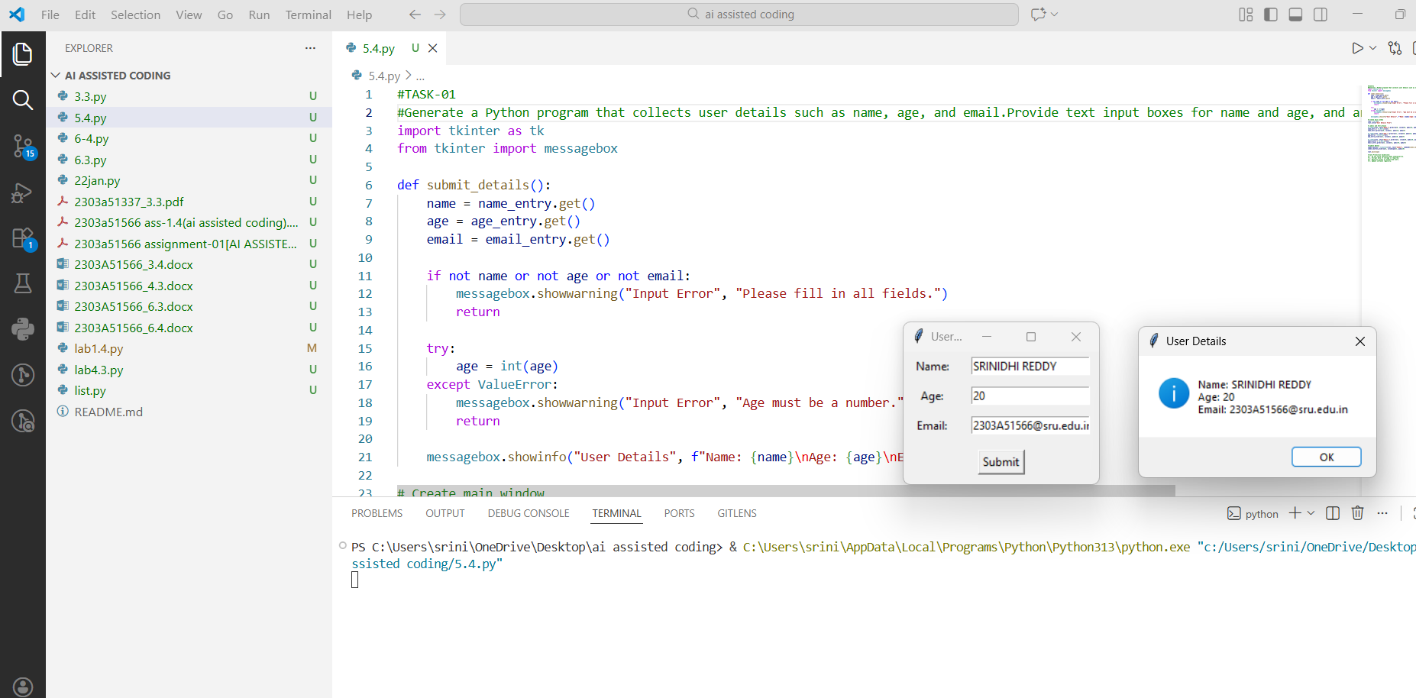
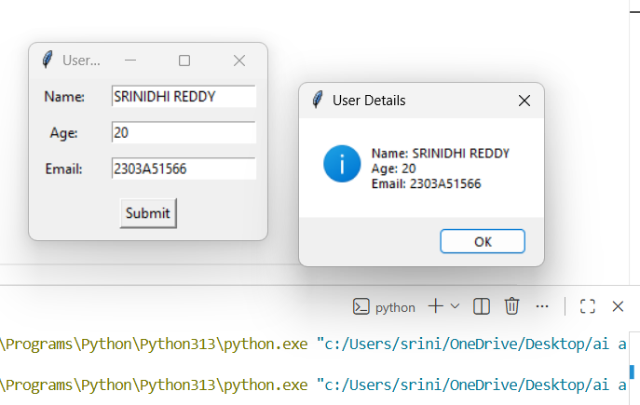

EXPLANATION:
The program uses Tkinter to collect user details like name, age, and email through a simple form.It validates the input and displays the details only when all values are entered correctly.
The comments explain how to protect user data by avoiding unnecessary storage, using encryption, and restricting access to sensitive information.

TASK-02:
PROMPT:
# generate a Python function for sentiment analysis and to identify and handle potential biases in the data
# This script performs sentiment analysis on text data and includes comments on identifying and handling potential biases.
# Perform sentiment analysis using TextBlob
# Identify potential biases in the text
# Check for overly positive or negative language
# Handle biases by providing context
# Direct input text (no user input)
# Analyze sentiment
# Display result

CODE:
# generate a Python function for sentiment analysis and to identify and handle potential biases in the data
# This script performs sentiment analysis on text data and includes comments on identifying and handling potential biases.
from textblob import TextBlob
def analyze_sentiment(text):
# Perform sentiment analysis using TextBlob
blob = TextBlob(text)
sentiment = blob.sentiment.polarity

# Identify potential biases in the text
# Check for overly positive or negative language
if sentiment > 0.5:
bias_note = "The text may be overly positive."
elif sentiment < -0.5:
bias_note = "The text may be overly negative."
else:
bias_note = "The text appears to be neutral."

# Handle biases by providing context
return {
'sentiment_score': sentiment,
'bias_note': bias_note
}
# Direct input text (no user input)
sample_text = "I absolutely love this product! It works perfectly and is amazing."
# Analyze sentiment
result = analyze_sentiment(sample_text)
# Display result
print("Text:", sample_text)
print("Sentiment Analysis Result:", result)
OUTPUT:
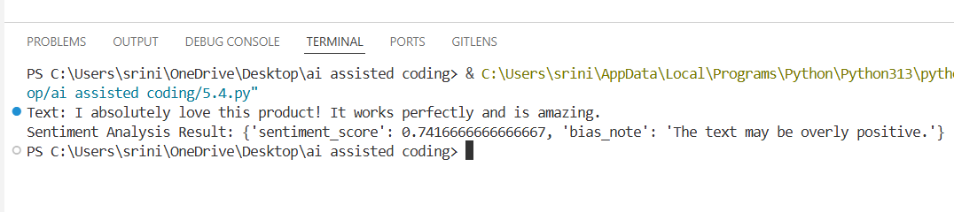
EXPLANATION:
This program uses TextBlob to analyze the sentiment of a given text.
It calculates and returns the polarity (positive or negative feeling) and subjectivity (opinion-based or factual).The comments explain simple ways to identify and reduce bias in data, such as using diverse datasets and regularly reviewing the data.

TASK-03
CODE:
#Generate a Python program that recommends products based on user history. Ask it to follow ethical guidelines like transparency and fairness.
# This script recommends products based on user history while adhering to ethical guidelines such as transparency and fairness.
# Generate that include explanations, fairness checks
import random
# Sample product database
products = {
'Electronics': ['Smartphone', 'Laptop', 'Headphones', 'Smartwatch'],
'Books': ['Fiction Novel', 'Science Textbook', 'Biography', 'Self-help Book'],
'Clothing': ['T-shirt', 'Jeans', 'Jacket', 'Sneakers']
}
def recommend_products(user_history):
# Analyze user history to determine preferences
preferred_categories = {}
for item in user_history:
for category, items in products.items():
if item in items:
if category in preferred_categories:
preferred_categories[category] += 1
else:
preferred_categories[category] = 1
# Sort categories by preference
sorted_categories = sorted(preferred_categories, key=preferred_categories.get, reverse=True)
# Recommend products from top preferred categories
recommendations = []
for category in sorted_categories:
available_products = [p for p in products[category] if p not in user_history]
recommendations.extend(random.sample(available_products, min(2, len(available_products)))
# Ensure fairness by including diverse product options
if len(recommendations) < 4:
for category, items in products.items():
if category not in sorted_categories:
available_products = [p for p in items if p not in user_history]
recommendations.extend(random.sample(available_products, min(1, len(available_products))))
# Limit recommendations to a maximum of 5 products
recommendations = recommendations[:5]
# Transparency: Explain the recommendation process
explanation = f"Recommendations are based on your previous purchases: {user_history}. We considered your preferences and ensured a diverse selection."
return {
'recommendations': recommendations,
'explanation': explanation
}
# Example user history
user_history = ['Smartphone', 'Fiction Novel', 'T-shirt']
result = recommend_products(user_history)
print("Product Recommendations:", result['recommendations'])
print("Explanation:", result['explanation'])

OUTPUT:
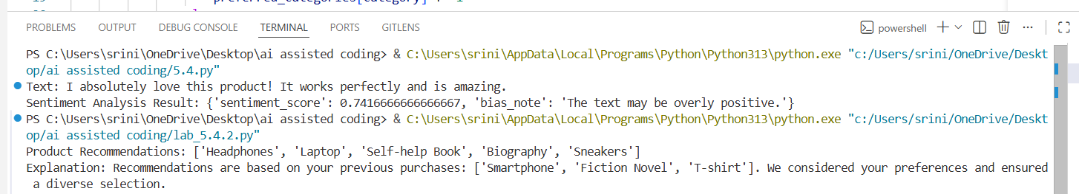
EXPLANATION:
This program recommends products based on what the user has previously interacted with.
It suggests items from similar categories while limiting recommendations per category to keep them fair and diverse.
The comments explain how ethical practices like transparency, fairness, and privacy are followed in the recommendation process.

TASK-04
CODE:
#TASK-04
#Secure Logging in Web Application
import logging
def setup_logging():
logger = logging.getLogger('web_app_logger')
logger.setLevel(logging.DEBUG)
console_handler = logging.StreamHandler()
file_handler = logging.FileHandler('web_app.log')
console_handler.setLevel(logging.INFO)
file_handler.setLevel(logging.DEBUG)
formatter = logging.Formatter(
'%(asctime)s - %(levelname)s - %(message)s'
)
console_handler.setFormatter(formatter)
file_handler.setFormatter(formatter)
logger.addHandler(console_handler)
logger.addHandler(file_handler)
return logger
# Example usage
if __name__ == "__main__":
logger = setup_logging()
logger.info("Application started.")
try:
logger.debug("Processing request.")
user_password = "secret123" # Never log this
logger.debug("User logged in.")
except Exception as e:
logger.error("Error: " + str(e))
finally:
logger.info("Application stopped.")
# Logging Ethics:
# 1. Do not log passwords.
# 2. Avoid storing personal data.
# 3. Use log levels properly.
# 4. Protect log files.

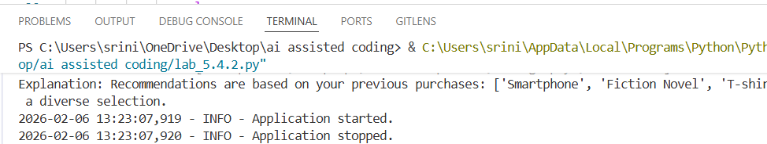
EXPLANATION:
code sets up a simple logging system for a Python web application.
It records important application events while carefully avoiding sensitive data like passwords and help track normal activity, debugging details.

TASK-05
CODE:
#TASK-05
#Machine Learning Model with Responsible Documentation
from sklearn.datasets import load_iris
from sklearn.model_selection import train_test_split
from sklearn.ensemble import RandomForestClassifier
from sklearn.metrics import classification_report
import joblib
def train_model():
iris = load_iris()
X = iris.data
y = iris.target
X_train, X_test, y_train, y_test = train_test_split(
X, y, test_size=0.2, random_state=42
)
model = RandomForestClassifier(
n_estimators=100,
random_state=42
)
model.fit(X_train, y_train)
return model, X_test, y_test
def evaluate_model(model, X_test, y_test):
y_pred = model.predict(X_test)
report = classification_report(y_test, y_pred)
print("Classification Report:\n", report)

if __name__ == "__main__":
model, X_test, y_test = train_model()
evaluate_model(model, X_test, y_test)
joblib.dump(model, "rf_iris_model.pkl")

"""
README – Responsible Usage Guidelines:
1. Explainability:
Understand how predictions are made.
2. Accuracy Limits:
Works only on Iris dataset.
3. Fairness:
Check for bias regularly.
4. Transparency:
Document training process.
5. Accountability:
Monitor performance continuously.”””
OUTPUT:
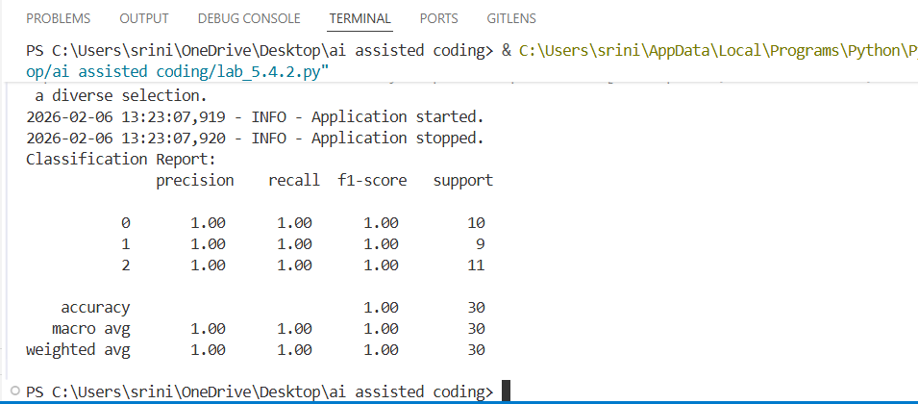
EXPLANATION:
This code builds a simple machine learning model using the Iris dataset and a Random Forest classifier. Shows how the data is split, the model is trained, evaluated. The added documentation and the need to monitor and improve the model over time.

