AI ASSISTED CODING
ASSIGNMENT-6.3
NAME:SRINIDHI REDDY
ROLL NUMBER:2303A51566
BATCH:09
---------------------------------------------------------------------------------------------------------
Task Description #1: Classes (Student Class)
PROMPT:
# Create a Python class named Student.
# Add attributes: name, roll_number, branch.
# Use __init__ to initialize attributes.
# Add display_details() to print student info.
# Create one Student object.
# Call the display_details() method.
CODE:
#Create a Python class named Student.
class Student:
def __init__(self, name, age, grade):
self.name = name
self.age = age
self.grade = grade

def get_info(self):
return f"Name: {self.name}, Age: {self.age}, Grade: {self.grade}"

#Add attributes: name, roll_number, branch.
self.roll_number = roll_number
self.branch = branch

#Use __init__ to initialize attributes.
self.roll_number = roll_number
self.branch = branch
#Add display_details() to print student info.
def display_details(self):
print(f"Name: {self.name}")
print(f"Age: {self.age}")
print(f"Grade: {self.grade}")
print(f"Roll Number: {self.roll_number}")
print(f"Branch: {self.branch}")

#Create one Student object.
student1 = Student("SrinidhiReddy", 20, "A", "1566", "Computer Science")

#Call the display_details() method.
student1.display_details()
OUTPUT:
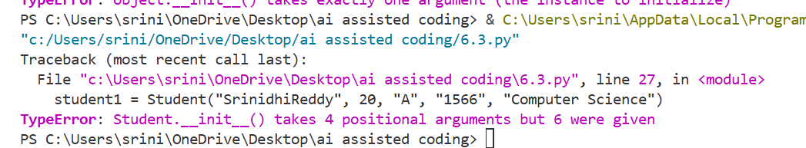
EXPLANATION:
This program uses Object-Oriented Programming to model student details. A Student class is created with attributes initialized using a constructor. A method is used to display student information. This improves code organization and reusability.

Task Description #2: Loops (Multiples of a Number)
PROMPT:
#Write a Python function that prints the first 10 multiples of a given number using a for loop.
#The number should be taken as user input.
#Write the same program to print the first 10 multiples of a given number,use a while loop

CODE:
#Write a Python function that prints the first 10 multiples of a given number using a for loop.
#The number should be taken as user input.
def print_multiples():
try:
number = int(input("Enter a number: "))
print(f"The first 10 multiples of {number} are:")
for i in range(1, 11):
print(number * i)
except ValueError:
print("Please enter a valid integer.")
print_multiples()

#Write the same program to print the first 10 multiples of a given number,use a while loop
def print_multiples_while():
try:
number = int(input("Enter a number: "))
print(f"The first 10 multiples of {number} are:")
count = 1
while count <= 10:
print(number * count)
count += 1
except ValueError:
print("Please enter a valid integer.")
print_multiples_while()
OUTPUT:
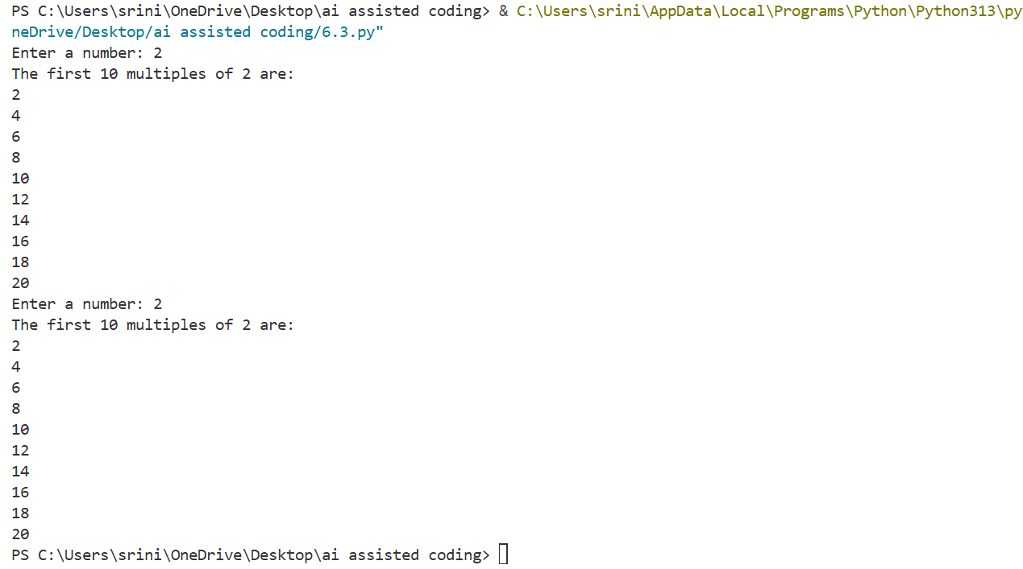
EXPLANATION:
- Uses for loop to generate first 10 multiples.
- Uses while loop as an alternative approach.
- Accepts user input for flexibility.
- Includes error handling for invalid input.

Task Description #3: Conditional Statements (Age Classification)
PROMPT:
# Generate nested if-elif-else conditional statements to classify age groups(e.g., child, teenager, adult, senior).
# Generate the same classification using alternative conditional structures (e.g.,simplified conditions or dictionary-based logic).
CODE:
# Generate nested if-elif-else conditional statements to classify age groups(e.g., child, teenager, adult, senior).
age = int(input("Enter your age: "))
if age < 0:
print("Invalid age.")
elif age < 13:
print("You are a child.")
elif age < 20:
print("You are a teenager.")
elif age < 65:
print("You are an adult.")
else:
print("You are a senior citizen.")

# Generate the same classification using alternative conditional structures (e.g.,simplified conditions or dictionary-based logic).
def classify_age(age):
"""Classify age groups using dictionary-based logic."""
age_groups = {
range(0, 13): "You are a child.",
range(13, 20): "You are a teenager.",
range(20, 65): "You are an adult.",
range(65, 150): "You are a senior citizen."
}
for age_range, message in age_groups.items():
if age in age_range:
return message
return "Invalid age."
user_age = int(input("Enter your age: "))
print(classify_age(user_age))
OUTPUT:
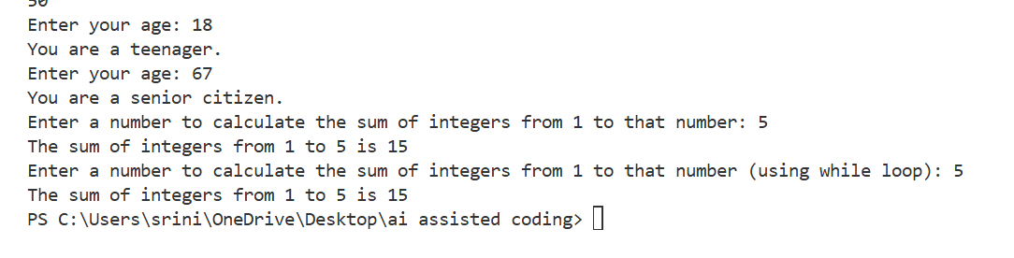
EXPLANATION:
- Applies conditional statements for decision making.
- Classifies age into child, teenager, adult, and senior.
- Demonstrates both nested and dictionary-based logic.
- Improves readability and logical structure.

Task Description #4: For and While Loops (Sum of First n Numbers)
PROMPT:
# Generate a sum_to_n() function using a for loop.
# Generate an alternative implementation using a while loop or a mathematical formula.
CODE:
# Generate a sum_to_n() function using a for loop.
def sum_to_n(n):
"""Calculate the sum of integers from 1 to n."""
total = 0
for i in range(1, n + 1):
total += i
return total
# Example usage:
number = int(input("Enter a number to calculate the sum of integers from 1 to that number: "))
print(f"The sum of integers from 1 to {number} is {sum_to_n(number)}")
# Generate an alternative implementation using a while loop or a mathematical formula.
def sum_to_n_while(n):
"""Calculate the sum of integers from 1 to n using a while loop."""
total = 0
i = 1
while i <= n:
total += i
i += 1
return total
# Example usage:
number = int(input("Enter a number to calculate the sum of integers from 1 to that number (using while loop): "))
print(f"The sum of integers from 1 to {number} is {sum_to_n_while(number)}")
OUTPUT:
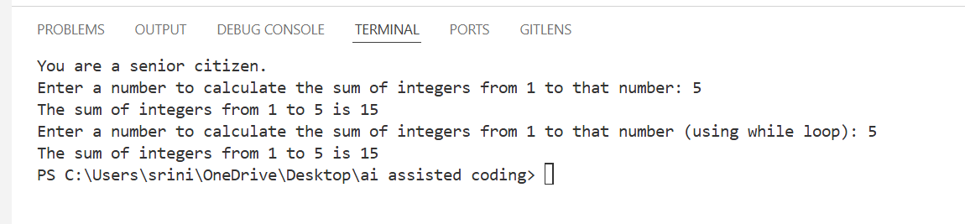
EXPLANATION:
- Calculates sum using a for loop.
- Provides alternative implementation using a while loop.
- Uses functions for reusability.
- Demonstrates loop control and arithmetic operations.

Task Description #5: Classes (Bank Account Class)
PROMPT:
#Write a Python BankAccount class with deposit(), withdraw(), and check_balance() methods
# Create an instance of BankAccount
# Demonstrate the functionality of each method
CODE:
#Write a Python BankAccount class with deposit(), withdraw(), and check_balance() methods
class BankAccount:
def __init__(self, initial_balance=0):
self.balance = initial_balance

def deposit(self, amount):
if amount > 0:
self.balance += amount
print(f"Deposited: ${amount}")
else:
print("Deposit amount must be positive.")

def withdraw(self, amount):
if 0 < amount <= self.balance:
self.balance -= amount
print(f"Withdrew: ${amount}")
else:
print("Insufficient funds or invalid withdrawal amount.")

def check_balance(self):
print(f"Current balance: ${self.balance}")
# Create an instance of BankAccount
account = BankAccount(100) # Initial balance of $100
account.check_balance()
account.deposit(50)
account.check_balance()
account.withdraw(30)
account.check_balance()
account.withdraw(150) # Attempt to withdraw more than the balance
account.check_balance()
# Demonstrate the functionality of each method
account.deposit(-20) # Attempt to deposit a negative amount
account.check_balance()
account.withdraw(50)
account.check_balance()
account.deposit(200)
account.check_balance()
account.withdraw(100)
account.check_balance()
OUTPUT:
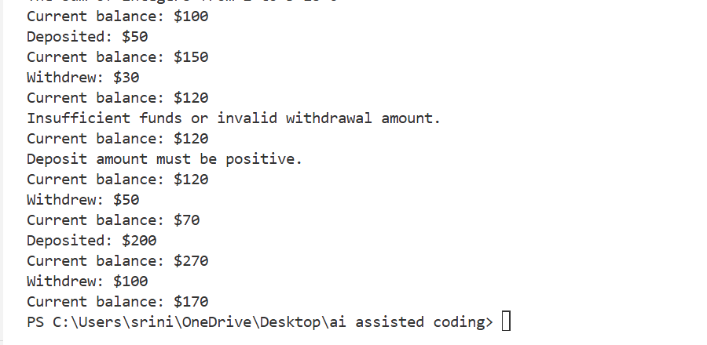
EXPLANATION:
- Models real-world banking system using a class.
- Implements deposit, withdraw, and balance check methods.
- Ensures validation for transactions.
- Demonstrates encapsulation and data security.

