JBoss

Jboss application server 4.x

Jboss application server 5.x

Jboss application server 6.x

Jboss application server 7.x

WildFly 8.x

WildFly 9.x

WildFly 10.0.x

EAP 4.X

EAP 5.X

EAP 6.1

EAP 6.4

EAP 7.0

**Servers**

REDHART - WildFly (JBoss) – Opensource

IBM - Websphere

Oracle - Weblogic

VMWare – TCServer

Oracle – GlassFish

Apache – Tomcat – Opensource

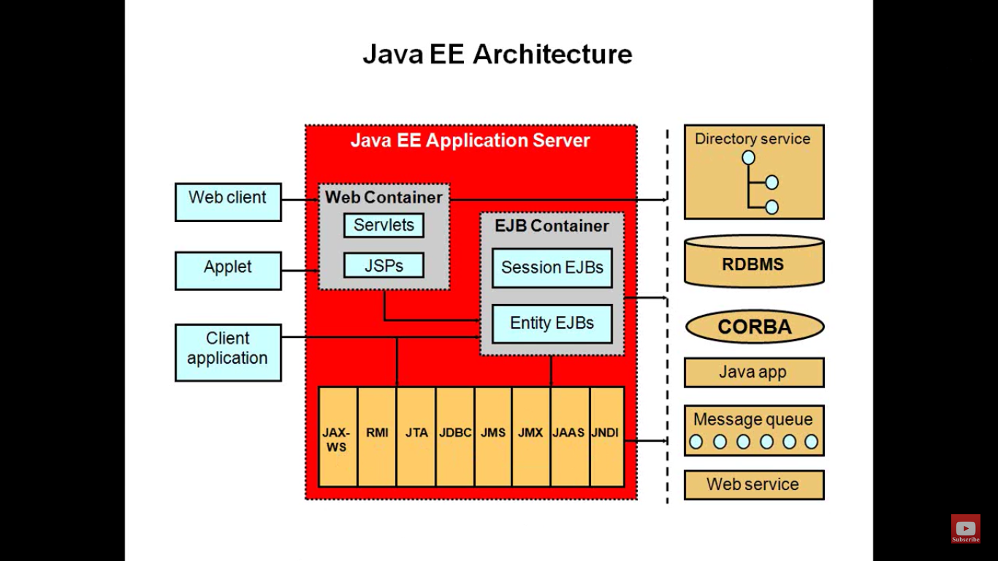

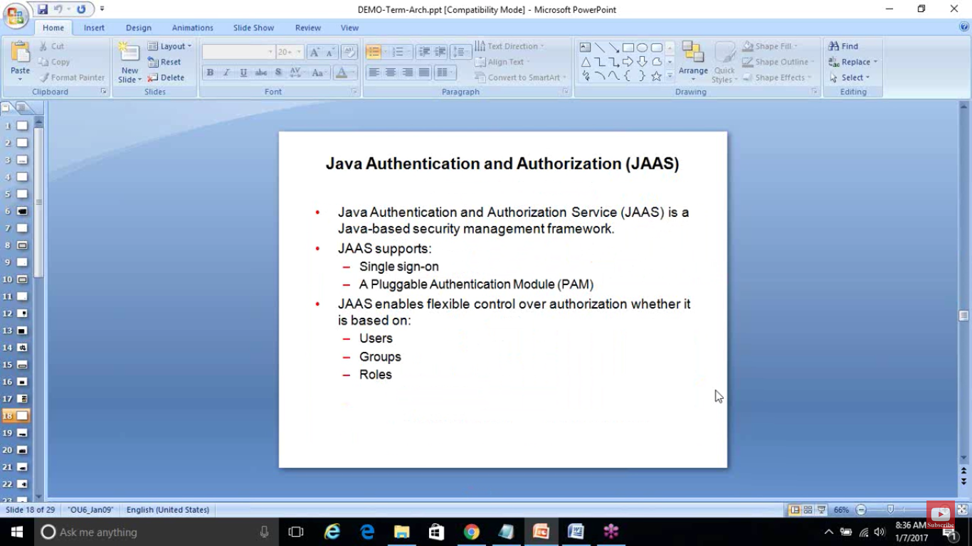

**JBoss Installation**

**Installation types**

1. **Unzip**
2. **GUI**
3. **Command line**
4. **Yum**
5. **Auto.xml**

**Prerequisites**

1. **Ensure you have user id (with necessary privileges, check with command “id”)**

* Go to jboss_home/bin and add user for manager OR application user: 1) # useradd srini
* Go to 2) # cd home/srini/.bash_profile
* Open # vi bash_profile (export the java path in this file)
* Open profile file in /etc/profile (export the java path in this file)

1. **JAVA set as with environmental variables. (check with java -version)**

* Download “jboss-eap-7.0.0-installer.jar” file
* Run “java -jar jboss-eap-7.0.0-installer.jar”
* Select the language.
* Select the OR give jboss installation path Ex: /user/jboss/eap7.0 (have to RWX permission to that path)
* Create username (default Admin username is “admin”, we can create our username here Ex: srini) and password
* Install quick start
* Install wanted packages.
* Give if you want custom port, we can go with default server port also
* Configure logging level.
* If you want create automatic installation script (for this it will use auto.xml file)
* Go to JBoss_home/bin/standalone.sh
* Ex: if Jboss home is EAP 7.1; but installed all the files in “jboss-eap-7.1” folder, than all data move from “jboss-eap-7.1” to “EAP 7.1” folder
* Jboss installation folder

**Deploy war file**

* Go to and run command JBossHome/bin/./ standalone.sh
* Go to UI console “http:localhost:9990/console”.
* Go to UI console “https:localhost:9993/console”.
* Click deploy an application, please upload new deploy, select the .war file

Four preconfigured profiles:

* **default** - Support of Java EE Web-Profile plus some extensions like RESTFul Web Services or support for EJB3 remote invocations
* **full** - Support of Java EE Full-Profile and all server capabilities without clustering
* **ha** - default profile with clustering capabilities
* **full-ha** - full profile with clustering capabilities