Depression Detection from Text, Image & Speech using Deep Learning Algorithm

In this project we are designing multimodal based deep learning and machine learning algorithms to detect depression from User Text Comment, Facial Expression Image and Speech Tones. In the past many algorithms were introduced to predict depression but all those algorithms were working on single data format like Text, Face or speech but not all.

Main intention of developing this application to detect user depression from all formats as humans are very sensitive and caring and will not show is depression to closed family member in order to avoid giving tension to them but often their depression can be identify either from face or his social media comments or in his speech. So we can detect depression in humans in all 3 multimodal format.

In propose work we deployed advanced deep learning algorithm called Convolution Neural Network (CNN2D) to detect depression from faces and voices. CNN consider best to classify data from images and speech. To identify depression from TEXT we employ Random Forest algorithm as in ML Random Forest is most accurate compare to other algorithms.

To train all format algorithms we have utilized 3 different dataset which is downloaded from below repository

Text dataset = https://www.kaggle.com/datasets/nikhileswarkomati/suicide-watch?select=Suicide_Detection.csv

Image dataset = <https://www.kaggle.com/datasets/ananthu017/emotion-detection-fer>

Speech dataset = <https://www.kaggle.com/datasets/uwrfkaggler/ravdess-emotional-speech-audio>

So by using above dataset we have trained above mention algorithms and then test each algorithm performance in terms of Accuracy, Precision, Recall and FSCORE. All algorithms manages to get an accuracy of over 95%

To implement this project we have designed following modules

1. Upload Depression Dataset: using this module will upload all types of dataset to application and then read each format data in array format
2. Pre-process Dataset: this module we will apply pre-processing techniques like image, speech, and text data shuffling, normalization and then split them into train and test where application will be using 80% dataset for training and 20% for testing
3. Train Facial Depression CNN Algorithm: this module will train CNN algorithm using facial images features and then trained a model and this model will be applied on 20% test images to calculate prediction accuracy
4. Train Speech Depression CNN Algorithm: this module will train CNN algorithm using speech features and then trained a model and this model will be applied on 20% test speech to calculate prediction accuracy
5. Train Text Depression Random Forest Algorithm: this module will train Random Forest algorithm using text features and then trained a model and this model will be applied on 20% test text features to calculate prediction accuracy
6. Accuracy Comparison Graph: using this module we will plot comparison graph between all algorithms
7. Predict Facial Depression: using this module will upload test image and then application detect weather facial features are depressed or non-depressed
8. Predict Speech Depression: using this module will upload test speech audio and then application detect weather test audio features are depressed or non-depressed
9. Predict Text Depression: using this module will upload test TEXT comments and then application detect weather test TEXT comments are depressed or non-depressed

SCREEN SHOTS

To run project double click on ‘run.bat’ file to get below screen

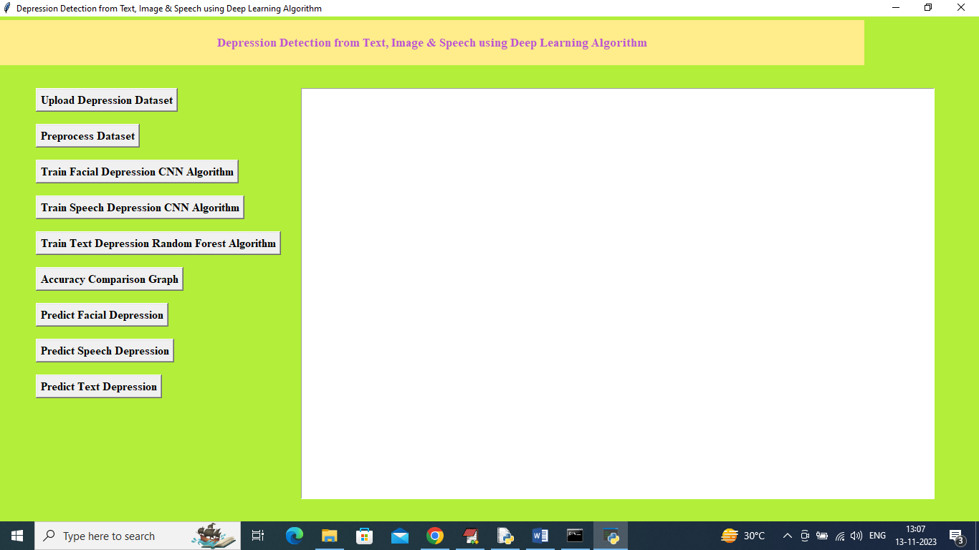

In above screen click on ‘Upload Depression Dataset’ button to upload dataset and get below output

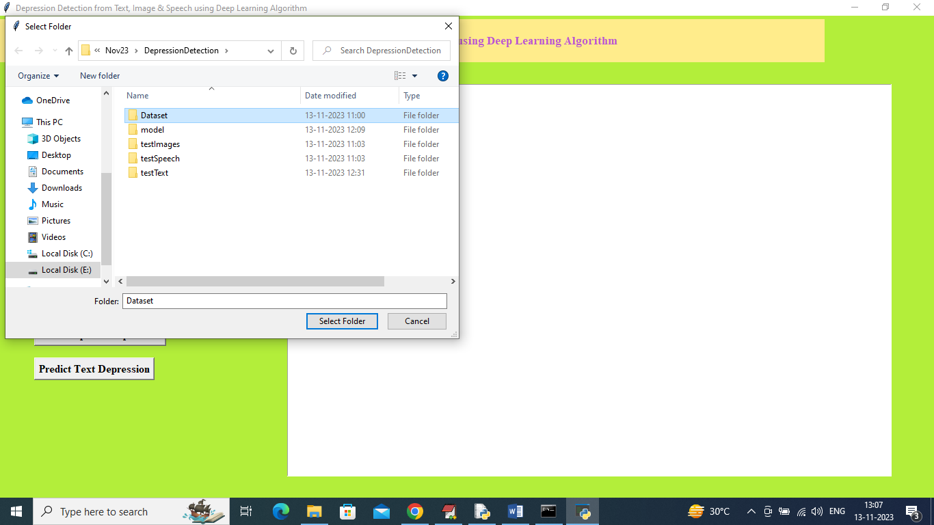

In above screen selecting and uploading all dataset folder and then click on ‘Select Folder’ button to load speech, image and text dataset and then will get below output

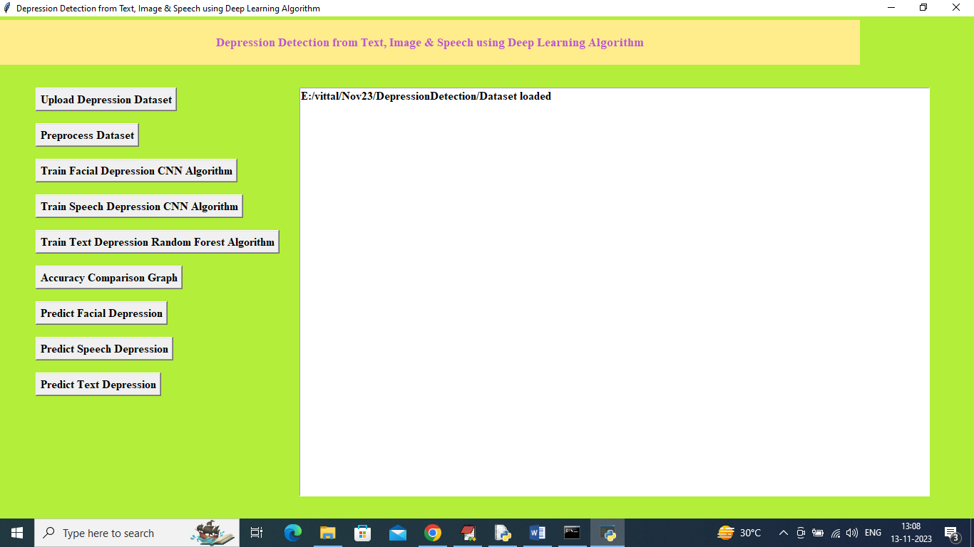

In above screen dataset loaded and now click on ‘Pre-process Dataset’ button to read, shuffle, normalize and split into train and test and then will get below output

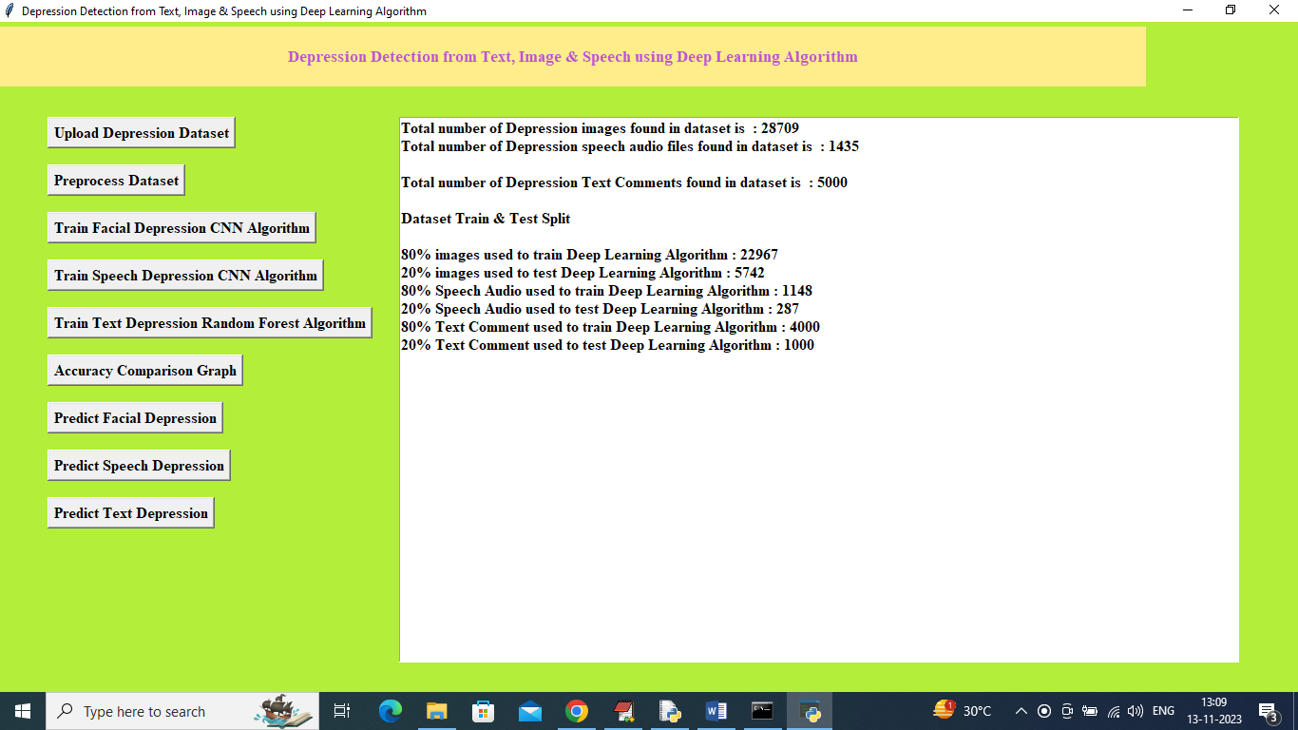

In above screen can see total images loaded, speech loaded and text commented loaded and then can see train and test size of each dataset format and now train and test data is ready and now click on ‘Train Facial Depression CNN Algorithm’ button to train algorithm and get below output

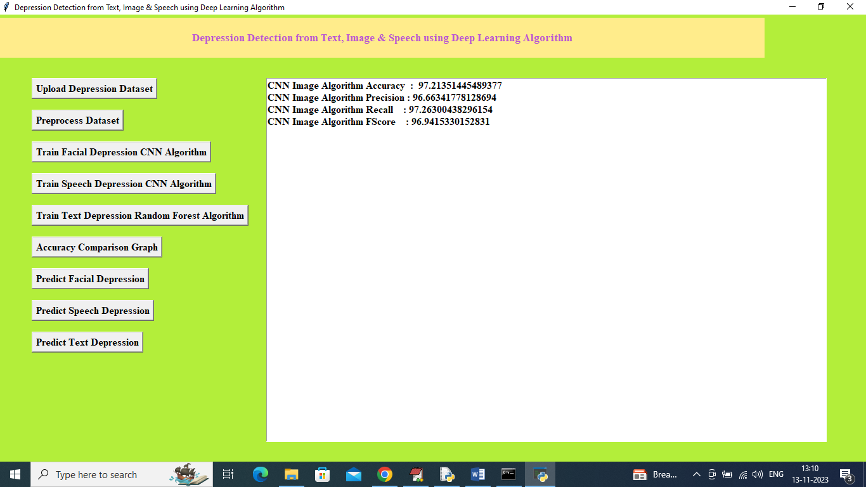

In above screen CNN on Facial images trained and it got test prediction accuracy as 97.21% and can see other metrics like precision, recall and FSCORE and now click on ‘Train Speech Depression CNN Algorithm’ button to train model and get below output

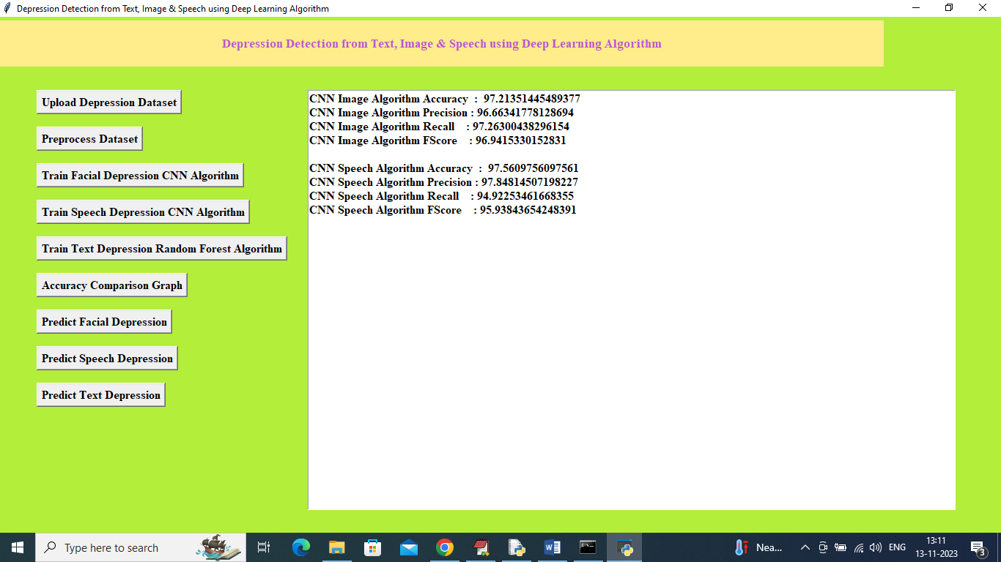

In above screen speech CNN got 97.56% accuracy and now click on ‘Train Text Depression Random Forest Algorithm’ button to get below output

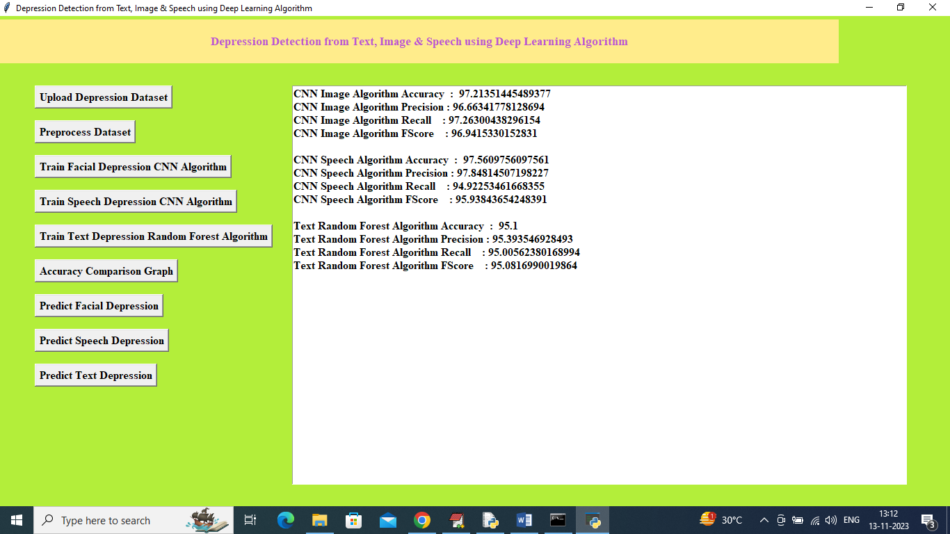

In above screen TEXT depression detection model got 95% accuracy and now click on ‘Accuracy Comparison Graph’ button to get below output

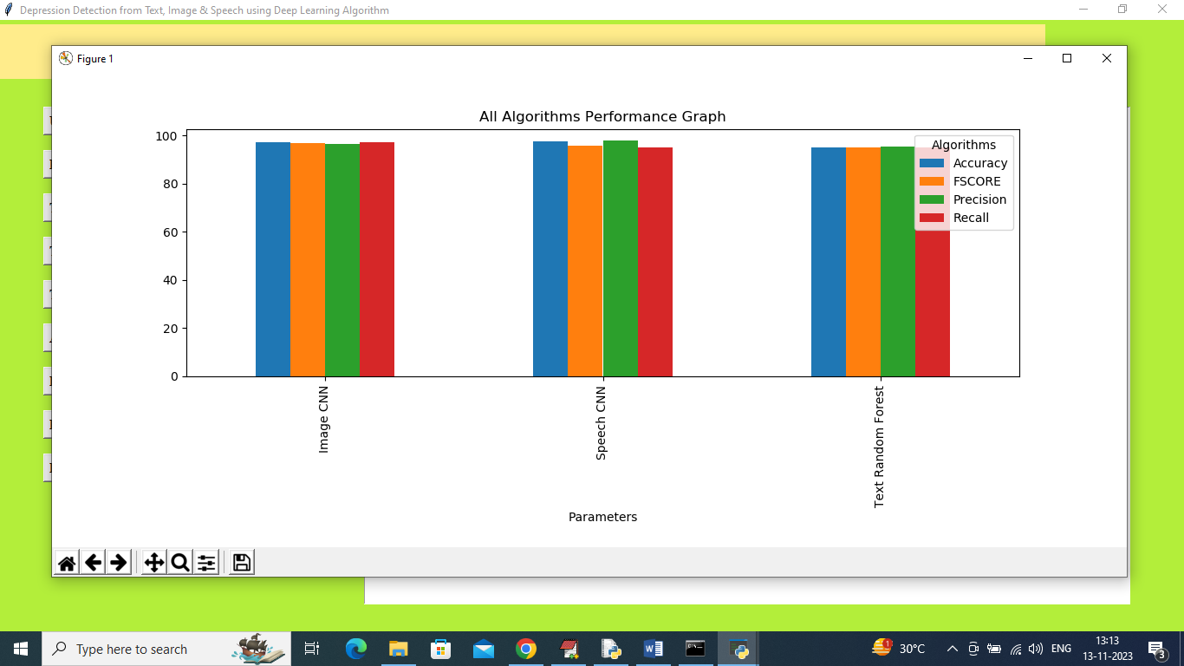

In above graph x-axis represents algorithm names and y-axis represents accuracy and other metrics in different colour bar and in above graph can see all algorithms accuracy is more than 95% and now close above graph and then click on ‘Predict Facial Depression’ button to upload test image and get below output

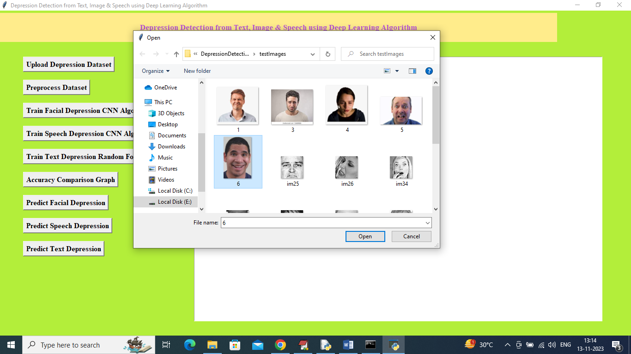

In above screen selecting and uploading 6.jpg image and then click on ‘Open’ image to get below output

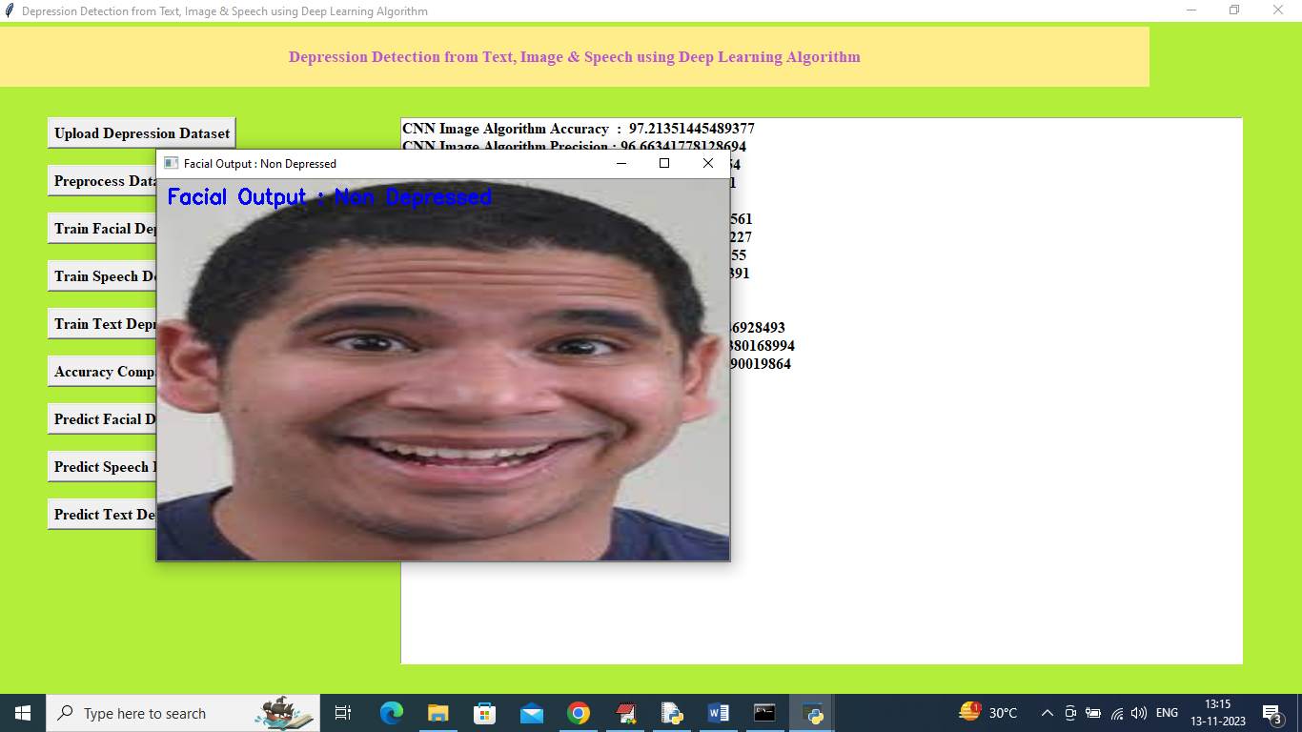

In above screen facial output detected as Non-depressed and similarly you can upload and test other images and below is another example

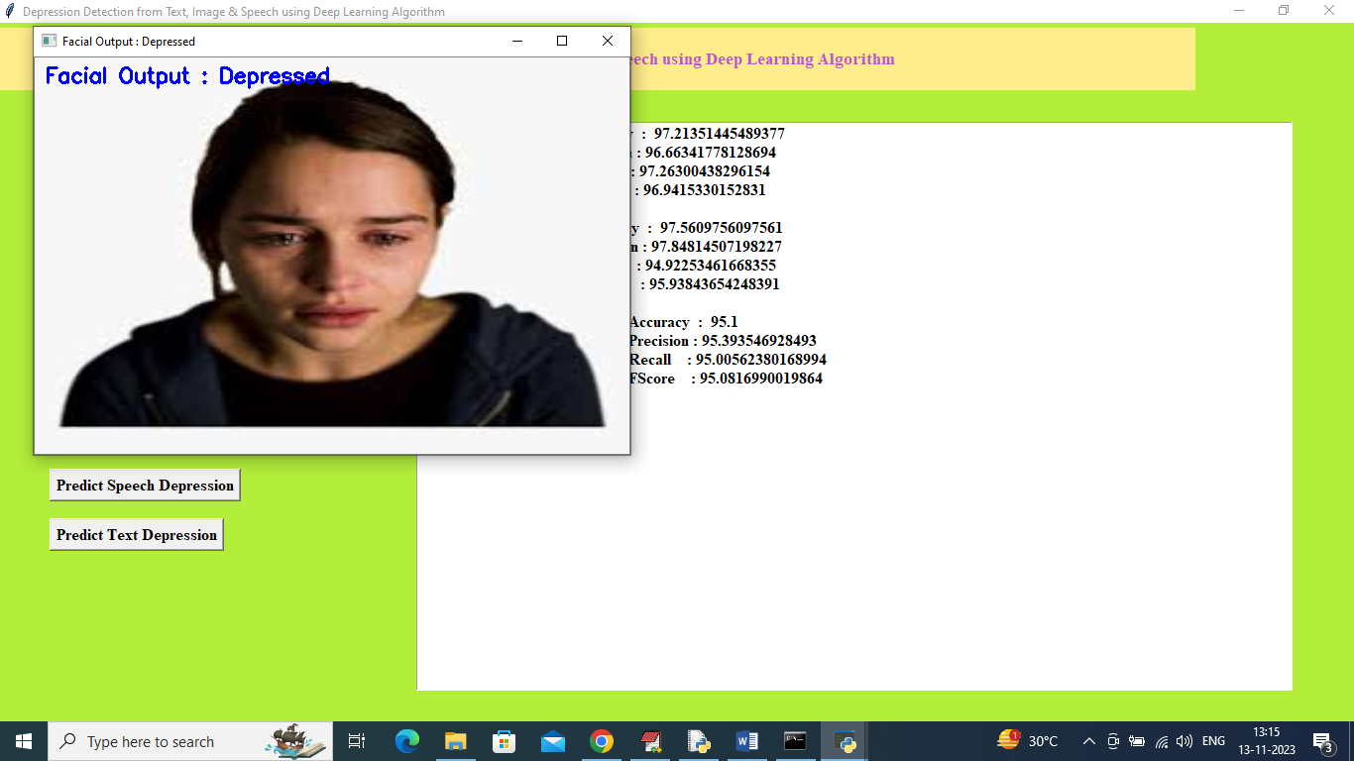

In above screen facial features detected as depressed and now close above image and then click on ‘Predict Speech Depression’ button to upload voice file

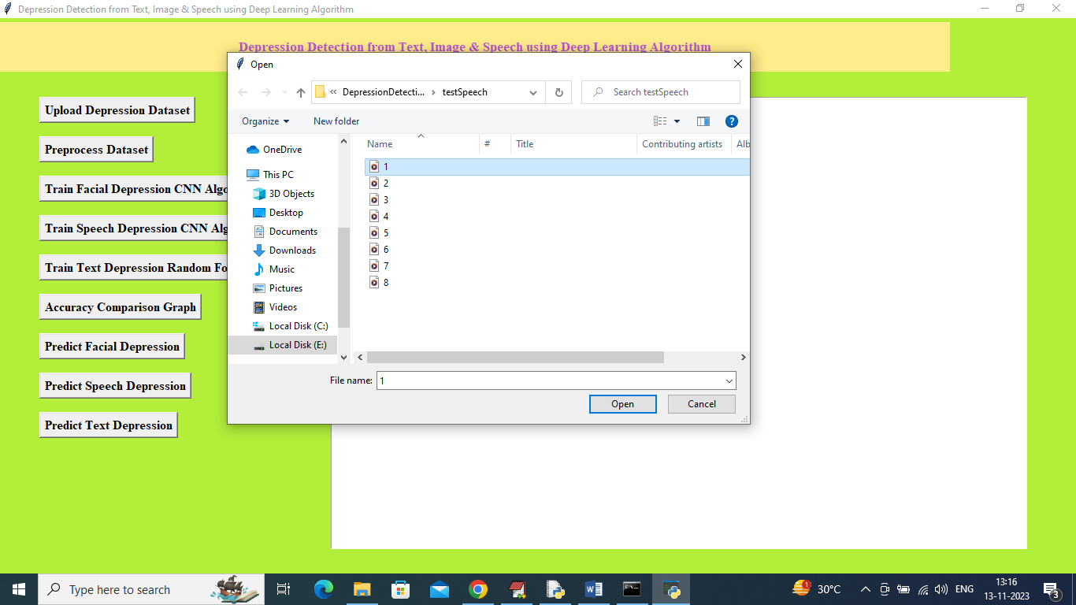

In above screen selecting and uploading 1.wav audio file and then click on ‘Open’ button to get below output

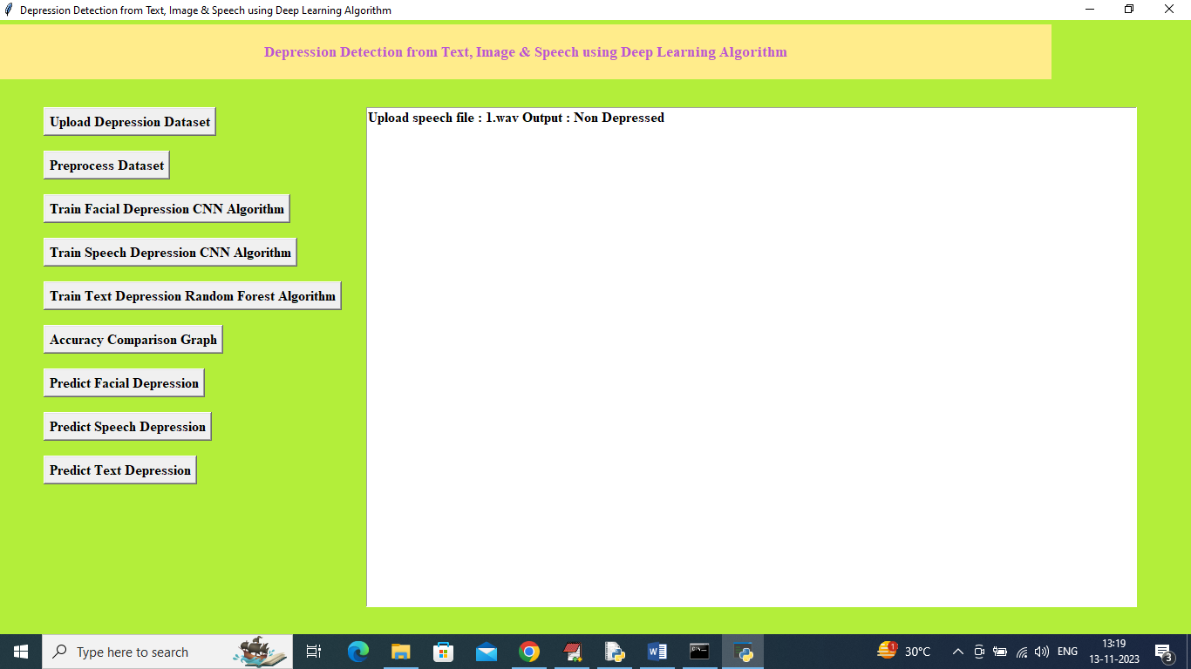

In above screen uploaded speech features detected as ‘Non-depressed’ and similarly you can upload and test other speech files and below is another example

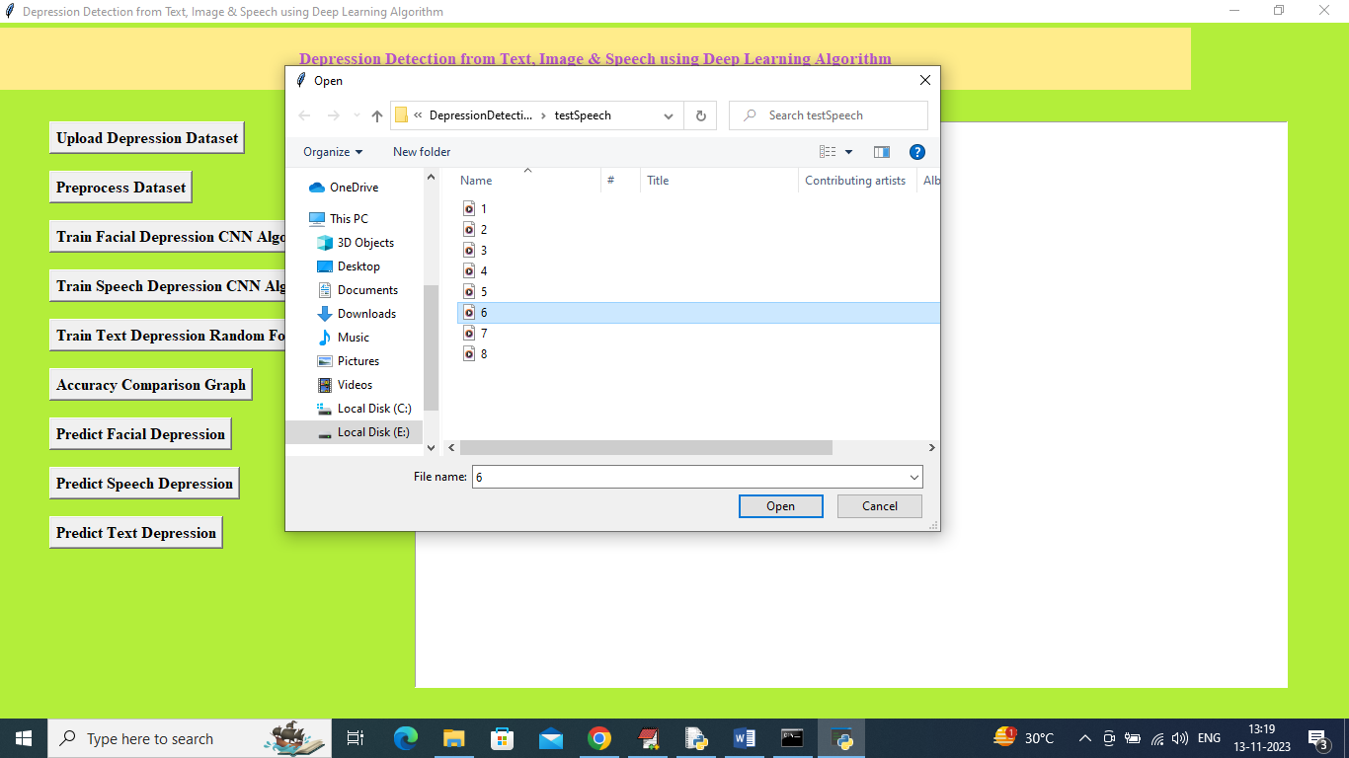

In above screen uploading another audio file and then click on ‘Open’ button to get below output

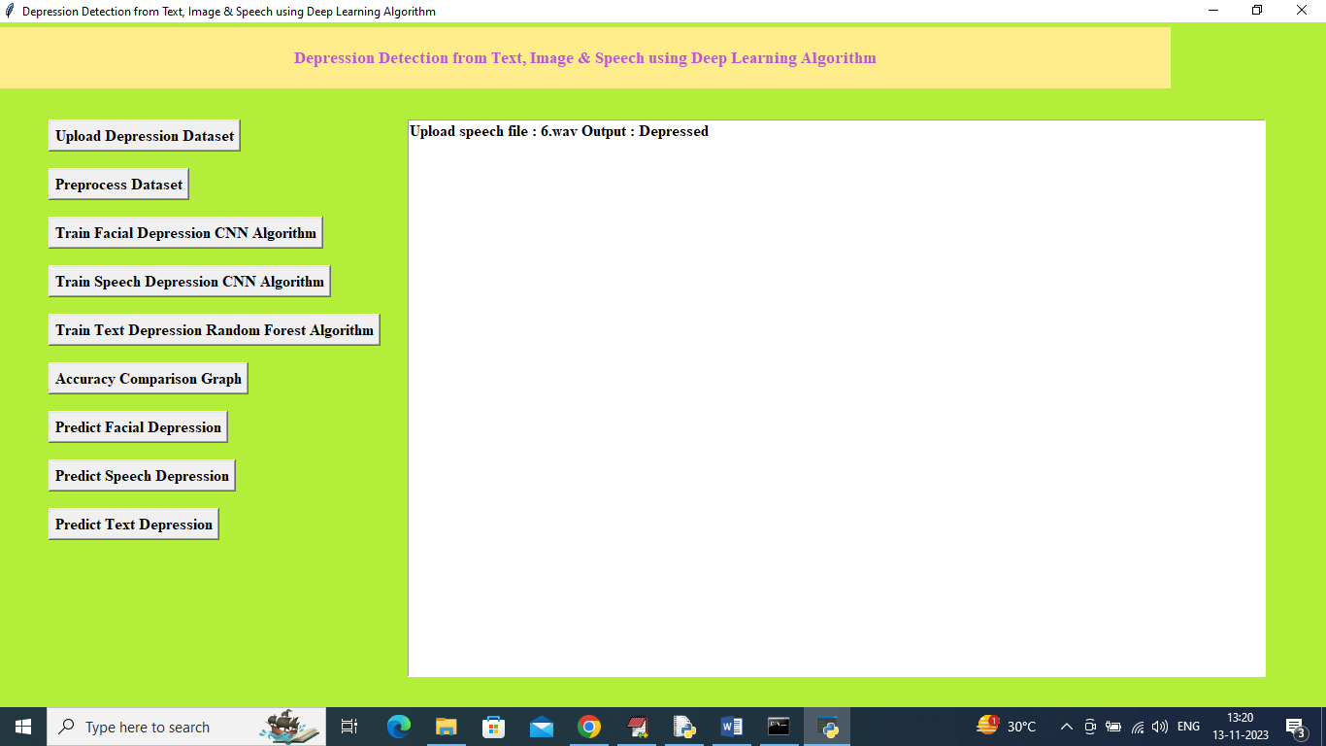

In above screen audio file detected as ‘depressed’ and now click on ‘Predict Text Depression’ button to upload TEST TEXT comments like below screen

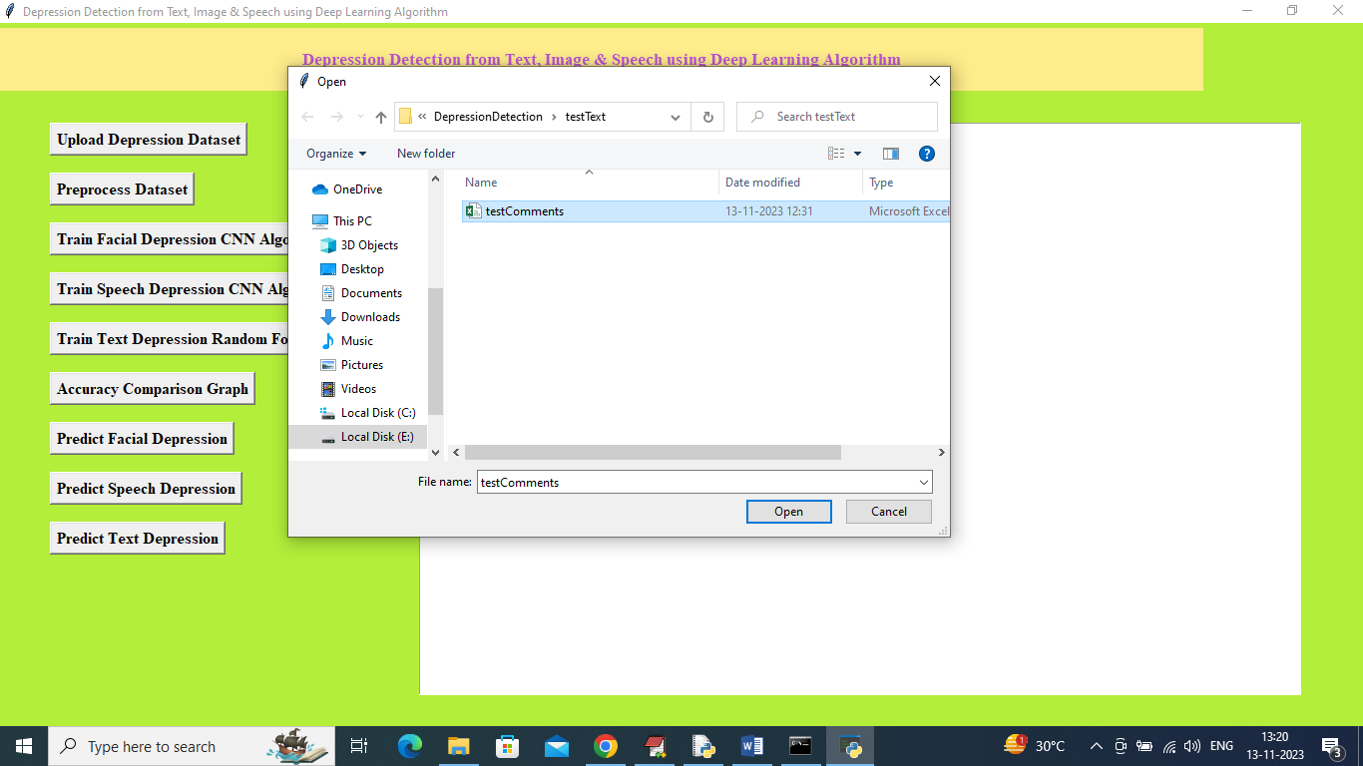

In above screen selecting and uploading ‘Test Comments.csv” file and then click on ‘Open’ button to get below output

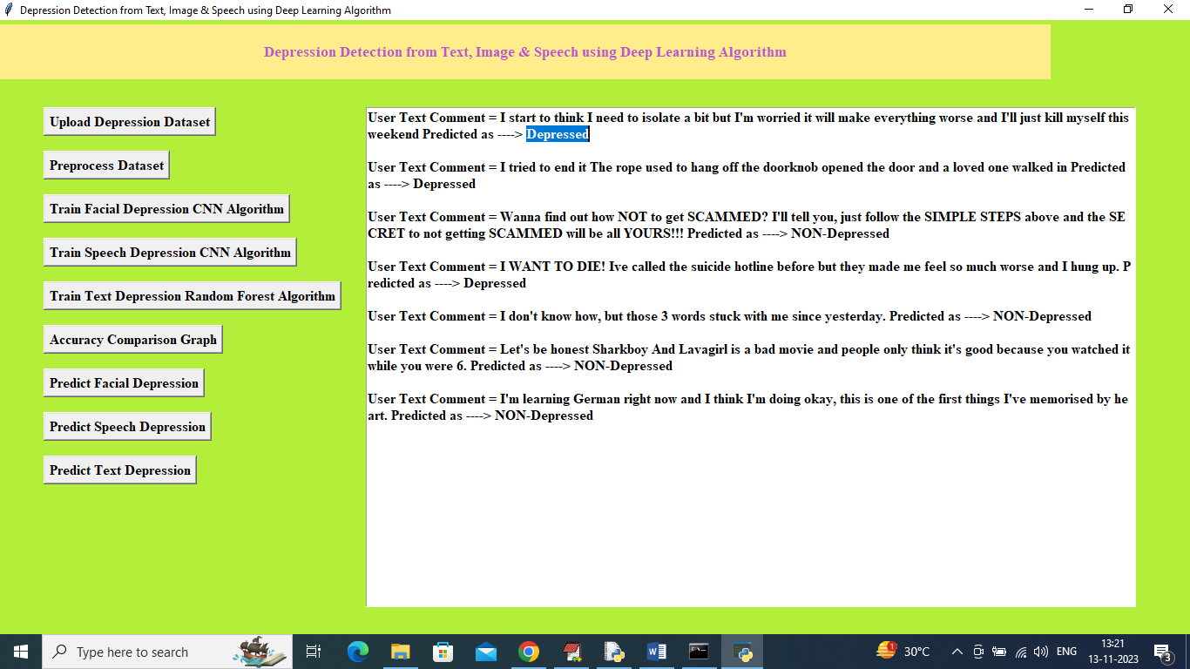

In above screen first displaying TEXT Comment and then after =🡺 symbol displaying predicted output as ‘Depressed or Non-depressed’.

So above are the prediction output from all 3 formats