Difference between BROWSER JS vs NODE.JS:

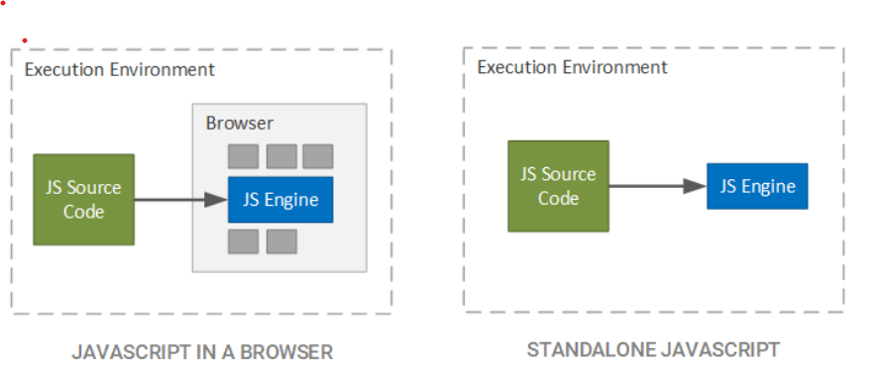

* Browser.js is mainly used for client-side applications like validations on a web page or dynamic page display and as the name suggests it gets executed in the browser only while in the case of Node.js javascript code gets executed outside the browser as it is an interpreter as well as an environment for running javascript and used for server-side applications. In nutshell, we can say Browser.js is used for frontend while Node.js is used for backend applications.
* Node.js has full system access i.e. can read and write directly to the file system like any other application that also concludes that we can write complete software using Node.js while Browser.js is sandboxed for the safety purposes and have access limited to the browser.
* In Node.js everything is a module i.e it is mandatory to keep everything inside a module while moduling is not mandatory for browser javascript.
* Browser.js runs any engine like Spider monkey (Firefox), JavaScript Core (Safari), V8 (Google Chrome) accordingly to the browser while Node.js runs in a V8 engine which is mainly used by google chrome.
* In Node.js many objects are missing like-
  + “window” object because it doesn’t have a window to draw anything.
  + “location” object is related to a particular URL that means it is for page-specific.
  + “document” object also, because it never have to render anything on a page.
* while browser.js has all these as predefined objects but the browser is missing on these-
  + “global” object contains several functions that are not available in browsers as they are needed for server-side works only.
  + “require” object which is used to include modules in the app.

**Execute the below code:**

**1) typeof(1):** Here 1 is number(integer) data type.

**2) typeof(1.1):** Here 1.1 is number(float) data type.

**3) typeof('1.1'):** Here '1.1' is string data type.

**4) typeof(true):** Here true is Boolean data type.

**5) typeof(null):** Here null is object data type**.**

**6) typeof(undefined):** Here undefined is undefined datatype only.

**7) typeof([]):** Here [] is object data type.

**8)typeof({}):** Here {} is object datatype.

**9)typeof(NaN):** Here Nan is number datatype**.**