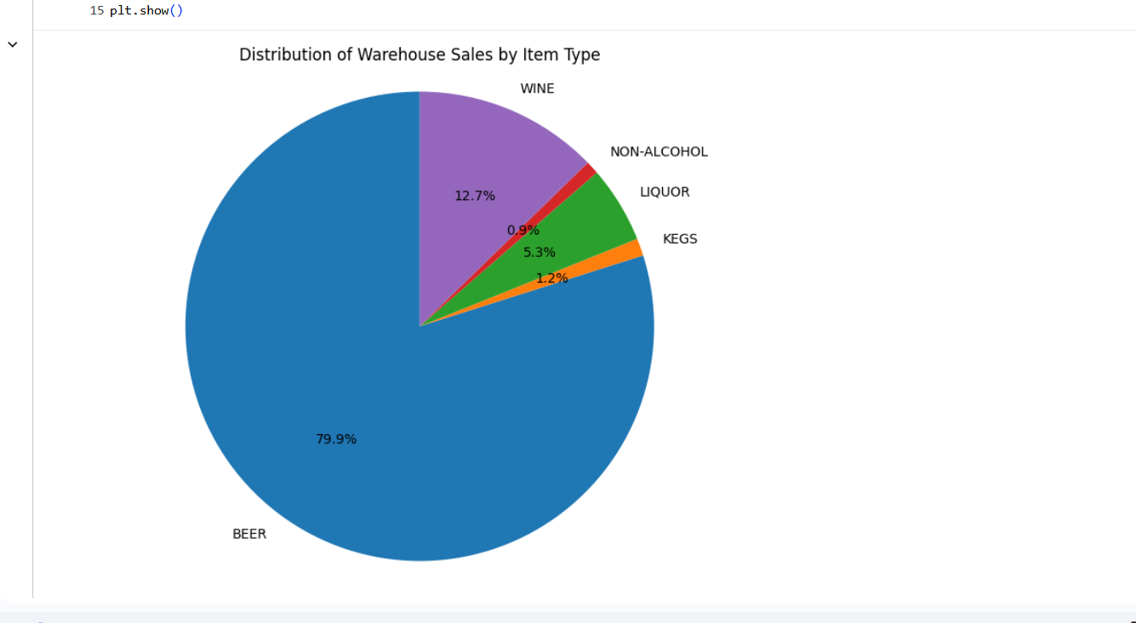
Business insights to analyze:
"Beer"

The pie chart illustrates how total warehouse sales are distributed across item types. It helps identify the major sales contributors and categories with relatively low contributions, supporting inventory management and sales planning.

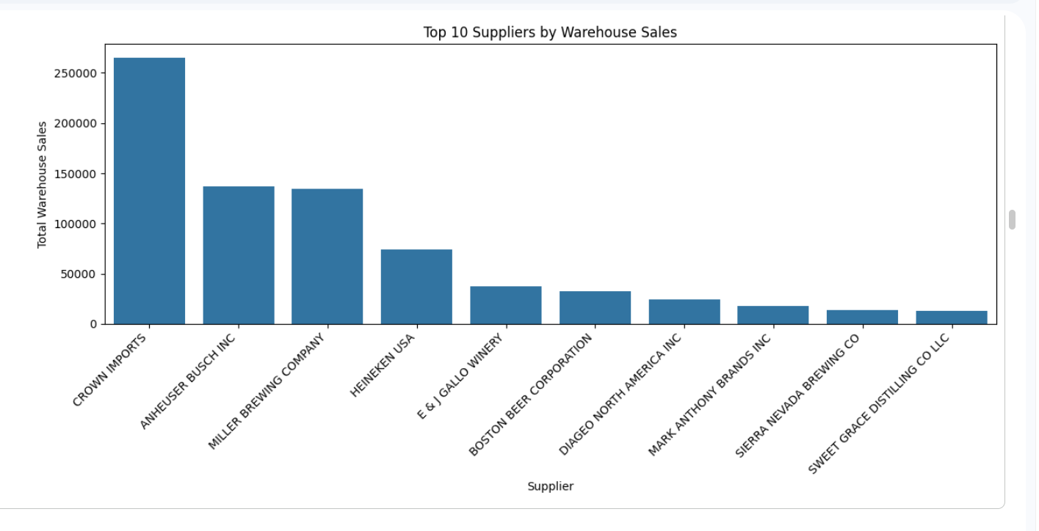
The analysis identifies the leading suppliers by warehouse sales and highlights differences in their contributions. These findings can support supplier relationship management, inventory planning, and purchasing decisions.

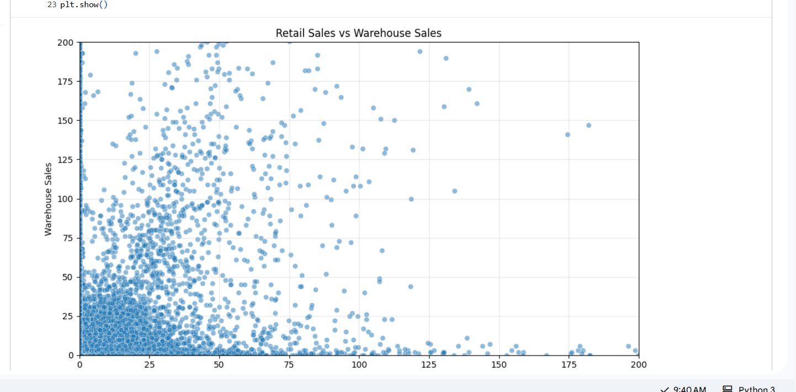

- Positive relationship: Higher retail sales may occur alongside higher warehouse sales.
- Clusters: Groups of points may reveal different product demand patterns.
- Outliers: Isolated points may indicate unusually high or low sales records.
- Inventory planning: Comparing retail transfers with warehouse sales may help identify patterns relevant to stock allocation.

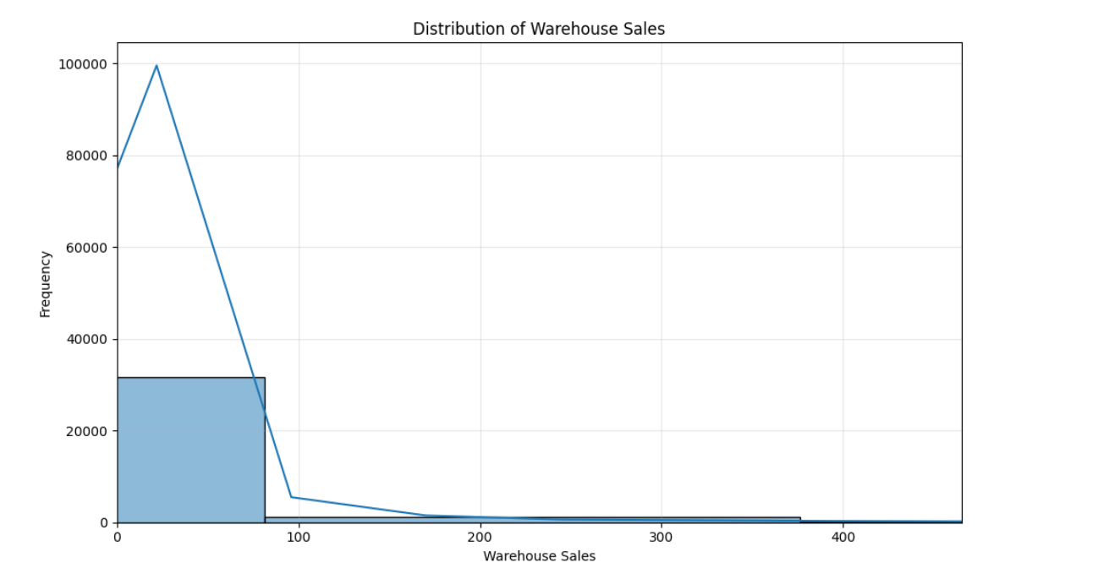
Warehouse Sales distribution analysis helps identify sales patterns, understand data variability, detect potential extreme values, and decide whether skewness treatment is required before building a Machine Learning model.

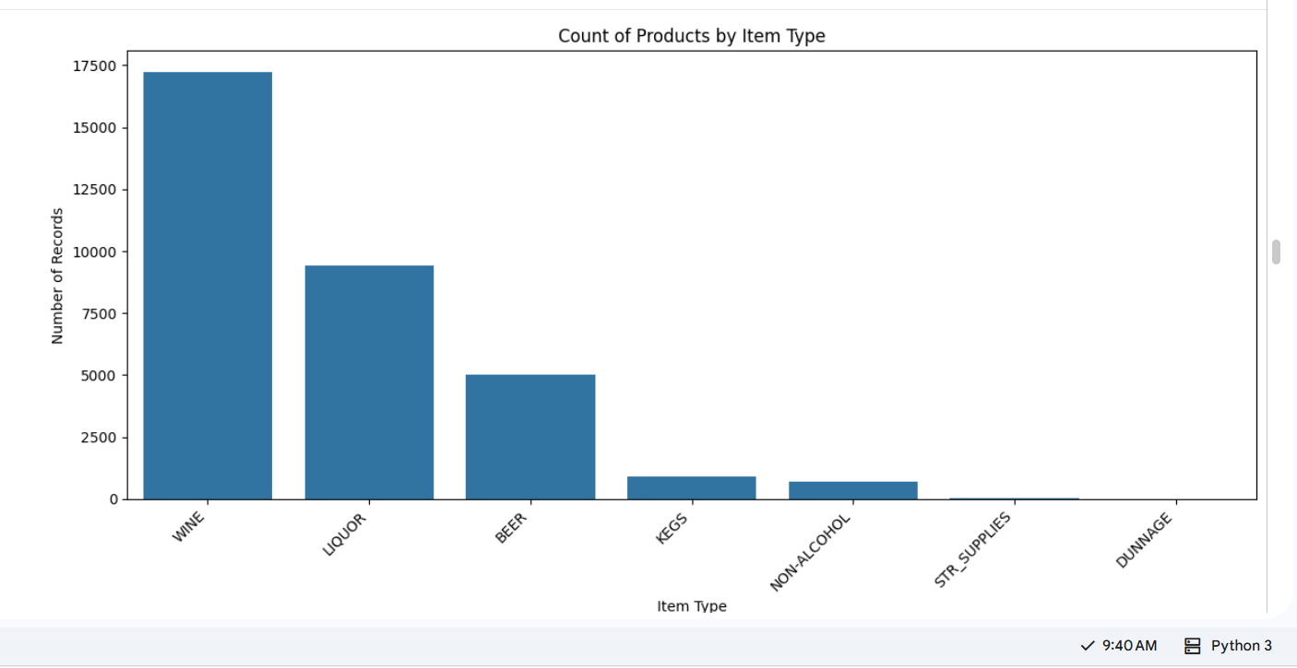
The item type analysis helps understand product category distribution and identify which categories have more or fewer records. This information can support inventory planning, product analysis, and category-wise sales strategies.

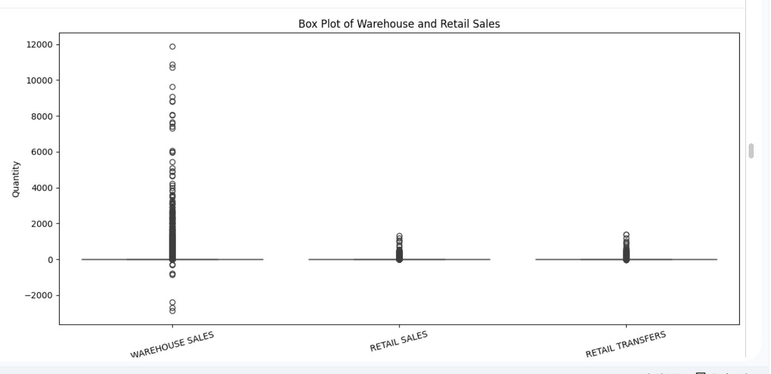

The box plot helps identify variability and potential extreme values in sales-related features. Outlier analysis is important before building regression models because extreme observations can influence model performance.


