**Tasks 1: Database Design:**

**1.Create the database named "TicketBookingSystem"**

CREATE DATABASE TicketBookingSystem;

USE TicketBookingSystem;

**2. Write SQL scripts to create the mentioned tables with appropriate data types, constraints, and relationships.**

**• Venue**

**• Event**

**• Customers**

**• Booking**

**Venue Table:**

CREATE TABLE Venue (

venue_id INT PRIMARY KEY,

venue_name VARCHAR(255),

address VARCHAR(255)

);

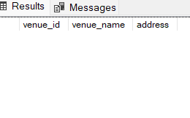

**Event Table:**

CREATE TABLE Event (

event_id INT PRIMARY KEY,

event_name VARCHAR(255),

event_date DATE,

event_time TIME,

venue_id INT,

total_seats INT,

available_seats INT,

ticket_price DECIMAL(10, 2),

event_type VARCHAR(50),

booking_id INT

);

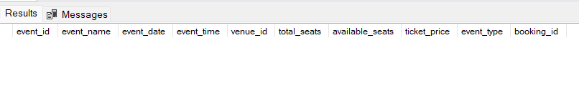

**Customer Table:**

CREATE TABLE Customer (

customer_id INT PRIMARY KEY,

customer_name VARCHAR(255),

email VARCHAR(255),

phone_number VARCHAR(20),

booking_id INT

);

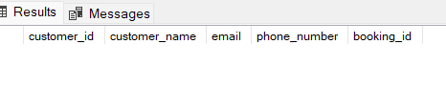

**Booking Table:**

CREATE TABLE Booking (

booking_id INT PRIMARY KEY,

customer_id INT,

event_id INT,

num_tickets INT,

total_cost DECIMAL(10, 2),

booking_date DATE

);

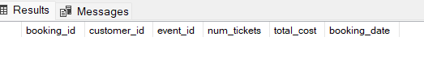

**4. Create appropriate Primary Key and Foreign Key constraints for referential integrity.**

Alter table Event

add venue_id INT

Alter table Event

add booking_id INT

Alter table Customer

add booking_id INT

Alter table booking

add customer_id INT

Alter table booking

add event_id INT

ALTER TABLE Event

add constraint FK_venue_id FOREIGN KEY (venue_id) REFERENCES Venue(venue_id);

ALTER TABLE Event

add constraint FK_booking_id FOREIGN KEY (booking_id) REFERENCES Booking(booking_id);

ALTER TABLE Customer

add constraint FKey_booking_id FOREIGN KEY (booking_id) REFERENCES Booking(booking_id);

ALTER TABLE booking

add constraint FK_customer_id FOREIGN KEY(customer_id) references Customer(customer_id);

ALTER TABLE booking

add constraint FK_event_id FOREIGN KEY(event_id) references Event(event_id);

**Tasks 2: Select, Where, Between, AND, LIKE:**

**1. Write a SQL query to insert at least 10 sample records into each table.**

INSERT INTO Venue (venue_id, venue_name, address) VALUES

(1, 'Delhi', 'Suite 640 1856 Turner Camp, East Harriett, NJ 34953'),

(2, 'Mumbai', 'F-1/10, Sector 10, Vashi'),

(3, 'Hyderabad', '5-1-459/7, Jam Bagh'),

(4, 'Bangalore', '92, 2nd Flr Mosque Road, Frazer Town'),

(5, 'Ahmedabad', 'Opp Spss Hall Nr Aditya Complex, Navrangpura'),

(6, 'Vadodara', '30, Narendra Park Society, Near'),

(7, 'Pune', 'Opp Green Roadways,near Hotel, Orient, Kasba Peth'),

(8, 'Madurai', 'D/g 29-30-31, Sardar Patel Cp, Station Road, Gidc, Ankleshwar'),

(9, 'Trichy', 'ABC Street,Navinagar'),

(10, 'Chennai', '12/13 agenda complex,AnnaNagar');

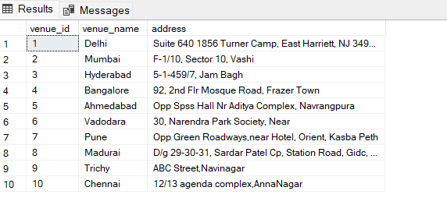

INSERT INTO Event (event_id, event_name, event_date, event_time, total_seats, available_seats, ticket_price, event_type, venue_id,booking_id)

VALUES

(1, 'Fictional', '2023-01-01', '12:00:00', 100, 50, 250.00, 'Movie',1,1),

(2, 'Kabbadi Cup', '2023-02-02', '15:30:00', 1500, 500, 380.00, 'Sports',2,2),

(3, 'Dance Concert', '2023-02-03', '15:00:00', 155, 100, 2000.00, 'Concert',3,3),

(4, 'Horror', '2023-02-04', '11:30:00', 150, 100, 300.00, 'Movie',4,4),

(5, 'singing', '2023-02-05', '12:30:00', 150, 100, 2000.00, 'Concert',5,5),

(6, 'Volleyball', '2023-02-06', '13:30:00', 150, 100, 300.00, 'Sports',6,6),

(7, 'Comics', '2023-02-07', '14:30:00', 150, 100, 200.00, 'Movie',7,7),

(8, 'Music', '2023-02-08', '15:30:00', 1000, 600, 3000.00, 'Concert',8,8),

(9, 'Thriller', '2023-02-09', '16:30:00', 350, 250, 200.00, 'Movie',9,9),

(10, 'Football', '2023-02-10', '17:30:00', 150, 100, 350.00, 'Sports',10,10);

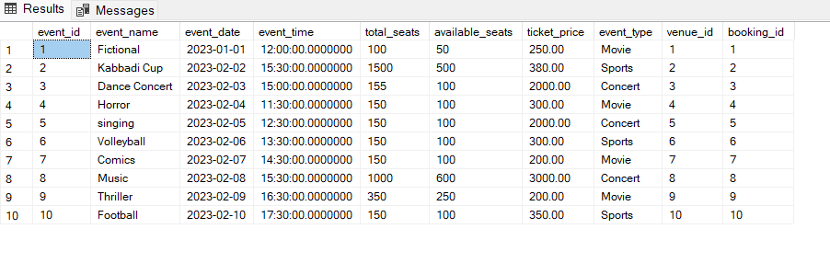

INSERT INTO Customer (customer_id, customer_name, email, phone_number, booking_id) VALUES

(1, 'John', 'john@example.com', '123-456-7890',1),

(2, 'Jane', 'jane@example.com', '987-654-3210',2),

(3, 'Bob', 'bob@example.com', '423-456-7890',3),

(4, 'Alice', 'alice@example.com', '523-456-7890',4),

(5, 'Charlie', 'charlie@example.com', '623-456-7890',5),

(6, 'Eva', 'eva@example.com', '723-456-7890',6),

(7, 'Frank', 'frank@example.com', '823-456-7000',7),

(8, 'Grace', 'grace@example.com', '923-456-7000',8),

(9, 'Henry', 'henry@example.com', '223-456-7000',9),

(10, 'Ivy', 'ivy.@example.com', '323-456-7890',10);

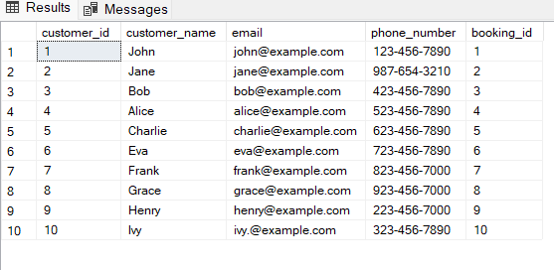

INSERT INTO Booking (booking_id, num_tickets, total_cost, booking_date, customer_id, event_id) VALUES

(1, 2, 4000.00, '2023-01-01 10:00:00',1,1),

(2, 3, 900.00, '2023-02-02 12:30:00',2, 2),

(3, 2, 5550.00, '2023-01-03 09:00:00',3, 3),

(4, 2, 4444.00, '2023-01-04 09:00:00', 4, 4),

(5, 1, 4300.00, '2023-01-05 10:00:00', 5, 5),

(6, 2, 3540.00, '2023-01-06 11:00:00', 6, 6),

(7, 4, 3670.00, '2023-01-07 11:00:00',7, 7),

(8, 2, 2240.00, '2023-01-08 10:00:00', 8, 8),

(9, 3, 4540.00, '2023-01-09 09:00:00',9,9),

(10, 2, 5540.00, '2023-01-10 10:00:00',10, 10);

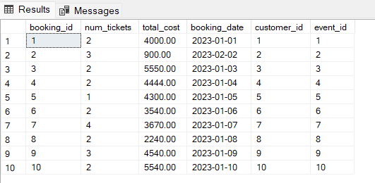

**2. Write a SQL query to list all Events.**

SELECT * FROM Event;



**3. Write a SQL query to select events with available tickets**.

SELECT event_id,event_name,available_seats FROM Event ;

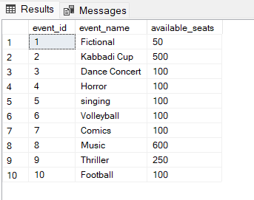

**4. Write a SQL query to select events name partial match with ‘cup’.**

SELECT * FROM Event

WHERE event_name LIKE '%cup%';

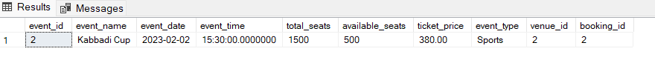

**5. Write a SQL query to select events with ticket price range is between 1000 to 2500**

SELECT * FROM Event

WHERE ticket_price BETWEEN 1000 AND 2500;

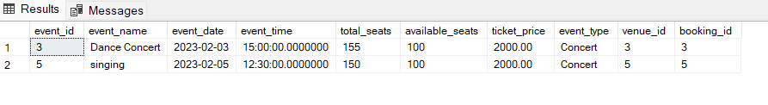

**6. Write a SQL query to retrieve events with dates falling within a specific range.**

SELECT * FROM Event

WHERE event_date BETWEEN '2023-01-01' AND '2023-12-31';

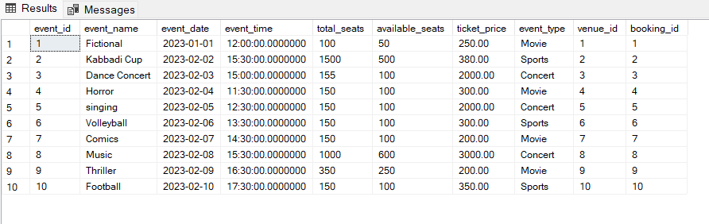

**7. Write a SQL query to retrieve events with available tickets that also have "Concert" in their name.**

SELECT * FROM Event

WHERE available_seats > 0 AND event_name LIKE '%Concert%';

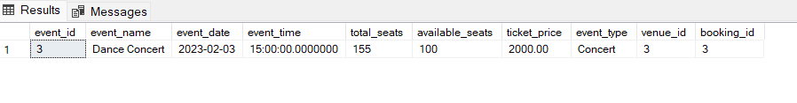

**8. Write a SQL query to retrieve users in batches of 5, starting from the 6th user.**

SELECT customer_id, customer_name, email, phone_number

FROM Customer

ORDER BY customer_id

OFFSET 5 ROWS

FETCH NEXT 5 ROWS ONLY;

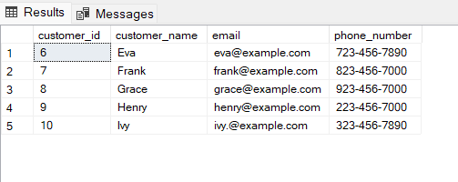

**9. Write a SQL query to retrieve bookings details contains booked no of ticket more than 4.**

SELECT * FROM Booking

WHERE num_tickets > =4;

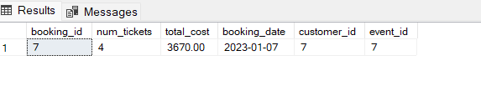

**10. Write a SQL query to retrieve customer information whose phone number end with ‘000’**

SELECT * FROM Customer

WHERE phone_number LIKE '%000';

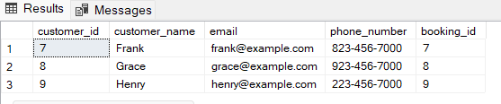

**11. Write a SQL query to retrieve the events in order whose seat capacity more than 15000.**

SELECT * FROM Event

WHERE total_seats > 150

ORDER BY total_seats;

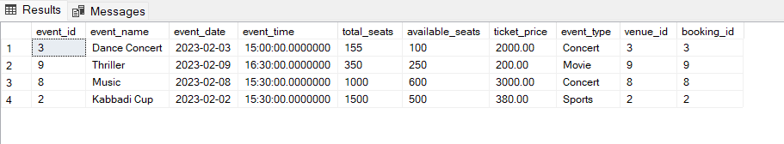

**12. Write a SQL query to select events name not start with ‘x’, ‘y’, ‘z’**

SELECT * FROM Event

WHERE event_name NOT LIKE 'x%' AND event_name NOT LIKE 'y%' AND event_name NOT LIKE 'v%';

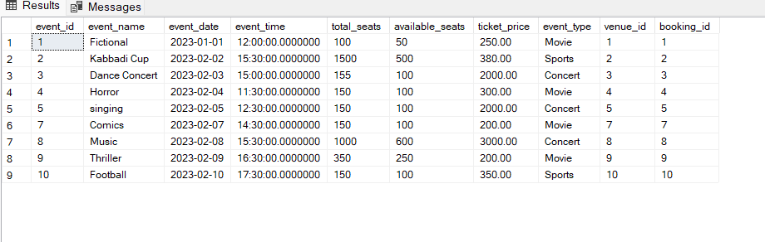

**TASK 3: Aggregate functions, Group By and Joins:**

**1. Write a SQL query to List Events and Their Average Ticket Prices**

SELECT e.event_id, e.event_name, AVG(e.ticket_price) AS average_ticket_price

FROM Event e

GROUP BY e.event_id, e.event_name;

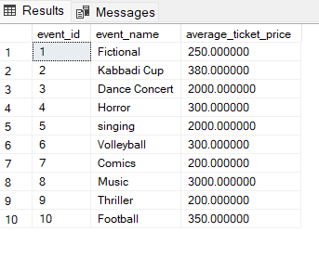

**2. Write a SQL query to Calculate the Total Revenue Generated by Events**.

SELECT SUM(B.total_cost) AS total_revenue FROM Booking B;

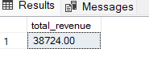

**3. Write a SQL query to find the event with the highest ticket sales.**

SELECT TOP 1 E.event_id,E.event_name,SUM(B.num_tickets) AS total_tickets_sold

FROM Event E

JOIN Booking B ON E.event_id = B.event_id

GROUP BY E.event_id, E.event_name

ORDER BY total_tickets_sold DESC;

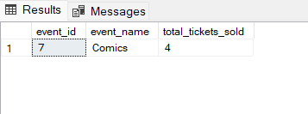

**4. Write a SQL query to Calculate the Total Number of Tickets Sold for Each Event.**

SELECT E.event_id, E.event_name, SUM(B.num_tickets) AS total_tickets_sold

FROM Event E

JOIN Booking B ON E.event_id = B.event_id

GROUP BY E.event_id, E.event_name;

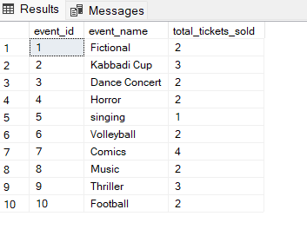

**5. Write a SQL query to Find Events with No Ticket Sales.**

SELECT e.event_id, e.event_name

FROM Event e

LEFT JOIN Booking b ON e.event_id = b.event_id

WHERE b.event_id IS NULL;

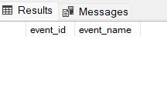

**6. Write a SQL query to Find the User Who Has Booked the Most Tickets**

SELECT TOP 1 c.customer_id, c.customer_name, SUM(b.num_tickets) AS total_tickets_booked

FROM Customer c

JOIN Booking b ON c.booking_id = b.booking_id

GROUP BY c.customer_id, c.customer_name

ORDER BY total_tickets_booked DESC;

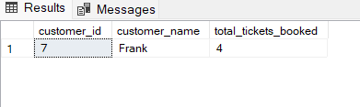

**7. Write a SQL query to List Events and the total number of tickets sold for each month.**

SELECT E.event_id,E.event_name,MONTH(B.booking_date) AS booking_month,SUM(B.num_tickets) AS total_tickets_sold

FROM Event E JOIN Booking B ON E.event_id = B.event_id

GROUP BY E.event_id, E.event_name, MONTH(booking_date)

ORDER BY booking_month, E.event_id;

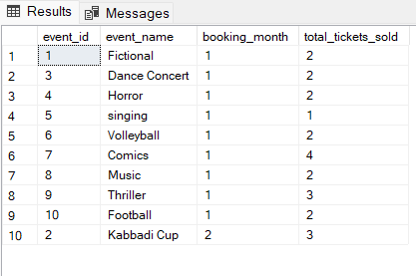

**8. Write a SQL query to calculate the average Ticket Price for Events in Each Venue**

SELECT V.venue_id, V.venue_name, AVG(E.ticket_price) AS average_ticket_price FROM Venue V

JOIN Event E ON V.venue_id = E.venue_id

GROUP BY V.venue_id, V.venue_name;

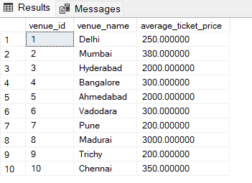

**9. Write a SQL query to calculate the total Number of Tickets Sold for Each Event Type.**

SELECT e.event_type, SUM(b.num_tickets) AS total_tickets_sold FROM Event e

JOIN Booking b ON e.event_id = b.event_id

GROUP BY e.event_type;

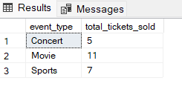

**10. Write a SQL query to calculate the total Revenue Generated by Events in Each Year.**

SELECT YEAR(B.booking_date) AS booking_year, SUM(B.total_cost) AS total_revenue

FROM Booking B

GROUP BY YEAR(B.booking_date)

ORDER BY booking_year;

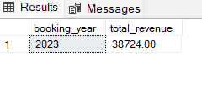

**11. List users who have booked tickets for multiple events:**

SELECT c.customer_id, c.customer_name, COUNT( b.event_id) AS num_events_booked

FROM Customer c

JOIN Booking b ON c.booking_id = b.booking_id

GROUP BY c.customer_id, c.customer_name

HAVING COUNT( b.event_id) > 1;

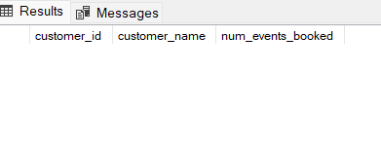

**12. Calculate the Total Revenue Generated by Events for Each User:**

select c.customer_id,c.customer_name, SUM(b.total_cost) as total_revenue from Customer c join Booking b on c.customer_id = b.customer_id group by c.customer_id, c.customer_name;

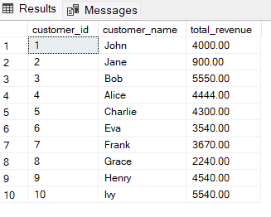

**13. Calculate the Average Ticket Price for Events in Each Category and Venue:**

SELECT e.event_type, v.venue_name, AVG(e.ticket_price) AS average_ticket_price

FROM Event e

JOIN Venue v ON e.venue_id = v.venue_id

GROUP BY e.event_type, v.venue_name;

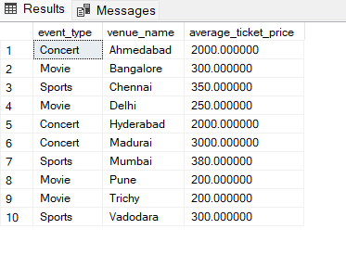

**14. List Users and the Total Number of Tickets They've Purchased in the Last 30 Days:**

SELECT c.customer_id, c.customer_name, COUNT(b.booking_id) AS total_tickets_purchased

FROM Customer c

JOIN Booking b ON c.booking_id = b.booking_id

WHERE b.booking_date >= DATEADD(DAY,-30,GETDATE())

GROUP BY c.customer_id, c.customer_name;

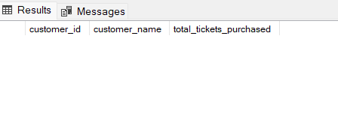

**TASK 4 – Subquery and its Types**

**1. Calculate the Average Ticket Price for Events in Each Venue Using a Subquery**.

SELECT v.venue_id, v.venue_name,

(SELECT AVG(e.ticket_price) FROM Event e WHERE e.venue_id = v.venue_id) AS average_ticket_price

FROM Venue v;

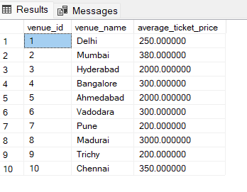

**2. Find Events with More Than 50% of Tickets Sold using subquery.**

SELECT e.event_id,e.event_name,e.total_seats,available_seats,ticket_price,event_type FROM Event e

WHERE (SELECT SUM(num_tickets) FROM Booking b WHERE b.event_id = e.event_id) > 0.5 * e.total_seats;

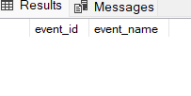

**3. Calculate the Total Number of Tickets Sold for Each Event.**

SELECT e.event_id, e.event_name,

(SELECT SUM(b.num_tickets) FROM Booking b WHERE b.event_id = e.event_id) AS total_tickets_sold

FROM Event e;

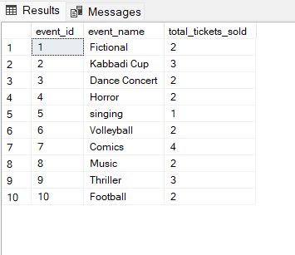

**4. Find Users Who Have Not Booked Any Tickets Using a NOT EXISTS Subquery.**

SELECT c.customer_id, c.customer_name FROM Customer c

WHERE NOT EXISTS ( SELECT 1 FROM Booking b WHERE c.booking_id = b.booking_id );

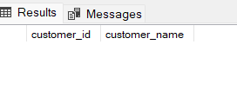

**5. List Events with No Ticket Sales Using a NOT IN Subquery**

SELECT e.event_id, e.event_name

FROM Event e

WHERE e.event_id NOT IN (SELECT DISTINCT event_id FROM Booking b);

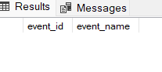

**6. Calculate the Total Number of Tickets Sold for Each Event Type Using a Subquery in the FROM Clause.**

SELECT

e.event_type,

SUM(b.num_tickets) AS total_tickets_sold

FROM

(SELECT

event_id,

event_type

FROM

Event) e

JOIN

Booking b ON e.event_id = b.event_id

GROUP BY

e.event_type;

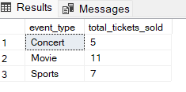

**7. Find Events with Ticket Prices Higher Than the Average Ticket Price Using a Subquery in the WHERE Clause.**

SELECT event_id, event_name, ticket_price FROM Event

WHERE ticket_price > ( SELECT AVG(ticket_price) FROM Event );

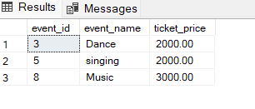

**8. Calculate the Total Revenue Generated by Events for Each User Using a Correlated Subquery.**

SELECT

c.customer_id,

c.customer_name,

(

SELECT

SUM(b.total_cost)

FROM

Booking b

WHERE

b.customer_id = c.customer_id

) AS total_revenue_generated

FROM

Customer c;

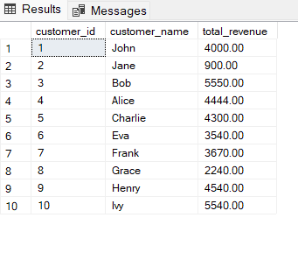

**9. List Users Who Have Booked Tickets for Events in a Given Venue Using a Subquery in the WHERE Clause**.

SELECT customer_id, customer_name

FROM Customer

WHERE customer_id IN (SELECT DISTINCT customer_id FROM Booking WHERE event_id IN (SELECT event_id FROM Event WHERE venue_id = 1));

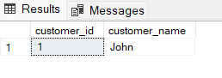

**10. Calculate the Total Number of Tickets Sold for Each Event Category Using a Subquery with GROUP BY**.

SELECT event_type, SUM(total_tickets_sold) AS total_tickets_sold

FROM (

SELECT event_id, event_type,

(SELECT SUM(num_tickets) FROM Booking WHERE Booking.event_id = Event.event_id) AS total_tickets_sold

FROM Event

) AS Subquery

GROUP BY event_type;

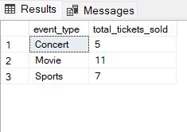

**11. Find Users Who Have Booked Tickets for Events in a Given Month Using a Subquery with DATE_FORMAT.**

SELECT

c.customer_id,

c.customer_name,

FORMAT(booking_date, 'MM-yyyy') AS booking_month

FROM

Customer c

JOIN

Booking b ON c.customer_id = b.customer_id

GROUP BY

c.customer_id, c.customer_name, FORMAT(booking_date, 'MM-yyyy');

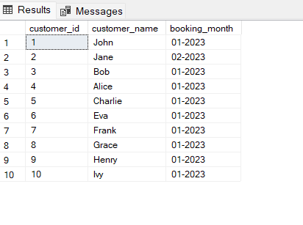

**12. Calculate the Average Ticket Price for Events in Each Venue Using a Subquery**

SELECT v.venue_id, v.venue_name,

(SELECT AVG(e.ticket_price) FROM Event e WHERE e.venue_id = v.venue_id) AS average_ticket_price

FROM Venue v;

