|  |  |
| --- | --- |
| EX : 2. | PROGRAM FOR IMPLEMENTATION OF SINGLY LINKED LIST |
| DATE: |

**AIM:**

To write the program for implementation of singly linked list.

**PROGRAM**:

#include<stdio.h>

#define maxsize 10

int list[max];

void insert();

void delete();

void search();

int main()

{

int n,choice;

do

{

printf("enter the number of elements in the list:");

scanf("%d",&n);

printf("1.insert\n 2.delete\n 3.search");

scanf("%d",&choice);

switch(choice)

{

case 1:

inser();

break;

case 2:

delete();

break;

case 3:

search();

break;

}

}

while(choice!=0);

return 0;

}

void insert()

{

int i, data, pos;

printf("\nEnter the array elements:\t");

for(i=0;i<n;i++)

{

scanf("%d",&list[i]);

}

printf("\nEnter the data to be inserted:");

scanf("%d",&data);

printf("\nEnter the position at which element to be inserted:");

scanf("%d",&pos);

if(pos==n)

printf("Array overflow");

for(i=n; i>=pos; i--)

{

list[i+1]=list[i];

}

list[pos]=data;

n=n+1;

printf("Array elements in the list:");

for(i=0;i<n;i++)

{

printf("%d ",list[i]);

}

return 0;

}

void delete ()

{

int i, data, pos,n;

printf("\nEnter the array elements:\t");

for(i=0;i<n;i++)

{

scanf("%d",&list[i]);

}

printf("\nEnter the position to be deleted:");

scanf("%d",&pos);

printf("\nDeleted data is %d",list[pos-1]);

for(i=pos-1;i<n-1;i++)

{

list[i]=list[i+1];

}

n=n-1;

printf("\nArray elements in the list:");

for(i=0;i<n;i++)

{

printf("%d ",list[i]);

}

return 0;

}

void search()

{

int n,i, search, count=0;

printf("\nEnter the array elements:\t");

for(i=0;i<n;i++)

{

scanf("%d",&list[i]);

}

printf("\nEnter the elements to be searched:");

scanf("%d",&search);

for(i=0;i<n;i++)

{

if(search == list[i])

count++;

}

if(count==0)

printf("\nElement not present in the list");

else

printf("\nElement present in the test");

}

**OUTPUT:**

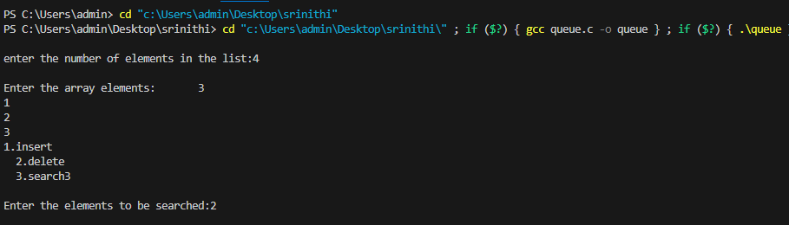

**RESULT**:

Thus, the the Program to **implement linked list has been executed and the output is verified.**