**HAZARDS**

Hazards are unwanted switching transients that may appear at the output of a circuit because different paths exhibit different propagation delays.

Hazards occur in combinational circuits, where they may cause a temporary false-output value. When this condition occurs in asynchronous sequential circuits, it may result in a transition to a wrong stable state.

**Hazards in Combinational Circuits**

**The following circuit demonstrates the occurrence of a hazard:**

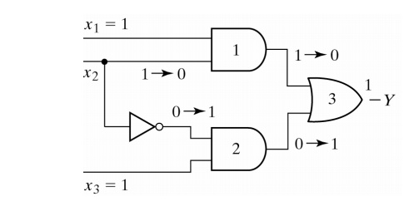

Assume that all three inputs are initially equal to 1. Then consider a change of x2 from 1 to 0. The output momentarily may go to 0 if the propagation through the inverter is taken into account.

The circuit implements the Boolean function in  sum-of-products

Y = x1x2 + x2’ x3

This type of implementation may cause the output to go to 0 when it should remain a 1. This is known as a **static 1-hazard**:



If the circuit was implemented in product-of-sums, namely:

Y = (x1 + x2’ )(x2 + x3 )

Then the output may momentarily go to 1 when it should remain 0. This is referred to as a **static 0-hazard**:

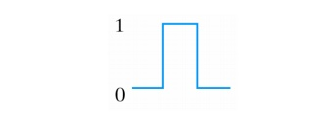

A third type of hazard, known as **dynamic hazard** causes the output to change 2 or 3 time when it should be change from 1 to 0 or 0 to 1:

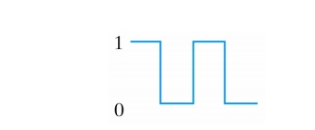

The occurrence of the hazard can be detected by inspecting the map of the particular circuit:

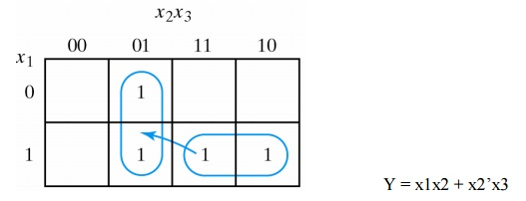

Y = x1x2 + x2’x3

The remedy for eliminating a hazard is to enclose the two minterms in question with another product term that overlaps both groupings:

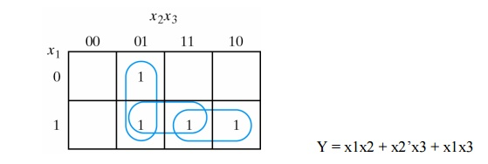

Y = x1x2 + x2’x3 + x1x3

**The hazard-free circuit is:**

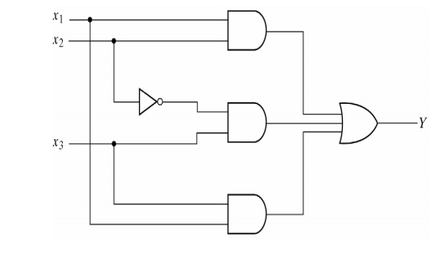

**Hazards in Sequential Circuits**

**Consider the following asynchronous sequential circuit:**

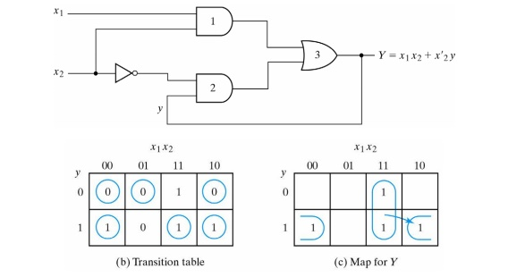

If the circuit is in total state yx1x2 = 111 and input x2 changes from 1 to 0, the next total state should be 110. However, because of the hazard, output Y may go 0 momentarily.

If this false signal feeds back into gate 2 before the output of the inverter goes to 1, the output of gate 2 will remain at 0 and the circuit will switch to the incorrect total state 010.

This can be eliminated by adding an extra gate.

**Essential Hazards**

An essential hazard is the result of the effects of a single input variable change reaching one feedback path before another feedback path.

Essential hazards cannot be corrected by adding redundant gates as in static hazards.

They can always be eliminated in a realization by the insertion of sufficient delays in the feedback paths. Facility in doing this comes only with experience.

Hazards are unwanted switching transients that may appear at the output of a circuit because different paths exhibit different propagation delays. • Hazards occur in combinational circuits, where they may cause a temporary false-output value. • When this condition occurs in asynchronous sequential circuits, it may result in a transition to a wrong stable state. 76 Hazards in Combinational Circuits • A hazard is a condition where a single variable change produces a momentary output change when no output change should occur. • Types of Hazards: Static hazard Dynamic hazard • Static Hazard In digital systems, there are only two possible outputs, a ‘0’ or a ‘1’. The hazard may produce a wrong ‘0’ or a wrong ‘1’. Based on these observations, there are three types, Static- 0 hazard, Static- 1 hazard, Dynamic Hazard 77 • Static- 0 hazard When the output of the circuit is to remain at 0, and a momentary 1 output is possible during the transmission between the two inputs, then the hazard is called a static 0- hazard. 78 • Static- 1 hazard When the output of the circuit is to remain at 1, and a momentary 0 output is possible during the transmission between the two inputs, then the hazard is called a static 1- hazard. 79 80 Circuit with static-1 hazard Circuit with static-0 hazard 81 Maps demonstrating a Hazard and its Removal Hazard-free Circuit • Dynamic Hazard A transient change occurring three or more times at an output terminal of a logic network when the output is supposed to change only once during a transition between two input states differing in the value of one variable. 82 83 Circuit with Dynamic hazard • Essential Hazard • An essential hazard is caused by unequal delays along two or more paths that originate from the same input. An excessive delay through an inverter circuit in comparison to the delay associated with the feedback path may cause such a hazard. • Essential hazards can be eliminated by adjusting the amount of delays in the affected path. To avoid essential hazards, each feedback loop must be handled with individual care to ensure that the delay in the feedback path is long enough compared with delays of other signals that originate from the input terminals. 84 Design of Hazard Free Circuits Design a hazard-free circuit to implement the following function. F (A, B, C, D) = Σm (1, 3, 6, 7, 13, 15) 85 K-map Implementation and grouping F=A’B’D+ A’BC+ ABD • Hazard- free realization 86 F=A’B’D+ A’BC+ ABD+ A’CD+ BCD Design a hazard-free circuit to implement the following function. F (A, B, C, D) = Σm (0, 2, 6, 7, 8, 10, 12). 87 K-map Implementation and grouping F= B’D’+ A’BC+ AC’D’ • Hazard- free realization 88 F= B’D’+ A’BC+ AC’D’+ A’CD’ Design a hazard-free circuit to implement the following function. F (A, B, C, D) = Σm (1, 3, 4, 5, 6, 7, 9, 11, 15). 89 K-map Implementation and grouping F= CD+ A’B+ B’D • Hazard- free realization 90 F= CD+ A’B+ B’D+ A’D End of Unit I