ASSIGNMENT -21.2

Srinithya Koudagani
2303A52034
Batch-38

Task 1 – AI-Assisted Pair Programming
• Use AI to generate an initial program (e.g., a simple To-Do List
Manager).
• Ask AI to suggest enhancements (such as error handling,
additional features, or refactoring).
• Compare the original and improved versions to understand the role
of AI in collaboration.
Prompt:
Generate a simple To-Do List Manager program in Python with basic add, delete, and display features. Then suggest improvements like error handling and additional functionalities.
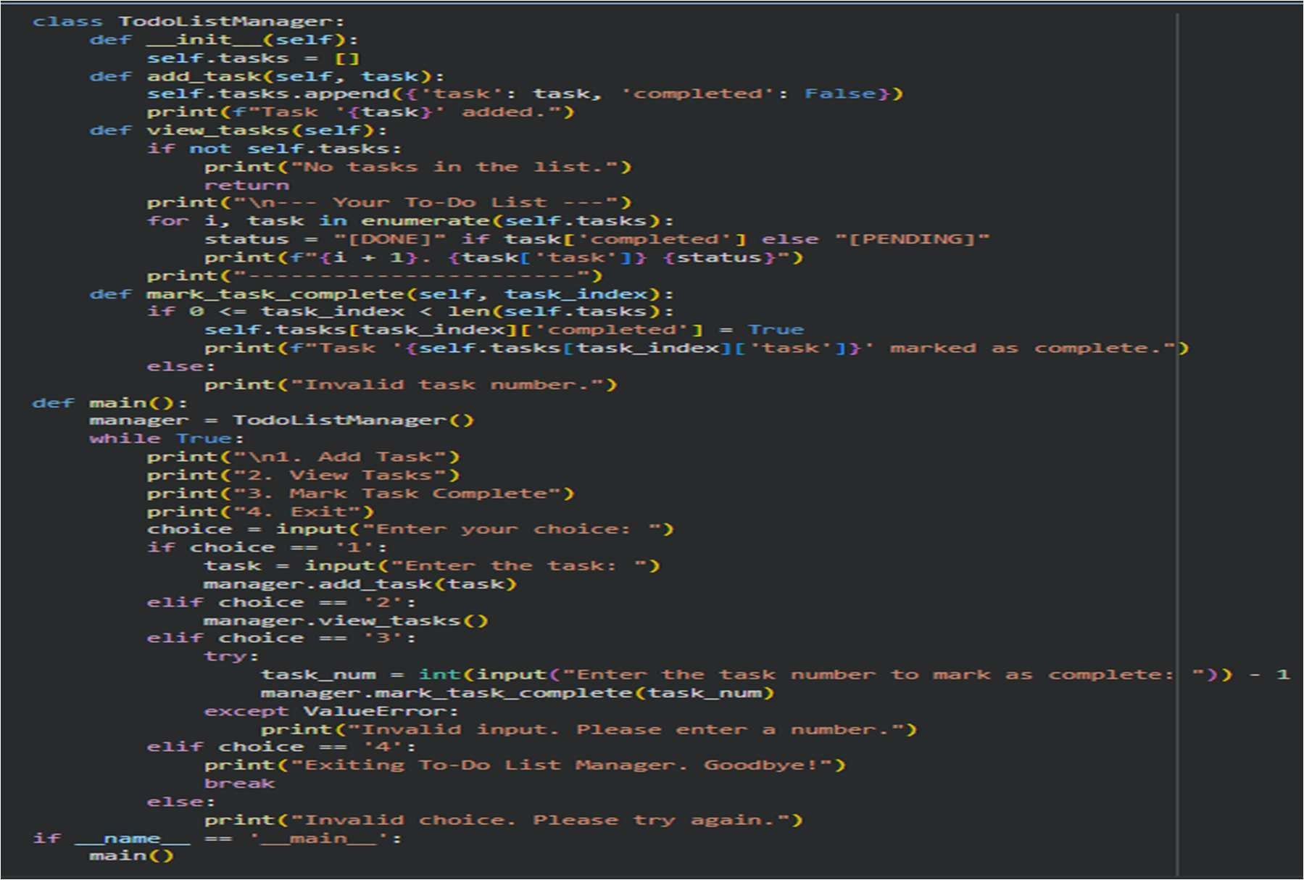
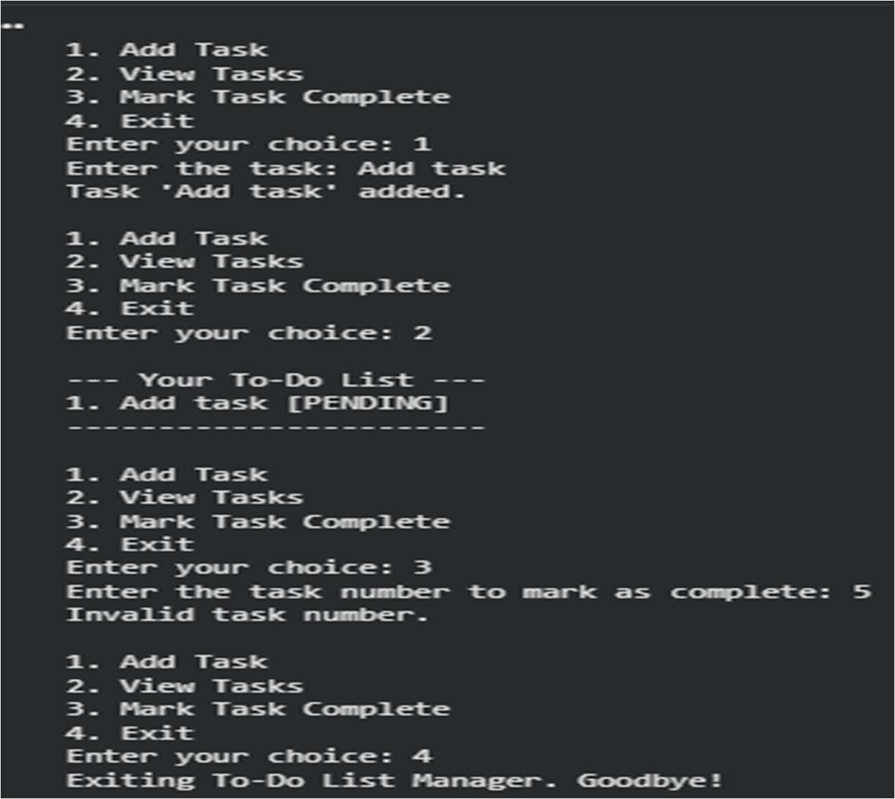
Explanation:
This task shows how AI can help as a coding partner by quickly creating an initial solution. The student then improves the code with the help of AI by adding features like input checking, saving data, and making it easier to use. By comparing both versions, it becomes clear how AI helps improve code quality and efficiency. It also shows how humans and AI can work together to build better solutions. This process helps develop strong problem-solving and coding skills.

Task 2 – Version Control Integration
Initialize a Git repository for your project.
Perform the following steps:
• Create and switch to a new branch.
• Add AI-assisted modifications.
• Commit with a meaningful message.
• Merge changes back into the main branch.
Reflect on how version control supports collaborative development
with AI assistance.
Prompt:
Guide me through initializing a Git repository, creating a new branch, making changes, committing them, and merging back into the main branch.

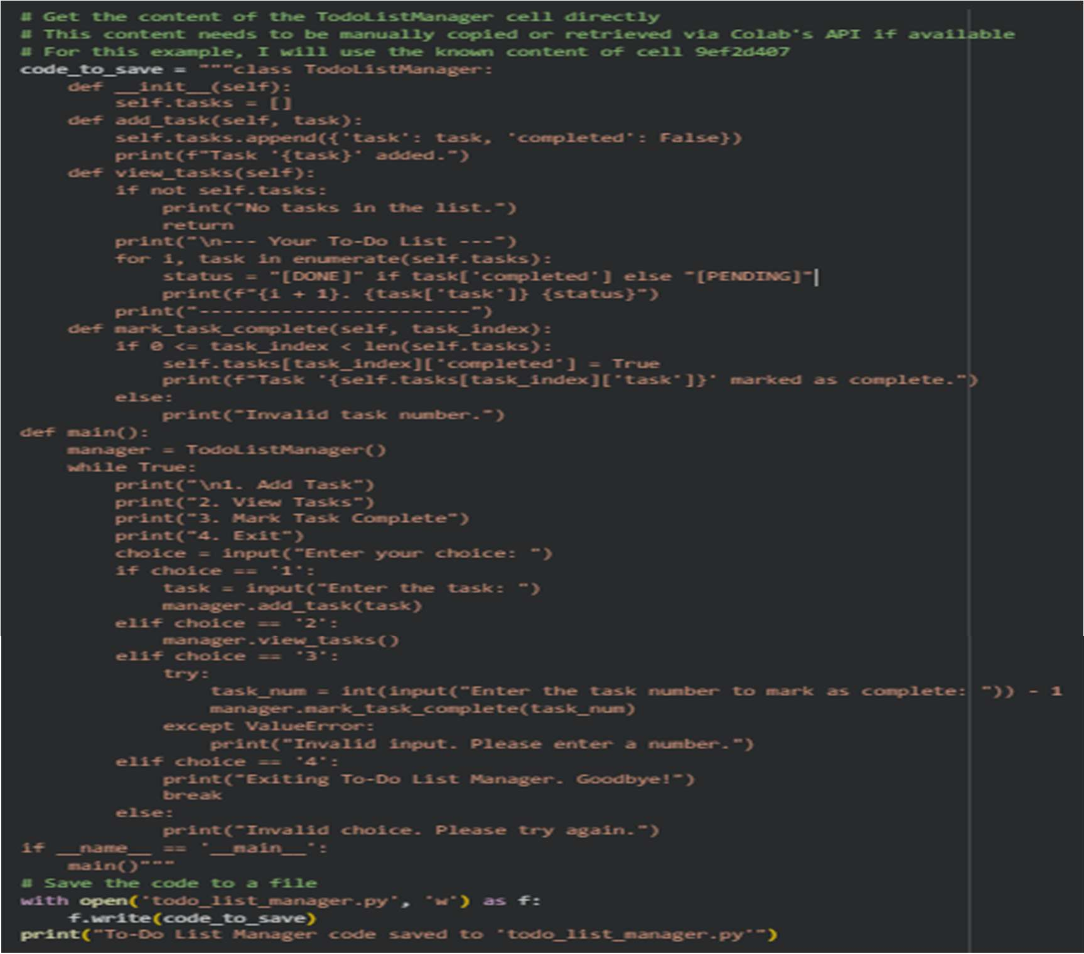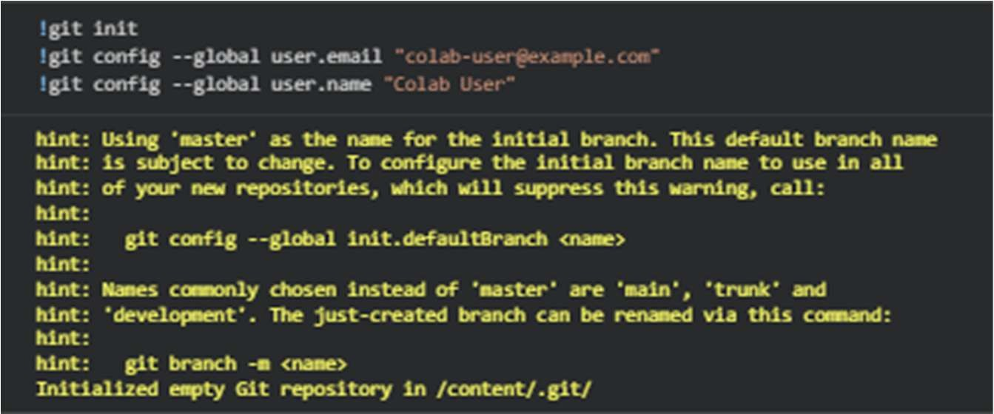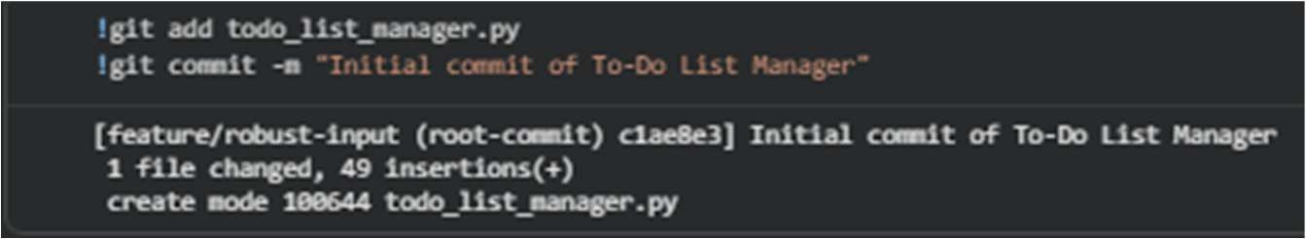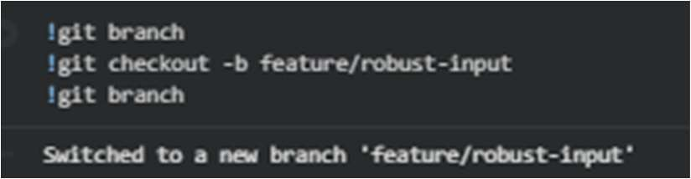
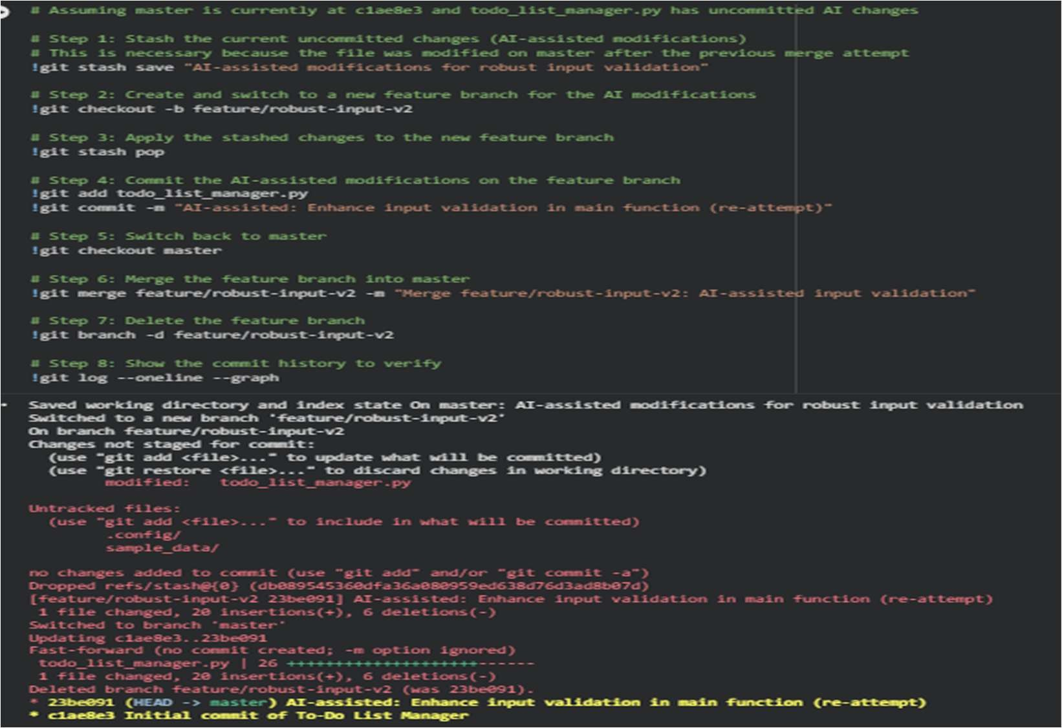
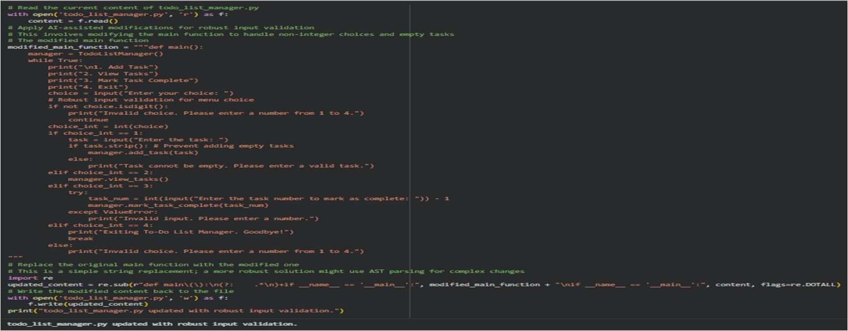
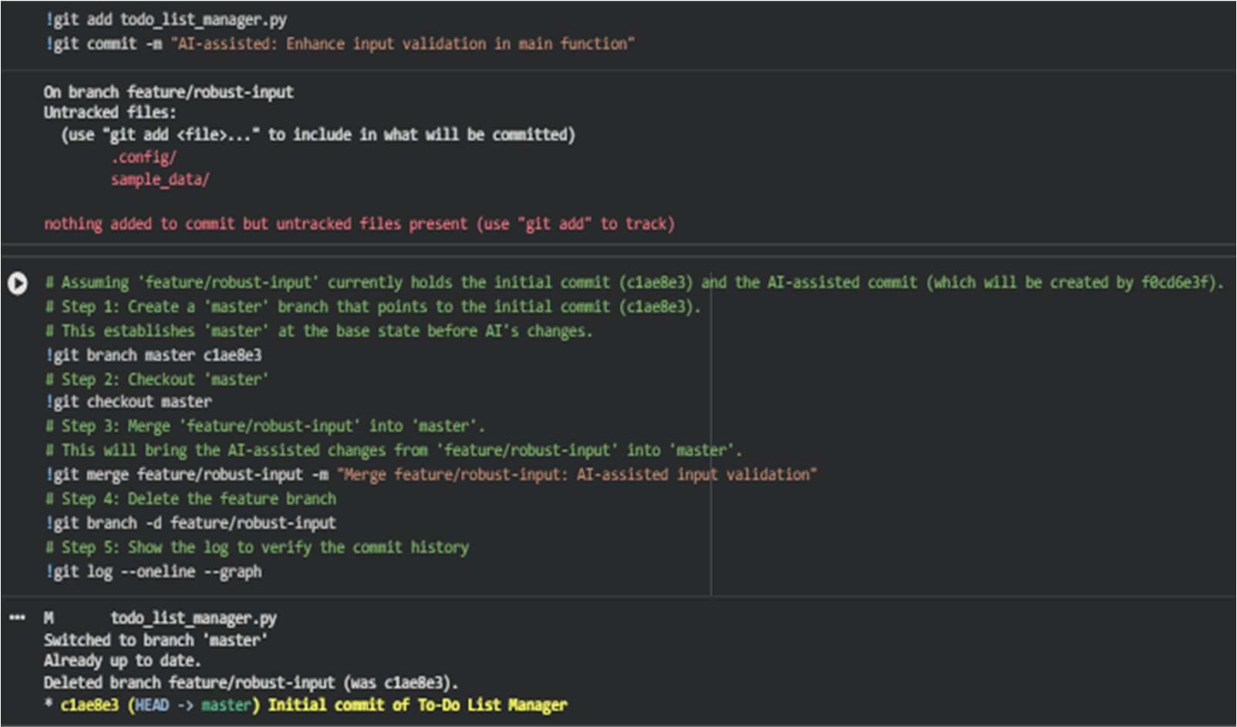
Explanation:
This task is about using Git to manage code changes in an organized way. Instead of editing the main code directly, changes are made in separate branches. AI can help by suggesting useful commands and good practices for saving changes. After that, all updates are merged together carefully to avoid conflicts. This shows how real software teams work together on projects.

Task 3 – AI for Commit Message Generation
• Use AI to generate concise, meaningful commit messages
based on the changes made.
• Compare AI-generated messages with human-written ones.
• Discuss how AI can improve documentation and traceability
in Git history.
Prompt:
Generate clear and concise Git commit messages based on the code changes made, following best practices.
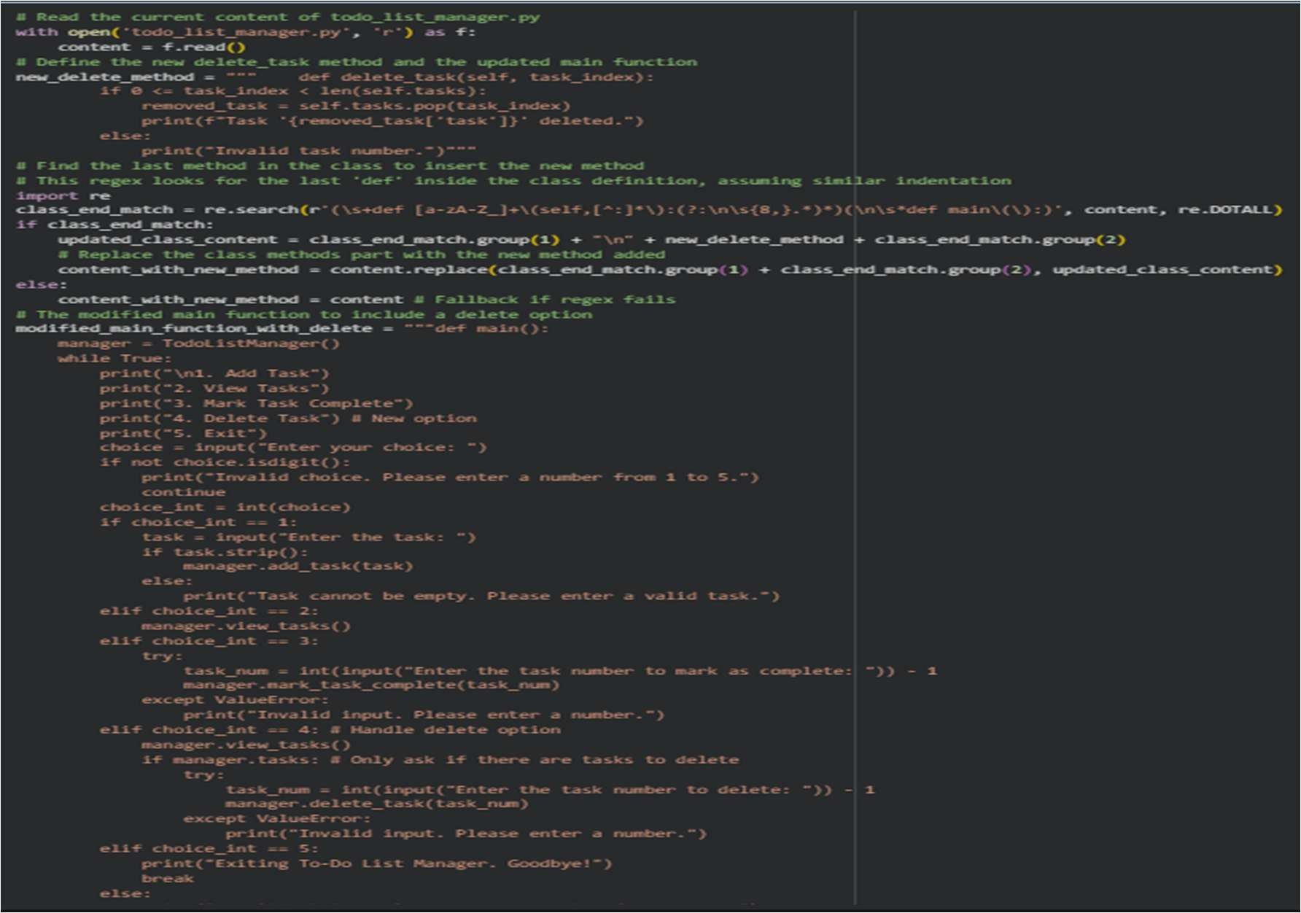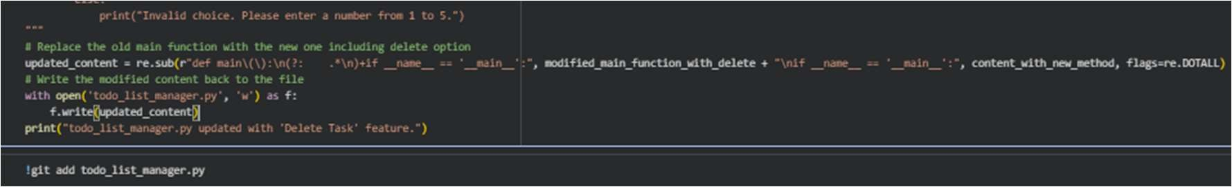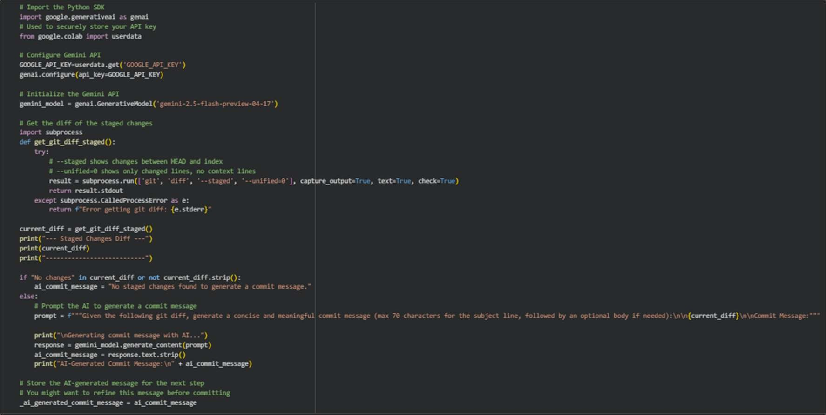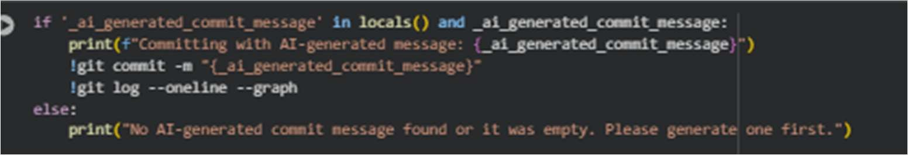
Explanation:
AI helps in automatically writing clear and meaningful commit messages. Good commit messages make it easier to understand changes and track the project history. By comparing AI-generated messages with human-written ones, students learn what makes a good message. AI also helps keep the format consistent and easy to read. This improves documentation and makes teamwork smoother.

Task 4 – Pair Programming Simulation
• Student A writes the initial version of a program.
• Student B, with AI assistance, suggests improvements or adds
features.
• Both students collaborate using Git branching and merging to
integrate their work.
Prompt:
Simulate pair programming where one developer writes initial code and another improves it with AI suggestions, using Git for collaboration.
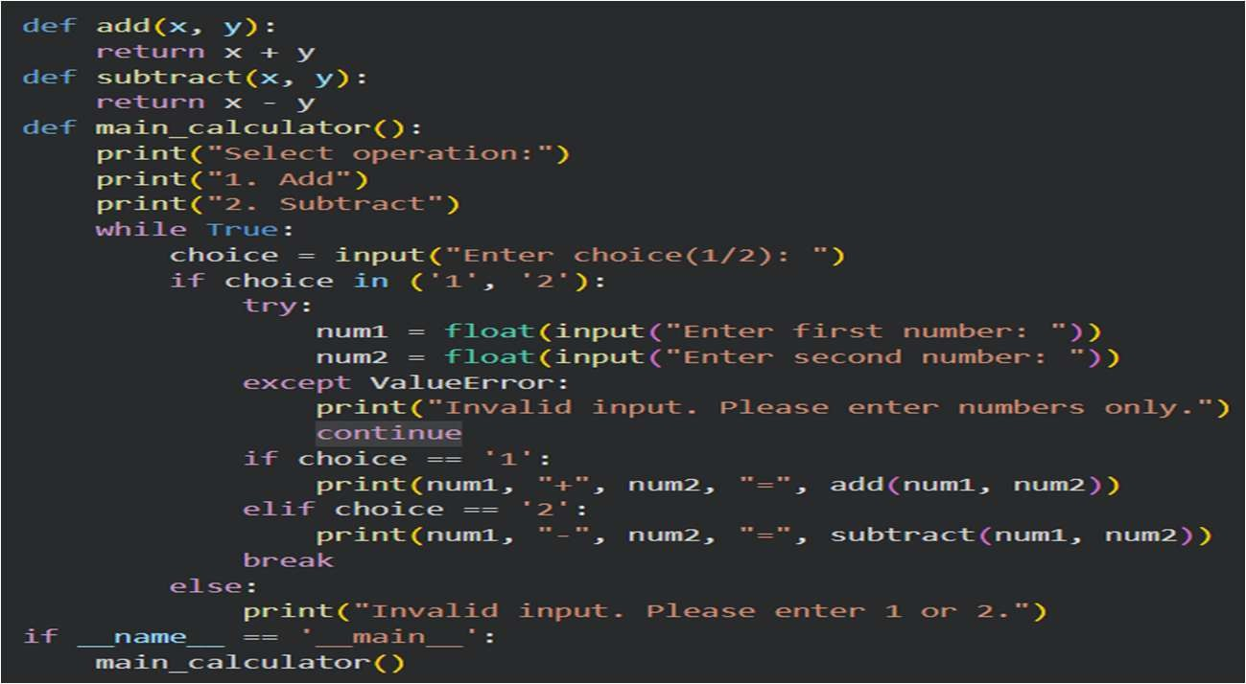
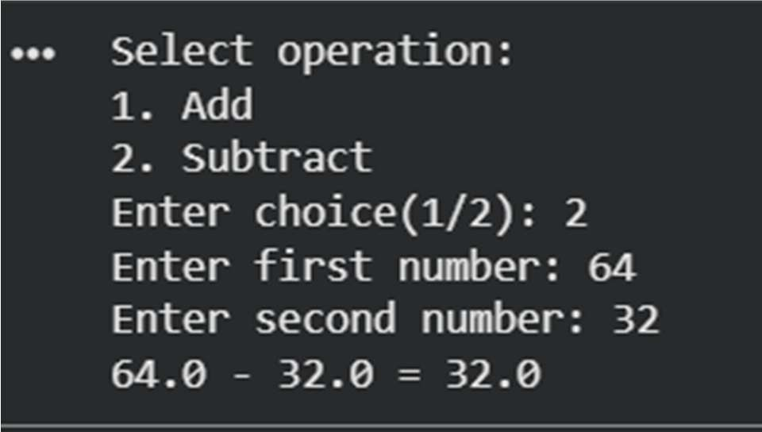
Explanation:
This task is similar to real-world pair programming where two developers work together on the same project. One person writes the basic code, while the other improves it with the help of AI tools. Using Git branches, both can work separately without affecting each other’s code. Later, their work is combined smoothly. This helps improve teamwork, code quality, and problem-solving skills, and shows how AI can assist in collaborative coding.

