ASSIGNMENT – 7.3

Srinithya 2303A52034
Batch – 38

Task 1: Fixing Syntax Errors Scenario
You are reviewing a Python program where a basic function definition contains a syntax error.
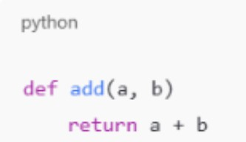
Requirements
- Provide a Python function add(a, b) with a missing colon
- Use an AI tool to detect the syntax error
- Allow AI to correct the function definition
- Observe how AI explains the syntax issue

Expected Output
- Corrected function with proper syntax
- Syntax error resolved successfully
- AI-generated explanation of the fix

OUTPUT:
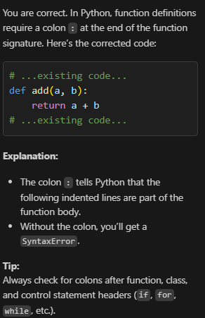



Task 2: Debugging Logic Errors in Loops Scenario
You are debugging a loop that runs infinitely due to a logical mistake.
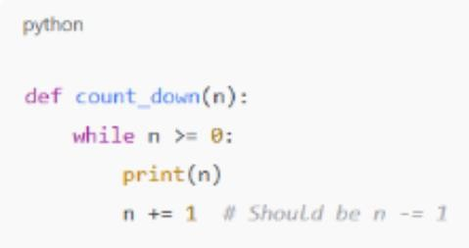
Requirements
- Provide a loop with an increment or decrement error
- Use AI to identify the cause of infinite iteration
- Let AI fix the loop logic
- Analyze the corrected loop behavior

Expected Output
- Infinite loop issue resolved
- Correct increment/decrement logic applied
- AI explanation of the logic error

OUTPUT:
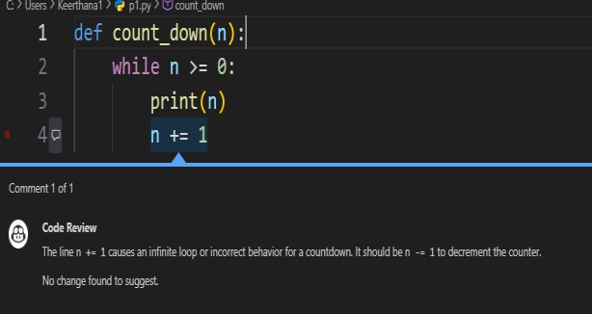
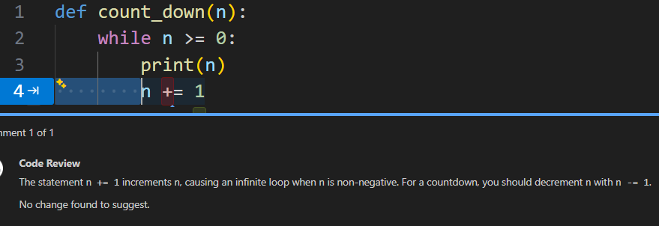

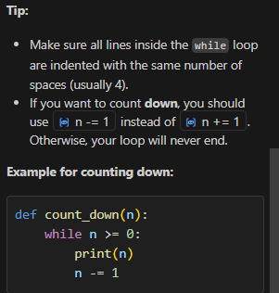

Task 3: Handling Runtime Errors (Division by Zero) Scenario
A Python function crashes during execution due to a division by zero error
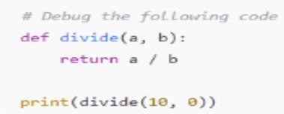
Requirements
- Provide a function that performs division without validation
- Use AI to identify the runtime error
- Let AI add try-except blocks for safe execution
- Review AI’s error-handling approach

Expected Output
- Function executes safely without crashing
- Division by zero handled using try-except
- Clear AI-generated explanation of runtime error handling
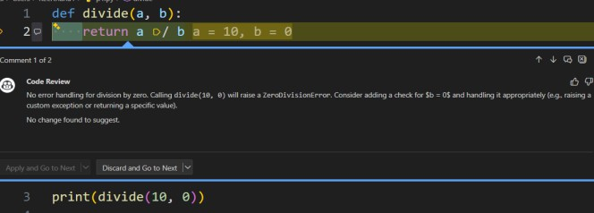

Explanation:
The runtime error occurs when dividing by zero.
Using a try-except block catches the ZeroDivisionError and prevents the program from crashing.

Task 4: Debugging Class Definition Errors
Scenario
You are given a faulty Python class where the constructor is incorrectly defined. Requirements
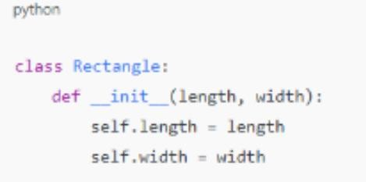
- Provide a class definition with missing self-parameter
- Use AI to identify the issue in the init () method
- Allow AI to correct the class definition
- Understand why self is required

Expected Output
- Corrected init () method
- Proper use of self in class definition
- AI explanation of object-oriented error
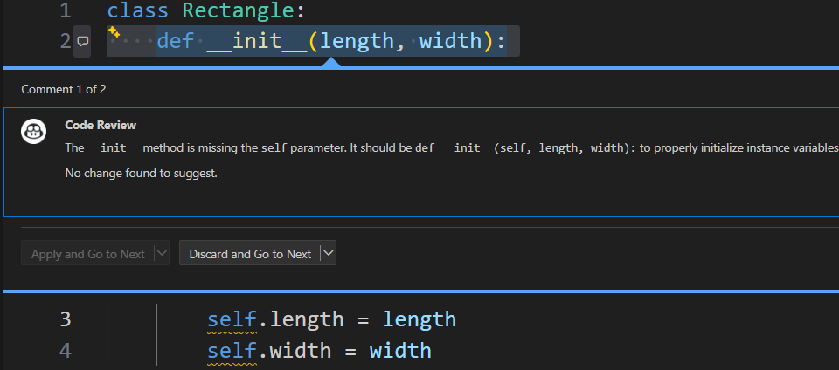

EXPLANATION:
The constructor init was missing the self parameter.
self refers to the current object and is required to store and access instance variables inside a class.

Task 5: Resolving Index Errors in Lists
Scenario
A program crashes when accessing an invalid index in a list. Requirements
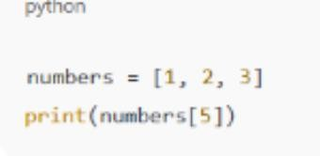
- Provide code that accesses an out-of-range list index
- Use AI to identify the Index Error
- Let AI suggest safe access methods
- Apply bounds checking or exception handling

Expected Output
- Index error resolved
- Safe list access logic implemented
- AI suggestion using length checks or exception handling
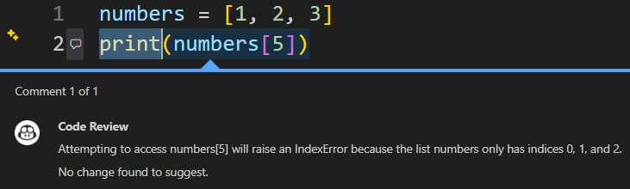
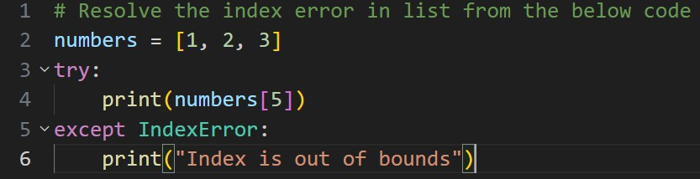

Explanation:
The error occurs because index 5 does not exist in the list.
Using try-except catches the Index Error and prevents the program from crashing.

