## What is Jenkins?

Jenkins is an open source automation tool written in Java programming language that allows continuous integration.

Jenkins **builds** and **tests** our software projects which continuously making it easier for developers to integrate changes to the project, and making it easier for users to obtain a fresh build.

It also allows us to continuously **deliver** our software by integrating with a large number of testing and deployment technologies.

Jenkins offers a straightforward way to set up a continuous integration or continuous delivery environment for almost any combination of languages and source code repositories using pipelines, as well as automating other routine development tasks.

With the help of Jenkins, organizations can speed up the software development process through automation. Jenkins adds development life-cycle processes of all kinds, including build, document, test, package, stage, deploy static analysis and much more.

Jenkins achieves CI (Continuous Integration) with the help of plugins. Plugins is used to allow the integration of various DevOps stages. If you want to integrate a particular tool, you have to install the plugins for that tool. For example: Maven 2 Project, Git, HTML Publisher, Amazon EC2, etc.

**For example:** If any organization is developing a project, then **Jenkins** will continuously test your project builds and show you the errors in early stages of your development.

Possible steps executed by Jenkins are for example:

* Perform a software build using a build system like Gradle or Maven Apache
* Execute a shell script
* Archive a build result
* Running software tests

**Work Flow:**

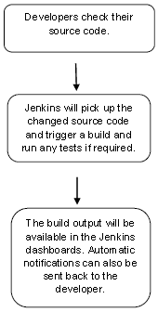

## History of Jenkins

Kohsuke Kawaguchi, who is a Java developer, working at SUN Microsystems, was tired of building the code and fixing errors repetitively. In 2004, he created an automation server called **Hudson** that automates build and test task.

In 2011, Oracle who owned Sun Microsystems had a dispute with Hudson open source community, so they forked Hudson and renamed it as **Jenkins**.

Both Hudson and Jenkins continued to operate independently. But in short span of time, Jenkins acquired a lot of contributors and projects while Hudson remained with only 32 projects. Then with time, Jenkins became more popular, and Hudson is not maintained anymore.

## What is Continuous Integration?

Continuous Integration (CI) is a development practice in which the developers are needs to commit changes to the source code in a shared repository at regular intervals. Every commit made in the repository is then built. This allows the development teams to detect the problems early.

Continuous integration requires the developers to have regular builds. The general practice is that whenever a code commit occurs, a build should be triggered.

## Continuous Integration with Jenkins

Let's consider a scenario where the complete source code of the application was built and then deployed on test server for testing. It sounds like a perfect way to develop software, but this process has many problems.

* Developer teams have to wait till the complete software is developed for the test results.
* There is a high prospect that the test results might show multiple bugs. It was tough for developers to locate those bugs because they have to check the entire source code of the application.
* It slows the software delivery process.
* Continuous feedback pertaining to things like architectural or coding issues, build failures, test status and file release uploads was missing due to which the quality of software can go down.
* The whole process was manual which increases the threat of frequent failure.

It is obvious from the above stated problems that not only the software delivery process became slow but the quality of software also went down. This leads to customer dissatisfaction.

So to overcome such problem there was a need for a system to exist where developers can continuously trigger a build and test for every change made in the source code.

This is what Continuous Integration (CI) is all about. Jenkins is the most mature Continuous Integration tool available so let us see how Continuous Integration with Jenkins overcame the above shortcomings.

Let's see a generic flow diagram of Continuous Integration with Jenkins:

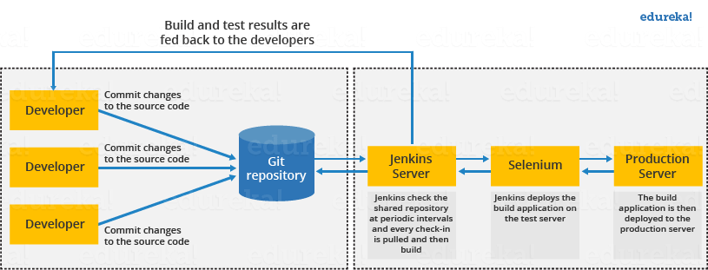

**Let's see how Jenkins works**. The above diagram is representing the following functions:

* First of all, a developer commits the code to the source code repository. Meanwhile, the Jenkins checks the repository at regular intervals for changes.
* Soon after a commit occurs, the Jenkins server finds the changes that have occurred in the source code repository. Jenkins will draw those changes and will start preparing a new build.
* If the build fails, then the concerned team will be notified.
* If built is successful, then Jenkins server deploys the built in the test server.
* After testing, Jenkins server generates a feedback and then notifies the developers about the build and test results.
* It will continue to verify the source code repository for changes made in the source code and the whole process keeps on repeating.

## Advantages and Disadvantages of using Jenkins

**Advantages of Jenkins**

* It is an open source tool.
* It is free of cost.
* It does not require additional installations or components. Means it is easy to install.
* Easily configurable.
* It supports 1000 or more plugins to ease your work. If a plugin does not exist, you can write the script for it and share with community.
* It is built in java and hence it is portable.
* It is platform independent. It is available for all platforms and different operating systems. Like OS X, Windows or Linux.
* Easy support, since it open source and widely used.
* Jenkins also supports cloud based architecture so that we can deploy Jenkins in cloud based platforms.

**Disadvantages of Jenkins**

* Its interface is out dated and not user friendly compared to current user interface trends.
* Not easy to maintain it because it runs on a server and requires some skills as server administrator to monitor its activity.
* CI regularly breaks due to some small setting changes. CI will be paused and therefore requires some developer's team attention.

## Jenkins Architecture

Jenkins follows Master-Slave architecture to manage distributed builds. In this architecture, slave and master communicate through TCP/IP protocol.

Jenkins architecture has two components:

* Jenkins Master/Server
* Jenkins Slave/Node/Build Server

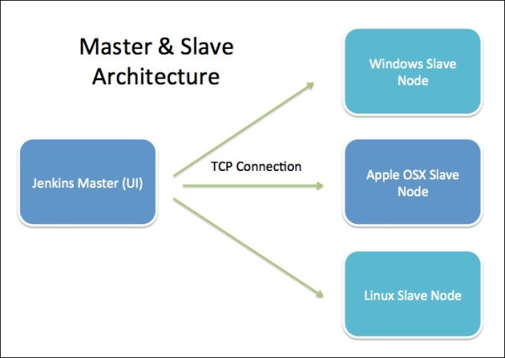

### Jenkins Master

The main server of Jenkins is the Jenkins Master. It is a web dashboard which is nothing but powered from a war file. By default it runs on 8080 port. With the help of Dashboard, we can configure the jobs/projects but the build takes place in Nodes/Slave. By default one node (slave) is configured and running in Jenkins server. We can add more nodes using IP address, user name and password using the ssh, jnlp or webstart methods.

The server's job or master's job is to handle:

* Scheduling build jobs.
* Dispatching builds to the nodes/slaves for the actual execution.
* Monitor the nodes/slaves (possibly taking them online and offline as required).
* Recording and presenting the build results.
* A Master/Server instance of Jenkins can also execute build jobs directly.

### Jenkins Slave

Jenkins slave is used to execute the build jobs dispatched by the master. We can configure a project to always run on a particular slave machine, or particular type of slave machine, or simple let the Jenkins to pick the next available slave/node.

As we know Jenkins is developed using Java is platform independent thus Jenkins Master/Servers and Slave/nodes can be configured in any servers including Linux, Windows, and Mac.

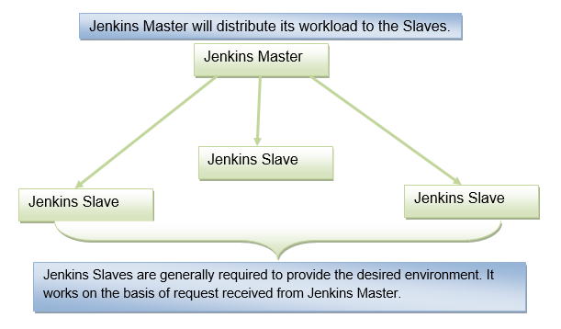

The above diagram is self explanatory. It consists of a Jenkins Master which is managing three Jenkins Slaves.

## Prerequisite

Before learning Jenkins, you should have a basic understanding of testing and Java.

# Installing Jenkins on Windows

## Hardware Requirements

|  |  |
| --- | --- |
| Memory | 2 GB RAM (Recommended) |
| Disk Space | We need at least 1 GB of space in our hard drive for Jenkins |

## Software Requirements

|  |  |
| --- | --- |
| JDK | We need either Java Development (JDK) or Java Runtime Environment (JRE) |
| Operating System | Jenkins can be installed on Windows, Mac OS X, Ubuntu/Debian, Red Hat/Fedora/CentOS, openSUSE, FReeBSD, OpenBSD, Gentoo. |
| Java Container | The WAR (Web Application Resource) file can be run in any container that supports Servlet 2.4/JSP 2.0 or later. (For example Tomcat 5). |

## Release Types

Jenkins supports two types of releases based on the organization needs:

* Long-term support release
* Weekly release

**Long term support release (LTS):** Long-term support releases (LTS) are available every 12 weeks. They are stable and are widely used and tested. Basically, this release is intended for end users.

**Weekly release:** This release is available in every week by fixing bugs in its earlier version. These releases are intended towards plugin developers.

We will use the long term support release (LTS) though the process remains the same for Weekly release.

## Install Java Version 8

Since Jenkins is a Java based application, therefore Java is a must.

To download the Java [Click here](https://www.oracle.com/technetwork/java/javase/downloads/jdk8-downloads-2133151.html" \t "https://www.javatpoint.com/_blank). Select file according to your platform.

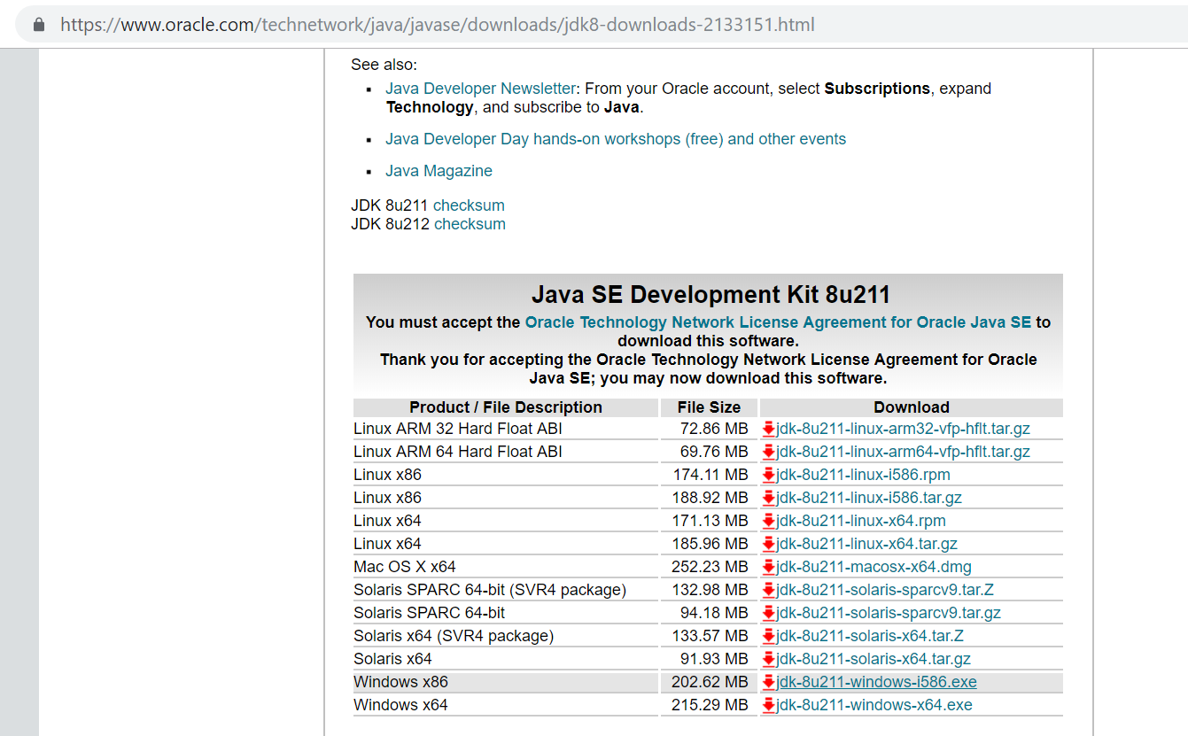

Then install the Java as follows:

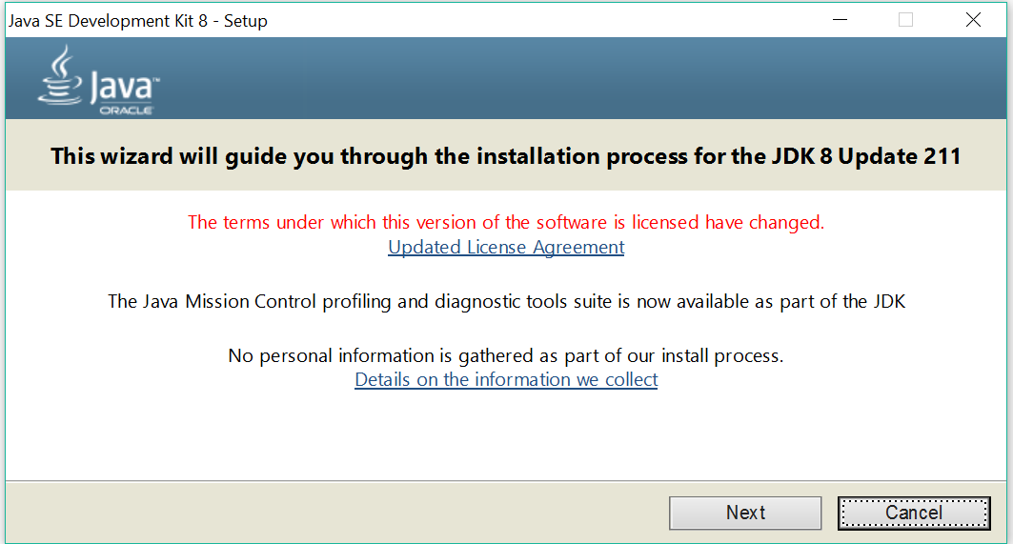  
  
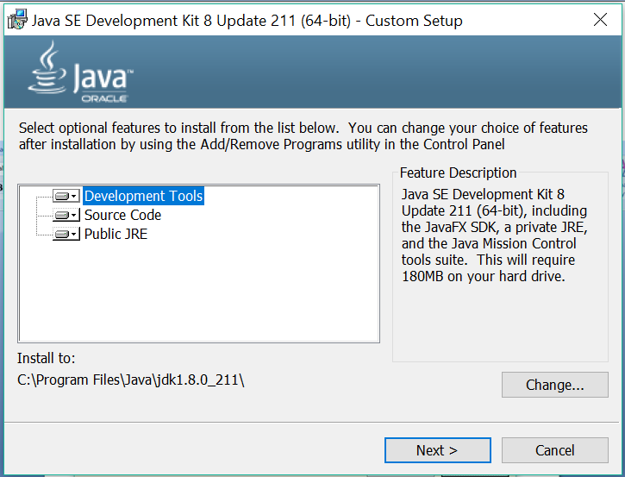  
  
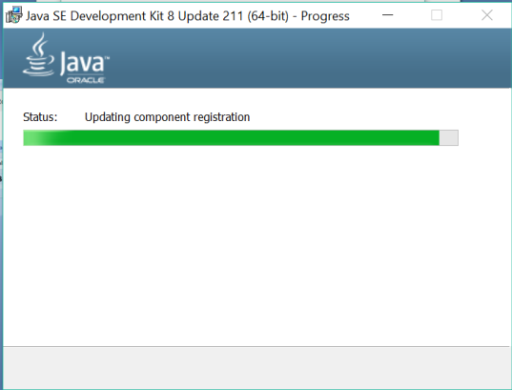  
  
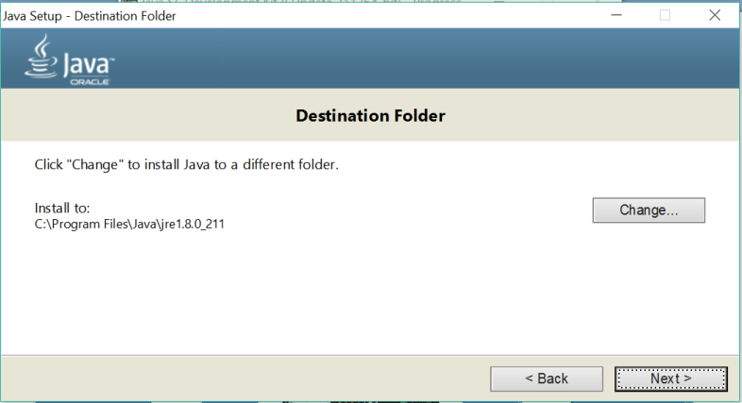  
  
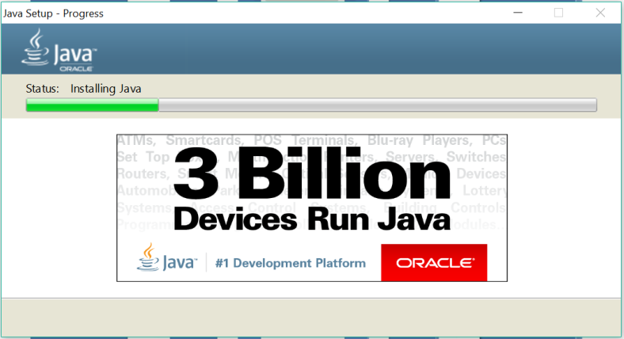  
  
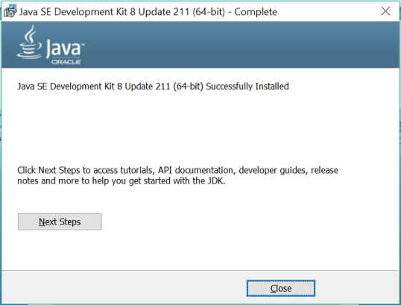

## Download Jenkins war File

This war is required to install Jenkins.

The official website for Jenkins is [https://jenkins.io/](https://jenkins.io/" \t "https://www.javatpoint.com/_blank)

When you click the given link, you will get the home page of the Jenkins official website as given below:

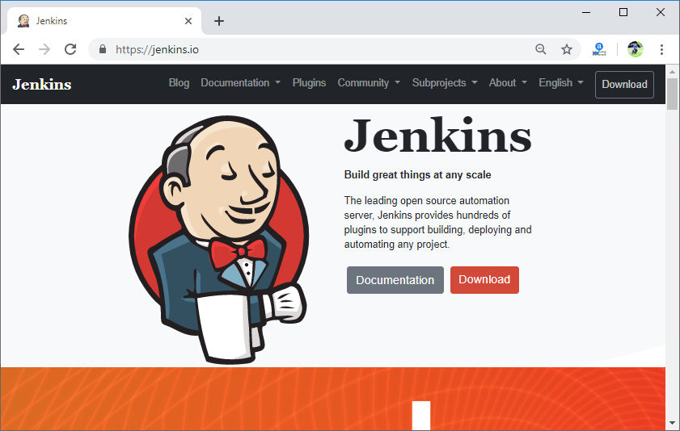

Click on the Download button.

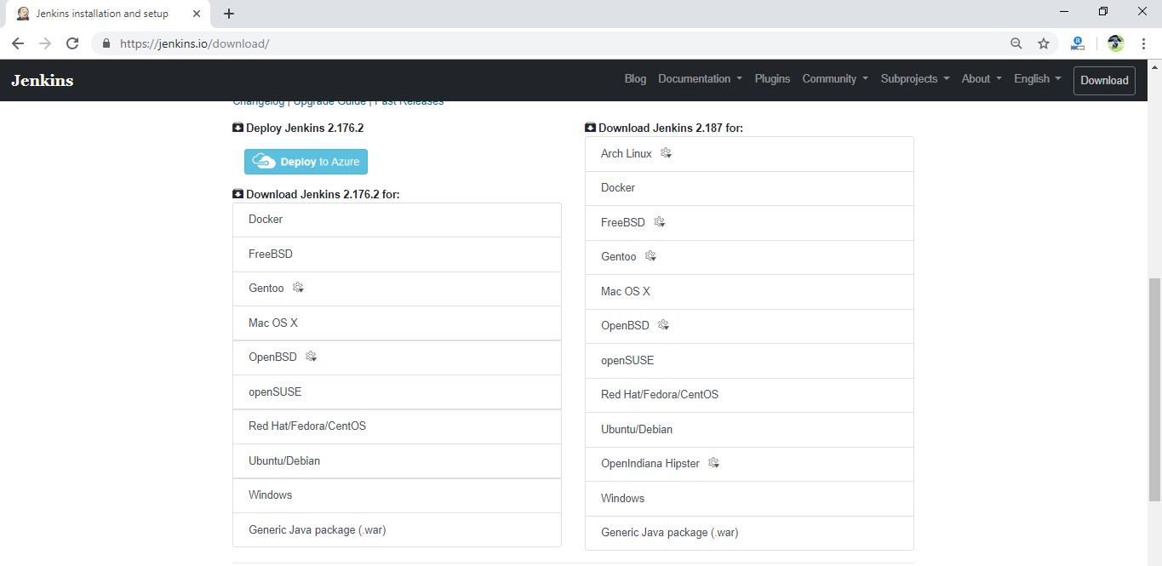

Click on Generic Java Package (.war) to download the Jenkins war file.

## Starting Jenkins

Open the command prompt and go to the directory where the Jenkins.war file is located. And then run the following command:

1. C:/Java -jar Jenkins.war

When you run this command, various tasks will run, one of which is the extraction of the war file which is done by an embedded webserver called winstone.

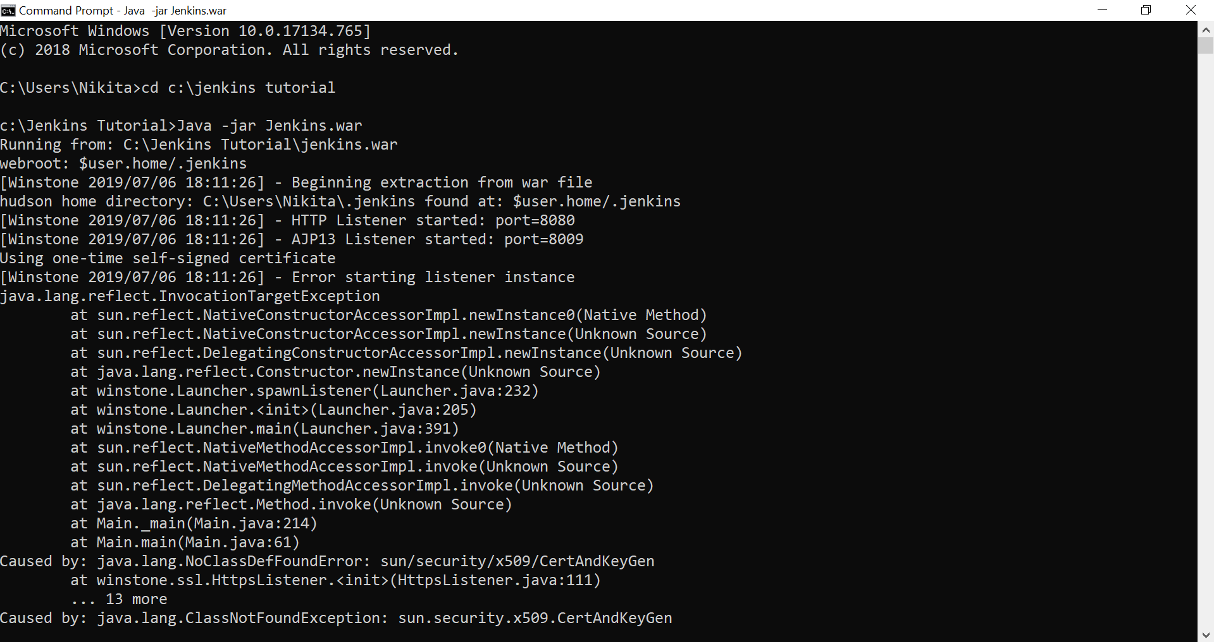  
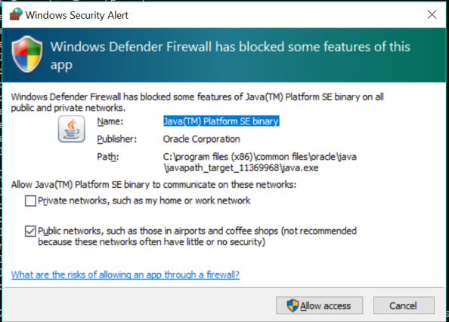

Click on **Allow access** button to allow the access.

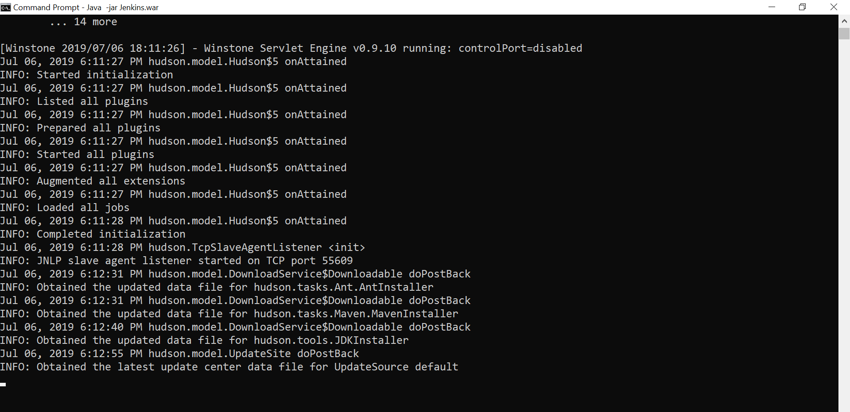

## Accessing Jenkins

Now you can access the Jenkins. Open your browser and type the following url on your browser:

1. http://localhost:8080

This url will bring up the Jenkins dashboard.

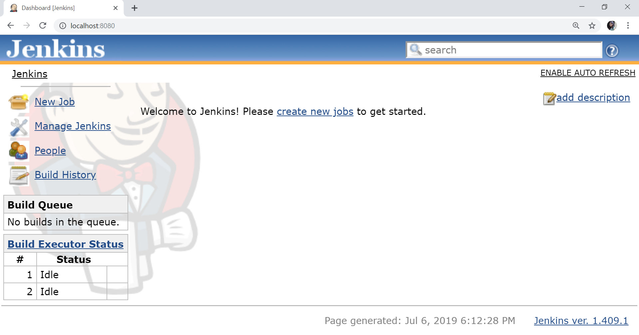

# Installing Jenkins on Ubuntu

Before moving on to installing the packages on the server, our system package manager must be updated. Use the following command to ensure your system package manager is up to date:

1. $ sudo apt update

## Install Java

Since Jenkins is written in Java, the first step is to install Java. Install the Java 8 OpenJDK package with the following command:

1. $ sudo apt install openjdk-8-jdk

The current version of Jenkins doesn't support Java 10 or more yet. If you have multiple java versions installed on your system then make sure java 8 is the default java version.

To check the version of java on your system, use the following command:

1. $ java -version

## Add the Jenkins Debian Repository

Import the GPG (GnuPG - GNU Privacy Guard) keys of the Jenkins repository using the following wget command:

1. $ wget -q -O - https://pkg.jenkins.io/debian/jenkins.io.key | sudo apt-key add -

The output of the above command should OK which means that the key has been successfully imported and packages from this repository will be considered trusted.

Now, add the Jenkins repository to the system with the following command:

1. sudo sh -c 'echo deb http://pkg.jenkins.io/debian-stable binary/ > /etc/apt/sources.list.d/jenkins.list'

## Install Jenkins

Once the Jenkins repository is enabled and keys and sources are added, update the apt package list:

1. $ sudo apt update

Now, install the latest version of Jenkins by using the following command:

1. $ sudo apt install jenkins

Once the installation is completed, Jenkins service will start automatically.

We can verify it with the help of following command:

1. $ systemctl status Jenkins

We should see something like this:

1. ● jenkins.service - LSB: Start Jenkins at boot time
2. Loaded: loaded (/etc/init.d/jenkins; generated)
3. Active: active (exited) since Wed 2019-07-06 1308 PDT; 2min 16s ago
4. Docs: man:systemd-sysv-generator(8)
5. Tasks: 0 (limit: 2319)
6. CGroup: /system.slice/jenkins.service

## Adjusting Firewall

If you are installing Jenkins on a remote server of Ubuntu that is protected by a firewall, you will need to open port **8080**. Consider that you are using **UFW** to manage your firewall; you can open the port with the following command:

1. $ sudo ufw allow 8080

Verify the change with the following command:

1. $ sudo ufw status

**Output will look like this:**

Status: active

To Action From

-- ------ ----

OpenSSH ALLOW Anywhere

8080 ALLOW Anywhere

OpenSSH (v6) ALLOW Anywhere (v6)

8080 (v6) ALLOW Anywhere (v6)

## Setting Up Jenkins

To set up the new Jenkins installation, open the browser, type the domain or IP address followed by port 8080, http://your_ip_or_domain:8080, and screen (unlock Jenkins screen) similar to the following will be displayed:

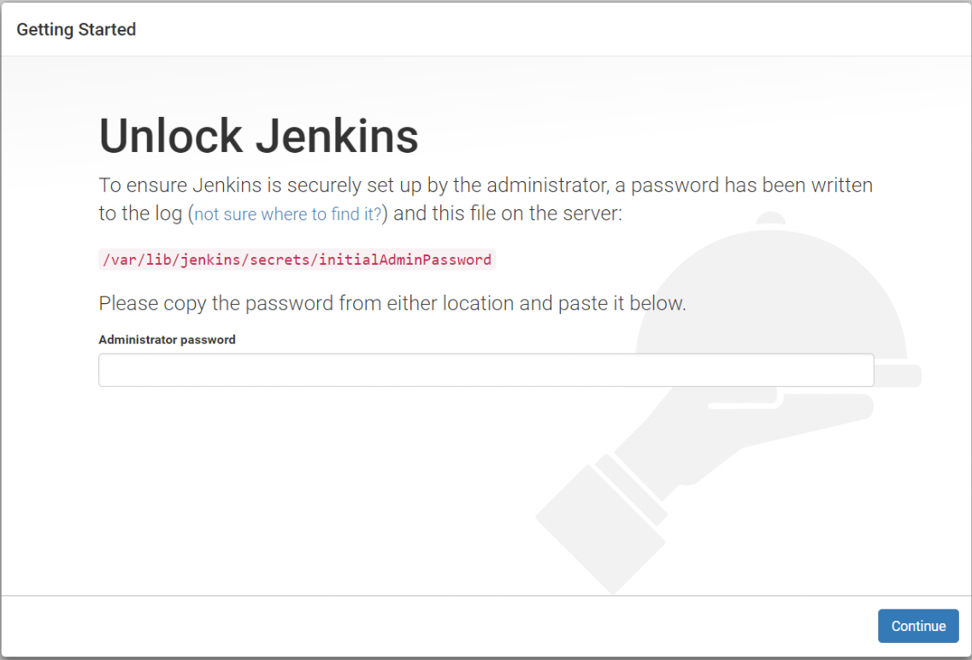

In the terminal, type the following cat command to see the password:

1. $ sudo cat /var/lib/jenkins/secrets/initialAdminPassword

Copy the password from the terminal and paste it into the "Administrator password" field and then click continue. Now, the screen presents the option of installing suggested plugins or selecting specific plugins:

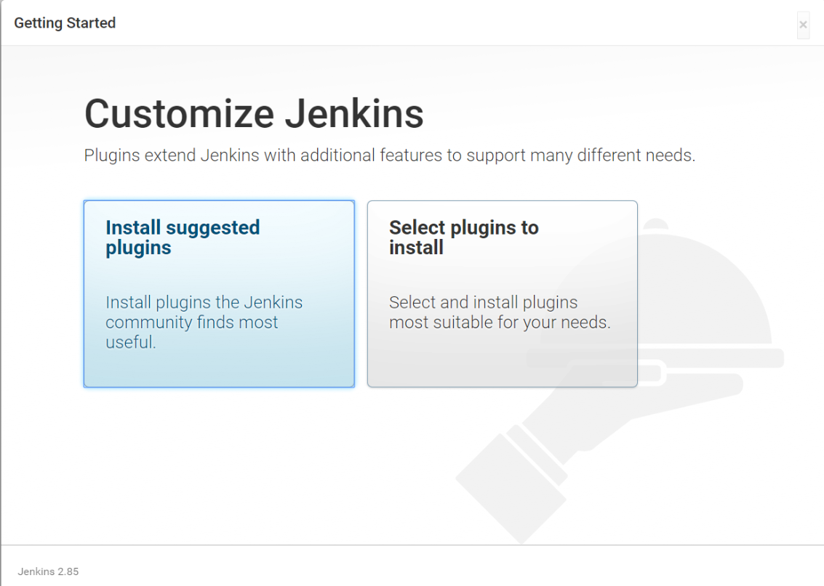

After the installation of plugins, it's time to create an admin account to login to Jenkins:

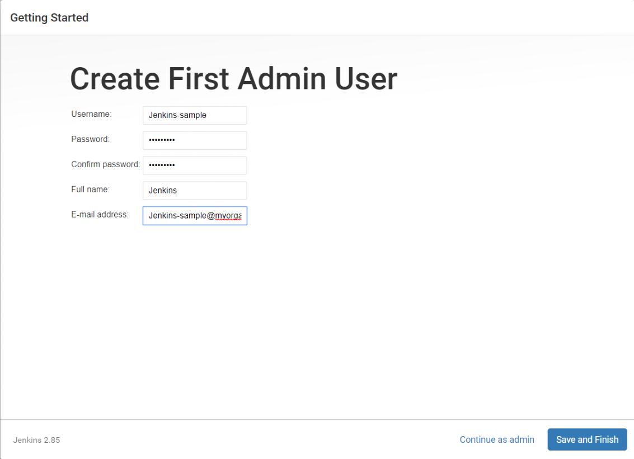

Fill the required fields and click on save and finish button.

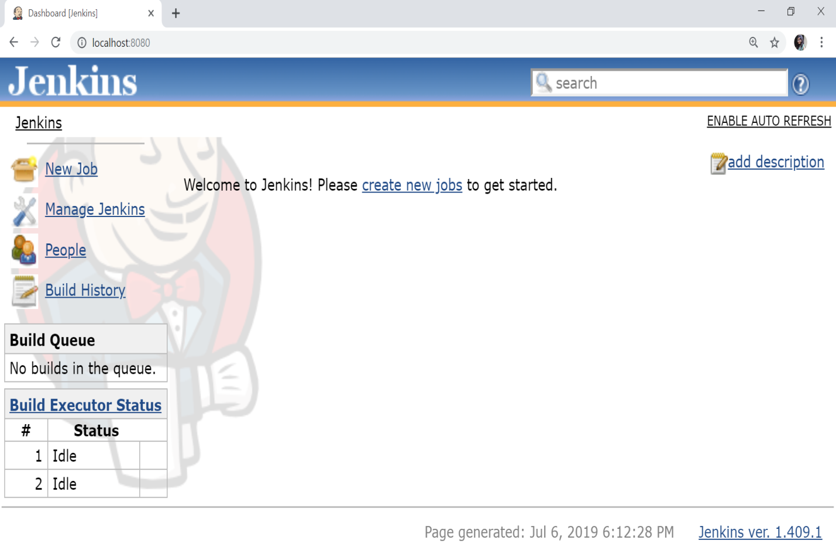

We have successfully setup Jenkins and now Jenkins server is ready for use.

# Java and Tomcat Setup for Jenkins

## Java Setup

Since Jenkins is written in Java. Therefore, Java must be installed on your system. To download and install the Java, go to our previous chapter of this tutorial.

Now, to set up the Java_Home environment variable on Windows [click here](https://javatutorial.net/set-java-home-windows-10" \t "https://www.javatpoint.com/_blank).

Once the java has been installed properly on your system and Java environment variable has been set, then you can verify it by using the following commands:

1. C:\ echo %JAVA_HOME%
3. C:\ javac -version
5. C:\ java -version

The following output should come:

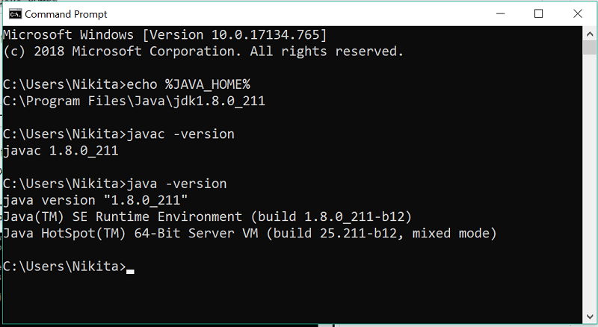

## Tomcat Setup

### Download Tomcat:

The official website to download the tomcat is [http://tomcat.apache.org/](https://tomcat.apache.org/" \t "https://www.javatpoint.com/_blank).

When you click the given link, you will get the home page of the official tomcat website as given below:

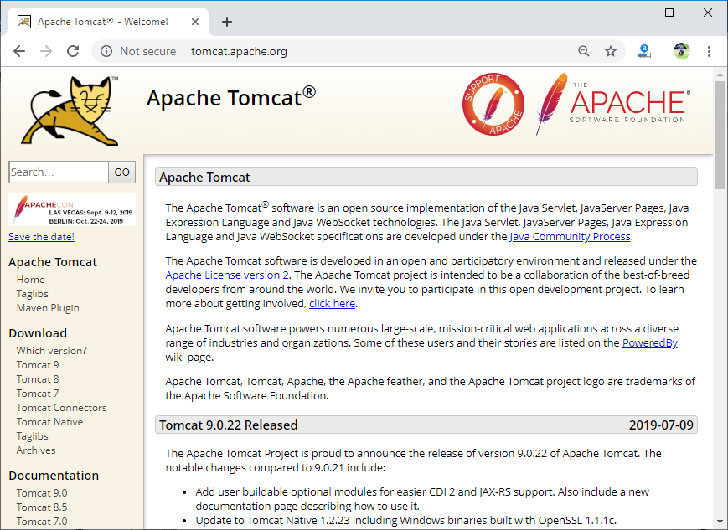

Go to the link [https://tomcat.apache.org/download-90.cgi](https://tomcat.apache.org/download-90.cgi" \t "https://www.javatpoint.com/_blank) to download the latest version of tomcat.

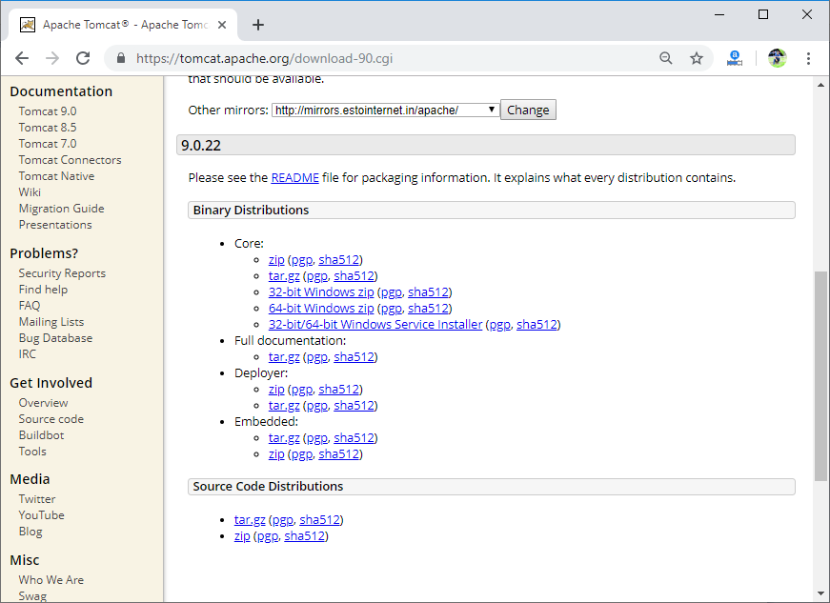

Go to the "Binary Distributions" section and download the file according to your platform. Here I am using 64-bit Windows zip for my 64-bit Windows operating system.

Unzip the contents of the downloaded zip file.

### Jenkins and Tomcat Setup

Copy the downloaded Jenkins.war file (downloaded from the previous section) and copy it to the **webapps** folder of the tomcat directory.

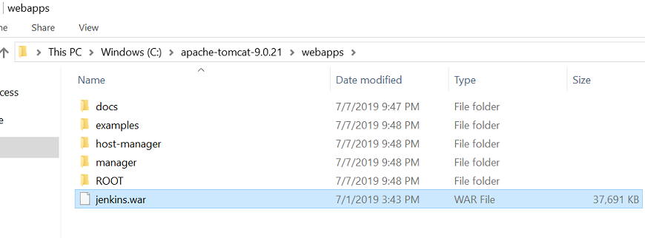

Now open the command prompt. From the command prompt, browse to the directory where the tomcat is located. Then, go to the bin directory of this tomcat folder and run the **startup.bat** file.

1. C:\apache-tomcat-9.0.21\bin>startup.bat

When you run the above command then following output will come:

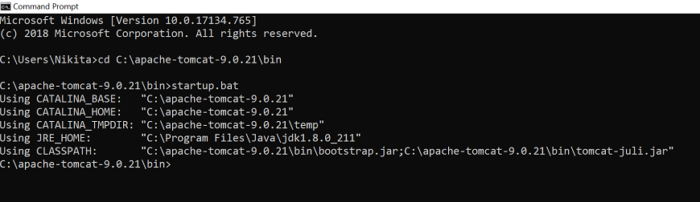

And two more windows will open. i.e., "Tomcat" window and "Windows Security Alert" window. Click on **Allow access** button in Windows Security Alert Window.

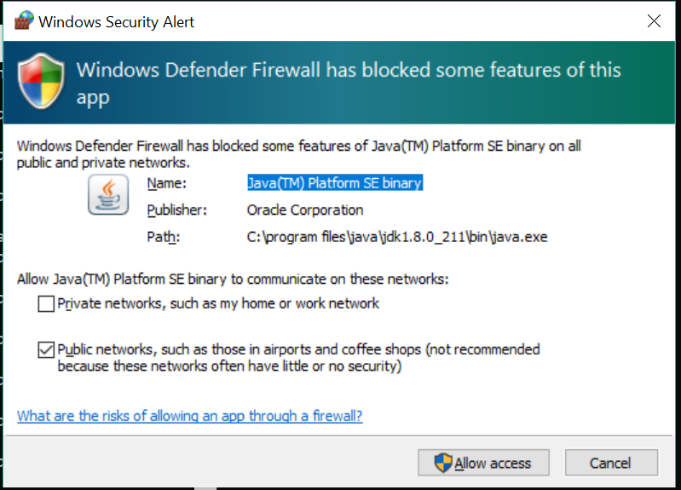  
  
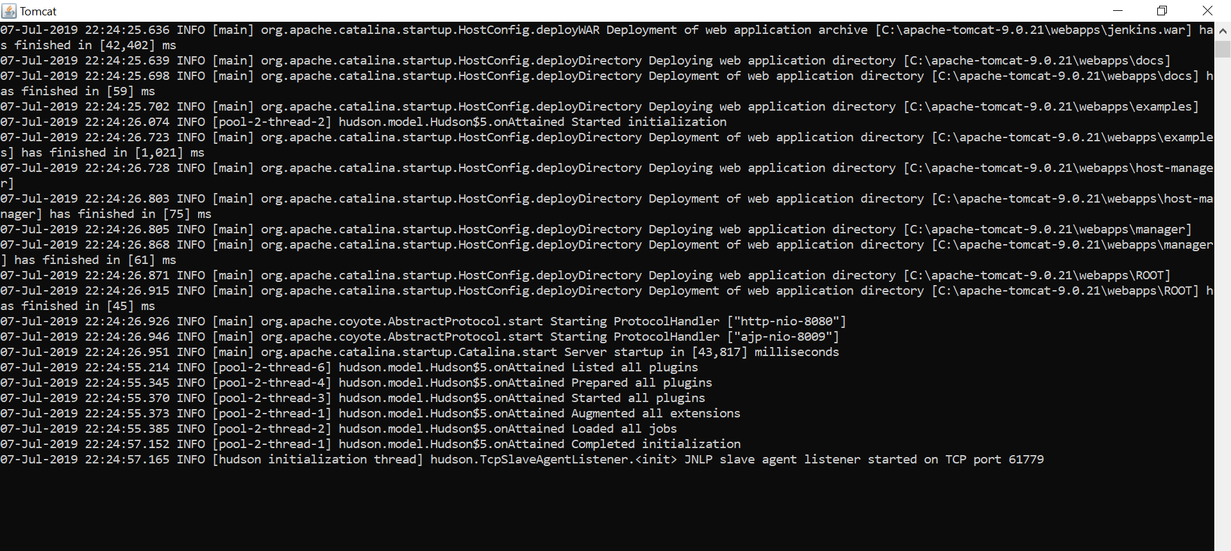

Once the processing is completed, the following line will come in the output of the Tomcat Window:

1. INFO [hudson initialization thread] hudson.TcpSlaveAgentListener.<init> JNLP slave agent listener started on TCP port 61779

Now, open the browser and go the link: [http://localhost:8080/jenkins](http://localhost:8080/jenkins" \t "https://www.javatpoint.com/_blank). The following page will open:

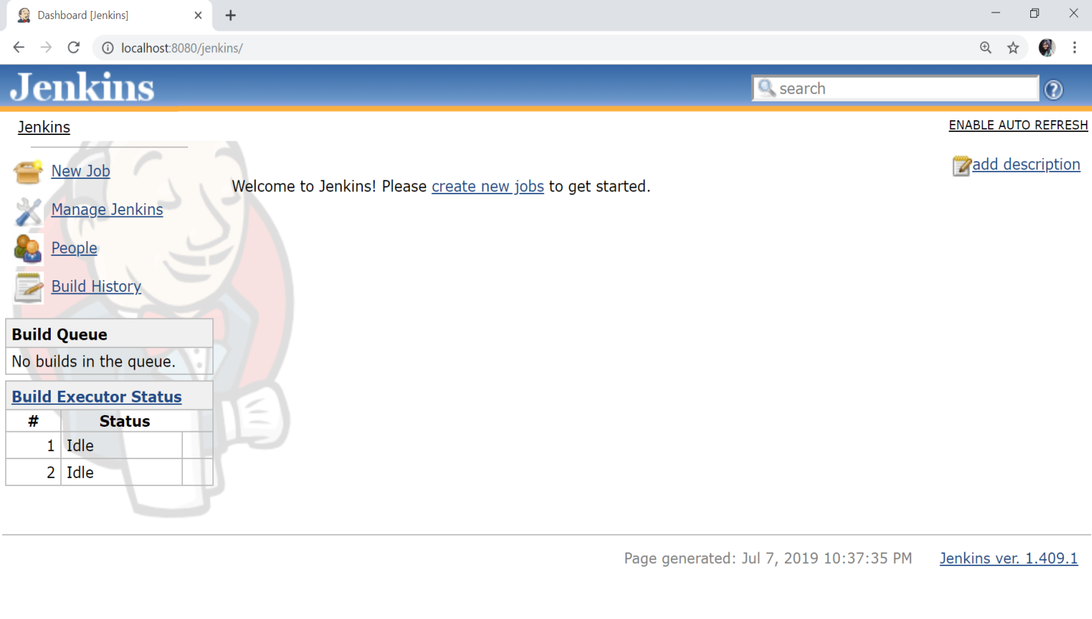

The setup of Jenkins with Tomcat is successfully done.