PetVision-Ops: An End-to-End MLOps Pipeline
for
Binary Cats vs Dogs Image Classification
AIMLCZG523 - Machine Learning Operations (MLOps)
BITS Pilani
August 2026
Repository: <INSERT GITHUB REPOSITORY LINK>

1. Setup and Install Instructions
The project is a single Python package laid out by concern (src/data, src/models, src/training, api, scripts) with three pinned requirement files: requirements.txt for the full training environment, requirements-api.txt for the slim serving container, and requirements-dev.txt for the test tooling. Splitting them is deliberate - the serving image never installs MLflow, DVC, scikit-learn or matplotlib, which keeps roughly 400 MB of training-only tooling out of production.
# Clone the repository
git clone <INSERT GITHUB REPOSITORY LINK>
cd Assignment-2-MLOPS

# Create and activate a virtual environment
python -m venv .venv
.venv\Scripts\activate # Windows

# Install dependencies
pip install -r requirements.txt

# Run the pipeline: download -> preprocess -> train
python src/data/download_data.py
python src/data/preprocess.py
python train.py

# Train the second candidate (transfer learning)
python train.py --architecture resnet18_finetune --epochs 4 \
--learning-rate 0.005 --run-name resnet18-finetune \
--artifact-name resnet18_finetune.pt

# Model registry: inspect, then let the promotion gate decide
python scripts/promote_model.py --show
python scripts/promote_model.py --dry-run
python scripts/promote_model.py

# Tests (79) and the CI-environment import check
python -m pytest -v
python scripts/check_ci_imports.py

# Run the API locally
python -m uvicorn api.main:app --host 0.0.0.0 --port 8000
# Swagger UI: http://127.0.0.1:8000/docs

# Build and run the Docker image
docker build -t cats-dogs-api:latest .
docker run --rm -p 8000:8000 cats-dogs-api:latest

# Deploy to local Kubernetes (Minikube) and smoke-test it
powershell -ExecutionPolicy Bypass -File scripts/deploy_local.ps1

# Browse experiments and the model registry
python -m mlflow ui --backend-store-uri sqlite:///mlflow.db
Every path, hyperparameter, split ratio, seed and normalisation constant is resolved through a single params.yaml read by one loader (src/config.py) - nothing in the codebase hardcodes a value, so the same code runs unmodified on a laptop, inside CI, and inside the Docker/Kubernetes runtime. The DVC pipeline (dvc.yaml) declares the same stages, so python -m dvc repro re-runs only the stages whose dependencies or parameters actually changed.
One environment note worth recording: the development machine runs Python 3.14, for which TensorFlow publishes no wheels. The models are therefore PyTorch nn.Modules. Nothing else about the design changes.

2. Data, Preprocessing and Modelling Choices

2.1 Data Acquisition
The dataset is Microsoft's Kaggle Cats and Dogs corpus (25,000 JPEGs, 12,500 per class), fetched at runtime by a download script rather than committed to the repository, so the raw data is always reproducible from source and no Kaggle credentials are required.
The full archive is 825 MB, far more than this assignment needs. Rather than download it all, the script opens the remote ZIP over HTTP Range requests, reads only its central directory, and then pulls only the byte ranges of the images it actually wants - 2,000 per class. Every image is decoded and verified before being re-saved as RGB JPEG, which silently drops the four corrupt files that are a known defect of this dataset (two per class, including the well-known Cat/666.jpg).
The resulting data/raw directory (4,000 images, 189 MB) is tracked with DVC. Git stores only a five-line pointer file recording the directory's md5 (7dcf4c5b...), its size and its file count; the images themselves never enter Git history. Confirming this is a one-liner: git ls-files data/ returns only .gitignore, raw.dvc and the processed pointer - no JPEGs.

2.2 Preprocessing and the 80/10/10 Split
Every image is converted to 224x224 RGB. The resize resizes the shorter side to 224 and takes a centre crop rather than squashing directly to a square: a 500x375 dog stays a correctly-proportioned dog instead of being horizontally compressed, which matters because aspect distortion is a systematic, not random, corruption of the input.
The split is computed per class, so it is stratified by construction and every split holds exactly 50/50 cats to dogs. It is seeded (seed 42), so anyone who clones the repository reproduces the identical split.

Split | cat | dog | total | share
train | 1,600 | 1,600 | 3,200 | 80 %
validation | 200 | 200 | 400 | 10 %
test | 200 | 200 | 400 | 10 %

Leakage was verified rather than assumed: the pairwise intersections of the train, validation and test filename sets are all empty, and their union is exactly 4,000 - nothing is shared between splits and nothing is silently dropped. Augmentation is deliberately NOT baked into these files; doing so would freeze the randomness and, worse, contaminate validation and test with augmented images.

2.3 Augmentation and Modelling Choices
Augmentation is applied to the training split only: RandomResizedCrop(224, scale 0.8-1.0), horizontal flip, rotation of plus or minus 15 degrees, and colour jitter of 0.2, followed by ImageNet normalisation. Validation and test receive resize and normalisation alone, so their scores remain an unbiased estimate. That the augmentation is genuinely live is asserted in the test suite: reading the same dataset index twice must return different tensors for the training split and identical tensors for the evaluation split.
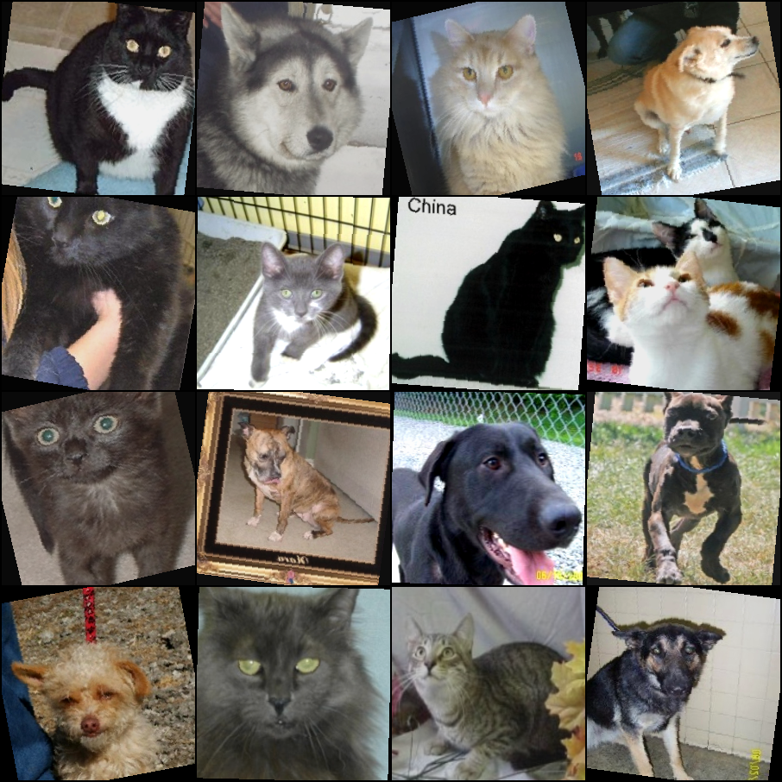
Figure 1. A live augmented training batch - visible rotation, cropping and colour jitter.
Two candidate models were trained, and both are kept.
Candidate 1 - baseline CNN, trained from scratch. Four convolutional blocks (32, 64, 128, 256 filters), each Conv3x3 + BatchNorm + ReLU + MaxPool, followed by global average pooling, dropout 0.5 and a 2-unit linear head: 389,410 parameters. Three choices are worth defending:
- Global average pooling instead of a flatten. Flattening 256x14x14 into a dense layer would cost roughly 25 million parameters - 64 times the whole network - and would overfit 3,200 training images badly. GAP keeps the classifier at 514 parameters and makes the network input-size agnostic.
- BatchNorm after every convolution. Without it, a from-scratch network at lr = 1e-3 frequently diverges in the first epochs.
- Two logits and a softmax rather than a single sigmoid. This pairs with CrossEntropyLoss and gives the API a clean per-class probability vector, which the brief requires.
Candidate 2 - ResNet18 fine-tuning. An ImageNet-pretrained ResNet18 with its backbone frozen and a fresh 2-class head. Only 1,026 of 11,177,538 parameters are trainable, so the backward pass touches 0.009 % of the network - which is exactly what makes fine-tuning practical on a CPU-only machine, at roughly the same wall-clock cost per epoch as the far smaller baseline.

Model | Accuracy | Precision | Recall | F1 | Test loss
Baseline CNN | 0.725 | 0.725 | 0.725 | 0.725 | 0.5633
ResNet18 fine-tune | 0.975 | 0.975 | 0.975 | 0.975 | 0.0654

The from-scratch baseline was trained first and kept deliberately. A baseline is what makes an improvement measurable: reporting 97.5 % alone says nothing about whether the pipeline or the architecture earned it, whereas 72.5 % to 97.5 % on an identical split, identical preprocessing and identical evaluation isolates the contribution of transfer learning to 25 percentage points.
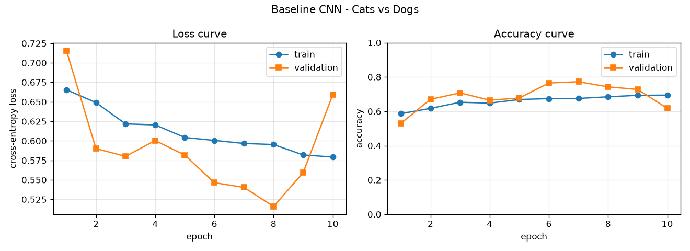
Figure 2. Baseline CNN loss and accuracy curves. Validation loss bottoms out at epoch 8 and then climbs, which is why the trainer restores the best weights rather than the last.
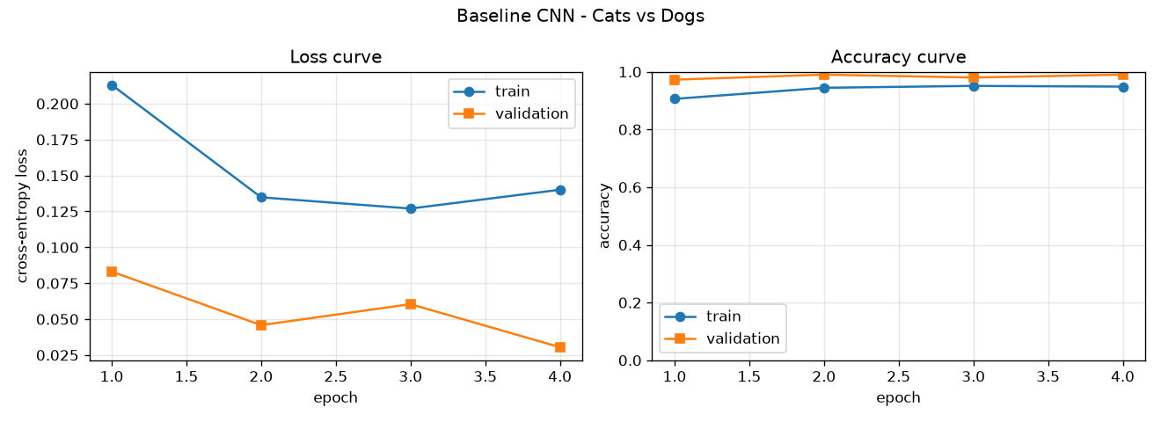
Figure 3. ResNet18 fine-tuning curves - validation accuracy passes 0.97 within one epoch.
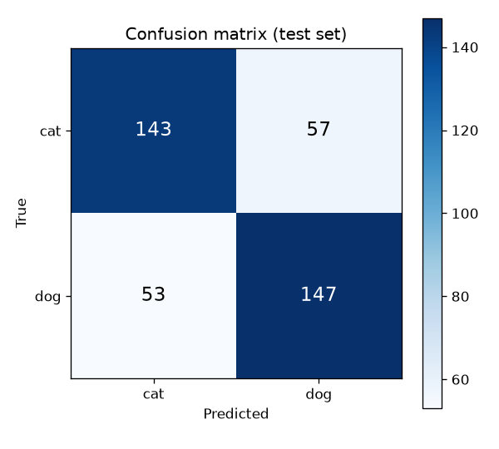
Figure 4. Baseline CNN holdout confusion matrix (errors balanced 57 vs 53).
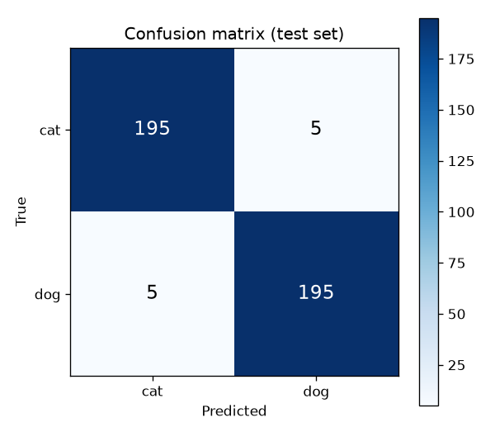
Figure 5. ResNet18 holdout confusion matrix - 5 errors per class, symmetric.
Early stopping watches validation loss with a patience of 3, and the best weights are restored before the test evaluation is run. On the baseline this mattered: validation loss reached 0.5159 at epoch 8 and then rose to 0.6591 by epoch 10, so serving the final-epoch weights would have cost roughly ten points of accuracy.

2.4 Model Packaging and Reproducibility
The serialised artifact is deliberately self-describing. A single .pt file carries the weights, the class order, the architecture name, the preprocessing configuration (image size, channels, normalisation mean and standard deviation), the run's test metrics and its MLflow run id. There is no separate scaler or label-map file that could drift out of sync with the weights, and the serving code rebuilds the exact training-time inference pipeline from the checkpoint alone rather than from assumptions.
Reproducibility was verified directly rather than asserted. Sending all 400 held-out test images to the running service over HTTP reproduces the training-time confusion matrix exactly - not approximately - for both models, in every environment they were deployed to. Per-image confidences match as well, so this is bitwise reproducibility rather than a rounding coincidence.

Model | Environment | Confusion matrix | Accuracy
Baseline | Training (in-process) | [[143,57],[53,147]] | 72.50 %
Baseline | Local uvicorn (HTTP) | [[143,57],[53,147]] | 72.50 %
Baseline | Docker container | [[143,57],[53,147]] | 72.50 %
Baseline | Kubernetes, 2 replicas | [[143,57],[53,147]] | 72.50 %
ResNet18 | Training (in-process) | [[195,5],[5,195]] | 97.50 %
ResNet18 | Local uvicorn (HTTP) | [[195,5],[5,195]] | 97.50 %

This is the check that catches the failure modes training-time evaluation cannot see: serving-time preprocessing drift, a class order that has silently inverted inside the artifact, or simply the wrong image version being deployed.

3. Experiment Tracking and Model Registry
MLflow (v3.15.2) provides experiment tracking against a local SQLite backend store (mlflow.db) with file-based artifacts, so no external tracking server is required. The SQLite backend is not a stylistic preference: MLflow 3.x has placed the plain-file store into maintenance mode and refuses to start against it, raising an explicit exception that recommends migrating to a database backend. This was discovered by smoke-testing the post-training code paths with synthetic data before committing to a long training run - had it not been caught there, it would have failed roughly 55 minutes into training, after all the compute had already been spent.
Each run logs every value in params.yaml, flattened to dotted keys (41-48 parameters depending on the candidate), plus device, library versions, trainable and total parameter counts and the split sizes. Per epoch it logs training and validation loss and accuracy and the epoch duration; at the end it logs the test loss, accuracy, macro precision, recall and F1, the best epoch, and the four confusion-matrix cells as individually queryable metrics. Seven artifacts are attached to each run: the loss and accuracy curves, the confusion matrix, the classification report, a metrics JSON, the serialised model, the split summary and the exact params.yaml used.

3.1 The Model Registry and Gated Promotion
Both candidates are registered as versions of a single registered model, cats-vs-dogs-classifier. Every training run registers a new version, tags it with its architecture, test accuracy, F1, loss, best epoch, class order and source run id, and marks it challenger. A training run never promotes itself.
ver architecture test_acc test_f1 loss aliases run
----------------------------------------------------------------------
1 baseline_cnn 0.7250 0.7250 0.5633 - d604ad0f
2 resnet18_finetune 0.9750 0.9750 0.0654 champion 3594a3ac <<
Promotion is a separate, gated decision made by scripts/promote_model.py, which applies one rule: promote only if the challenger's test accuracy exceeds the champion's by more than min_delta (default 0.005). The threshold exists so that a statistically meaningless gain - say 0.2 percentage points - cannot churn production. Both outcomes were exercised: the ResNet18 challenger was promoted over the baseline champion with a margin of +0.2500, and the reverse comparison was correctly rejected at -0.2500. The boundary behaviour is unit-tested.
Crucially, promotion is wired to serving. Promoting a version exports that version's checkpoint to artifacts/model.pt, which is the exact file the Docker image bakes in, so only a promoted model can ever be served. The /health endpoint reports the live architecture and MLflow run id, so a running service identifies precisely which registry version is answering requests - there is no ambiguity about what is deployed.
One implementation detail cost a debugging cycle and is worth recording: MLflow 3.x defaults to the traced pt2 serialisation format, which requires an input_example so it can trace the forward pass. The first registration attempt failed for this reason. Because the registration call was wrapped defensively, the 15-minute training run itself was not lost, and a small register_model.py script was able to backfill both runs into the registry in seconds rather than requiring a retrain.
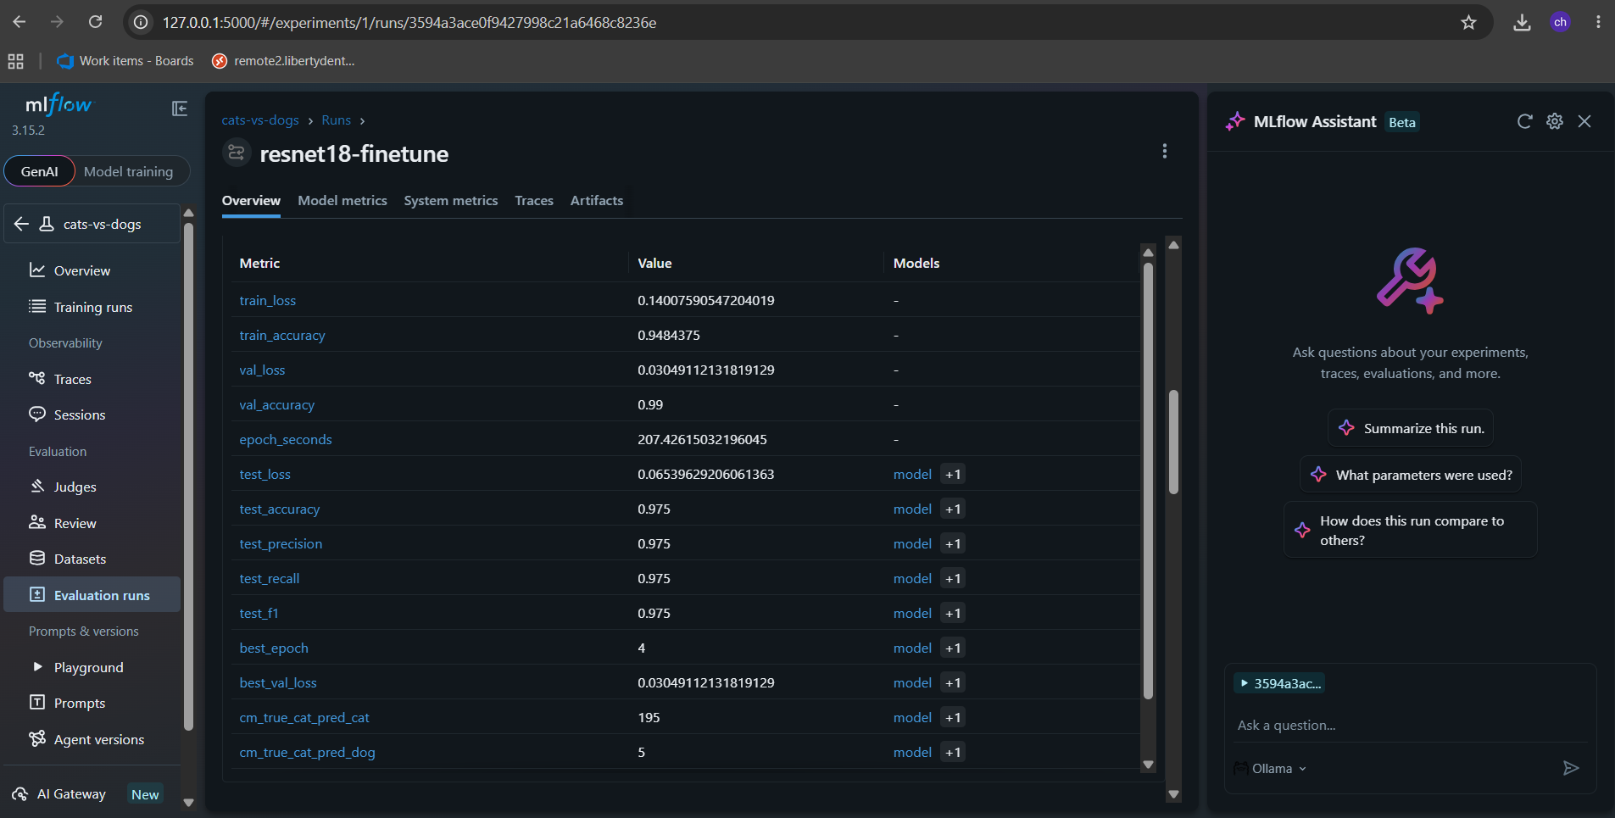
Figure 6. MLflow experiment overview - baseline-cnn and resnet18-finetune runs.

4. Architecture Diagram
The pipeline acquires and version-controls the dataset with DVC, preprocesses it to a fixed 224x224 RGB stratified split, and trains candidate models with MLflow tracking. Each run registers a version in the MLflow Model Registry; a gated promotion step decides which version carries the champion alias and exports that champion as the single serving artifact. The artifact is served by a FastAPI application exposing health, prediction, metrics and interactive documentation endpoints, containerised by a Docker image built on the PyTorch CPU wheel index, built and smoke-tested by a GitHub Actions CI pipeline, published to the GitHub Container Registry, and deployed by a CD pipeline to a Kubernetes cluster running two replicas behind a NodePort Service, where post-deployment smoke tests and a true-versus-predicted evaluation gate the release.
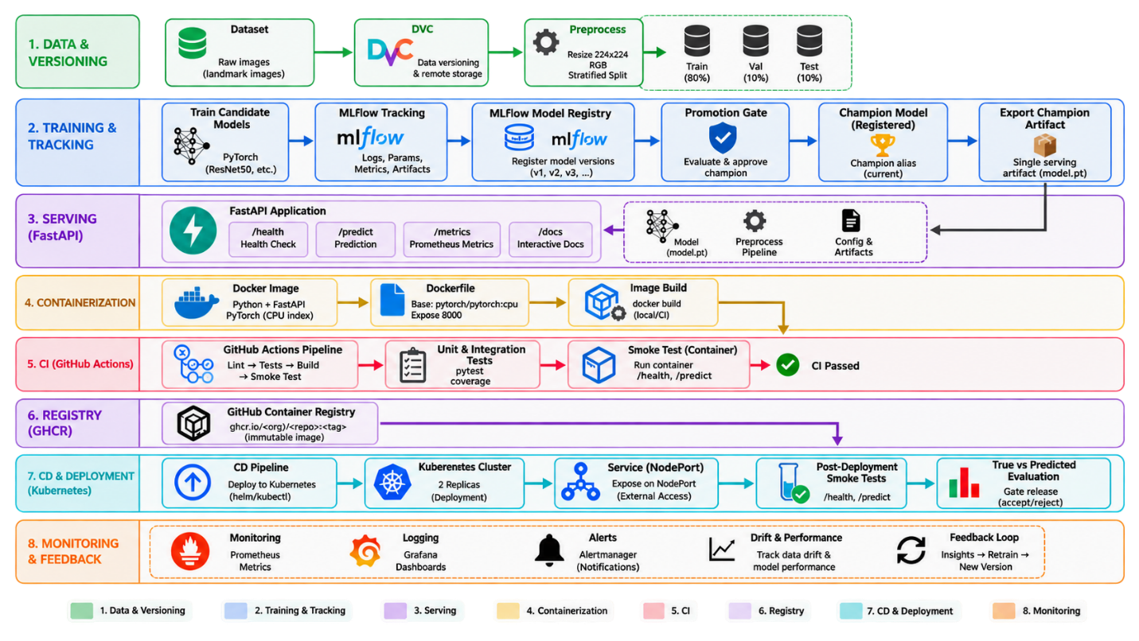Figure 8. End-to-end architecture, colour-coded by concern.

5. CI/CD and Deployment Workflow

5.1 Continuous Integration
A GitHub Actions workflow (.github/workflows/ci.yml) runs on every push and pull request to main. The test job runs as a matrix across Python 3.12 and 3.13; 3.11 is deliberately excluded because numpy 2.5.2 declares requires_python >= 3.12, so the pinned dependency set cannot be satisfied there. The job installs the pinned serving and test dependencies from the PyTorch CPU wheel index (which keeps torch at roughly 200 MB rather than 2.5 GB), inspects the committed model artifact and prints its architecture, class order, run id, metrics and the current registry champion, then runs the full suite with JUnit XML and coverage reporting.

Test module | Tests | What it protects
test_preprocessing.py | 24 | Geometry, normalisation, the 80/10/10 split, bad input
test_inference.py | 22 | Model shapes, checkpoint loading, HTTP contract
test_registry.py | 22 | Model factory and the promotion gate
test_monitoring.py | 11 | Counters, latency percentiles, log format

The build job declares needs: test, so a red suite can never produce a published image. It builds the image, reports its size, layer count, run-as user and entrypoint, loads it locally and smoke-tests the running container - /health must return status ok, /predict must return a label, and a non-image upload must be rejected with HTTP 400 - and only then pushes to the GitHub Container Registry tagged latest, sha-<commit> and the branch name. Every run uploads its evidence: JUnit XML, coverage.xml and an HTML coverage report per Python version, plus the built image's own /health, /predict and /metrics responses and its container logs, retained for 90 days.
Overall line coverage is 50 %, but that single figure is misleading: the serving path that actually runs in production is covered between 88 % and 100 % (model_loader 100 %, preprocessing 100 %, the model factory 100 %, monitoring 96 %, the FastAPI app 88 %). The low numbers belong to the training scripts, which are verified by being executed - the two model runs are their test - rather than by unit tests that would need the DVC dataset checked out. Unit-testing a 40-minute training loop is not the right tool for it.
The gates were proven by a real failure rather than only by green runs. One CI run failed for two genuine reasons: the Python 3.11 matrix entry could not install the pinned numpy, and a test imported MLflow, which CI deliberately does not install. In that run the image build was skipped and the entire CD workflow was skipped - no image was published and no deployment occurred. That failure is more convincing evidence that the gates work than any successful run. The fixes were a pin-compatible matrix and moving the promotion gate's logic into a module that imports no MLflow; a helper script, scripts/check_ci_imports.py, now reproduces CI's serving-only environment locally so this class of failure cannot recur.
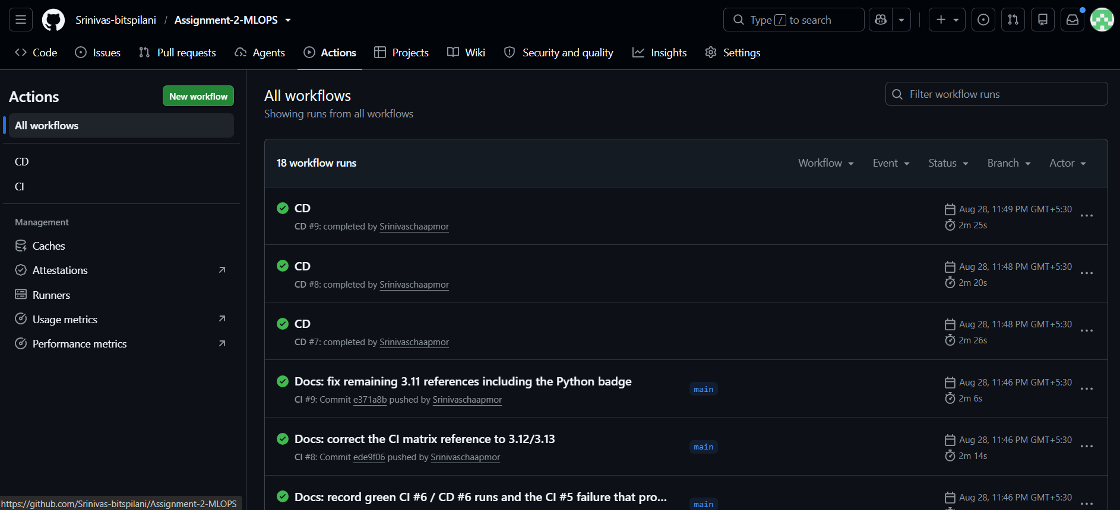Figure 9. CI pipeline: matrix tests, image build, live container smoke-test and GHCR publish.
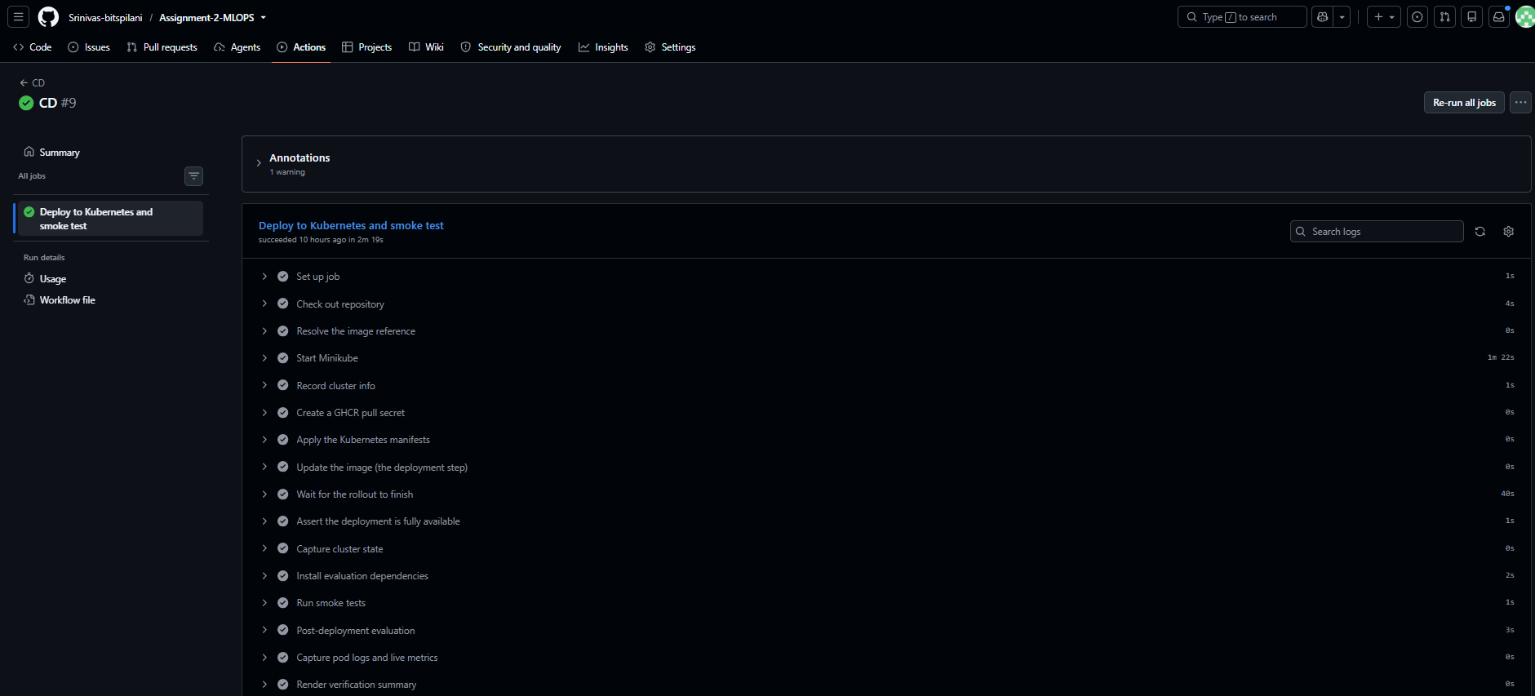Figure 10. The gate under failure: a red test suite skips the image build and the whole CD workflow.

5.2 Continuous Deployment and Kubernetes
The CD workflow (.github/workflows/cd.yml) is triggered automatically by a successful CI run on main. It resolves the immutable image reference ghcr.io/<owner>/<repo>:sha-<commit>, starts a Minikube cluster inside the runner, creates a GHCR pull secret, applies the manifests, and performs the actual deployment with kubectl set image against that SHA tag. Deploying an immutable SHA rather than latest is what makes a deployment reproducible and a rollback meaningful.
The workflow then waits for the rollout, and asserts explicitly that readyReplicas equals the desired replica count rather than trusting the rollout message. It captures the cluster state, runs the smoke tests, runs a post-deployment evaluation, and captures pod logs and live metrics. The smoke tests are the gate: the script exits non-zero on any failure, which fails the whole job. On failure the workflow captures pod logs and descriptions first and only then runs kubectl rollout undo - capturing before rolling back matters, because the rollback destroys the evidence of why it was needed.
The Deployment runs two replicas with maxUnavailable set to zero for zero-downtime updates, CPU and memory requests and limits, and two distinct probes: a readiness probe that keeps a pod out of the Service until its model has finished loading, and a liveness probe that restarts a wedged pod. The container runs as a non-root user (uid 10001), matched by the pod securityContext.
The Service is a NodePort rather than a LoadBalancer. On Minikube there is no cloud load-balancer controller, so a LoadBalancer Service would sit in the pending state indefinitely; NodePort on a fixed port gives the smoke tests a stable URL. The same manifests apply unchanged to a managed cluster with the type switched.
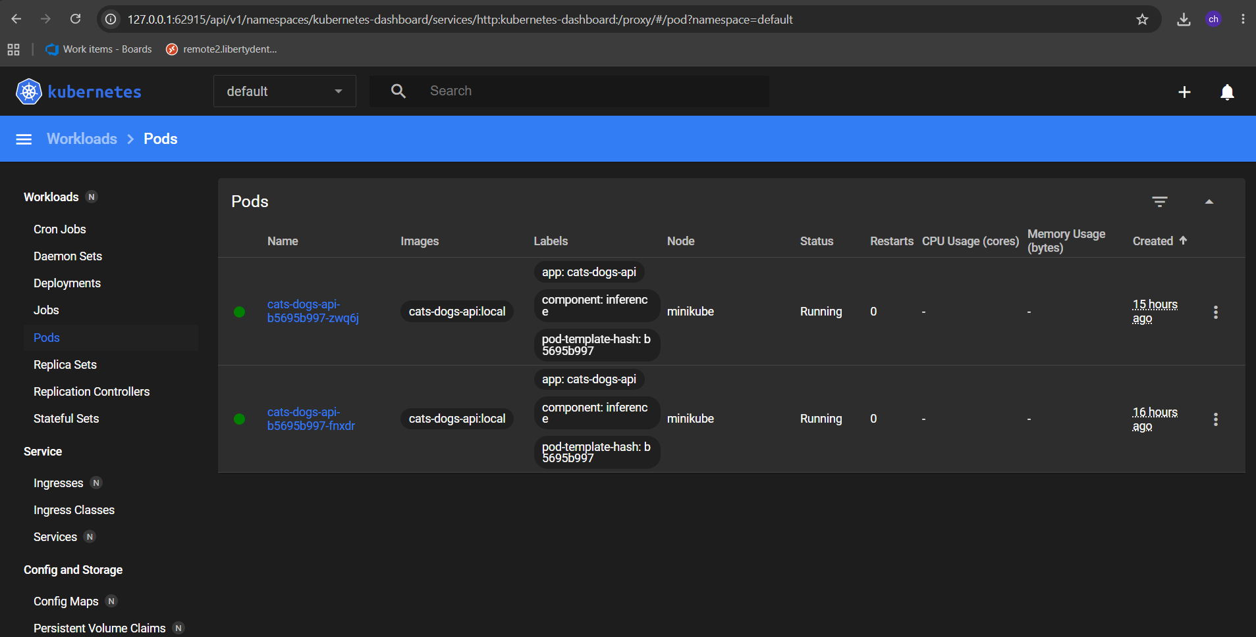Figure 12. kubectl confirming both Pods Running and the NodePort Service.

5.3 API Testing
FastAPI auto-generates interactive Swagger documentation at /docs from the same Pydantic response models that shape every reply. Error handling is explicit and tested: a non-image upload returns HTTP 400 with a decode message rather than a stack trace, a missing file field returns 422, an upload above 10 MB returns 413, and a request that arrives before the model has loaded returns 503 - never a 500.
curl http://localhost:8000/health

{"status":"ok","api_version":"1.0.0","model_loaded":true,
"architecture":"resnet18_finetune","classes":["cat","dog"],
"image_size":224,"mlflow_run_id":"3594a3ac...","test_accuracy":0.975}

curl -X POST -F "file=@data/processed/test/dog/dog_00013.jpg" \
http://localhost:8000/predict

{"filename":"dog_00013.jpg","predicted_label":"dog","predicted_index":1,
"confidence":0.9995,"probabilities":{"cat":0.0005,"dog":0.9995},
"inference_time_ms":151.77}
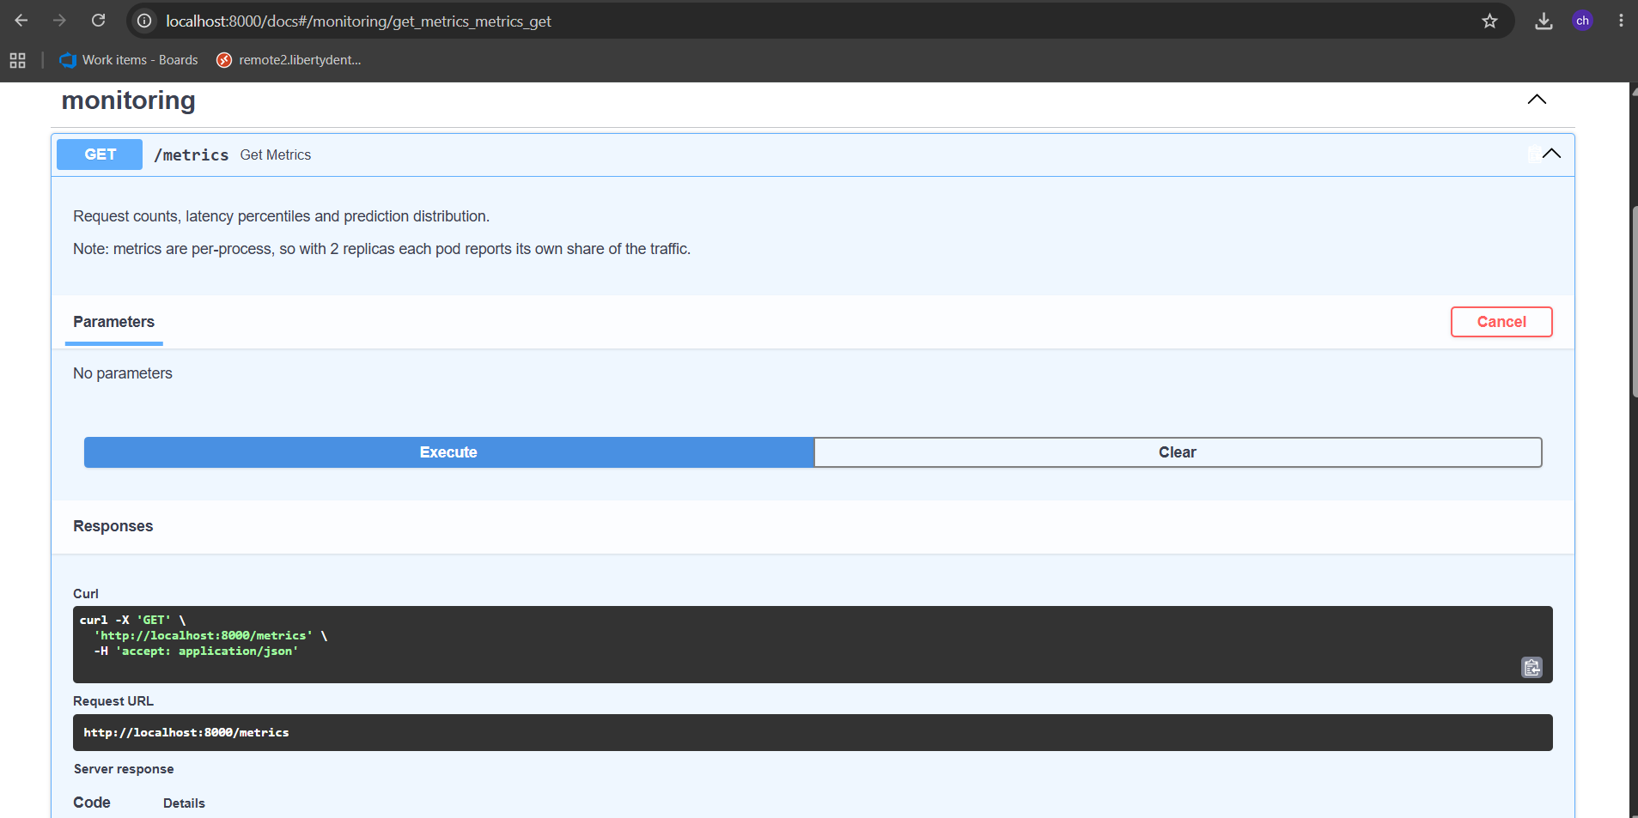Figure 14. Swagger UI: the POST /predict endpoint, its schema and an example response.

6. Monitoring and Logging
Every request is timed and counted by a single middleware, so monitoring covers all endpoints uniformly and no handler has to remember to instrument itself. Each request emits one structured JSON line to stdout - method, path, status code, latency and client - which means kubectl logs and docker logs collect it with no additional agent. Predictions emit a second, richer event carrying the filename, byte count, predicted label, confidence, the full probability vector and the server-side inference time, so predictions can be audited after the fact and compared against true labels.
Health-probe requests are counted but deliberately not logged. Kubernetes probes fire every few seconds against /health, and logging them would bury the real traffic in noise within minutes.
{"timestamp":"2026-08-28T13:12:54Z","event":"prediction","filename":"dog_00013.jpg",
"bytes":24489,"predicted_label":"dog","confidence":0.7587,
"probabilities":{"cat":0.2413,"dog":0.7587},"inference_time_ms":78.19}
{"timestamp":"2026-08-28T13:12:54Z","event":"request","method":"POST",
"path":"/predict","status":200,"latency_ms":83.59,"client":"172.17.0.1"}
A /metrics endpoint exposes request counts broken down by endpoint and status class, an error count and error rate, latency statistics (count, mean, min, max and the 50th, 95th and 99th percentiles), and prediction counts by label with a mean confidence. Latency percentiles are computed over a bounded 1,000-entry window so that a long-running pod cannot grow memory without limit, while the totals still count every request. The same numbers are also rendered in Prometheus text exposition format at /metrics/prometheus, and every response carries an X-Response-Time-ms header.

Deployment | mean | p50 | p95 | max | server-side inference
Local uvicorn (Windows) | 141 ms | 144 ms | 186 ms | 201 ms | 120 ms
Kubernetes (Linux, 2 replicas) | 84 ms | 84 ms | 102 ms | 126 ms | 61 ms

Post-deployment evaluation is handled by a dedicated script that never touches the model object. It sends real HTTP requests to the running service and compares the true label - taken from the folder each image came from - with the label returned on the wire, reporting a confusion matrix, per-class recall, overall accuracy, client-observed latency percentiles and the service's own metrics snapshot, and writing a JSON report. When the DVC dataset is not checked out, as in CI, it falls back to simulated requests and states explicitly that the resulting accuracy is not meaningful rather than quietly presenting a fabricated number.
One limitation is recorded honestly rather than hidden: the metrics are per-process, so with two replicas each pod reports only its own share of the traffic. This surfaced concretely during testing - a kubectl port-forward against the Service forwards to a single pod rather than load-balancing across them, so one pod logged 406 predictions while the other logged 5. Aggregating across pods is what a real Prometheus deployment scraping each pod individually would add; the /metrics/prometheus endpoint already emits a compatible format for exactly that.
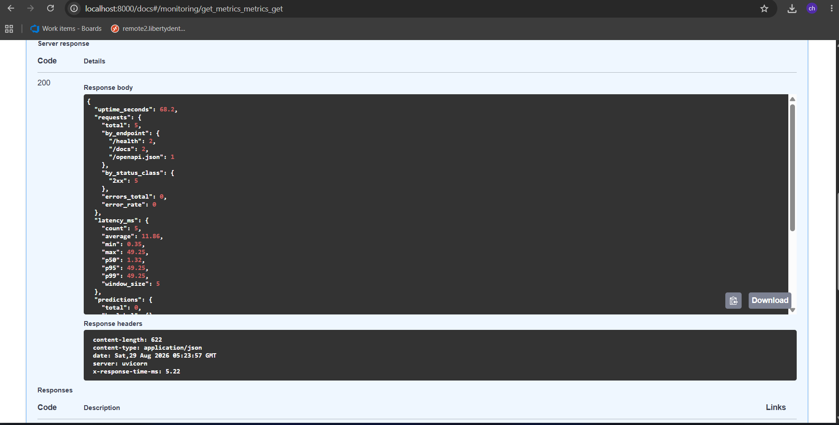Figure 16. Live metrics: request counts by endpoint, latency percentiles and predictions by label.

7. Link to Code Repository and Video
The complete code, Dockerfile, Kubernetes manifests, DVC pipeline, tests, CI and CD workflows, and the captured verification evidence are available at:
<INSERT GITHUB REPOSITORY LINK>
A short video recording of the overall pipeline in action:
<INSERT GOOGLE DRIVE VIDEO LINK>
The repository additionally contains docs/EVIDENCE.md, a committed record of captured output from real runs - both promotion decisions, the full MLflow experiment dump, the coverage breakdown, the train/serve consistency tables and the confirmed pipeline runs - so the results can be inspected without depending on any external service remaining available.

