**Climate Change and Economy Growth Data Analysis based on the World Bank Data**

**Student Name: SrINIVAS Vegisetti**

**Student ID: 21080840**

My GitHub link: [Click Here…](https://github.com/Srinivas-herts/Herts-Assignments.git)

Performed data analysis on climate change data, 07 countries were selected to do the visualization and look over the interrelations of the different factors on climate change where Total population Growth (%), Energy Consumption (%), GDP in USD, Energy consumption for Climate changes and Economic Changes, Agriculture Value added to GDP, and Female Employment (%) in Industry

The analysis initiates some correlations with causes behind them, and factors were investigated.

Figure 1 Total population Growth analysis using Bar Plot

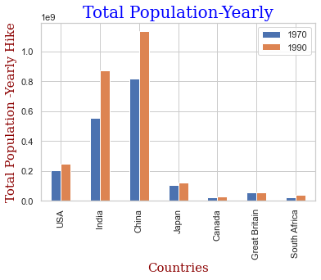 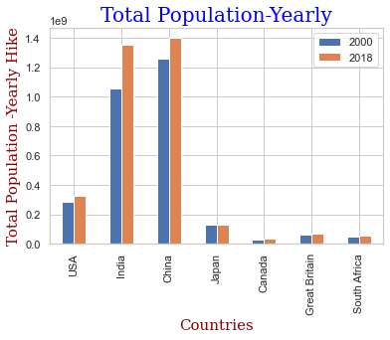

1. Visualized the bar graph using the data from 07 countries based on 4 years. We can observe India and China are the most populated. India's population growth in 2018 was further than China's. Canada is the country with the smallest population, albeit it's growing slightly. The population of Japan was the same in 2000 and 2018; this is a surprising discovery and suggests that the nation has effective population control systems. we can analyze the impact it creates based on population growth and how pollution affects the Total population of any country. Different colors show the year-wise change in the total population of 07 different countries.

Figure 2 Electricity Consumption Analysis using Scatter Plot which affects Climate Change:

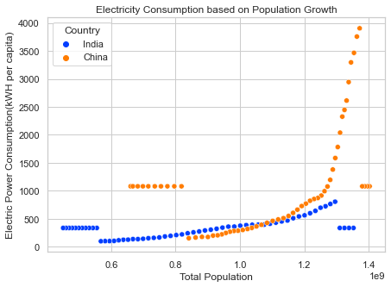

2. Analysis done by plotting the scatter chart to show the Electricity Consumption in India and China on the different indicators of the total population based on world bank data, based on the population growth (%) we can assume that people are compelled to stay indoors and use more power as a result of the increasing levels of air pollution, which exacerbates the environmental problems by raising greenhouse gas emissions of the total territorial area. India and China have seen an overwhelming increase in their total population growth from 10.4% to 40.0% in the last 60 years which has impacted Air Pollution in the country negatively.

Figure 3 GDP in USD Economy Growth Analysis using Line Plot:

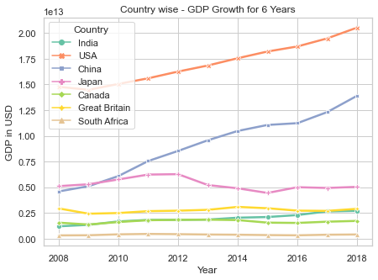

3. The above Line graph explains the analysis made on the GDP in USD of Seven rich countries based on Six years. Based on the year, the graph explains the highest GDP ratio of the United States in 2018. The lowest changes were seen in the graphs for South Africa. The above graph shows that USA and China have upward trends and that economic growth as measured by GDP is proportional to the degrowth movement which is supported by the fact that it has a negative impact on society and the environment.

Figure 4 Energy Consumption Analysis using Multi-Line Plot which affects climate change

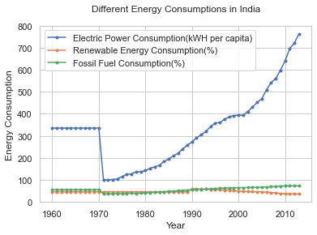

4. The above multi-Line graph shows the Energy consumption Analysis based on six years. Here highest line shows the continuous change in Electric Power consumption over the years for India which pollutes the air and helps to affect climate change. On the other hand, the consumption of Renewable Energy is low as compared to electrical energy which supports mitigating climate change in India. Whereas, Fossil Fuel consumption seems to have increased between 2000 and 2010. Hence, this explains Energy consumption has increased significantly over time and pollutes the environment.

Figure 5 Energy Consumption Analysis using Multi-Line Plot which helps to stabilize the economy

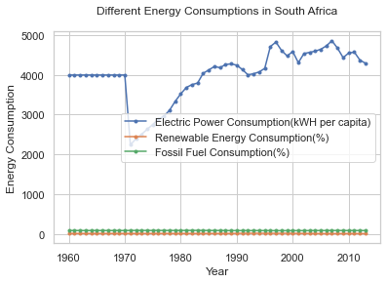

5. The above multi-Line graph shows the Energy consumption Analysis based on six years. Here highest line shows the continuous change in Electric Power consumption over the years for India which helps the growth of the economy but helps to affect climate change.

On the other hand, the consumption of Renewable Energy is low as compared to electrical energy which supports mitigating climate change in South Africa but increases the costs economically for the population investing money to buy Electric Power. Whereas, Fossil Fuel consumption seems to be stable in South Africa. Hence, this explains Energy consumption has increased significantly over time and helps stabilize the economy.

Figure 6 Agriculture value added to GDP in Economy Growth Analysis using Line Plot:

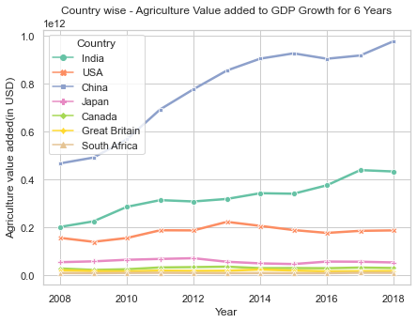

6. The above Line graph explains the analysis made on the Agriculture Valued added to the GDP of Seven rich countries based on Six years. Based on the year, the graph explains the highest GDP ratio of China in 2018 is 9.78 billion. The lowest changes were seen in the graphs for South Africa. The above graph shows that USA and China have increasing trends and that economic growth as measured by GDP is proportional to the degrowth movement which is supported by the fact that it has a negative impact on society and the environment.

Figure 6 Female Employment in Industry for Economy Growth Analysis using Tabular Format:

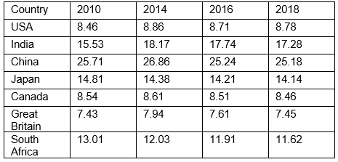

6. The above table shows the data on how Female employment alleviated. For Female employment, the data explains about four years were from 2010, 2014, 2016, and 2018. By this analysis, we can observe that the numbers are in incrementing order over the years which added 8% to 25% value to the Economic growth of 6 countries.