REQUEST FOR PROPOSAL (RFP-Wizard Ver. 1.0)

SOFTWAREREQUIREMENT SPECIFICATION

For RFP-Wizard

Version 1.0

DesignedandDeveloped By: -

**VEDANT TECH SOLUTIONS**

Contents

1. INTRODUCTION 3

1.1 Purpose of the documents 3

1.2 Scope of the documents 3

1.3 About the Software 3

1.4 Definitions and Acronyms 3

2 SCOPE OF WORK 4

2.1 Top Level Requirements 4

2.2 Detail Requirements 4

2.2.1 System Requirement 4

2.3 Functional Requirements 6

2.4 Use Cases Admin Module 6

2.5 Use Cases Master Module………………………………………………………………………………………12

2.6 Use cases Demand Module………………………………………………………………………………….…36

Use Cases Print Page……………………………………………………………………………………………66

2.7 Table Description…………………………………………………………………………………………………..67

# 1. INTRODUCTION

## 1.1 Purpose of the documents

This is the Software Requirement Specification Document for defining the application development for automation of RFP-Wizard. This system shall be implemented as web Based application.

## 1.2 Scope of the documents

The document’s scope covers the Requirements for RFP-Wizard process automation.

## 1.3 About the Software

Request for Proposal (RFP-Wizard Ver. 1.0) is an application designed and developed by Vedant Tech Solutions, Bangalore for DRDO and LRDE. RFP-Wizard is Java based front end application and MYSQL server-based backend.

## 1.4 Definitions and Acronyms

|  |  |
| --- | --- |
|  |  |
|  |  |
|  |  |
|  |  |
|  |  |
|  |  |
|  |  |

# 2 SCOPE OF WORK

## 2.1 Top Level Requirements

| Requirement Id | Name | Use Case |
| --- | --- | --- |
| REQ001 | Admin Module | 2.4, 2.4.1, 2.4.2, 2.4.3, |
| REQ002 | Master Module | 2.5, 2.5.1, 2.5.2, 2.5.3, 2.5.4, 2.5.5, 2.5.6, 2.5.7, 2.5.8, 2.5.9, 2.5.10, 2.5.11, |
| REQ003 | Demand Module | 2.6, 2.6.1, 2.6.2, 2.6.3, 2.6.4, 2.6.5, 2.6.6, 2.6.7, 2.6.8, 2.6.9, 2.6.10, 2.6.11, 2.6.12, |

### 2.2 Detail Requirement

### 2.2.1 System Requirement

1. System should be web based
2. System should support all latest browsers (Mozilla, IE, Chrome etc.)
3. System should run on windows OS.

**Login Interface:**

All the users will see the same login page when they enter RFP-Wizard system. This page asks the users a Username and Password.

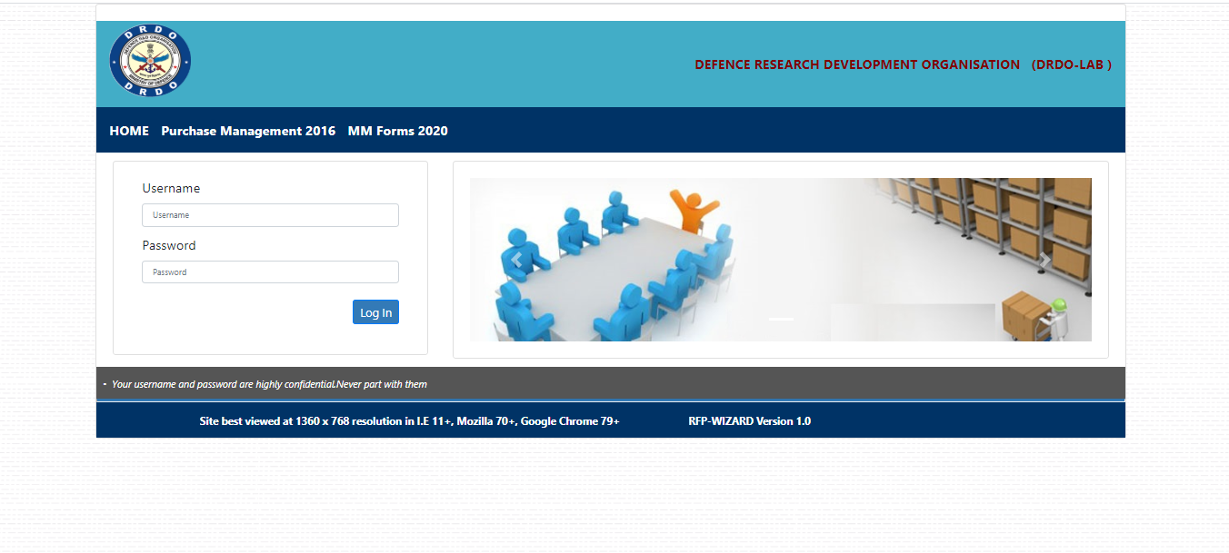

Fig 1. Login Interface

**Dashboard Interface:**

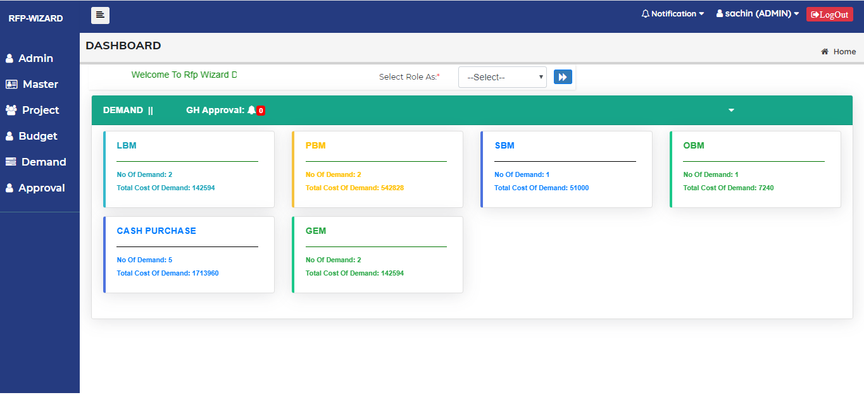

Fig 2. Dashboard Interface

## 2.3 Functional Requirements

#### 2.4 Use Cases- Admin Module

## User interface

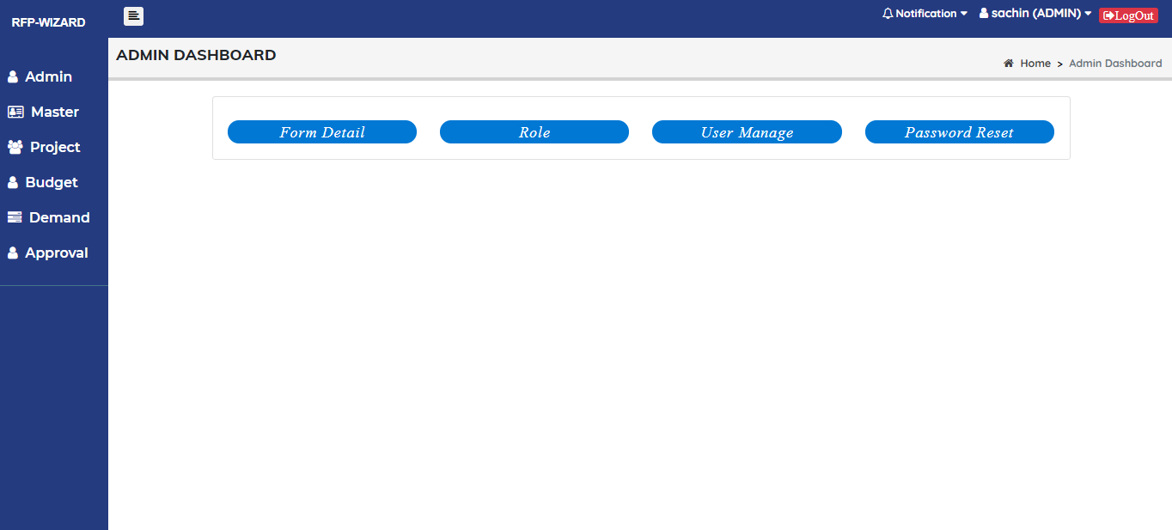

Fig 3. Admin Dashboard

|  |  |
| --- | --- |
| **Title** | **Admin** |
| **Primary actors** | Admin |
| **Secondary actors** |  |
| **Description** | This module is to add Role, Manage Users and Reset the password. |
| **Notes** | 1. Provision to manage Role. 2. Provision to manage User. 3. Provision to manage Password. |
| **Linked Requirement** | REQ001 – Admin should be able to Manage Role, Manage User and Password. |

#### 2.4.1. Use case – Role

## User interface

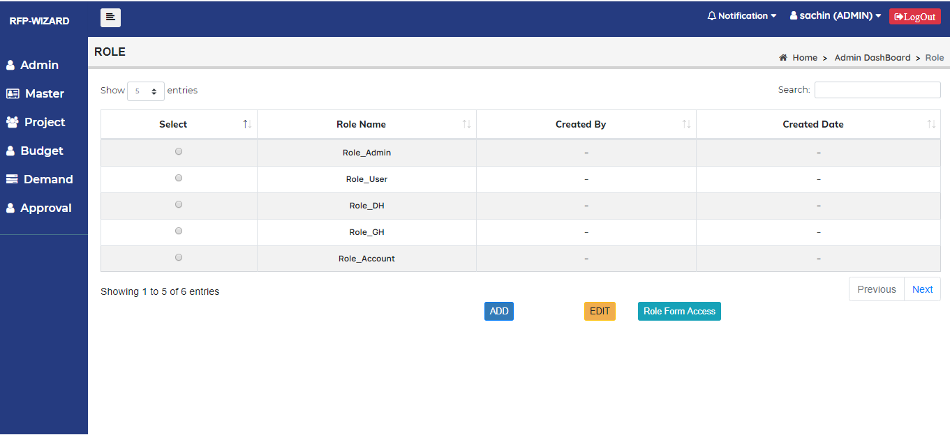

Fig 4. Role interface

* This module is to Add, Edit and assign Role to the users.

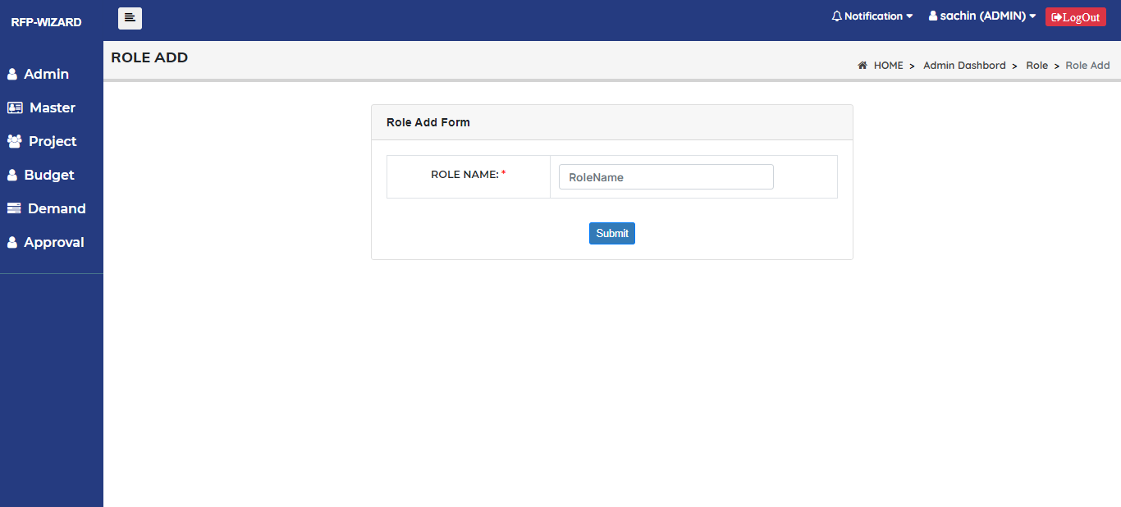

Fig 5. Add Role interface

|  |  |
| --- | --- |
| **Title** | **Add Role** |
| **Primary actors** | Admin |
| **Secondary actors** |  |
| **Description** | This module is to Add Role. |
| **Conditions** | **Role Name:**   * Should be Text box, It should Accept Alphanumeric character. |
| **Notes** | Role Name |
| **Mandatory fields** | Role name |
| **Linked Requirement** | REQ001 – Admin should be able to Add Roles. |

## User interface: Role Form Access

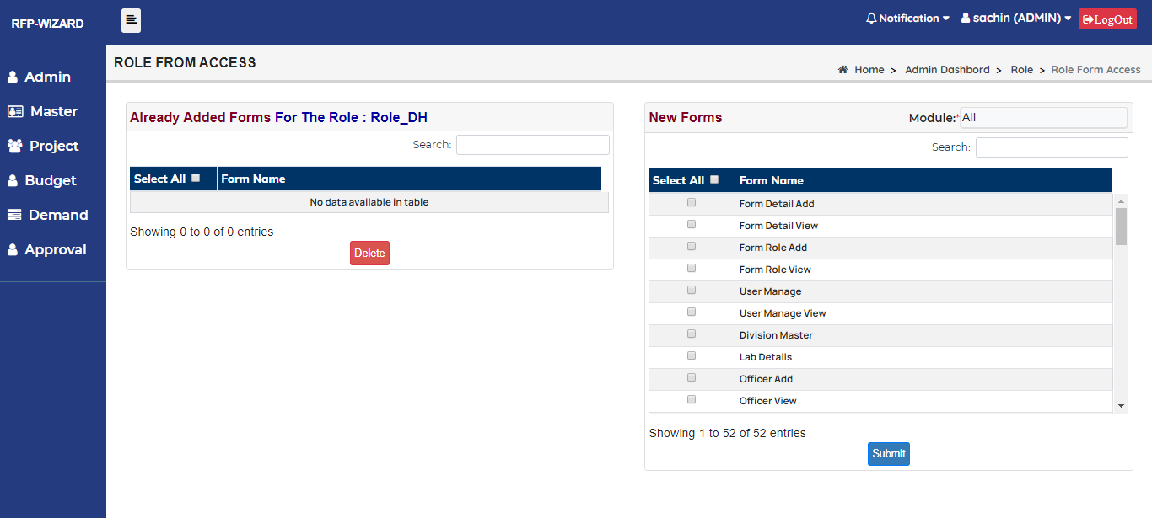

Fig 6. Role Form Access interface

* This module is to assign Role Forms to the users.

#### 2.4.2. Use case – User Manage

## User interface: User Manage List

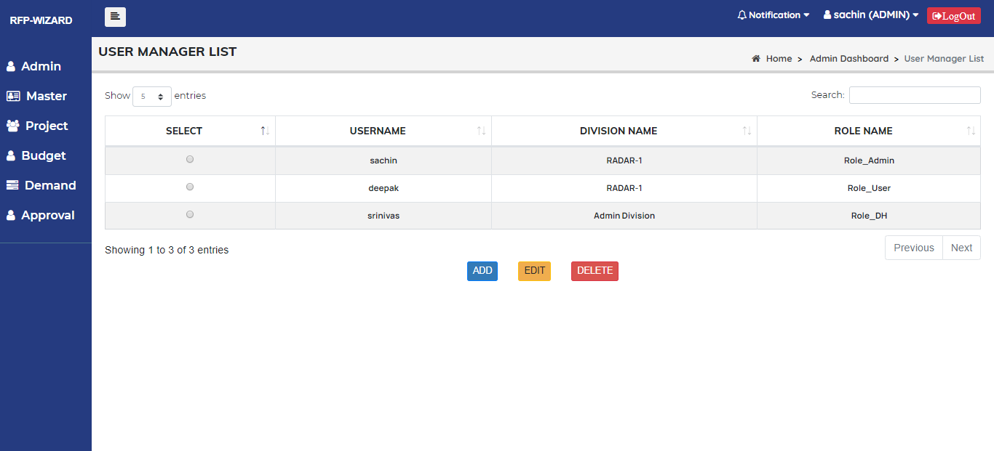

Fig 7. User Manage list interface

* This module is to Add, Edit and Delete users.

## User interface: User Manage ADD

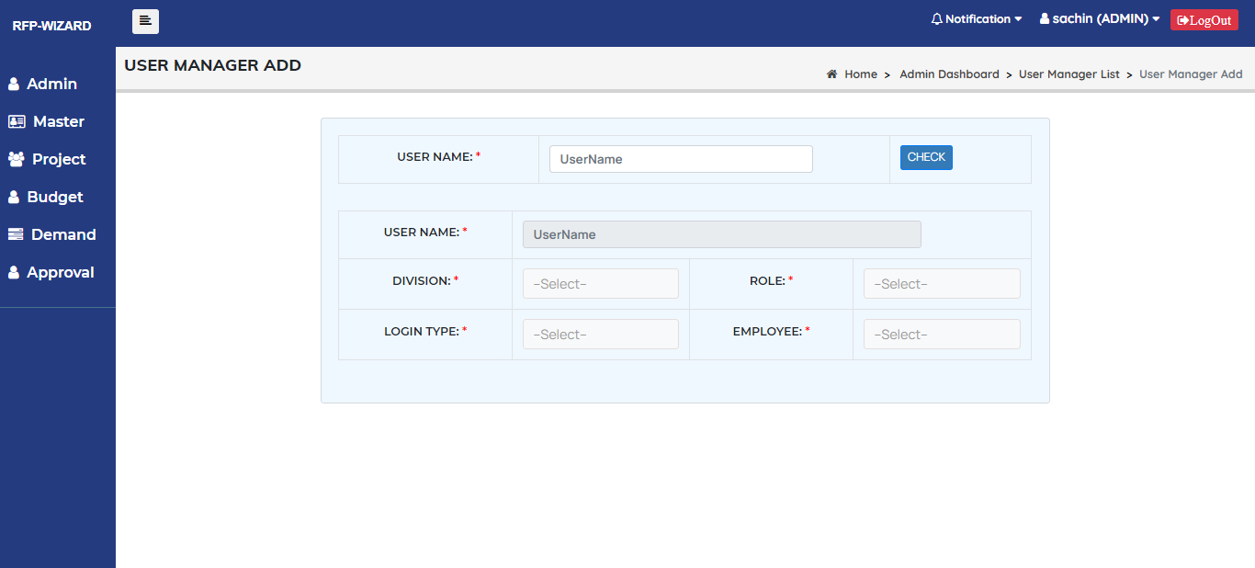

Fig 8. User Manage Add interface

|  |  |
| --- | --- |
| **Title** | **User Manager Add** |
| **Primary actors** | Admin |
| **Secondary actors** |  |
| **Description** | This module is to add user details. |
| **Notes** | User Name, Division, Role, Login Type and Employee. |
| **Conditions** | **User Name:**   * Should be Text box, Should Accept Alphanumeric character. * It should not accept duplicate username.   **Division:**   * Should be drop down   **Role:**   * Should be drop down   **Login Type:**   * Should be drop down   **Employee:**   * Should be drop down |
| **Mandatory fields** | User Name, Division, Role, Login Type and Employee. |
| **Linked Requirement** | REQ001 – Admin should be able to add User details. |

#### 2.4.3. Use case – Password Reset

## User interface

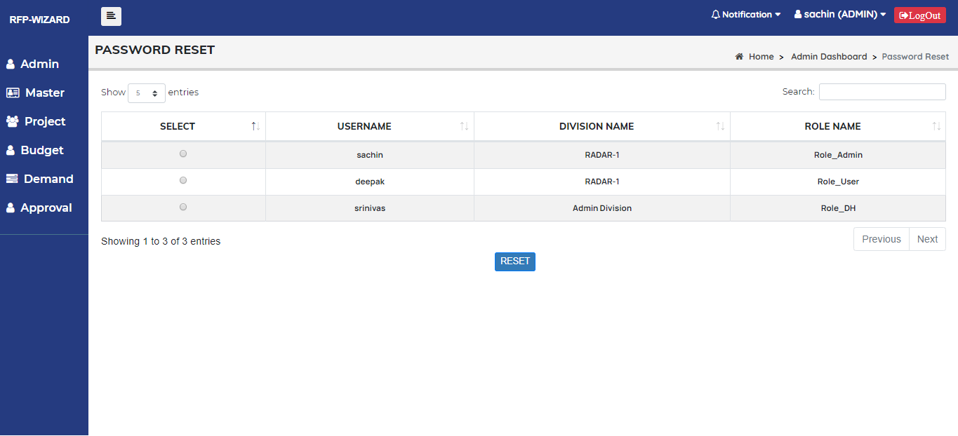

Fig 9. Password Reset interface

|  |  |
| --- | --- |
| **Title** | **Password Reset** |
| **Primary actors** | Admin |
| **Secondary actors** |  |
| **Description** | This module is use to Reset User password. |
| **Notes** |  |
| **Mandatory fields** |  |
| **Linked Requirement** | REQ001 – Admin should be able to Reset user password. |

#### 2.5 Use Cases- Master Module

## User interface

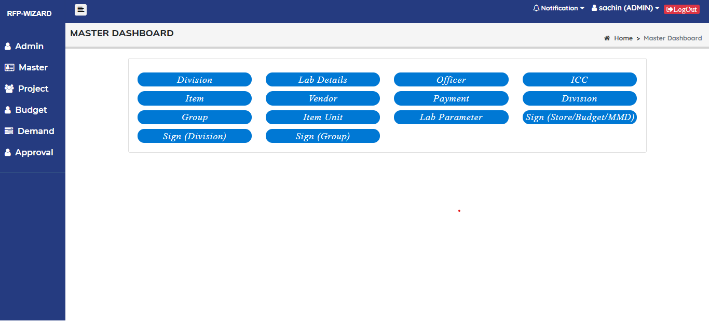

Fig 10. Master Dashboard interface

|  |  |
| --- | --- |
| **Title** | **Master Module** |
| **Primary actors** | Admin |
| **Secondary actors** |  |
| **Description** | This module is to Add Division, Lab details, Officer, ICC, Item, Vendor, Payment, Group, Item Unit, Lab Parameter and Sign Authorities. |
| **Notes** | 1. Provision to manage Division. 2. Provision to manage Lab details. 3. Provision to manage Officer details. 4. Provision to manage ICC. 5. Provision to manage Item details. 6. Provision to manage Item Unit details. 7. Provision to manage Vendor details. 8. Provision to manage Payment details. 9. Provision to manage Group details. 10. Provision to manage Sign Authority. |
| **Mandatory fields** |  |
| **Linked Requirement** | REQ002 – Admin should be able to manage Master Module. |

#### 2.5.1 Use Cases- Division Module

## User interface

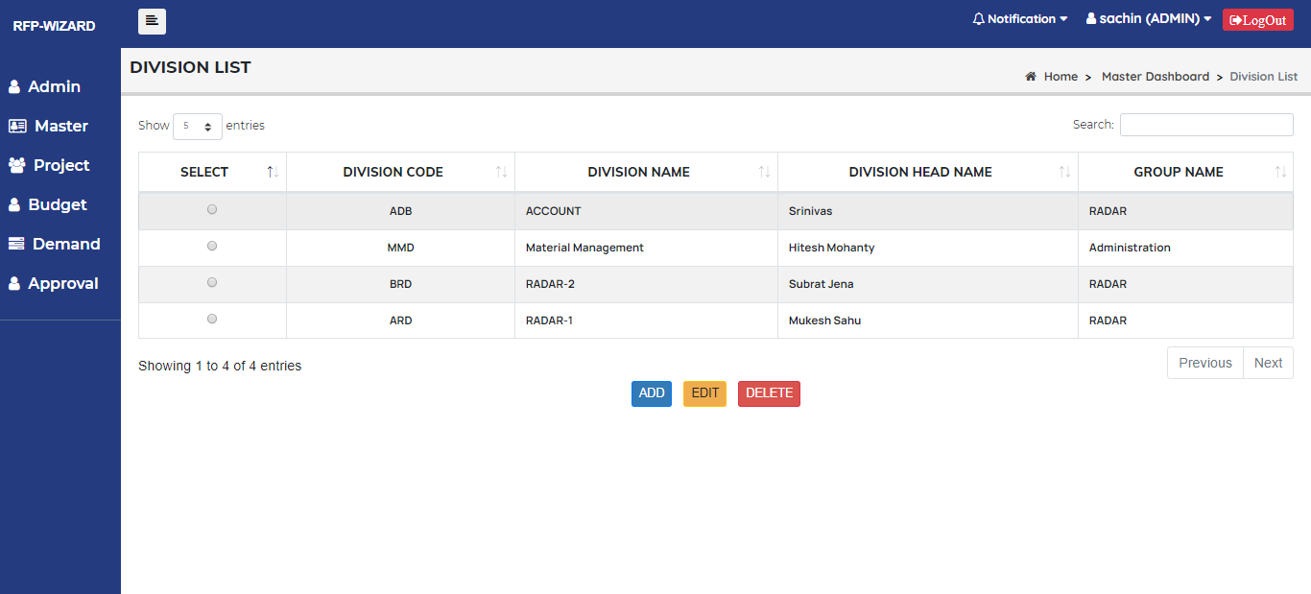

Fig 11. Division List interface

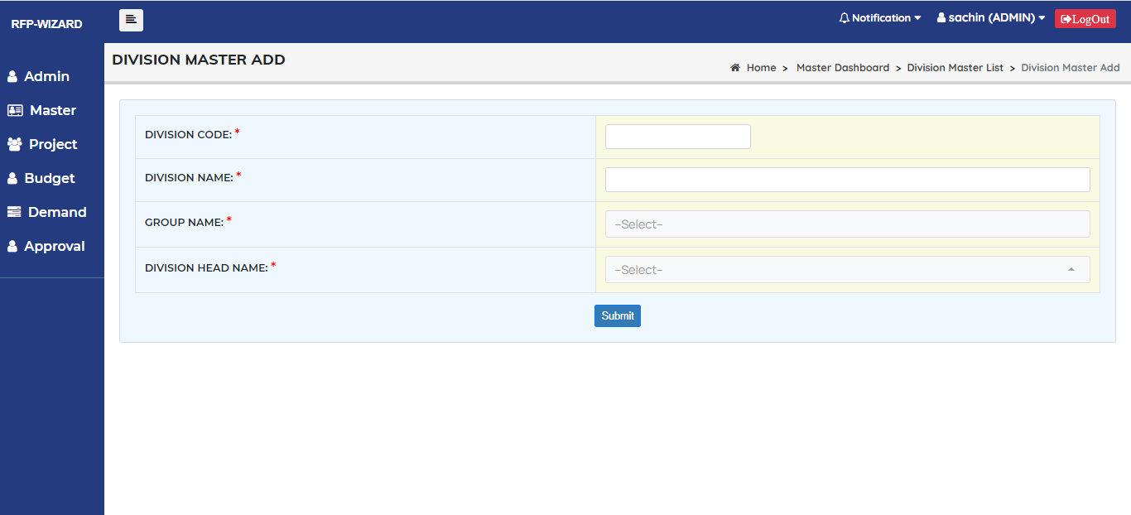

Fig 12. Division Master Add interface

|  |  |
| --- | --- |
| **Title** | **Division** |
| **Primary actors** | Admin |
| **Secondary actors** |  |
| **Description** | This module is to Add, Edit and delete Division details. |
| **Notes** | Division Code, Division Name, Group Name, Division Head Name. |
| **Mandatory fields** | All fields are mandatory. |
| **Linked Requirement** | REQ002 – Admin should be able to manage Division details. |

|  |  |
| --- | --- |
| **Fields** | **Conditions** |
| **Division Code** | It should be text box and it should Accept Alphanumeric character. |
| **Division Name** | It should be text box and it should Accept Alphanumeric character. |
| **Group Name** | It should be drop down and it should Display Employee list. |
| **Division Head Name** | It should be drop down and it should Display Division Employee list. |

#### 2.5.2 Use Cases- Lab details Module

## User interface

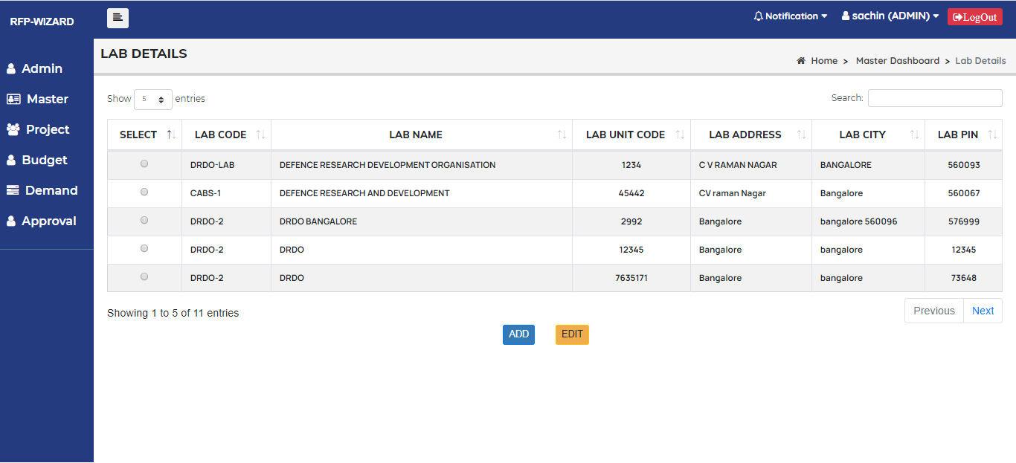

Fig 13. Lab details list interface

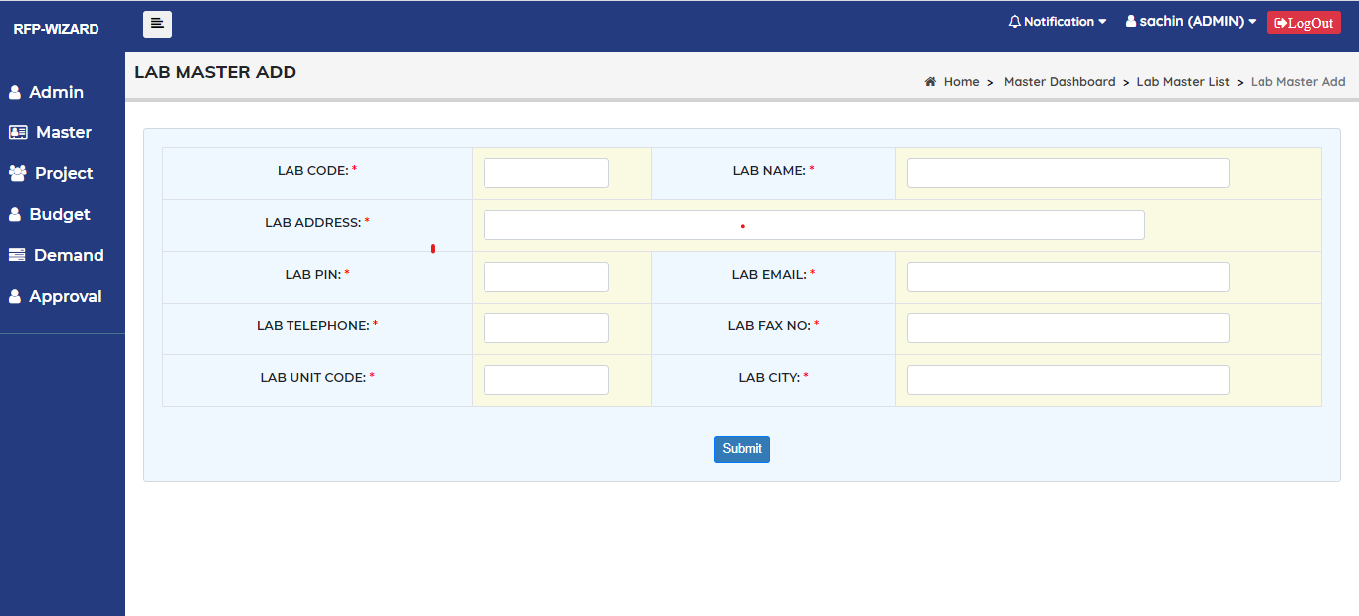

Fig 14. Lab details add interface

|  |  |
| --- | --- |
| **Title** | **Lab details** |
| **Primary actors** | Admin |
| **Secondary actors** |  |
| **Description** | This module is to Add, Edit and delete Lab details. |
| **Notes** | Lab Code, Lab Name, Lab Address, Lab Pin, Lab Email, Lab Telephone, Lab Fax No, Lab Unit Code, Lab city. |
| **Mandatory fields** | All fields are mandatory. |
| **Linked Requirement** | REQ002 – Admin should be able to manage Lab details. |

|  |  |
| --- | --- |
| **Fields** | **Conditions** |
| **Lab Code** | It should be text box and it should Accept Alphanumeric character. |
| **Lab Name** | It should be text box and it should Accept Alphanumeric character. |
| **Lab Address** | It should be Text box and it should Accept alphanumeric character. |
| **Lab City** | It should be Text box and it should Accept alphanumeric character. |
| **Lab Email** | It should be Text box and it should Accept alphanumeric character. |
| **Lab Pin** | It should be Text box and it should accept only Positive Numbers but It cannot be more than 6 digits. |
| **Lab Unit Code** | It should be Text box and it should Accept alphanumeric character |
| **Lab Telephone** | It should be Text box and it should accept only positive numbers. |
| **Lab Fax No** | It should be Text box and it should accept alphanumeric character. |

#### 2.5.3 Use Cases- Officer Module

## User interface

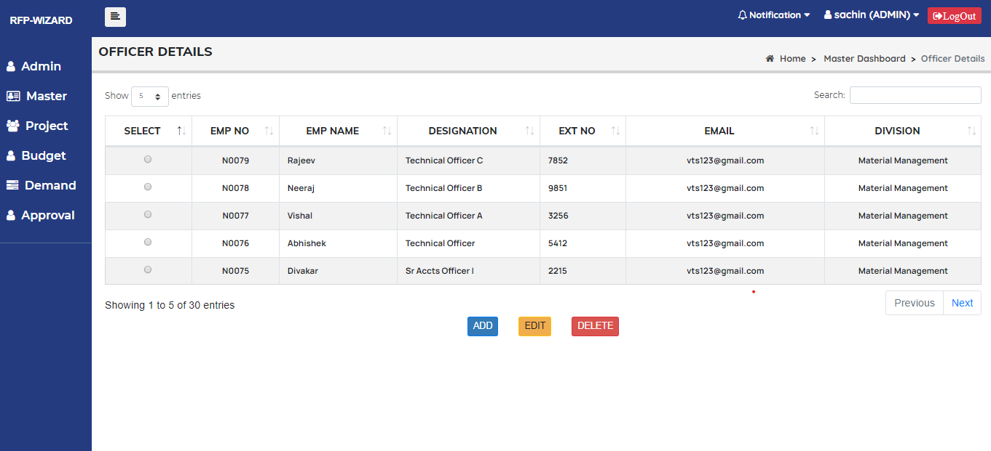

Fig 15. Officer details list interface

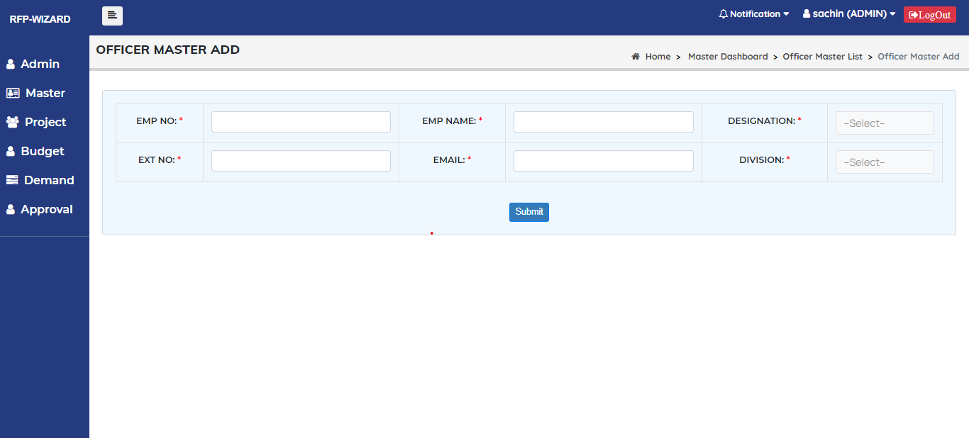

Fig 16. Officer details add interface

|  |  |
| --- | --- |
| **Title** | **Officer details** |
| **Primary actors** | Admin |
| **Secondary actors** |  |
| **Description** | This module is to Add, Edit and delete Officer details. |
| **Notes** | Emp No, Emp Name, Designation, EXT No, Email, Division. |
| **Mandatory fields** | All fields are mandatory. |
| **Linked Requirement** | REQ002 – Admin should be able to manage Officer details. |

|  |  |
| --- | --- |
| **Fields** | **Conditions** |
| **Emp No** | It should be text box and it should Accept Alphanumeric character. |
| **Emp Name** | It should be text box and it should Accept Alphanumeric character. |
| **Designation** | It should be Drop down and it should display designations list. |
| **EXT No** | It should be Text box and it should Accept only positive Numbers. |
| **Email** | It should be Text box and it should Accept alphanumeric character |
| **Division** | It should be Drop down and It should display division list. |

#### 2.5.4 Use Cases- ICC Module

## User interface

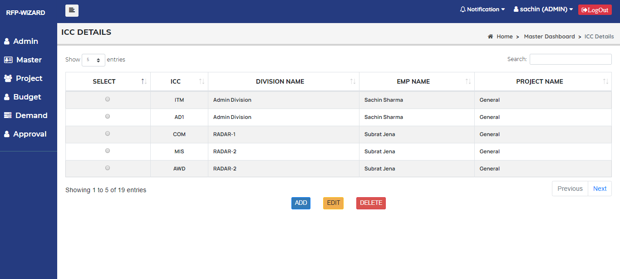

Fig 17. ICC details list interface

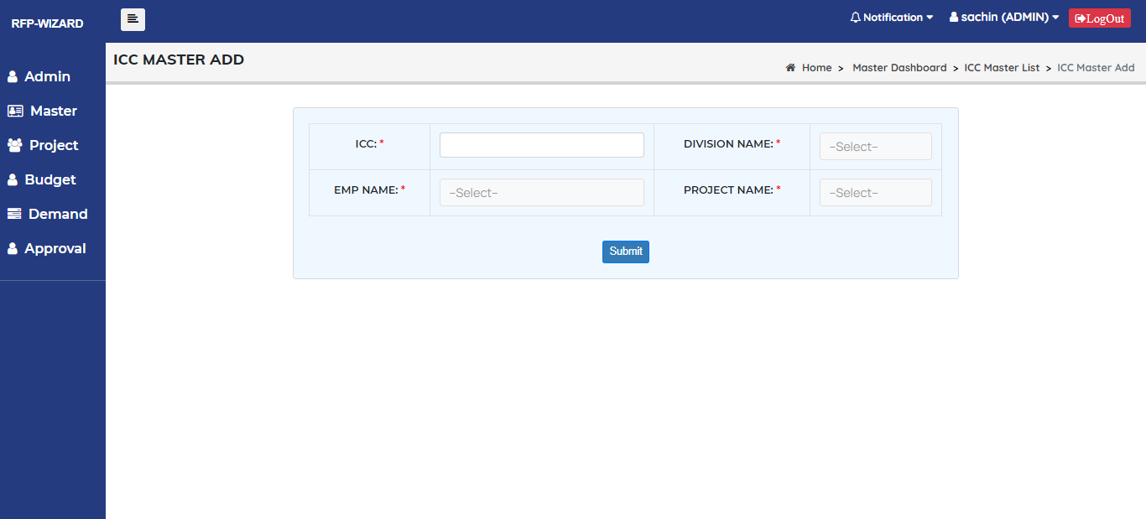

Fig 18. ICC details add interface

|  |  |
| --- | --- |
| **Title** | **ICC details** |
| **Primary actors** | Admin |
| **Secondary actors** |  |
| **Description** | This module is to Add, Edit and delete ICC details. |
| **Notes** | ICC, Division Name, Emp Name, Project Name. |
| **Mandatory fields** | All fields are mandatory. |
| **Linked Requirement** | REQ002 – Admin should be able to manage ICC details. |

|  |  |
| --- | --- |
| **Fields** | **Conditions** |
| **ICC** | It should be text box and it should Accept Alphanumeric character but It cannot be more than 3 digits. |
| **Division Name** | It should be drop down and it should display division list. |
| **Emp Name** | It should be Drop down and it should display Emp list. |
| **Project Name** | It should be Drop down and it should display Project list. |

#### 2.5.5 Use Cases- Item Module

## User interface

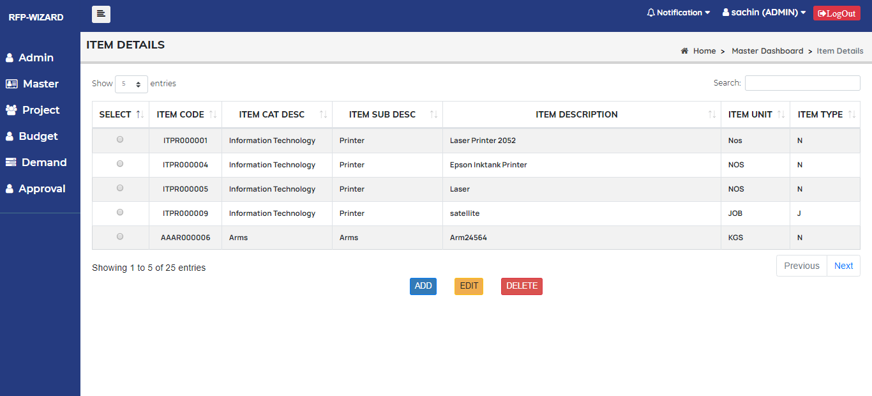

Fig 19. Item details list interface

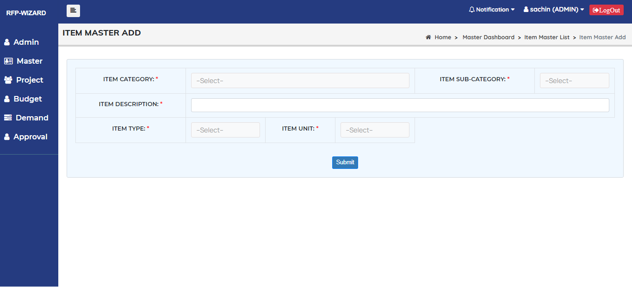

Fig 20. Item details add interface

|  |  |
| --- | --- |
| **Title** | **Item details** |
| **Primary actors** | Admin |
| **Secondary actors** |  |
| **Description** | This module is to Add, Edit and delete Item details. |
| **Notes** | Item category, Item Sub-Category, Item Description, Item Unit, Item Type. |
| **Mandatory fields** | All fields are mandatory. |
| **Linked Requirement** | REQ002 – Admin should be able to manage Item details. |

|  |  |
| --- | --- |
| **Fields** | **Conditions** |
| **Item Category** | It should be drop down and it should display Category list. |
| **Item Sub-Category** | It should be drop down and it should display Sub-Category list. |
| **Item description** | It should be Text box and it should accept alphanumeric character. |
| **Item Unit** | It should be drop down and It should display item unit list. |
| **Item Type** | It should be drop down and it should display item Type list. |

#### 2.5.6 Use Cases- Vendor Module

## User interface

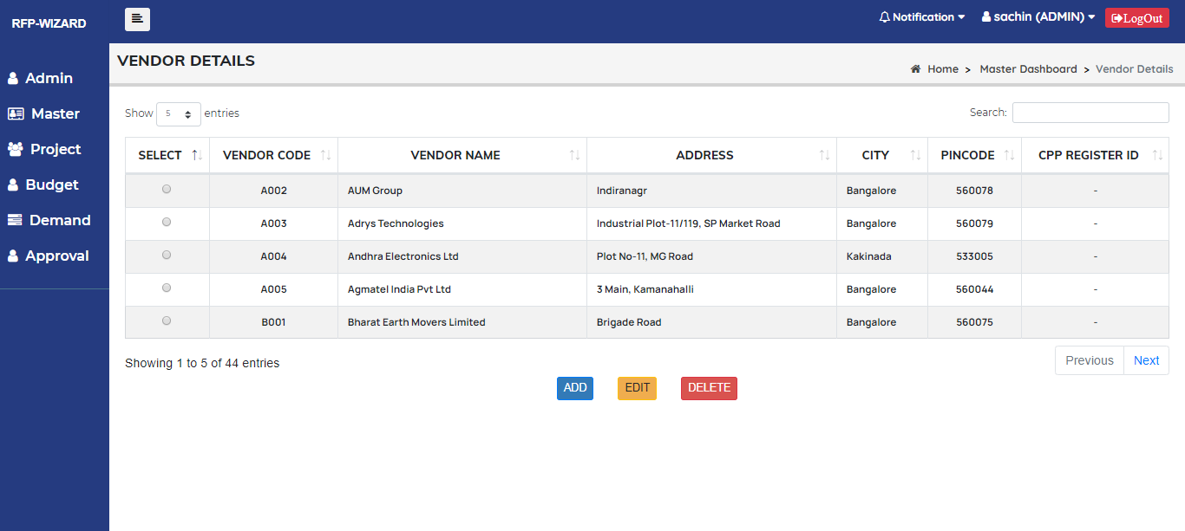

Fig 21. Vendor details list interface

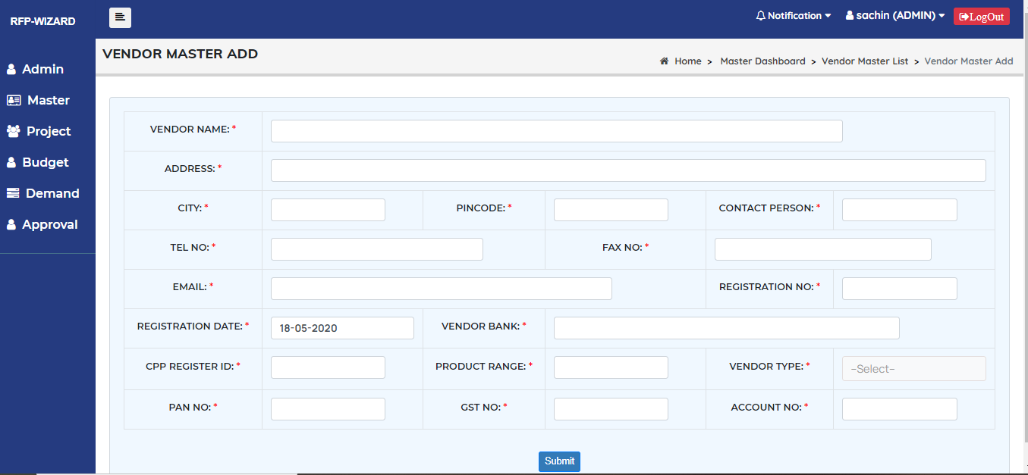

Fig 22. Vendor details add interface

|  |  |
| --- | --- |
| **Title** | **Vendor** |
| **Primary actors** | Admin |
| **Secondary actors** |  |
| **Description** | This module is to Add, Edit and delete vendor details. |
| **Notes** | Vendor Name, Address, City, Pin Code, Contact Person, Tel No, Fax No, Email, Registration No, Registration Date, Vendor Bank, CPP Register ID, Product Range, Vendor Type, PAN No, GST No, Account No. |
| **Mandatory fields** | All fields are mandatory. |
| **Linked Requirement** | REQ002 – Admin should be able to manage Vendor details. |

|  |  |
| --- | --- |
| **Fields** | **Conditions** |
| **Vendor Name** | It should be Text box and It should accept alphanumeric character. |
| **Address** | It should be Text box and it should accept alphanumeric character. |
| **City** | It should be Text box and it should accept alphanumeric character. |
| **Pin Code** | It should be Text box and it should accept only positive numbers but cannot be more than 6 digits. |
| **Contact Person** | It should be Text box and it should accept alphanumeric character. |
| **Tel No** | It should be Text box and it should Accept only Positive Numbers. |
| **Fax No** | It should be Text box and it should accept alphanumeric character. |
| **Email** | It should be Text box and It should accept alphanumeric character. |
| **Registration No** | It should be Text box and it should accept alphanumeric character. |
| **Registration Date** | It should be calendar and by default, it should be current date. |
| **Vendor Bank** | It should be Text box and it should accept alphanumeric character. |
| **CPP Register Id** | It should be Text box and it should accept alphanumeric character. |
| **Product Range** | It should be Text box and it should accept alphanumeric character. |
| **Vendor Type** | It should be drop down and it should display vendor type list. |
| **PAN No** | It should be Text box and It should accept alphanumeric character but cannot be more than 10 digits. |
| **GST No** | It should be Text box and it should accept alphanumeric character. |
| **Account No** | It should be Text box and it should accept only positive Numbers. |

#### 2.5.7 Use Cases- Payment Module

## User interface

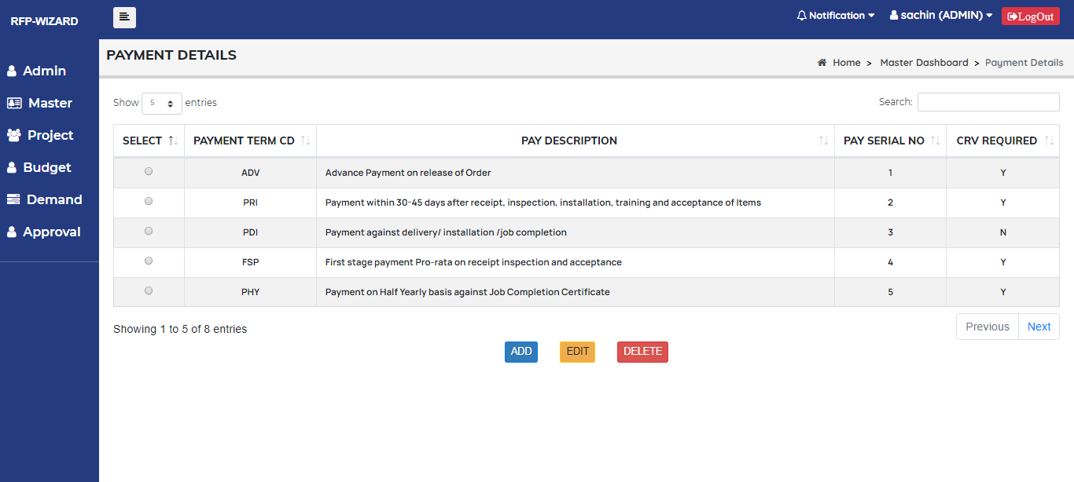

Fig 23. Payment details list interface

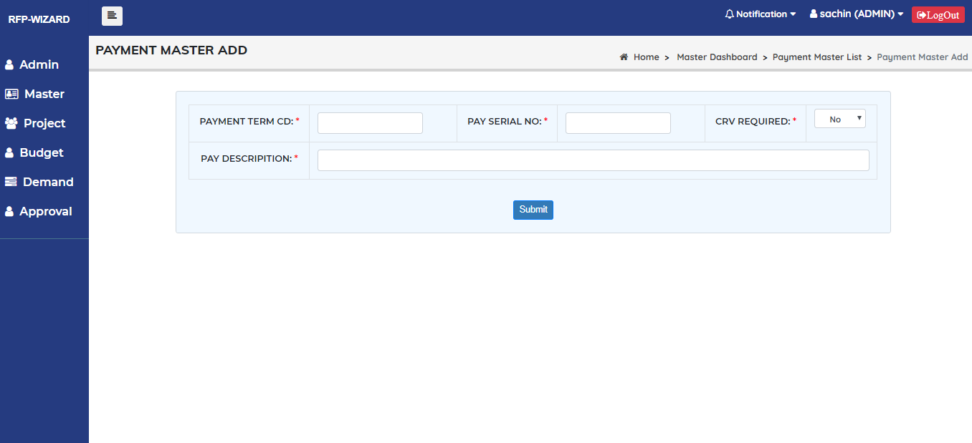

Fig 24. Payment details add interface

|  |  |
| --- | --- |
| **Title** | **Payment** |
| **Primary actors** | Admin |
| **Secondary actors** |  |
| **Description** | This module is to Add, Edit and delete Payment details. |
| **Notes** | Payment term Cd, Pay Serial No, CRV Required, Pay Description. |
| **Mandatory fields** | All fields are mandatory. |
| **Linked Requirement** | REQ002 – Admin should be able to manage Payment details. |

|  |  |
| --- | --- |
| **Fields** | **Conditions** |
| **Payment term Cd** | It should be Text box and it should accept alphanumeric characters but cannot be more than 3 digits. |
| **Pay Serial No** | It should be Text box and it should accept only positive Numbers. |
| **CRV Required** | It should be drop down and It should display Yes or No. |
| **Pay description** | It should be Text box and it should accept alphanumeric characters. |

#### 2.5.8 Use Cases- Item Unit Module

## User interface

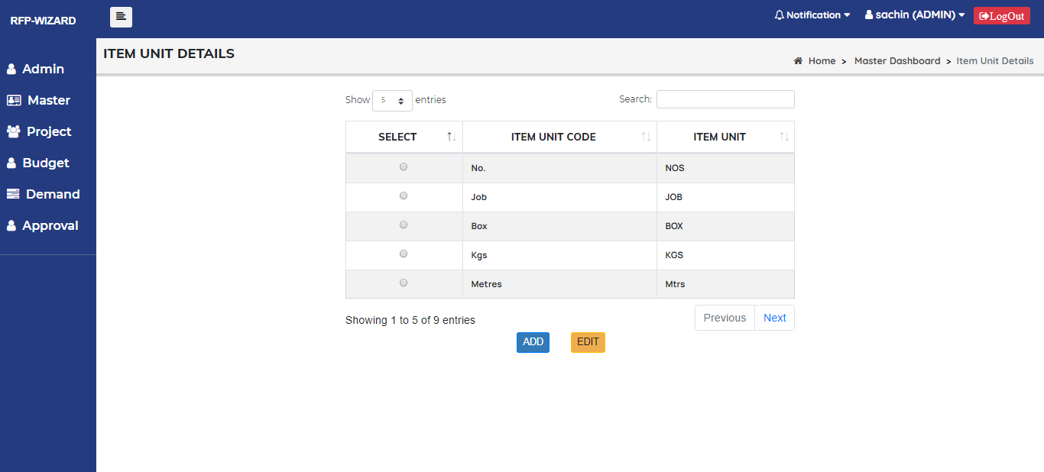

Fig 25. Item Unit details interface

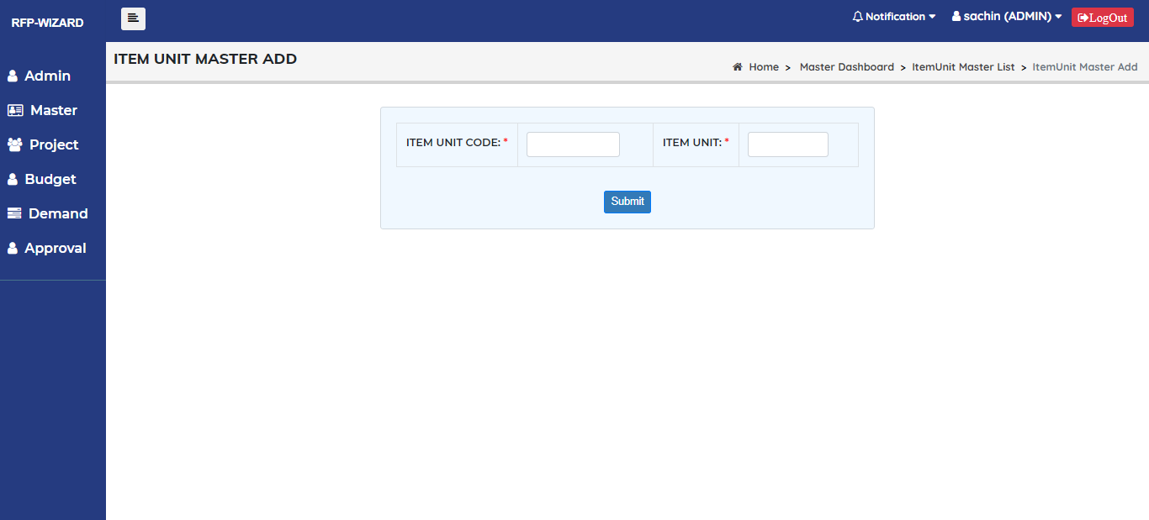

Fig 26. Item Unit details add interface

|  |  |
| --- | --- |
| **Title** | **Item Unit** |
| **Primary actors** | Admin |
| **Secondary actors** |  |
| **Description** | This module is to Add, Edit Item Unit details. |
| **Notes** | Item Unit Code, Item Unit |
| **Mandatory fields** | All fields are mandatory. |
| **Linked Requirement** | REQ002 – Admin should be able to manage Item Unit details. |

|  |  |
| --- | --- |
| **Fields** | **Conditions** |
| **Item Unit Code** | It should be Text box and it should be alphanumeric. |
| **Item Unit** | It should be Text box and it should be alphanumeric. |

#### 2.5.9 Use Cases- Lab Parameter Module

## User interface

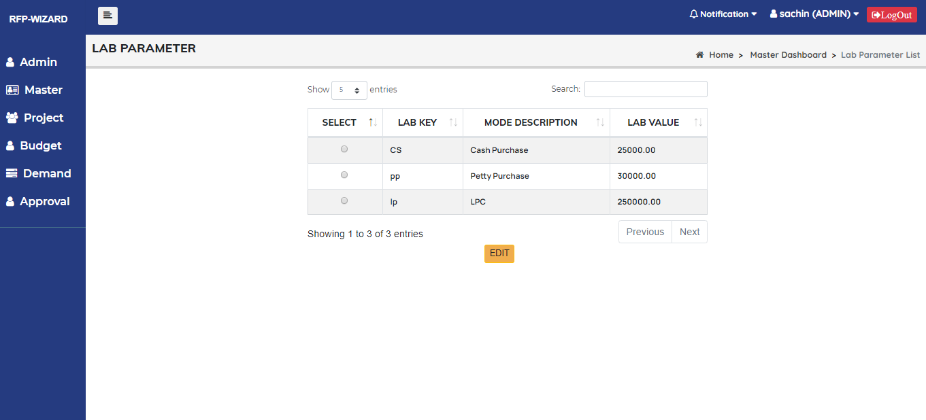

Fig 27. Lab parameter details interface

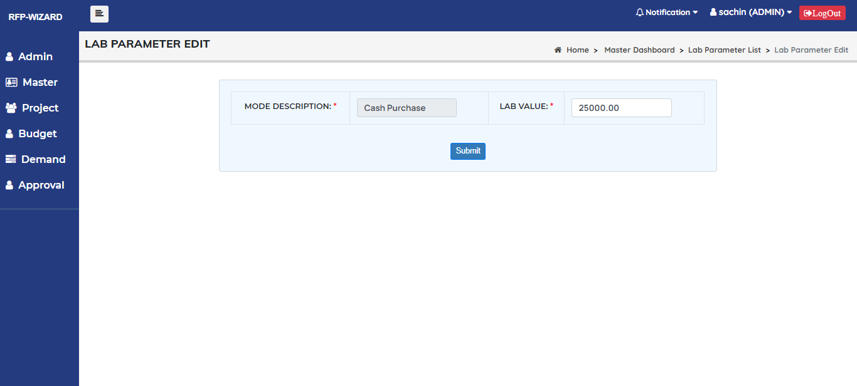

Fig 28. Lab parameter details Edit interface

|  |  |
| --- | --- |
| **Title** | **Lab Parameter** |
| **Primary actors** | Admin |
| **Secondary actors** |  |
| **Description** | This module is to Edit Lab parameter details. |
| **Notes** | Lab Value |
| **Mandatory fields** |  |
| **Linked Requirement** | REQ002 – Admin should be able to manage Lab parameter details. |

|  |  |
| --- | --- |
| **Fields** | **Conditions** |
| **Lab Value** | It should be Text box and it should accept only positive Numbers. |

#### 2.5.10 Use Cases- Sign Authority (Division)

## User interface

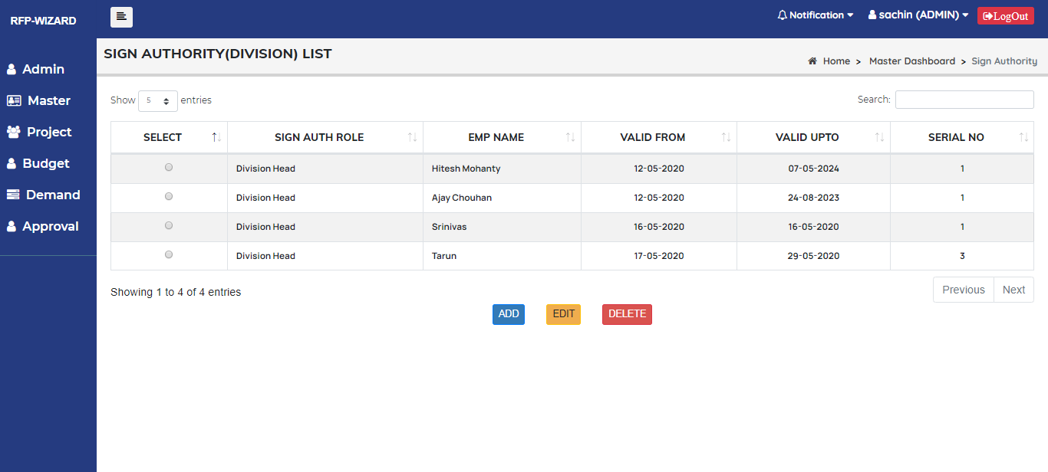

Fig 29. Sign Authority (Division) list interface

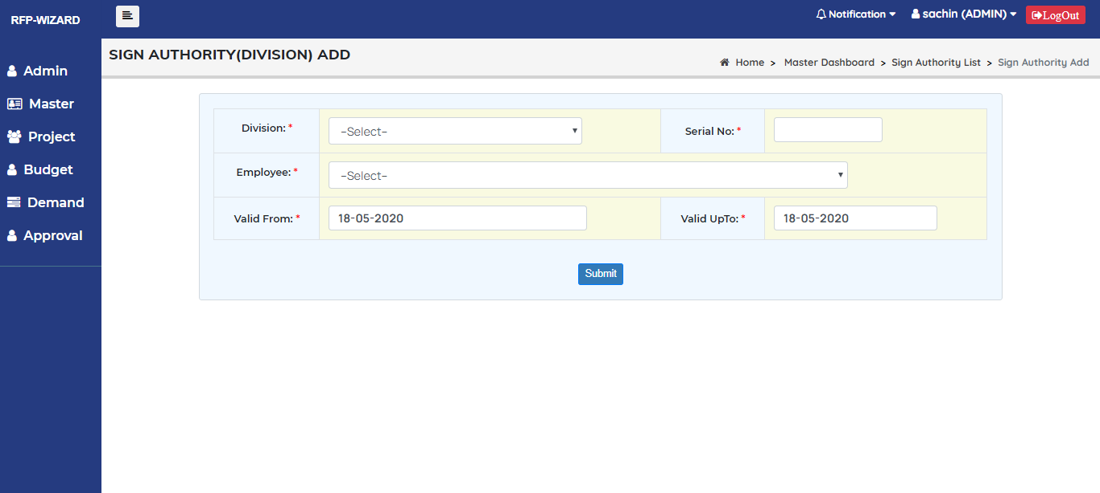

Fig 30. Sign Authority (Division) add interface

|  |  |
| --- | --- |
| **Title** | **Sign Authority (Division)** |
| **Primary actors** | Admin |
| **Secondary actors** |  |
| **Description** | This module is to Add, Edit, and delete Sign Authority details. |
| **Notes** | Division, Serial No, Employee, Valid from, Valid Up to. |
| **Mandatory fields** | All fields are mandatory |
| **Linked Requirement** | REQ002 – Admin should be able to manage Sign Authority (division) details. |

|  |  |
| --- | --- |
| **Fields** | **Conditions** |
| **Division** | It should be drop down and it should display divisions list. |
| **Serial No** | It should be Text box and it should accept only positive Numbers. |
| **Employee** | It should be drop down and it should display selected division employees list. |
| **Valid from** | It should be Calendar and by default, it should be current date. |
| **Valid Upto** | It should be Calendar and Date cannot be less than Valid from date. |

#### 2.5.11 Use Cases- Sign Authority (Budget/MMG/STORE)

## User interface

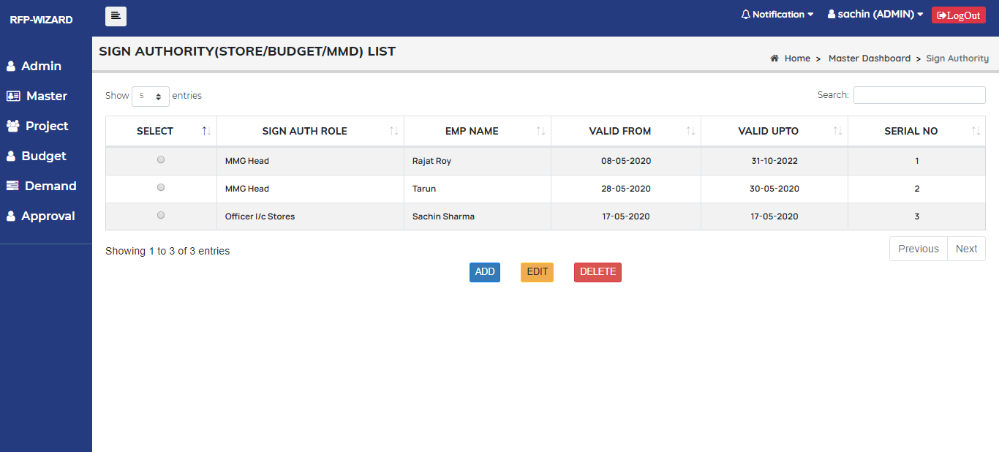

Fig 31. Sign Authority (Store/MMG/Budget) list interface

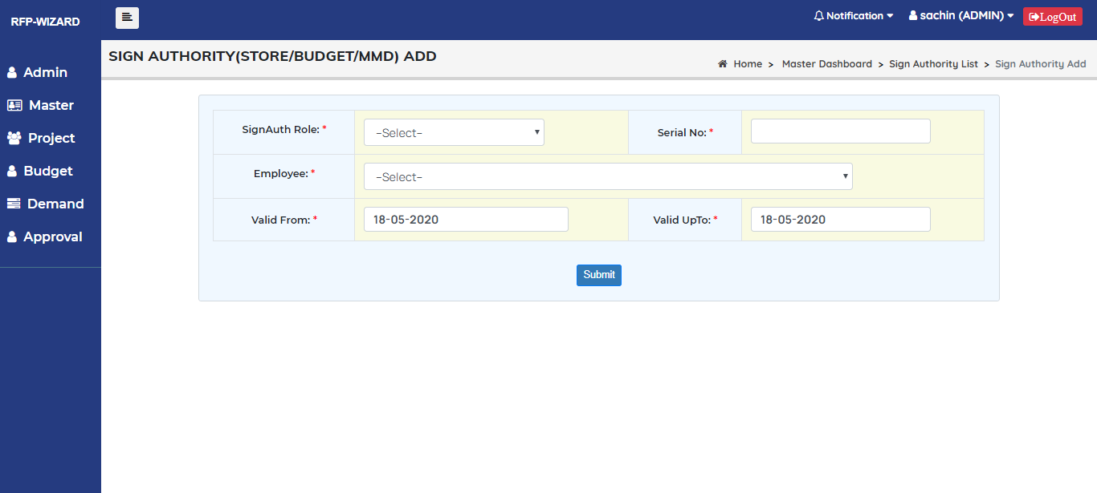

Fig 32. Sign Authority (Store/MMG/Budget) add interface

|  |  |
| --- | --- |
| **Title** | **Sign Authority (Store/MMG/Budget)** |
| **Primary actors** | Admin |
| **Secondary actors** |  |
| **Description** | This module is to Add, Edit, and delete Sign Authority (Store/MMG/Budget) details. |
| **Notes** | Sign Authority Role, Serial No, Employee, Valid from, Valid Up to. |
| **Mandatory fields** | All fields are mandatory |
| **Linked Requirement** | REQ002 – Admin should be able to manage Sign Authority (Store/budget/MMG) details. |

|  |  |
| --- | --- |
| **Fields** | **Conditions** |
| **Sign Authority Role** | It should be drop down and it should display Sign Authority roles list. |
| **Serial No** | It should be Text box and it should accept only positive Numbers. |
| **Employee** | It should be drop down and it should display employees list. |
| **Valid from** | It should be Calendar and by default, it should be current date. |
| **Valid Up to** | It should be Calendar and date cannot be less than Valid from date. |

#### 2.6 Use Cases- Demand Module

## User interface

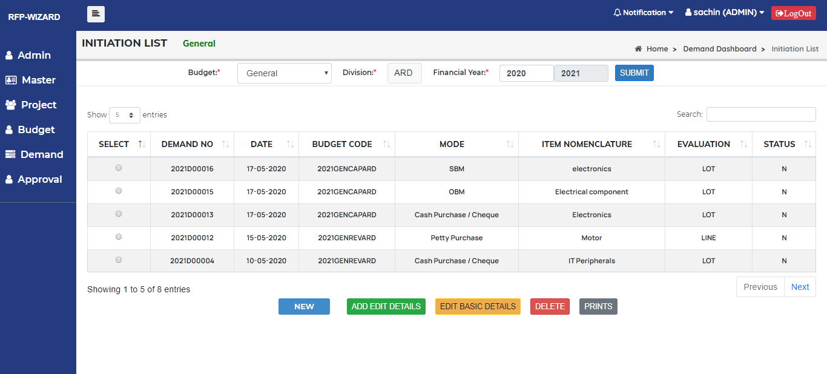

Fig 33. Demand Initiation list interface

|  |  |
| --- | --- |
| **Title** | **Demand** |
| **Primary actors** | Admin/User |
| **Secondary actors** |  |
| **Description** | This module is to Add, Edit, Change and delete demand details. |
| **Notes** | Budget, Division, Financial year. |
| **Mandatory fields** | All fields are mandatory |
| **Linked Requirement** | REQ003 – Admin/user should be able to manage Demand details. |

|  |  |
| --- | --- |
| **Fields** | **Conditions** |
| **Budget** | It should be drop down and it should display different budget list. |
| **Division** | It should be Drop down and it should display different division list.   1. For Admin it should display all divisions. 2. For User It should display his division only. |
| **Financial year** | It should be calendar and by default, it should be current year. |

* Demand list should display according to Budget, division and financial year.
* If Budget head is General It should display General item only, If Project It should display Project Items only.

#### 2.6 .1 Use Cases- Basic Details add

## User interface

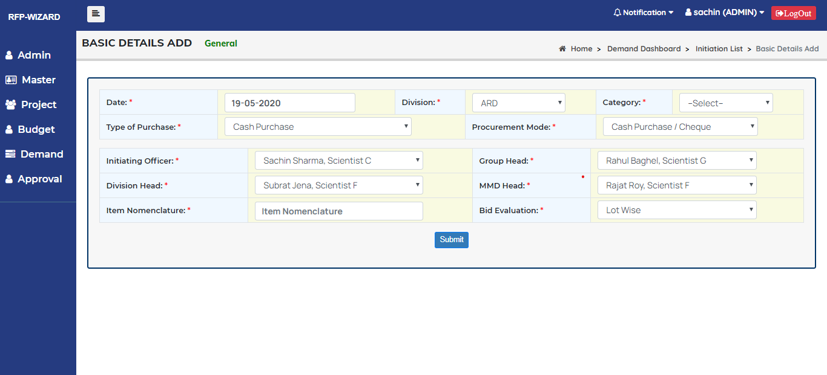

Fig 34. Basic details add interface

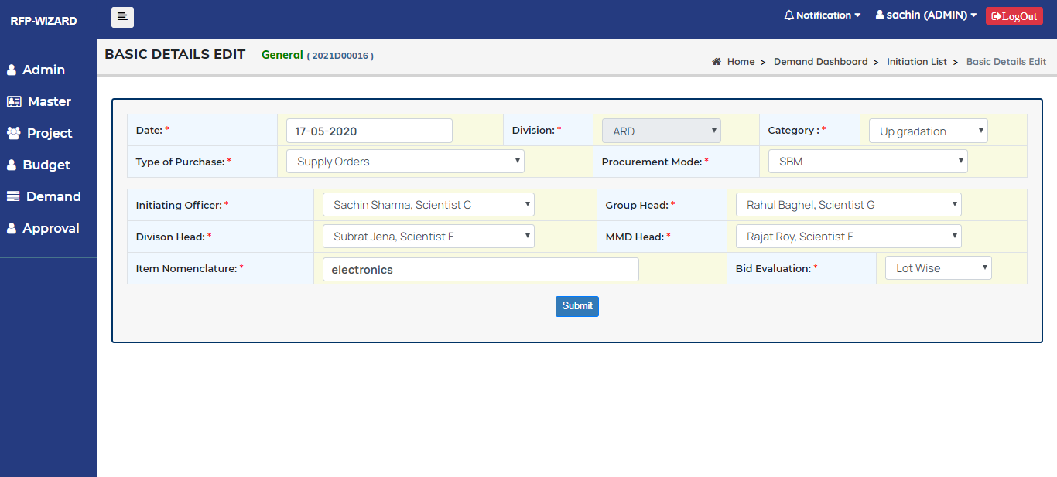

Fig 35. Basic details edit interface

|  |  |
| --- | --- |
| **Title** | **Demand add/edit** |
| **Primary actors** | Admin/User |
| **Secondary actors** |  |
| **Description** | This module is to Add/Edit demand details. |
| **Notes** | Date, Division, Category, Type of Purchase, Procurement Mode, initiating officer, Group head, Division Head, MMD Head, Item Nomenclature, Bid Evaluation. |
| **Mandatory fields** | All fields are mandatory |
| **Linked Requirement** | REQ003 – Admin/user should be able to manage Add/Edit Demand details. |

|  |  |
| --- | --- |
| **Fields** | **Conditions** |
| **Date** | It should be calendar and by default, it should be current date |
| **Division** | It should be Drop down and it should display divisions list.   1. For Admin it should display all divisions 2. For User It should display his division only |
| **Category** | It should be drop down and it should display Category list |
| **Type of Purchase** | It should be Drop down and it should display Type of Purchase list. |
| **Procurement mode** | It should be Drop down and it should display Mode list. |
| **Initiating Officer** | It should be Drop down and Initiating officer should be a login officer |
| **Group Head** | It should be Drop down and it should display Group Head list. |
| **Division Head** | It should be Drop down and it should display Division Head emp list. |
| **MMD Head** | It should be Drop down and it should display MMD Head list. |
| **Item Nomenclature** | It should be Text box and it should accept alphanumeric characters. |
| **Bid Evaluation** | It should be drop down and It should display Line Wise and Lot Wise. |

|  |  |
| --- | --- |
| **Bid Evaluation** | **Item Other Details** |
| Lot Wise | For all items, it should have Only one Item other details |
| Line Wise | Each item should have Item other details page |

**Conditions:**

|  |  |  |  |  |  |
| --- | --- | --- | --- | --- | --- |
| **Demand Method** | **Method description** | **Mode Applicable** | **Change to** | **Tender** | **Supplier** |
| CS | Cash Purchase | No | GM, PP | NO | NO |
| GM | GeM | No | CS, PP, SO, AM, SE | NO | NO |
| PP | Petty Purchase | No | CS, GM | NO | NO |
| SO | Supply Order | Yes | AM, SE, FE, DC, FC, GM | YES | EXCEPT op tender mode |
| AM | Maintenance Contracts | Yes | SO, SE, FE, DC, FC, GM | YES | EXCEPT op tender mode |
| SE | Service Orders | Yes | AM, SE, FE, DC, FC, GM | YES | EXCEPT op tender mode |
| FE | Imports (FE) | Yes | SO, AM, SE, DC, FC, GM | YES | EXCEPT op tender mode |
| DC | Development Contract | Yes | SO, AM, SE, FE, FC, GM | YES | EXCEPT op tender mode |
| FC | Fabrication Contract | Yes | SO, AM, SE, FE, DC, GM | YES | EXCEPT op tender mode |
| RC | Rate Contract | No | No Change | NO |  |
| CR | CARS | No | No Change | NO |  |
| PS | CAPSI | No | No Change | NO |  |
| SW | SWOD | No | No Change | NO |  |
| FI | Factory Indent | No | No Change | NO |  |

|  |  |
| --- | --- |
| **Procurement Mode** | **Vendor** |
| LPC | Three Vendors |
| LBM | Minimum 7 Vendors |
| PBM | One Vendor |
| SBM | One Vendor |
| OBM | No Vendor |

#### 2.6 .2 Use Cases- Other Details

## User interface

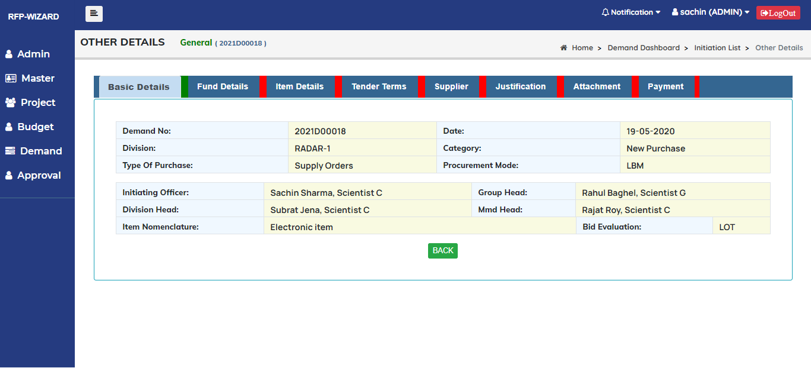

Fig 36. Other details interface

|  |  |
| --- | --- |
| **Title** | **Other details** |
| **Primary actors** | Admin/User |
| **Secondary actors** |  |
| **Description** | This module is to Add/Edit and delete other details. |
| **Notes** | Basic details, Fund details, Item details, Tender terms, Supplier, Justification, Attachments, Payment |
| **Mandatory fields** |  |
| **Linked Requirement** | REQ003 – Admin/user should be able to manage Add/Edit Other details. |

* Tabs should have Green and Red Colour to show completed or not.
* If Tab is completed should change colour to Green If not it should be Red.

#### 2.6 .3 Use Cases- Fund Details

## User interface

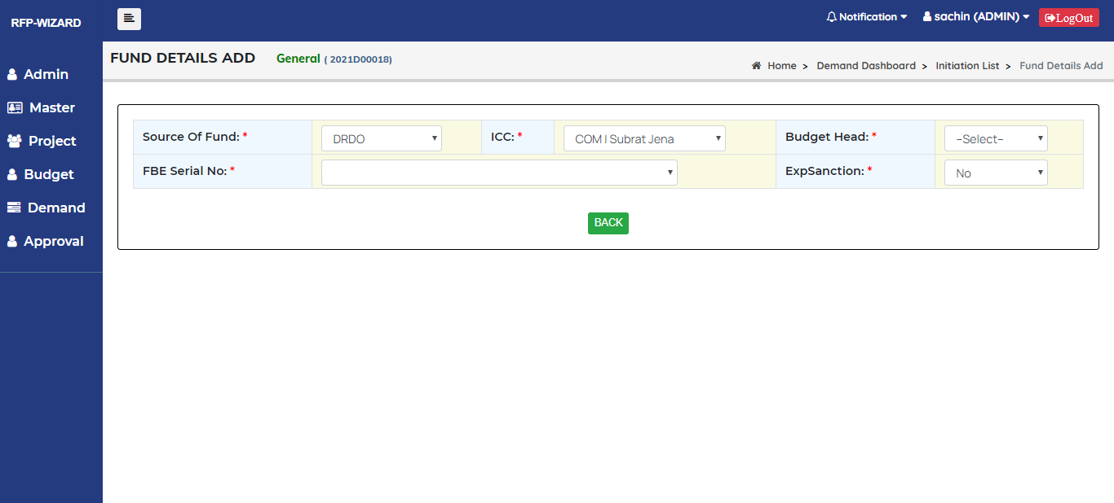

Fig 37. Fund details add interface

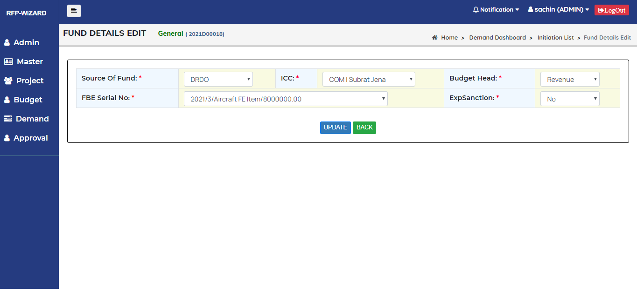

Fig 38. Fund details edit interface

|  |  |
| --- | --- |
| **Title** | **Fund details** |
| **Primary actors** | Admin/User |
| **Secondary actors** |  |
| **Description** | This module is to Add/Edit Fund details. |
| **Notes** | Source of Fund, ICC, Budget Head, FBE Serial No, ExpSanction. |
| **Mandatory fields** | All fields are mandatory |
| **Linked Requirement** | REQ003 – Admin/user should be able to manage Fund details. |

|  |  |
| --- | --- |
| **Fields** | **Conditions** |
| **Source of Fund** | It should be drop down and it should display Source of fund list. |
| **ICC** | It should be Drop down and it should display ICC list. |
| **Budget Head** | It should be Drop down and It should display General and Project. |
| **FBE Serial No** | It should be Drop down and it should display FBE Serial No. according to budget head. |
| **Exp Sanction** | It should be Drop down and it should display Yes/No. |

#### 2.6 .4 Use Cases- Item Details

## User interface

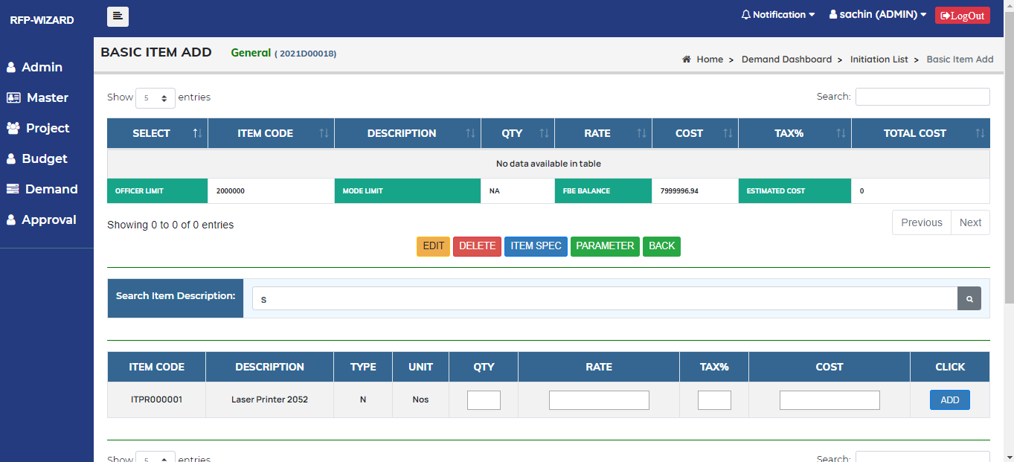

Fig 39. Item details add interface

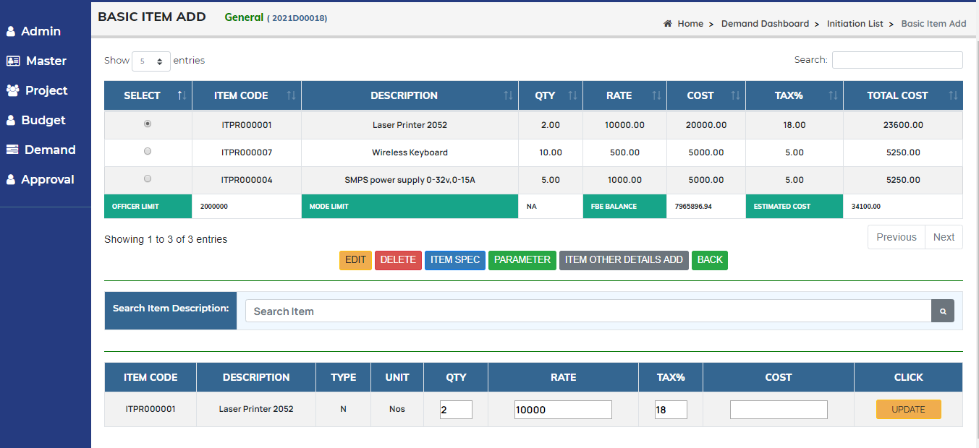

Fig 40. Item details edit interface

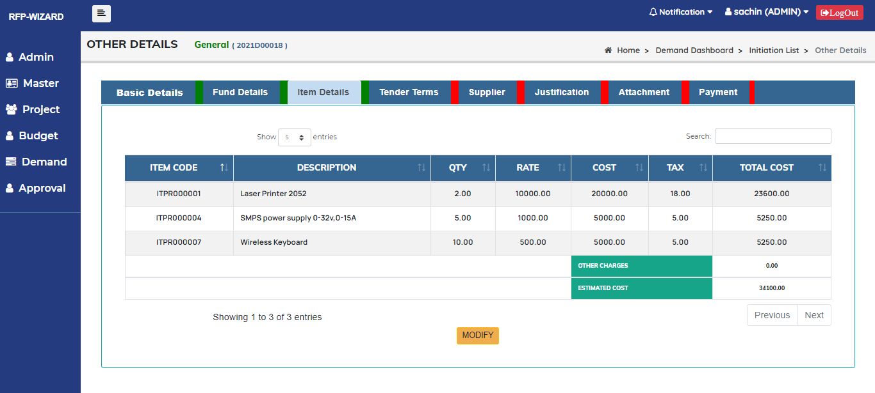

Fig 41. Item details interface

|  |  |
| --- | --- |
| **Title** | **Item details** |
| **Primary actors** | Admin/User |
| **Secondary actors** |  |
| **Description** | This module is to Add/Edit and delete Item details. |
| **Notes** | Search item Description, QTY, Rate, Tax, Cost. |
| **Mandatory fields** | All fields are mandatory Except search |
| **Linked Requirement** | REQ003 – Admin/user should be able to manage Item details. |

|  |  |
| --- | --- |
| **Fields** | **Conditions** |
| **Search Item description** | It should be text box and it should accept alphanumeric character.   1. Enter data and click on search button it should display item list. |
| **QTY** | It should be Text box and it should accept only positive numbers. |
| **Rate** | It should be Text box and it should accept only positive numbers. |
| **Tax** | It should be Text box and it should accept only positive numbers. |
| **Cost** | It should be auto calculate.   1. Item Cost cannot be more than **Mode limit** and **officer limit** |

|  |  |
| --- | --- |
| **Mode** | **Mode Limit** |
| Cash Purchase | 25000 |
| Petty Purchase | 25000 |
| Local Purchase | 250000 |
| All Other than CS, PP, LP | NA |

|  |  |
| --- | --- |
| **Initiating Officer** | **Officer Limit** |
| Scientist B | 1000000 |
| Scientist C | 2000000 |
| Scientist D | 3000000 |
| Scientist E | 5000000 |
| Scientist F | 50000000 |
| Scientist G | 100000000 |
| SSO I | 1500000 |
| SSO II | 1500000 |
| Sr. Accounts Officer | 1500000 |
| Accounts Officer | 1500000 |
| Stores Officer | 1500000 |
| Technical Officer C | 1500000 |
| Technical Officer B | 1500000 |
| Technical Officer A | 1500000 |
| Technical Officer | 1500000 |
| Chief Admin Officer | 1500000 |
| Commander | 1500000 |
| Gp Capt | 1500000 |
| Lt. Colonel | 1500000 |
| Sr Accts Officer I | 1500000 |
| Sr. Admin Officer I | 1500000 |
| Sr. Admin Officer II | 1500000 |
| Director | 2500000000 |

#### 2.6 .4 Use Cases- Item Spec Details

## User interface

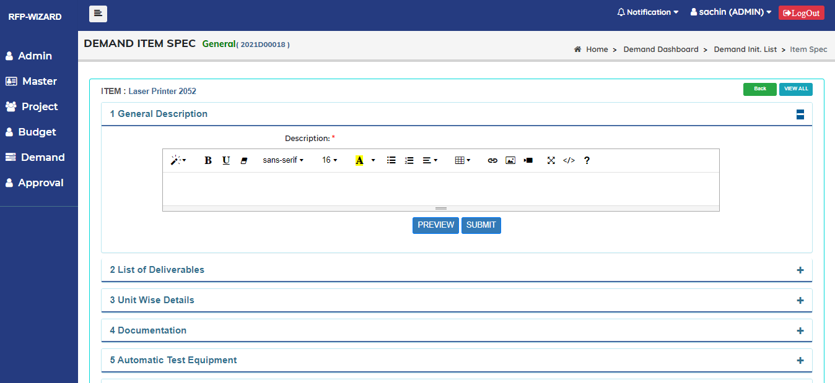

Fig 42. Item Spec details add interface

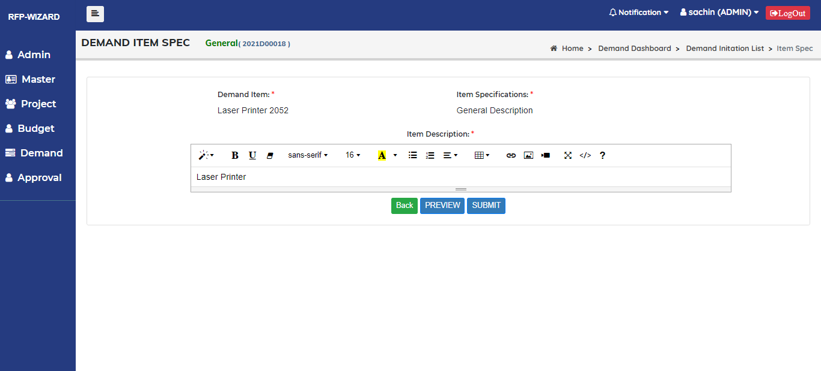

Fig 43. Item Spec details edit interface

|  |  |
| --- | --- |
| **Title** | **Item Spec details** |
| **Primary actors** | Admin/User |
| **Secondary actors** |  |
| **Description** | This module is to Add/Edit Item Spec details. |
| **Notes** |  |
| **Mandatory fields** |  |
| **Conditions** | All item Spec Should have editor page. |
| **Linked Requirement** | REQ003 – Admin/user should be able to manage Item Spec details. |

#### 2.6 .5 Use Cases- Item Parameter Details

## User interface

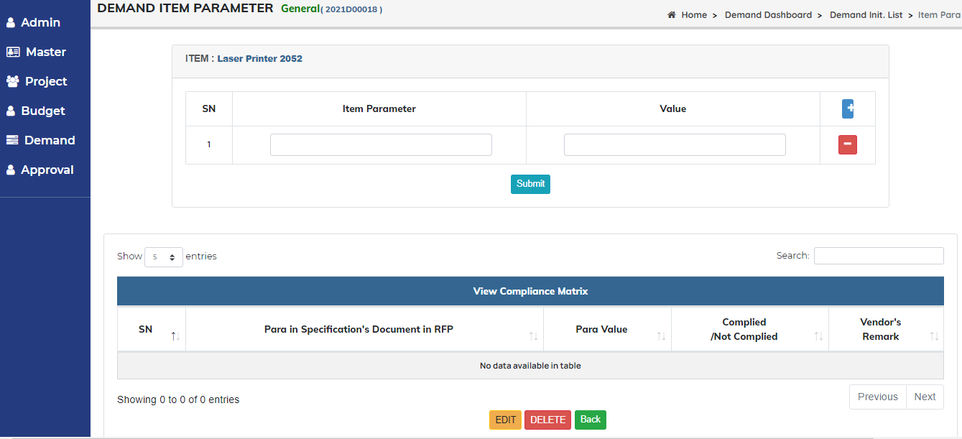

Fig 44. Item Parameter add interface

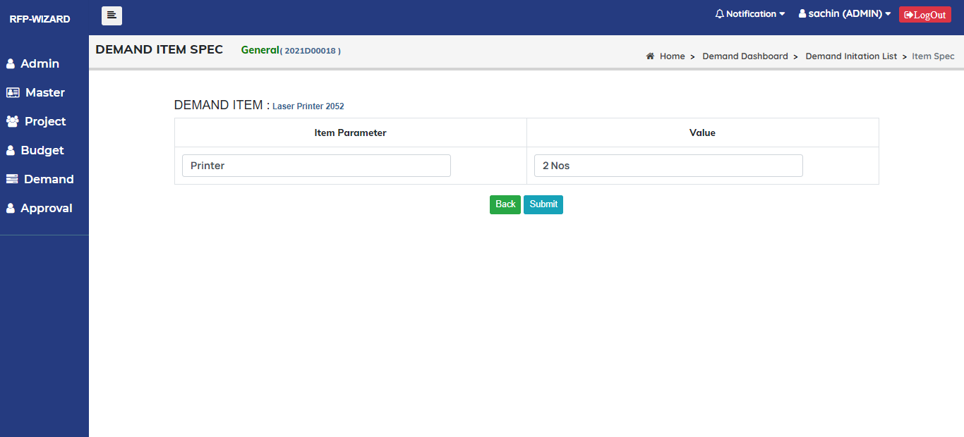

Fig 45. Item Parameter edit interface

|  |  |
| --- | --- |
| **Title** | **Item Parameter details** |
| **Primary actors** | Admin/User |
| **Secondary actors** |  |
| **Description** | This module is to Add/Edit and delete Item Parameter details. |
| **Notes** | Item Parameter, Value |
| **Mandatory fields** | All fields are mandatory |
| **Linked Requirement** | REQ003 – Admin/user should be able to manage Item Parameter details. |

|  |  |
| --- | --- |
| **Fields** | **Conditions** |
| **Item Parameter** | It should be text box and it should accept alphanumeric character |
| **Value** | It should be Text box and it should accept alphanumeric characters. |

#### 2.6 .6 Use Cases- Item other Details

## User interface

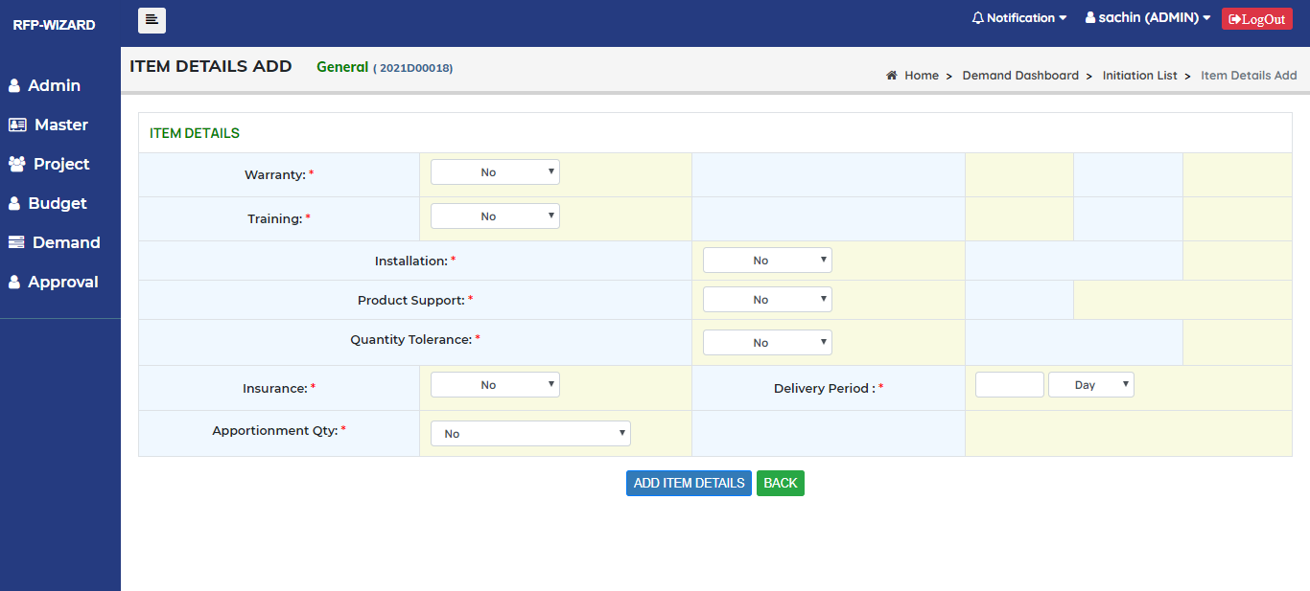

Fig 46. Item Other details add interface

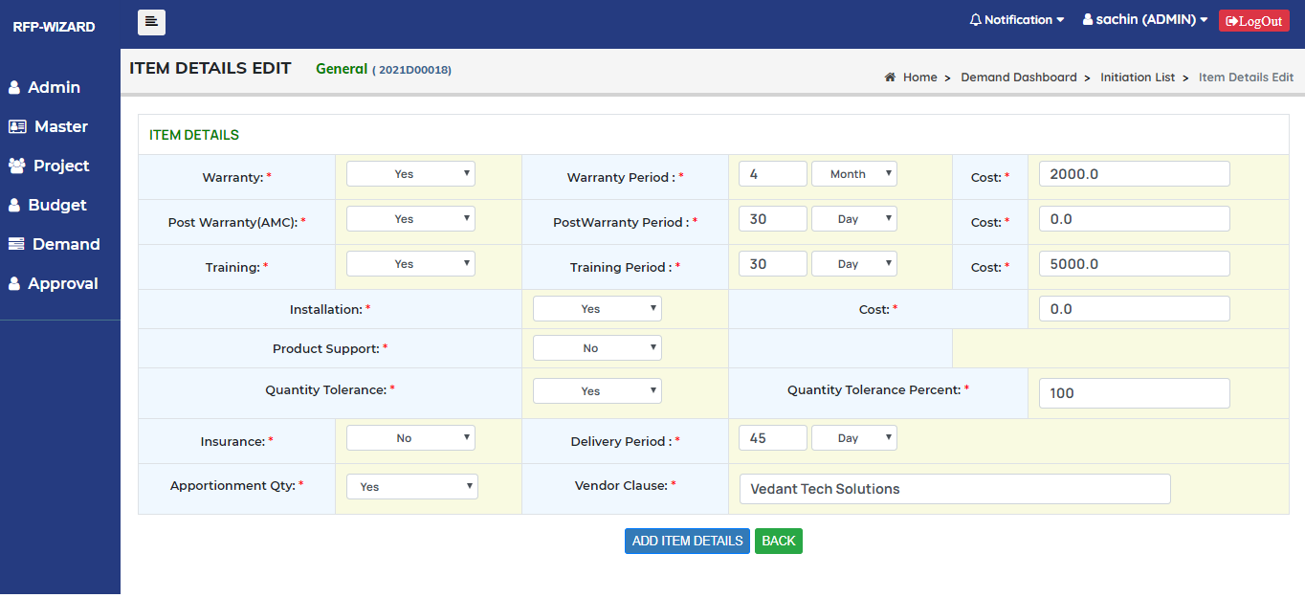

Fig 47. Item Other details Edit interface

|  |  |
| --- | --- |
| **Title** | **Item other details** |
| **Primary actors** | Admin/User |
| **Secondary actors** |  |
| **Description** | This module is to Add/Edit Item other details. |
| **Notes** | Warranty, Warranty period, Cost, Post Warranty, Post Warranty period, Training, Training period, Installation, Product Support, Product support period, Quantity tolerance, Quantity tolerance percent, Insurance, Delivery period, Apportionment QTY, Vendor clause. |
| **Mandatory fields** | All fields are mandatory |
| **Linked Requirement** | REQ003 – Admin/user should be able to manage Item other details. |

|  |  |
| --- | --- |
| **Fields** | **Conditions** |
| **Warranty** | It should be drop down and it should display Yes/No.   1. If Yes it should ask for Warranty Period details and cost. |
| **Warranty Period** | It should have Text box and drop down   1. Text box should accept only positive numbers. 2. Drop down should display day, week, Month and year. |
| **Cost** | It should be Text box and it should accept only positive numbers. |
| **Post Warranty** | It should be drop down and it should display Yes/No.   1. If Yes it should ask for Post Warranty Period details and cost. |
| **Post Warranty Period** | It should have Text box and drop down   1. Text box should accept only positive numbers. 2. Drop down should display day, week, Month and year. |
| **Training** | It should be drop down and it should display Yes/No.   1. If Yes it should ask for Training Period details and cost. |
| **Training Period** | It should have Text box and drop down   1. Text box should accept only positive numbers. 2. Drop down should display day, week, Month and year. |
| **Product Support** | It should be drop down and it should display Yes/No.   1. If Yes it should ask for Product Support Period details. |
| **Product Support Period** | It should have Text box and drop down   1. Text box should accept only positive numbers. 2. Drop down should display day, week, Month and year. |
| **Quantity Tolerance** | It should be drop down and it should display Yes/No.   1. If Yes it should ask for Quantity Tolerance percent. |
| **Quantity Tolerance Percent** | It should be Text box and it should accept only positive numbers. |
| **Insurance** | It should be drop down and it should display Yes/No. |
| **Delivery Period** | It should have Text box and drop down   1. Text box should accept only positive numbers. 2. Drop down should display day, week, Month and year. |
| **Apportionment Qty** | It should be drop down and it should display Yes/No.   1. If Yes it should ask for Vendor clause details. |
| **Vendor Clause** | It should be Text box and it should accept alphanumeric characters. |

#### 2.6 .7 Use Cases- Tender terms

## User interface

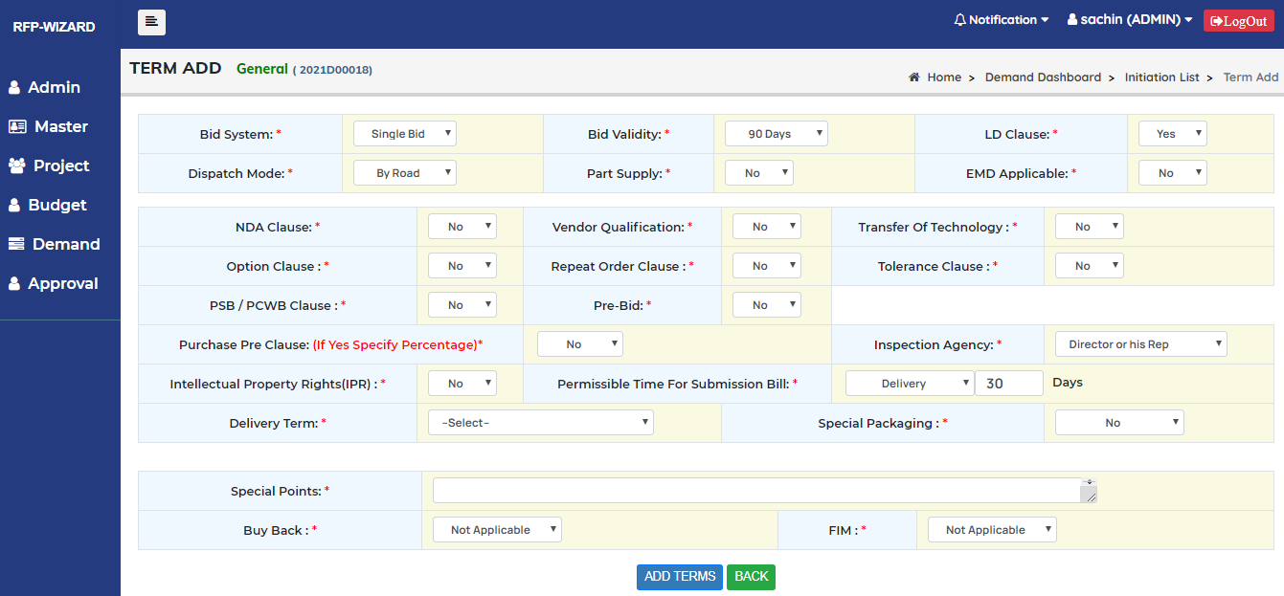

Fig 48. Tender add interface

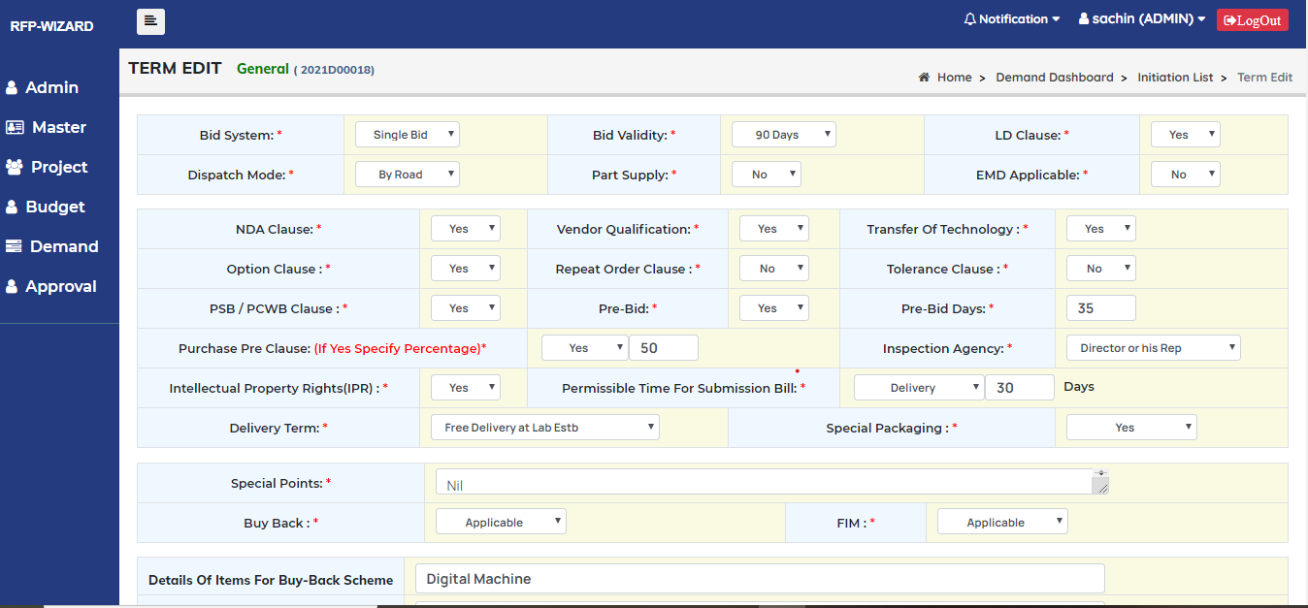

Fig 49. Tender edit interface

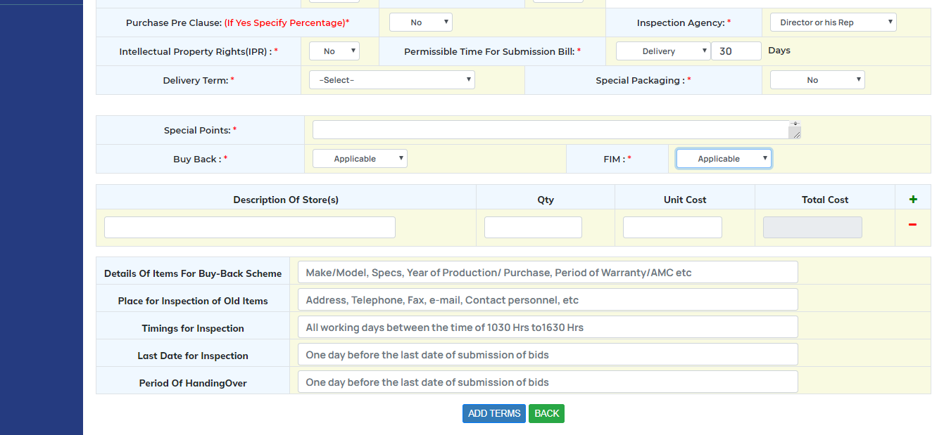

Fig 50. Buy Back and FIM add interface

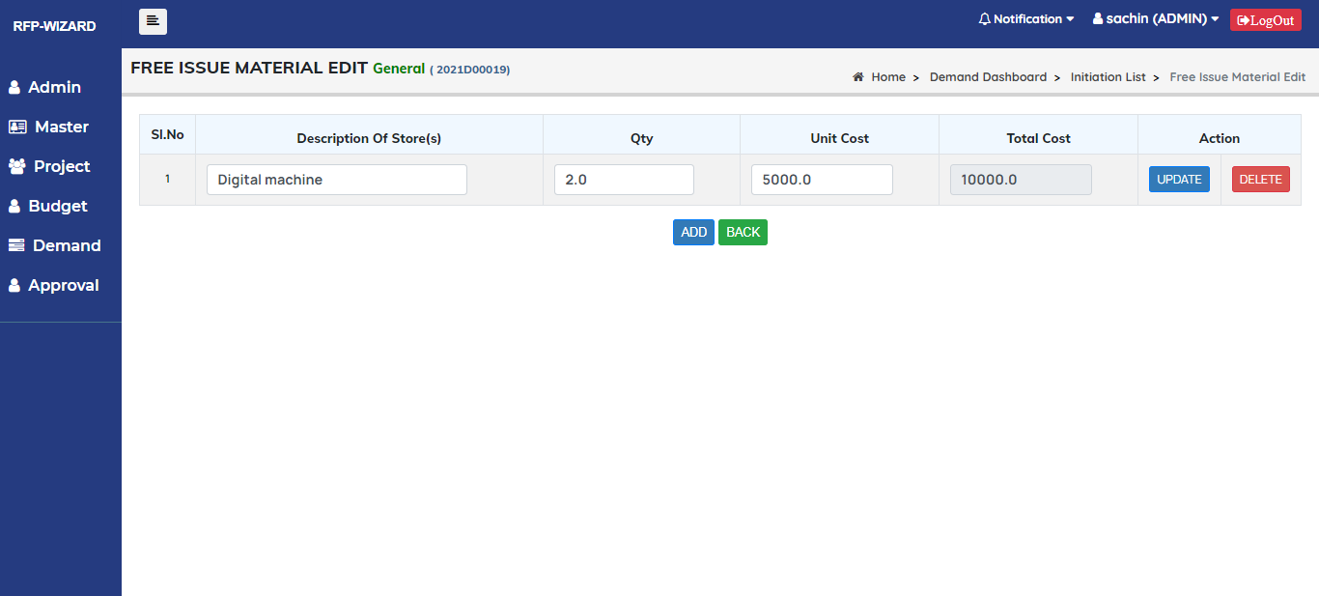

Fig 51. FIM Edit interface

|  |  |
| --- | --- |
| **Title** | **Tender terms** |
| **Primary actors** | Admin/User |
| **Secondary actors** |  |
| **Description** | This Tab is to Add/Edit tender terms. |
| **Notes** | Bid system, Bid validity, LD clause, Dispatch Mode, Part supply, EMD applicable, NDA Clause, Vendor qualification, Transfert of technology, Option clause, Repeat order clause, Tolerance clause, PSB/PCWB clause, Pre-Bid, Pre-Bid days, Purchase pre clause, Inspection Agency, IPR, Permissible time for bill submission, Delivery term, Special packaging, Special points, Buy back, FIM |
| **Mandatory fields** | All fields are mandatory |
| **Linked Requirement** | REQ003 – Admin/user should be able to manage tender terms. |

|  |  |
| --- | --- |
| **Fields** | **Conditions** |
| **Bid System** | It should be drop down and it should display Single Bid and Two Bid. |
| **Bid validity** | It should be drop down and it should display Bid days |
| **LD clause** | It should be drop down and it should display Yes/No. |
| **Dispatch Mode** | It should be drop down and it should display dispatch modes. |
| **Part supply** | It should be drop down and it should display Yes/No. |
| **EMD clause** | It should be drop down and it should display Yes/No. |
| **NDA1 clause** | It should be drop down and it should display Yes/No. |
| **Vendor Qualification** | It should be drop down and it should display Yes/No in drop down   1. If Yes it should ask for vendor clause details. |
| **Vendor Clause** | It should be Text box and it should accept alphanumeric |
| **Transfer of Technology** | It should be drop down and it should display Yes/No. |
| **Option Clause** | It should be drop down and it should display Yes/No. |
| **Repeat order Clause** | It should be drop down and it should display Yes/No. |
| **Tolerance clause** | It should be drop down and it should display Yes/No. |
| **PSB/PCWB clause** | It should be drop down and it should display Yes/No. |
| **Pre-Bid** | It should be drop down and it should display Yes/No.   1. If yes it should ask pre-bid days |
| **Pre-Bid days** | It should be Text box and it should accept only positive numbers. |
| **Purchase Pre-clause** | It should be drop down and it should display Yes/No in drop down   1. If yes it should ask percentage |
| **Inspection Agency** | It should be drop down and it should display inspection agencies list. |
| **IPR** | It should be drop down and it should display Yes/No. |
| **Permissible time for bill submission** | It should have drop down and text box   1. It should display Delivery, Inspection and supply in drop down 2. Text box should accept only numbers |
| **Delivery Term** | It should be drop down and it should display delivery terms. |
| **Special Packaging** | It should be drop down and It should display Yes/No. |
| **Special points** | It should be text box and it should accept alphanumeric. |
| **Buy back** | It should be drop down and it should display applicable and not applicable.   1. If applicable, it should ask item details |
| **FIM** | It should be drop down and it should display applicable and not applicable.   1. If applicable, it should ask FIM details |

#### 2.6 .8 Use Cases- Supplier

## User interface

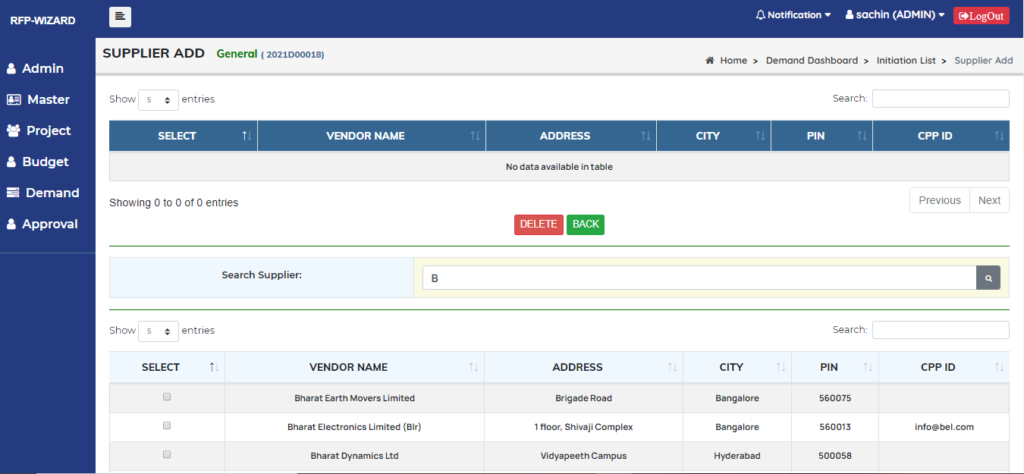

Fig 52. Supplier add interface

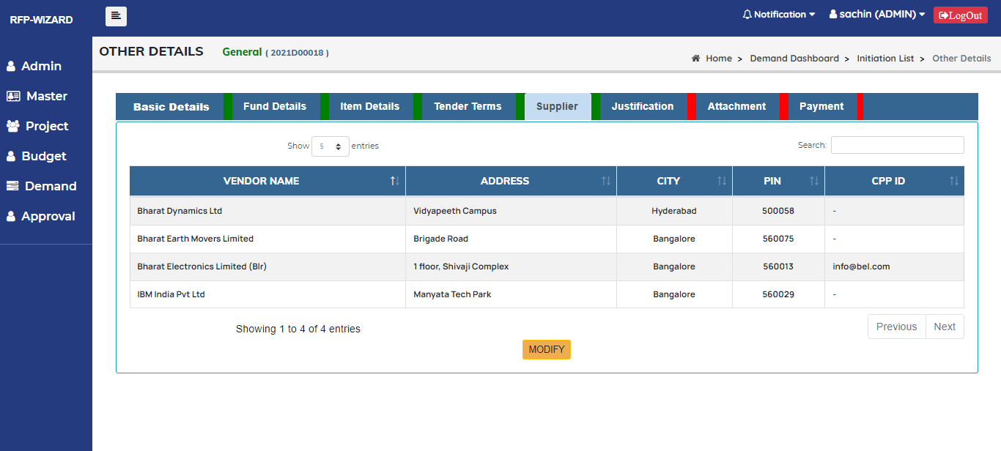

Fig 53. Supplier list interface

|  |  |
| --- | --- |
| **Title** | **Supplier** |
| **Primary actors** | Admin/User |
| **Secondary actors** |  |
| **Description** | This Tab is to Add and delete supplier. |
| **Notes** |  |
| **Mandatory fields** |  |
| **Linked Requirement** | REQ003 – Admin/user should be able to manage supplier details. |

|  |  |
| --- | --- |
| **Procurement Mode** | **Vendor** |
| LPC | It should have at least Three Vendors |
| LBM | It should have Minimum 7 Vendors |
| PBM | It should have only One Vendor |
| SBM | It should have only One Vendor |
| OBM | No Vendor |

* Added vendor should not display in search list.

#### 2.6 .9 Use Cases- Justification

## User interface

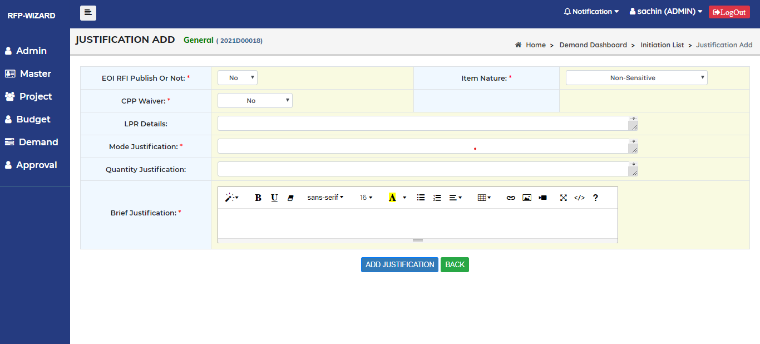

Fig 54. Justification add interface

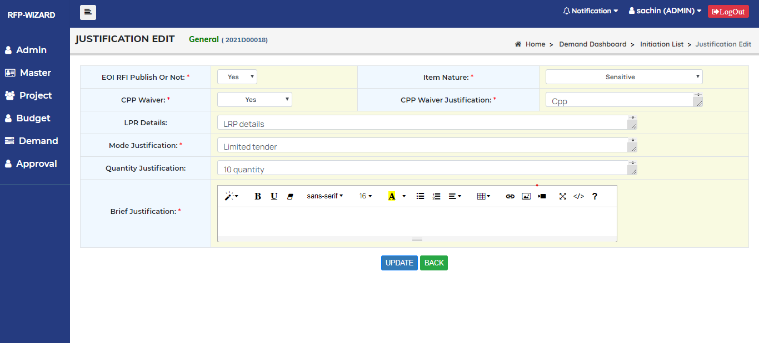

Fig 55. Justification edit interface

|  |  |
| --- | --- |
| **Title** | **Justification** |
| **Primary actors** | Admin/User |
| **Secondary actors** |  |
| **Description** | This Tab is to Add/Edit Justification. |
| **Notes** | EOI RFI Publish, Item Nature, Cpp Waiver, LPR details, Mode justification, Quantity Justification, Brief justification. |
| **Mandatory fields** | All fields are mandatory except LPR details and Quantity justification. |
| **Linked Requirement** | REQ003 – Admin/user should be able to manage Justification. |

|  |  |
| --- | --- |
| **Fields** | **Conditions** |
| **EOI RFI Publish** | It should be drop down and it should display Yes/No. |
| **Item Nature** | It should be drop down and it should display Sensitive and Non sensitive. |
| **CPP Waiver** | It should be drop down and it should display Yes/No.   1. If Yes it should ask Cpp Waiver Justification |
| **CPP Waiver Justification** | It should be Text box and it should accept alphanumeric. |
| **LPR details** | It should be Text box and it should accept alphanumeric |
| **Mode Justification** | It should be Text box and It should accept alphanumeric |
| **Quantity Justification** | It should be Text box and it should accept alphanumeric |
| **Brief Justification** | It should be editor |

#### 2.6 .10 Use Cases- Attachment

## User interface

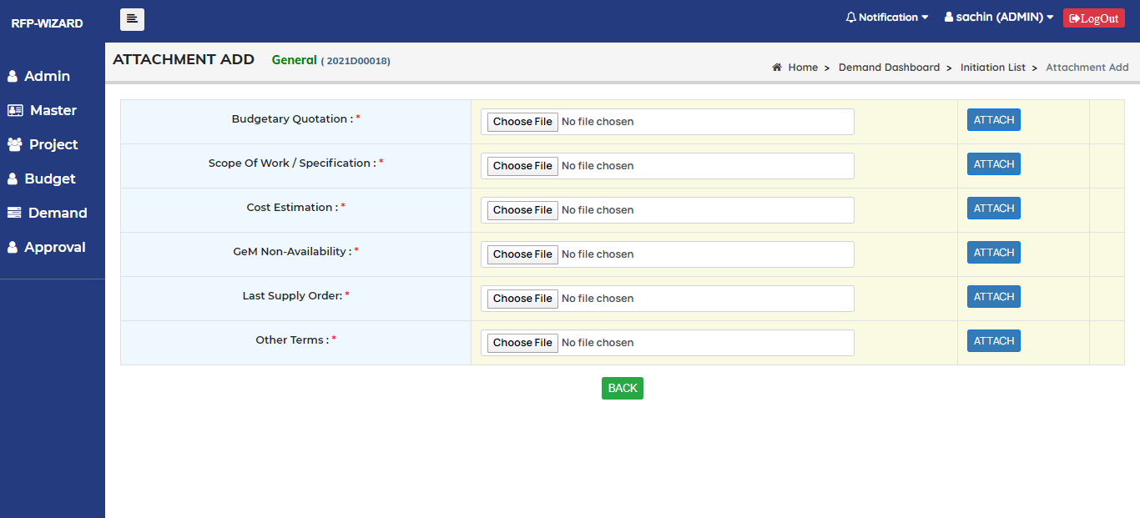

Fig 56. Attachment add Interface

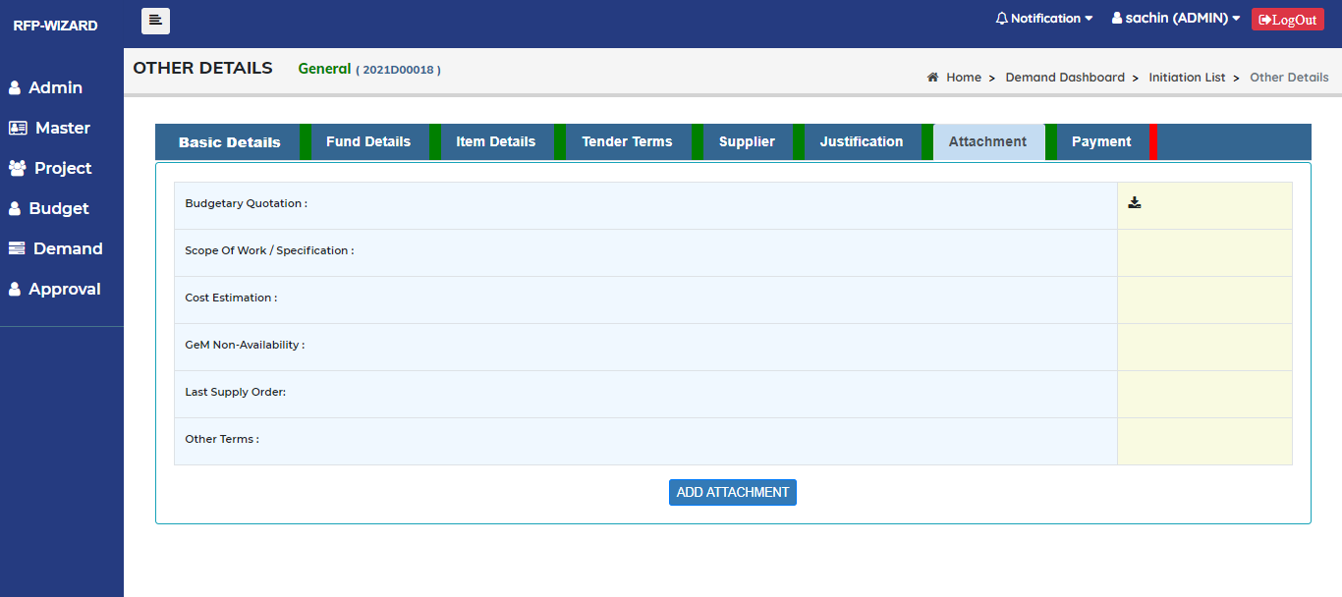

Fig 57. Attachment detail Interface

|  |  |
| --- | --- |
| **Title** | **Attachments** |
| **Primary actors** | Admin/User |
| **Secondary actors** |  |
| **Description** | This Tab is to Add Attachments. |
| **Notes** | Choose file |
| **Mandatory fields** |  |
| **Linked Requirement** | REQ003 – Admin/user should be able to manage Attachment. |

* Attachment should accept only PDF files.

#### 2.6 .11 Use Cases- Payment

## User interface

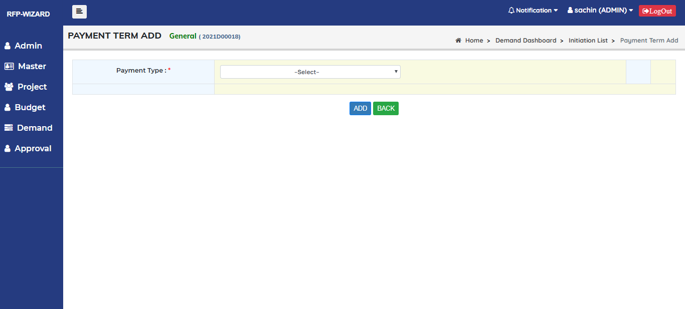

Fig 58. Payment add Interface

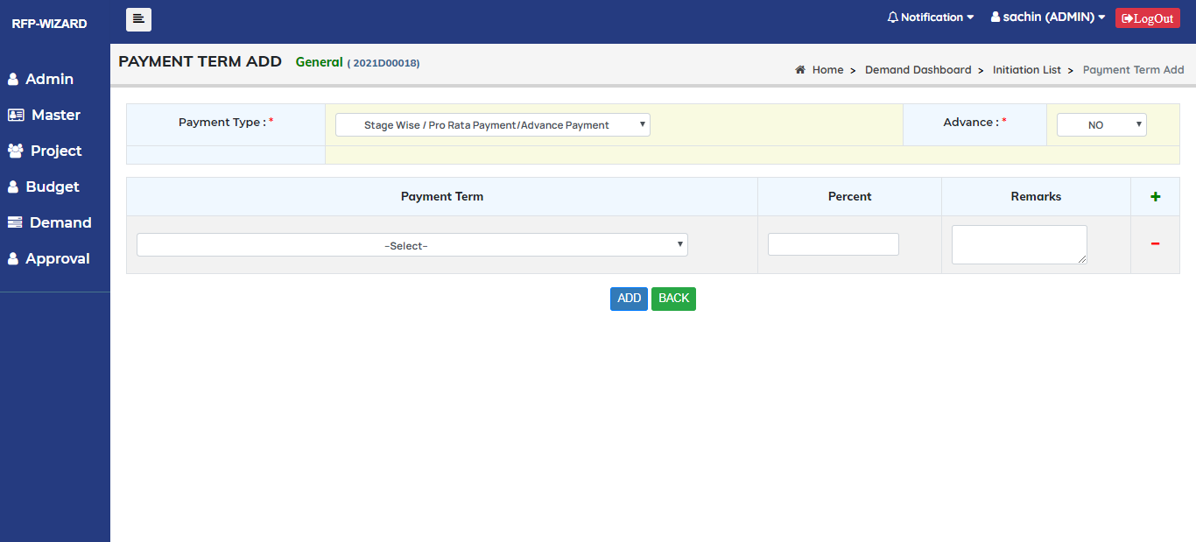

Fig 59. Payment add Interface (Stage wise)

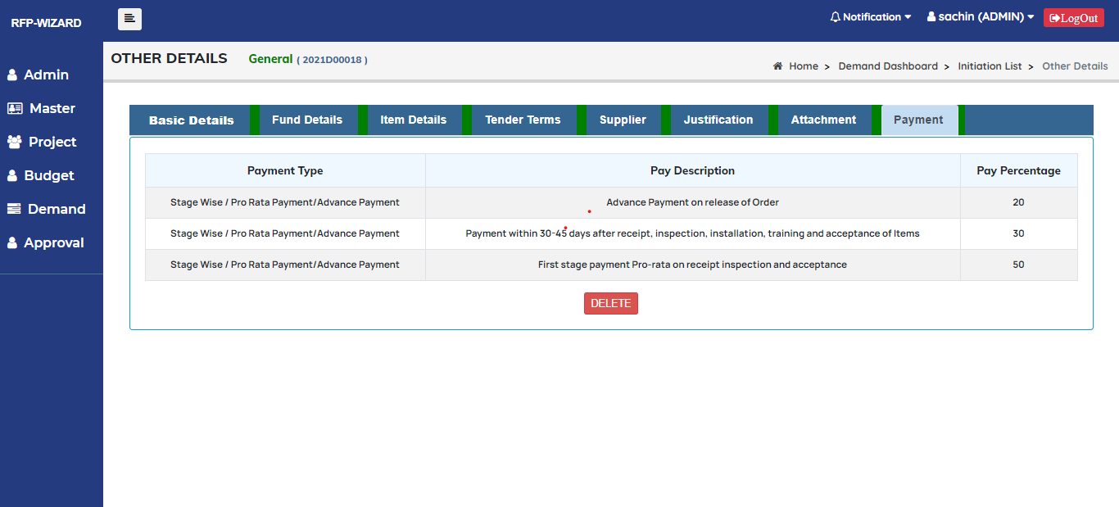

Fig 60. Payment details Interface (Stage wise)

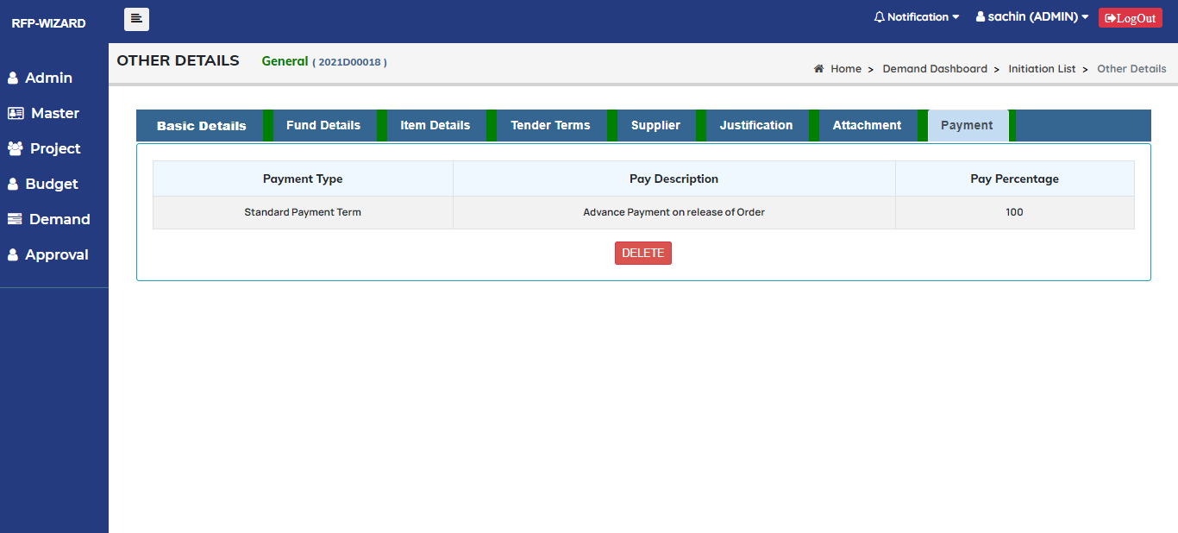

Fig 61. Payment details Interface (Standard)

|  |  |
| --- | --- |
| **Title** | **Payment** |
| **Primary actors** | Admin/User |
| **Secondary actors** |  |
| **Description** | This Tab is to Add and delete payment details. |
| **Notes** | Payment Type, Payment term. |
| **Mandatory fields** | All fields are mandatory |
| **Linked Requirement** | REQ003 – Admin/user should be able to manage Payment details. |

|  |  |
| --- | --- |
| **Fields** | **Conditions** |
| **Payment Type** | It should be drop down and it should display Payment types   1. If payment type is stage wise it should ask stage wise percentage |
| **Payment Term** | It should be drop down and it should display Payment term list. |
| **Percent** | It should be Text box and it should accept only positive numbers   1. Percentage cannot be more than 100% |
| **Advance** | It should be drop down and it should display Yes/No. |
| **Comment** | It should be Text box and it should accept alphanumeric |

#### 2.6.12 Use Cases- Print

|  |  |
| --- | --- |
| **Form Name** | **Conditions** |
| DRDO.DM.01 | This Form Should display All other than CS and PP. |
| DRDO.DM.02 | This Form should display If demand mode is **PAM**. |
| DRDO.DM.03 | This Form should display If demand mode is **SBM**. |
| DRDO.DM.04 | This Form should display if budget fund is **CAPITAL.** For All purchases **except** **CS** and **PP** |
| DRDO.DM.05 | This Form should display for **CS** and **PP**. For monthly report on petty purchase |
| DRDO.DM.06 | This Form should display for **CS** and **PP**. |
| DRDO.BM.01 | This Form should display for Notice Inviting Bids. |
| DRDO.BM.02 | This Form Should display All other than CS and PP. |
| Appendix-A | For all Demand, This Form Should display If Item list is More than **3**. |
| Appendix-B | This Form Should display If Vendors are More than **3**. All Other than **CS, PP, GeM, PAM and SBM.** |
| Appendix-C | This Form Should display if Bid Evaluation is **Line Wise**. All other than CS, GeM and PP. |
| Appendix-D | This Form Should display for **Item Specs**. All other than CS, GeM and PP. |
| Appendix-E | This Form Should display for **Item Parameter**. All other than CS, GeM and PP. |

#### Tables

* Allotment
* Allotment Item
* Allotment rev
* Attach allotment
* Attach sanction
* Audit path
* Audit stamping
* Budget fund
* Budget head
* Budget item
* Content
* Conversion
* Currency
* Delivery term
* Demand attachment
* Demand Booking
* Demand Buy back
* Demand Cancel
* Demand Capital
* Demand category
* Demand FIM
* Demand Inspection
* Demand Item
* Demand item Description
* Demand item parameter
* Demand Item Specification
* Demand Item Specification details
* Demand item Specification sub
* Demand Justification
* Demand Main
* Demand Main FE
* Demand Method
* Demand Mode
* Demand PAC
* Demand Parameter
* Demand Payment
* Demand Repeat
* Demand SBM
* Demand Supplier
* Demand Terms
* Demand Transaction
* Division Employee
* Division Group
* Division Master
* Employee
* Employee Designation
* FBE Main
* FBE Sub
* FBE Sub Approve
* Form Detail
* Form Module
* Form Role
* Form Role Access
* Hibernate Sequence
* Inventory Holder
* Item
* Item Cat
* Item Cat Sub
* Item Type
* Item Unit
* Lab Master
* Lab Parameter
* Login
* Login Division
* Login Role Security
* Login Type
* Payment Term
* Payment Type
* Person
* Project Employee
* Project Fund
* Project Fund rev
* Project HOA
* Project Item
* Project Master
* Project Sanction
* Project Sanction rev
* Project type
* Role Security
* Sign Authority role
* Sign Role Authority
* Sign Trans Demand
* Sign trans Demand5
* TBL lab Parameter

#### Table Description

|  |  |
| --- | --- |
| **Table** | **Description** |
| **Allotment** | This table is responsible for storing the information of Allotment such as Allotment Id, Financial year, Allotment Item Id, Budget Head Id, Project Id, Project Code, Allotment Cost and Revision No. |
| **Allotment item** | This table is responsible for storing the information of Allotment item such as Allotment item Id, Budget head id. Budget head code, Major Head, Minor Head, Sub Head, Sub Minor Head, Head of accounts, Serial No, Group Id, Is General, Is Project, Is Misc, Is ceiling. |
| **Allotment rev** | This table Keeps information Allotment rev such as Allotment rev id, Allotment id, Financial year, Allotment Item id, Budget Head id, Project id, Project code, Allotment Cost, Revision No. |
| **Attach Allotment** | This table Keeps information such as Attach Allotment id, Attach Allotment, Financial year, File Name. |
| **Allotment Sanction** | This table is responsible for storing the information of Attach Sanction Id, Project Id, Attach Sanction, File Name. |
| **Audit Patch** | This table is responsible for storing the information of Audit Patch id, Audit Patch No, Audit patch details, Audit patch date. |
| **Audit Stamping** | This table keeps the information of Audit Stamping id, Login Id, User Name, Login Date, Login Date time, Ip Address, Mac Address, Logout Type, Logout Date time. |
| **Budget Fund** | This table keeps the information of Budget fund id, Funds From, Is Active. |
| **Budget Head** | This table is responsible for storing the information of Budget Head id, Budget Head Code, Budget Head Description, Budget Type. |
| **Budget item** | This table is responsible for storing the information of Budget item id, Budget Head id, Allotment Item id, Budget Code, Major Head, Minor Head, Sub Head, Sub Minor Head, Head of Accounts, ReFe, Is Allotment. |
| **Content** | This table is responsible for storing the information of Content RPF. |
| **Conversion** | This table is responsible for storing the information of Conversion Id, Currency code, Currency Name, Currency Rate, Exchange date. |
| **Currency** | This table is responsible for storing the information of Currency like Currency Id, Currency code, Currency Name. |
| **Delivery term** | This table is responsible for storing the information of Delivery term like Delivery term Id, Delivery term. |
| **Demand Attachment** | This table is responsible for storing the information of Demand Attachment such as Attachment Id, Demand No, BQ Attach, BQ Modified by, BQ Modified date, Sow Attach, Sow Modified By, Sow modified date, Ce Attach, Ge Attach, Lso Attach, ODA attach. |
| **Demand Booking** | This table is responsible for storing the information of Demand Booking such as Demand booking Id, Demand No, FBE Main Id, Budget Code, Fbe Serial No, Item Cost, Item Tax, Warranty Cost, Post Warranty cost, Training Cost, Installation Cost, Item Other Cost, Estimated Cost, Booking Cost. |
| **Demand Buy Back** | This table is responsible for storing the information of Demand Buy Back such as Buy Back details Id, Demand No, Details of Items, Place for Inspection, Timing for Inspection, Last Date for inspection, Period of Handing over. |
| **Demand Cancel** | This table is responsible for storing the information of Demand Cancel such as Demand cancel Id, Demand No, MMG Control No, Tender Enquiry No, cancel date, Authority, Reason cancel. |
| **Demand Capital** | This table is responsible for storing the information of Demand Capital such as Demand Capital Id, Demand No, Broad Specification, Life Time. |
| **Demand Category** | This table is responsible for storing the information of Demand Category such as Demand Category Id and Demand Category. |
| **Demand FIM** | This table is responsible for storing the information of Demand FIM such as Demand Fim Id, Demand No, Item Description, Item Quantity, Item Rate, Item Cost. |
| **Demand Inspection** | This table is responsible for storing the information of Demand Inspection such as Demand Inspection Id and Inspection Authority. |
| **Demand Item** | This table is responsible for storing the information of Demand Items such as Demand Item id, Demand No, Item Id, Item Rate, Item QTY, Item cost, Item tax, Item Tax cost, Item Other Charges and Total Cost. |
| **Demand Item description** | This table is responsible for storing the information of Demand Item description such as Demand Item Desc id, Demand No, Item Id, Warranty, Warranty type, Warranty Duration, Warranty Cost, Post Warranty, Post Warranty type, Post Warranty Duration, Post Warranty cost, Training, Training type, Training duration, Training Cost, installation, installation cost, Product Support, Product support duration Type, Product Support duration, Product support cost, Insurance, Insurance Cost, Quantity Tolerance, Quantity tolerance per, Delivery period type, Delivery period duration, Apportionment Qty and Vendor clause. |
| **Demand item Parameter** | This table is responsible for storing the information of Demand Item parameter such as Parameter id, Demand No, Item Id, Parameter, Value and Para item id. |
| **Demand Item Spec** | This table is responsible for storing the information of Demand Item spec such as Item Id and Description. |
| **Demand Item Spec Details** | This table is responsible for storing the information of Demand Item spec details such as Item spec details id, Demand No, Demand Item Id, Item spec id, Item sub Spec id, Item sub of sub spec id and details, |
| **Demand Item Spec Sub** | This table is responsible for storing the information of Demand Item spec Sub such as Item Spec sub Id and Sub Descriptions. |
| **Demand Justification** | This table is responsible for storing the information of Demand Justification Sub such as Demand Justification Id, demand No, EOI RFI Publish, Item Nature, Cpp Waiver Justification, LPR details, Brief Justifications, Purpose Justification, Mode Justification, Quantity Justification and any other Justification. |
| **Demand Main** | This table is responsible for storing the information of Demand Main such as Demand Main id, Demand No, Demand date, Division Id, ICC Holder Id, Project Id, Budget Code, FBE serial No, Fund Source, EXP Sanction, Initiating officer Id, Designation Id, Category demand id, Demand method, Demand method id, Demand mode name, Broad Heading, Bid Evaluation, Estimated cost and Demand Flag. |
| **Demand Main FE** | This table is responsible for storing the information of Demand Main Fe such as Demand main FE Id, Demand No, Currency Id, FE Amount and Conversion Rate. |
| **Demand Method** | This table is responsible for storing the information of Demand Method such as Demand Method Id, Demand Method, Demand Method Desc, Mode Applicable, and Serial No. |
| **Demand Mode** | This table is responsible for storing the information of Demand Mode such as Demand Mode Id, Demand Method, Demand Mode Name, Mode Description, and Mode Applicable. |
| **Demand PAC** | This table is responsible for storing the information of Demand PAC such as Demand PAC Id, Demand No, OEM Vendor Code, Vendor Code, PAC Reason A, PAC Reason B and PAC Reason Other. |
| **Demand Parameter** | This table is responsible for storing the information of Demand Parameter such as Demand parameter Id, Division Code, Period and Demand Serial No. |
| **Demand Payment** | This table is responsible for storing the information of Demand Payment such as Demand payment Id, Demand No, Payment Type Id, Payment term Id, Pay percentage, Advance and Remarks. |
| **Demand Repeat** | This table is responsible for storing the information of Demand Repeat such as Demand Repeat Id, Demand No, Demand Type, So No, So Date, Lab Name, Vendor Id, Vendor Name and Total Cost. |
| **Demand SBM** | This table is responsible for storing the information of Demand SBM such as Demand SBM Id, Demand No, Vendor Code, SBM Reason A, SBM Reason B, …F, SBM Other Reason. |
| **Demand Supplier** | This table is responsible for storing the information of Demand Supplier such as Demand Supplier Id, Demand No and Vendor Code. |
| **Demand Terms** | This table is responsible for storing the information of Demand Terms such as Demand Terms Id, Demand No, Pre-Bid, Pre-Bid Days, Bid System, Bid Validity, Dispatch Mode, Part Supply, EMD Applicable, NDA Clause, Vendor Qualification, TOT Clause, Option Clause, Repeat Clause, Tolerance Clause, Purchase Pre Clause, Purchase percent, IPR Clause, Submission Bill, Submission Activity, Special Points, Buy Back Applicable, Free issue Material, LD Clause, SD Clause, Delivery Term, Delivery Term Cost, Inspection Agency and Special Packaging. |
| **Demand Transaction** | This table is responsible for storing the information of Demand Transaction such as Demand Transaction Id, Demand Main Id, Demand Action and Demand details. |
| **Division Employee** | This table is responsible for storing the information of Division employee such as Demand Employee Id, Emp Id and Division Id. |
| **Division Group** | This table is responsible for storing the information of Division Group such as Group Id, Group Code, Group Name and Group Head Id. |
| **Division Master** | This table is responsible for storing the information of Division Master such as Division Id, Division Code, Division Name, Division Head Id and Group Id. |
| **Employee** | This table is responsible for storing the information of Employee such as Emp Id, Emp No, Emp Name, Designation Id, EXT No, Email and division id. |
| **Employee Designation** | This table is responsible for storing the information of Employee Designation such as Designation Id, Designation Code, Designation and Limit. |
| **FBE Main** | This table is responsible for storing the information of FBE Main such as FBE Main Id, Division Id, Financial Year, Budget Head Id, Project Id, Project Code, Budget Code, Total FBE, FBE Flag, Submit Date and Approval date. |
| **FBE Sub** | This table is responsible for storing the information of FBE Sub such as FBE Sub Id, FBE Main Id, Budget Item Id, Item Serial No, Item Details, Item FBE Amount, Item Org Amount, Expected date and FBE Sub Flag. |
| **FBE Sub Approve** | This table is responsible for storing the information of FBE Sub Approve such as FBE Sub Approve Id, FBE Sub Id, FBE Main Id, Budget Item Id, Item Serial No, Item Detail, Item FBE, Amount, Demand Booking, Order Commitment, Bill Expenditure, FBE Balance, Expected date and FBE Approve Flag. |
| **Form Detail** | This table is responsible for storing the information of Form Detail such as  Form detail Id, Form Module Id, Form Name, Form URL, Form Disp Name, Form Admin, Form Serial No and Form Color. |
| **Form Module** | This table is responsible for storing the information of Form Module such as Form Module id, Form Module Name, Module icon, Module URL and Serial No. |
| **Form Role** | This table is responsible for storing the information of Form Role such as Form Role Id and Form Role Name. |
| **Form Role Access** | This table is responsible for storing the information of Form Role Access such as Form Role Access Id, Form Role Id and Form Detail Id. |
| **Inventory Holder** | This table is responsible for storing the information of Inventory Holder such as Inventory Holder Id, ICC, Division Id, Emp Id and Project Id. |
| **Item** | This table is responsible for storing the information of Item such as Item Id, Item Code, Item Cat Code, Item sub Code, Item Description, Item Unit, Item Type and Item Flag. |
| **Item Cat** | This table is responsible for storing the information of Item Cat such as Item Cat Id, Item Cat Code, Item Cat Description. |
| **Item Cat Sub** | This table is responsible for storing the information of Item Cat Sub such as Item Cat sub Id, Item Cat Code, Item Sub Code and Item sub Description. |
| **Item Type** | This table is responsible for storing the information of Item Type such as Item type Id, Item type Code and Item type. |
| **Item Unit** | This table is responsible for storing the information of Item Unit such as Item Unit Id, Item Unit Code and Item Unit. |
| **Lab Master** | This table is responsible for storing the information of Lab Master such as Lab Master Id, Lab Code, Lab Name, Lab Unit Code, Lab Address, Lab city, Lab Pin, Lab Tel No, Lab Fax No and Lab Email. |
| **Lab Parameter** | This table is responsible for storing the information of Lab Parameter such as Lab Parameter Id, Lab Key, Mode description and Lab Value. |
| **Login** | This table is responsible for storing the information of Login such as Login Id, User Name, Password, Emp Id, Division Id, Form Role Id and Login Type. |
| **Login Division** | This table is responsible for storing the information of Login Division such as Login Division Id, Login Id, Division Id and Serial No. |
| **Login Role Security** | This table is responsible for storing the information of Login Role Security such as Login Role Security Id, Login Id and Role Id. |
| **Login Type** | This table is responsible for storing the information of Login Type such as Login Type Id, Login Type and Login Description. |
| **Payment Term** | This table is responsible for storing the information of Payment term such as Payment term Id, Payment term Cd, Pay Description, Pay Serial No, CRV Required and Pay Type Code. |
| **Payment Type** | This table is responsible for storing the information of Payment Type such as Payment Type Id and Payment Type. |
| **Person** | This table is responsible for storing the information of Person such as Id, Name and Country. |
| **Project Employee** | This table is responsible for storing the information of Project Employee such as Project Employee Id, Login Id and Project Id. |
| **Project Fund** | This table is responsible for storing the information of Project Fund such as Project fund Id, Project Id, DRDO Share, IAF Share, BEL Share, Total Amount and Revision No. |
| **Project Fund Rev** | This table is responsible for storing the information of Project Fund Rev such as Project Fund Rev Id, Project Fund Id, Project Id, DRDO Share, IAF Share, BEL Share, Total Amount and Revision No. |
| **Project HOA** | This table is responsible for storing the information of Project HOA such as Project HOA Id, Project Id, Project Sanction Id, Budget Item Id, Re Fe, Sanction Cost, Expenditure, Out Commitment, Dipl and Balance. |
| **Project Item** | This table is responsible for storing the information of Project Item such as Project Item Id, Project Id, Budget Head, Item Description, QTY Indended, Product Tree Ref, Qty Planned, Qty Phased Manner, CecRefCost, Currency Code, Cost Reference, Milestone Item, Demand Quarter, Upload Date. |
| **Project Master** | This table is responsible for storing the information of Project Master such as Project Id, Project Code, Project ImmsCd, Project Name, Project Description, Unit Code, Project Type, Sanction No, Sanction Date, Total Sanction cost, Sanction Cost RE, Sanction Cost FE, PDC, Project Director, Project Sanction Authority, Board Reference, Revision No, Is Main WC, Work Centre, Objective and deliverable. |
| **Project Sanction** | This table is responsible for storing the information of Project Sanction such as Project Sanction Id, Project Id, Project Code, Budget Item Id, Sanction Cost and Revision No. |
| **Project Sanction Rev** | This table is responsible for storing the information of Project Sanction such as Project Sanction Id, Project Id, Project Code, Budget Item Id, Sanction Cost and Revision No. |
| **Project Type** | This table is responsible for storing the information of Project Type such as Project Type Id, Project Type and Is Work Center. |
| **Role Security** | This table is responsible for storing the information of Role Security such as Role Id and Role Name. |
| **Sign Authority Role** | This table is responsible for storing the information of Sign Authority Role such as Sign Authority Role Id, Form Module Id, Sign Authority Code, Sign Authority Role and Serial No. |
| **Sign Role Authority** | This table is responsible for storing the information of Sign Role Authority such as Sign Role Authority Id, Sign Authority Id, Division Id, Emp Id, Valid From, Valid Up to and Serial No. |
| **Sign Trans Demand** | This table is responsible for storing the information of Sign Transaction demand such as Sign Trans Demand Id, Demand No, dvh Emp id, Gph Emp Id, Str Emp Id, Bud Emp Id, Mmd Emp Id. |
| **Vendor** | This table is responsible for storing the information of Vendor such as Vendor Id, Vendor Code, Address, City, Pin Code, Contact Person, Tel No, Fax No, Email, Registration No, Registration date, Validity date, Cpp Register id, Product range, Vendor Type, PAN, GST No, Vendor Bank and Account No. |
| **Vendor Parameter** | This table is responsible for storing the information of Vendor Parameter such as Vendor Parameter Id, Vendor Ext, Vendor Ext Serial No. |
| **Vendor Qualification** | This table is responsible for storing the information of Vendor Qualification such as Vendor Qualification Id, Demand No and Qualification Criteria. |