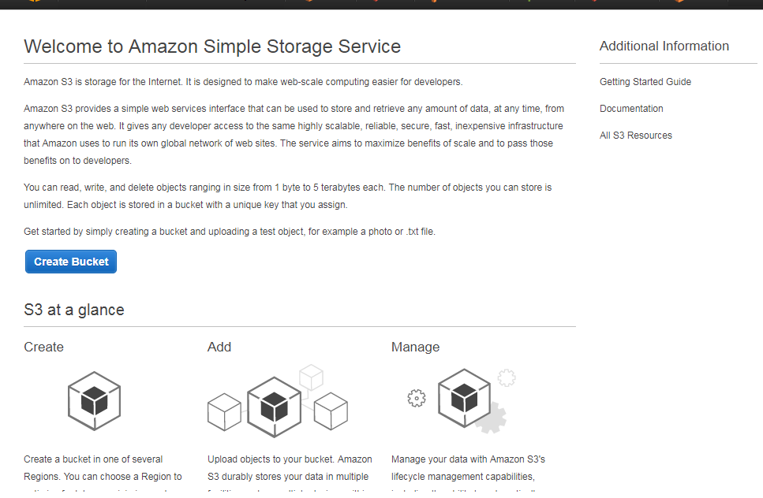

When we click on “create bucket”. Then it will re-directed to new page which shown below image. In that we have to provide unique name to bucket. Because s3 is not depends on any particular region. It is globally used by all users.

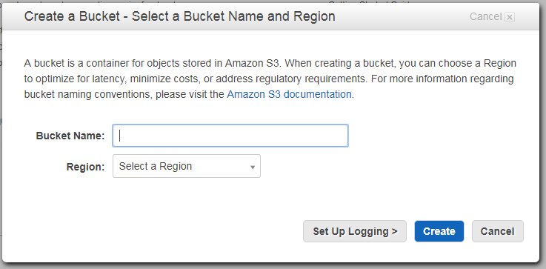

Different regions have different set of rules to accept the bucket name.

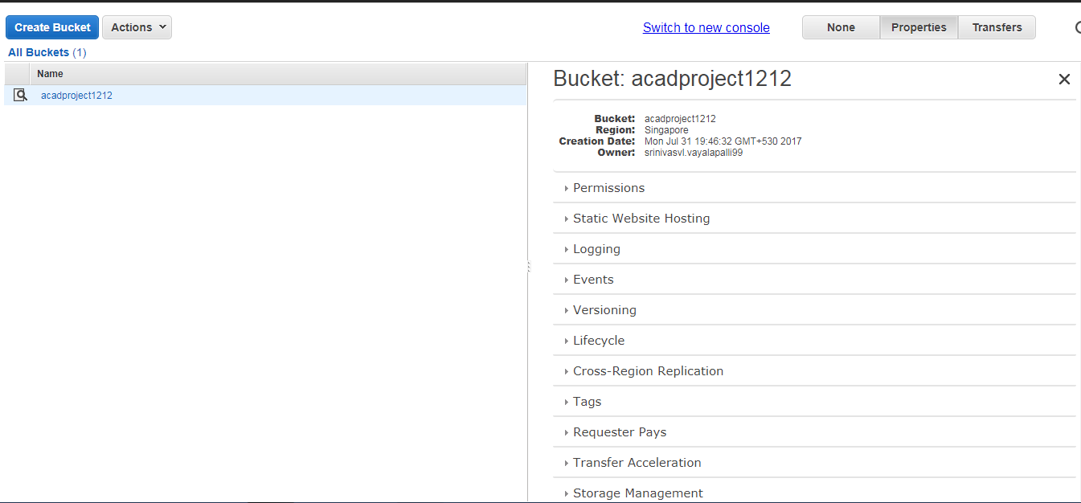

If we success to provide unique name to bucket, then it will create a bucket with that provided name as in above image. Here we can see the bucket name “acadproject1212” . 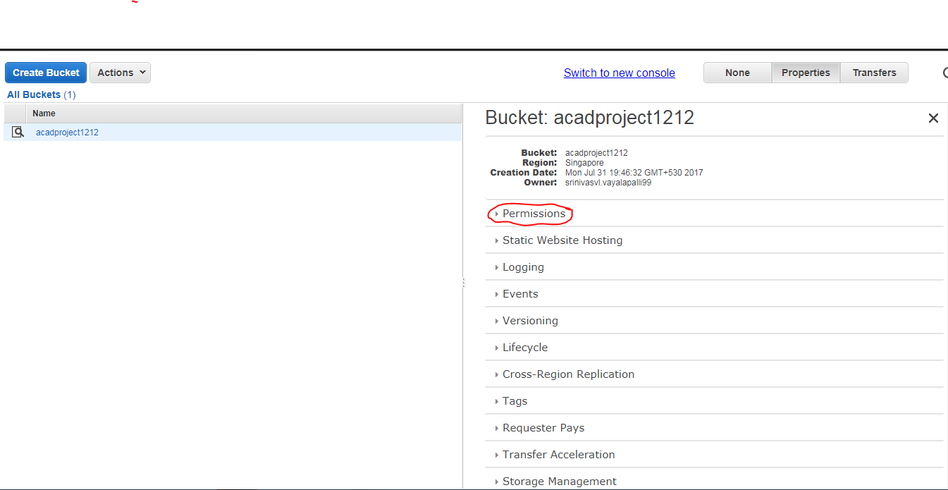

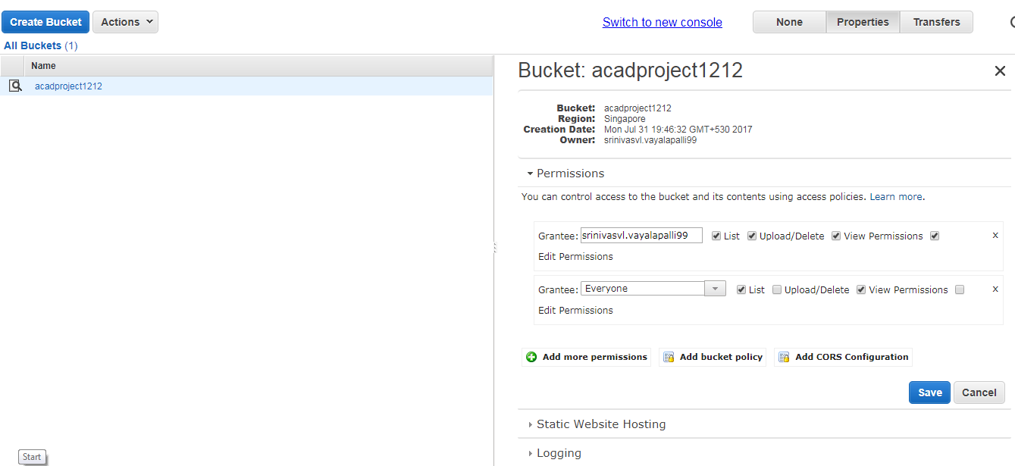

To change the permissions goto properties, then click on permissions then we can see some options like add policies and more.

We can grant permissions to one or more than one permissions by click on the add more permissions button. 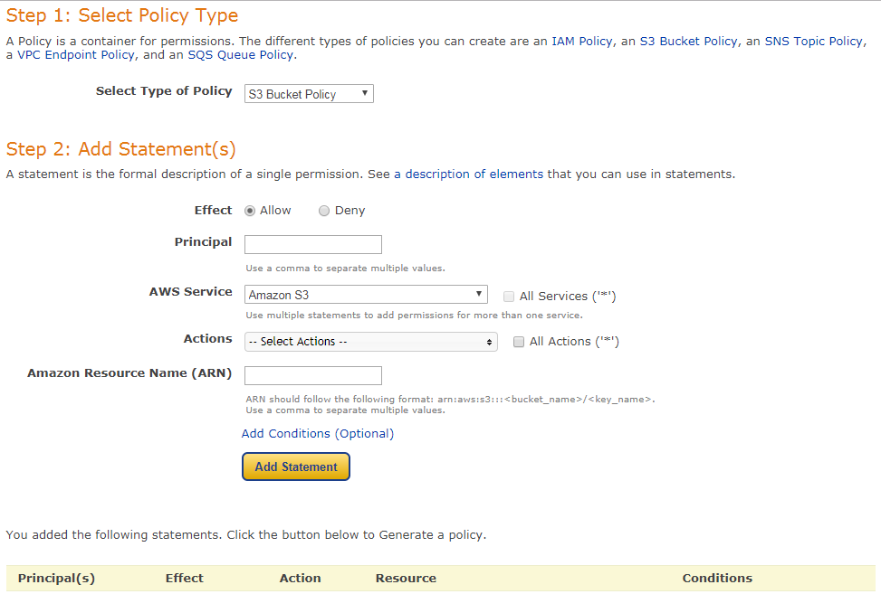

To provide more security we can create bucket policy by click on “bucket policy” button. We have to provide the all details then click on add statement after that proceed to next step.

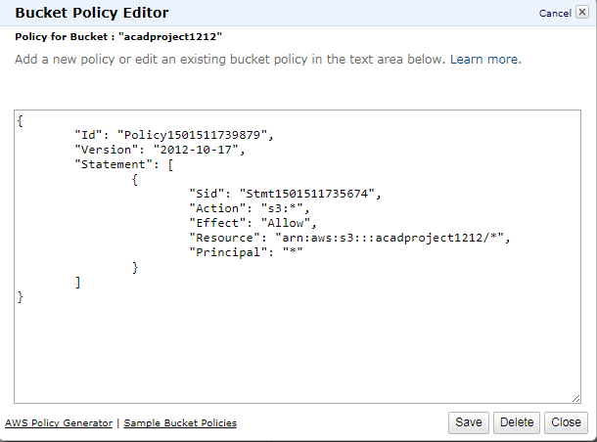

If the provided details are correct, then amazon will generate code for us. Then simply copy and past that code as it is in previous page and click on save button.