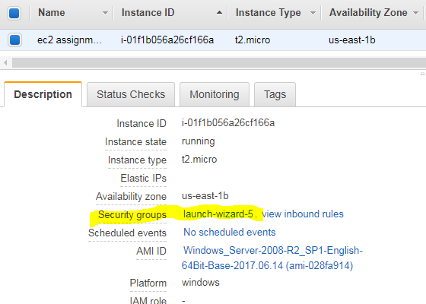

After the creation of EC2 instance, If you click on Description button we can see the option like Security groups. We can see here highlighted part on the above image.

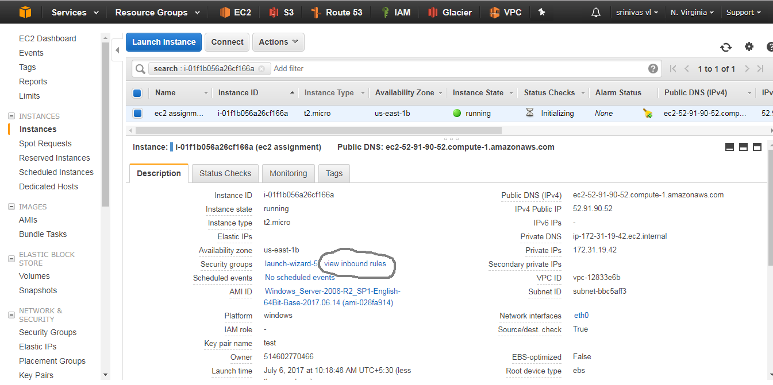

After click on view inbound rules, then it will display “Edit inbound rules” like below image.

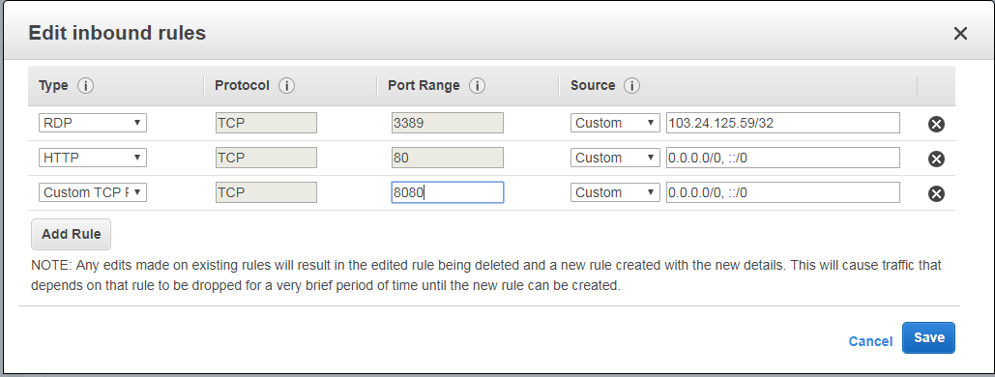

Here we can add some of the rules like for remote access of instance add RDP, for suppose access the machine from the internet or web we have to enable that http(port 80) etc.

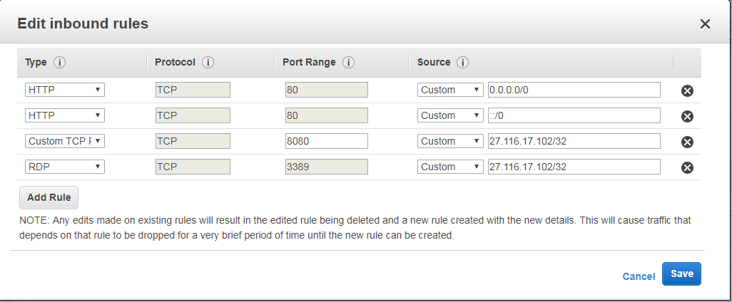

To add the new rules simply click on the ad rules button and add all the rules depends on the user requirement. If we provide our own system ip address in inbound rules, that means we can only access that machine with our own system. If we want assign permission to public then choose simply 0.0.0.0/0