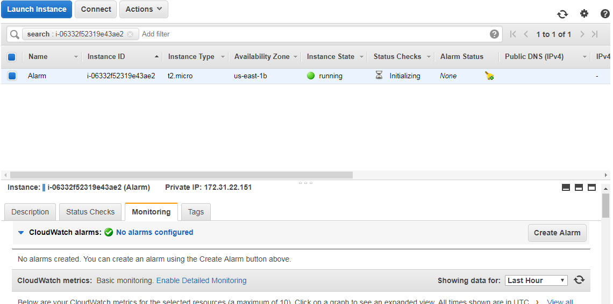

After the creation of EC2 instance, goto Monitoring option then we can see cloudwatch alarm configuration. To create an alarm, click on the create alarm button.

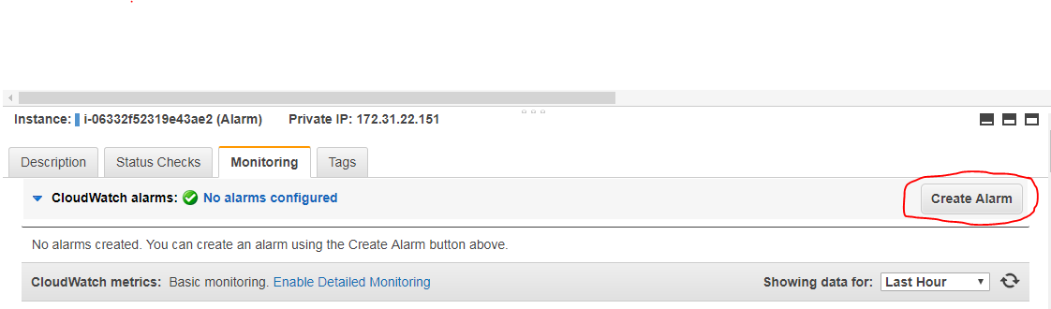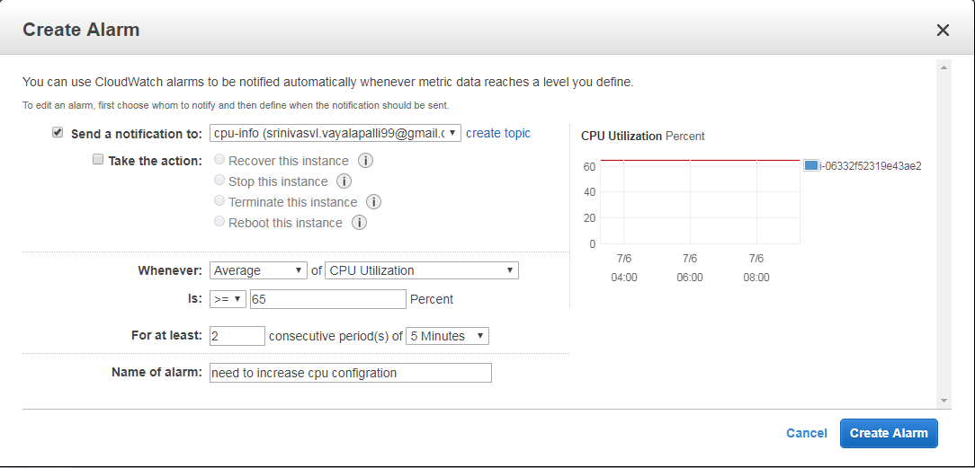

After click on the create alarm button, we can directed to the page which shown in above image. Then provide the details which we have require. In create topic we have to provide your gmail account to get the all notification about your instances. Then select that take action option for receive the notification to your gmail from AWS account.

So here we can see the alarm which is created for the CPU utilization when reaches the grater than 65%

For at least 2 consecutive periods. But in real time we have to set 1 consecutive time and 1 minute for no loss.

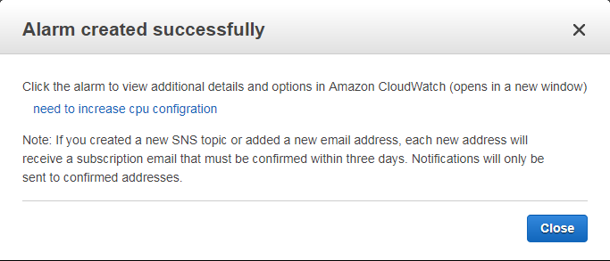Click on the create button, it will create the alarm for that particular instance.

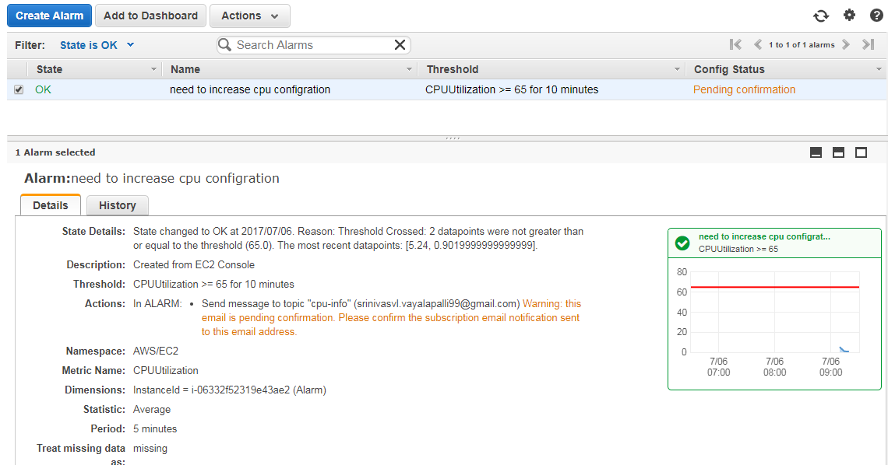

So here we can see the created alarm named as ok.

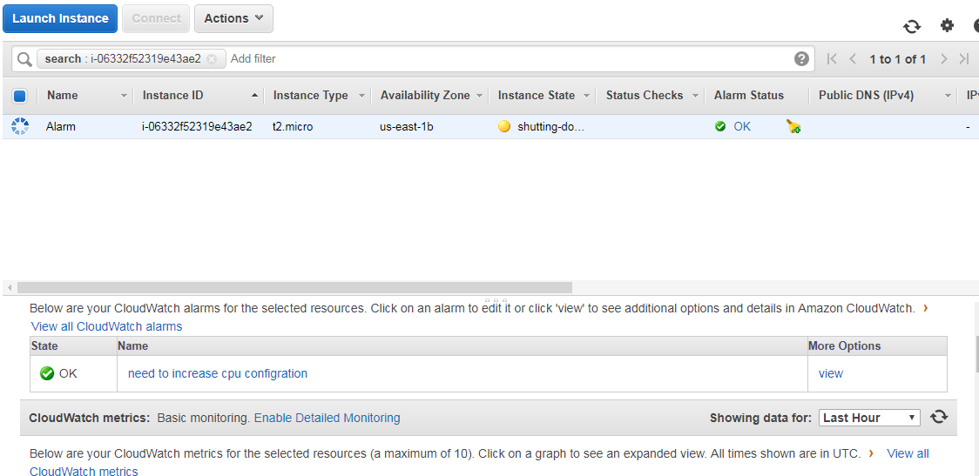

From the left hand side we can see Alarm status has one alarm.