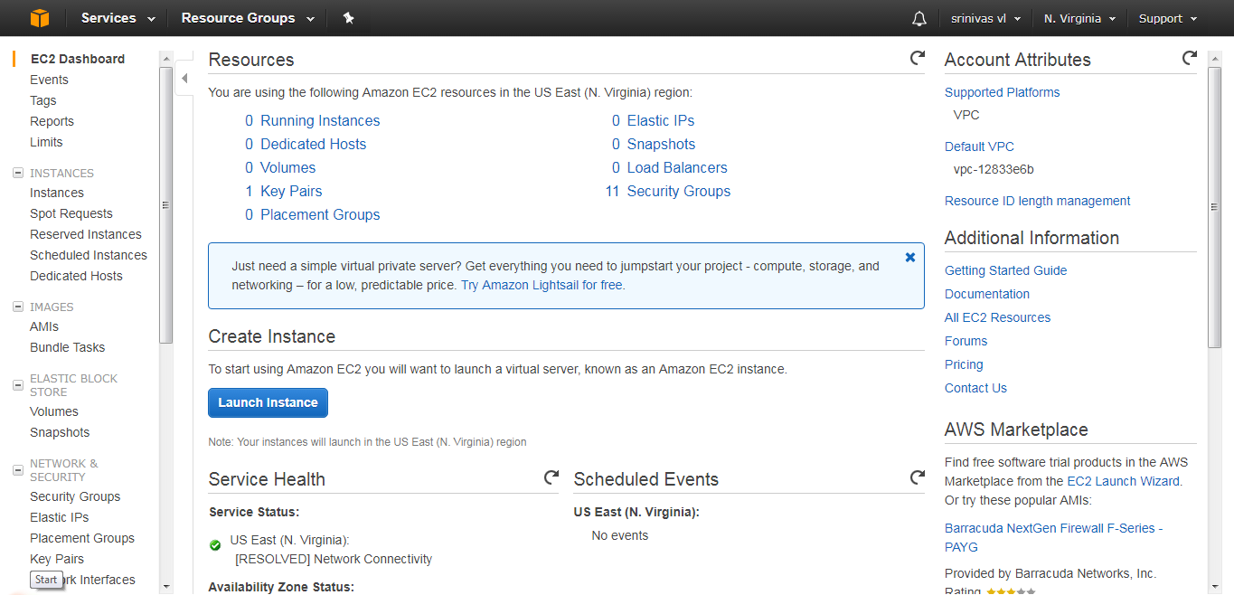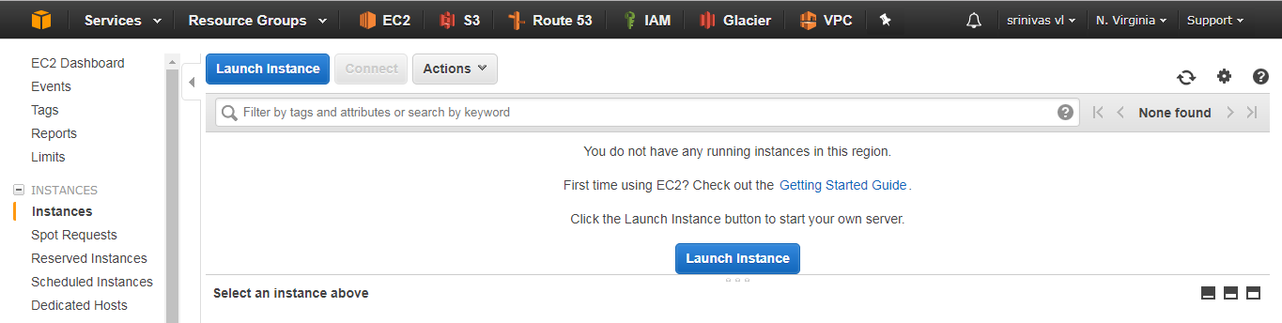

In this step first we will click on the running instances. After that we will redirected to Launch instances page(2nd  image). Click on launch instances button. Then it will redirected to the page which is having different Amazon Machine Image(AMI).

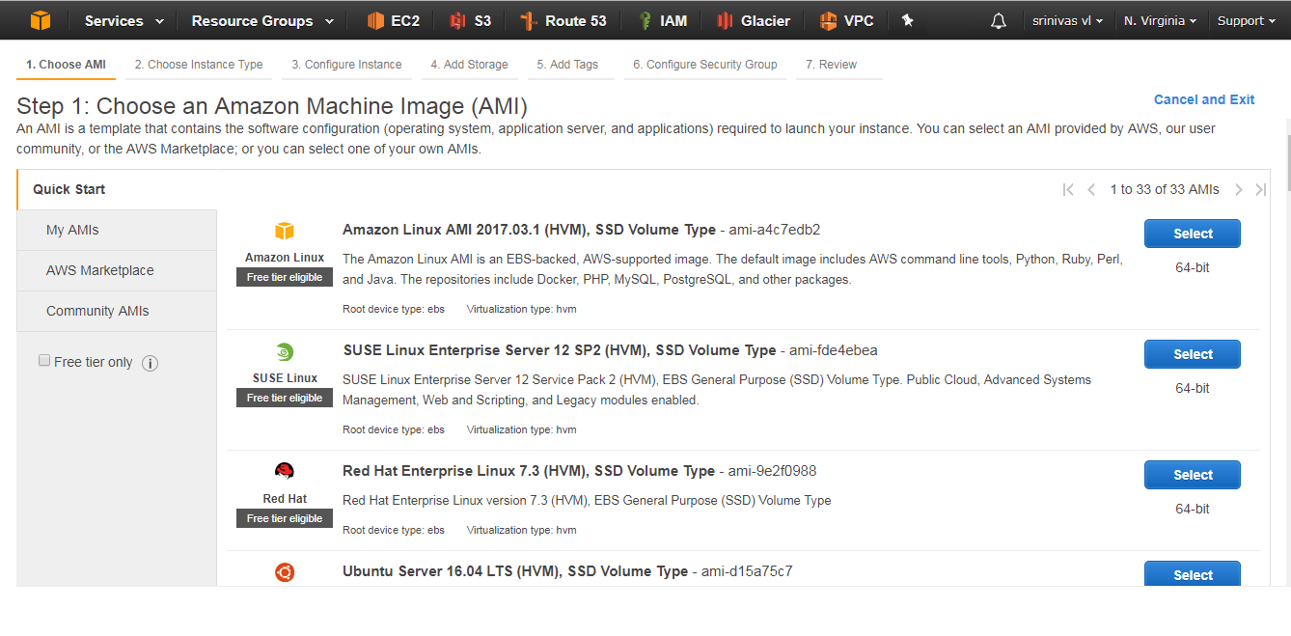

These all are the pre-created images by Amazon to the customers. They can choose the AMI which is suitable to their own work conditions. Free tier eligible AMI’s are free AMI’s provided by the amazon.

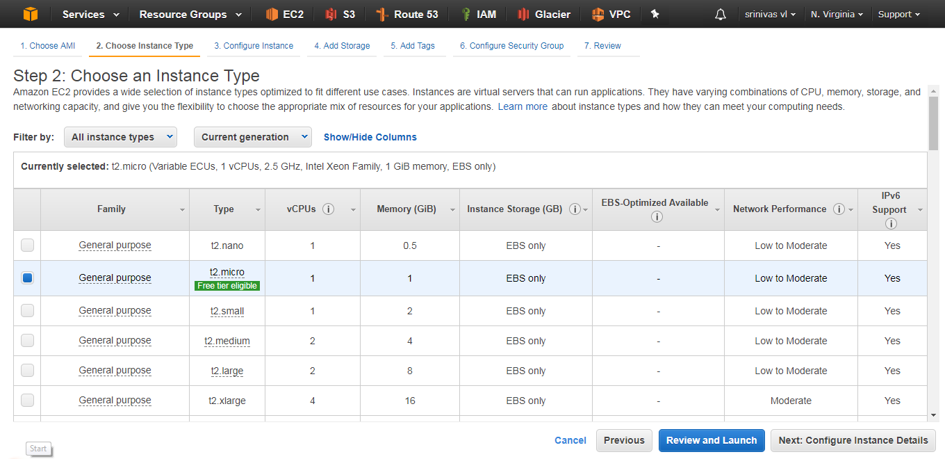

After that it we will enter into 2nd step i.e choose instance type. We are creating for the testing purpose. So select the free tier eligible. Then click configure Instance details.

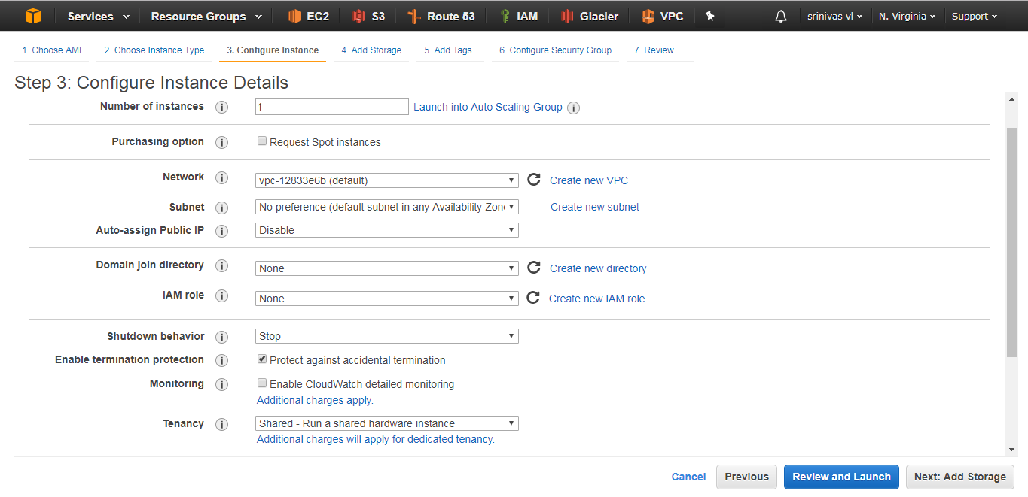

Here we have to provide the instance details like number of instances, we can select the subnet, public ip and IAM role etc. But if we assign that public ip then it will change the ip address frequently(DYNAMIC).

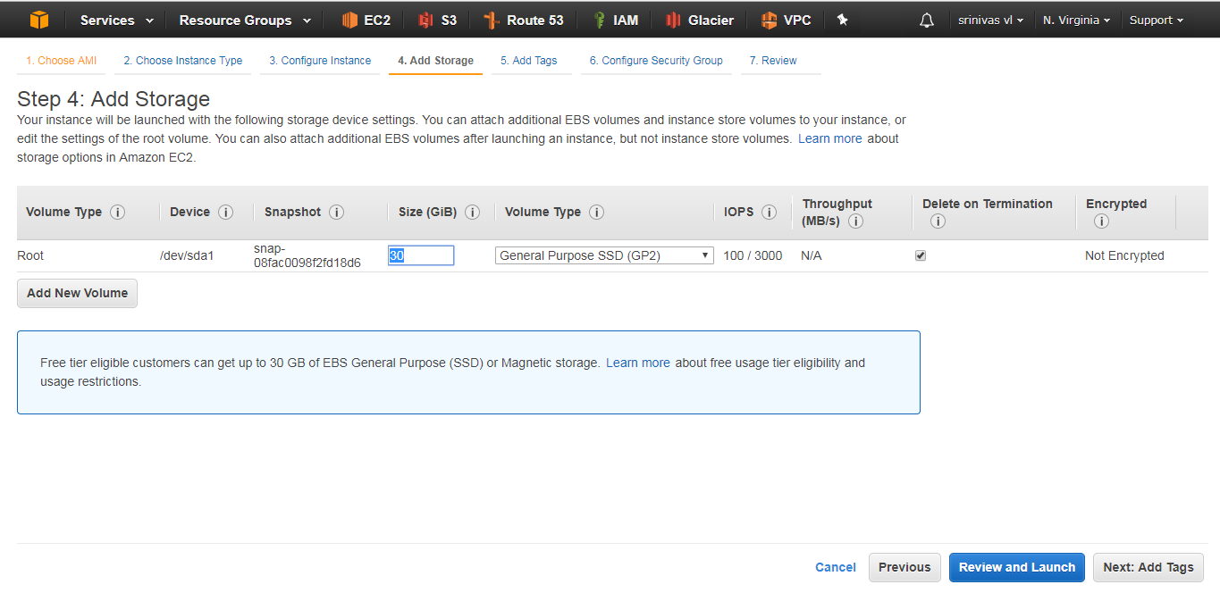

In this step we will add not change the size of the machine. It will lead you to pay extra charges. If you want to add new volumes we can add by clicking on add new volumes button.

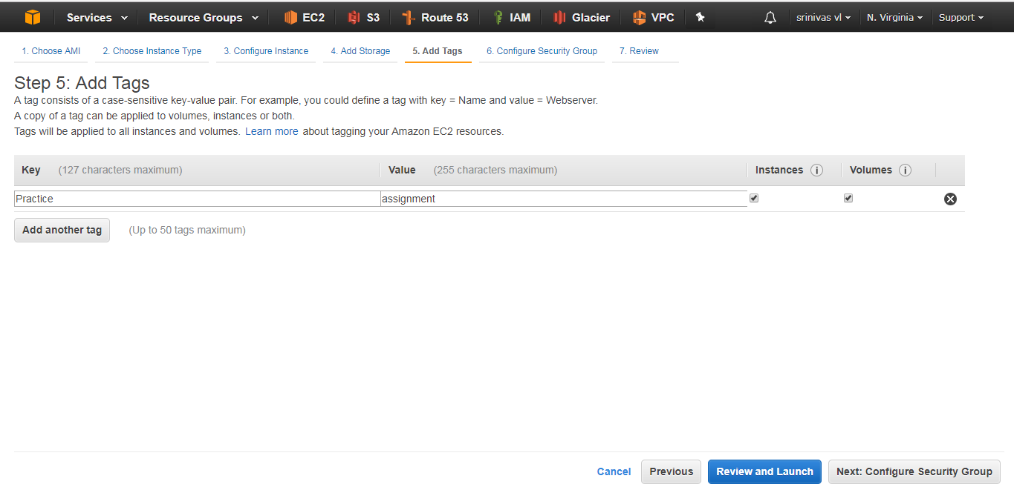

This add tag option is useful when you refer again that instance after creation of long time. We can provide the name that can useful to recognize later.

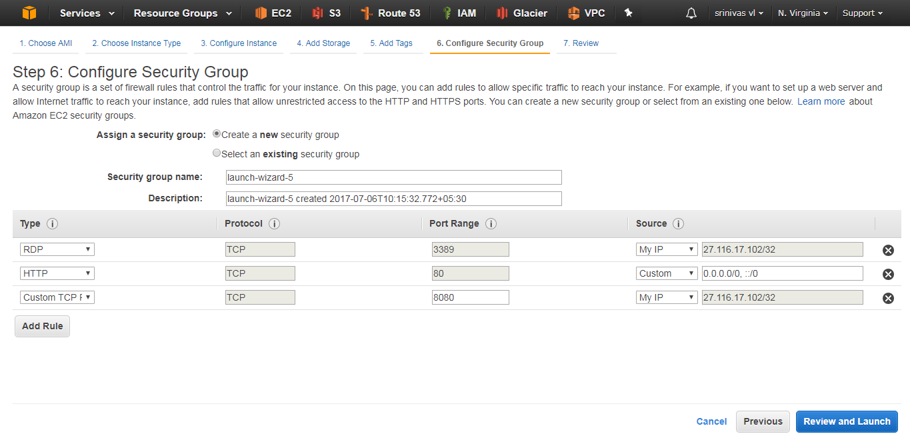

This is comes under the security of your machine. Because here we have to provide the accessing rules to the machine for future accessing purpose. We can use one security group for the multiple number of instances.

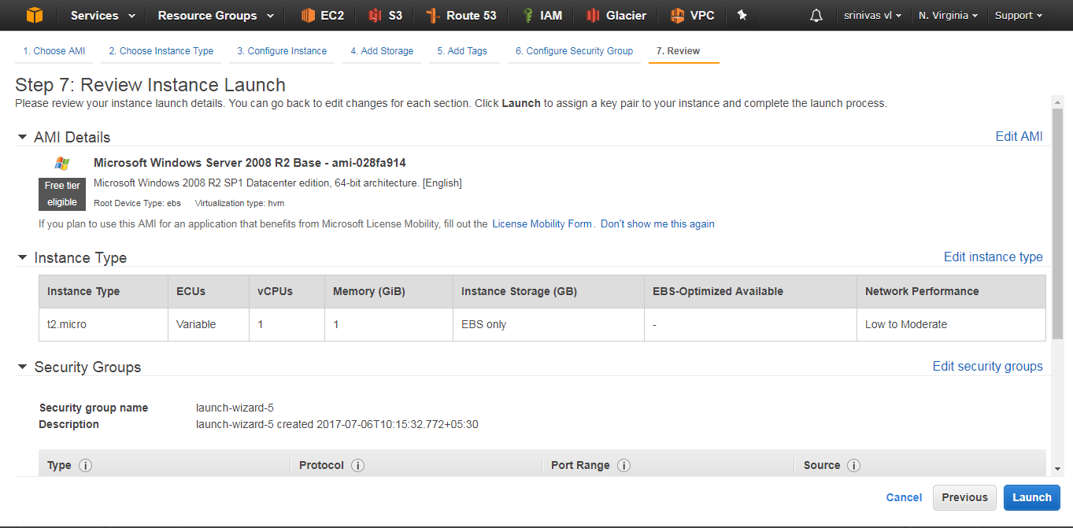

This is the last step of instance creation. Here we can see the all properties of instances which we want to create. Click the launch button to launch instance.

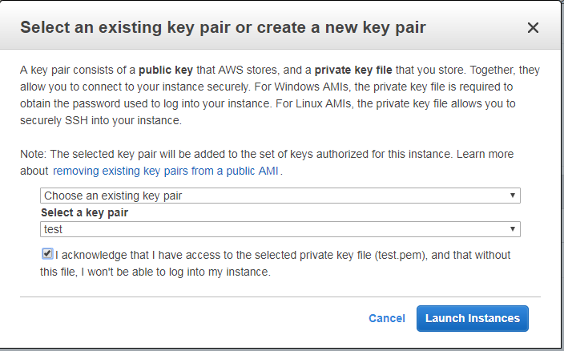

After that we have to provide the key pair. This is used as the password for the instance. Then amazon will creation url for your instance.

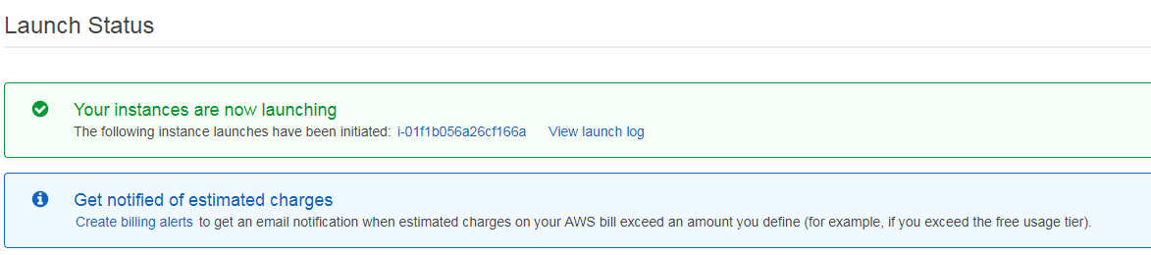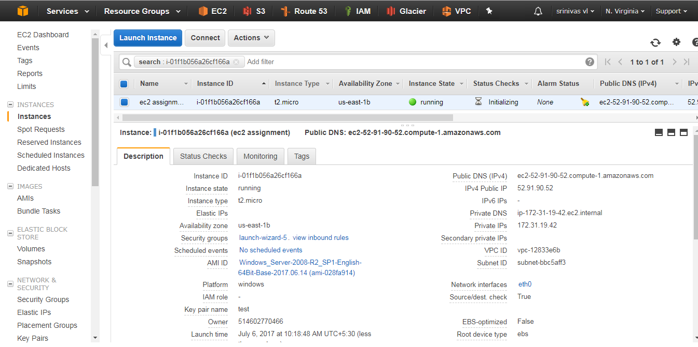

Required EC2 Instance is created