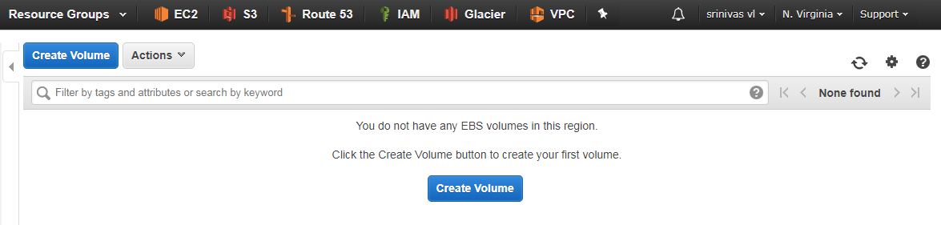

Click on the create volume button to create a volume.

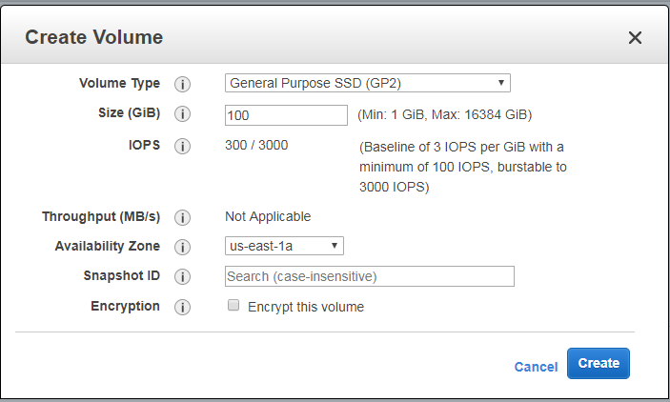

There are two types of volumes in AWS i.e solid-state drives and Hard-disk Drives. So in above testing case we were selected General Purpose SSD(Solid-State-Drives). We can select the size of the size of volume depends on the user requirement and the Availability Zone also.

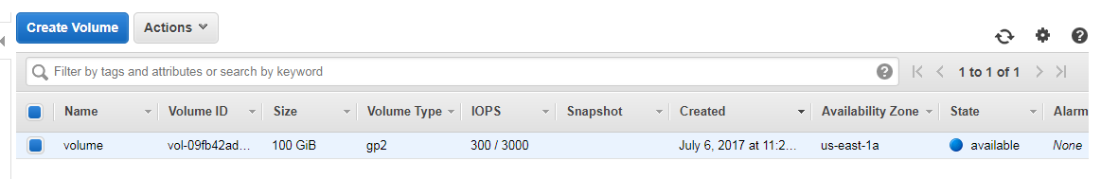

After selecting the all options click on create button to create the required volume. Then it will create the volume like as shown in above image. So far we were done with creation of volume.

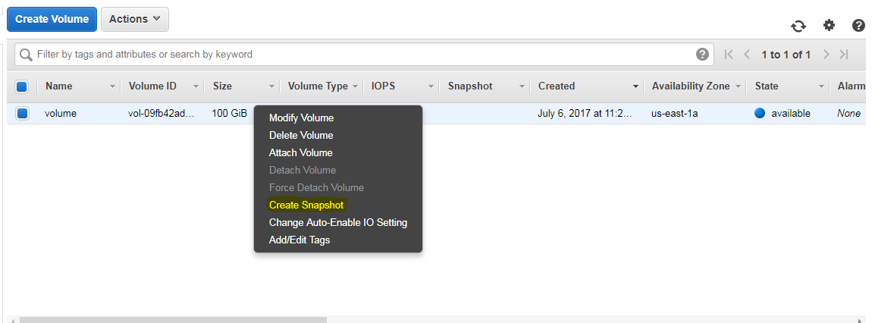

To create the snapshot, right click on the volume then select the snapshot option to create snapshot of required volume. Then it will redirected to create snapshot page as shown below.

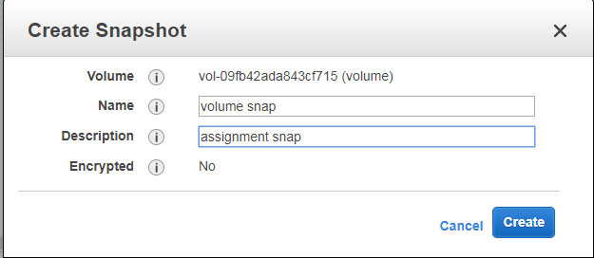

Give the proper name and description to snapshot and click on create button to create snapshot.

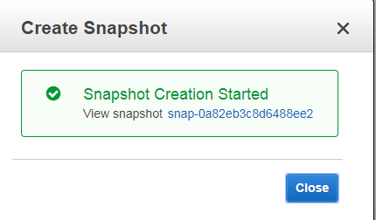

We can open that snapshot by click in that provided snapshot link.

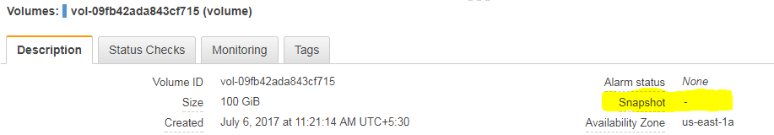

You can go and check the volume description option to see the snapshot which is added to the respective volume as we created.