**DBMS - Mini Project**

**Car Rental Management System**

**Submitted By: Name: Y Srinivas**

**SRN: PES1UG20CS517**

**V Semester Section I**

# Short Description and Scope of the Project

**Description**:

* Car rental management system is a utility which can be useful for a car rental agency and for people who rent cars, by providing solutions for managing cars, customers and the cars taken for rent by customers.
* Our system provides customer to have different pick-up and drop-off locations and will impose late fee if the rental car is returned beyond the return date and time.
* Customer has a choice to rent a car with or without the driver.
* If customer rents a car with the driver, then they will be charged driver fare based on the driver experience.
* If customer decides to rent a car without driver, then he has to provide his driving license number that is mandatory.
* Customer has given with a lot discount coupons each coupon has different discount percentage.
* After they return the Car, we are going to enter the actual return date. Based on all these details we are going to calculate the Amount to be paid by the customer using Functions and updating the payment details using procedure and Cursors.

**Scope**:

* Renting a car is a self-sustaining system which is the best opportunity for the people who cannot afford to buy the car in their family.
* Due to this system the people can borrow the car on rent for some time and do they compulsory work while paying the charges the rented car.
* Making a company available to customers 24 hours a day, seven days a week.
* Online systems reduce the time it takes to rent a car and the costs of hiring people to input data into paper-based records.
* Having all the records in one place it is much easier for you to track your expenses and budget appropriately. This can help with financial planning and decision-making for the future of your business.

**ER Diagram**

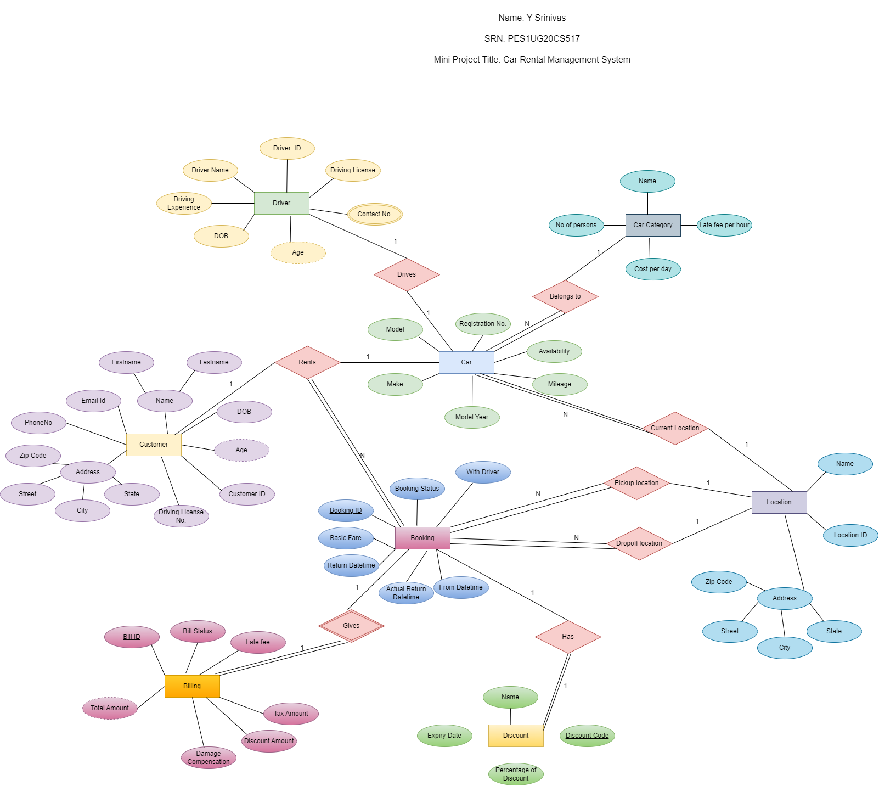

# Relational Schema

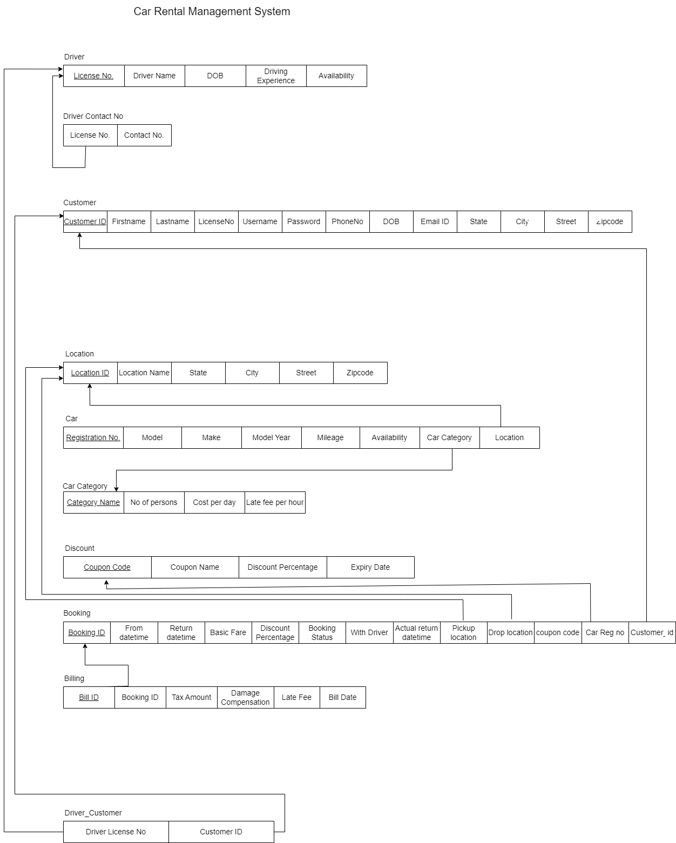

**DDL statements - Building the database**

-- Driver's information

create table driver_info(

    dl_number char(16) not null,

    constraint pk_driver_dl primary key(dl_number),

    driver_name varchar(35) not null,

    driver_dob date not null,

    driving_experience int not null,

    available boolean default true

);

alter table driver_info

add constraint check_experience check(driving_experience >= 2);

-- Drivers Contact numbers

create table driver_contacts(

    dl_number char(16) not null,

    constraint fk_driver_dl foreign key(dl_number) references driver_info(dl_number),

    phone_no char(10)

);

alter table driver_contacts

modify phone_no char(10) not null;

alter table driver_contacts

add constraint check_phone check(char_length(phone_no) = 10);

-- Customer's information

create table customer_info(

    customer_id int not null auto_increment,

    dl_number char(16) unique,

    firstname varchar(35) not null,

    lastname varchar(35) not null,

    phone_no char(10) not null,

    username varchar(35) not null unique,

    password varchar(50) not null,

    dob date not null,

    email varchar(35),

    state varchar(35) not null,

    city varchar(35) not null,

    street varchar(35) not null,

    zipcode char(5) not null,

    constraint pk_customer_id primary key(customer_id),

    constraint check_phone_customer check(char_length(phone_no) = 10)

);

alter table customer_info auto_increment = 20000;

create table locations(

    location_id int not null auto_increment,

    location_name varchar(50) not null,

    state varchar(35) not null,

    city varchar(35) not null,

    street varchar(35) not null,

    zipcode int(5) not null,

    constraint pk_location_id primary key(location_id)

);

alter table locations auto_increment = 40000;

alter table locations

modify location_name varchar(50) not null unique;

-- Car Category

create table car_category(

    category_name varchar(35) not null,

    no_persons int not null,

    cost_per_day double not null,

    late_fee_per_hour double not null,

    constraint pk_category_name primary key(category_name)

);

-- Car details

create table car_details(

    registration_no char(6) not null,

    model_name varchar(35) not null,

    make varchar(35) not null,

    model_year int(4) not null,

    mileage double not null,

    available boolean default true,

    category varchar(35) not null,

    car_location int not null,

    constraint pk_car_reg primary key(registration_no),

    constraint fk_car_category foreign key(category) references car_category(category_name),

    constraint fk_car_location foreign key(car_location) references locations(location_id)

);

-- Discount

create table discount(

    coupon_code char(4) not null,

    coupon_name varchar(35) not null,

    discount_percentage double not null,

    expiry_date date not null,

    constraint pk_discount_coupon primary key(coupon_code)

);

-- Booking Details

create table booking_details(

    booking_id int not null auto_increment,

    from_date date not null,

    return_date date not null,

    basic_fare double not null, -- no. of days * price per day of car - discount amt

    discount_percentage double default 0, -- from discount percentage

    booking_status boolean default false,

    with_driver boolean default false,

    actual_return_date date not null,

    pickup_location int not null,

    drop_location int not null,

    coupon_code char(4),

    car_reg_no char(6) not null,

    customer_id int not null,

    booking_date date default current_date(),

    constraint pk_booking_id primary key(booking_id),

    constraint fk_booking_coupon foreign key(coupon_code) references discount(coupon_code),

    constraint fk_booking_car foreign key(car_reg_no) references car_details(registration_no),

    constraint fk_booking_pickup foreign key(pickup_location) references locations(location_id),

    constraint fk_booking_pickdrop foreign key(drop_location) references locations(location_id),

    constraint fk_booking_customer foreign key(customer_id) references customer_info(customer_id)

);

alter table booking_details auto_increment=50000;

-- Billing Details

create table billing_details(

    bill_id int not null auto_increment,

    booking_id int not null,

    tax_amount double default 20.0,

    damage_compensation double default 0,

    late_fee double default 0, -- if actual return date > return date

    bill_date date default current_date(),

    constraint pk_bill_id primary key(bill_id),

    constraint fk_bill_booking foreign key(booking_id) references booking_details(booking_id)

);

alter table billing_details auto_increment = 60000;

-- Customer who has booked with driver those detils will be stored here

create table booking_with_driver(

    id int not null auto_increment,

    driver_dl char(16) not null,

    customer_id int not null,

    booking_id int not null,

    booking_date date default current_date(),

    constraint pk_driver_customer_id primary key(id),

    constraint fk_booking_driver_customer foreign key(driver_dl) references driver_info(dl_number),

    constraint fk_booking_customer_driver foreign key(customer_id) references customer_info(customer_id),

    constraint fk_booking_id foreign key(booking_id) references booking_details(booking_id)

);

alter table booking_with_driver auto_increment = 70000;

# Populating the Database

-- driver's data

insert into driver_info values

    ( "HR-0619830034761", "Liam", "1975-01-07", 15, true),

    ( "HR-0619850034771", "Noah", "1970-03-17", 8, false),

    ("HR-0619880034781", "Oliver", "1985-05-20", 10, true),

    ( "HR-0619890034791", "Elijah", "1995-07-11", 6, false),

    ( "HR-0619820034661", "James", "1972-09-18", 20, true);

-- driver's contacts

insert into driver_contacts values

    ("HR-0619830034761", 9982641789),

    ("HR-0619830034761", 9927593732),

    ("HR-0619850034771", 8535919898),

    ("HR-0619880034781", 9972104143),

    ("HR-0619890034791", 6363212645),

    ("HR-0619890034791", 7676676566),

    ("HR-0619820034661", 9591858426);

-- Customers info

insert into customer_info( dl_number, firstname, lastname, phone_no, username, password, dob, email, state, city, street, zipcode ) values

    ( "HR-0719830034891", "Adler", "Anderson", 8322335022, "alderanderson", "1234@", "2000-02-04", "alderanderson@gmail.com", "Alabama", "Montgomery", "Main Street.", 40202 ),

    ( "HR-0719830034892", "Seth", "Ivan", 7926870547, "sethivan", "abcd@", "2002-03-05", "sethivan@gmail.com", "Alaska", "Juneau", "2nd Street.", 40203 ),

    ( "HR-0719830034893", "Riley", "Gilbert", 9822334254, "rileygilbert", "wxyz@", "1975-04-06", "rileygilbert@gmail.com", "Arizona", "Phoenix", "7th Street.", 40204),

    ( null, "Jorge", "Dan", 9841310497, "jorgedan", "1234@", "1980-05-07", null, "Arkansas", "Little Rock", "3rd Street.", 40205 ),

    ( "HR-0719830034895", "Brian", "Roberto", 9998958055, "brianroberto", "abcd@", "2003-06-08", "brianroberto@gmail.com", "California", "Sacramento", "1st Street.", 40207 ),

    ( null, "Ramon", "Miles", 7759228501, "ramonmiles", "wxyz@", "2005-07-09", "ramonmiles@gmail.com", "Alabama", "Montgomery", "Main Street", 40202),

    ("HR-0719830034897","Liam","Nathaniel",8212415127,"liamnathaniel","1234@","1960-08-10","liamnathaniel@gmail.com","Alabama","Montgomery","Main Street",40202);

-- Locations

insert into locations(location_name, state, city, street, zipcode) VALUES

    ( 'Private AIRPORT', "Alabama", "Montgomery", "Main Street.", 40202 ),

    ( 'DALLAS LOVE FIELD AIRPORT', "Alabama", "Montgomery", "Main Street.", 40202 ),

    ( 'LOS ANGELES INTL AIRPORT', "Alaska", "Juneau", "2nd Street.", 40203 ),

    ( 'DALLAS/ FORT WORTH INTL AIRPORT', "Alabama", "Montgomery", "Main Street.", 40202 ),

    ( 'WEST HOUSTON AIRPORT', "Arizona", "Phoenix", "7th Street.", 40204),

    ( 'WASHINGTON DULLES INTL AIRPORT', "California", "Sacramento", "1st Street.", 40207);

-- car category

insert into car_category values

    ('ECONOMY', 5, 30, 0.9),

    ('COMPACT', 5, 32, 0.96),

    ('MID SIZE', 5, 35, 1.05),

    ('STANDARD', 5, 38, 1.14),

    ('FULL SIZE', 5, 40, 1.2),

    ('LUXURY CAR', 5, 75, 2.25),

    ('MID SIZE SUV', 5, 36, 1.08),

    ('STANDARD SUV', 5, 40, 1.2),

    ('FULL SIZE SUV', 8, 60, 1.8),

    ('MINI VAN', 7, 70, 2.1);

-- Car Details

insert into car_details( registration_no, model_name, make, model_year, mileage, category, car_location) values

    ( 'AB1234', 'CIVIC', 'HONDA', 2014, 8, 'ECONOMY', 40000),

    ( 'SD4567', 'FIESTA', 'FORD', 2015, 6, 'ECONOMY', 40001),

    ( 'GLZ2376', 'COROLLA', 'TOYOTA', 2016, 5.000, 'ECONOMY', 40002),

    ( 'WER3245', 'ACCENT', 'HYUNDAI', 2014, 12.356, 'ECONOMY', 40003),

    ( 'HJK1234', 'CIVIC', 'HONDA', 2015, 20.145, 'ECONOMY', 40004),

    ( 'GLS7625', 'FOCUS', 'FORD', 2014, 12.01, 'COMPACT', 40001),

    ( 'FKD8202', 'GOLF', 'VOLKSWAGAN', 2016, 11.5, 'COMPACT', 40002),

    ( 'HNX1890', 'PRIUS', 'TOYOTA', 2015, 7.8, 'COMPACT', 40003),

    ( 'KJS1983', 'PRIUS', 'TOYOTA', 2014, 9.5, 'COMPACT', 40004),

    ( 'SDL9356', 'FOCUS', 'FORD', 2016, 10, 'COMPACT', 40003),

    ( 'OTY7293', 'CRUZE', 'CHEVROLET', 2016, 14, 'MID SIZE', 40002);

-- discount details

insert into discount( coupon_code, coupon_name, expiry_date, discount_percentage) values

    ( 'D678', 'IBM CORPORATE', '2023-01-25', 25),

    ( 'D234', 'CTS CORPORATE', '2024-09-02', 20),

    ( 'D109', 'WEEKLY RENTALS', '2022-11-09', 25),

    ( 'D972', 'ONE WAY SPECIAL', '2023-12-15', 20),

    ( 'D297', 'UPGRADE SPECIAL', '2025-02-18', 20),

    ( 'D756', 'HOLIDAY SPECIAL', '2021-10-29', 10);

**Join Queries**

1. Show all the car details and category to which car belongs to where car available for booking.

Query:

select * from car_details inner join car_category on category = category_name where available = true order by cost_per_day;

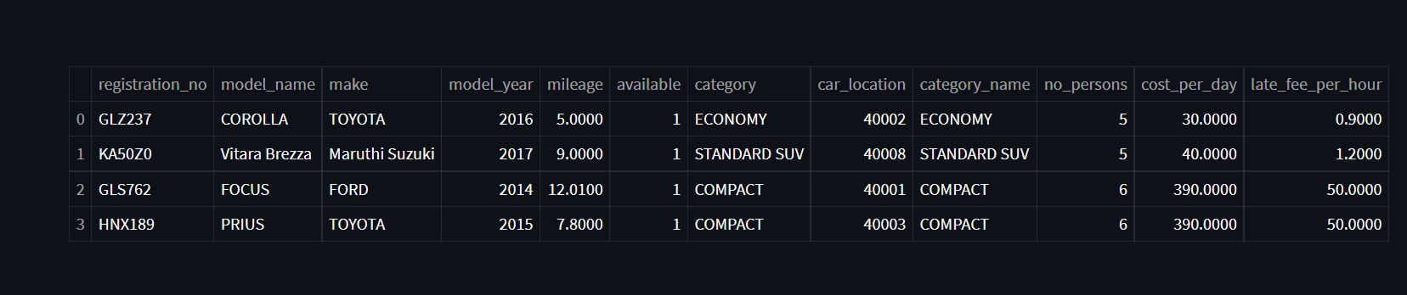

1. Show car details along with its current location.

Query:

select * from car_details inner join locations on car_location = location_id;

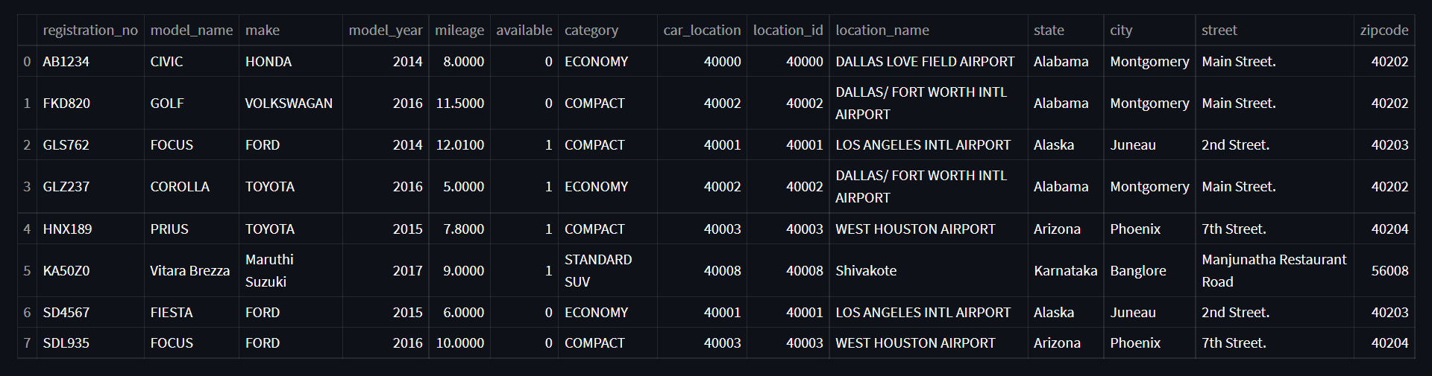

1. Show cars booked by a customer.

Query:

select Firstname,Lastname, model_name from customer_info join

(booking_details join car_details) where customer_info.Customer_ID =

booking_details.Customer_ID and Registration_No = Car_Reg_No;

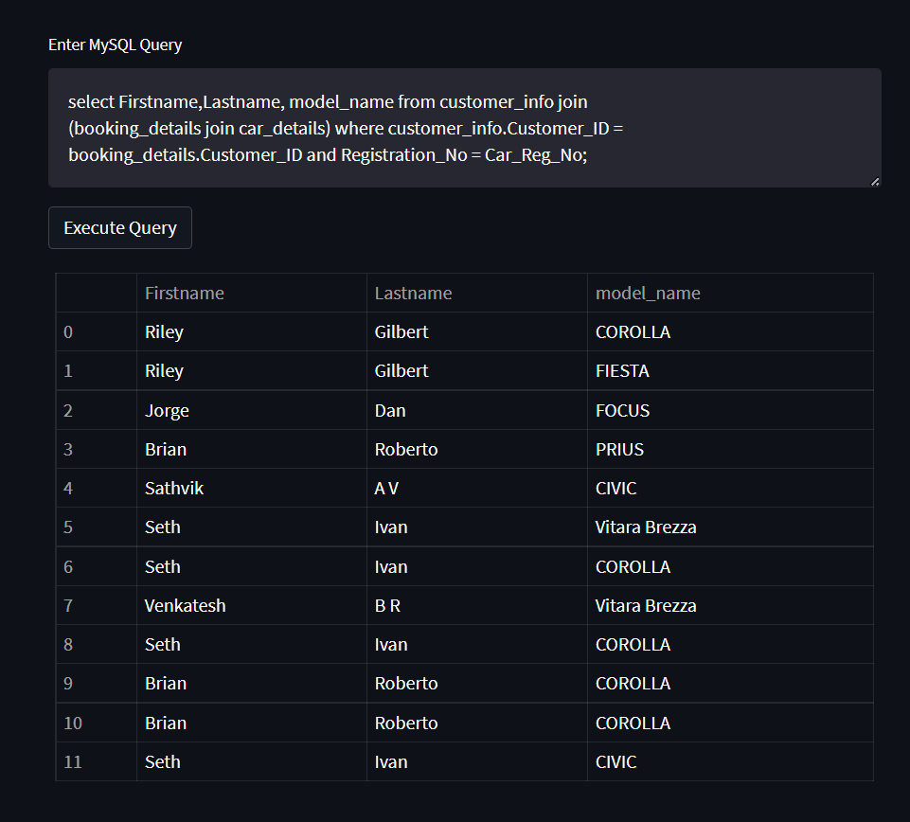

1. Display Car Details along with along with the category to which it belongs, No of persons it can hold, Cost per day.

Query:

select * from car_details inner join car_category on category = category_name order by cost_per_day;

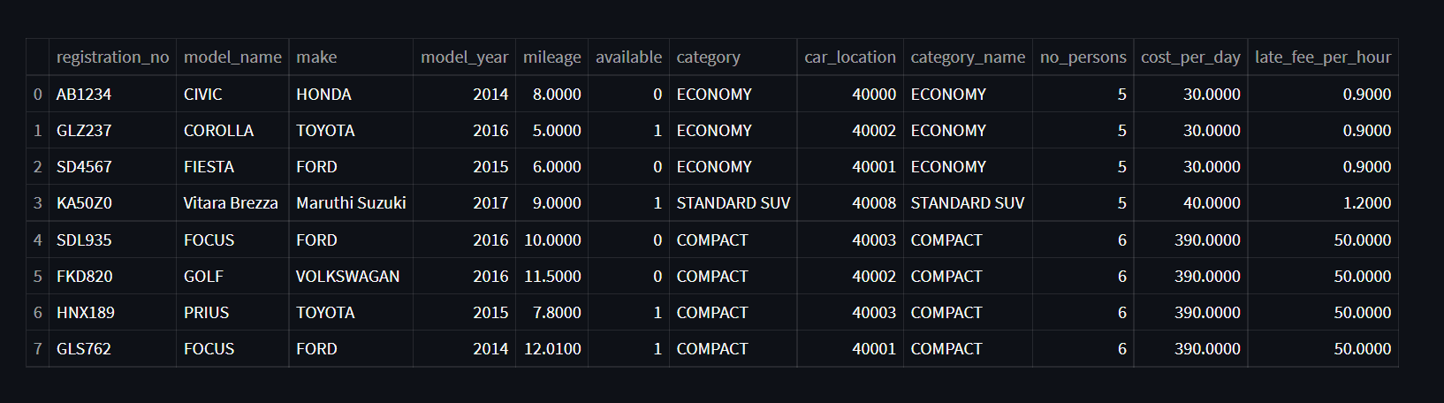

# Aggregate Functions

1. Show number of bookings made by each customer.

Query:

select username as CustomerName, count(*) as NoOfTimes from booking_details as B inner join customer_info as C on B.customer_id = C.customer_id  group by c.username order by NoOfTimes desc;

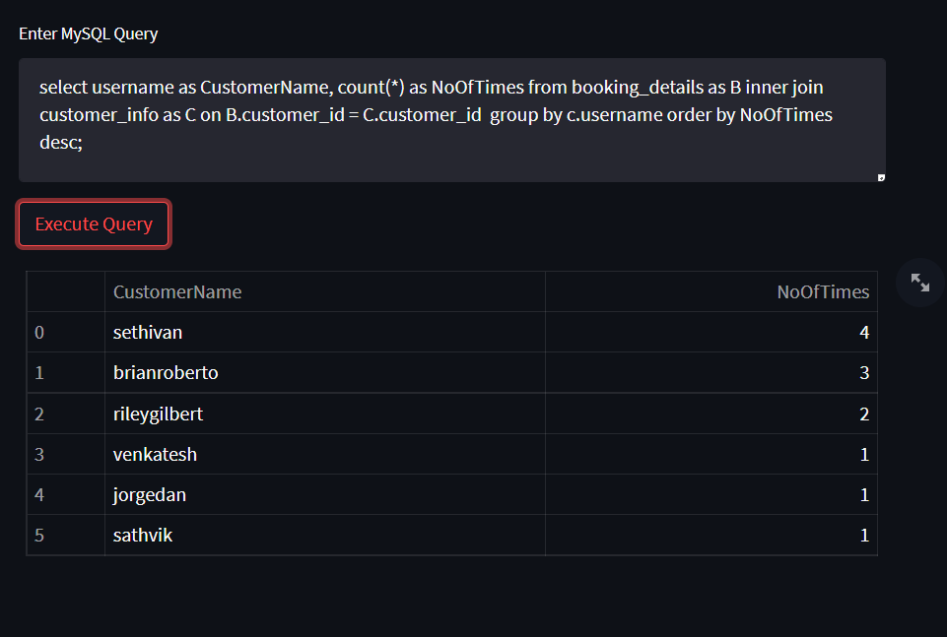

1. Show total number of bookings done till today.

Query:

select count(*) as TotalBookings from booking_details;

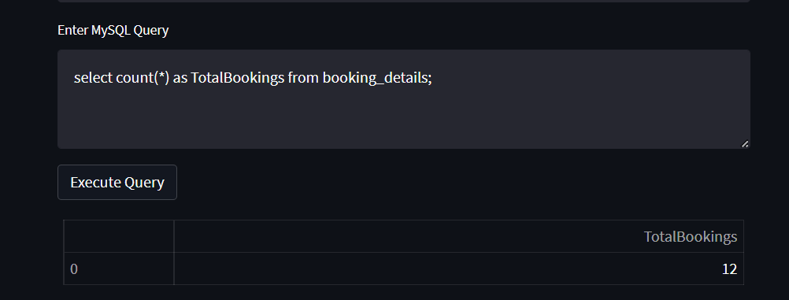

1. Show number of cars booked on particular date.

Query:

select booking_date as OnDate, count(*) as CarsBooked from booking_details group by booking_date;

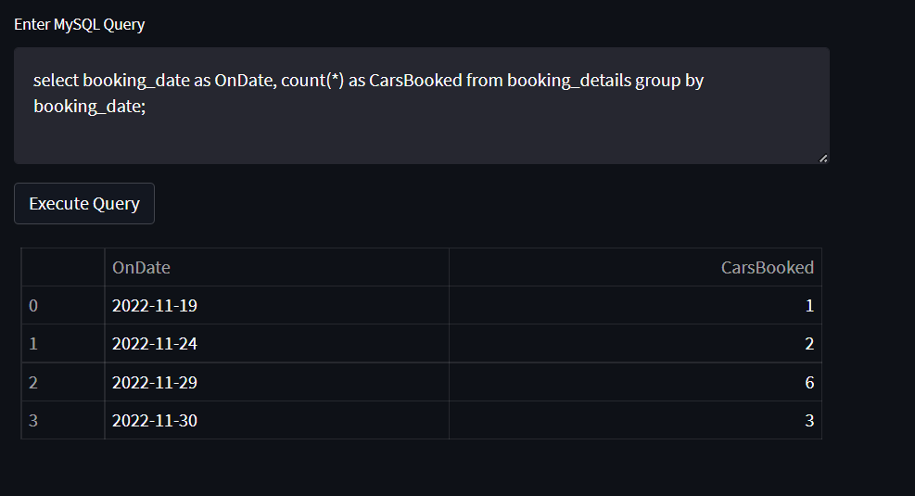

1. Show number of cars belong to each category.

Query:

select category, count(*) as NoOfCars from car_details group by category;

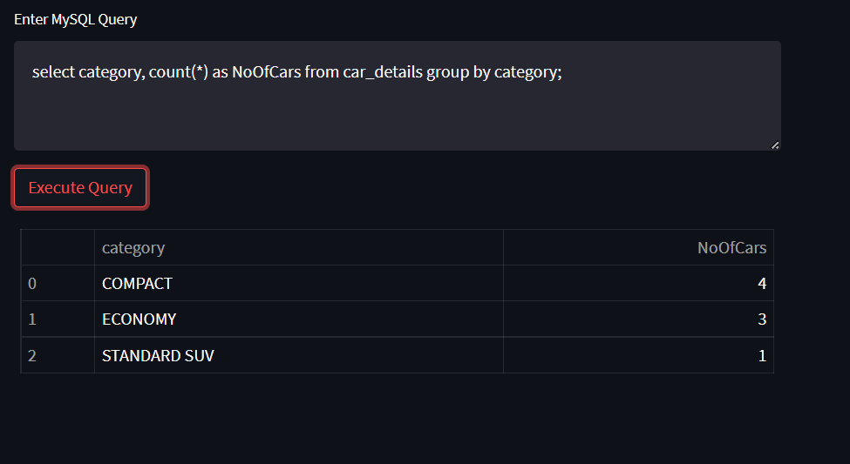

# Set Operations

1. Display the Customer First name and Last Name who have returned the Car on or before the Return Date.

Query**:**

select Firstname,Lastname from customer_info join booking_details where

customer_info.Customer_ID = booking_details.Customer_ID and Return_Date =

Actual_Return_Date

UNION

select Firstname,Lastname from customer_info join booking_details where

customer_info.Customer_ID = booking_details.Customer_ID and Return_Date >

Actual_Return_Date;

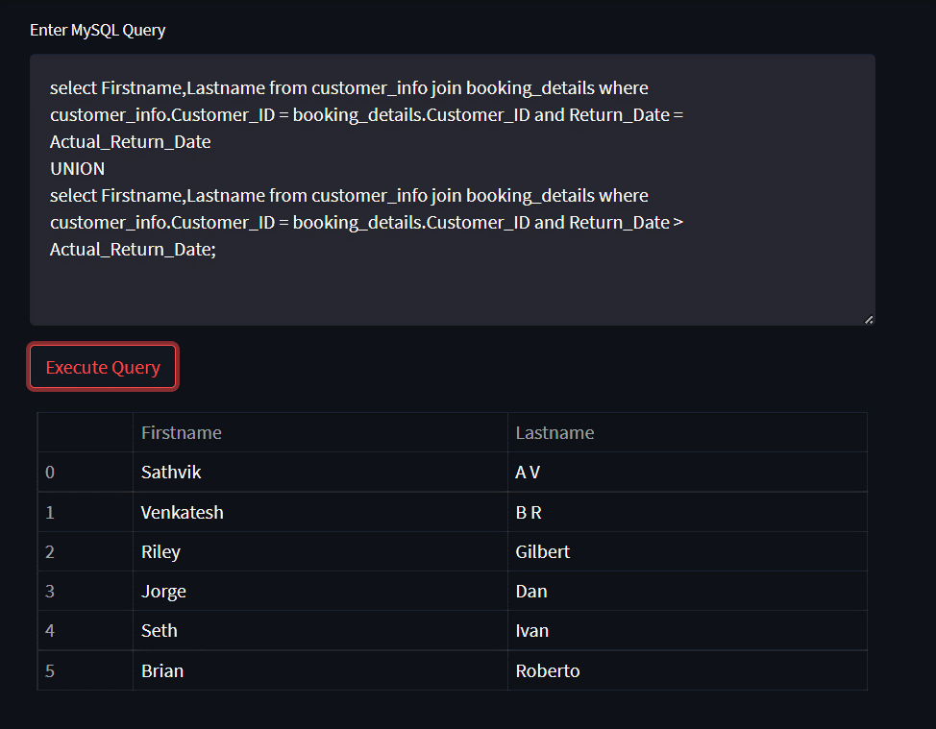

1. **Display the Car that were Booked and the Model_Year >2014.**

**Query:**

select Make,Model_name,Model_Year from car_details join booking_details where

Registration_No = Car_Reg_No

EXCEPT

select Make,Model_name,Model_Year from car_details where Model_Year <= 2014;

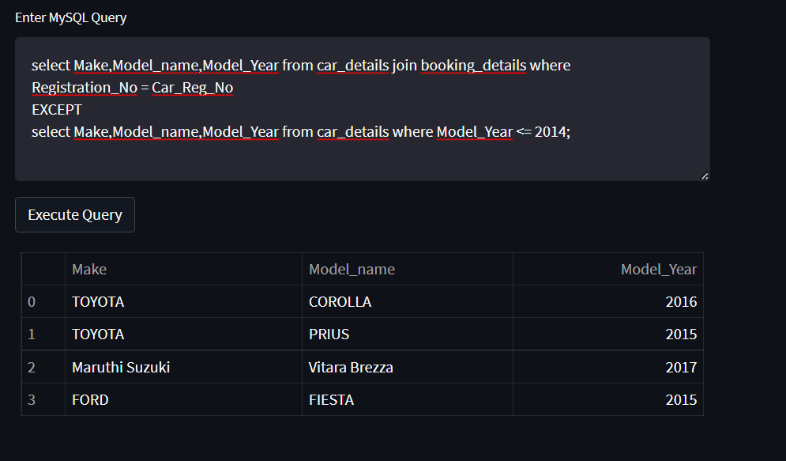

# Functions and Procedures

**Function to calculate driver fare based on his experience.**

drop function if exists driver_charge;

DELIMITER $

CREATE FUNCTION driver_charge (experience int)

  RETURNS double

   DETERMINISTIC

    BEGIN

     DECLARE charge double;

        IF experience > 3 and experience < 6

            THEN SET charge = 500.0;

        ELSEIF  experience > 5 and experience < 10

            THEN SET charge = 700.0;

        ELSEIF  experience >= 10

            THEN SET charge = 1000.0;

        ELSE set charge = 0;

        END IF;

     RETURN charge;

    END $

delimiter ;

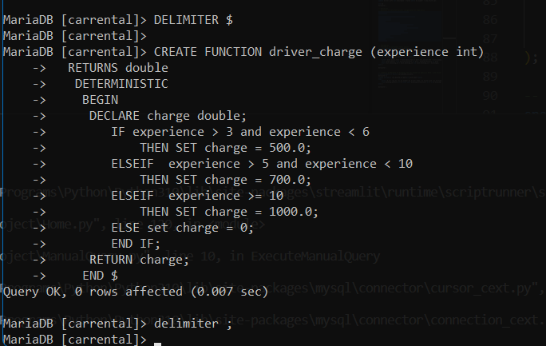

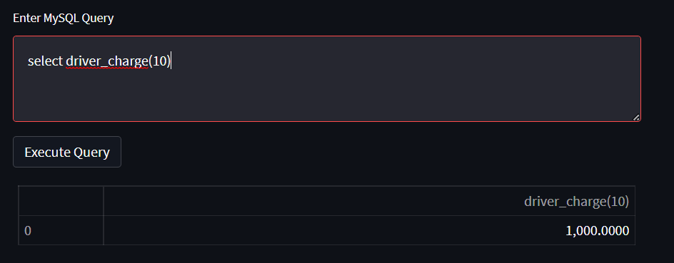

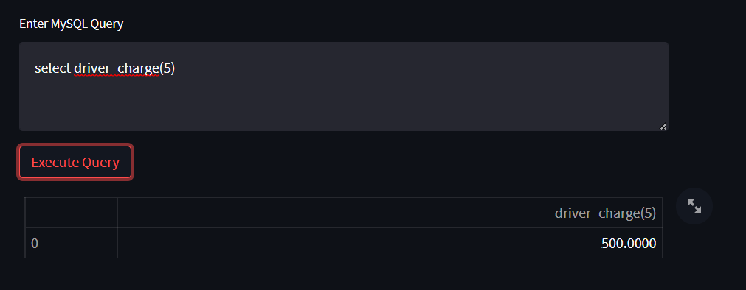

**Procedure to calculate total amount of a booking with including tax amount and driver fare.**

drop procedure if exists get_total_amount;

delimiter $

create Procedure get_total_amount(IN bookingid INT, OUT total_amount double)

begin

    DECLARE driver_experience_p int default 0;

    select book.basic_fare + book.basic_fare * bill.tax_amount/100 + bill.damage_compensation + bill.late_fee

    into total_amount from billing_details as bill, booking_details as book

    where bill.booking_id = book.booking_id and book.booking_id = bookingid;

end $

delimiter ;

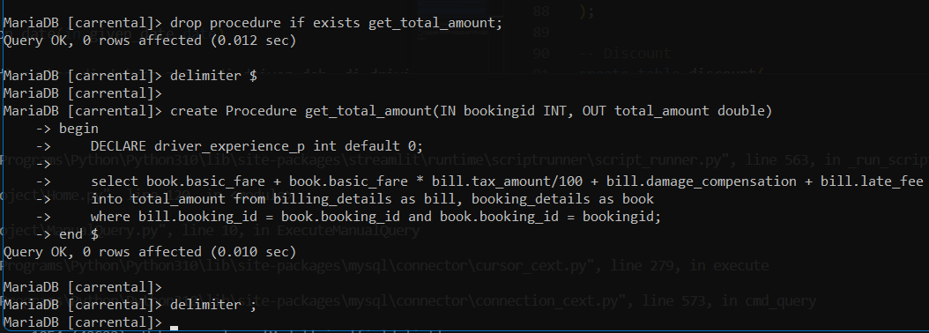

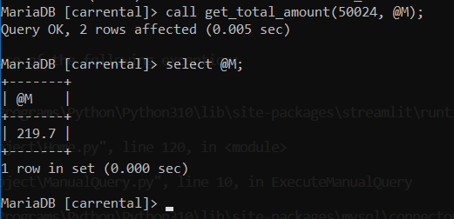

# Triggers and Cursors

1. Set the availability of a particular driver to false when that car is booked.

drop trigger if exists after_driver_customer;

delimiter $$

create trigger after_driver_customer

after insert

on booking_with_driver for each row

begin

update driver_info set available = false where dl_number = new.driver_dl;

end $$

delimiter ;

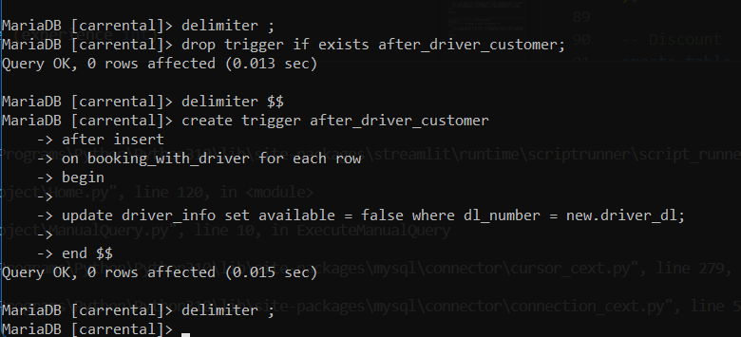

Initial available drivers.

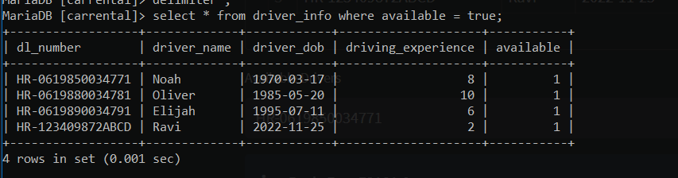

After Booking with driver.

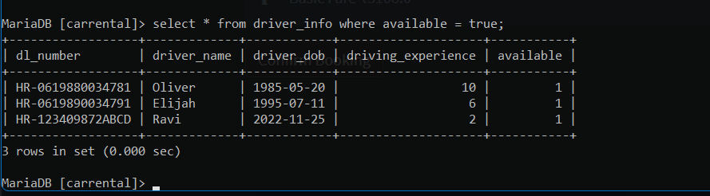

A cursor for looping over the usernames of customers, and a NOT FOUND handler:

drop procedure if exists createUsernameList;

DELIMITER $$

CREATE PROCEDURE createUsernameList (

    INOUT usernameList varchar(4000)

)

BEGIN

    DECLARE finished INTEGER DEFAULT 0;

    DECLARE username varchar(100) DEFAULT "";

    -- declare cursor for employee email

    DEClARE curUsername

        CURSOR FOR

            SELECT username FROM customer_info;

    -- declare NOT FOUND handler

    DECLARE CONTINUE HANDLER

        FOR NOT FOUND SET finished = 1;

    OPEN curUsername;

    getUsername: LOOP

        FETCH curUsername INTO username;

        IF finished = 1 THEN

            LEAVE getUsername;

        END IF;

        -- build email list

        SET usernameList = CONCAT(username,";",usernameList);

    END LOOP getUsername;

    CLOSE curUsername;

END$$

DELIMITER ;

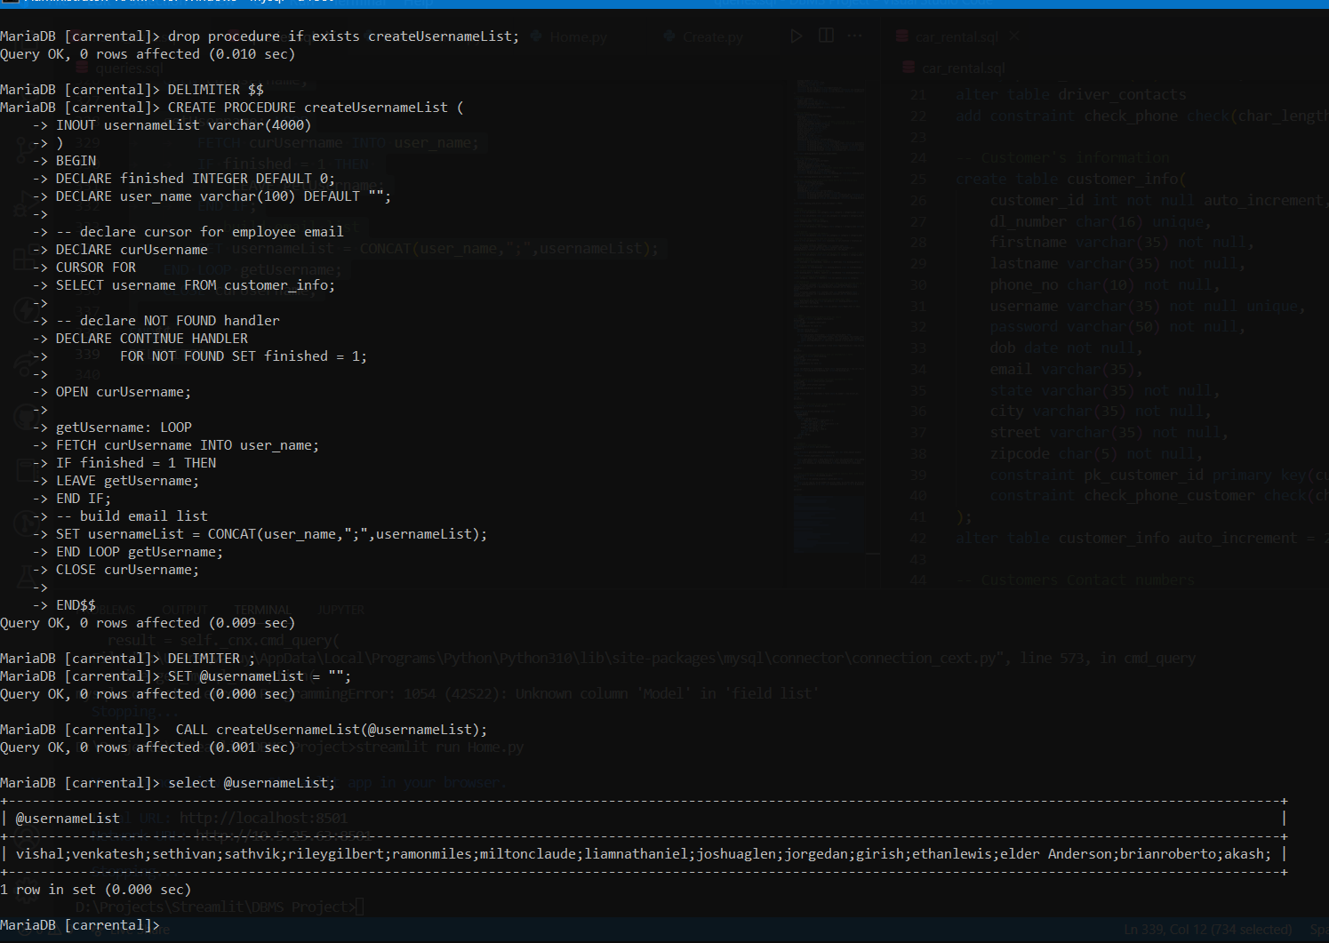

Modification Given during demo:

create a prodecudre to dispalay the car booked on specific date  with driver details.

**Query**:

drop procedure if exists car_booked_on_date;

delimiter $

create procedure car_booked_on_date(in given_date date)

begin

    select B.car_reg_no, di.dl_number,di.driver_name, di.driver_dob, di.driving_experience, di.available, b.booking_date

    from booking_details as B inner join booking_with_driver as D on B.booking_id = D.booking_id inner join driver_info as di on D.driver_dl = di.dl_number where b.booking_date = given_date;

end $

delimiter ;

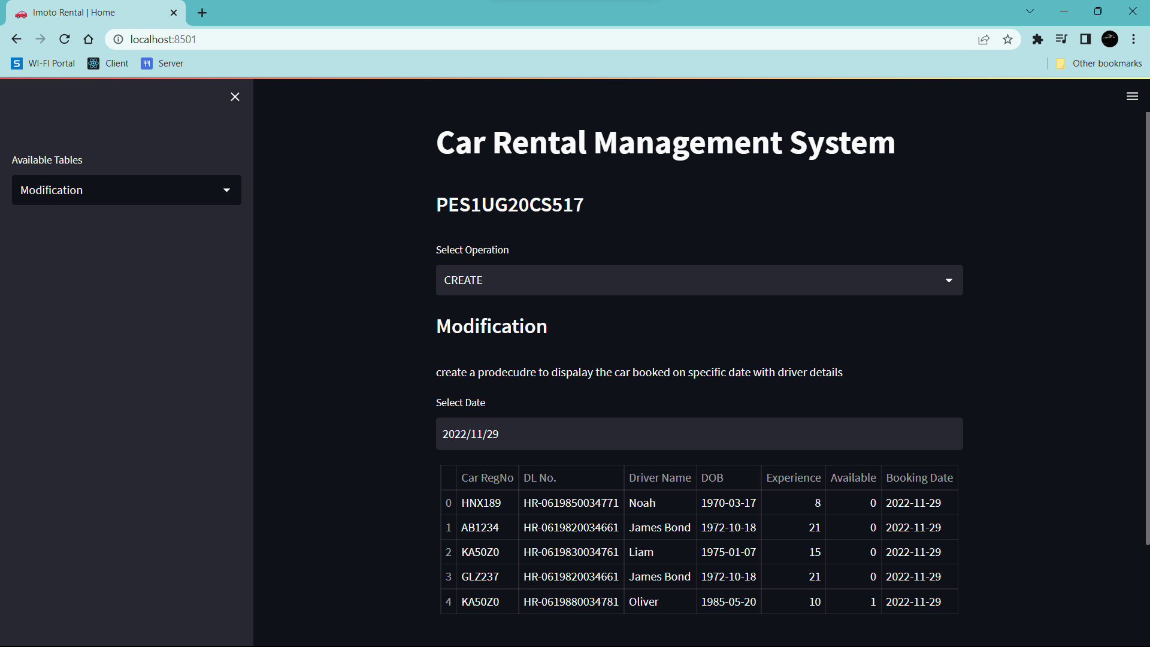

# Developing a Frontend

The frontend should support

1. Addition, Modification and Deletion of records from any chosen table

**Create**:

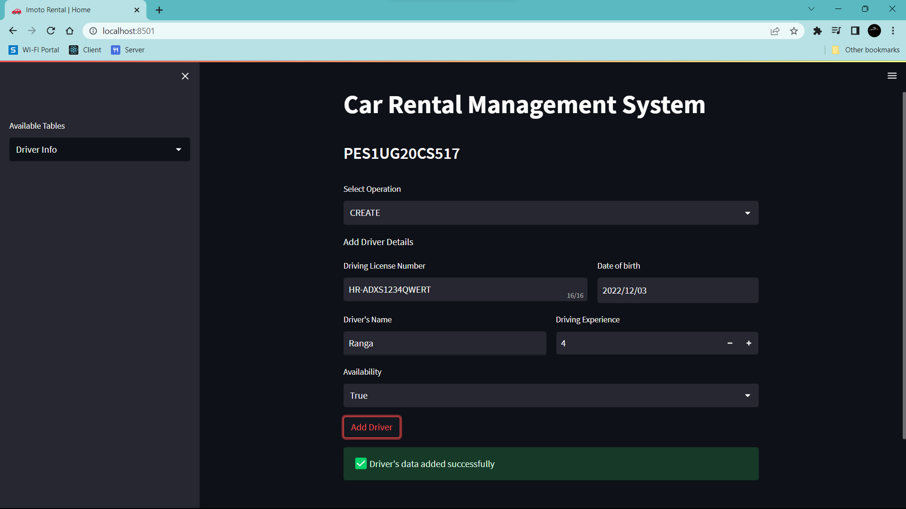

**Read:**

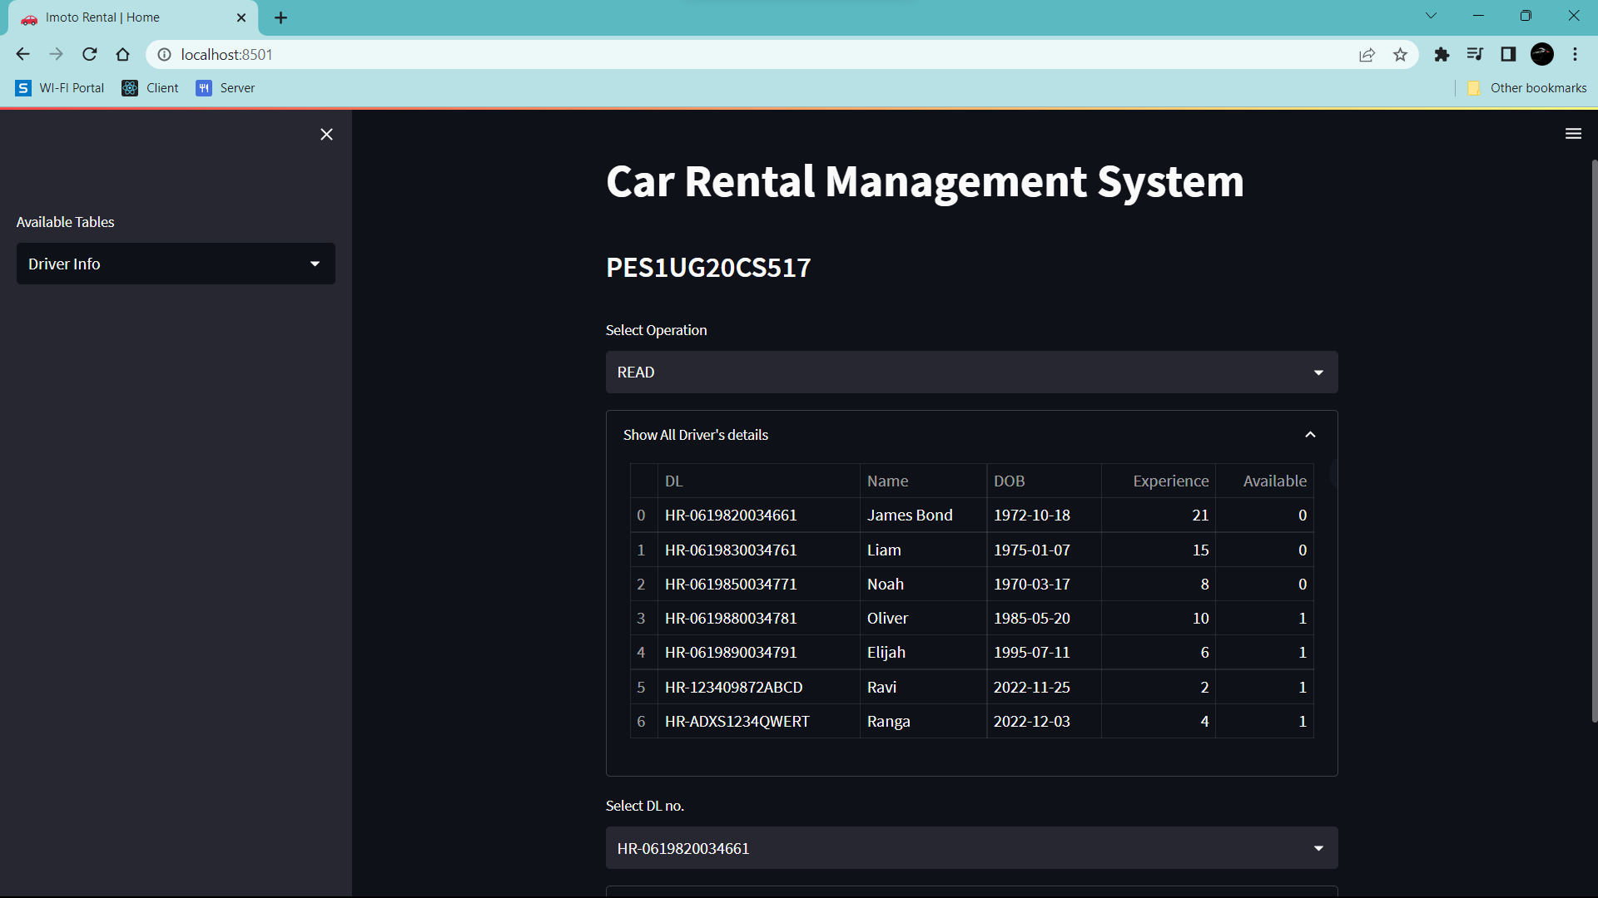

**Update:**

**Before Update:**

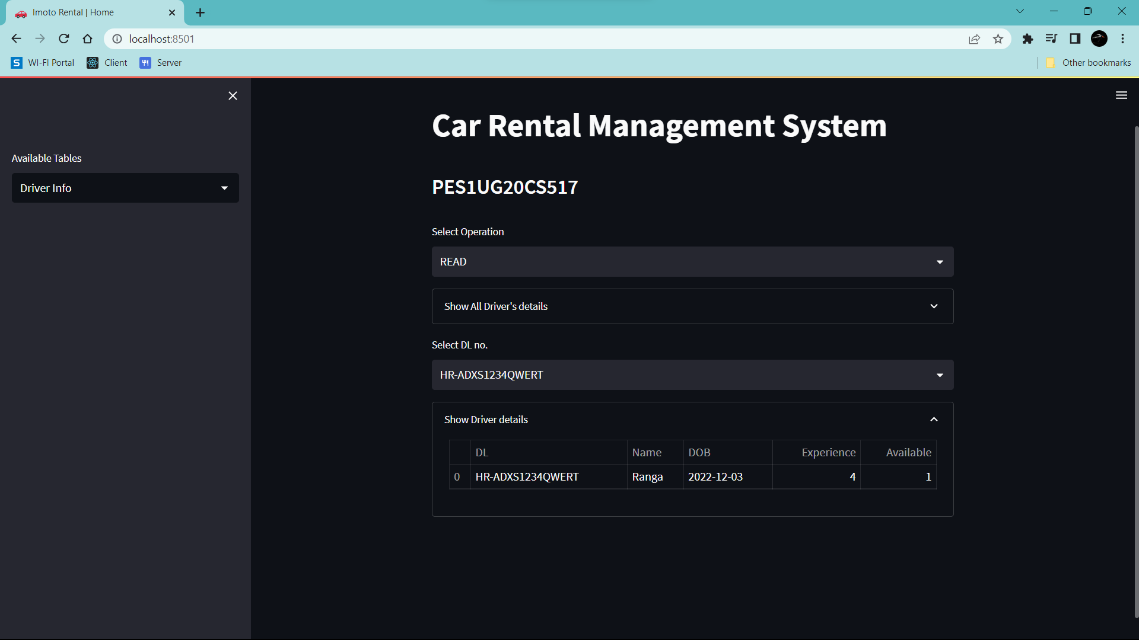

**After Update:**

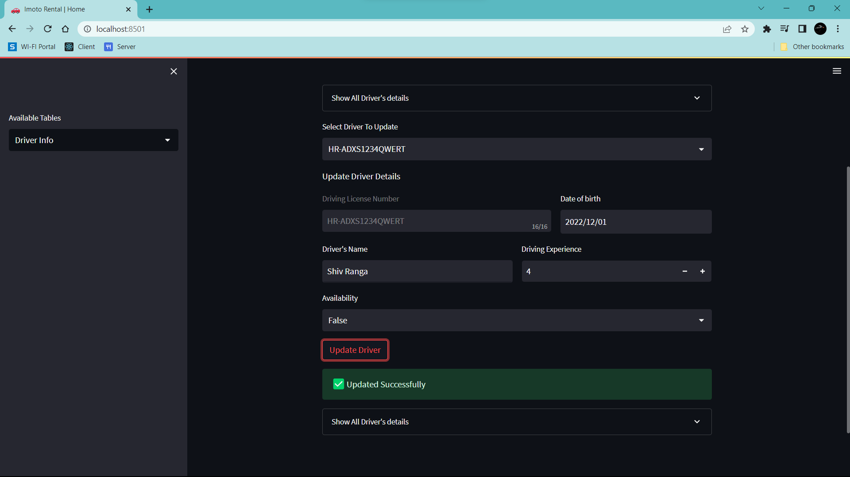

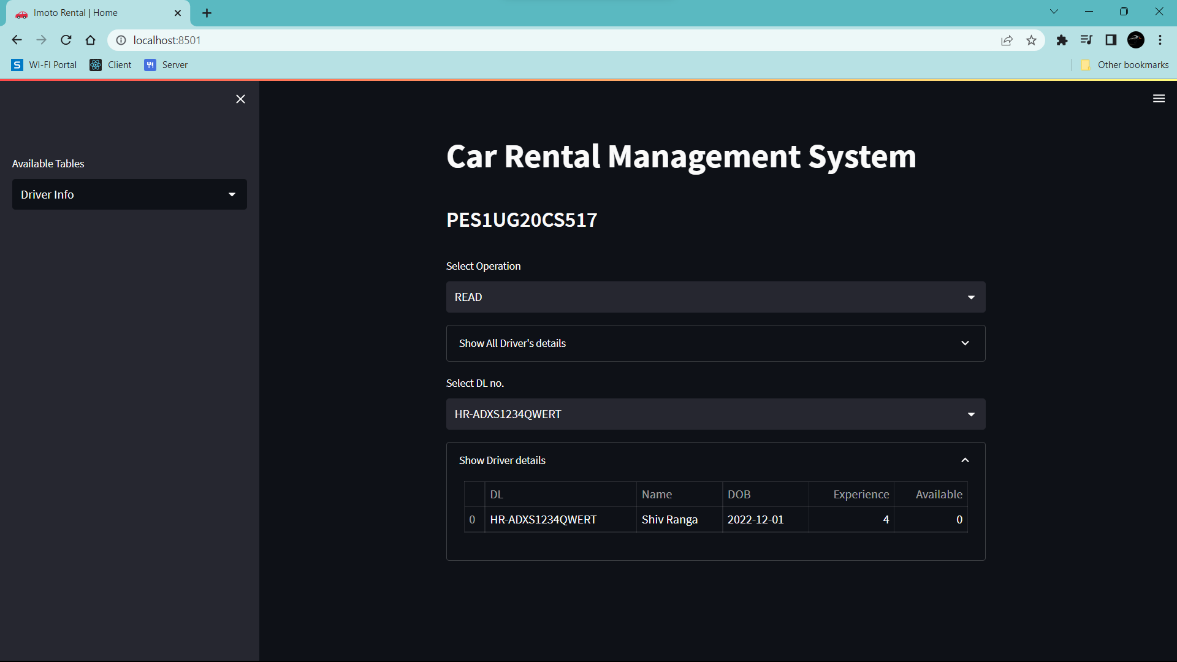

Before Delete:

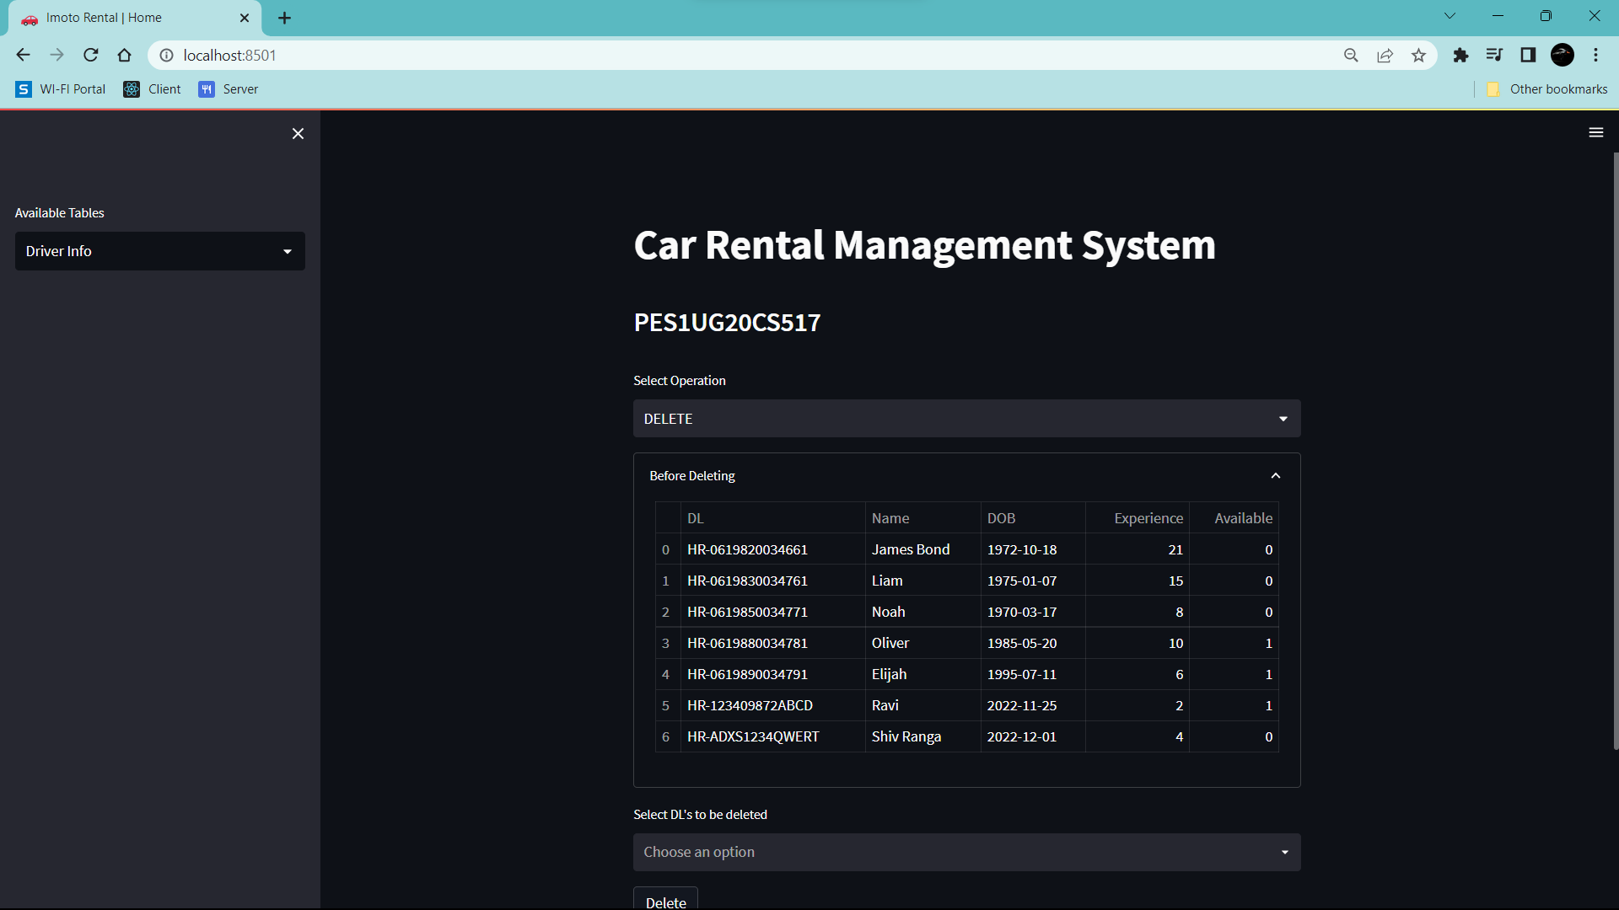

After Delete:

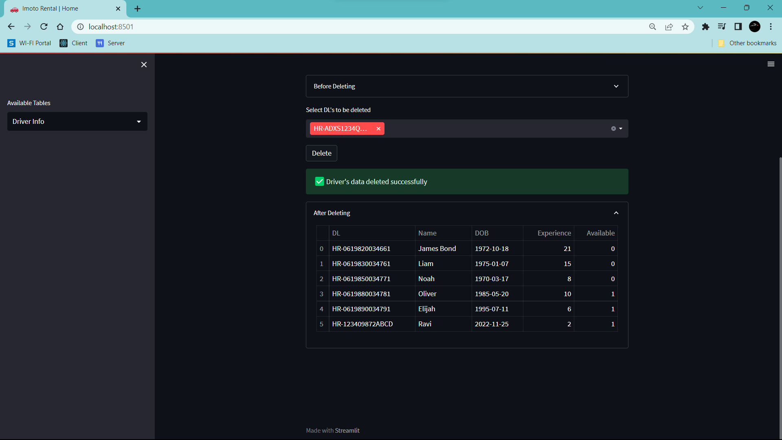

1. There should be an window to accept and run any SQL statement and display the result

