# **ONLINE LEARNING PLATFORM – COURSECRAFT**

* **UseCase Diagram**

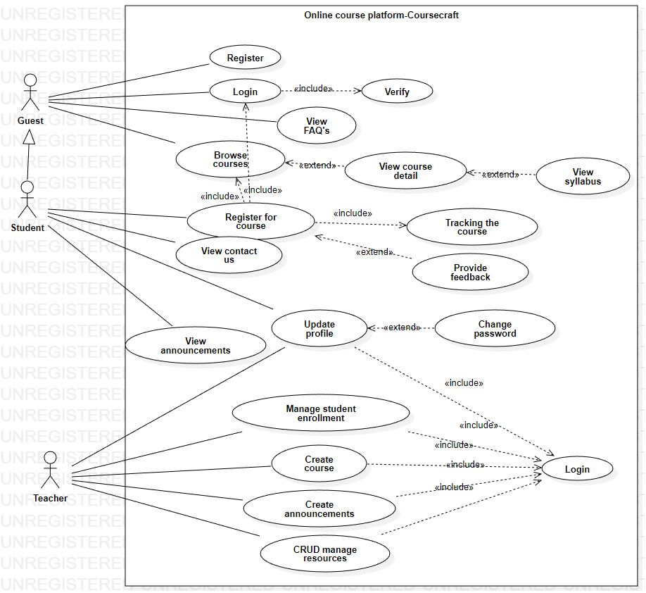

* **Class Diagram**

