ASSIGNMENT 7.3
TASK 01: Fixing Syntax Errors
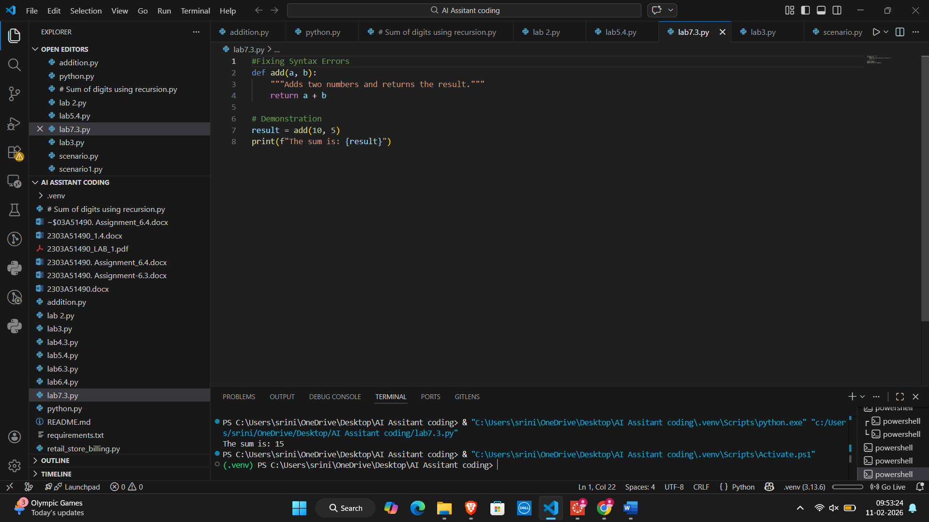
Code Analysis:
The fix is simple but fundamental. By adding the :, we satisfy the Python interpreter's requirement for block initiation. This allows the function to be stored in memory and called later in the program.
TASK 02: Debugging Logic Errors in Loops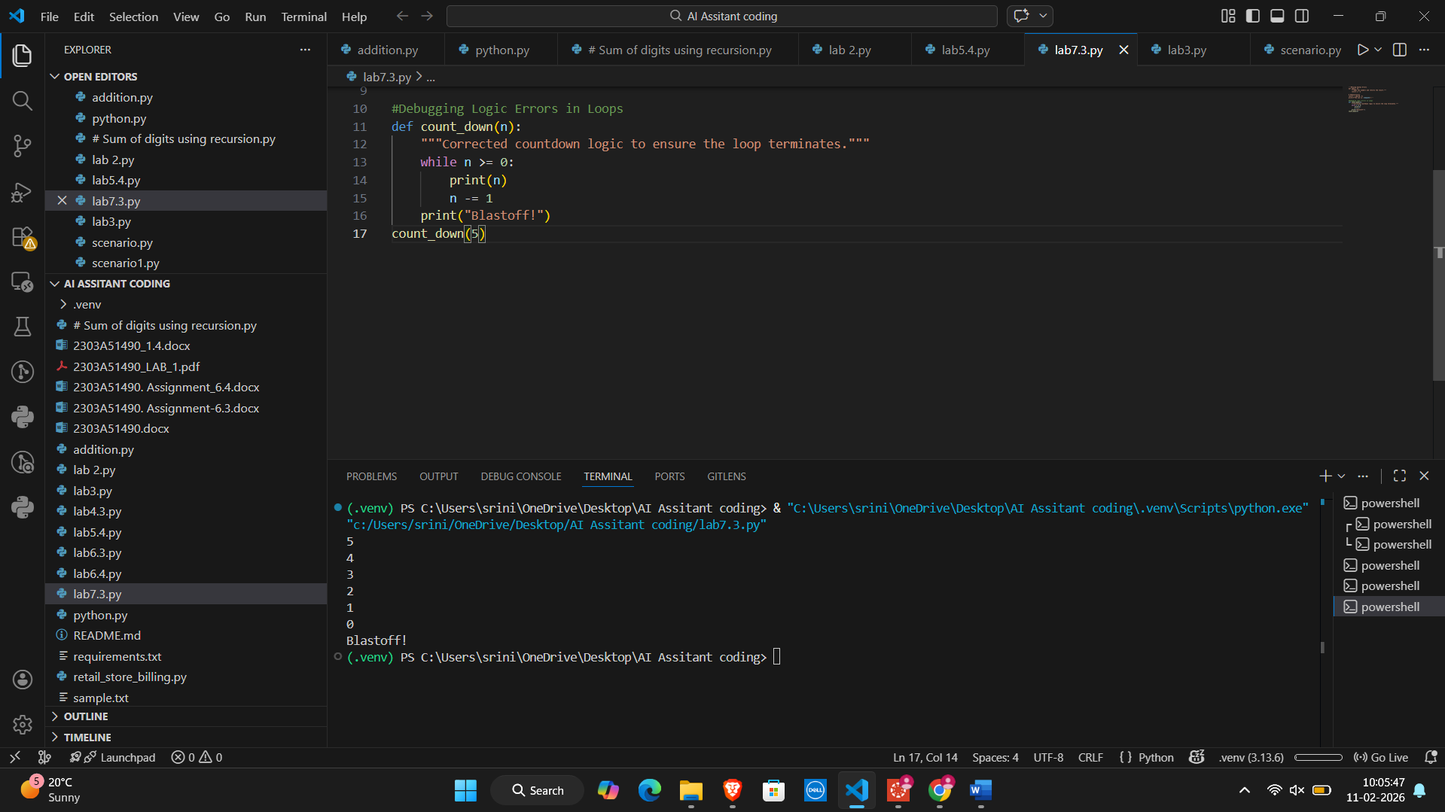
Code Analysis:
The research indicates that the most effective way to avoid these errors is to follow the "Loop Invariant" principle: always ensure that the variable controlling the loop is modified in every iteration and that the modification brings it closer to the exit condition.
TASK 03: Handling Runtime Errors (Division by Zero)
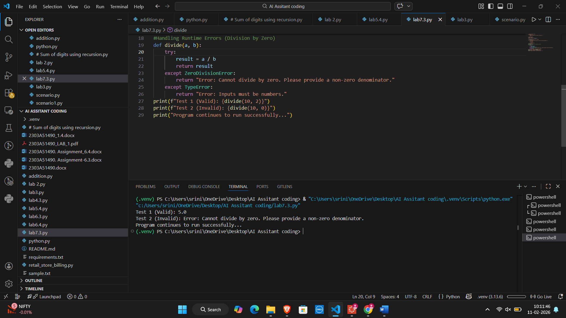
Code Analysis:
By wrapping the division in a try-except block, we move from Reactive programming (waiting for a crash) to Proactive programming (anticipating and managing risks). In professional software, this ensures that one small error doesn't take down the entire system.
TASK 04: Debugging Class Definition Errors
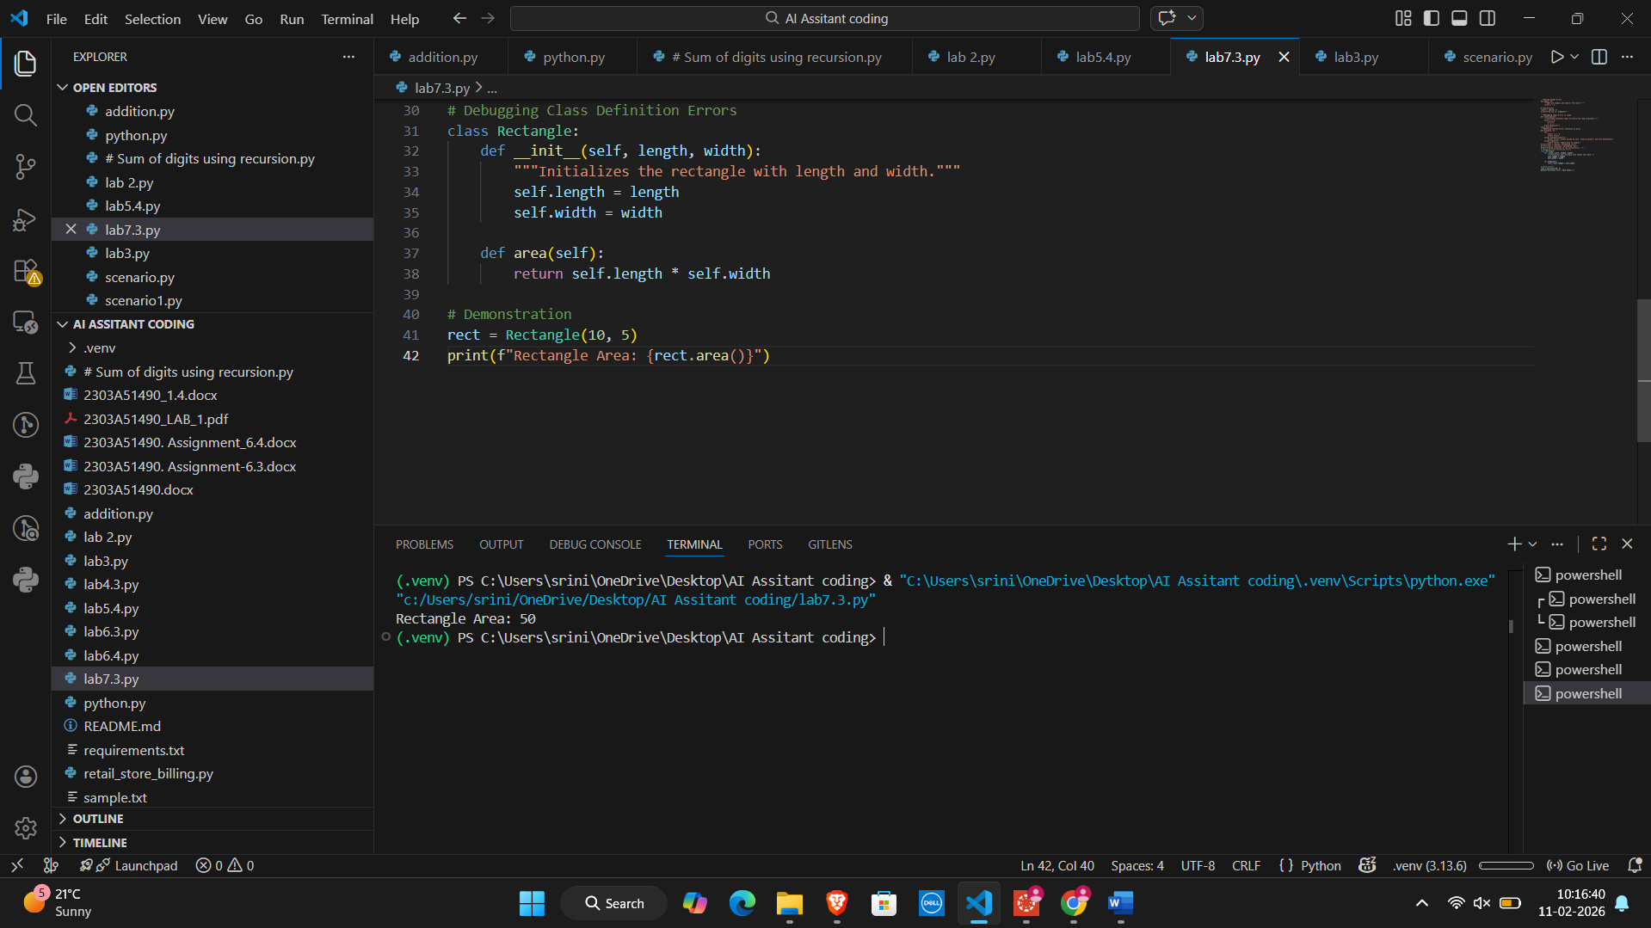
Code Analysis:
By adding self and fixing the dunder (double underscore) naming, we transform a broken function into a valid constructor. This allows the class to store data uniquely for every object created from it.
TASK 05: Resolving Index Errors in Lists
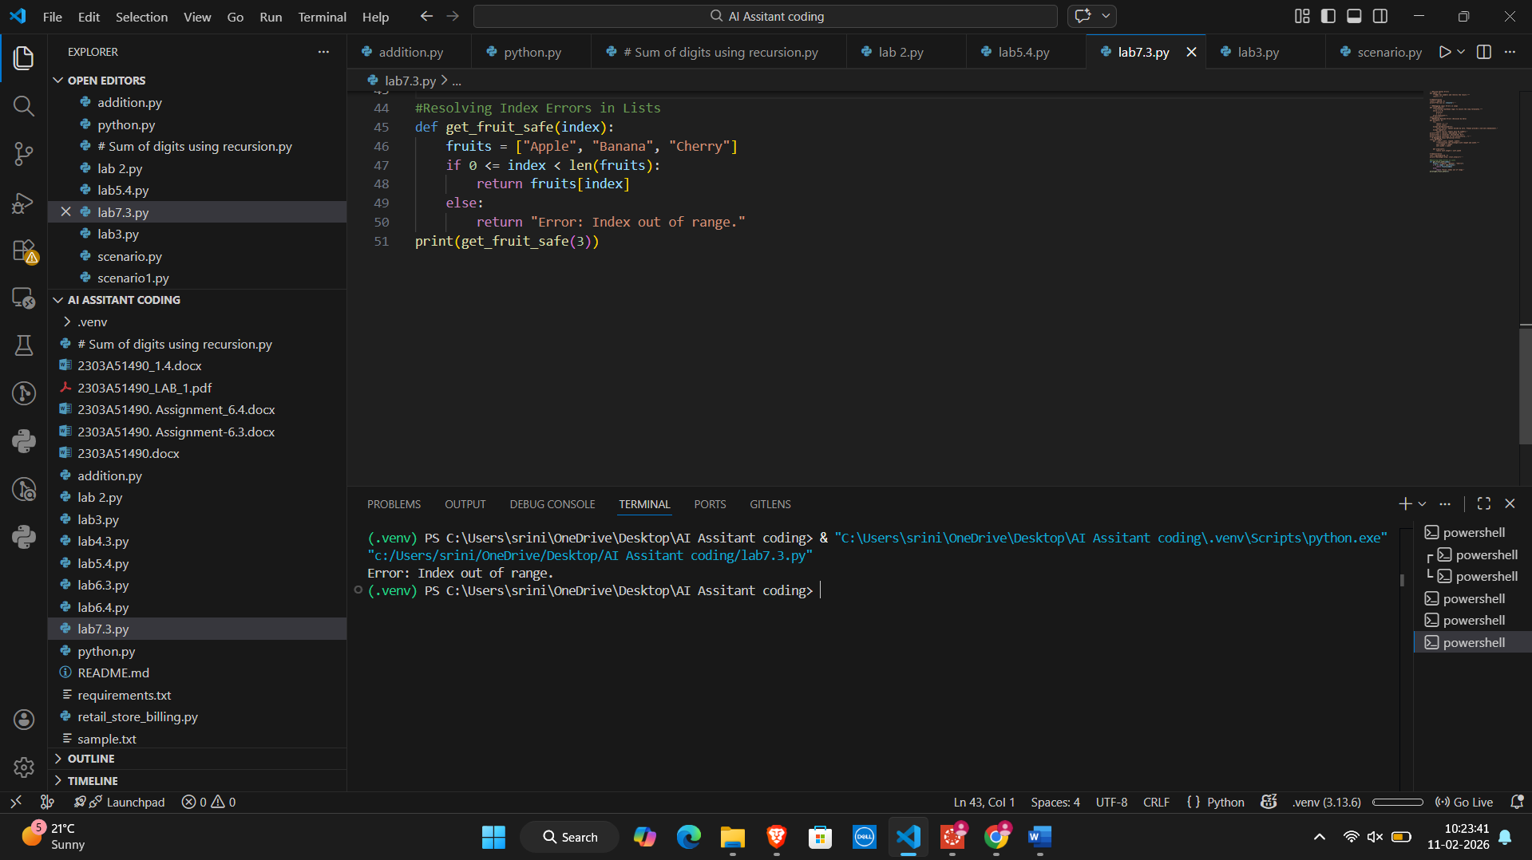
Code analysis:
By implementing bounds checking or try-except blocks, you ensure your program is "robust"—meaning it can handle incorrect data or unexpected states without stopping. In professional development, safe list access is a requirement for building stable applications.

