ASSIGNMENT_10.3
Problem Statement 1: AI-Assisted Bug Detection
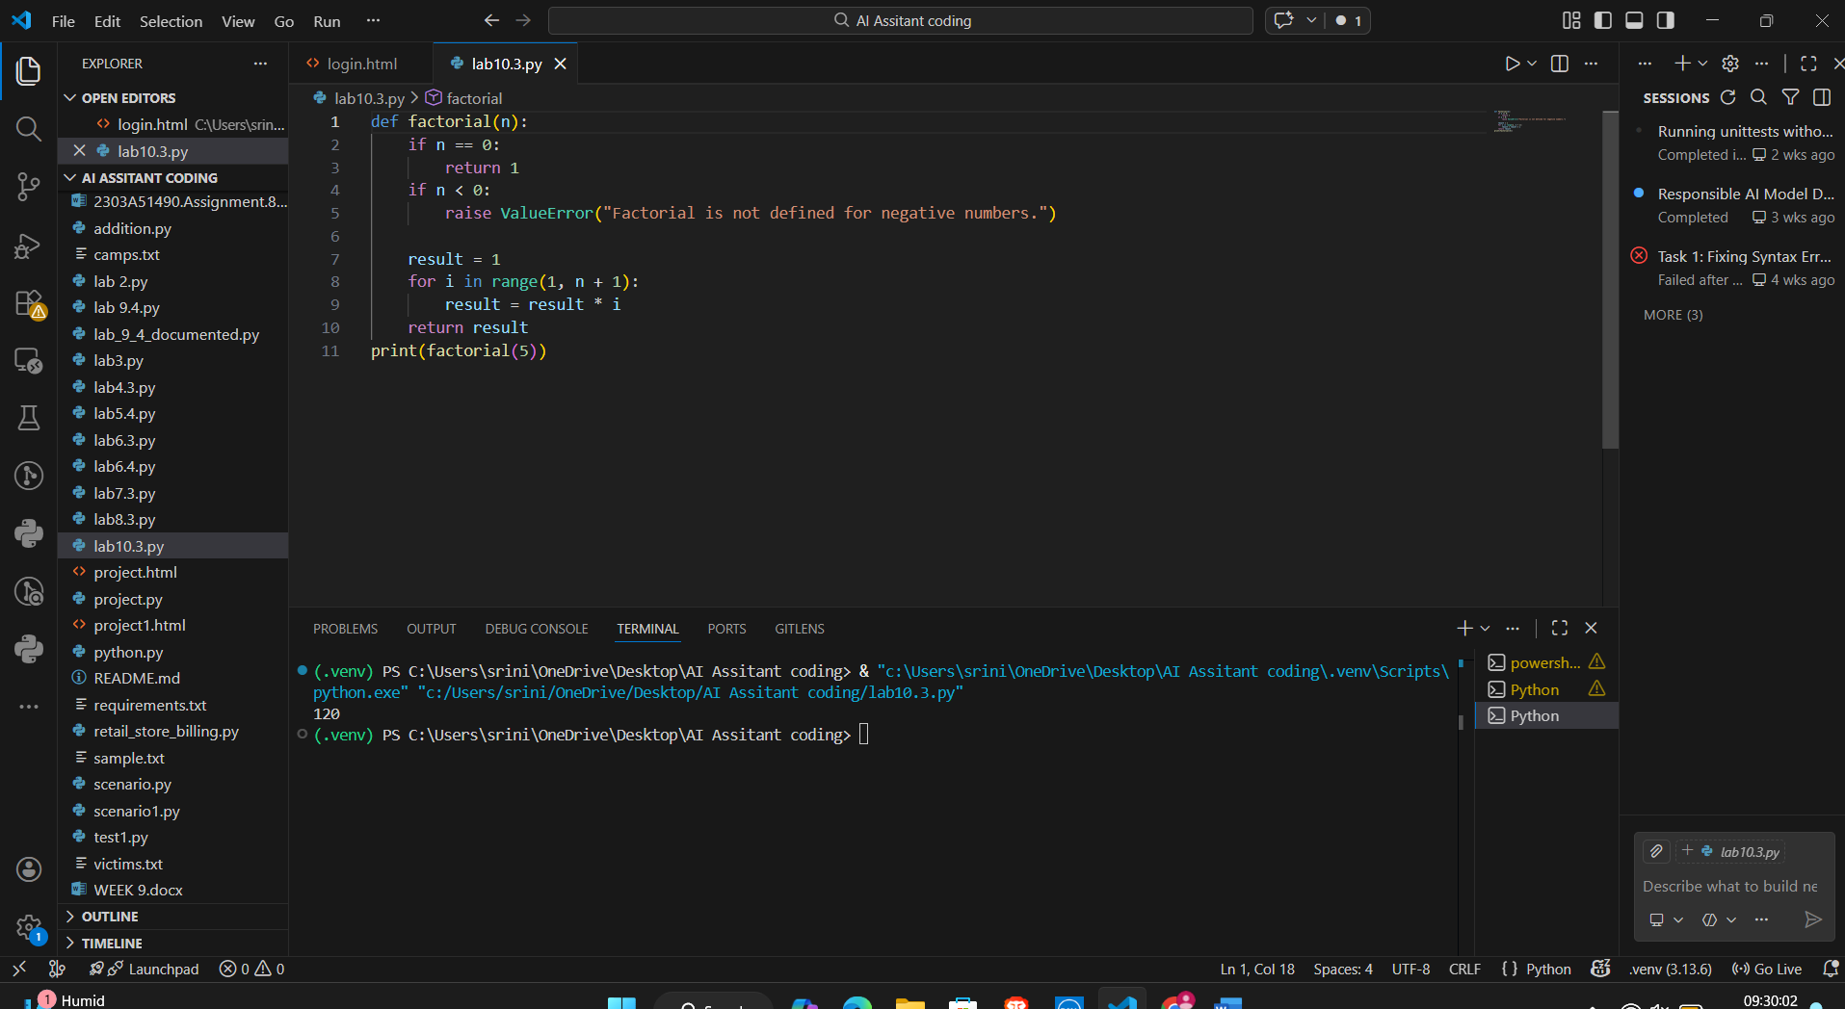
Code Analysis:
Think through the mathematical definition of a factorial. Check the junior developer's code for loop boundaries and edge cases like zero or negative integers, then provide a corrected Python function.
Problem Statement 2: Task 2 — Improving Readability & documentation
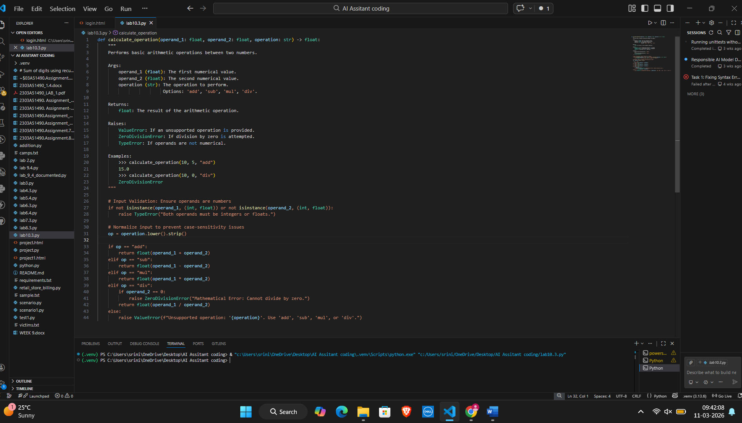
Code Analysis:
The refactored code is Self-Documenting. Even without the comments, a human can read the function name and parameters and understand exactly what is required. It shifts the burden of "remembering how it works" from the human to the code itself.
Problem Statement 3: Enforcing Coding Standards
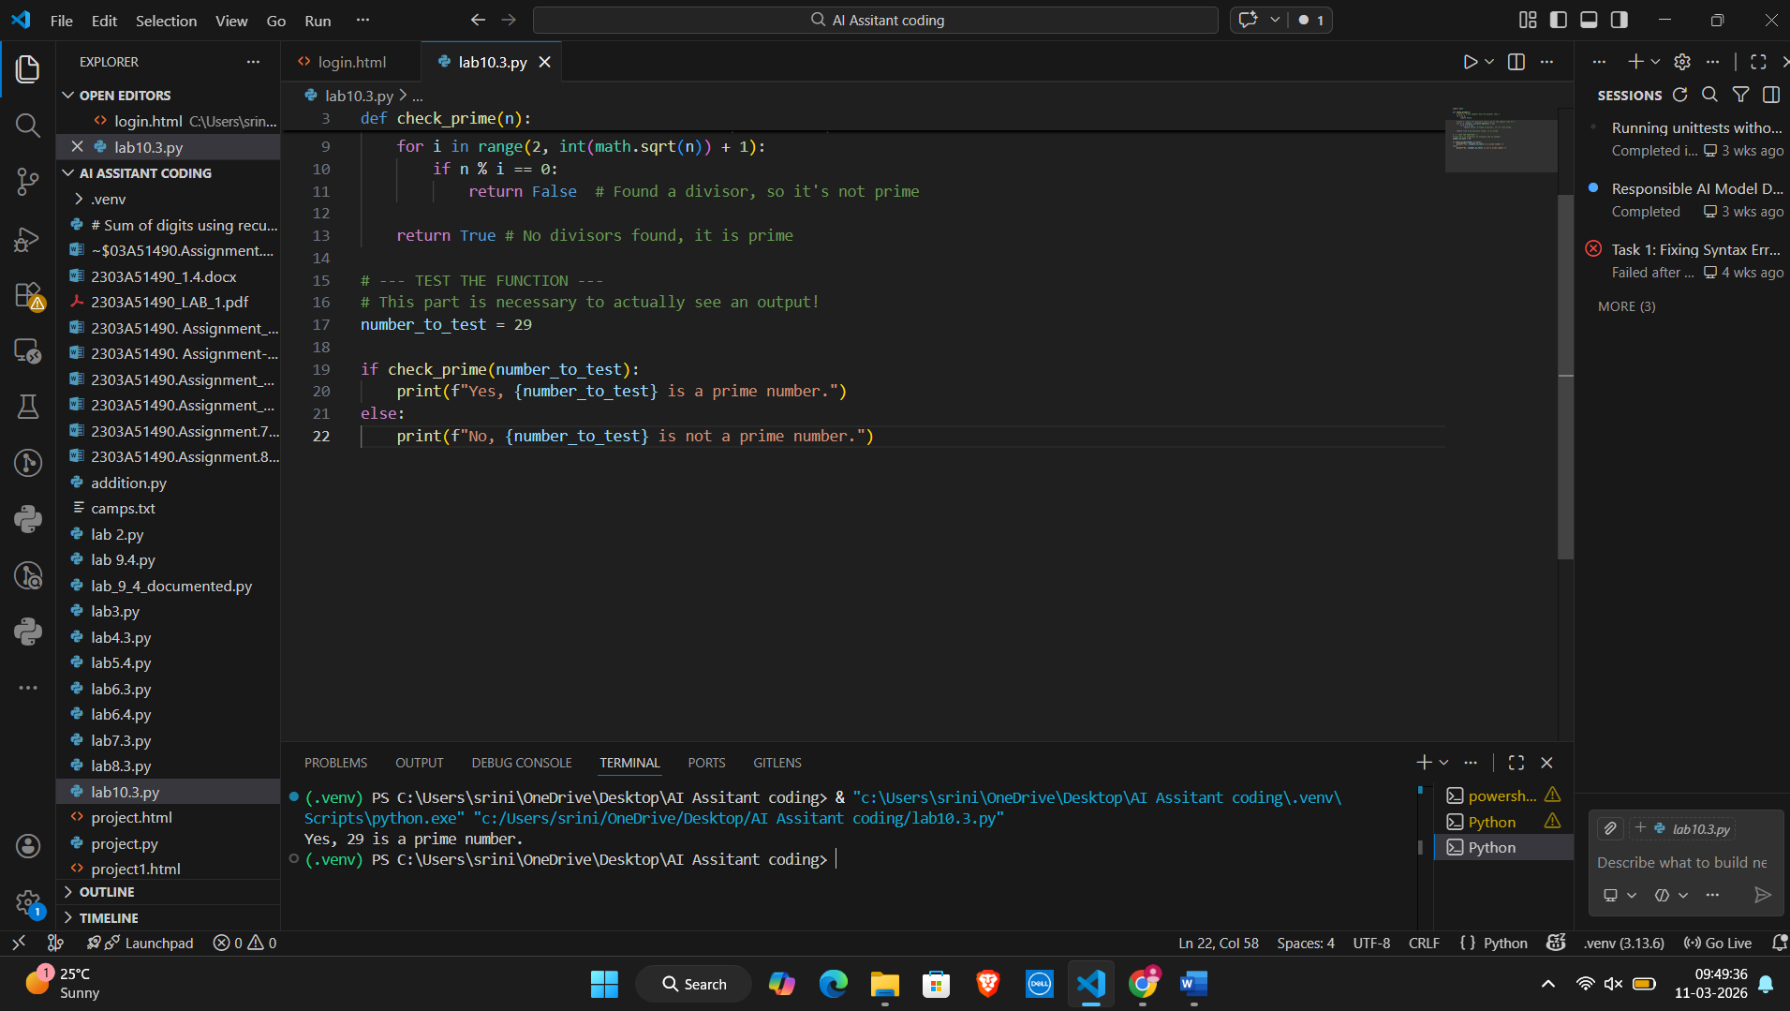
Code Analysis:
A function is like a recipe. Writing the recipe (def Checkprime) doesn't cook the food. You have to "call" the function (e.g., check_prime(7)) and then print() the result to see it in your console.
Problem Statement 4: AI as a Code Reviewer in Real Projects
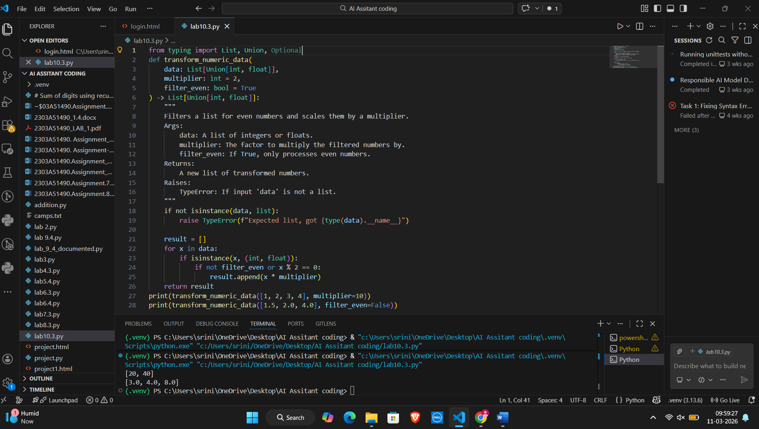
Code Analysis:
The ideal workflow is AI-First, Human-Second. Let the AI clean up the style and basic bugs, then let a human verify the logic and architecture.
Problem Statement 5: — AI-Assisted Performance Optimization
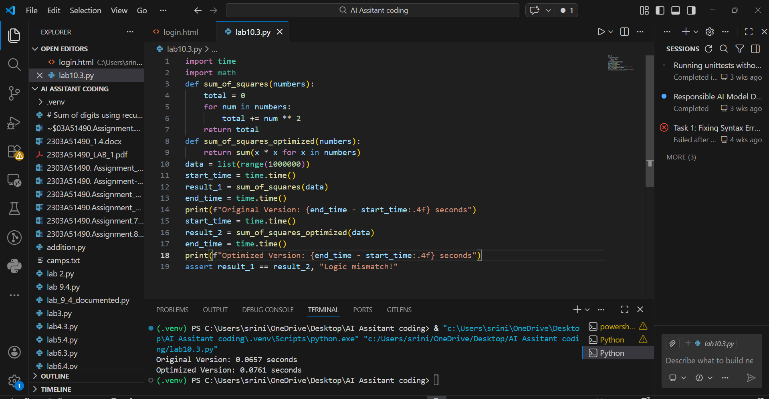
Code Analysis:
Always optimize last. Write readable code first, then use AI or profiling tools to find the specific parts that are slow. For 1,000 items, the original code is fine. For 1,000,000,000 items, NumPy is mandatory.

