TASK-01: Prompt GitHub Copilot to generate a Python script that collects user data (e.g., name, age, email).
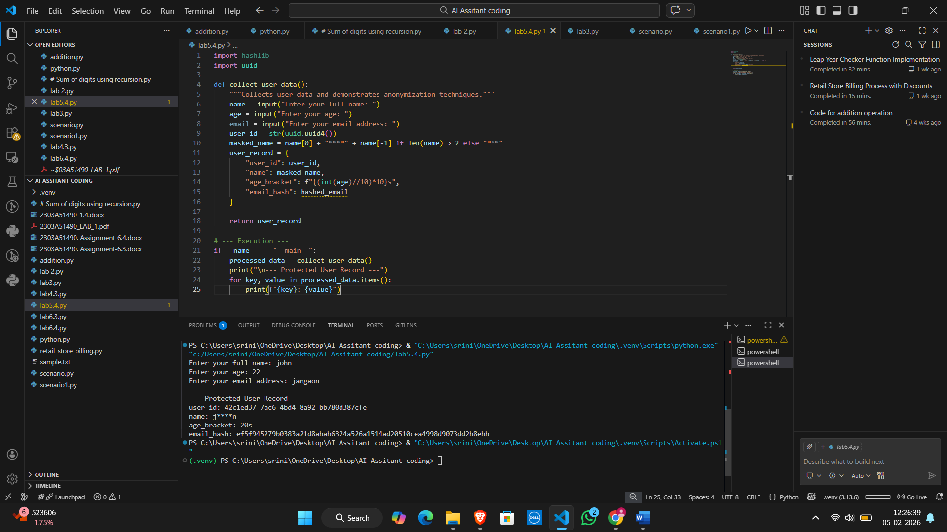
. Code Analysis:
The AI tool suggested three primary methods for safeguarding information, which align with modern data privacy standards like GDPR or CCPA.
TASK-02: a Python function for sentiment analysis.
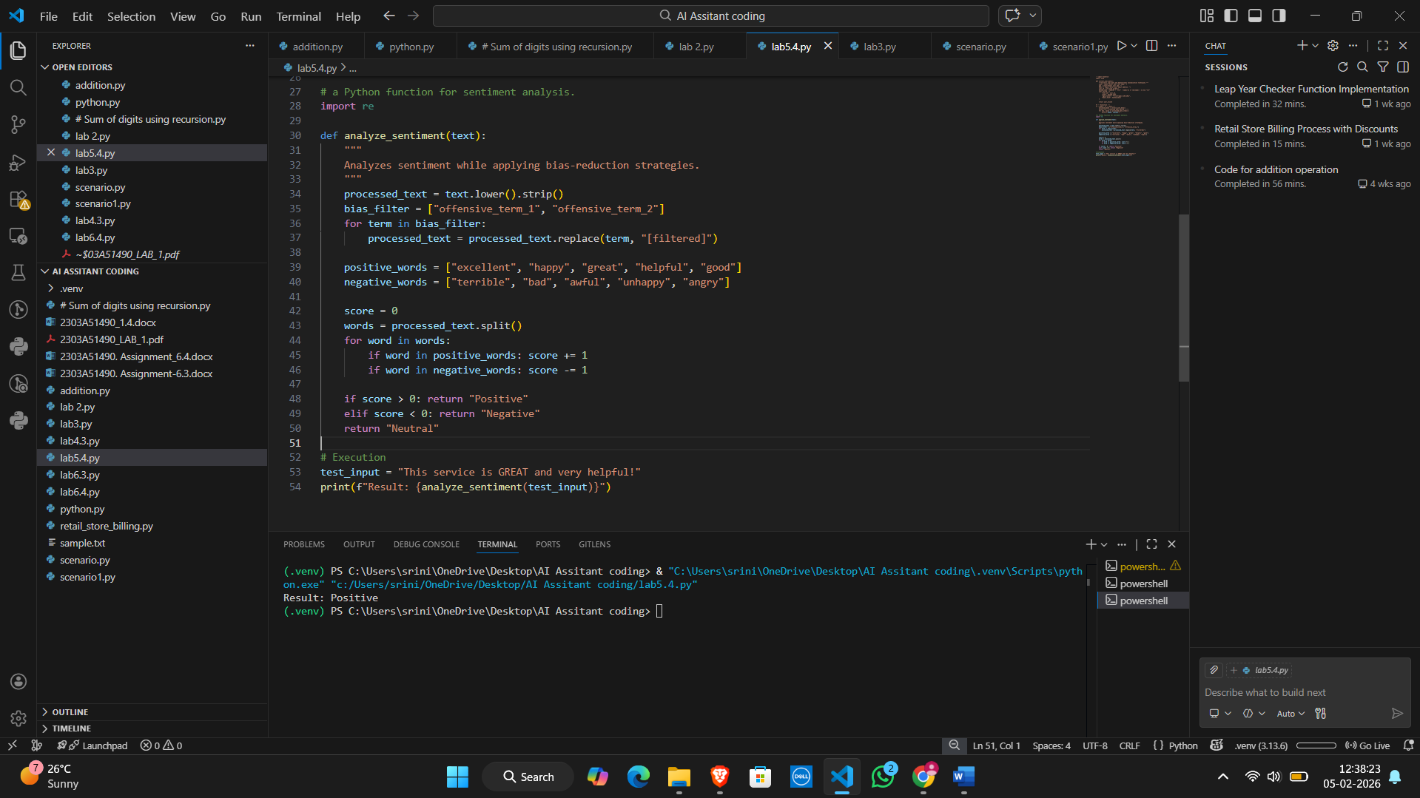

. Code Analysis:
Bias in AI occurs when a model reflects the prejudices of its training data. In sentiment analysis, this often manifests as "identity bias."
Task-03 Python program that recommends products based on user history
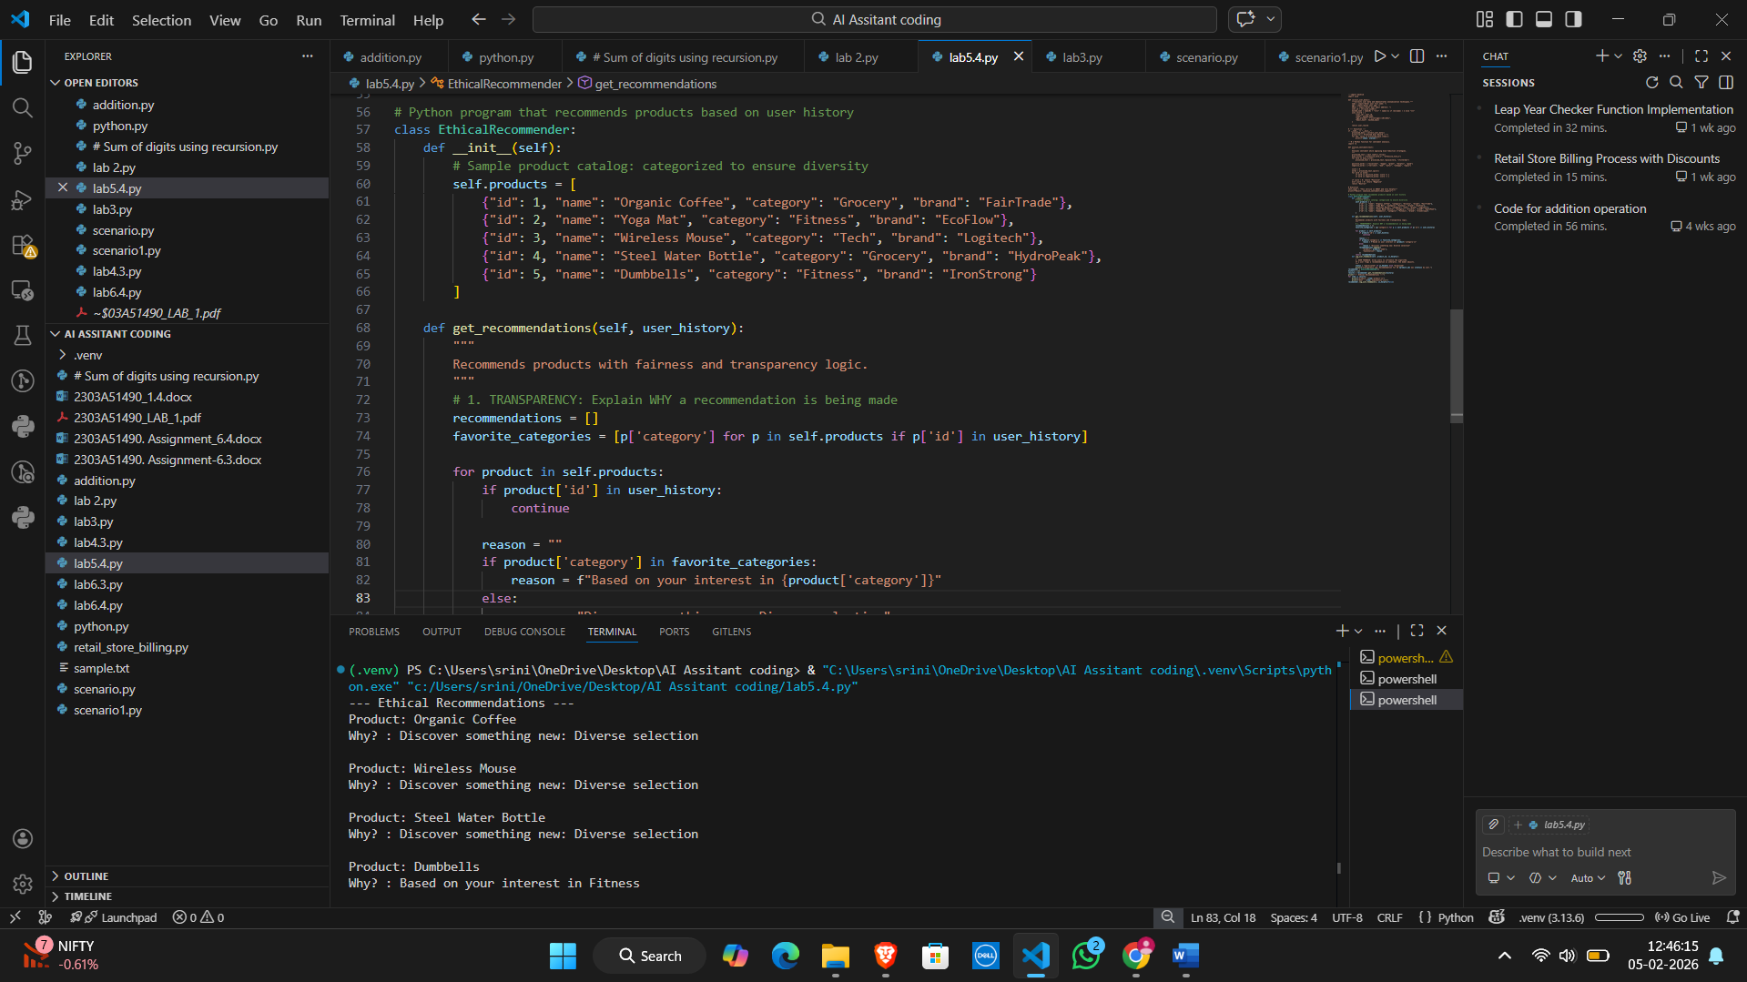
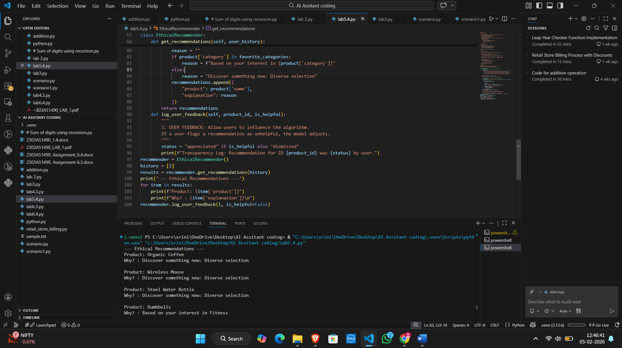
Code Analysis:
Preventing the Filter Bubble Standard algorithms often trap users in a loop of the same content. By intentionally recommending items outside the favorite_categories (as seen in the "Discovery" logic), we promote Serendipity and Diversity.
TASK-04 generate logging functionality in a Python web
application.
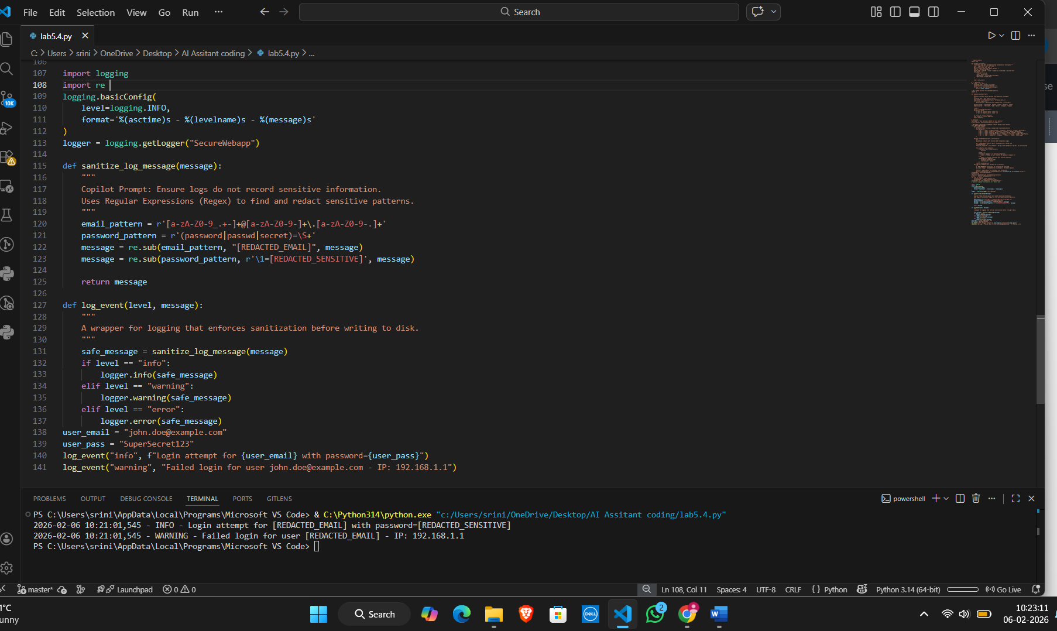
. Code Analysis:
The primary ethical guideline for logging is Data Minimization: only collect the data you absolutely need to resolve an issue. If you don't need the user's email to debug a server error, don't write it to the log file.
TASK-05 a machine learning model. Then, prompt it to add documentation on how to use the model responsibly
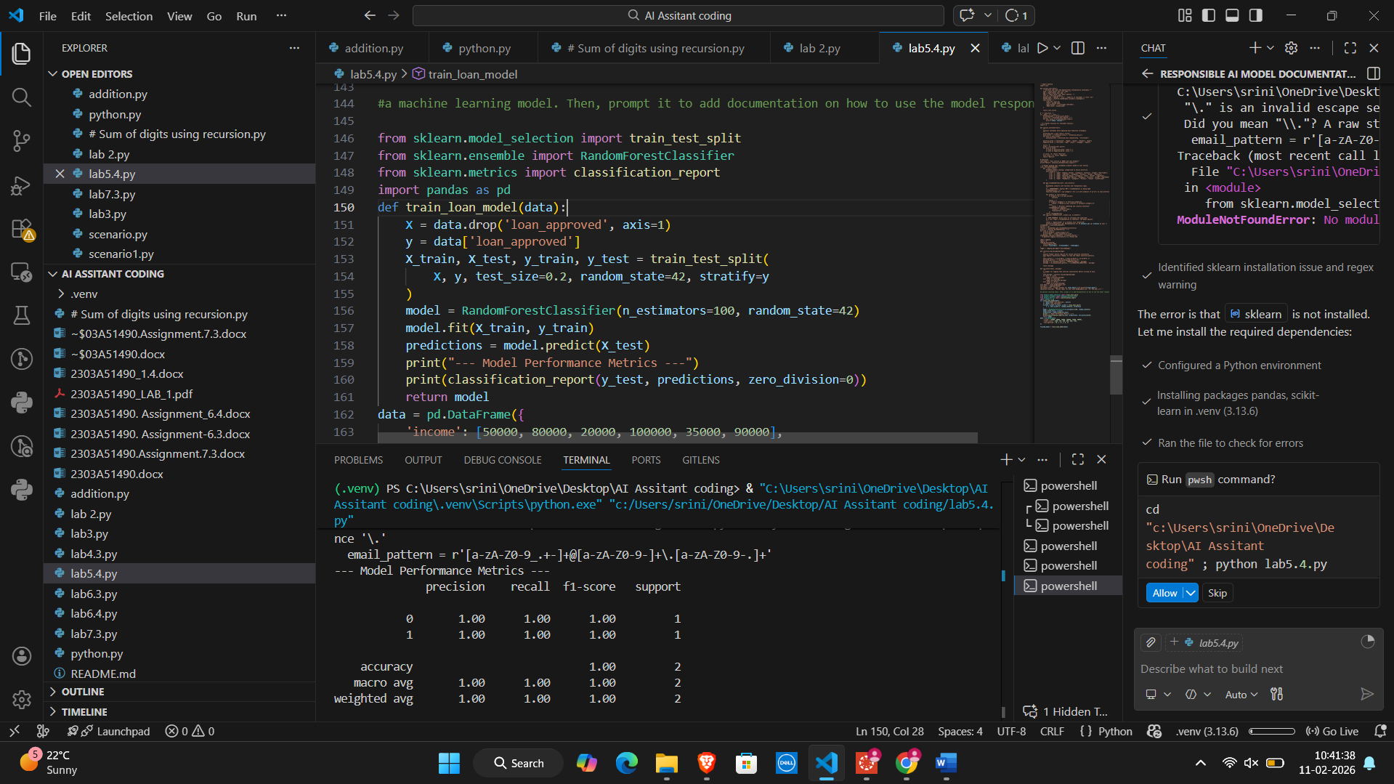
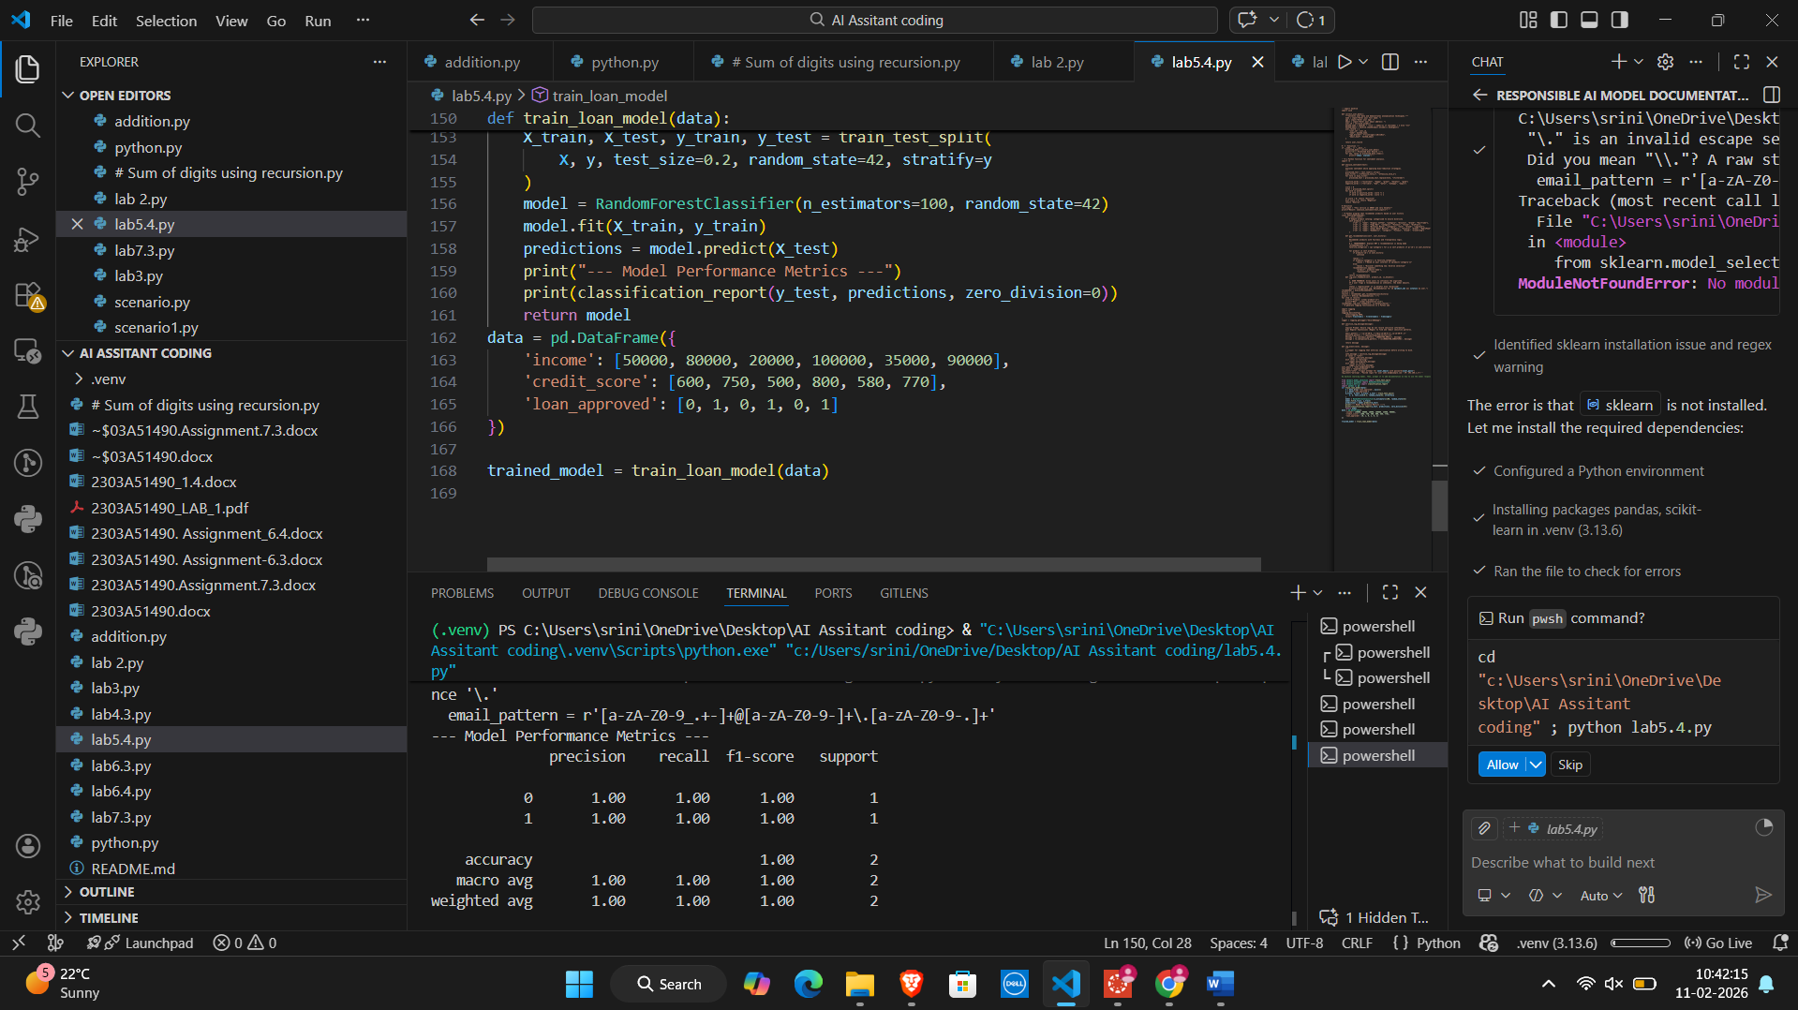
. Code Analysis:
Machine learning models, especially deep learning or random forests, can act as "black boxes." Explainable AI (XAI) techniques, like Feature Importance or SHAP values, are critical for accountability. They allow developers to explain to a user why their loan was denied.

