1. Install Jupyter notebook and run the first program and share the screenshot of the output.

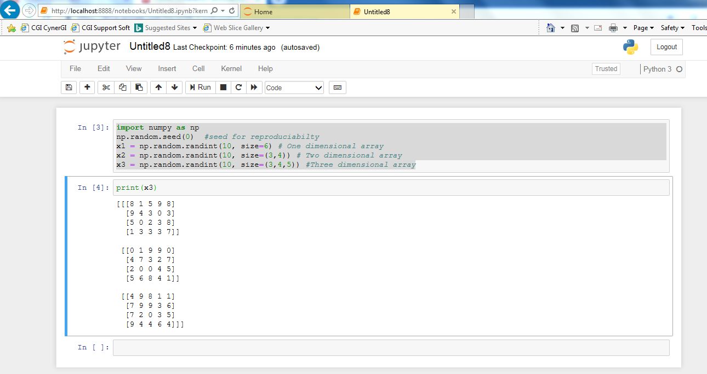

2) Write a program which will find all such numbers which are divisible by 7 but are not a

multiple of 5, between 2000 and 3200 (both included). The numbers obtained should be printed

in a comma-separated sequence on a single line.

Code:

MyList = []

for i in range(2000,3200):

if(i%7 == 0) and (i%5 != 0):

MyList.append(i)

print(MyList)

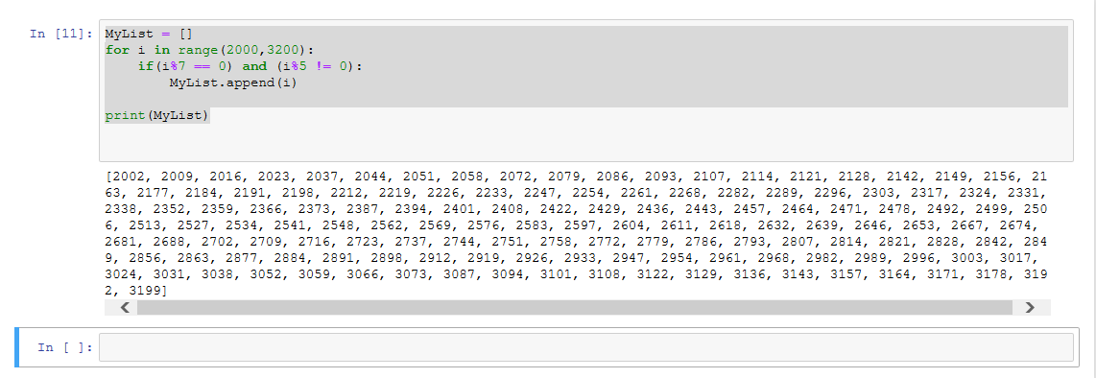

3) Write a Python program to accept the user's first and last name and then getting them printed

in the the reverse order with a space between first name and last name.

Code:

​print("Enter your first name:")

FirstName = input("prompt")

print("Enter your second name:")

SecondName = input("prompt")

print('---------------------')

print(SecondName + " " + FirstName)

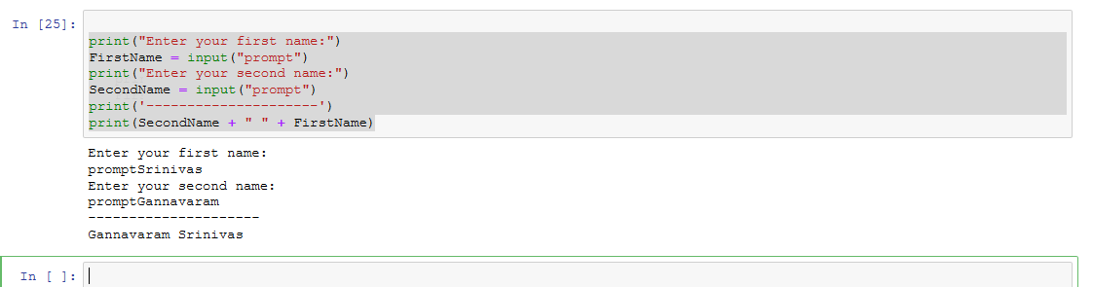

4) Write a Python program to find the volume of a sphere with diameter 12 cm.

Formula: V=4/3 \* π \* r3

code:

pi = 3.1415926535897931

r= 6.0

V= 4.0/3.0\*pi\* r\*\*3

print('The volume of the sphere is: ',V)

