Session 10: Assignment 1

**Problem statement:**

Scipy:

We have the min and max temperatures in a city In India for each months of the year.

We would like to find a function to describe this and show it graphically, the dataset

given below.

Task:

1. fitting it to the periodic function

2. plot the fit

Data

Max = 39, 41, 43, 47, 49, 51, 45, 38, 37, 29, 27, 25

Min = 21, 23, 27, 28, 32, 35, 31, 28, 21, 19, 17, 18

Code:

%matplotlib inline

import numpy as np

temp_max = np.array([39, 41, 43, 47, 49, 51, 45, 38, 37, 29, 27, 25])

temp_min = np.array([21, 23, 27, 28, 32, 35, 31, 28, 21, 19, 17, 18])

import matplotlib.pyplot as plt

months = np.arange(12)

plt.plot(months, temp_max, 'go')

plt.plot(months, temp_min, 'co')

plt.xlabel('Month')

plt.ylabel('Min and max temperature')

from scipy import optimize

def yearly_temps(times, avg, ampl, time_offset):

return (avg

+ ampl * np.cos((times + time_offset) * 1.8 * np.pi / times.max()))

res_max, cov_max = optimize.curve_fit(yearly_temps, months,

temp_max, [40, 20, 0])

res_min, cov_min = optimize.curve_fit(yearly_temps, months,

temp_min, [-40, 20, 0])

days = np.linspace(0, 12, num=365)

plt.figure()

plt.plot(months, temp_max, 'go')

plt.plot(days, yearly_temps(days, *res_max), 'm-')

plt.plot(months, temp_min, 'co')

plt.plot(days, yearly_temps(days, *res_min), 'y-')

plt.xlabel('Month')

plt.ylabel('Temperature ($^\circ$C)')

plt.show()

Output:

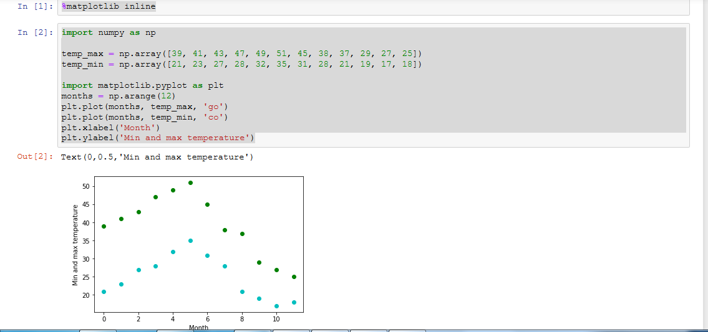

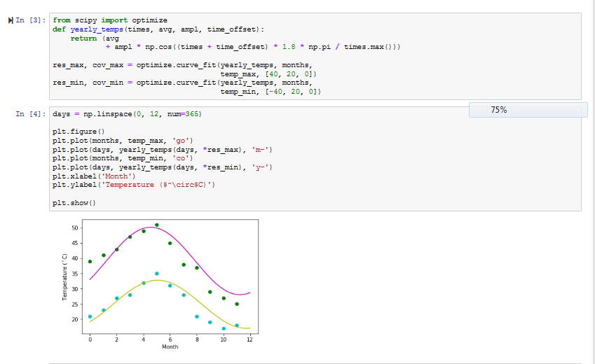

Problem Statement

Matplotlib:

This assignment is for visualization using matplotlib:

data to use:

url=

https://raw.githubusercontent.com/Geoyi/Cleaning-Titanic-Data/master/titanic_original.cs

v

titanic = pd.read_csv(url)

Charts to plot:

1. Create a pie chart presenting the male/female proportion

2. Create a scatterplot with the Fare paid and the Age, differ the plot color by gender

Code:

import pandas as pd

import numpy as np

import os

titanic = pd.read_csv("https://raw.githubusercontent.com/Geoyi/Cleaning-Titanic-Data/master/titanic_original.csv")

titanic.head()

import matplotlib.pyplot as plt

# Gender data based on sex

gender_data = titanic['sex'].value_counts()

# Change the type float

gender_data = gender_data.astype(float)

import matplotlib.pyplot as plt

# Gender data based on sex

gender_data = titanic['sex'].value_counts()

# Change the type float

gender_data = gender_data.astype(float)

# set chart vars

fig = plt.figure(figsize=(8,4))

ax = fig.add_axes((0,0,0.5,1))

ax.set_title(' Gender Distribution on the Titanic ',

bbox={'facecolor':'white', 'pad':5})

labels = 'Male', 'Female'

colors = ['skyblue', 'pink']

explode = (0.1, 0)

plt.pie(gender_data, explode=explode, labels=labels, colors=colors,

autopct='%1.1f%%', shadow=True, startangle=60)

plt.axis('equal')

plt.show()

import seaborn as sns

sns.set(style='darkgrid') # I like the ticks :)

sns.lmplot(x='fare', y='age', data=titanic,

fit_reg=True, # Show regression line

hue='sex', # Color by gender

scatter_kws={'alpha':0.5}) # use alpha to show concentration

Output:

