**Session 13: assignment 1**

**Problem Statement**

Read the following data set:

https://archive.ics.uci.edu/ml/machine-learning-databases/adult/adult.data

Task:

1. Create an sqlalchemy engine using a sample from the data set

2. Write two basic update queries

3. Write two delete queries

4. Write two filter queries

5. Write two function queries

* Task 1: Create an sqlalchemy engine using a sample from the data set

Code:

import random

import numpy as np

import pandas as pd

import sqlite3

from IPython.display import display

### Read data set

adult_data_df = pd.read_csv('https://archive.ics.uci.edu/ml/machine-learning-databases/adult/adult.data')

### Change column names

adult_data_df.columns =["age","workclass","fnlwgt","education","education_num","marital_status","occupation","relationship","race","sex","capital_gain","capital_loss","hours_per_week","native_country","income"]

display(adult_data_df.head(5))

###Task 1. Create an sqlalchemy engine using a sample from the data set

import sqlalchemy

from sqlalchemy import create_engine

engine = create_engine('sqlite:///sqladb', echo=False)

adult_data_df.to_sql('sqladb', engine, if_exists='replace')

connection = sqlite3.connect("sqladb")

cursor = connection.cursor()

Output:

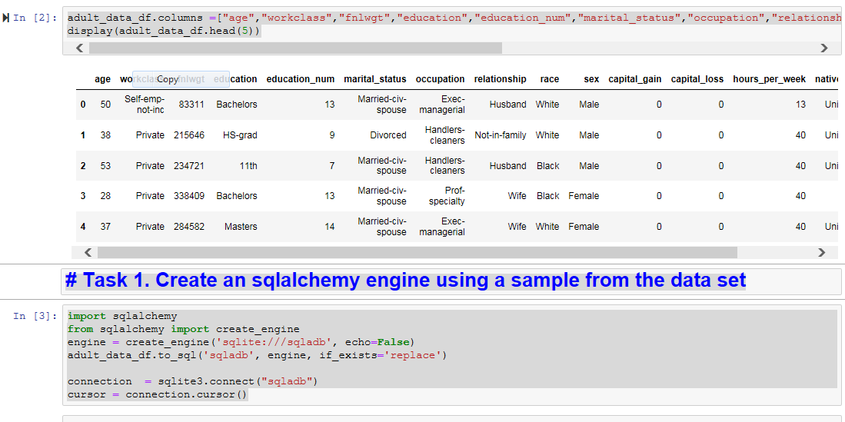

* 2) Write two basic update queries

Code:

cursor.execute('UPDATE sqladb SET education = " Masters" where fnlwgt = " 83311"')

cursor.execute('UPDATE sqladb SET fnlwgt = "315647" where fnlwgt = "215646"')

print(pd.read_sql_query("SELECT * FROM sqladb", connection).head(5))

Output:

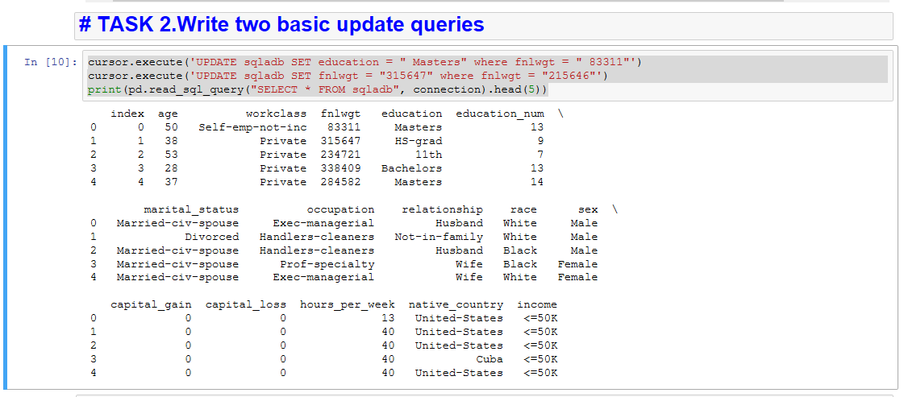

* 3: Write two delete queries

Code:

cursor.execute('DELETE FROM sqladb WHERE fnlwgt = " 234721"')

cursor.execute('DELETE FROM sqladb WHERE education_num = " 13" AND fnlwgt = " 338409"')

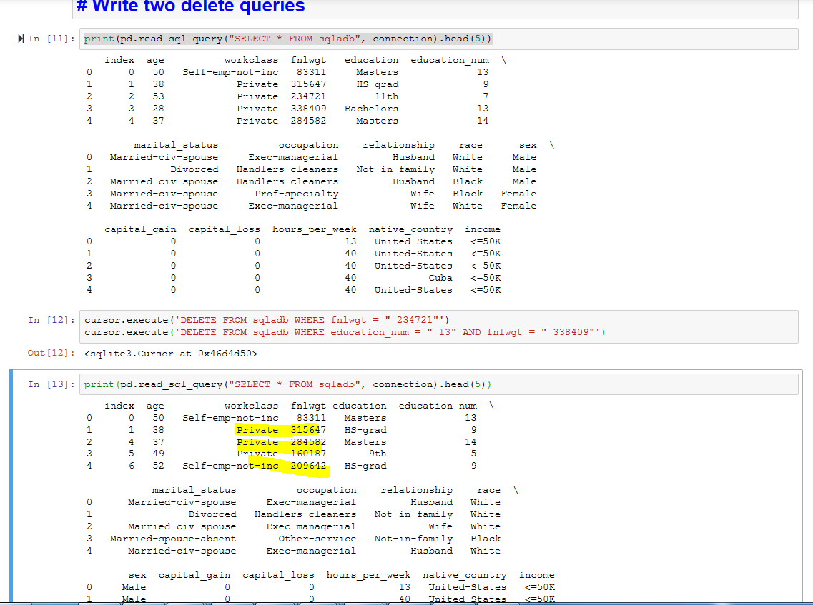

* 4: Write two filter queries

Code:

cursor.execute('SELECT DISTINCT * FROM sqladb WHERE education = " Masters" AND age < 25 AND fnlwgt = " 166851"')

output = cursor.fetchall()

print(output)

cursor.execute('SELECT DISTINCT * FROM sqladb WHERE workclass = " Private" AND marital_status = " Divorced" AND age > 70 group by native_country ')

output = cursor.fetchall()

print(output)

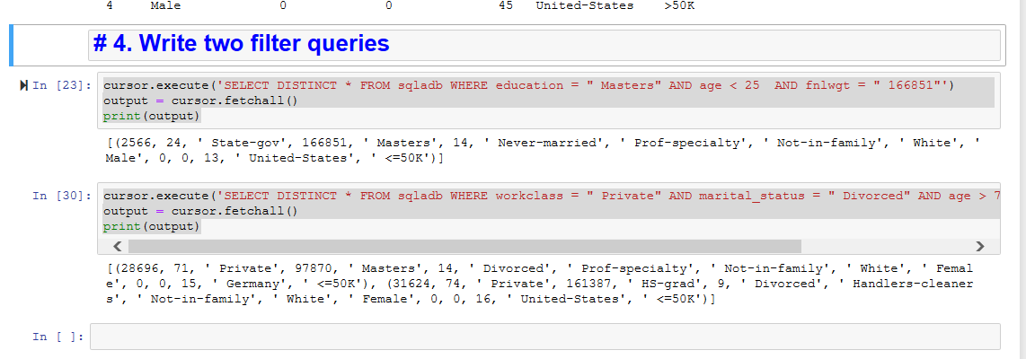

* 5. Write two function queries

Code:

def new_entry(db_file, new_data):

query = "INSERT INTO sqladb VALUES (?, ?, ?, ?, ?, ?, ?, ?, ?, ?, ?, ?, ?, ?, ?, ?);"

cursor.execute(query, list(new_data))

cursor.close()

connection.close()

new_entry('sqladb',('72190', '54','Private', '123456', 'Masters', '10', 'Married', 'Front_End', 'In_Family', 'Indian', 'Male', '0', '0', '40', 'United-States', '>=50K'))

def age_check():

connection = sqlite3.connect("sqladb")

cursor = connection.cursor()

cursor.execute('SELECT avg(age) FROM sqladb WHERE education=" Masters" AND workclass=" Private"')

output = cursor.fetchall()

print(output)

connection.close()

age_check()

