1. Write a program which accepts a sequence of comma-separated numbers from console and

generate a list.

values = input("Input some comma seprated numbers : ")

list = values.split(",")

print('List : ',list)

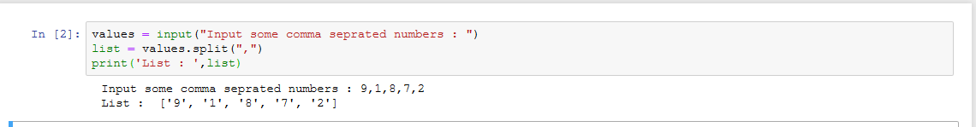

2. Create the below pattern using nested for loop in Python.

for i in range(4):

for j in range(i+1):

print('\*', end=' ')

print("\r")

for i in range (4,0,-1):

for j in range(0, i + 1):

print('\*', end=' ')

print("\r")

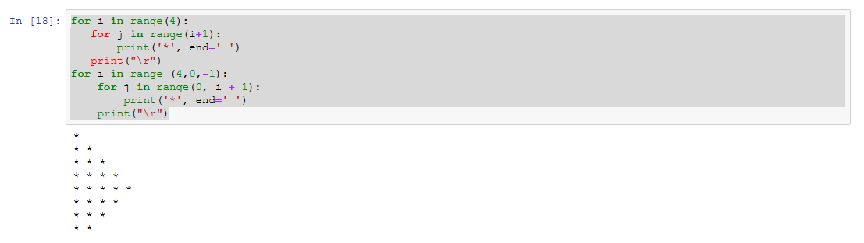

3. Write a Python program to reverse a word after accepting the input from the user.

word = input("Input a word: ")

for char in range(len(word) - 1, -1, -1):

print(word[char], end="")

print("\n")

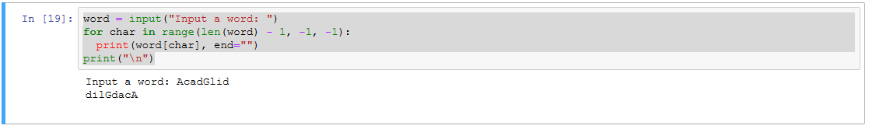

4 Write a Python Program to print the given string in the format specified in the sample

output.

WE, THE PEOPLE OF INDIA, having solemnly resolved to constitute India into a SOVEREIGN,

SOCIALIST, SECULAR, DEMOCRATIC REPUBLIC and to secure to all its citizens

Sample Output:

WE, THE PEOPLE OF INDIA,

having solemnly resolved to constitute India into a SOVEREIGN, !

SOCIALIST, SECULAR, DEMOCRATIC REPUBLIC

and to secure to all its citizens

Code :

print("WE, THE PEOPLE OF INDIA, \n\thaving solemnly resolved to constitute India into a SOVEREIGN, ! \n\t\t SOCIALIST, SECULAR, DEMOCRATIC REPUBLIC \n\t\t and to secure to all its citizens")

