Assignment 3:

1. Program :

"""

Question 1:

Write a Python Program to implement your own myreduce() function which works exactly

like Python's built-in function reduce()

Question 2:

Write a Python program to implement your own myfilter() function which works exactly

like Python's built-in function filter()

"""

# Reduce will produce a single result

def myreduce(func, my_list):

# Get first item in sequence and assign to result

result = my_list[0]

# iterate over remaining items in sequence and apply reduction function

for item in my_list[1:]:

result = func(result, item)

return result

# Custom filter function

def myfilter(func, my_list):

# Initialize empty list

result = []

# iterate over sequence of items in sequence and apply filter function

for item in my_list:

if func(item):

result.append(item)

# return funal output

return result

# test myreduce function

def sum(x,y): return x + y

# test myfilter function

def ispositive(x):

if (x <= 0):

return False

else:

return True

print ("Sum on list [1,2,3] using custom reduce function " + str(myreduce(sum, [1,2,3])) )

print ("Filter only positive Integers on list [0,1,-2,3,4,5] using custom filter function" + str(myfilter(ispositive, [0,1,-2,3,4,5])))

Output:

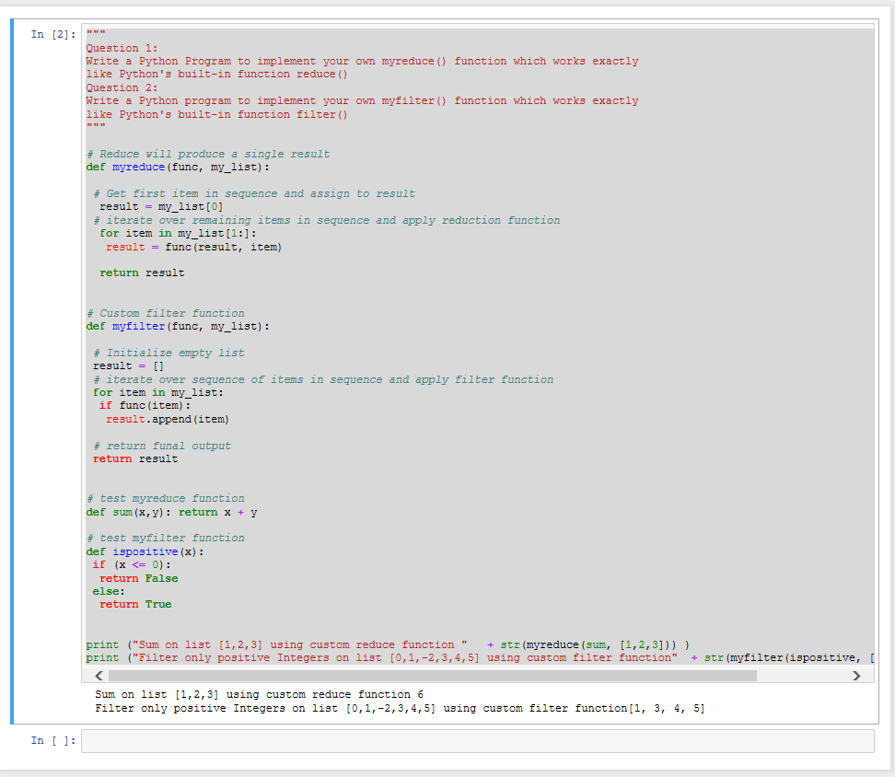

1. Program

Write List comprehensions to produce the following Lists

* ['A', 'C', 'A', 'D', 'G', 'I', ’L’, ‘ D’]

AcadName = "AcadGlid"

my_list = [x.upper() for x in AcadName]

my_list

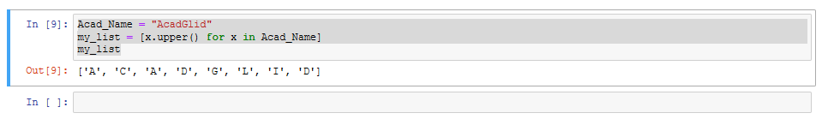

* ['x', 'xx', 'xxx', 'xxxx', 'y', 'yy', 'yyy', 'yyyy', 'z', 'zz', 'zzz', 'zzzz']

my_string = 'xyz'

my_list = [i*j for i in my_string for j in range(1,5)]

my_list

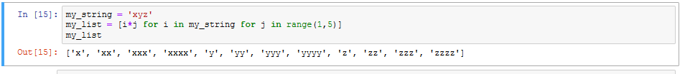

* ['x', 'y', 'z', 'xx', 'yy', 'zz', 'xxx', 'yyy', 'zzz', 'xxxx', 'yyyy', 'zzzz']

my_string = 'xyz'

my_list = [i*j for i in range(1,5) for j in my_string]

my_list

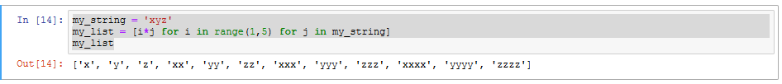

* [[2], [3], [4], [3], [4], [5], [4], [5], [6]]

list = [[x+y] for x in range(2,5) for y in range(3)]

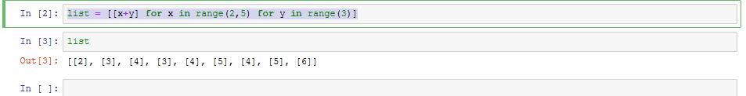

* [[2, 3, 4, 5], [3, 4, 5, 6], [4, 5, 6, 7], [5, 6, 7, 8]]

my_list = [[x+y for x in range(1,5)] for y in range(1,5)]

my_list

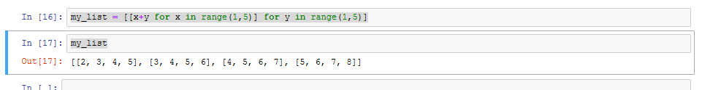

* [(1, 1), (2, 1), (3, 1), (1, 2), (2, 2), (3, 2), (1, 3), (2, 3), (3, 3)]

my_list = [(j,i) for i in range(1,4) for j in range(1,4)]

my_list

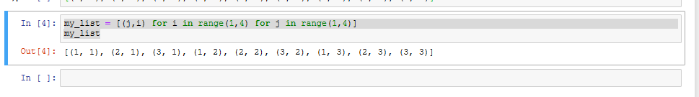

1. Implement a function longestWord() that takes a list of words and returns the longest one.

Code:

a=[]

n= int(input("Enter the number of elements in list:"))

for x in range(0,n):

element=input("Enter element" + str(x+1) + ":")

a.append(element)

max1=len(a[0])

temp=a[0]

for i in a:

if(len(i)>max1):

max1=len(i)

temp=i

print("The word with the longest length is:")

print(temp)

Output:

