**Session 9: Assignment 1**

Problem Statement

Read the dataset from the below link

https://raw.githubusercontent.com/guipsamora/pandas_exercises/master/06_Stats/US

_Baby_Names/US_Baby_Names_right.csv

Question 1) Delete unnamed columns

Code :

import pandas as pd

df = pd.read_csv("https://raw.githubusercontent.com/guipsamora/pandas_exercises/master/06_Stats/US_Baby_Names/US_Baby_Names_right.csv")

df.drop(df.columns[df.columns.str.contains('unnamed',case = False)],axis = 1)

Output:

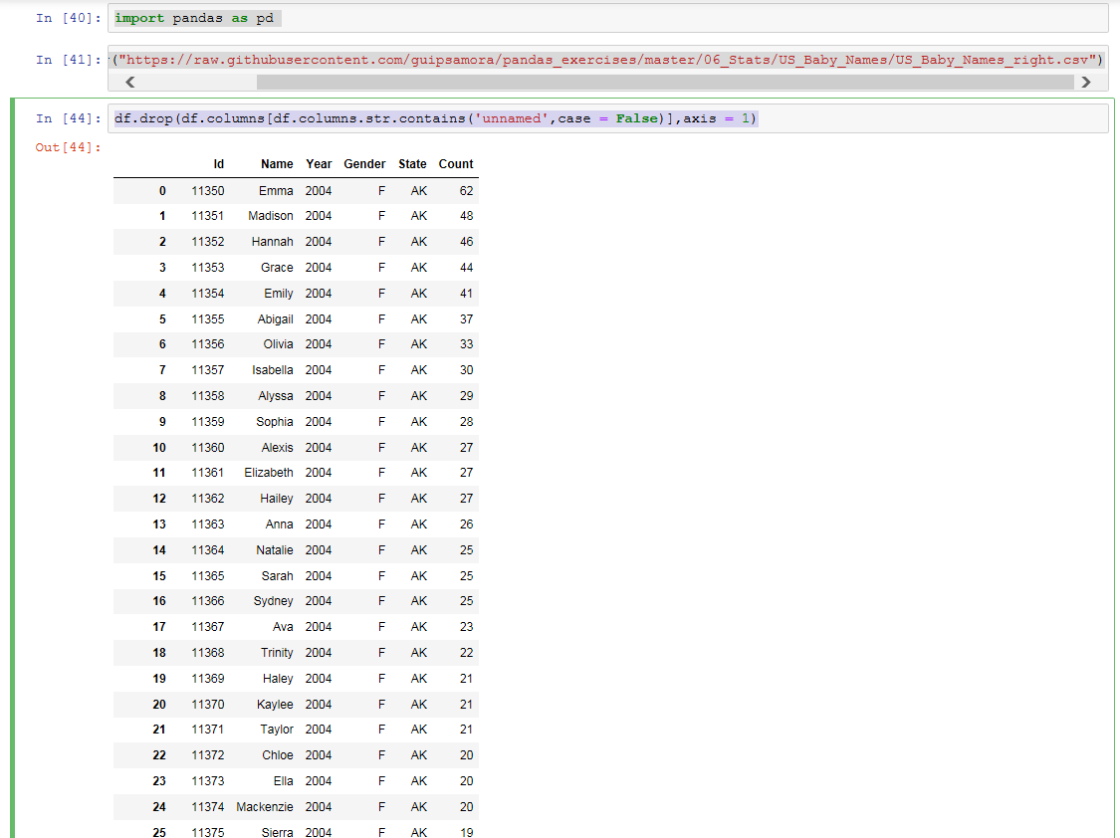

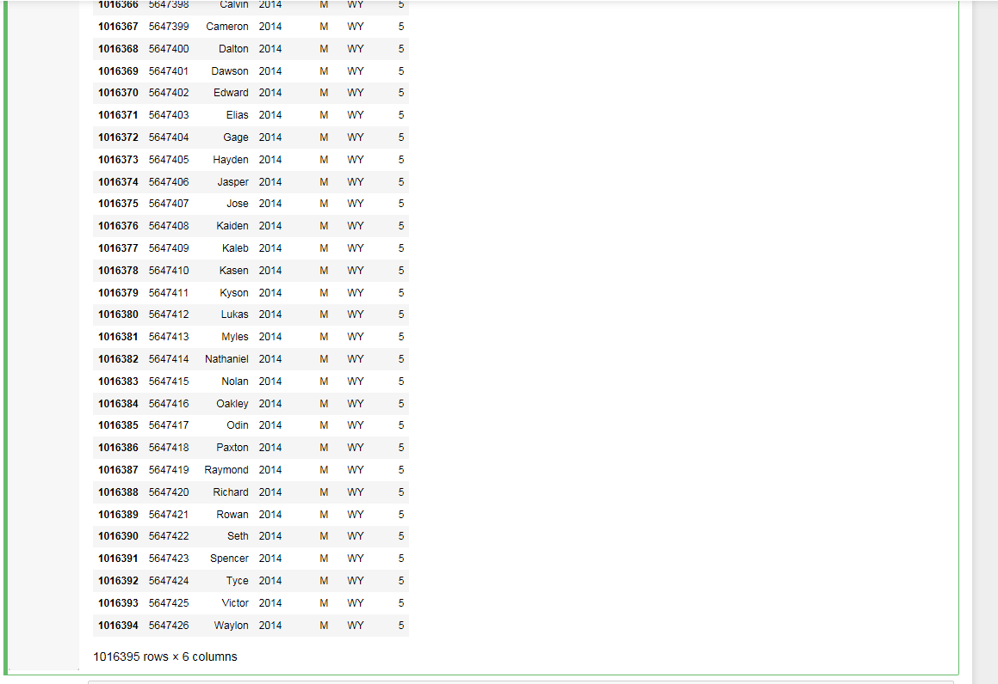

Question 2) Show the distribution of male and female

Code:

import pandas as pd

import matplotlib.pyplot as plt

from matplotlib.pyplot import figure

df = pd.read_csv("https://raw.githubusercontent.com/guipsamora/pandas_exercises/master/06_Stats/US_Baby_Names/US_Baby_Names_right.csv")

figure(num=None, figsize=(8, 6), dpi=80, facecolor='w', edgecolor='k')

df.groupby(['Gender','State'])['Count'].size().unstack().plot(kind='bar',stacked=True)

Output:

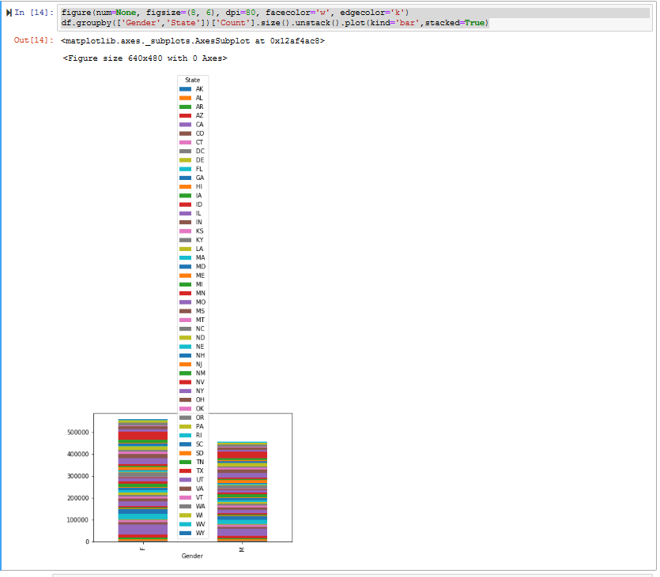

Question 3) Show the top 5 most preferred names

Code:

import pandas as pd

import matplotlib.pyplot as plt

from matplotlib.pyplot import figure

df = pd.read_csv("https://raw.githubusercontent.com/guipsamora/pandas_exercises/master/06_Stats/US_Baby_Names/US_Baby_Names_right.csv")

df['Name'].value_counts()[df['Name'].value_counts() == df['Name'].value_counts()].head()

Output:

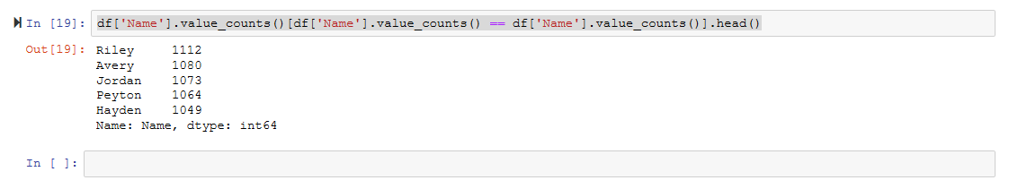

Question 4) What is the median name occurence in the dataset

Code:

import pandas as pd

df = pd.read_csv("https://raw.githubusercontent.com/guipsamora/pandas_exercises/master/06_Stats/US_Baby_Names/US_Baby_Names_right.csv")

df2 = df.iloc[int((len(df.index)+1)/2)]

df2['Name']

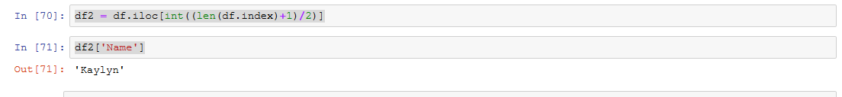

Question 5) Distribution of male and female born count by states

Code:

counts = df.groupby(['State','Gender']).count()

counts

