**Hospital Management systems (USE CASE DIAGRA)**

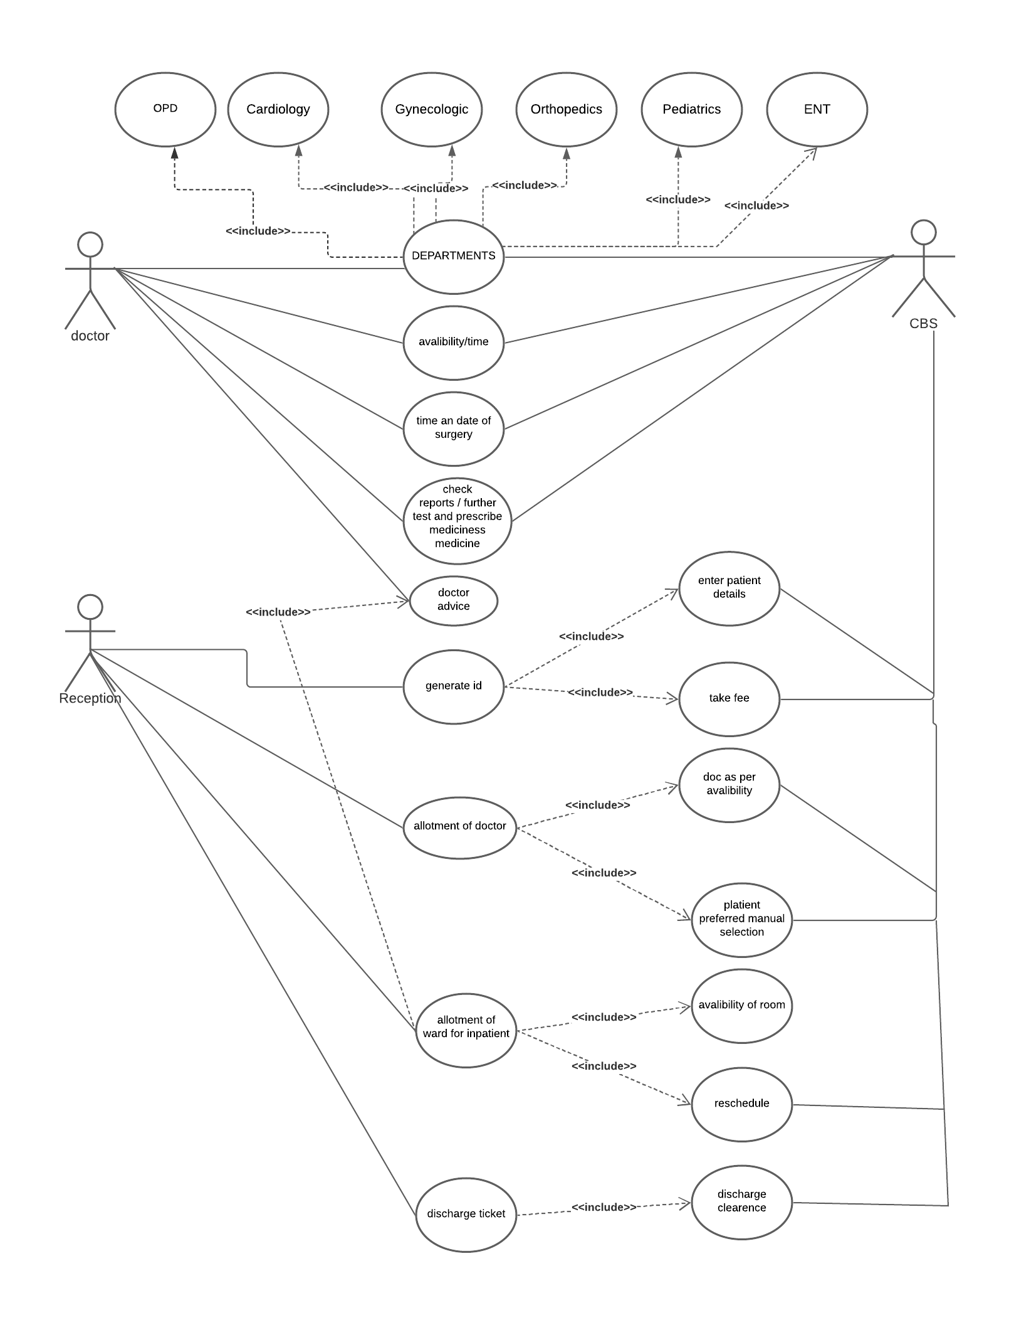

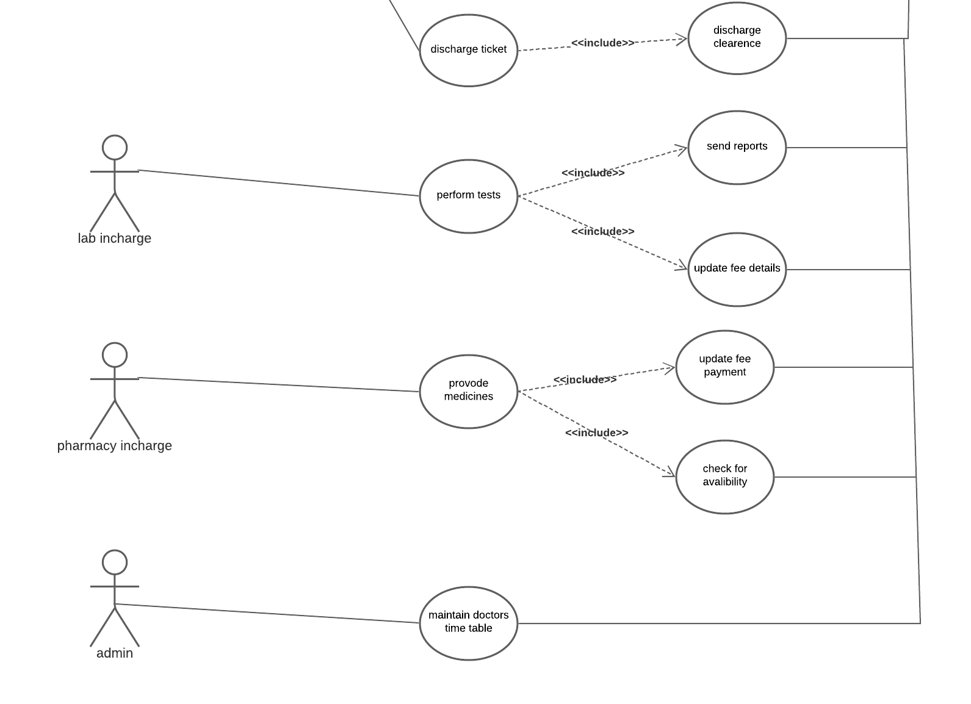

**USE CASE SPECIFICATION:**

Use Case ID: UC001 Use Case Name: Enter Patient Details

1. Use Case Description The given use case will enter patient details.

2. Actor Receptionist

3. Pre-Conditions Active network connection should be available

Receptionist should have valid Patient ID before

search.

4. Basic Flow Step 1: Receptionist will open Hospital

Management System.

Step 2: Receptionist can search Patient by

option

Step 3: Search Patient by Patient ID

Step 4: Receptionist can also register patient.

5. Alternative Flow 1.1 No Response from HMS

· If in step 1 of basic flow fails, if the

Receptionist is not able to open HMS

then the use case ends with a failure

condition or User (Receptionist) can take

help of the concerned department, if not

able to find the Patient details with

patient ID in search option.

· The Use case Resumes at Step 1

1.2 Unable to Search Patient Details

· If in step 2 of basic flow fails, if

Receptionist are not able to search

patient details from search option then.

The use case ends showing the system

prompt error message “unable display

patient” and use case ends with failure

note.

· The Use Case resumes at Step 2.

1.3 Wrong Patient name or ID

· If in step 3 of basic flow fails, if

Receptionist may have entered the

Patient name or ID wrongly. The use

case ends showing the system prompt

error message “unable display patient

details” and use case ends with failure

note.

· The Use Case resumes at Step 3.

1.4 Not able to register new patient

· If in step 4 of basic flow fails, if the

Receptionist is not available to register

new patient then the system will display

a message “Patient details not

accepted” and ask Receptionist to recheck the patient detail.

· The use case resumes at Step 4

6. Exceptional Flow Valid error condition is displayed if there is any

error

7. Post –Conditions Receptionist is able to successfully view the

patient information needed

Use Case ID: UC002 Use Case Name: Doctors Allocation

1. Use Case Description In this use case after Receptionist search patient

ID, can now check the doctor availability for

doctor consultation.

2. Actor Receptionist

3. Pre-Conditions Active network connection should be available

Receptionist should be able to check doctor

availability as well as fixes appoint with OPD &

in- patients.

4. Basic Flow Step 1: Receptionist Checks Doctors availability

Step 2: Fix doctors appoint with OPD

Step 3: Fix doctors appoint with In-patient

5. Alternative Flow 1.1 Unable to Checks Doctors Availability

· Receptionist can take assistance from

the IT department, if not able to check

the doctor’s availability.

If the required Doctor availability information is

not loading, Receptionist can contact IT

department.

· The use case resumes at Step 1

1.2 Unable to Fix Doctors Appointment

· User (Receptionist) may not able to fix

appointment with the concerned doctor,

the system should through error” Valid

error while fixing the appointment with

doctor.”

Receptionist may not be able to re-schedule the

appoint with doctor, the system should through

error that “Appointment Re-scheduling failed”

· The Use case resumes at Step 2 & 3

6. Exceptional Flow Valid error condition is displayed if there is any

error in

7. Post –Conditions Receptionist can check Doctor’s availability ‘N’

number of times.

Use Case ID: UC003 Use Case Name: Receives Payment

1. Use Case Description In this use case the Receptionist, can receive

payment with regard to consultation fee, lab fee

& pharmacy fee with the help of payment

functionality.

2. Actor Receptionist

3. Pre-Conditions There is an active net connection and

Receptionist is able to successfully receives

payment with the help of payment button

4. Basic Flow Step 1: Receptionist can receive payment for

consultation fee, lab fee & pharmacy fee.

Step 2: Receptionist can click on the payment

gateway.

Step 3: Receptionist can choose the mode of

payment.

Step 4: Receive the payment

5. Alternative Flow 1.1 Unable to receive payment

The Receptionist may not able to receive

payment for patients by any of the source:

· If payment button is not working.

· If the payment gateway session timed

out.

· If payment gateway session expires.

the system should through error that “Try Again”

The Use case resumes to Step 2

6. Exceptional Flow Valid error condition is displayed if there is any

error in accessing the information

7. Post –Conditions The payment is being deducted from the

patients account.

Use Case ID: UC004 Use Case Name: Ward Allotment

1. Use Case Description In this use case the Receptionist can allot ward

to patients as per ward availability and doctor’s

advice.

2. Actor Receptionist

3. Pre-Conditions Active network connection should be available

For allotment of ward, Receptionist should have

valid patient ID to search.

For ward allotment, the patient must have

reference from doctors that need to be

submitted to Receptionist.

4. Basic Flow Step 1: Receptionist Searches patient with

patient ID

Step 2: Checks ward Availability

Step 3: Receptionist can update ward allotment

status to patient.

5. Alternative Flow 1.1 Ward List not visible

If the receptionist may not be able to view the

ward availability list, the system should through

error that “Try Again”.

The Use case resumes to Step 2.

1.2 Unable to update Ward Availability

Receptionist may not be able to edit details

related to ward allotment; the system should

through error that “Try Again”.

The use case resumes to Step 3.

6. Exceptional Flow Valid error condition is displayed if there is any

error in

7. Post –Conditions Receptionist can check ward availability status

‘N’ number of times

Use Case ID: UC004 Use Case Name: Patient Discharge

1. Use Case Description In this use case Receptionist can access the

Patient Discharge formality as per doctor advice

and part due’s

2. Actor Receptionist

3. Pre-Conditions Active network connection should be available

For discharge certificate, Receptionist should

have valid patient ID to search.

For discharge certificate, the patient must have

reference from doctors that need to be

submitted to Receptionist.

4. Basic Flow Step 1: Receptionist Searches patient with

patient ID

Step 2: Checks Patient Discharge formality

Step 3: Receptionist can update discharge status

to patient.

5. Alternative Flow 1.1 Patient Discharge Formality not visible

If the receptionist may not be able to view the

patient discharge formality, the system should

through error that “Try Again”.

The Use case resumes to Step 2.

1.3 Unable to update Discharge Formality

Receptionist may not be able to edit details

related to discharge; the system should through

error that “Try Again”.

The use case resumes to Step 3.

6. Exceptional Flow Valid error condition is displayed if there is any

error in

7. Post –Conditions Receptionist can check discharge status of

patient ‘N’ number of times

Use Case ID: U005 Use Case Name: Practice Test

1. Use Case Description In this use case the Doctors can prescribe test to

the patient after checkup.

2. Actor Doctor

3. Pre-Conditions There is an active net connection and

Doctor must have required patient information

before checkup.

4. Basic Flow Step 1: Doctor can check up patient

Step 2: Doctor can prescribe test

5. Alternative Flow 1.1 Unable to upload Test

Due to some reason, If the doctor is not able to

upload the list of prescribed tests, the system

should through error saying “Upload Test Details

Again”

The use case will resume step 2.

6. Exceptional Flow Valid error condition is displayed if there is any

error in

7. Post –Conditions Doctor can successfully upload the test details.

Use Case ID: UC006 Use Case Name: Prescribe Medicine

1. Use Case Description In this use case the Doctors can prescribe

medicine to the patient after checkup.

2. Actor Doctor

3. Pre-Conditions There is an active net connection and

Doctor must have required patient information

before checkup.

4. Basic Flow Step 1: Doctor can check up patient

Step 2: Doctor can prescribe test

5. Alternative Flow 1.1 Unable to upload Medicine

Due to some reason, If the doctor is not able to

upload the list of prescribed medicine, the

system should through error saying “Upload

Medicine Details Again”

The use case will resume step 2.

6. Exceptional Flow Valid error condition is displayed if there is any

error in submission of the request

7. Post –Conditions Doctor can successfully upload the medicine

details.

Use Case ID: UC008 Use Case Name: Review Reports

1. Use Case Description In this use case the Doctors can review patient

reports.

2. Actor Doctor

3. Pre-Conditions Active network connection should be available

For viewing reports, doctor should have patient

ID.

4. Basic Flow Step 1: Doctors opens HMS

Step 2: Inserts Patient ID.

Step 3: Checks the test reports published by lab.

Step 4: Doctor can further update patient.

5. Alternative Flow 1.1 Unable to view Test report

If the doctor is not able to view prescribed test

of patient, the system should through error

saying “Re-fresh Browser”

The use case will resume step 3.

6. Exceptional Flow Valid error condition is displayed at the time of

form submission.

7. Post –Conditions Doctor is able to successfully review patient

report.

Use Case ID: UC009 Use Case Name: Doctors Time Slot

1. Use Case Description In this use case the Admin can maintain doctor’s

time slot.

2. Actor Admin

3. Pre-Conditions Active network connection should be available

For maintaining doctor’s time slot, the admin

must have valid Doctor schedule.

4. Basic Flow Step 1: Admin opens HMS

Step 2: Inserts Doctor ID.

Step 3: Checks the Doctors Schedule.

Step 4: Admin can further update doctor’s time

slot.

Step 5: Admin submits the schedule.

5. Alternative Flow 1.1 Doctor Schedule not visible

If the Admin is not able to view doctor’s schedule

by entering the Doctor ID, the system should

through error saying “Re-fresh Browser”

The use case will resume step 3.

1.2 Not able to update doctor’s time

If the Admin is not able to update doctors

schedule, the system should through error

saying “Try Again”

The use case will resume step 4.

6. Exceptional Flow Valid error condition is displayed if there is any

error in

7. Post –Conditions Admin is able to successfully update & maintain

doctor schedule.

Use Case ID: UC 010 Use Case Name: Upload Test Details

1. Use Case Description In this use case the lab in charge, after collecting

test samples from the patient must update

system.

2. Actor Lab In charge

3. Pre-Conditions There is an active net connection

For updating patient test details, the lab in charge must have valid Patient ID.

4. Basic Flow Step 1: Lab In-charge opens HMS

Step 2: Inserts Patient ID.

Step 3: Checks the prescribed test as per

doctor’s advice.

Step 4: Lab in charge upload the test reports.

Step 5: Lab in charge submit the report.

5. Alternative Flow 1.1 Unable to upload test reports

Due to some reason, If the lab in-charge is not

able to upload the test reports, the system

should through error saying “Upload Reports

Details Again”

The use case will resume step 4.

6. Exceptional Flow Valid error condition is displayed if there is any

error in the data entered

7. Post –Conditions Lab in-charge is able to successfully upload the

patient test report.

Use Case ID: UC 010 Use Case Name: Lab Fee Details

1. Use Case Description In this use case the lab in charge must have to

update lab fee details depending upon the test

taken by the patient.

2. Actor Lab In charge

3. Pre-Conditions There is an active net connection

For updating patient fee details, the lab in charge

must have valid Patient ID and list of tests.

4. Basic Flow Step 1: Lab In-charge opens HMS

Step 2: Inserts Patient ID.

Step 3: Update lab fee details.

5. Alternative Flow 1.1 Unable to update Lab Fee

If the lab in-charge is not able to update the lab

fee details, the system should through error

saying “Submit Again”

The use case will resume step 3.

6. Exceptional Flow Valid error condition is displayed if there is any

error in the data entered

7. Post –Conditions Lab in-charge is able to successfully update the

lab fee detail.

Use Case ID: UC 010 Use Case Name: Enter Medicine Payment

1. Use Case Description In this use case the Pharma in charge must have

to update medicine payment details depending

upon doctor’s prescription.

2. Actor Pharma In charge

3. Pre-Conditions There is an active net connection

For updating medicine payment details, the

pharma in charge must have valid Patient ID and

list of prescribed medicine.

4. Basic Flow Step 1: Pharma In-charge opens HMS

Step 2: Inserts Patient ID.

Step 3: Check’s list of prescribed medicine.

Step 4: Update medicine payment details.

5. Alternative Flow 1.1 Unable to update medicine payment

If the pharma in-charge is not able to update the

medicine payment details, the system should

through error saying “Submit Again”

The use case will resume step 4.

6. Exceptional Flow Valid error condition is displayed if there is any

error in the data entered

7. Post –Conditions Pharma in-charge is able to successfully update

the medicine payment detail.

Activity diagram

