Functional Requirement Document

Hospital Management system

Altaf

# **Document Version Control List**

|  |  |  |  |
| --- | --- | --- | --- |
| Version | Date | Author | Description |
| 01 | 02-05-2020 | Altaf | FRD Doc |
|  |  |  |  |
|  |  |  |  |
|  |  |  |  |

# **Distribution List**

|  |  |  |  |  |
| --- | --- | --- | --- | --- |
| Version | Date | Name | Role | Distribution Purpose |
| 01 | 03-05-2020 | Ronald | Senior BA | Doc Owner |
| 01 | 03-05-2020 | Veer | Project Manager | Project Sponsor |
|  |  |  |  |  |
|  |  |  |  |  |

Contents

**1.** **Document Version Control List** 1

**2.** **Distribution List** 1

**3.** **Business Rules** 3

**4.** **System Rules** 3

**5.** **Control Flow** 3

**6.** **Purpose** 3

**7.** **Project Background** 3

**8.** **Project Objective** 3

**9.** **Business Requirements** 3

**9.1.** **Stake Holder Requirements** 4

**10.** **Assumptions & Constraints** 4

**11.** **Use Case Diagrams [UML]** 4

**11.1.** **Actor Specific Use Case Diagrams** 4

**11.2.** **Use Case Specifications** 5

**9. Activity Diagram** 5

**9.1.** **Process Specific Activity Diagrams** 5

**9.2.** **Activity Specification** 6

**9.2.1.** **Basic Flow** 6

**9.2.2.** **Alternative Flow** 6

**9.2.3.** **Exception Flow** 6

**10.** **Functional Requirements** 6

**11.** **Non Functional Requirements** 6

**12.** **Prototyping** 7

**13.** **Master Tables** 7

**14.** **Notes** 7

# 

# **Business Rules**

* System should allow only valid staff to use the Hospital Management System which will have no access to the patient
* Administrator can view the doctor availability Sheets, Doctors Leave, Pharmacy Requirement, Staff attendance
* Patients have no access to HMS System
* Hospital Should have all the legal Permissions

Administrator can view the doctor availability Sheets, Doctors Leave, Pharmacy Requirement, Staff attendance

# **System Rules**

* System should pop up for any error.
* Registration cannot be done for a specified if he is not available
* System must daily backup the data by 12pm.
* System must allow admin to update, doctor’s availability and doctors leaves to reception
* System should pop up a message, if any issues in the system from railways side.
* System should not allow any access to the patient
* System should not allow if the individual logins are incorrect

System should not allow one department to access the other department without proper authentication

# **Control Flow Diagram**

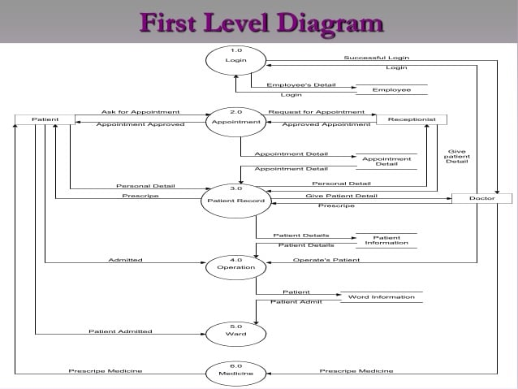

# **Purpose**

* To create fully digital Hospital Management system
* To eradicate the risk of losing data
* To increase the transparency in the system
* To completely avoid manual process in the system making it digital
* To speed up the process in between the departments
* To enhance the working capabilities of the Hospital management system

# **Project Background**

Hospitals that are providing Best Treatments to Patients in need had to face a lot of problems with the sheets and papers (non computerized) traditional hospital setup which earlier made all the process run in backlog and create a lot of confusion with huge files and papers increasing the chance of error where all the process starting from registering a patient ending at discharge are being done manually.

The proposed IT solution will provide multiple logins for different departments like (Admin, Doctor, Reception, Lab, Pharmacy) where each user is provided with UI having predefined columns for inputs along with easy and interactive menu items which cover all the process which is being done manually. few more adaptive features mobile notifications to doctor can be added in the further updates of Hospital Management System

# **Project Objective**

* The system captures the personal details of the patient, the doctor or department they want to take and appointment further generating unique Token Number.
* It reduces the existing manual process of writing the details on the paper
* Patient registrations will pop up on the doctors UI
* It simplifies the Process eradicating confusion, making it simple and fast.
* Receptionist can view the availability of doctor’s, time of availability, availability8 of beds from admissions in the HMS portal
* All the form the lab fees, Admission fees for inpatient services, and doctor fees is collected at the reception
* Discharge Note / out pass is issued at the reception after the full and final settlement of outstanding dues
* Lab can check for the tests prescribed by the doctors to their patients on the Lab UI after successful Login, they can also send digital reports to doctors and digital copy of medical bill for Lab service to the reception for payment
* Pharmacy can see the Medicines prescribed by their doctors once they login into their UI and generate bill, Amount for pharmacy will be collected there it self and the bill is generated
* Request for Stock can be placed through online which will be sent to the admin department for approval
* Admin has specified login though which the admin team can view and work on all the necessary changes and keep updated with different branches in hospital
* Project saves both time and energy for the Hospital, Doctor, Patient, Pharmacy, Lab there by increasing the transparency in the system.

# **Business Requirements**

**A web-based system to be developed for following: -**

|  |  |  |  |  |
| --- | --- | --- | --- | --- |
| **Sl. No.** | **Requirement ID** | **Requirement Name** | **Description** | **Priority** |
| **1** | **BR001** | Web portal | Interface used to support the Hospital Management system process. | High |
| **2** | **BR002** | Login Credential | Verify and allow authorised users (Doctor, Reception, Lab, Pharmacy, Admin) | High |
| **3** | **BR003** | View Doctor availability | Reception should be allowed to see the doctor’s availability | High |
| **4** | **BR004** | Check Room availability | Reception should be allowed to view room availability for  inpatient | High |
| **5** | **BR005** | Book appointment | Reception should be able to book appointment on doctors availability | High |
| **6** | **BR006** | Collect payment | Reception should be able to collect payment from the patient and generate bill | High |
| **7** | **BR007** | Doctor prescription | Doctor should be able to prescribe medicine or lab tests to patients | High |
| **8** | **BR008** | Lab in charge | Lab in charge should be able to upload lab test results to doctor | High |
| **9** | **BR009** | Lab in charge to reception | Lab in charge should be able to update lab bills of patients to reception for payments | High |
| **10** | **BR010** | Doctor | Doctor should be able to update his availability in his portal after login | High |
| **11** | **BR011** | Doctor | Doctor should be able to update his leaves to admin from his portal | High |
| **12** | **BR012** | Pharmacy | Pharmacy should be able to view inventory in their portal | High |
| **13** | **BR013** | Pharmacy | Pharmacy Should be able to generate bills and collect payments from patients | High |
| **14** | **BR014** | Pharmacy stock request | Pharmacy should be able to generate stock request to admin | High |
| **15** | **BR015** | Admin | Admin should be able to view doctors’ availability and scheduled leaves | High |
| **16** | **BR016** | Admin | Admin should be able to update reception on doctor’s time sheets and leave schedule | High |
| **17** | **BR017** | Discharge note | Reception should be able to generate discharge note to patient after full settlement of bill | High |

## **Stake Holder Requirements**

|  |  |
| --- | --- |
| **Stakeholder** | **Requirements** |
| Reception | 1)login is compulsory  2)should be able to register a patient  3) should be able to check with doctors’ availability  4) should be able to check with room availability  5) should be able to receive bills from lab  6) should be able to enter patient details  7) should be able to generate bills  8) should be able to generate discharge notes |
| Doctor | 1. Login is compulsory 2. Should be able to update availability to admin 3. Should be able to update leaves to Admin 4. Should be able to send lab prescription to lab 5. Should be able to send prescription to Pharmacy 6. Should be able to receive lab reports from lab |
| LAB | 1. Login is compulsory 2. Should be able to receive tests requests from doctor 3. Should be able to send test reports to doctor 4. Should be able to send lab test bills to the reception |
| Pharmacy | 1. Login is compulsory 2. Should be able to receive prescription from doctor 3. Should be able to bill patients for medicines and collect amount 4. Should be able to check stock inventory in the system 5. Should be able to place stock request to admin 6. Should be able to receive conformation from admin |
| Admin | 1. Login is compulsory 2. Should be able to check doctors time sheets 3. Should be able to check doctors leave sheets 4. Should be able to check pharmacy stock request 5. Should be able to update pharmacy stock request to purchase department 6. Should be able to update doctors’ availability and leaves to reception |

# **Assumptions & Constraints**

|  |
| --- |
| *Assumptions* |
| * No additional change request. * Proper funding is provided. * There is internet connectivity present. * Discharge is done at the reception. * The system is up and running. |
| Constraints |
| * Login will be provided to the staff (Admin, Doctor, Reception, Lab, Pharmacy) * Registration is compulsory for patients * System should update on every new patient Registration or Discharge * The whole System should update on every day basis where no one can access it (mostly in night). * Registration should be able to discharge patient. * Vacant beds should be updated into the system |

# **Use Case Diagrams [UML]**

## **Actor Specific Use Case Diagrams**

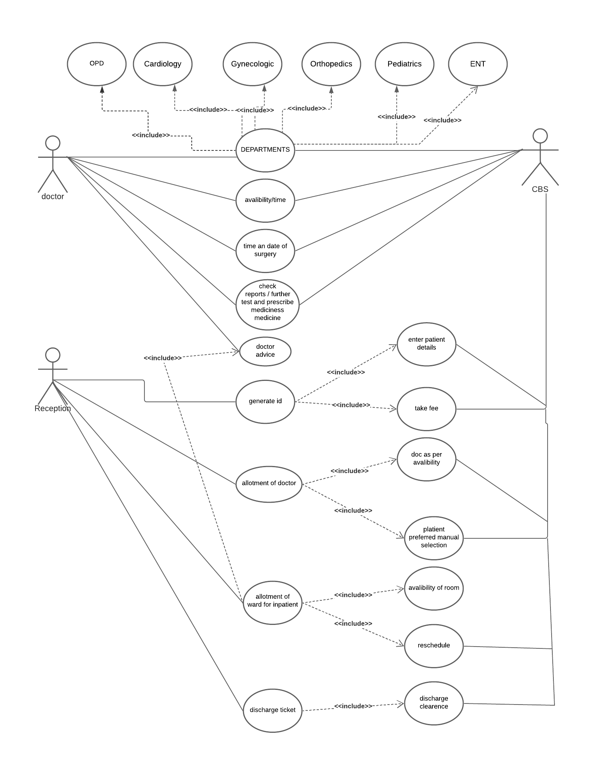

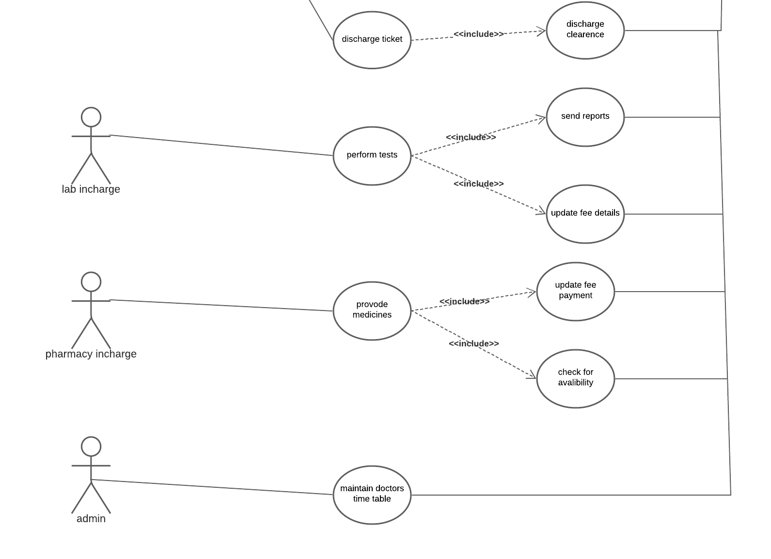

## **Use Case Specifications**

|  |  |
| --- | --- |
| **Use Case ID** | RRS_CS6_UC1 |
| **Use Case Name** | Enter Patient Details |
| **Brief Description** | The given use case will enter patient details. |
| **Actors** | Receptionist |
| **Pre-Condition** | Active network connection should be available  Receptionist should have valid Patient ID before  search. |
| **Basic Flow** | Receptionist will open Hospital  Management System.  Step 2: Receptionist can search Patient by  option  Step 3: Search Patient by Patient ID  Step 4: Receptionist can also register patient. |
| **Alternative Flow** | No Response from HMS  · If in step 1 of basic flow fails, if the  Receptionist is not able to open HMS  then the use case ends with a failure  condition or User (Receptionist) can take  help of the concerned department, if not  able to find the Patient details with  patient ID in search option.  · The Use case Resumes at Step 1  1.2 Unable to Search Patient Details  · If in step 2 of basic flow fails, if  Receptionist are not able to search  patient details from search option then.  The use case ends showing the system  prompt error message “unable display  patient” and use case ends with failure  note.  · The Use Case resumes at Step 2.  1.3 Wrong Patient name or ID  · If in step 3 of basic flow fails, if  Receptionist may have entered the  Patient name or ID wrongly. The use  case ends showing the system prompt  error message “unable display patient  details” and use case ends with failure  note.  · The Use Case resumes at Step 3.  1.4 Not able to register new patient  · If in step 4 of basic flow fails, if the  Receptionist is not available to register  new patient then the system will display  a message “Patient details not  accepted” and ask Receptionist to recheck the patient detail.  · The use case resumes at Step 4 |
| **Exceptional Flow** | Valid error condition is displayed if there is any error in accessing the information. |
| **Post Condition** | Receptionist is able to successfully view the  patient information needed. |
| **Scenarios** | No Response from the server. |

|  |  |
| --- | --- |
| **Use Case ID** | RRS_CS6_UC2 |
| **Use Case Name** | Doctors Allocation |
| **Brief Description** | In this use case after Receptionist search patient  ID, can now check the doctor availability for  doctor consultation. |
| **Actors** | Receptionist |
| **Pre-Condition** | Active network connection should be available  Receptionist should be able to check doctor  availability as well as fixes appoint with OPD &  in- patients. |
| **Basic Flow** | Receptionist Checks Doctors availability  Step 2: Fix doctors appoint with OPD  Step 3: Fix doctors appoint with In-patient |
| **Alternative Flow** | Unable to Checks Doctors Availability  · Receptionist can take assistance from  the IT department, if not able to check  the doctor’s availability.  If the required Doctor availability information is  not loading, Receptionist can contact IT  department.  · The use case resumes at Step 1  1.2 Unable to Fix Doctors Appointment  · User (Receptionist) may not able to fix  appointment with the concerned doctor,  the system should through error” Valid  error while fixing the appointment with  doctor.”  Receptionist may not be able to re-schedule the  appoint with doctor, the system should through  error that “Appointment Re-scheduling failed”  · The Use case resumes at Step 2 & 3 |
| **Exceptional Flow** | Valid error condition is displayed if there is any error in accessing the information. |
| **Post Condition** | Receptionist can check Doctor’s availability ‘N’  number of times. |
| **Scenarios** | No Response from the server. |

|  |  |
| --- | --- |
| **Use Case ID** | RRS_CS6_UC3 |
| **Use Case Name** | Receives Payment |
| **Brief Description** | In this use case the Receptionist, can receive  payment with regard to consultation fee, lab fee  & Pharmacy fee with the help of payment  functionality. |
| **Actors** | Receptionist |
| **Pre-Condition** | There is an active net connection and  Receptionist is able to successfully receives  payment with the help of payment button |
| **Basic Flow** | Receptionist can receive payment for  consultation fee, lab fee & pharmacy fee.  Step 2: Receptionist can click on the payment  gateway.  Step 3: Receptionist can choose the mode of  payment.  Step 4: Receive the payment |
| **Alternative Flow** | 1 Unable to receive payment  The Receptionist may not able to receive  payment for patients by any of the source:  · If payment button is not working.  · If the payment gateway session timed  out.  · If payment gateway session expires.  the system should through error that “Try Again” The Use case resumes to Step 2 |
| **Exceptional Flow** | Valid error condition is displayed if there is any error in accessing the information. |
| **Post Condition** | The payment is being deducted from the  patients account. |
| **Scenarios** | No Response from the server. |

|  |  |
| --- | --- |
| **Use Case ID** | RRS_CS6_UC4 |
| **Use Case Name** | Ward Allotment |
| **Brief Description** | In this use case the Receptionist can allot ward  to patients as per ward availability and doctor’s  advice. |
| **Actors** | Receptionist |
| **Pre-Condition** | Conditions Active network connection should be available  For allotment of ward, Receptionist should have  valid patient ID to search.  Forward allotment, the patient must have  reference from doctors that need to be  submitted to Receptionist. |
| **Basic Flow** | Receptionist Searches patient with  patient ID  Step 2: Checks ward Availability  Step 3: Receptionist can update ward allotment  status to patient. |
| **Alternative Flow** | Ward List not visible  If the receptionist may not be able to view the  ward availability list, the system should through  error that “Try Again”.  The Use case resumes to Step 2.  1.2 Unable to update Ward Availability  Receptionist may not be able to edit details  related to ward allotment; the system should  through error that “Try Again”.  The use case resumes to Step 3. |
| **Exceptional Flow** | Valid error condition is displayed if there is any error in accessing the information. |
| **Post Condition** | Receptionist can check ward availability status  ‘N’ number of times. |
| **Scenarios** | No Response from the server. |

|  |  |
| --- | --- |
| **Use Case ID** | RRS_CS6_UC5 |
| **Use Case Name** | Patient Discharge |
| **Brief Description** | In this use case Receptionist can access the  Patient Discharge formality as per doctor advice  and part due’s |
| **Actors** | Receptionist |
| **Pre-Condition** | Active network connection should be available  For discharge certificate, Receptionist should  have valid patient ID to search.  For discharge certificate, the patient must have  reference from doctors that need to be  submitted to Receptionist. |
| **Basic Flow** | Receptionist Searches patient with  patient ID  Step 2: Checks Patient Discharge formality  Step 3: Receptionist can update discharge status  to patient. |
| **Alternative Flow** | Patient Discharge Formality not visible  If the receptionist may not be able to view the  patient discharge formality, the system should  through error that “Try Again”.  The Use case resumes to Step 2.  1.3 Unable to update Discharge Formality  Receptionist may not be able to edit details  related to discharge; the system should through  error that “Try Again”.  The use case resumes to Step 3. |
| **Exceptional Flow** | Valid error condition is displayed if there is any error in accessing the information. |
| **Post Condition** | Receptionist can check discharge status of  patient ‘N’ number of times. |
| **Scenarios** | No Response from the server. |

|  |  |
| --- | --- |
| **Use Case ID** | RRS_CS6_UC6 |
| **Use Case Name** | Practice Test |
| **Brief Description** | In this use case the Doctors can prescribe test to  the patient after checkup |
| **Actors** | Doctor |
| **Pre-Condition** | There is an active net connection and  Doctor must have required patient information  before checkup. |
| **Basic Flow** | Doctor can check up patient  Step 2: Doctor can prescribe test |
| **Alternative Flow** | Unable to upload Test  Due to some reason, If the doctor is not able to  upload the list of prescribed tests, the system  should through error saying “Upload Test Details  Again”  The use case will resume step 2. error that “Try Again”.  The use case resumes to Step 3. |
| **Exceptional Flow** | Valid error condition is displayed if there is any error in accessing the information. |
| **Post Condition** | Doctor can successfully upload the test details. |
| **Scenarios** | No Response from the server. |

|  |  |
| --- | --- |
| **Use Case ID** | RRS_CS6_UC7 |
| **Use Case Name** | Prescribe Medicine |
| **Brief Description** | this use case the Doctors can prescribe  medicine to the patient after checkup |
| **Actors** | Doctor |
| **Pre-Condition** | There is an active net connection and  Doctor must have required patient information  before checkup. |
| **Basic Flow** | Doctor can check up patient  Step 2: Doctor can prescribe test |
| **Alternative Flow** | Unable to upload Test  Due to some reason, If the doctor is not able to  upload the list of prescribed tests, the system  should through error saying “Upload Test Details  Again”  The use case will resume  step 2. error that “Try Again”.  The use case resumes to Step 3. |
| **Exceptional Flow** | Valid error condition is displayed if there is any error in accessing the information. |
| **Post Condition** | Doctor can successfully upload the test details. |
| **Scenarios** | No Response from the server. |

|  |  |
| --- | --- |
| **Use Case ID** | RRS_CS6_UC8 |
| **Use Case Name** | Review Reports |
| **Brief Description** | In this use case the Doctors can review patient  reports. |
| **Actors** | Doctor |
| **Pre-Condition** | Active network connection should be available  For viewing reports, doctor should have patient  ID. |
| **Basic Flow** | Doctors opens HMS  Step 2: Inserts Patient ID.  Step 3: Checks the test reports published by lab.  Step 4: Doctor can further update patient |
| **Alternative Flow** | 1.1 Unable to view Test report  If the doctor is not able to view prescribed test  of patient, the system should through error  saying “Re-fresh Browser”  The use case will resume step 3 The use case resumes to Step 3. |
| **Exceptional Flow** | Valid error condition is displayed if there is any error in accessing the information. |
| **Post Condition** | Doctor is able to successfully review patient  report. |
| **Scenarios** | No Response from the server. |

|  |  |
| --- | --- |
| **Use Case ID** | RRS_CS6_UC9 |
| **Use Case Name** | Doctors Time Slot |
| **Brief Description** | Use Case Description In this use case the admin can maintain doctor’s  time slot |
| **Actors** | Admin |
| **Pre-Condition** | Active network connection should be available  For maintaining doctor’s time slot, the admin  must have valid Doctor schedule |
| **Basic Flow** | Admin opens HMS  Step 2: Inserts Doctor ID.  Step 3: Checks the Doctors Schedule.  Step 4: Admin can further update doctor’s time  slot.  Step 5: Admin submits the schedule. |
| **Alternative Flow** | 1.1 Doctor Schedule not visible  If the Admin is not able to view doctor’s schedule  by entering the Doctor ID, the system should  through error saying “Re-fresh Browser”  The use case will resume step 3.  1.2 Not able to update doctor’s time  If the Admin is not able to update doctors  schedule, the system should through error  saying “Try Again”  The use case will resume step 4 |
| **Exceptional Flow** | Valid error condition is displayed if there is any error in accessing the information. |
| **Post Condition** | Admin is able to successfully update & maintain  doctor schedule. |
| **Scenarios** | No Response from the server. |

|  |  |
| --- | --- |
| **Use Case ID** | RRS_CS6_UC10 |
| **Use Case Name** | Upload Test Details |
| **Brief Description** | In this use case the lab in charge, after collecting  test samples from the patient must update  system. |
| **Actors** | Lab In charge |
| **Pre-Condition** | There is an active net connection  For updating patient test details, the lab in charge must have valid Patient ID |
| **Basic Flow** | Lab In-charge opens HMS  Step 2: Inserts Patient ID.  Step 3: Checks the prescribed test as per  doctor’s advice.  Step 4: Lab in charge upload the test reports.  Step 5: Lab in charge submit the report |
| **Alternative Flow** | 1.1 Unable to upload test reports  Due to some reason, If the lab in-charge is not  able to upload the test reports, the system  should through error saying “Upload Reports  Details Again”  The use case will resume step 4 |
| **Exceptional Flow** | Valid error condition is displayed if there is any error in accessing the information. |
| **Post Condition** | Conditions Lab in-charge is able to successfully upload the  patient test report |
| **Scenarios** | No Response from the server. |

|  |  |
| --- | --- |
| **Use Case ID** | RRS_CS6_UC11 |
| **Use Case Name** | Lab Fee Details |
| **Brief Description** | Description In this use case the lab in charge must have to  update lab fee details depending upon the test  taken by the patient. |
| **Actors** | Lab In charge |
| **Pre-Condition** | There is an active net connection  For updating patient fee details, the lab in charge  must have valid Patient ID and list of tests |
| **Basic Flow** | Lab In-charge opens HMS  Step 2: Inserts Patient ID.  Step 3: Update lab fee details |
| **Alternative Flow** | Unable to update Lab Fee  If the lab in-charge is not able to update the lab  fee details, the system should through error  saying “Submit Again”  The use case will resume step |
| **Exceptional Flow** | Valid error condition is displayed if there is any error in accessing the information. |
| **Post Condition** | Lab in-charge is able to successfully update the  lab fee detail. |
| **Scenarios** | No Response from the server. |

|  |  |
| --- | --- |
| **Use Case ID** | RRS_CS6_UC11 |
| **Use Case Name** | Enter Medicine Payment |
| **Brief Description** | In this use case the Pharma in charge must have  to update medicine payment details depending  upon doctor’s prescription.  system. |
| **Actors** | Pharma In charge |
| **Pre-Condition** | There is an active net connection  For updating medicine payment details, the  pharma in charge must have valid Patient ID and  list of prescribed medicine. |
| **Basic Flow** | Step 1: Pharma In-charge opens HMS  Step 2: Inserts Patient ID.  Step 3: Check’s list of prescribed medicine.  Step 4: Update medicine payment details |
| **Alternative Flow** | 1.1 Unable to update medicine payment  If the pharma in-charge is not able to update the  medicine payment details, the system should  through error saying “Submit Again”  The use case will resume step 4. |
| **Exceptional Flow** | Valid error condition is displayed if there is any error in accessing the information. |
| **Post Condition** | Pharma in-charge is able to successfully update  the medicine payment detail. |
| **Scenarios** | No Response from the server. |

# **Activity Diagram**

## **Process Specific Activity Diagrams**

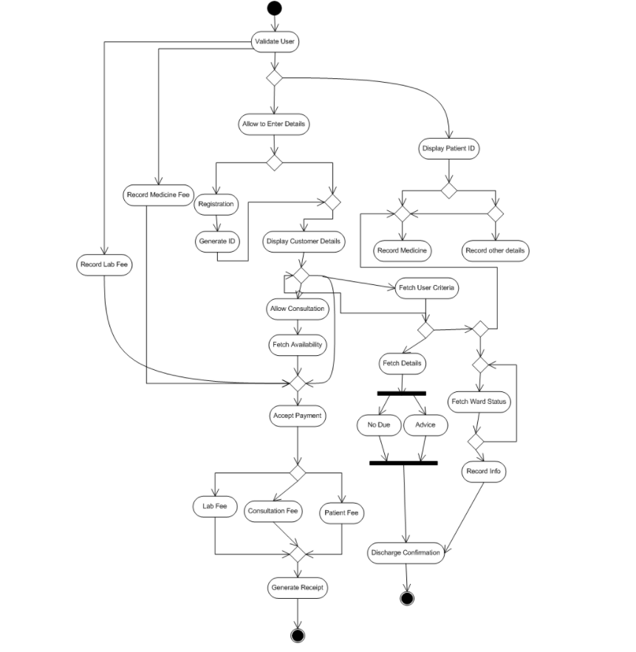

## **12.2. Activity Specification**

|  |  |
| --- | --- |
| **Basic Flow** | Process Steps:  Step 1: Flow starts when patient is registered at the reception  Step 2: doctor availability is checked at the reception  Step 3: doctor prescribes lab tests to patient  Step 4: tests results are received  Step 5: prescribes medicines to patient  Step 6: asks patient to pay dues at the reception  Step 7: if surgery required reception checks fir admission dates  Step 8: admission is rescheduled for available dates  Step 9: reception asks for bill payment  Step 10: payment received  Step 11: discharge note is issued  Step 12: patient buys medicines from pharmacy  Step 13: pharmacy generates bill  Step 14: patient makes payment at the pharmacy  Step 15: flow ends |
| **Alternative Flow** | Process Steps:  Step 1: Ask reception to enter patient details  Step 2: Accept patient details and check the availability of doctor  Step 3: doctor available  Step 4: conform appointment  Step 5: ask patient to pay lab charge  Step 6: conform payment generate receipt  Step 7: upload lab reports to doctor  Step 8: give prescribed medicines at pharmacy  Step 9: Generate bill  Step 10: check for full settlement of dues  Step 11: check with doctor ion patients discharge Step 12: conform discharge  Step 13: generate discharge note, process ends |
| **Exception Flow** | Process Steps:  Step 1: Ask reception to enter patient details  Step 2: Accept registration details from reception  Step 3: Check weather doctor is available or not  Step 4: doctor not available  Step 5: Ask reception to check for another doctor.  Step 6: check for room availability  Step 7: Rooms not available  Step 8: Ask reception to reschedule admission.  Step 9: Rooms available  Step 10: conform room and send message to patients’ mobile number  Step 11: display patient record on doctor’s screen  Step 12: allow doctor to prescribe medicines  Step 13: allow doctor to prescribe lab tests  Step 14: tests successful  Step 15: display test results on doctor’s screen  Step 16: update lab payment due to reception  Step 17: Ask doctor if there is any admission required  Step 18: doctor wants to admit the patient  Step 19: check for room availability  Step 20: Room available book and send conformation message to patient  Step 21: room not available reschedule appointment  Step 23: patient discharged check payment due  Step 24: issue discharge note  Step 25: check for prescription  Step 26: update pharmacy on prescription  Step 27: generate bill at pharmacy, process ends. |
|  |  |

# **Functional Requirements**

|  |  |  |  |  |
| --- | --- | --- | --- | --- |
| **S.No.** | **Req ID** | **Req Name** | **Description** | **Priority** |
| 1 | RQ 1 | Login Validation | System should validate the login credentials of staff (Reception, doctor, admin, lab, pharmacy) | Should |
| 2 | RQ 2 | View Doctor Availability | System should allow reception to view doctor availability details | Should |
| 3 | RQ 3 | Check room availability | System should allow reception to view room availability details | Should |
| 4 | RQ 4 | Book appointment | System should allow reception to book room if available | Should |
| 5 | RQ 5 | Make Payment | System should allow reception to accept payment from the patient for registration and room booking | Must |
| 6 | RQ 6 | Display patient record | System must display patient record on the doctor’s screen | Could |
| 7 | RQ 7 | Display lab tests | System must display lab tests prescribed by the doctor on the lab technician screen | Must |
| 8 | RQ 8 | Update system on registration and discharge of patient | System must be updated when a patient Is registered / admitted or discharged | Must |
| 9 | RQ 9 | Update lab results to doctor | System must update lab results to doctor after the tests are completed | Must |
| 10 | RQ10 | Update lab test bill to reception | System must update lab test bills to reception once the lab in charge updates it | Must |
| 11 | RQ11 | Notifications | Notifications could be sent to patients email and mobile regarding their bills | Could |

# **Non Functional Requirements**

|  |  |  |
| --- | --- | --- |
| S.NO | Req ID | Description |
| 1 | NFR 1 | System response time should be maximum 1sec |
| 2. | NFR 2 | All data should have a regular backup. |
| 3. | NFR 3 | System must be connected to internet 24/7 |
| 4. | NFR 4 | Interface- should be user friendly |
| 5. | NFR 5 | Security- Pop up to change password after every 30 days. |

# **Prototyping**

1. **HMS Home Page**

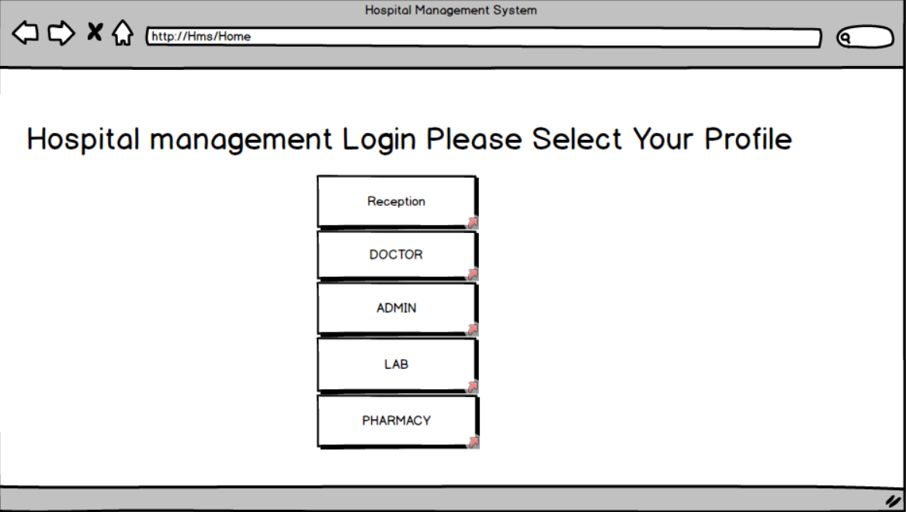

1. **Reception login page**

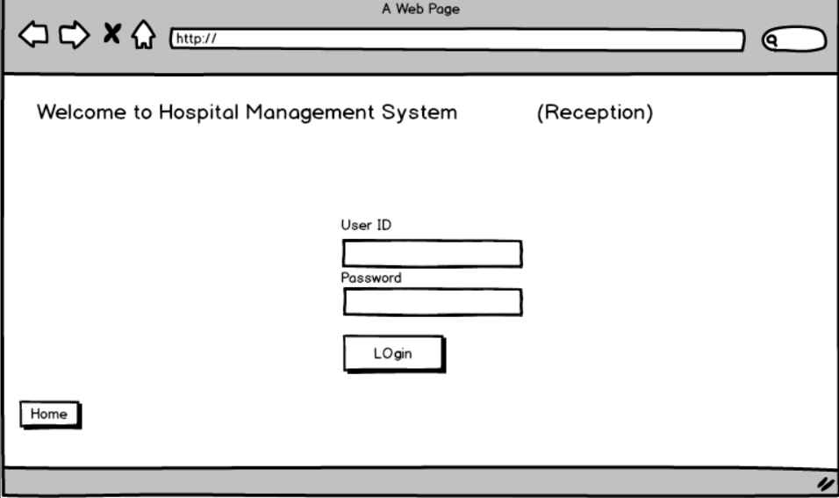

1. **Reception home page**

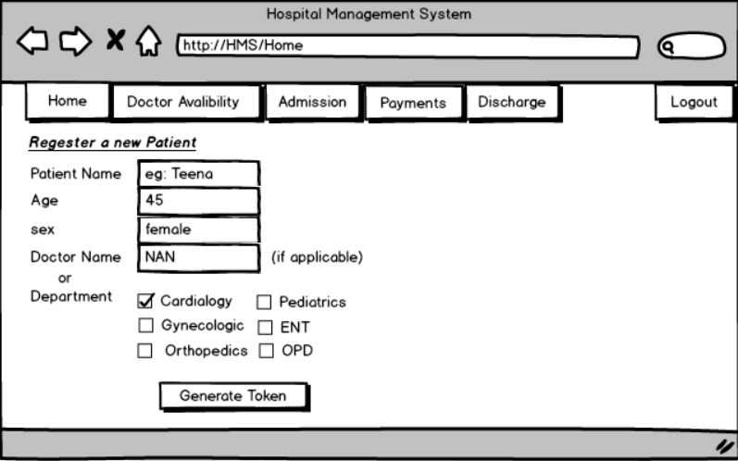

1. **Token conformation page**

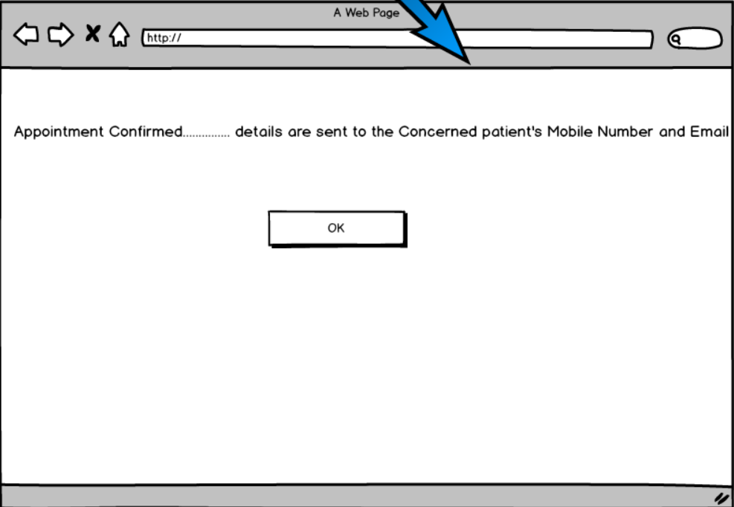

Doctor avaliabity check page

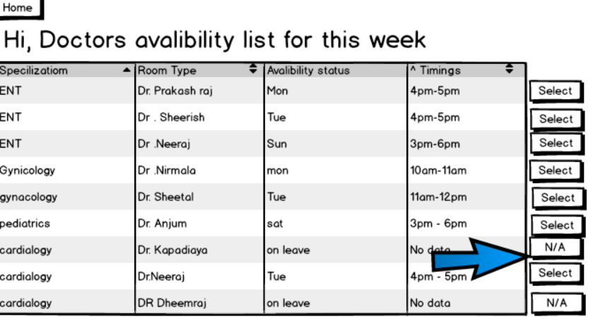

Appoint with doctor conformation page



1. **Admission check page**

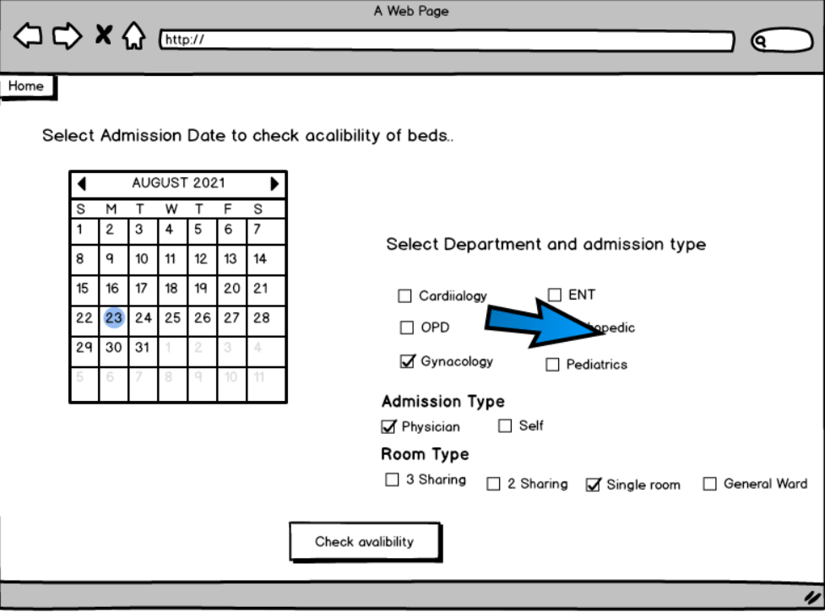

1. **Admission avalibility page**

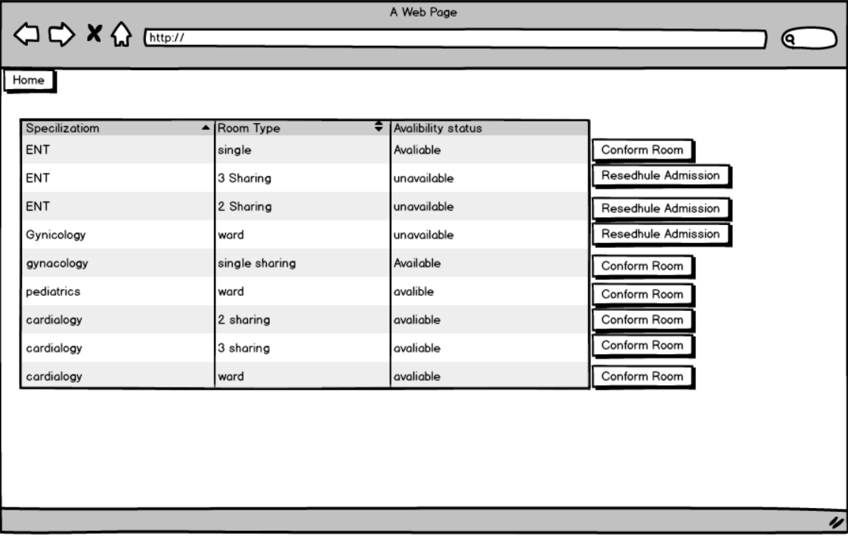

1. Admission conformation page

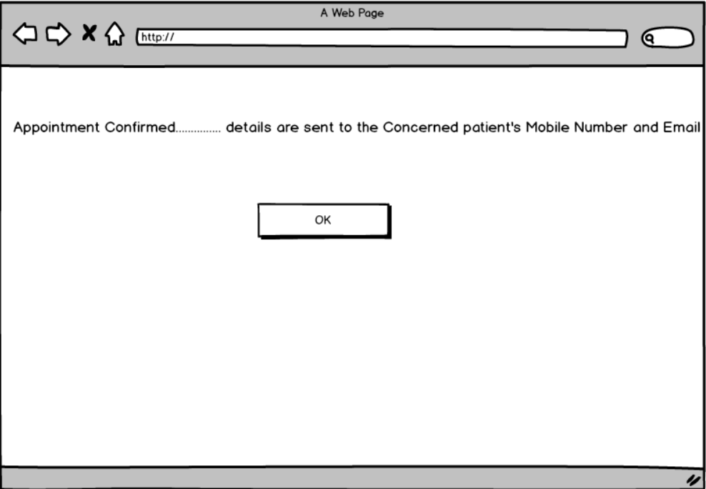

# Payements page

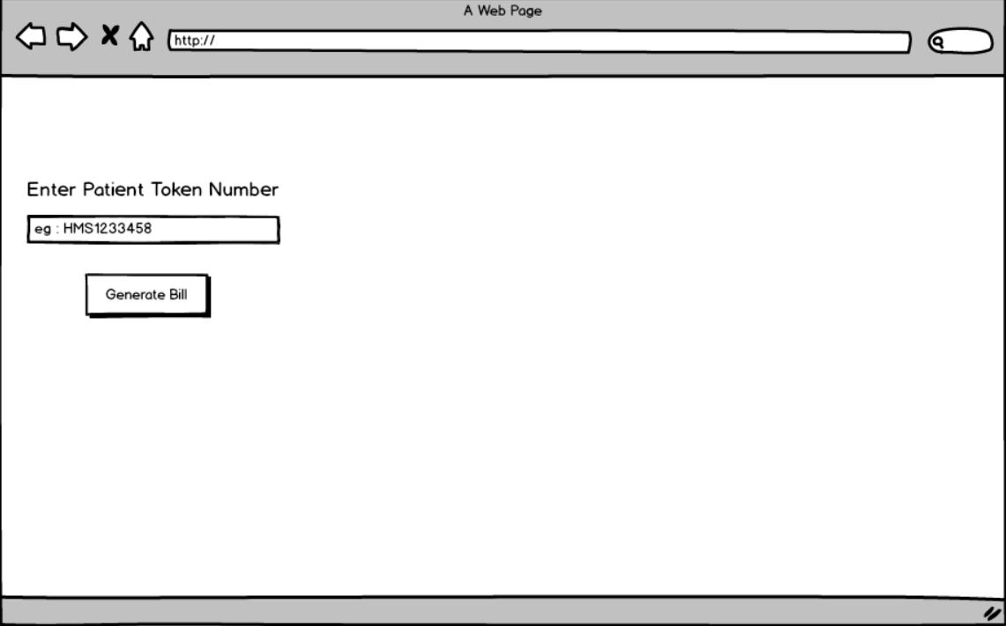

Billing page

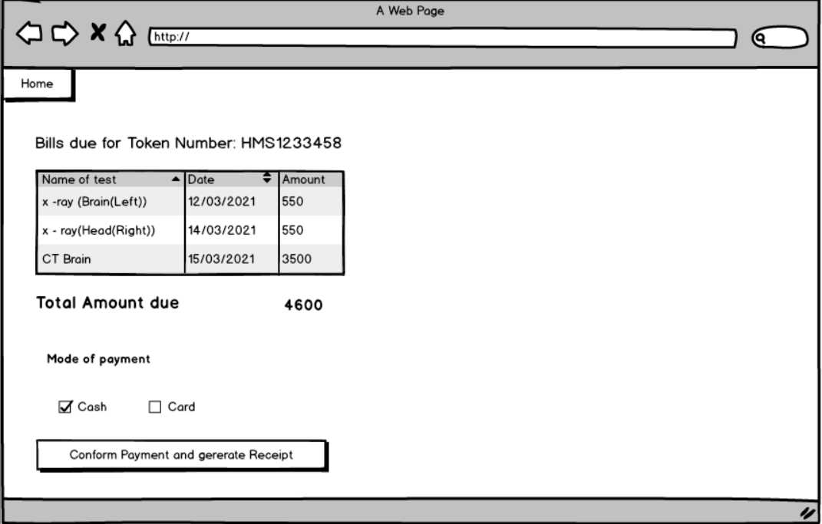

# **Payment conformation page**

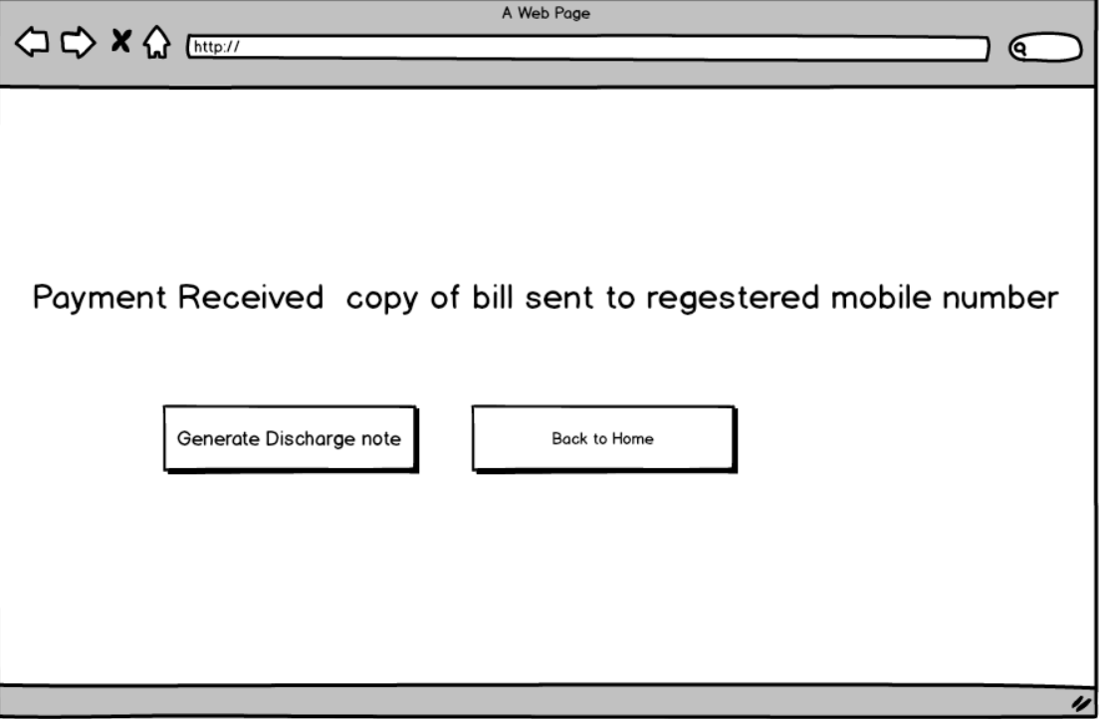

# **Discharge page**

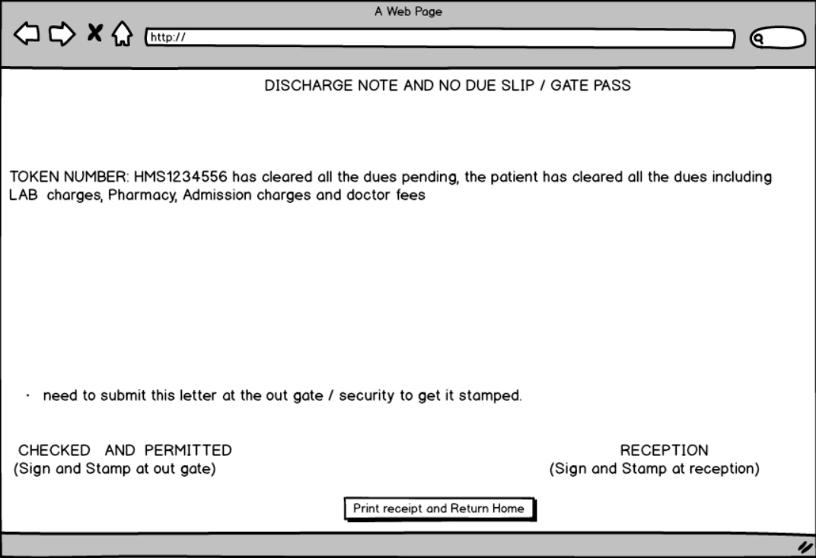

**Doctor login page**

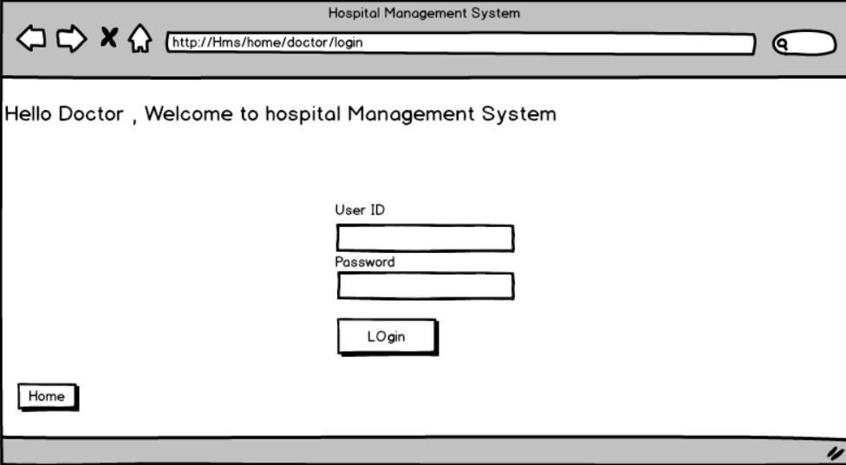**doctors home page**

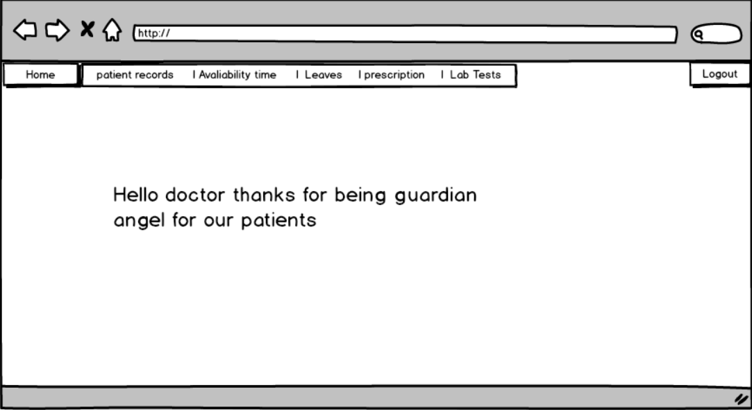

**doc avalibility update**

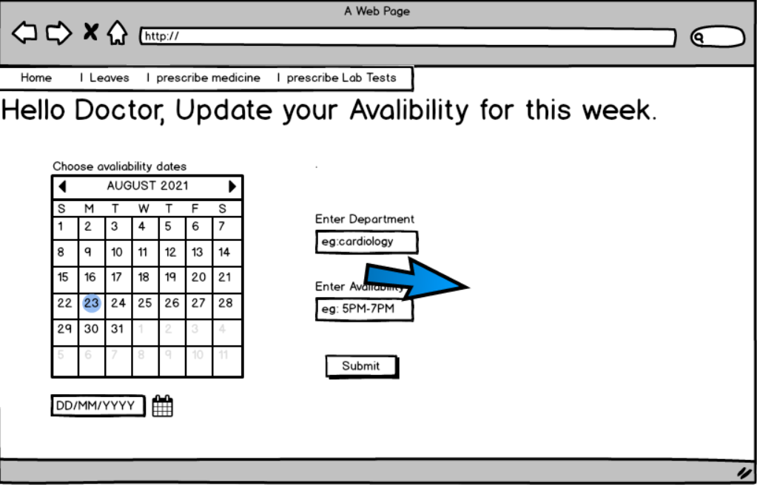**doctor leave update**

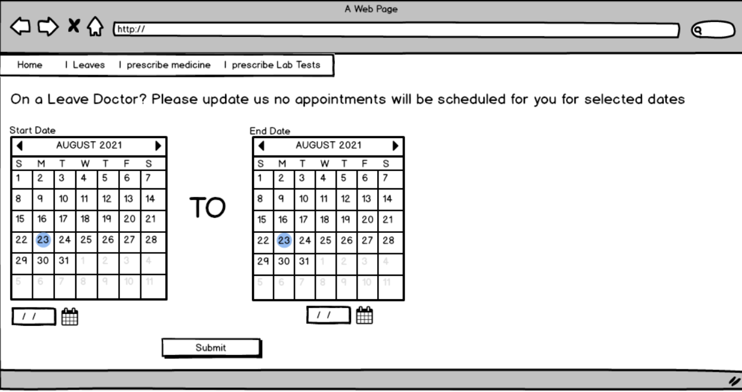

# **Lab prescription**

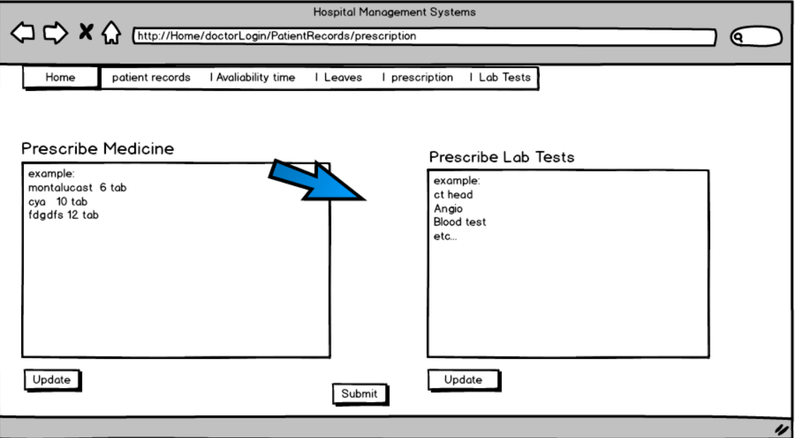

**Medicine prescription**



**Patient details**

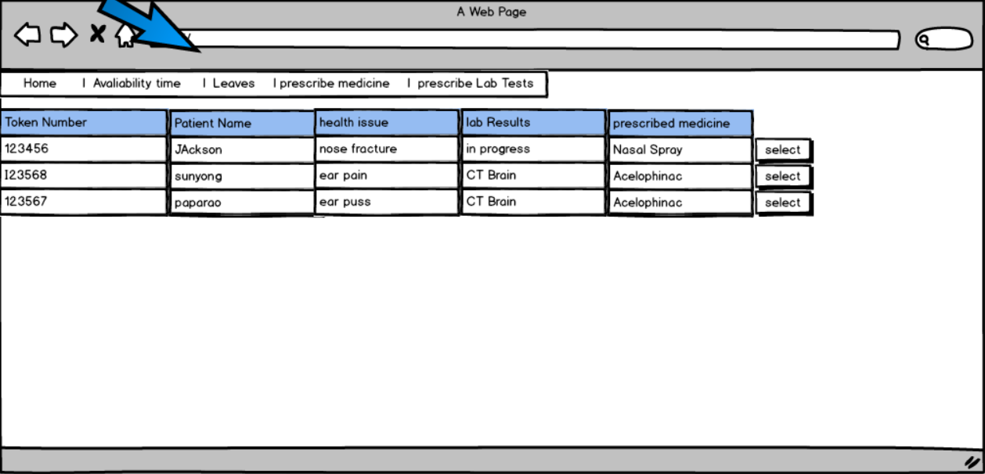**admin login page**

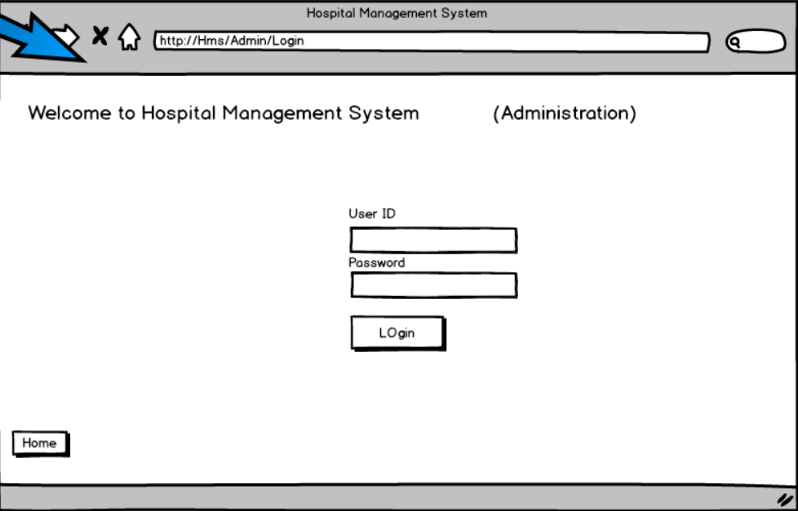

# **Admin dash**

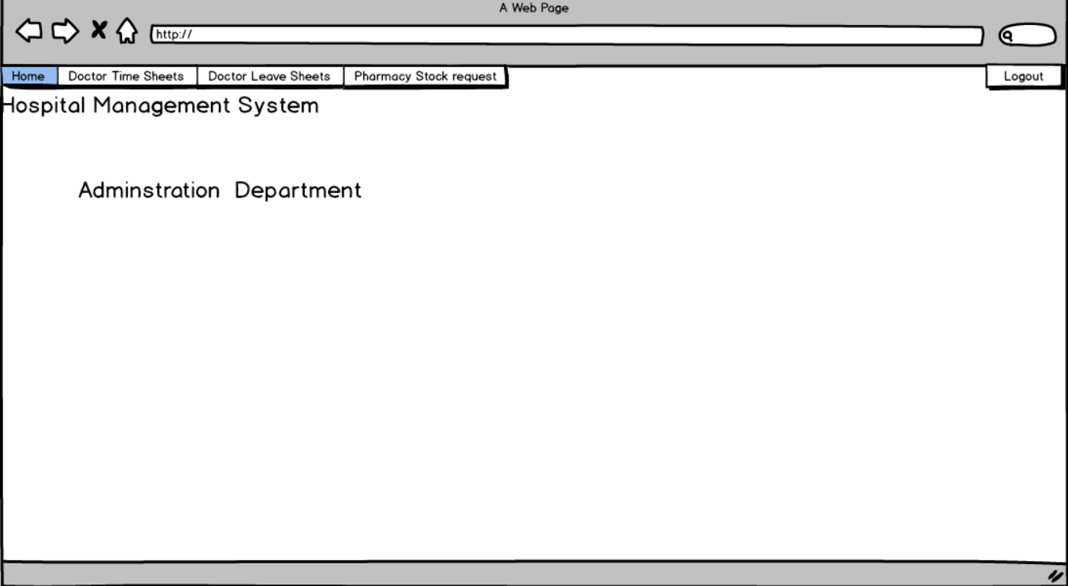

**Admin to track doctors’ availability**

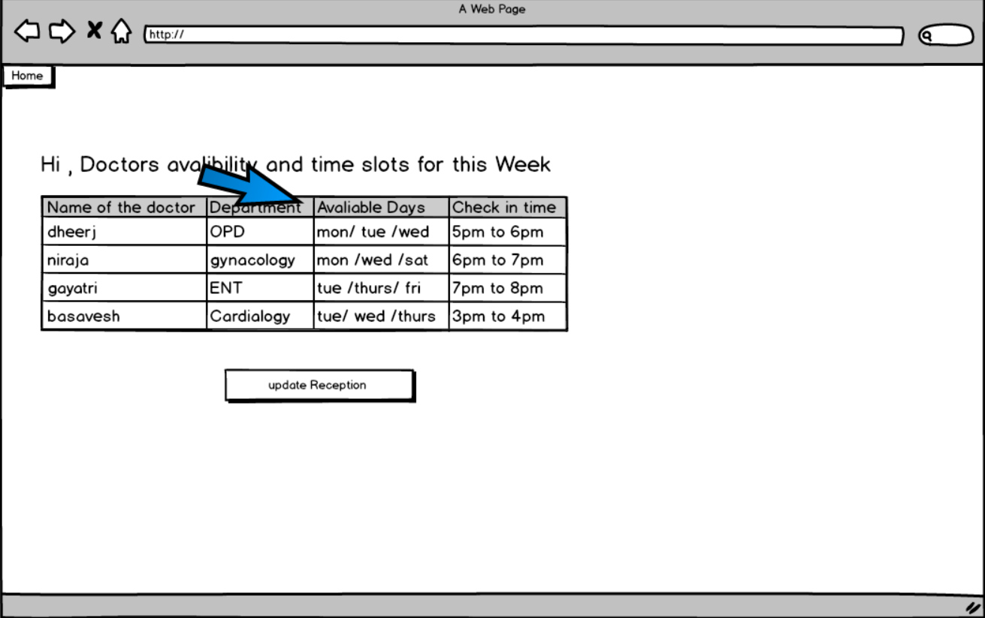

**Admin to track doctors leave**

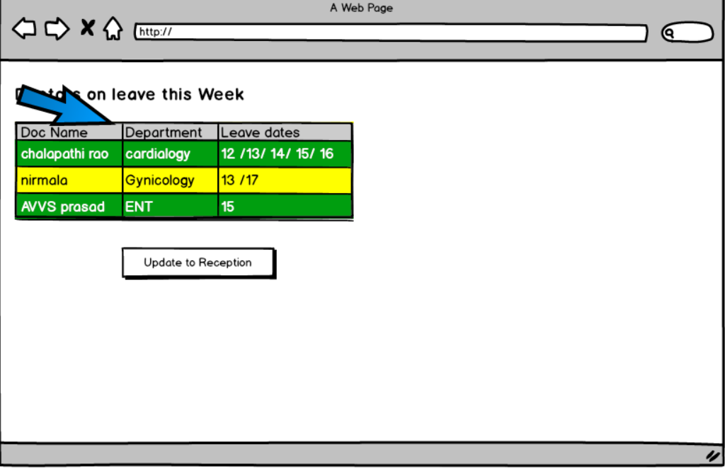**pharmacy stock request**

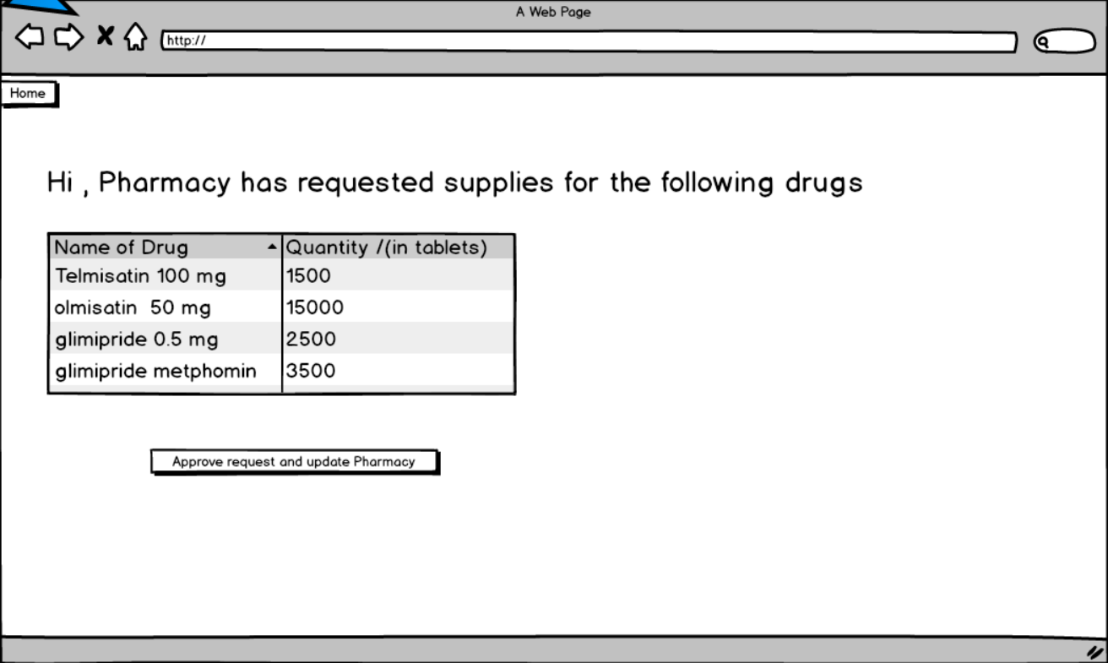

# **Lab login page**

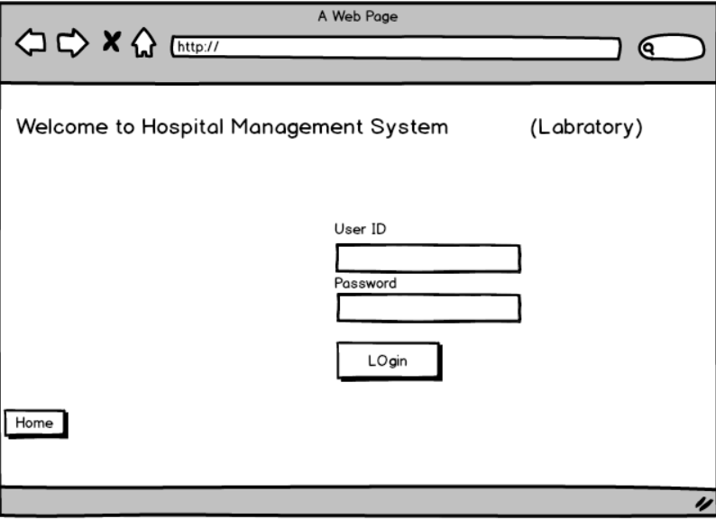

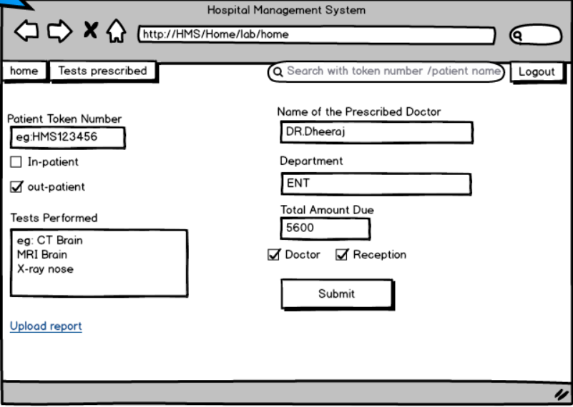**Lab Home page**

**lab prescription received from doctor**

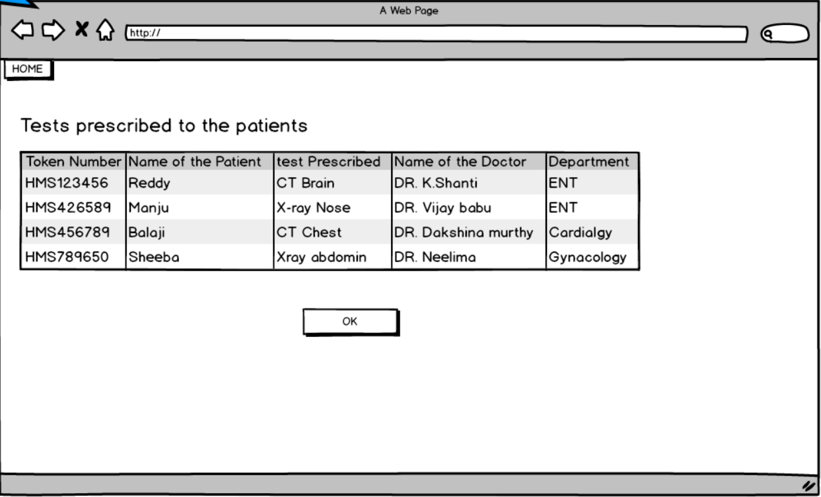

**Pharmacy login page**

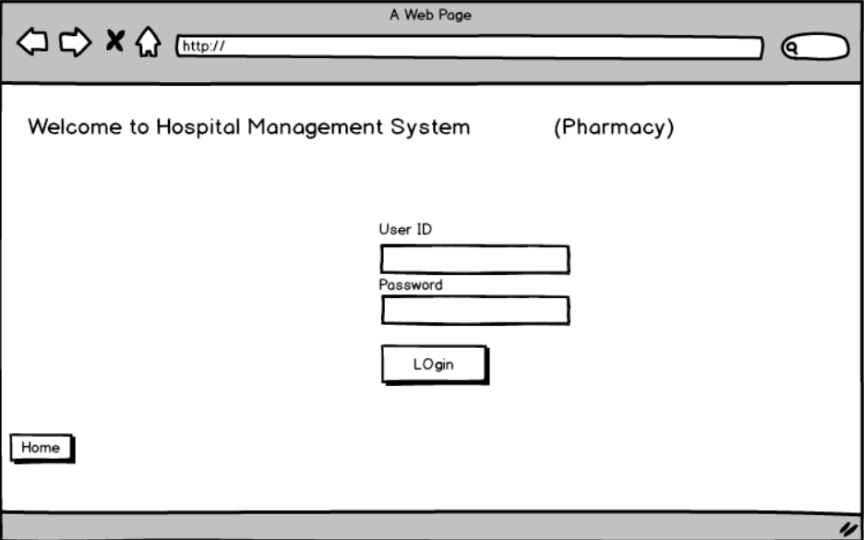

**Pharmacy inventory page**

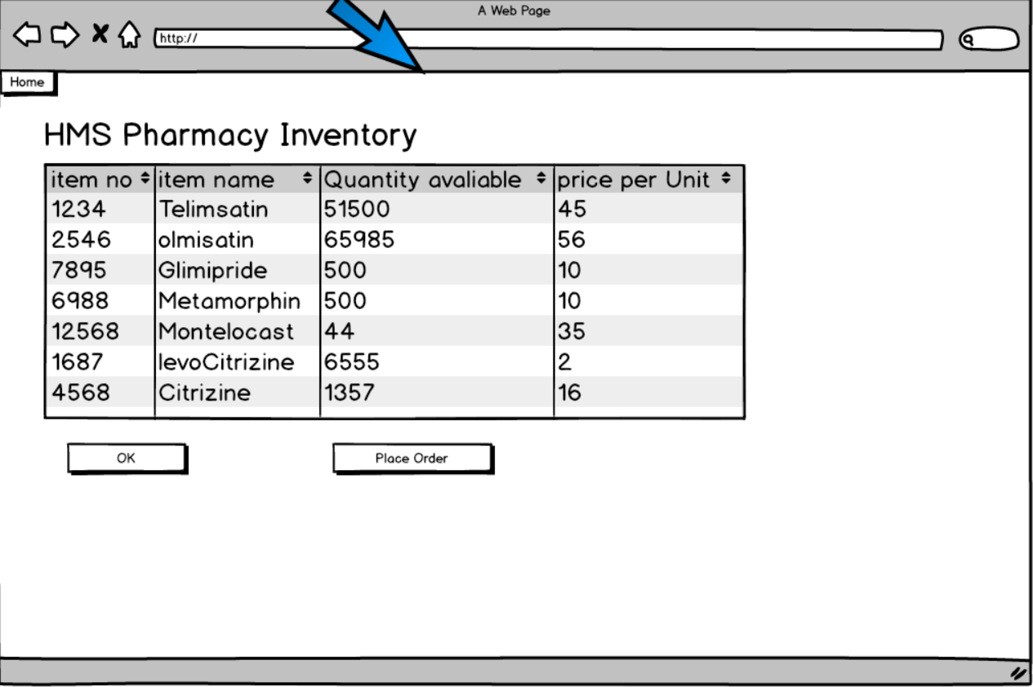

**Pharmacy stock request page**

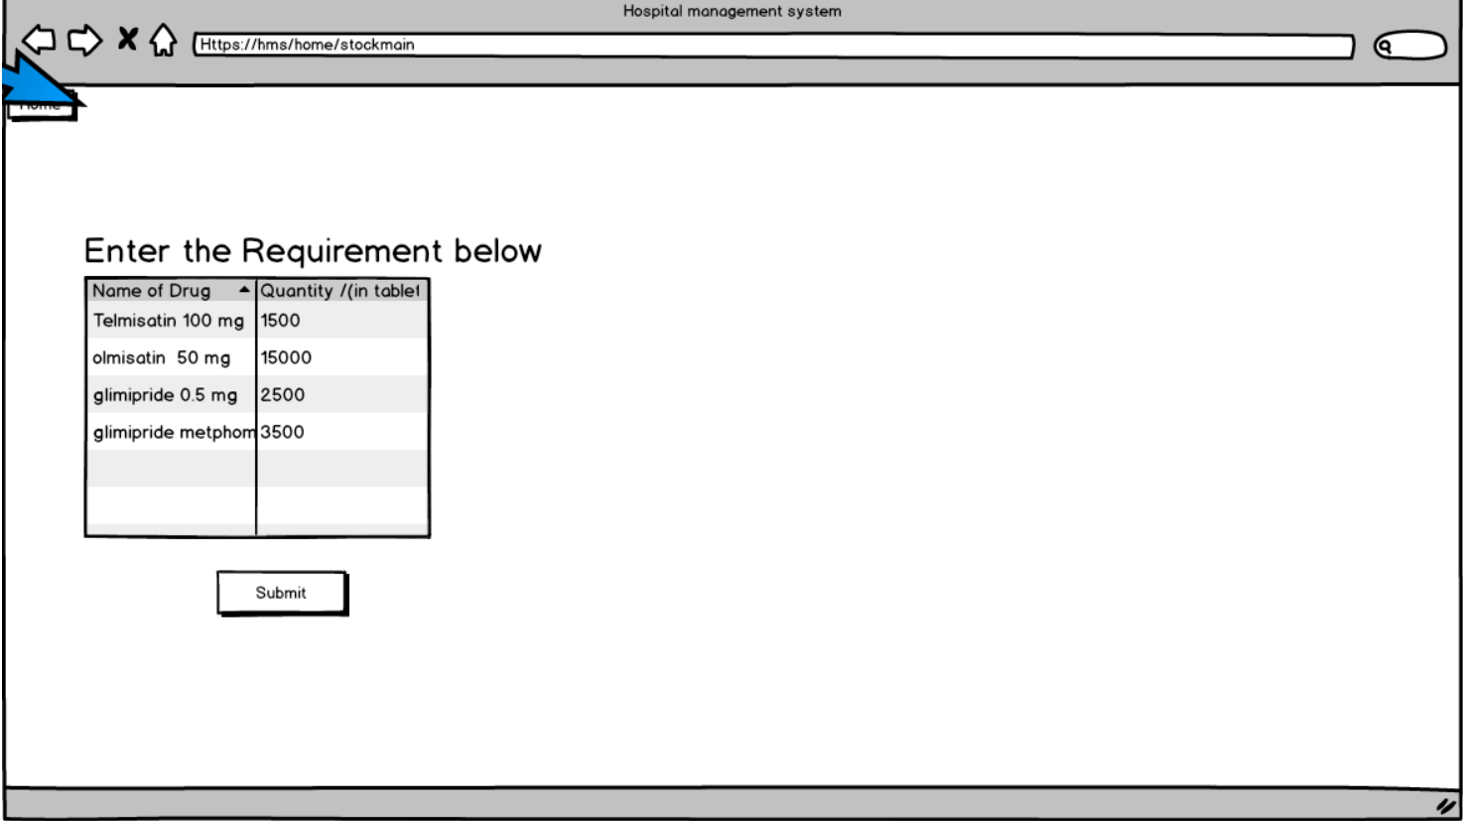

# **Pharmacy billing page**

