Business Requirement Document



**Hospital Management System**

Contents

1. Document Revisions 4

2. Approvals 4

3. RACI Chart for This Document 5

Codes Used in RACI Chart 5

RACI Chart 5

4. Introduction 6

4.1. Business Goals 6

4.2. Business Objectives 6

4.3. Business Rules 6

4.4. Background 6

4.5. Project Objective 6

4.6. Project Scope 6

4.6.1. In Scope Functionality 6

4.6.2. Out Scope Functionality 6

5. Assumptions 7

6. Constraints 7

7. Risks 7

Technological Risks 7

Skills Risks 7

Political Risks 7

Business Risks 7

Requirements Risks 7

Other Risks 7

8. Business Process Overview 8

8.1. Legacy System (AS-IS) 8

8.2. Proposed Recommendations (TO-BE) 8

9. Business Requirements 8

10. Appendices 8

10.1. List of Acronyms 8

10.2. Glossary of Terms 8

10.3. Related Documents 8

# Document Revisions

|  |  |  |
| --- | --- | --- |
| Date | Version Number | Document Changes |
| 05/02/20xx | 0.1 | Initial Draft |
|  |  |  |
|  |  |  |
|  |  |  |
|  |  |  |
|  |  |  |
|  |  |  |
|  |  |  |
|  |  |  |

# Approvals

|  |  |  |  |  |
| --- | --- | --- | --- | --- |
| **Role** | **Name** | **Title** | **Signature** | **Date** |
| Project Sponsor | xyz |  |  | 3/5/2021 |
| Business Owner | xyz |  |  | 3/5/2021 |
| Project Manager | xyz |  |  | 3/5/2021 |
| System Architect | xyz |  |  | 3/5/2021 |
| Development Lead | xyz |  |  | 3/5/2021 |
| User Experience Lead | xyz |  |  | 3/5/2021 |
| Quality Lead | xyz |  |  | 3/5/2021 |
| Content Lead | xyz |  |  | 3/5/2021 |

# RACI Chart for This Document

### RACI Chart

|  |  |  |  |  |  |  |  |
| --- | --- | --- | --- | --- | --- | --- | --- |
| **Name** | **Position** | **\*** | **R** | **A** | **S** | **C** | **I** |
| **xxx** | **Project manager** |  |  | **A** |  |  |  |
| **xxx** | **BA** |  | **R** |  |  |  |  |
| **xxx** | **Project sponsor** |  |  |  |  |  | **I** |
| **xxx** | **Stakeholder** |  |  |  |  | **C** |  |
| **xxx** | **Sr.BA** |  |  |  | **S** |  | **I** |

# Introduction

## Business Goals

The Hospital Management System Provides a digital platform to keep a complete track of all the Patient records right from the registration to the discharge, it provides individual User interfaces for each of the major actors in the HMS (Reception, Admin, Doctor, Lab, Pharmacy) which are internally linked to Each department for the transfer and sharing of information. Admin has full control over the different branches of the system. Process starts at the reception by registering a patient and also ends at the reception after full and final settlement of the dues.

## Business Objectives

To achieve the business goals the proposed IT solution is incorporated with needed functionalities.

These functionalities which are present in software are listed below:

* Receptionist can check the availability of doctors, availability of beds for admission in different departments.
* Receptionist can generate token after entering the patient details
* Doctor will be notified about the patient’s registration in his UI
* Doctor can prescribe medicines and prescribe Lab tests directly to the lab and pharmacy from his system
* Doctor can update his available days and times in that particular week
* Doctor can update his Leaves directly in this screen which is further updated to the admin
* Lab tests are directly updated to corresponding patient’s token number which will reflect on the doctor’s screen
* The bills of concerned patients are directly updated in the payments tab in the reception screen for payments from the Lab
* Reception closes the patient record after full and final settlement of the pending payments and a discharge token is generated
* Pharmacy gets the prescription directly once the doctor prescribes it along with the token number
* Pharmacy can send stock request to the admin through HMS portal
* Pharmacy can generate bill to the patient after collecting the fees
* Admin can track the availability of doctor and also have a track of their leaves which is further updated to reception with just a click
* Admin can view and approve stock requests from the pharmacy department and also track the functionality of HMS staff

## Business Rules

* System should allow only valid staff to use the Hospital Management System which will have no access to the patient
* Administrator can view the doctor availability Sheets, Doctors Leave, Pharmacy Requirement, Staff attendance
* Patients have no access to HMS System
* Hospital Should have all the legal Permissions

## Background

Hospitals that are providing Best Treatments to Patients in need had to face a lot of problems with the sheets and papers (non computerized) traditional hospital setup which earlier made all the process run in backlog and create a lot of confusion with huge files and papers increasing the chance of error where all the process starting from registering a patient ending at discharge are being done manually.

The proposed IT solution will provide multiple logins for different departments like (Admin, Doctor, Reception, Lab, Pharmacy) where each user is provided with UI having predefined columns for inputs along with easy and interactive menu items which cover all the process which is being done manually. few more adaptive features mobile notifications to doctor can be added in the further updates of Hospital Management System

## Project Objective

* The system captures the personal details of the patient, the doctor or department they want to take and appointment further generating unique Token Number.
* It reduces the existing manual process of writing the details on the paper
* Patient registrations will pop up on the doctors UI
* It simplifies the Process eradicating confusion, making it simple and fast.
* Receptionist can view the availability of doctor’s, time of availability, availability8 of beds from admissions in the HMS portal
* All the form the lab fees, Admission fees for inpatient services, and doctor fees is collected at the reception
* Discharge Note / out pass is issued at the reception after the full and final settlement of outstanding dues
* Lab can check for the tests prescribed by the doctors to their patients on the Lab UI after successful Login, they can also send digital reports to doctors and digital copy of medical bill for Lab service to the reception for payment
* Pharmacy can see the Medicines prescribed by their doctors once they login into their UI and generate bill, Amount for pharmacy will be collected there it self and the bill is generated
* Request for Stock can be placed through online which will be sent to the admin department for approval
* Admin has specified login though which the admin team can view and work on all the necessary changes and keep updated with different branches in hospital
* Project saves both time and energy for the Hospital, Doctor, Patient, Pharmacy, Lab there by increasing the transparency in the system.

## Project Scope

### In Scope Functionality

* Recording Patient’s Details at the time of registration.
* Providing Token ID to patients after registration.
* Complete digital Transfer of records from all the departments in HMS (Reception, Doctor, Lab, pharmacy, Admin)
* Doctor can prescribe Lab tests and medicines thorough the HMS Portal
* Doctors can update on their availability of their dates and available timings for that week
* Pharmacy can receive medicines prescribed to the patients by the doctor directly once prescribed.
* Facilitates payment through cash and credit
* Allows admin to update doctors’ availability and leave dates
* Allows reception to check the availability of beds and the availability of doctors
* Allows pharmacy to place stock request to admin
* Doctor can directly receive the lab reports once uploaded in lab
* Reduces confusion and maintenance of heavy physical files.

### Out Scope Functionality

* Generating email or SMS about the specified doctor’s appointment availability to the patients

# Assumptions

* Additional security for the application to protect confidential Hospital and patient health Records.
* Internet access to the system must be 24/7 or else the application will not work.
* Hospital can gain access to the system by using computer or mobile

# Constraints

* Data base should store huge volume of patients Information, employee information, and management information.

# Risks

## Technological Risks

There are no high-end technologies used in this project so there is no technological risk associated with it.

## Skills Risks

There is no skill risks associated with this project because Staff can access and work on system if they have working experience on computer.

## Political Risks

* Hospital management system must renew its permission from state or central Health Ministry.
* Proper Acknowledgment of the changing political conditions in Hospital Established places.

## Business Risks

Cancelling the project not only incur loss in terms of cost and time already dedicated towards it up till cancelation point and cannot improve the quality of service provided to patients.

## Requirements Risks

* Providing complete digital platform to the hospital staff, Doctors will help in hassle free transactions which can save time and eliminate the risk of losing data.
* Providing the best of available resources in a faster span of time.
* Creating a system which can mitigate the risk of losing data in files there by saving time.

## Other Risks

None

# 8. Business Process Overview

The process begins when the patient enters the Hospital

* Patient will be given a token number after the initial registration process; fee payment is completed in which the patients record is sent to the doctor. Information is reflected on the doctor’s screen once the registration process is completed. Doctor can click on the Patient medical Record on his UI and can prescribe Lab Tests, Medicines to the patient. The tests prescribed by the doctor reflect on the Lab UI, and the medicines prescribed on the Pharmacy UI through which they will be informed about what is being prescribed by the doctor to which patient, Doctor portal has tabs through which they can access and update their availability timings and days during a week. doctors can also view the test reports sent by the lab, and track their progress. Admin is considered as the center of control of a hospital, so the admin will have access to view doctors time sheets, availability, and leave sheets updated by doctors. They also are notified regarding the stock request sent by the Pharmacy the process ends again at the reception when the patient is giving a discharge note after full and final settlement of his dues

## 8.1 Legacy System (AS-IS)

Reception initiates the process by creating a Medical Record to patient at the reception, patient has to spend more time in preserving all the copies and maintain ques to visit doctor, higher paper will cause higher information loss and consume space and more energy in maintenance of records. doctor will not know the number of appointments he has and their health issue. Pharmacy will have to put more effort in maintain the stock, any stock request would take very long time to process. Doctors will not be able to update their leaves in advance information travel would take a lot of time and would cause to risk patients due to information discrepancy.

Admin will be unaware of all the process in the hospital, time to react after monitoring would be very high, huge physical strain would be there in all the branches of the HMS



## 8.2 Proposed Recommendations (TO-BE)

In the proposed system manual process is completely removed. The Doctors and Hospital staff can access system online and check availability of the appointments with doctors, generate token to patients, check the availability of beds for inpatient visit. Patient has to complete the registration process to open a medical record and generate a token id. The system generates unique token id for Every patient. HMS can maintain health records of their patients. All the process is automated right from registration of patient to the discharge. Including the pharmacy bill generation to payments.

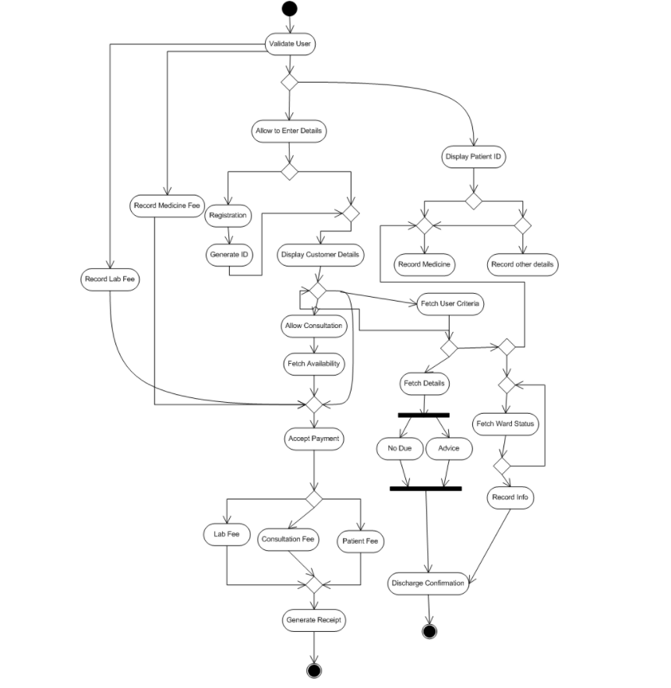

# 9. Business Requirements

|  |  |  |  |
| --- | --- | --- | --- |
| Sr.no | Business requirement | Functionality | Priority |
| 1 | System home page should display the rules and regulations issued by the HMS | Staff interface | High |
| 2 | System should display complete HMS information such as logins, | Customer interface | High |
| 3 | System should capture personal details of the new patient to generate unique Token id | Database functionality | High |
| 4 | Existing doctor will be able to update his availability and his leaves | Doctors interface | High |
| 5 | Receptionist can view the availability of doctor’s, time of availability, availability8 of beds from admissions in the HMS portal | Staff interface | High |
| 6 | Receptionist can check the availability of doctors, availability of beds for admission in different departments. | Staff interface | High |
| 7 | Lab tests are directly updated to corresponding patient’s token number which will reflect on the doctor’s screen | Staff interface | High |
| 8 | The bills of concerned patients are directly updated in the payments tab in the reception screen for payments from the Lab | System functionality | Medium |
| 9 | System should check staff validity while Login | System functionality | High |
| 10 | Administrator can view the doctor availability Sheets, Doctors Leave, Pharmacy Requirement, Staff attendance | Admin functionality | High |

# 10. Appendices

## 10.1 List of Acronyms

## 10.2 Glossary of Terms

## 10.3 Related Documents