VISVESVARAYA TECHNOLOGICAL UNIVERSITY
“Jnana Sangama”, Belagavi-560014

Fullstack Development Project Report
On
“ Blockchain-Based Certificate Generation and Validation System for Refugees”
Submitted in partial fulfillment of the requirement of VI Semester
Fullstack Development (21CS62)
Submitted by,
Abhishek Shridhar Hegde | 1RF21IS004
Kemthur Suraj | 1RF21IS028
Prithvi P Shenoy 1RF21IS040
S Harini 1RF21IS044

Under the guidance of

Prof. Pushpa G
Assistant Professor
Dept. of ISE
RVITM, Bangalore.


DEPARTMENT OF INFORMATION SCIENCE AND ENGINEERING

RV INSTITUTE OF TECHNOLOGY AND MANAGEMENT®
Chaitanya Layout, JP Nagar 8th Phase, Kothanur, Bengaluru-560076

2023-2024

RV INSTITUTE OF TECHNOLOGY AND MANAGEMENT®
(Affiliated to Visvesvaraya Technological University, Belagavi & Approved by AICTE, New Delhi)
Chaitanya Layout, JP Nagar 8th Phase, Kothanur, Bengaluru-560076

DEPARTMENT OF INFORMATION SCIENCE & ENGINEERING


Certificate

Certified that the project work titled ‘Blockchain-Based Certificate Generation and Validation System for Refugees’ is carried out by Abhishek Shridhar Hegde (1RF21IS004) and Kemthur Suraj (1RF21IS028) and Prithvi P Shenoy (1RF21IS040) and S Harini (1RF21IS044), who are bonafide students of RV Institute of Technology and Management, Bangalore, in partial fulfillment for the award of degree of Bachelor of Engineering in Information Science and Engineering of the Visvesvaraya Technological University, Belgaum during the year 2023-2024. It is certified that all corrections/suggestions indicated for the internal Assessment have been incorporated in the report deposited in the departmental library. The project report has been approved as it satisfies the academic requirements in respect of project work prescribed by the institution for the said degree.

Signature of the Guide | Signature of the HOD | Signature of the Principal
Prof. Pushpa G  Assistant Professor, Dept ISE  RVITM, Bangalore. | Dr. Latha C A  Prof. & Head, Dept. of ISE  RVITM, Bangalore. | Dr. Jayapal R  RVITM, Bangalore.
Name of the Examiners |  | Signature with date

RV INSTITUTE OF TECHNOLOGY AND MANAGEMENT®
(Affiliated to Visvesvaraya Technological University, Belagavi & Approved by AICTE, New Delhi)
Chaitanya Layout, JP Nagar 8th Phase, Kothanur, Bengaluru-560076

DEPARTMENT OF INFORMATION SCIENCE & ENGINEERING

DECLARATION

We, Abhishek Shridhar Hegde (1RF21IS004) and Kemthur Suraj (1RF21IS028) and Prithvi P Shenoy (1RF21IS040) and S Harini (1RF21IS044), the students of sixth semester B.E., Information Science and Engineering, hereby declare that the project titled “Blockchain-Based Certificate Generation and Validation System for Refugees” has been carried out by us and submitted in partial fulfillment for the award of degree of Bachelor of Engineering in Information Science and Engineering. We do declare that this work is not carried out by any other students for the award of degree in any other branch.

Place: Bangalore Name Signature

Date: 1. Abhishek Shridhar Hegde

2. Kemthur Suraj

3. Prithvi P Shenoy

4. S Harini

ACKNOWLEDGEMENT

We express our profound gratitude to Dr. Jayapal R, Principal, RVITM, Bangalore, for providing the necessary facilities and an ambient environment to work.
We are grateful to Dr. Latha C A, Head of Department, Information Science and Engineering, RVITM, Bangalore, for her valuable suggestions and advice throughout my/our work period.
We would like to express our deepest gratitude and sincere thanks to our guide, Prof. Pushpa G for the keen interest and encouragement in the project, whose guidance made the project into reality.
We would like to thank all the staff members of Department of Information Science and Engineering for their support and encouragement during the course of this project.

ABSTRACT

The global refugee crisis has created unprecedented levels of displacement, forcing millions to leave their homes due to conflict, persecution, or natural disasters. Refugees often face significant barriers in accessing essential services such as education, healthcare, and employment due to a lack of reliable and verifiable identification and certification. Traditional methods of issuing and verifying certificates are prone to forgery, loss, and accessibility issues, complicating the situation further. In response to these challenges, this project introduces a Blockchain-based Certificate Generation and Validation System for refugees. By leveraging blockchain technology, this system aims to provide a secure, tamper-proof, and easily verifiable method for refugees to prove their identity and qualifications.

This project utilizes several blockchain tools and technologies to ensure the robustness and effectiveness of the proposed solution. MetaMask is integrated as part of the decentralized system to manage digital identities and interact with the blockchain. The Solidity compiler runs on the Remix IDE to compile the certificate generation code, while Ganache and Truffle offer the necessary blockchain features for development and testing. The frontend, developed using the Django framework, allows refugees to generate and validate certificates through a user-friendly interface. This system not only enhances the security and integrity of the certification process but also streamlines administrative procedures, reducing potential human errors and increasing efficiency.

The implementation of this project demonstrates the potential of modern technology in addressing critical humanitarian issues. By providing refugees with reliable and verifiable certificates, the system significantly improves their ability to access essential services and integrate into new communities. This project includes a comprehensive guide on how the system works and a detailed FAQ section to assist users in navigating the platform. Ultimately, this blockchain-based solution contributes to the overall well-being and stability of refugees, offering a scalable and robust approach to certificate management in refugee contexts.

CONTENTS
1. Introduction 2
1.1 Introduction to Blockchain Technology 2
1.2 The Global Refugee Crisis 2
1.3 Importance of Reliable Certification for Refugees 3
1.4 Blockchain Tools Overview 3
1.4.1 MetaMask 3
1.4.2 Solidity Compiler on Remix IDE 3
1.4.3 Ganache and Truffle 3
2. Requirement Analysis 4
2.1 Software Requirements 4
2.1.1 Operating System: Windows 7 or above 4
2.1.2 Programming Language: Python 4
2.1.3 Front-end Development: Django Framework 4
2.1.4 Back-end Development: SQLite 4
2.2 Hardware Requirements 4
2.2.1 Processor: Pentium IV or above 4
2.2.2 RAM: 4 GB or more 4
2.2.3 Hard Disk: 3 GB or more 4
2.3 Functional Requirements 4
2.3.1 User Authentication 4
2.3.2 Certificate Issuance 4
2.3.3 Certificate Storage and Management 4
2.3.4 Certificate Verification 4
2.3.5 User Interface 5
2.3.6 Security and Privacy 5
2.3.7 Scalability and Performance 5
2.4 Non-Functional Requirements 5
2.4.1 Scalability 5
2.4.2 Security 5
2.4.3 Reliability 5
2.4.4 Compatibility 5
2.4.5 Accessibility 5
3. Design 6
3.1 Architecture 6
3.1.1 System Architecture Overview 7
3.1.2 Detailed Component Descriptions 7
3.2 Use Case Diagram 7
3.2.1 Purpose and Functionality 8
3.2.2 Interaction of Website Functionalities 8
4. Implementation 10
4.1 Introduction to Front-End Tools 10
4.1.1 HTML 10
4.1.2 CSS 10
4.2 Introduction to Framework Tools 11
4.2.1 Django Framework 11
4.3 Introduction to Back-End Tools 11
4.3.1 SQLite 11
4.3.2 Ganache 12
4.3.3 MetaMask 12
4.3.4 Remix IDE 12
4.4 Module Descriptions 13
4.4.1 views.py 14
4.4.2 Certificate.sol 15
4.4.3 forms.py 17
4.4.4 models.py 17
5. Snapshots 19
5.1 Homepage - with verifier for entering certificate ID (Figure 5.1) 19
5.2 Guide and roadmap (Figure 5.2) 20
5.3 FAQs - on blockchain (Figure 5.3) 20
5.4 Ganache (Figure 5.4) 21
5.5 Generate certificate (Figure 5.5) 22
5.6 Ganache transaction (Figure 5.6) 22
5.7 Generated certificate (Figure 5.7) 23
5.8 Verification of certificate (Figure 5.8) 23
5.9 Admin Interface (Figure 5.9) 24

Conclusion and Enhancement 25
References 26

CHAPTER 1
INTRODUCTION
The global refugee crisis has led to unprecedented levels of displacement, with millions of individuals forced to flee their homes due to conflict, persecution, or natural disasters. As refugees seek safety and stability, they often face significant challenges in accessing essential services such as education, healthcare, and employment. One critical barrier is the lack of reliable and verifiable identification and certification, which are necessary for accessing these services and integrating into new communities. Traditional methods of issuing and verifying certificates are prone to forgery, loss, and accessibility issues, further complicating the plight of refugees [1].
In response to these challenges, this project introduces the development of a Blockchain-Based Certificate Generation and Validation System for refugees. Blockchain technology, with its decentralized and immutable characteristics, offers a promising solution to the problems associated with traditional certification systems. By leveraging blockchain, the proposed system ensures that certificates are secure, tamper-proof, and easily verifiable, providing a reliable method for refugees to prove their identity and qualifications [2].
The system is designed to store certificates on the Ethereum blockchain, utilizing smart contracts written in Solidity and compiled using the Remix IDE to automate the issuance and validation processes. This approach not only enhances the security and integrity of the certificates but also streamlines administrative procedures, reducing the potential for human error. The user-friendly interface, developed with Django, enables refugees and authorized entities to interact seamlessly with the platform, ensuring ease of use and accessibility [3].
This project aims to demonstrate how modern technology can address critical humanitarian issues, offering a robust and scalable solution for certificate management in refugee contexts. By providing refugees with reliable and verifiable certificates, the system has the potential to significantly improve their ability to access essential services and integrate into their new communities, ultimately contributing to their overall well-being and stability.

1.1 Overview of Blockchain Technology
Blockchain technology, a decentralized ledger system, offers a revolutionary way to securely and transparently record transactions across multiple computers. This technology underpins cryptocurrencies like Bitcoin but has vast applications beyond financial transactions. Each transaction, or "block," is cryptographically linked to the previous one, forming a "chain." The key features of blockchain include decentralization, immutability, transparency, and security.
In a decentralized blockchain network, no single entity has control over the entire chain as shown in Fig 1.1, reducing the risk of corruption and tampering. The immutability of blockchain ensures that once a block is added to the chain, it cannot be altered. This feature, combined with the transparency provided by public ledgers, makes blockchain an ideal solution for applications requiring trust and integrity.
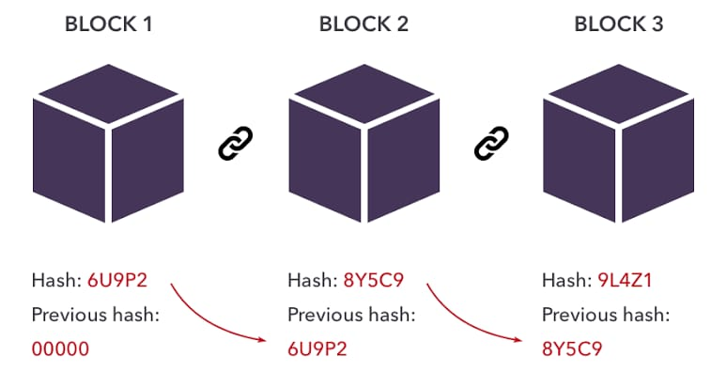
Fig 1.1 – Blockchain Representation
1.2 Refugees and the Need for Secure Certification
Refugees often face significant challenges in proving their identity, education, and work credentials. Traditional paper-based certificates can be lost, damaged, or falsified, making it difficult for refugees to access essential services, secure employment, or continue their education. The need for a reliable, tamper-proof, and easily verifiable certification system is critical for this vulnerable population.
Blockchain technology offers a solution to this problem by providing a secure and transparent way to generate, store, and validate certificates. By leveraging blockchain, refugees can have their credentials verified quickly and reliably, improving their access to opportunities and services.
1.3 Project Objectives
The primary objective of this project is to develop a blockchain-based certificate generation and validation system specifically designed for refugees. This system aims to:
- Provide a secure, tamper-proof method for generating and storing certificates.
- Enable easy and reliable verification of these certificates by relevant authorities.
- Utilize decentralized blockchain technology to ensure the integrity and transparency of the certification process.
1.4 Blockchain Tools and Technologies
To implement this system, the following blockchain tools and technologies are utilized:
- MetaMask: A cryptocurrency wallet and gateway to blockchain apps, MetaMask facilitates interactions with the Ethereum blockchain. It allows users to manage their Ethereum accounts and sign blockchain transactions securely.
- Solidity: A high-level programming language for writing smart contracts on the Ethereum blockchain. The certificate generation code is written in Solidity and compiled using the Remix IDE.
- Remix IDE: An open-source web and desktop application that provides a comprehensive suite of tools for developing, deploying, and managing Solidity smart contracts. It simplifies the process of writing and testing smart contracts.
- Ganache: A personal blockchain for Ethereum development, Ganache enables developers to deploy and test smart contracts in a controlled environment. It simulates the blockchain, allowing for rapid testing and iteration.
- Truffle: A development framework for Ethereum, Truffle provides a suite of tools for compiling, deploying, and testing smart contracts. It streamlines the development process and integrates seamlessly with Ganache and MetaMask.

CHAPTER 2
REQUIREMENTS ANALYSIS
The requirement analysis specifies the requirements needed to develop the blockchain-based certificate generation and validation system for refugees. In this phase, we collect the necessary requirements for designing the project. The requirements collected are then analyzed and carried to the next phase.
2.1 Software Requirements
- Operating System: Windows 7 or above
- Programming Language: Python and Solidity
- Front-end Development: Django framework
- Blockchain Integration: MetaMask, Ganache, Truffle, Remix IDE
- Database: SQLite (for non-blockchain data)
2.2 Hardware Requirements
- Processor: Pentium IV or above
- RAM: 4 GB or more
- Hard disk: 3 GB or more
2.3 Functional Requirements
- User Authentication: Allows personnel to register, log in, and log out securely.
- Certificate Issuance: Authorized entities generate certificates for refugees, which are stored securely on the Ethereum blockchain.
- Certificate Storage and Management: Certificates are stored on the Ethereum blockchain, making them tamper-proof and verifiable. Users can easily view and retrieve their certificates via a user-friendly interface.
- Certificate Verification: Third parties can verify the authenticity of certificates through a blockchain-based process using a public verification portal.
- User Interface: A responsive web interface, built with Django, ensures accessibility across devices and ease of use.
- Security and Privacy: Sensitive data is encrypted and access-controlled, complying with data protection regulations. Role-based access control (RBAC) restricts information access based on user roles.
- Scalability and Performance: The system handles increasing users and certificates efficiently, ensuring quick certificate generation, storage, retrieval, and verification.
- Guides and FAQs: A detailed guide on how the system works and a section for frequently asked questions (FAQs) are included on the website to assist users.
2.4 Non-Functional Requirements
- Scalability: The platform is capable of handling an increasing number of users and certificates without significant degradation in performance.
- Security: Implemented robust security measures to protect user data, certificates, and other sensitive details from unauthorized access, breaches, or cyber-attacks.
- Reliability: Ensures high system availability and minimal downtime to prevent disruption to users' ability to log in, generate, and manage certificates.
- Compatibility: The platform is compatible with various web browsers to ensure a seamless user experience regardless of the device used to access it.
- Accessibility: Designed a platform with accessibility features to cater to all users, ensuring inclusivity and compliance with accessibility standards.

CHAPTER 3
DESIGN
The design phase of the blockchain-based certificate generation and validation system for refugees includes the architecture of the system and the use-case diagram. This chapter provides a detailed description of the system's components, their interactions, and the functionalities offered to users.
3.1 Architecture
The architecture of the system is designed to leverage blockchain technology to ensure the security, transparency, and immutability of the generated certificates. Figure 3.1 illustrates a blockchain-based credential verification process involving three parties: the issuer, the recipient, and the verifier.
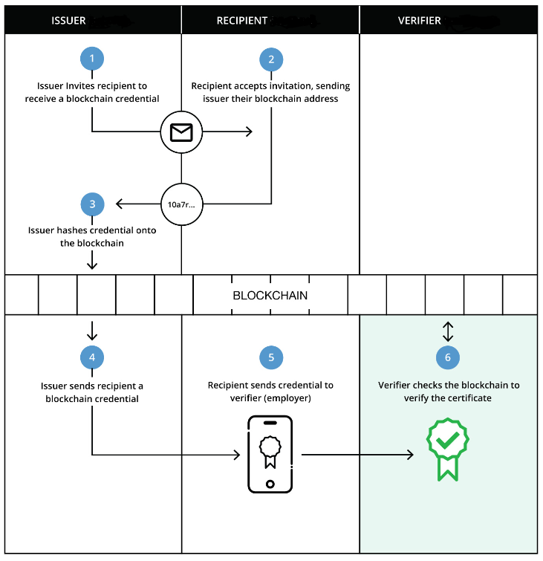
Fig 3.1 – Architecture Design of the proposed system
- Issuer: The issuer is an authorized entity responsible for generating and issuing certificates to refugees. This entity could be an educational institution, a government agency, or an NGO. The issuer invites the recipient to receive a credential, collects the necessary information, and generates the certificate using a smart contract written in Solidity. The certificate is then hashed and stored on the Ethereum blockchain.
- Recipient: The recipient is the refugee who receives the certificate. The recipient uses the platform's user-friendly interface to request and obtain their certificate. Once issued, the certificate is stored in the recipient's digital wallet, accessible through MetaMask.
- Verifier: The verifier is any third party that needs to validate the authenticity of the certificate. This could be an employer, an educational institution, or a service provider. The recipient shares the credential with the verifier, who then checks the blockchain to confirm its validity. The verification process is streamlined through a public verification portal, ensuring quick and reliable validation.
The backend of the system is developed using Ganache and Truffle to provide a local blockchain environment for testing and deployment. The frontend is built with Django, ensuring a responsive and accessible user interface. MetaMask is integrated to facilitate interactions with the Ethereum blockchain, allowing users to manage their digital identities and certificates securely.
3.2 Use-Case Diagram
A use-case diagram is a visual representation of the interactions between users (actors) and the system. It shows how different users interact with the system's functionalities to achieve their goals. Figure 3.2 illustrates the interactions of website functionalities by different users through a use-case diagram for the system platform.
- User Authentication:
  - Actors: Refugee (Recipient), Issuer
  - Description: Both refugees and issuers need to register and log in to the system. The authentication process ensures that only authorized users can access and interact with the platform.

- Certificate Issuance:
  - Actors: Issuer
  - Description: The issuer generates and issues certificates to refugees. This process involves collecting the necessary information from the recipient, generating the certificate using smart contracts, and storing it on the blockchain.
- Certificate Storage and Management:
  - Actors: Recipient
  - Description: The recipient can view and manage their certificates through the user-friendly interface. Certificates are stored securely on the Ethereum blockchain, making them tamper-proof and easily accessible.
- Certificate Verification:
  - Actors: Verifier
  - Description: The verifier checks the validity of the certificates shared by the recipient. The verification process involves accessing the public verification portal and confirming the authenticity of the certificate through the blockchain.
- Guides and FAQs:
  - Actors: Recipient, Verifier
  - Description: The platform includes a detailed guide on how the system works and a section for frequently asked questions (FAQs) to assist users. This ensures that all users can easily understand and navigate the platform's functionalities.
- Security and Privacy Management:
  - Actors: System Administrator
  - Description: The system administrator manages security and privacy settings, ensuring that sensitive data is encrypted and access-controlled. Role-based access control (RBAC) restricts information access based on user roles.
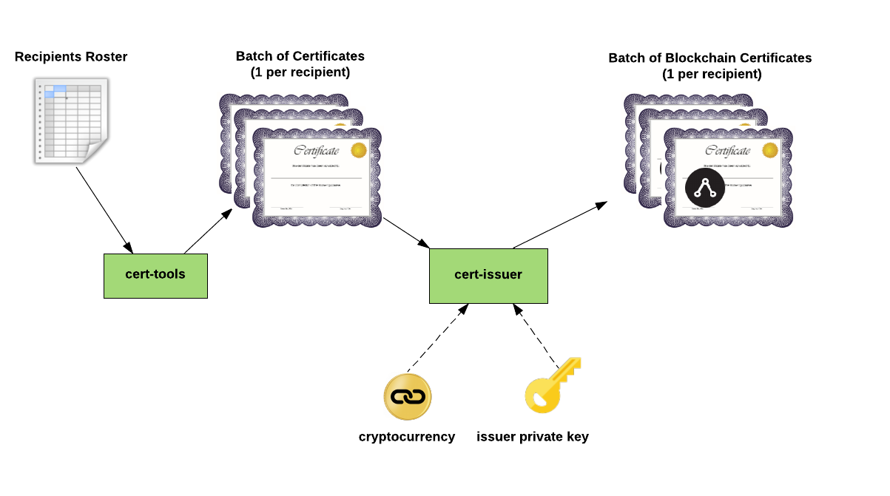
Fig 3.2 – Use Case Diagram of the proposed system
The use-case diagram (Figure 3.2) provides a comprehensive overview of the interactions between different users and the system. It illustrates the main functionalities and the goals achieved by each user, highlighting the seamless integration of blockchain technology to enhance the security and reliability of the certificate generation and validation process.
By designing the system with a focus on user interactions and blockchain integration, this project aims to provide a robust and scalable solution for managing certificates for refugees. The architecture and use-case diagram collectively ensure that the system is secure, user-friendly, and capable of meeting the needs of all stakeholders involved.

CHAPTER 4
IMPLEMENTATION
This chapter outlines the various modules utilized in the development of the blockchain-based certificate generation and validation system for refugees. Each section provides detailed information on the front-end tools, framework tools, and back-end tools used in the project, followed by specific modules and their functionalities.
4.1 Introduction to Front-End Tools
4.1.1 HTML
HTML forms the backbone of web development, defining the structure and content of web pages. In our project, HTML was utilized to create a clean and organized layout for the user interface. We employed semantic elements like <header>, <nav>, <section>, and <footer> to enhance the readability and accessibility of the code. HTML5 features, such as <video>, <audio>, and <canvas>, were leveraged to integrate multimedia content seamlessly. Forms were implemented using <form>, <input>, and <button> tags to facilitate user interactions and data submission. Additionally, attributes like id, class, and data-* were used to link HTML elements with CSS for styling and JavaScript for dynamic functionalities. The project also adhered to best practices for HTML coding, ensuring proper nesting, closing of tags, and inclusion of meta tags for SEO optimization and responsiveness. Through meticulous HTML implementation, we achieved a robust and user-friendly web interface that serves as the foundation for our application's front-end.
4.1.2 CSS
In this project, CSS is utilized to enhance the visual presentation of the web pages. CSS is responsible for the layout, colors, fonts, and overall aesthetic of the website, providing a more engaging user experience. The styles are defined in an external stylesheet, ensuring a clean separation between content (HTML) and presentation (CSS). We used CSS Grid and Flexbox for responsive design, allowing the web pages to adapt seamlessly to different screen sizes. Custom classes and IDs were employed to apply specific styles to individual elements. Additionally, media queries were implemented to fine-tune the appearance on various devices. CSS variables were used to maintain consistent styling across the project, making it easier to update colors and fonts globally. By leveraging advanced CSS selectors, we were able to target elements efficiently, enhancing the maintainability and scalability of the codebase. Finally, browser compatibility was tested to ensure the website looks and functions correctly across different web browsers.
4.2 Introduction to Framework Tools
4.2.1 Django Framework
Django is a high-level Python web framework that encourages rapid development and clean, pragmatic design. It is known for its "batteries-included" philosophy, offering numerous built-in features such as authentication, URL routing, and a robust ORM (Object-Relational Mapping) system. Django follows the MVT (Model-View-Template) architectural pattern, which helps in organizing code efficiently and separating the business logic from the user interface. The framework's emphasis on reusability and "Don't Repeat Yourself" (DRY) principles significantly reduces the amount of code developers need to write.
One of Django's key strengths is its powerful admin interface, which allows developers to manage site content with minimal configuration. It provides automatic database synchronization with models, making database migrations straightforward and hassle-free. Django’s templating engine is highly versatile, enabling the creation of dynamic HTML content with ease. The framework also includes robust security features, such as protection against SQL injection, cross-site scripting (XSS), and cross-site request forgery (CSRF).
Django's scalability and flexibility make it suitable for both small projects and large-scale applications. Its comprehensive documentation and active community support make it accessible for developers of all skill levels. Additionally, Django integrates seamlessly with front-end technologies like JavaScript, CSS, and various web APIs, allowing for the development of modern, interactive web applications. Overall, Django is a powerful and versatile tool for building web applications, combining ease of use with advanced functionality.
4.3 Introduction to Back-End Tools
4.3.1 SQLite
SQLite is a lightweight, self-contained, serverless SQL database engine widely used in embedded systems and applications. It is an open-source project, making it freely available for both personal and commercial use. Unlike other SQL databases, SQLite stores the entire database as a single cross-platform file, making it highly portable. It is ACID-compliant, supporting transactions, and provides most of the SQL92 standard features. Due to its minimal setup and ease of use, SQLite is commonly used in mobile applications, small to medium-sized websites, and testing environments. The proposed system utilizes the relational database model, which organizes data into tables consisting of rows and columns. The system incorporates essential database concepts to enhance functionality and user experience. The SQLite database, guided by a well-defined relational schema, leverages key concepts to enforce constraints for the database.
4.3.2 Ganache
Ganache is a personal blockchain for Ethereum development that allows developers to create their own private Ethereum blockchain for testing purposes. It is part of the Truffle Suite, designed to simplify the development and testing of smart contracts. Ganache provides features like instant mining of transactions, adjustable mining speed, and customizable blockchain parameters, making it highly flexible for testing various scenarios. It also offers a user-friendly interface to view and manage accounts, transactions, and events. By using Ganache, developers can test their applications in a controlled environment before deploying them to the main Ethereum network, ensuring greater reliability and security.
4.3.3 MetaMask
MetaMask is a popular cryptocurrency wallet and gateway to blockchain applications, especially for the Ethereum network. It operates as a browser extension and mobile app, enabling users to manage their digital assets and interact with decentralized applications (dApps) directly from their browser or mobile device. MetaMask provides a secure identity vault, giving users control over their private keys and digital identities. It simplifies the process of connecting to the Ethereum blockchain, allowing users to easily perform transactions, manage tokens, and access various dApps.
MetaMask supports a wide range of Ethereum-based tokens and is compatible with major browsers like Chrome, Firefox, and Brave. It also offers features like customizable gas fees, which help users optimize their transaction costs. By providing an intuitive interface and robust security measures, MetaMask has become an essential tool for both novice and experienced users in the blockchain ecosystem, facilitating seamless interaction with the decentralized web.

4.3.4 Remix IDE
Remix IDE is a powerful, web-based integrated development environment for developing, deploying, and testing smart contracts on the Ethereum blockchain. It supports Solidity, the primary programming language for writing Ethereum smart contracts, and offers a range of features to streamline the development process. These features include syntax highlighting, error checking, and a comprehensive debugger, which help developers identify and resolve issues quickly. Remix IDE also integrates with the Ethereum Virtual Machine (EVM), enabling users to simulate contract execution and test various scenarios without deploying to the main network. Additionally, it provides seamless integration with other tools in the Ethereum ecosystem, such as MetaMask and Ganache, enhancing the overall development experience. By offering an intuitive and feature-rich environment, Remix IDE is a valuable resource for both beginners and experienced developers working on Ethereum-based projects.
4.4 Modules
4.4.1 views.py
In Django, views.py is a core file where the application's logic is implemented. It handles HTTP requests and returns HTTP responses, often interacting with models and templates to render dynamic content. Views can be written as functions or class-based views, allowing for flexible and reusable code. This file plays a crucial role in defining how the application responds to user interactions and requests.
from django.shortcuts import render
from django.http import HttpResponse
from django.utils.safestring import mark_safe

def home(request):
return render(request, 'verifier/home.html')

def about(request):
return render(request, 'verifier/faq.html')

def community(request):
return render(request, 'verifier/community.html')

def getapp(request):
return render(request, 'verifier/getapp.html')

def issue_certificate(request):
if request.method == 'POST':
form = IssueCertificateForm(request.POST)
if form.is_valid():
recipient = form.cleaned_data['recipient_address']
refname=form.cleaned_data['refugee_name']
cerdata=form.cleaned_data['certificate_data']
add=form.cleaned_data['address']
valuntil=form.cleaned_data['valid_until']
dob=form.cleaned_data['date_of_birth']
refcount=form.cleaned_data['country']
issdate=form.cleaned_data['issuing_date']
gend=form.cleaned_data['gender']

certificate_id = f"REF-{form.cleaned_data['refugee_name'][:3].upper()}-{int(time.time())}"

refugee=Certificate.objects.create(refugee_name=refname,country_name=refcount,date_of_birth=dob,address=add,gender=gend,certificate_id=certificate_id,valid_until=valuntil,issue_date=issdate,generated_by=request.user)
#form.save()

# Call the smart contract function to issue the certificate
tx_hash = contract.functions.issueCertificate(recipient,form.cleaned_data['refugee_name'],form.cleaned_data['country'],str(form.cleaned_data['date_of_birth']),form.cleaned_data['address'],form.cleaned_data['gender'],str(certificate_id),str(form.cleaned_data['issuing_date']),str(form.cleaned_data['valid_until'])).transact({'from': web3.eth.accounts[0]})

# Wait for the transaction receipt
receipt = web3.eth.wait_for_transaction_receipt(tx_hash)

return render(request, 'certificates/certificate_confirmation.html', {
'certificate_id': certificate_id,
'refugee_name': form.cleaned_data['refugee_name'],
'valid_until': form.cleaned_data['valid_until']})
else:
form = IssueCertificateForm()
return render(request,'certificates/generate_certificate.html')

In Django, views.py is a core file where the application's logic is implemented. It handles HTTP requests and returns HTTP responses, often interacting with models and templates to render dynamic content. Views can be written as functions or class-based views, allowing for flexible and reusable code. This file plays a crucial role in defining how the application responds to user interactions and requests.
4.4.2 Certificate.sol
This Solidity smart contract, named CertificateRegistry, allows for the issuance and verification of certificates on the Ethereum blockchain. It uses a mapping to associate Ethereum addresses with certificate data. The issueCertificate function assigns a certificate to a recipient's address, ensuring no certificate has been previously issued to that address. The verifyCertificate function enables anyone to retrieve and view the certificate data associated with a specific address.
// SPDX-License-Identifier: MIT
pragma solidity ^0.8.0;

contract CertificateRegistry {
struct Certificate {
string refugeeName;
string countryName;
string dateOfBirth;
string addres;
string gender;
string certificateId;
string issueDate;
string validUntil;
address generatedBy;
}

mapping(address => Certificate) public certificates;
mapping(string => address) public certificateIds;

function issueCertificate(
address recipient,
string memory refugeeName,
string memory countryName,
string memory dateOfBirth,
string memory addres,
string memory gender,
string memory certificateId,
string memory issueDate,
string memory validUntil,
address generatedBy
) public {
require(bytes(certificates[recipient].certificateId).length == 0, "Certificate already issued");
require(certificateIds[certificateId] == address(0), "Certificate ID already exists");

Certificate memory newCertificate = Certificate({
refugeeName: refugeeName,
countryName: countryName,
dateOfBirth: dateOfBirth,
addres: addres,
gender: gender,
certificateId: certificateId,
issueDate: issueDate,
validUntil: validUntil,
generatedBy: generatedBy
});

certificates[recipient] = newCertificate;
certificateIds[certificateId] = recipient;
}

function verifyCertificateById(string memory certificateId) public view returns (
string memory refugeeName,
string memory countryName,
string memory dateOfBirth,
string memory addres,
string memory gender,
string memory certificateId_,
string memory issueDate,
string memory validUntil,
address generatedBy
) {
address recipient = certificateIds[certificateId];
require(recipient != address(0), "Certificate not found");

Certificate storage cert = certificates[recipient];
return (
cert.refugeeName,
cert.countryName,
cert.dateOfBirth,
cert.addres,
cert.gender,
cert.certificateId,
cert.issueDate,
cert.validUntil,
cert.generatedBy
);
}
}

4.4.3 forms.py
In Django, forms.py is used to create and manage web forms. It simplifies the process of handling user input and data validation.

from django import forms

class IssueCertificateForm(forms.Form):
recipient_address = forms.CharField(label='Recipient Address', max_length=100)
certificate_data = forms.CharField(label='Certificate Data', widget=forms.Textarea)
valid_until = forms.DateField(label='Valid Until', widget=forms.DateInput(attrs={'type': 'date'}))
issuing_date = forms.DateField(label='Issuing Date', widget=forms.DateInput(attrs={'type': 'date'}))
address = forms.CharField(label='Address', max_length=255)
refugee_name = forms.CharField(label='Refugee Name', max_length=100)
date_of_birth = forms.DateField(label='Date of Birth', widget=forms.DateInput(attrs={'type': 'date'}))
country = forms.CharField(label='Country', max_length=100)
gender = forms.ChoiceField(label='Gender', choices=[('male', 'Male'), ('female', 'Female'), ('other', 'Other')])

4.4.4 models.py
In Django, models.py is a crucial file where the data structures for the application are defined using Django's Object-Relational Mapping (ORM) system. Each class in models.py corresponds to a database table, and its attributes represent the fields in that table. This file allows to create, retrieve, update, and delete records in the database using Python code. Additionally, it supports defining relationships between different models, making complex queries easier to manage. By using models.py, developers can maintain a clear and organized structure for their application's data layer.
from django.db import models
from django.contrib.auth.models import User

class Certificate(models.Model):
refugee_name = models.CharField(max_length=255)
country_name = models.CharField(max_length=100) # Added for country
date_of_birth = models.DateField() # Added for date of birth
address = models.CharField(max_length=255) # Corrected 'address'
gender = models.CharField(max_length=10) # Added for gender
certificate_id = models.CharField(max_length=50, unique=True)
issue_date = models.DateField(auto_now_add=True)
valid_until = models.DateField()
generated_by = models.ForeignKey(User, on_delete=models.CASCADE)

def __str__(self):
return self.certificate_id

By integrating front-end technologies like HTML and CSS, alongside the powerful Django framework, and leveraging back-end tools such as SQLite, Ganache, MetaMask, and Remix IDE, a robust and user-friendly application was created. The detailed exploration of each module, including views.py, Certificate.sol, forms.py, and models.py, has highlighted the intricacies of the system's architecture and functionality.

CHAPTER 5
SNAPSHOTS
This chapter provides a visual walkthrough of the key components and functionalities of our blockchain-based certificate generation and validation system. Each snapshot is accompanied by a detailed description to give a clear understanding of the user interface and its features.
5.1 Homepage
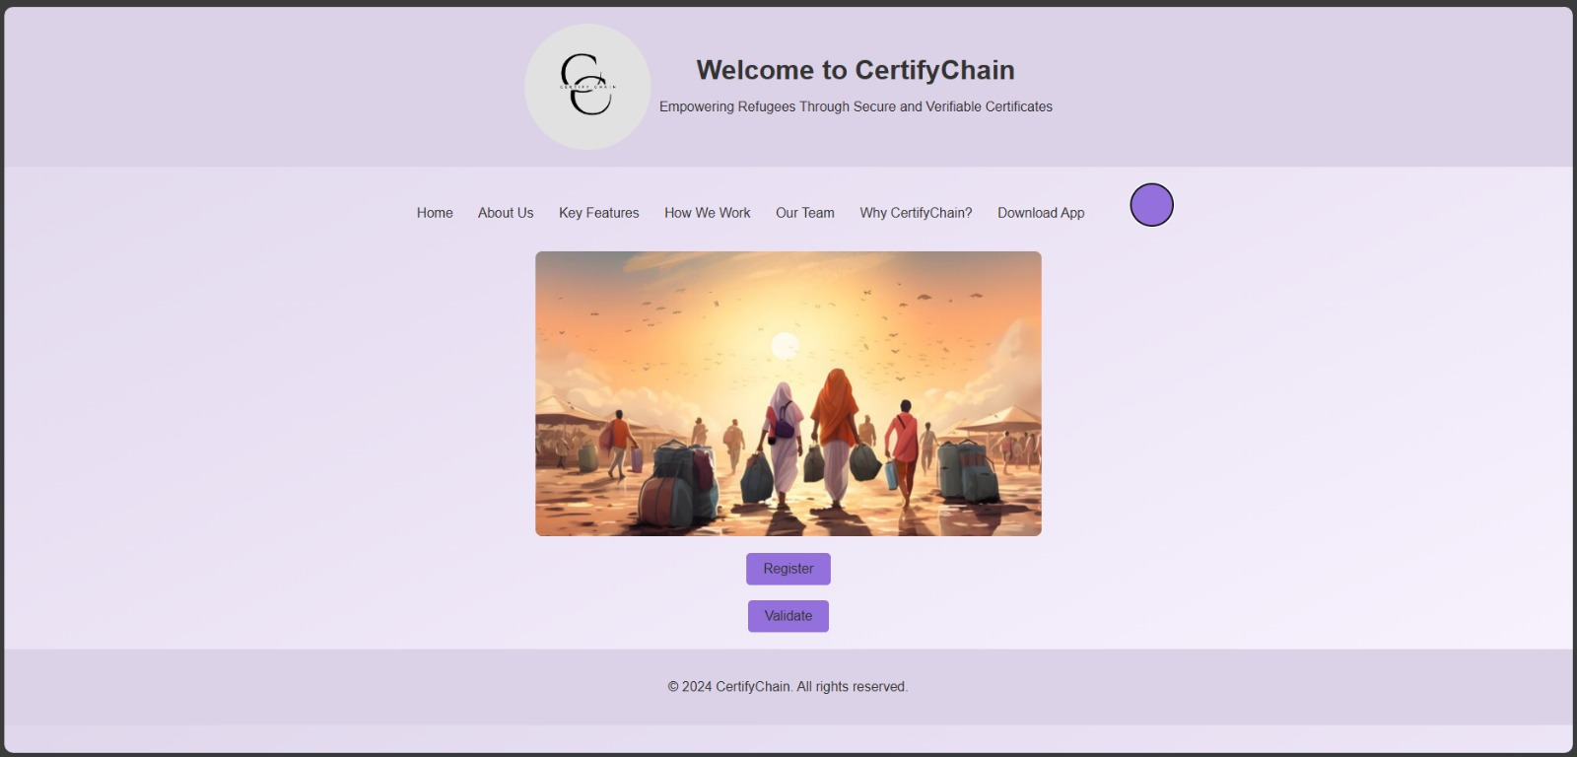
Fig. 5.1 – Homepage of the Website
Fig. 5.1 showcases the homepage of the application. This is the initial landing page for users, featuring a clean and intuitive interface. At the center of the page is the certificate verifier section, where users can enter a certificate ID to check its validity. This simple yet effective design ensures that users can quickly access the verification functionality.

5.2 Guide - With Roadmap and Recipient Experience
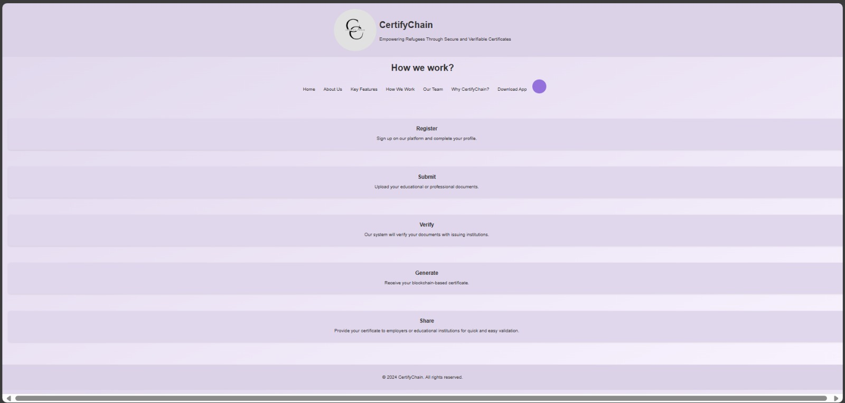
Fig. 5.2 – Guide for the website
Fig. 5.2 displays the Guide section of the application. This page provides users with an introduction to the system and a comprehensive roadmap detailing how to use the application. It includes step-by-step instructions, helping users navigate through the various features and functionalities with ease. The guide is essential for new users, ensuring they understand how to generate and verify certificates efficiently.
5.3 FAQs - On Blockchain
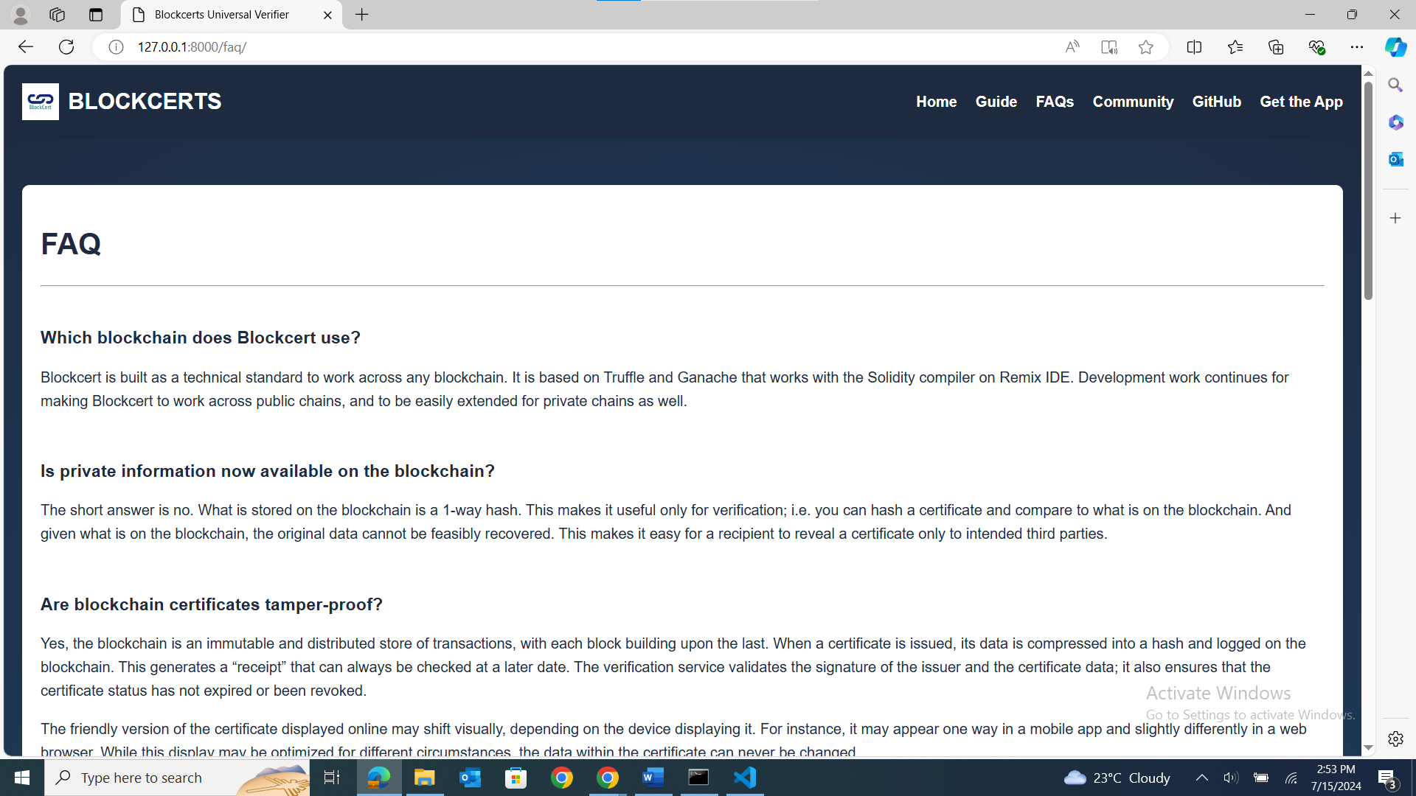
Fig. 5.3 – FAQs on Blockchain
Fig. 5.3 illustrates the FAQs page, which addresses common questions about blockchain technology and its application in the certificate generation and validation system. This section aims to educate users on the benefits and workings of blockchain, making the technology more accessible and understandable. The FAQs are categorized for easy navigation, allowing users to find answers to their queries swiftly.
5.4 Ganache
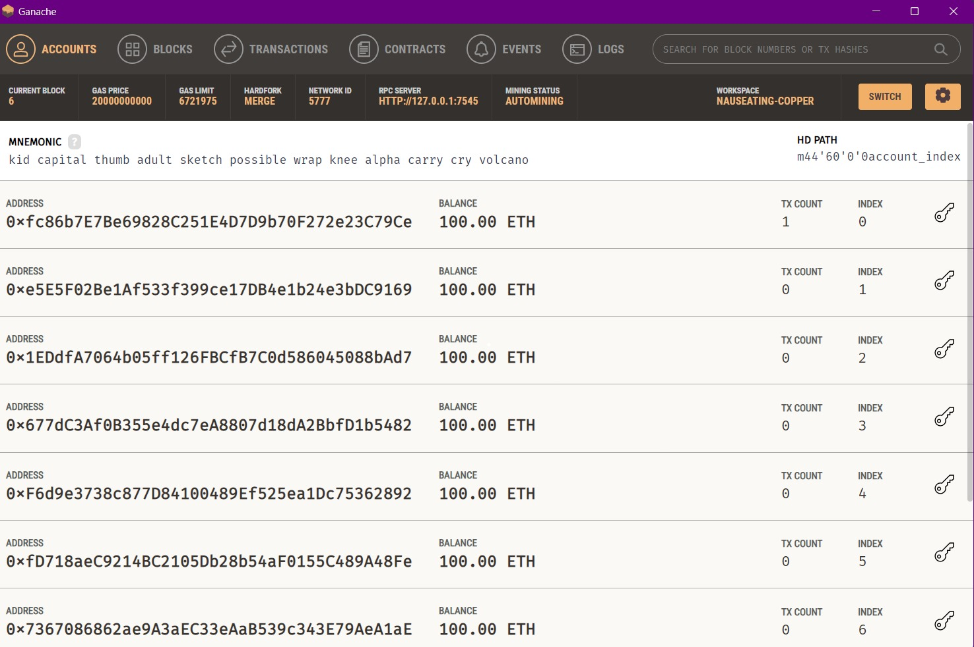
Fig. 5.4 – Ganache Interface
Fig. 5.4 shows a snapshot of Ganache, a personal blockchain used for testing and development. In this context, Ganache is used to simulate the Ethereum blockchain environment, enabling developers to test smart contracts and transactions locally before deploying them to the main network. The snapshot highlights the interface where developers can view accounts, transactions, and blocks, providing a detailed view of the blockchain's state during development.

5.5 Generate Certificate
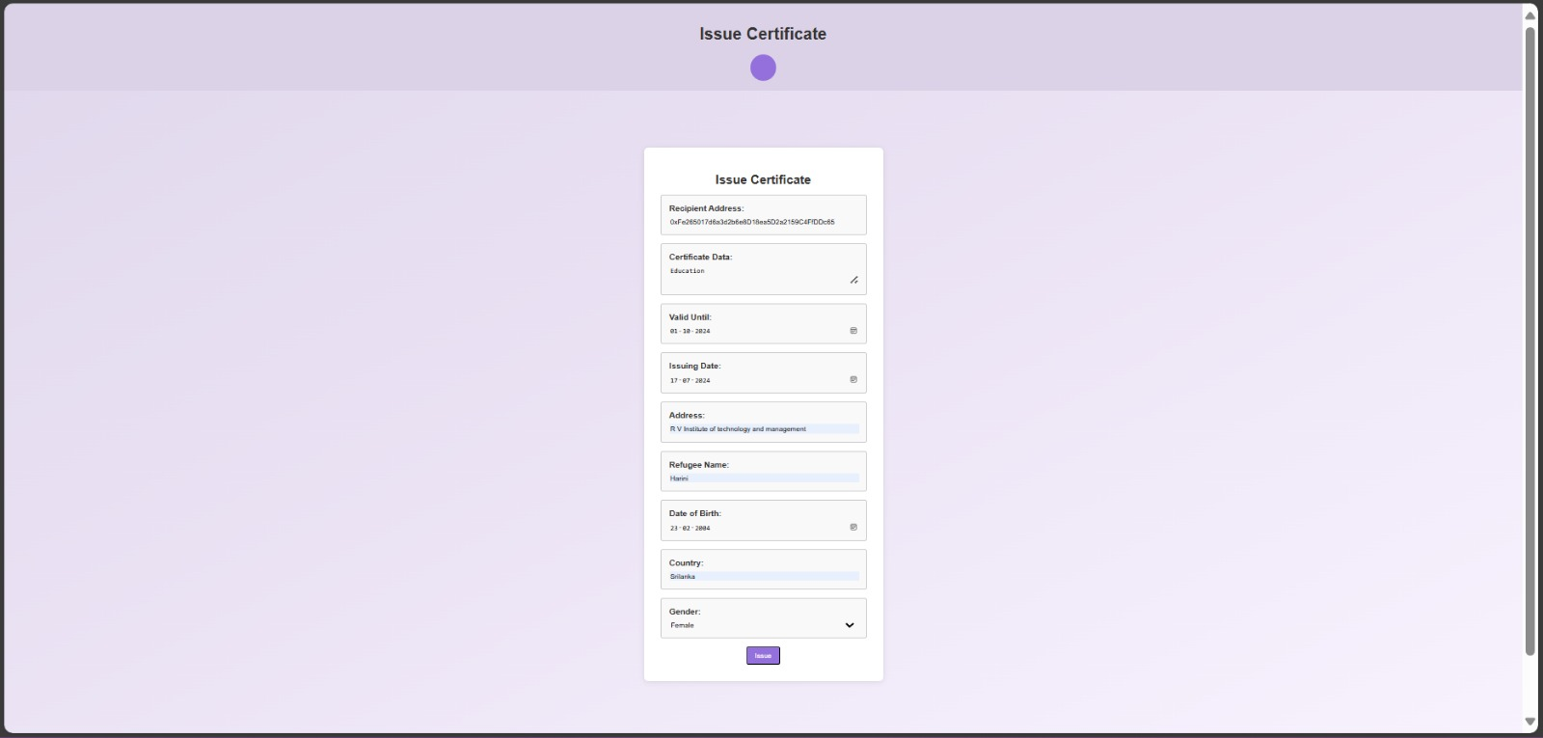
Fig. 5.5 – Generated Certificate
Fig. 5.5 presents information required to generate certificate within the system. This form includes essential details such as the refugee's name, country, date of birth, and other relevant information. The visually appealing design ensures that the certificate is both professional and easily readable.
5.6 Ganache Transaction
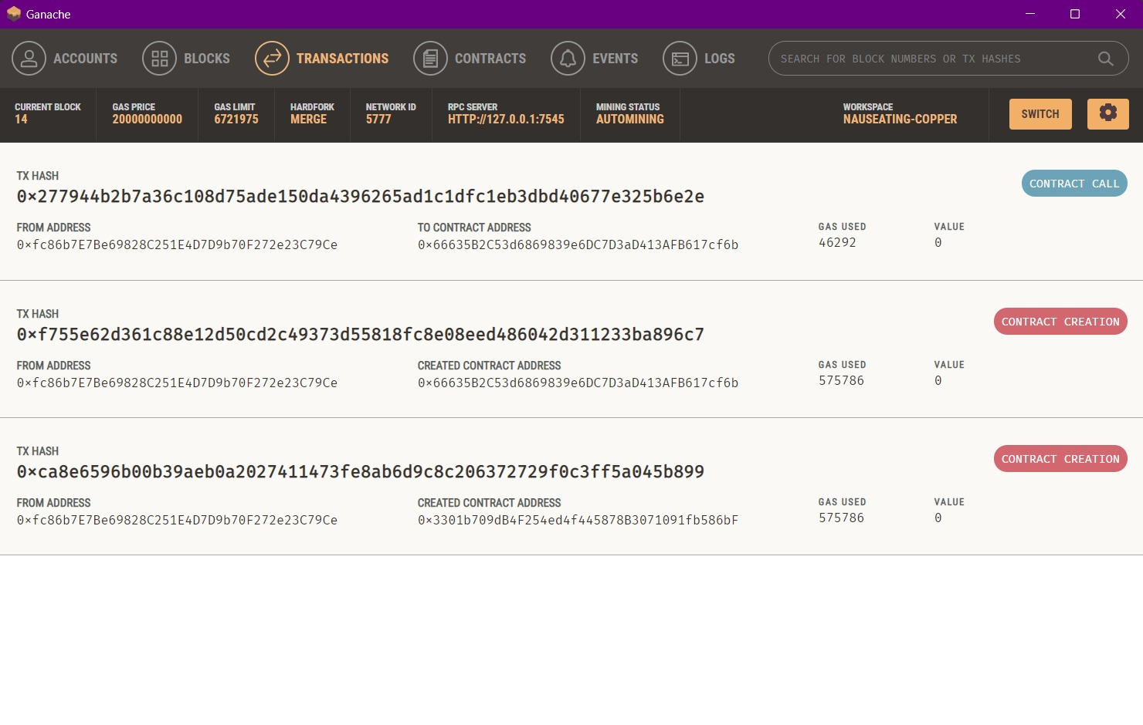
Fig. 5.6 – Transaction in Ganache
Fig. 5.6 captures a specific transaction in Ganache. This transaction represents the issuance of a certificate on the blockchain, including details such as the transaction ID, sender, recipient, and timestamp. Viewing the transaction in Ganache provides transparency and verifiability, ensuring that all certificate issuances are recorded on the blockchain for future reference.
5.7 Generated Certificate
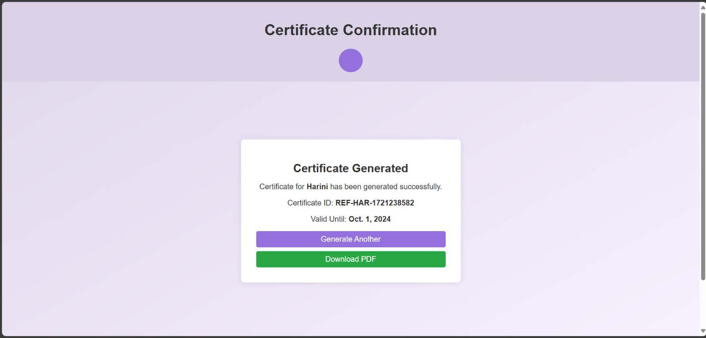
Fig 5.7 – Generated Certificate
Fig. 5.7 presents a generated certificate within the system. This certificate includes essential details such as the refugee's name, country, date of birth, and other relevant information. The visually appealing design ensures that the certificate is both professional and easily readable. This snapshot demonstrates the successful generation of certificates within the application.
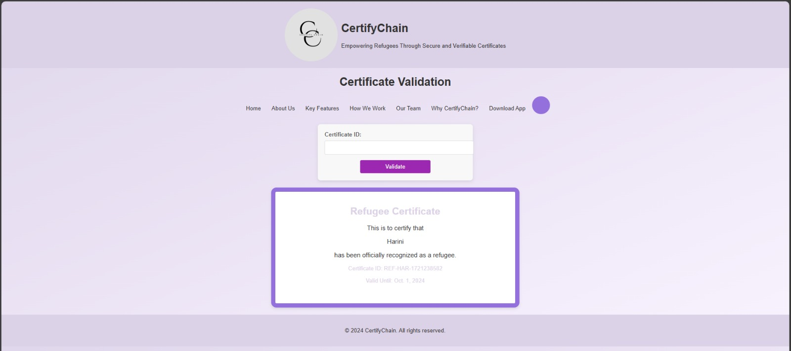
5.8 Verification of Certificate
Fig. 5.8 – Verification
Fig. 5.8 shows the verification process of a certificate. After entering the certificate ID on the homepage, users are presented with a verification result. This result confirms the authenticity of the certificate, displaying the relevant details and verification status. This snapshot illustrates the final step in the user journey, providing assurance and trust in the system's integrity.
5.9 Admin Interface
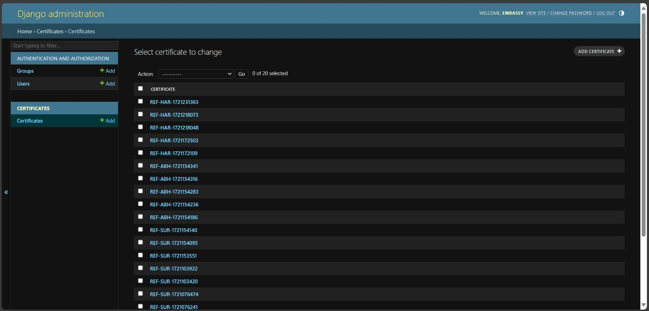
Fig. 5.9 – Admin Interface
The project, leverages Django's robust administrative capabilities to streamline management tasks. The Django admin interface, depicted in the Fig. 5.9, exemplifies its intuitive design and powerful features. From managing user permissions to seamlessly integrating with the blockchain data.

CONCLUSION AND FUTURE ENHANCEMENTS
The project represents a significant advancement in addressing the unique challenges faced by refugees in verifying their educational and professional credentials. By utilizing blockchain technology, this system provides a secure, decentralized, and immutable platform for the issuance and validation of certificates, thereby mitigating risks associated with document fraud and loss. The implementation of this system ensures that refugees can reliably present their qualifications to employers, educational institutions, and other stakeholders, facilitating smoother integration into new communities and job markets. This project exemplifies how innovative technology can be harnessed to empower marginalized populations, providing them with the tools needed to rebuild their lives with dignity and confidence. The success of this initiative underscores the potential of blockchain technology to drive social good, highlighting its role in creating more inclusive and equitable systems globally.
Future Enhancements:
- User-Friendly Mobile Application: Create a user-friendly mobile application to facilitate easier access for refugees to manage their credentials, including features such as multi-language support and offline access.
- Enhanced Privacy and Security: Implement advanced encryption techniques and privacy-preserving protocols to ensure the highest level of security and privacy for user data.
- Smart Contract Automation: Utilize smart contracts to automate various processes within the system, such as credential issuance and validation, reducing the need for manual intervention and increasing efficiency.
- AI and Machine Learning Integration: Explore the integration of AI and machine learning to enhance the validation process, such as automatically detecting fraudulent activities and providing insights for continuous improvement.

REFERENCES
- M. S. Mohamed, M. S. Abdiwahab, and R. Elgohary, "Certificate Generator using Blockchain Technology (BlockCert)," Special Issue Published in Int. Jnl. Of Advanced Networking & Applications (IJANA), pp. 132-135.
- S. Pu and J. S. L. Lam, "The benefits of blockchain for digital certificates: A multiple case study analysis," Technology in Society, vol. 72, p. 102176, 2023.
- N. Swetha and S. Priya, "Online Certificate Validation Using Blockchain," Special Issue Published in Int. Jnl. Of Advanced Networking & Applications (IJANA), pp. 132-135.
- J.-C. Cheng, N.-Y. Lee, C. Chi, and Y.-H. Chen, "Blockchain and smart contract for digital certificate," in 2018 IEEE International Conference on Applied System Invention (ICASI), pp. 1046-1051, 2018.
- A. S. Kareem and A. C. Shakir, "Verification Process of Academic Certificates Using Blockchain Technology," Kirkuk Journal of Science, vol. 18, no. 1, pp. 62-75, 2023.

