Project Documentation

Project Title :- Movie Streaming Platform Database

Functions
- Users → One user can subscribe to many plans and watch many movies on the platform.
- Movies → One movie can be watched by many users and can belong to many genres.
- Genres → One genre can have many movies under it.
- Movie_Genre → Connects movies with multiple genres.
- Subscriptions → One user can have multiple subscriptions over time.
- Watch_History → Stores which user watched which movie and when.
- Reviews → One user can give many reviews and one movie can have many reviews.
- Payments → Stores payment details for user subscriptions.

Requirements
- Users :- Stores user registration details, contact information, account status, and profile data of platform users.

- Movies :- Stores movie details such as title, release year, duration, language, rating, and additional metadata (OTT rights, language availability, box office, etc.).

- Genres :- Stores different movie genres like Action, Drama, Comedy, Sci-Fi, etc.

- Movie_Genre :- Stores the mapping between movies and genres to handle the many-to-many relationship.

- Subscriptions :- Stores subscription plan details of users including plan type, start date, and end date.

- Watch_History :- Stores information about which user watched which movie along with watch timestamp.

- Reviews :- Stores user ratings and reviews for movies.

- Payments :- Stores payment transaction details for subscriptions such as amount, date, and payment mode.

- ENTITIES USED :-

Entity Name | Description
Users | Represents platform users who can subscribe to plans, watch movies, and give reviews.
Movies | Represents movies available on the platform along with details and metadata.
Genres | Represents different movie categories such as Action, Drama, Comedy, Sci-Fi, etc.
Movie_Genre | Associative (bridge) entity used to connect Movies and Genres tables to resolve the many-to-many relationship between them.
Subscriptions | Represents subscription plans taken by users to access platform content.
Watch_History | Associative entity used to connect Users and Movies tables, storing which user watched which movie and when.
Reviews | Associative entity used to connect Users and Movies tables, storing user ratings and reviews for movies.
Payments | Associative entity used to connect Subscriptions and payment transactions, storing payment details for each subscription.

- RELATION BETWEEN ENTITIES :-
ER DIAGRAM:-

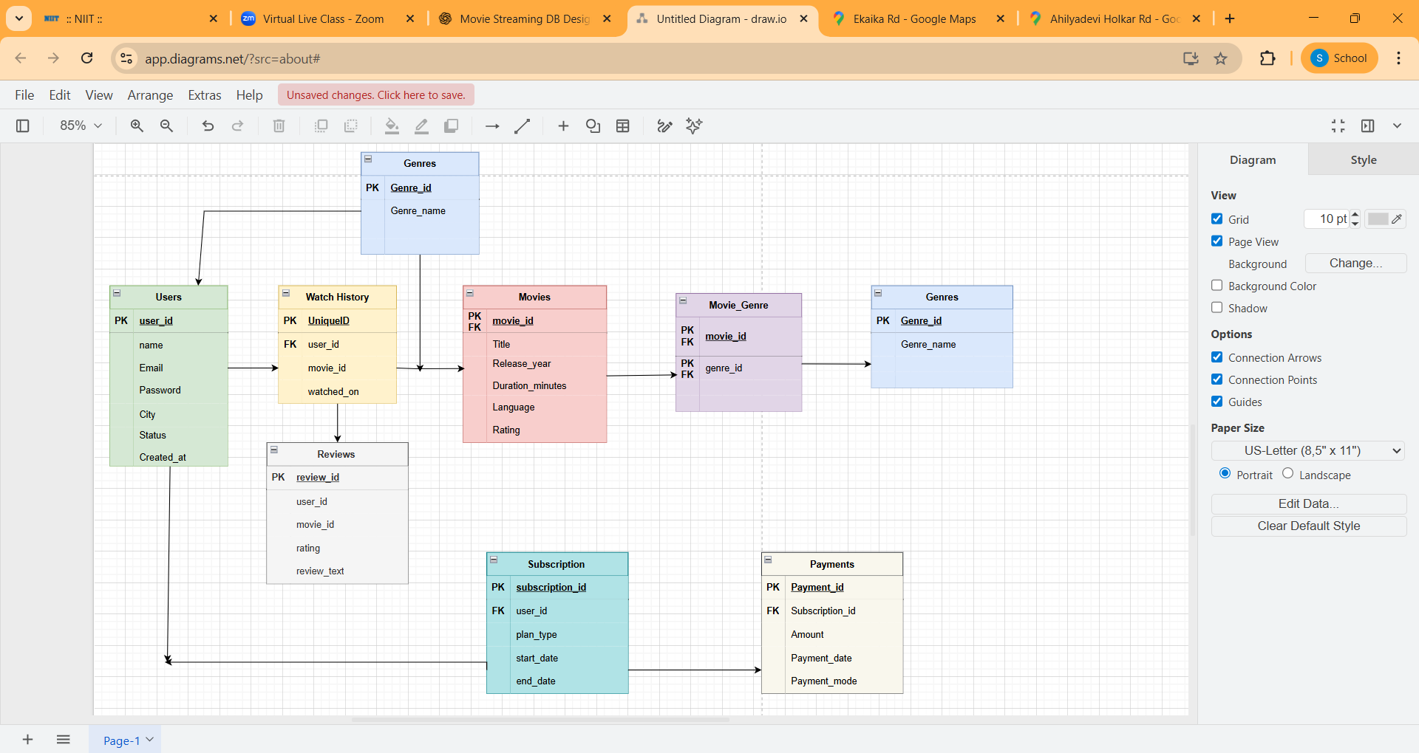

LIST OF TABLES

Table Name | Primary Key (PK) | Foreign Key(s) (FK) | Key Constraints
Users | user_id | — | email (UNIQUE), name (NOT NULL), password (NOT NULL)
Movies | movie_id | — | title (NOT NULL), release_year (CHECK ≥ 1900), duration_minutes (CHECK > 0), rating (CHECK 0–10)
Genres | genre_id | — | genre_name (UNIQUE, NOT NULL)
Movie_Genre | (movie_id, genre_id) | movie_id → Movies.movie_id, genre_id → Genres.genre_id | Composite PK, both FKs (NOT NULL)
Subscriptions | subscription_id | user_id → Users.user_id | plan_type (CHECK: Basic/Standard/Premium), start_date (NOT NULL)
Watch_History | history_id | user_id → Users.user_id, movie_id → Movies.movie_id | watched_on (DEFAULT CURRENT_TIMESTAMP)
Reviews | review_id | user_id → Users.user_id, movie_id → Movies.movie_id | rating (CHECK 1–5), review_text (NULL allowed)
Payments | payment_id | subscription_id → Subscriptions.subscription_id | amount (CHECK > 0), payment_mode (NOT NULL)

OBJECTIVES :-
Objective | Task | Problem Statement | How We Achieved It | Technique Used (with Commands)
Objective 1: Overall Content Performance Analysis | Task 1 | Identify High-Rated Movies for Content Quality Analysis | Filtered movies with rating above 8 to find top-performing content. | DQL (SELECT, WHERE rating > 8)
 | Task 2 | Identify Highest and Lowest Rated Movies | Sorted movies to extract the top and bottom rated titles. | DQL (SELECT, ORDER BY, LIMIT)
 | Task 3 | Rank Top 5 Movies for Promotion Strategy | Ranked movies by rating in descending order and shortlisted top 5. | DQL (SELECT, ORDER BY DESC, LIMIT 5)
 | Task 4 | Compare Ratings Across Languages to Identify Global Performers | Compared movie ratings across languages using ANY and ALL to find cross-language outperformers. | DQL (SELECT, Subquery, ANY, ALL)
Objective 2: User Engagement & Viewing Behaviour | Task 1 | Analyze User Viewing Behaviour | Mapped users with the movies they watched using joins. | DQL (SELECT, JOIN)
 | Task 2 | Identify Highly Active Users | Grouped watch history and filtered users who watched more than one movie. | DQL (SELECT, GROUP BY, COUNT, HAVING)
Objective 3: Content Popularity & Distribution Analysis | Task 1 | Identify Most-Watched Movies | Counted movie views to identify the most popular movie. | DQL (SELECT, COUNT, GROUP BY, ORDER BY)
 | Task 2 | Analyze Content Distribution by Language | Grouped movies by language to understand catalog distribution. | DQL (SELECT, GROUP BY, COUNT)
Objective 4: Query Performance Optimization Using Indexes | Task 1 | Optimize Movie Search by Rating Threshold (Above 8.5) | Created an index on rating to speed up filtering of high-rated movies. | DDL + DQL (CREATE INDEX, SELECT WHERE rating > 8.5)
 | Task 2 | Optimize Payment Mode Filtering for UPI Transactions | Created an index on payment_mode to improve UPI-based queries. | DDL + DQL (CREATE INDEX, SELECT WHERE payment_mode = 'UPI')
Objective 5: Ensuring Data Integrity Through Automation & Security | Task 1 | Automate Year-wise Movie Retrieval | Created a stored procedure to fetch movies released in 2023. | DDL + DQL (CREATE PROCEDURE, CALL)
 | Task 2 | Restrict Invalid Review Ratings | Created a trigger to allow ratings only between 1 and 5. | DDL + DML (CREATE TRIGGER, INSERT)
 | Task 3 | Ensure Atomic User and Subscription Creation | Used transaction to save user and subscription together safely. | TCL + DML (START TRANSACTION, COMMIT)
 | Task 4 | Store Movie Box Office Metadata in JSON Format | Added JSON column and stored box office data using JSON_SET. | DDL + DML (ALTER TABLE, UPDATE, JSON_SET)
 | Task 5 | Validate Constraints and Debug Query Performance | Tested invalid inserts and analyzed query performance using EXPLAIN. | DML + DQL (INSERT, EXPLAIN)

Srinivas Patel
Managing and Querying Database

