**Vendor Inquiry Tool**

User Guide v1.2.3

**Introduction:**

The Vendor Inquiry Tool (VIT) simplifies the usage of different data sources that give indications about which internal and external vendors contribute services into a specific client Account.

The step-by-step guidance addresses requirement to create a list or exhibit of subprocessors, the “Vendor List,” for an Account. A Vendor List is the list of vendors, internal or external, that participate in the delivery of a GTS service contract and that, in doing so, may process client-owned EU Personal Data (PD), as defined by the GDPR.

The core of this instruction is working with different types of data sources that are currently available to build the Vendor List by the VIT. The instruction is intentionally on operational level, with detailed technical instructions how to work with the available information sources (Assets).

Please consider that the list of potential subprocessors extracted from VIT form the basis for a Vendor List needed for the Client DPA exhibit template. However, the Account needs to add the team’s own knowledge about sub-processors and apply further judgement in order to narrow down suggestions to the actual vendors used to delivery services, offerings and which tools are used by the team to process customer data.

In fact, for further assets like Tools, Data Center, and the Center of Competencies (“CICs”) and their Service Areas) the Account needs to provide inputs (e.g. about Tools, Service Areas or CIC usage) with its contract and delivery knowledge. In case of questions, the Geo/Local SR&RM will assist with understanding.

With all of the above, Accounts create their final Vendor List, imbed that into the client-DPA Exhibit, and manage as needed, to obtain client consent.

**Creating the Vendor List**

The following text integrates with the [GDPR implementation Guide for GTS IS Existing Accounts](https://w3-connections.ibm.com/communities/service/html/communityview?communityUuid=b05f931b-3198-4f96-84ef-0fa158cca595#fullpageWidgetId=W59b656e32b11_4246_87bd_8c56657ac7dc&file=b517ed14-ebf8-400c-82cd-1954e654e4fc). It relates specifically to the vendor part, and breaks this down into more granular operational steps.

The DPA Exhibit template, Subprocessors, is structured into four sections: IBM and Third Parties, inside and outside of the EEA (European Economic Area), as follows. Addresses or Countries are to be captured as noted. Information about the Vendors should be inserted directly into the DPA Exhibit template. If there are a lot of vendors, the List can be attached as an addendum – but in that event, the same information still needs to be captured.

IBM may use the following Subprocessor(s) in the Processing of Client Personal Data:

a. IBM companies located in the European Economic Area or countries considered by the European Commission to have adequate protection

|  |  |
| --- | --- |
| **Name of Subprocessor** | **Address of Subprocessor** |
|  |  |

b. Third Party Sub-processors located in the European Economic Area or countries considered by the European Commission to have adequate protection

|  |  |
| --- | --- |
| **Name of Subprocessor** | **Country in which Subprocessor is located** |
|  |  |

c. IBM Data Importers (IBM companies established outside either the European Economic Area or countries considered by the European Commission to have adequate protection)

|  |  |
| --- | --- |
| **Name of IBM Data Importer** | **Address of IBM Data Importer** |
|  |  |

d. Third Party Data Importer (non-IBM companies established outside either the European Economic Area or countries considered by the European Commission to have adequate protection)

|  |  |
| --- | --- |
| **Name of Third Party Data Importer** | **Country in which the Third Party Data Importer is located** |
|  |  |

**Supporting Assets**

Vendor and subprocessors information is not currently centralized in one location within IBM. Rather, the information is being compiled from multiple sources into VIT, which we refer to here as “Assets.” When reviewing each of these Assets, the Account will have to apply their own knowledge of the subprocessors on their contract, to combine and refine vendors from multiple Assets into one list for the DPA Exhibit. The five main types of Assets include lists of:

1. Active **Purchase Orders** **(POs) for Local Services,** as linked to each Account. Giving the customer name, VIT is able to extract the relevant POs identified for this customer.

2) GDPR relevant GTS IS **Standard Offering Vendors,** with internal and external sub-processors retained by Offering Mangers to provide services for a global standard offering. Giving the customer name, VIT is able to extract the active offerings identified for this customer.

3) List of GDPR relevant GTS IS **Standard GTS global Tool Vendors,** internal and external. Basis is a survey to Tool owners

4) List of active **Purchase Orders (POs) used by IBM Data Centers** to provide. This is a subset of above 1) focusing on services purchased on a Data Center level (thus, above Account level).

5) List of IBM **Centers of Competency “CIC” Vendors** (global & local used by the IBM Delivery organization).

The steps you need to follow are:

1. Identify the customer name and relevant data from the assets you need to extract form VIT. Please notice you can query VIT also just looking for assets different than 1 and 2.
2. Analyze the data and identify the vendors that potentially need to be included in the DPA. Please notice there are some tips/suggestions at the bottom of this doc;
3. Based the vendors you have chosen, classify them as (i) IBM entities located in EAA, (ii) Third Parties vendors located in EAA, (iii) IBM entities located outside EAA or countries considered by the European Commission to have adequate protection and (iv) Third Parties vendors located outside EAA or countries considered by the European Commission to have adequate protection and then fill the DPA- Vendor list

**Phase 1: How to extract the data from VIT**

1. **Basic Search (Asset 1 and 2)**

Minimum Input into the Web Front End are Geography, Market and Customer Name. ~~In addition, you can also query one or more other assets (from 3 to 5) located in the “optional fields” separately (without any customer name~~

The following link brings you the [VIT Webpage](http://9.212.159.10/gdpr/dashboard.php). You are presented the following screen:

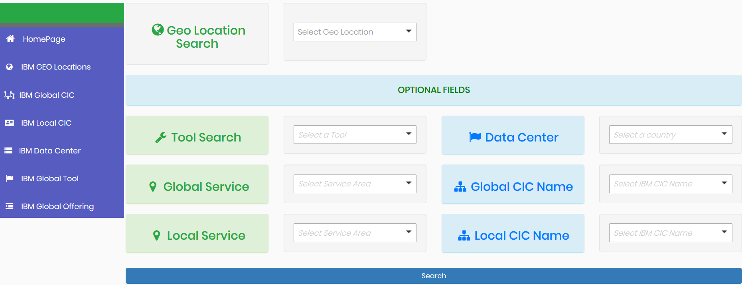

**1) Enter Search Data**

Enter the Geo, this opens a new field for Market Search.

Enter the Market, this opens a new field for Customer search.

Enter a Customer Name or sub-string first into the search field. Only then a viable pick-list is presented. One or more of the offered customer names (there could be different spellings for the same customer) can be selected.

The below picture shows how to identify FCA account located in DACH. You can see that there are similar names that you can select.

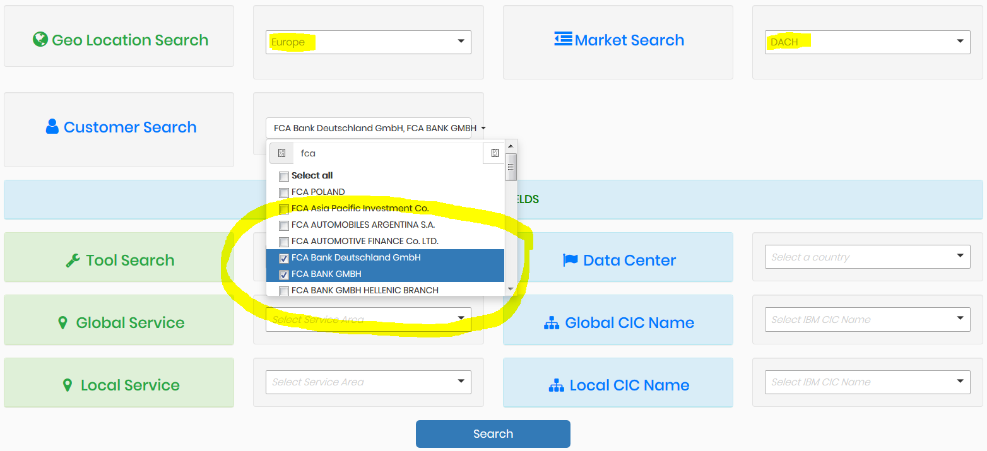

**2) Run Search**

Scroll down and press the **blue bar “Search”.**

**3) Result**

Below the “Search” button, the tool shows to you the query parameters you filled

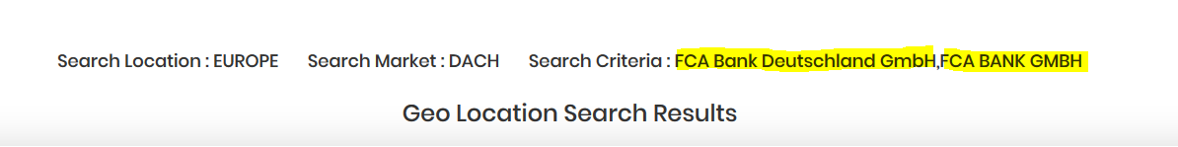

The tool picks up information from Asset 1 and Asset 2:

1. The Purchase Orders (POs) that directly point to the selected Account as well as Purchase Orders for shared services that this Account may participate in.
2. It also checks the contract for references to GTS IS Standard Offerings and then picks up the legal entities that Offering owners stated participate in the delivery of such Offering(s).

This results in a list of potential subprocessors, that form the basis for a Vendor List needed for the Client DPA exhibit template, part 6.

The **result is organized by Data source**. In this case the result is a list of vendors / subprocessors behind POs and a list of vendors / subprocessor behind Offerings.

**Result (1) Vendors behind POs pointing to this Account/Contract:**

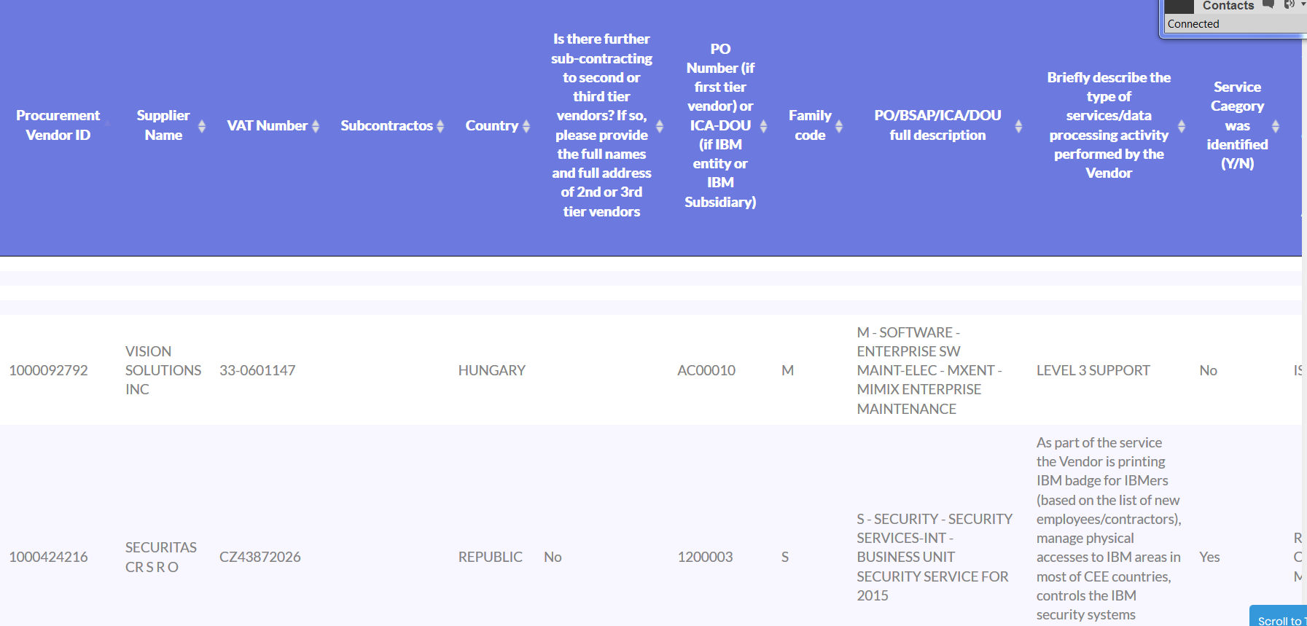

If you scroll to the bottom of the PO results, and scroll to the right, it becomes visible whether a PO directly aims at this Account, or whether the PO results from shared services being ordered.

Example: (see far right column)

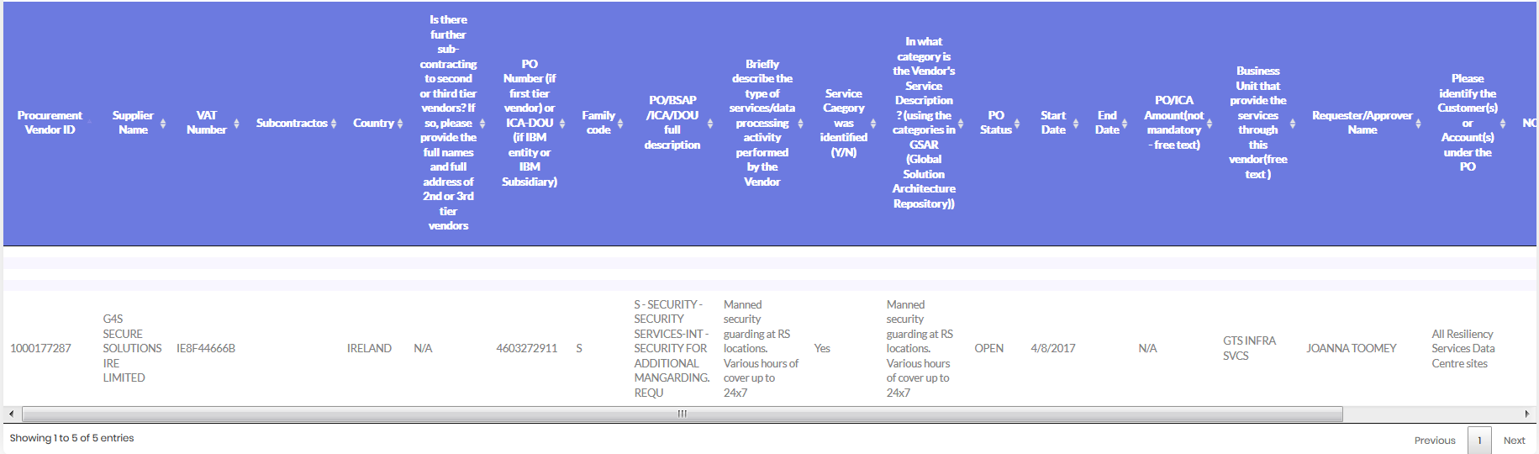

Please Note:

Some POs may appear as “Closed”. They are still listed for history purposes. The account may judge if the vendor will keep supplying such services in future. If so, please consider to include the vendor on your vendor-list.

**Result (2) Vendors behind Offerings** referenced in the Account/Contract:

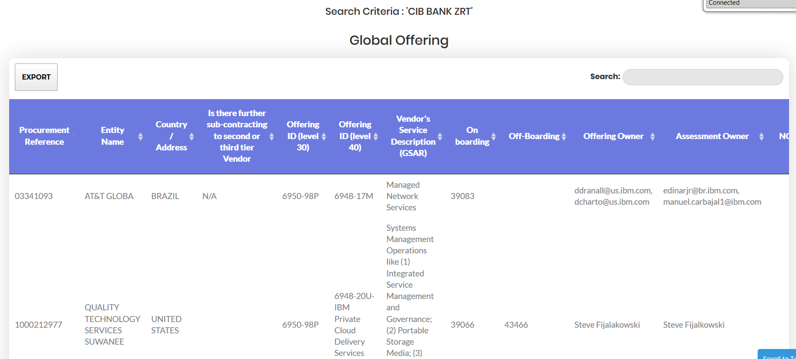

**3) Export Results:**

For further work, the results can be exported, e.g. as an Excel listing

Scroll up to find the “Export All” button

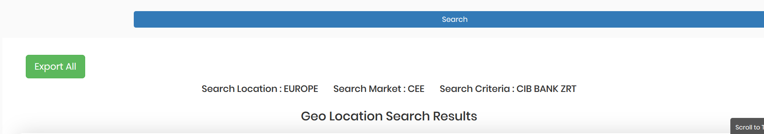

This results in a workbook with a number of tabs. Each tab hold the results for different pieces of the search.

In this case you find the results under “Europe GEO…” and “IBM Global Offering”, as other options had not been selected.

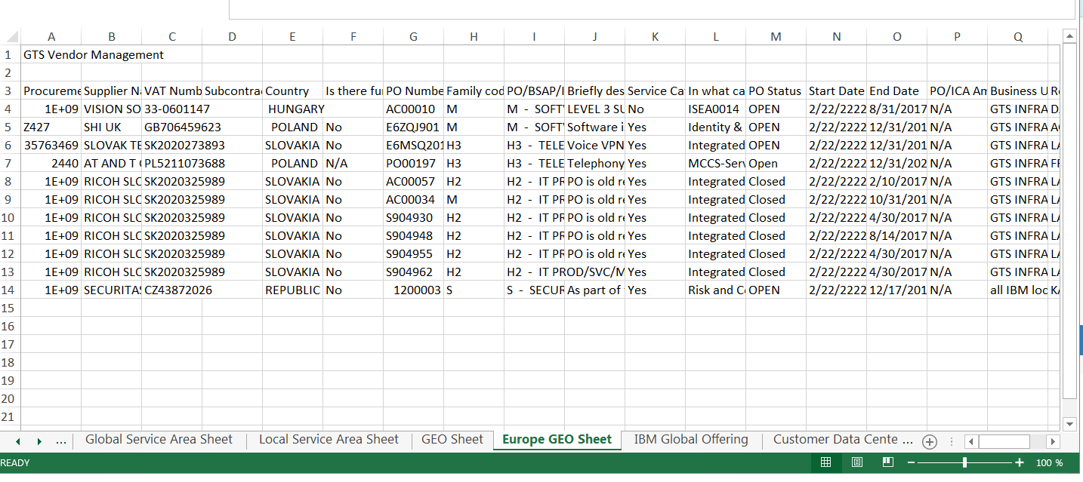

It is also possible to export only the vendors behind the POs, or only the vendors behind GTS Global Offerings.

Click on the “Export” button next to one of the results. (in this example for Offerings).

It is suggested to export the data only using the XLS format, which allows to easily analyze the output off line.

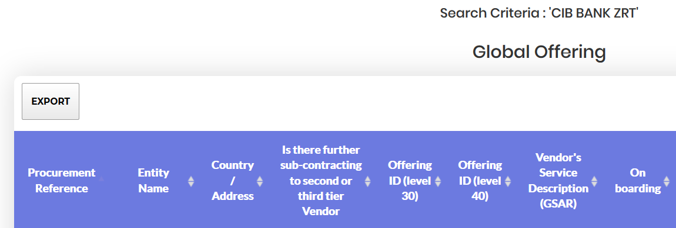

Click on e.g. Excel.

This results in an xls file with one worksheet, showing the entries for the vendors behind the GTS IS standard offerings, that this Account/Contract referenced to.

Work with this material to build the vendor-list.

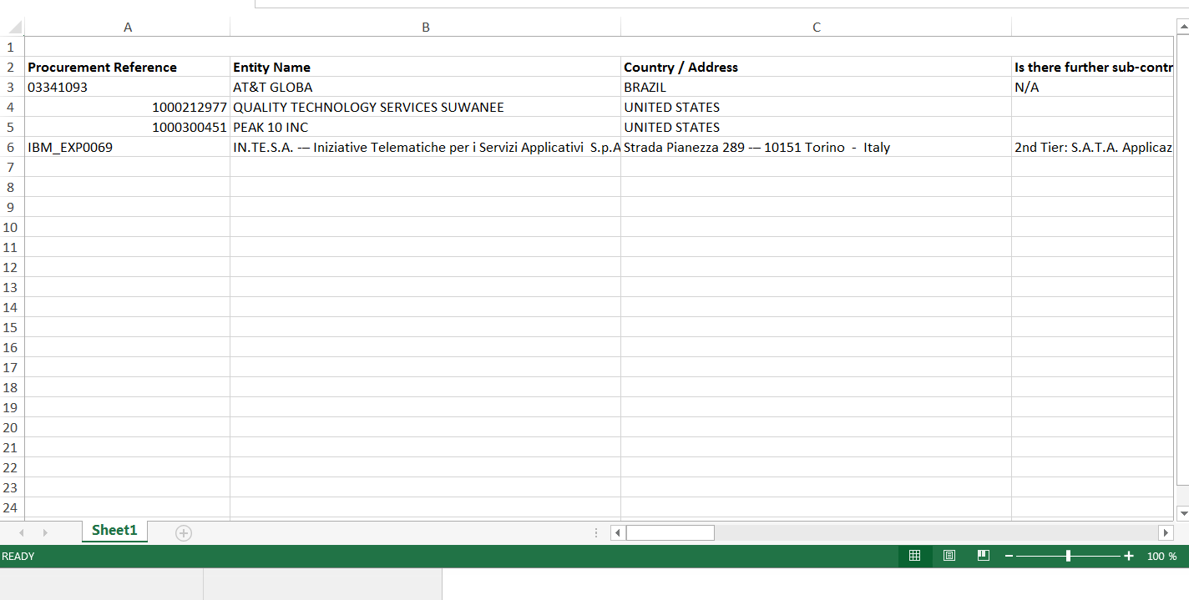

**Similarly, this can be done for other result categories.**

1. **Further Searches**
   1. **Asset N° 3: Global Tool search**

If a specific GTS global tool is used as part of your client contract, directly go to the Tools search, type in the tool name. You can choose one or more tool(s) at the same time.

The below picture shows how to select 3 different tools (Citrix, Frontline and ISIM)

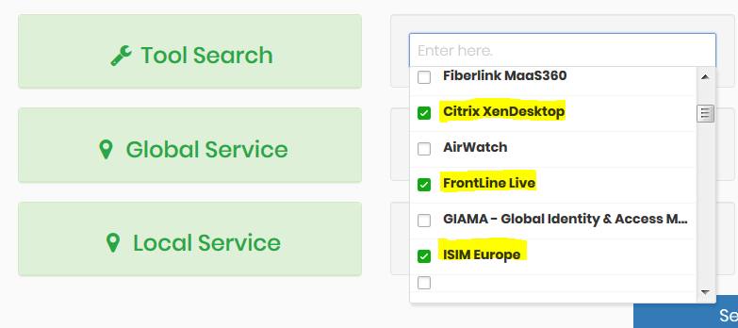

Then press the “Search” button. The result is presented.

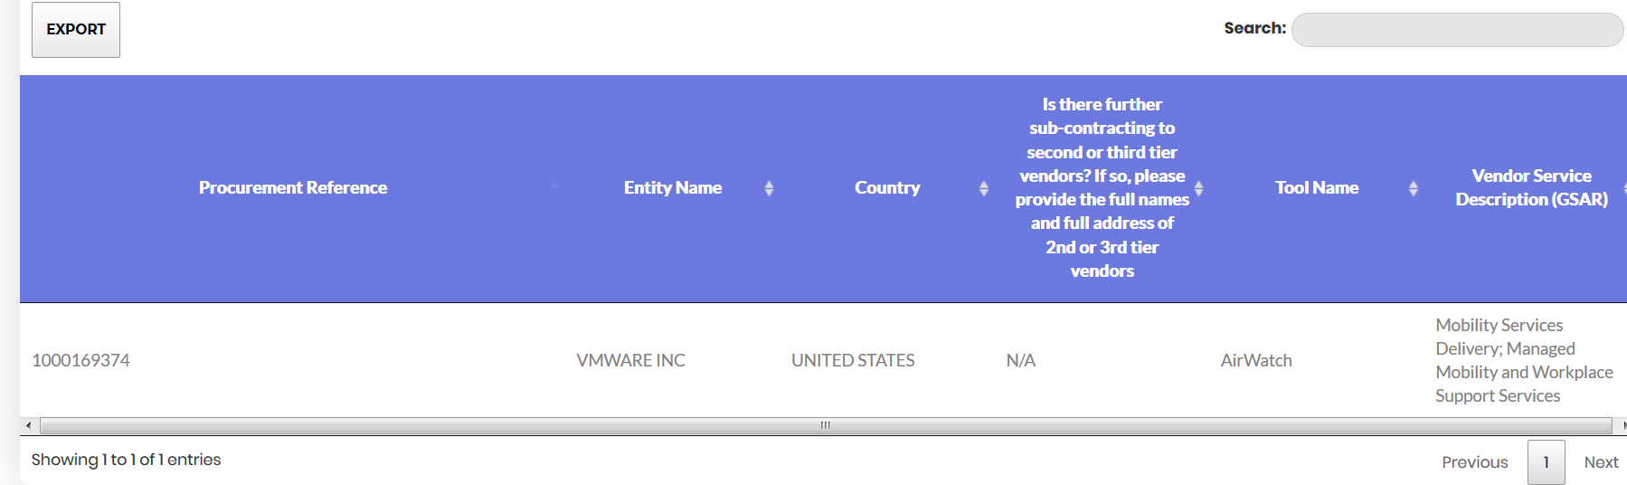

And can be exported as described above under (A) already.

* 1. **Asset N° 4: IBM Data Centers**

If a specific GTS Data Center is used as part of your client contract, directly go to the Data Center search, then type (or select) the country where the DC is located. You can choose one or more of them at the same time.

The below picture shows how to select 2 different Data Centers located in Turkey and Austria

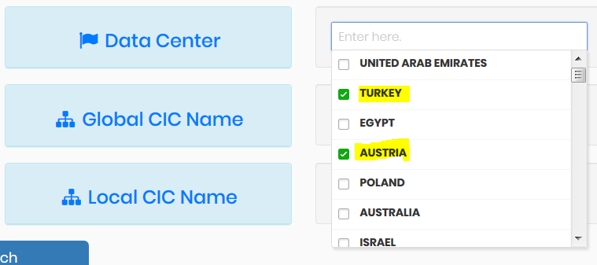

Then press the “Search” button. The result is presented.

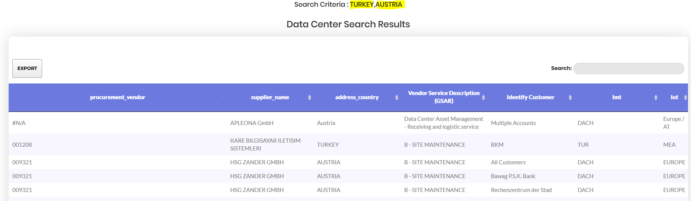

And can be exported as described above under (A) already.

* 1. **Asset N° 5: List of IBM Centers of Competency “CIC” Vendors: Global Services / Service Areas**

The IBM GTS CICs can be selected in different ways (valid for both Local & Global IBM CICs):

a) Select specific “Services Areas”: the IBM CICs supply different services grouped in specific services areas. The Services Areas may be delivered by one or more than one IBM CICs. Selecting this choice, VIT will provide the list of IBM CICs that supply such specific services area(s);

b) IBM CIC Name: in this menu, are listed all GTS IBM CIC by country. Choosing this menu, VIT will provide the list of Services areas supplied by the specific IBM CIC(s)

Please notice that VIT provides information regarding **GTS CICs ONLY!**

**Querying the “Services Areas”**

If you know about certain Service Areas that your Account orders from an IBM CIC, go directly to the Global Service field and pick a Service Area from the list. As the below picture is showing you, you can select one or more service areas (in this case Wintel, VMWare/Citrix and Linux)

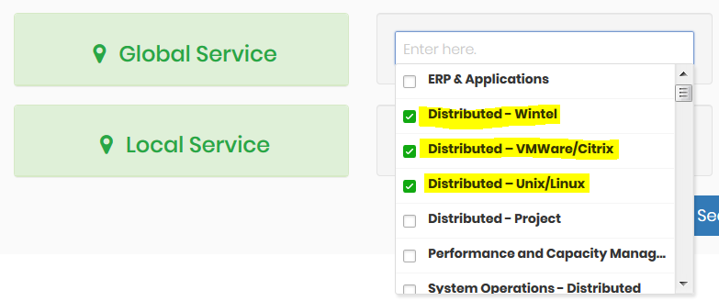

Again, press the “Search”.

The result shows all the CICs that offer this service. You can narrow down this list with knowledge about the CIC(s) used. Export capabilities are as described above.

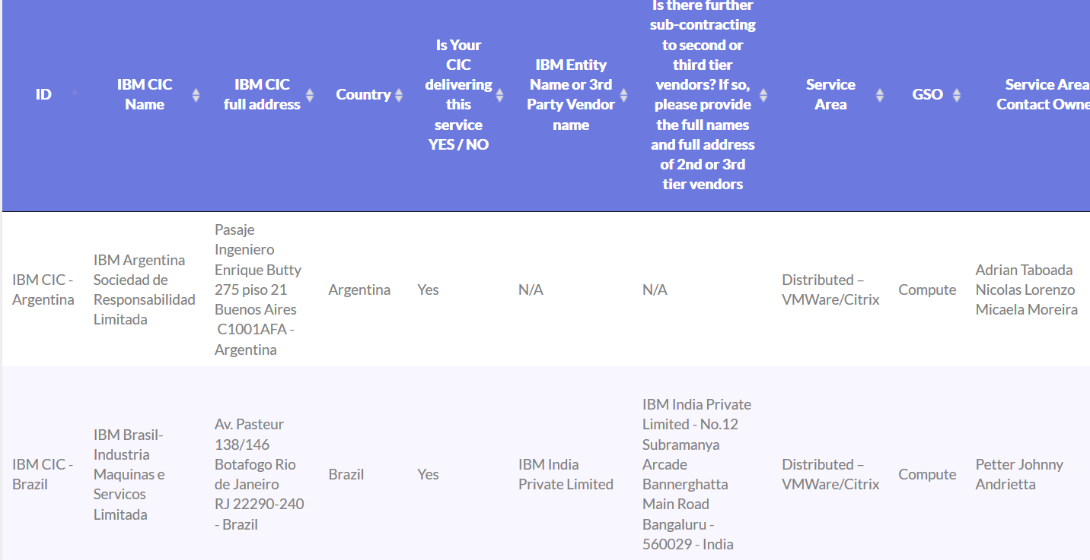

**IBM CIC Name**

You may know the country where the IBM CIC is locate and you many need to understand the Services Areas supplied by a specific IBM CIC. In order to do so, you may select the specific IBM CIC into the IBM CIC name like the follow picture is showing (in this case IBM CIC India and IBM CIC Brazil)

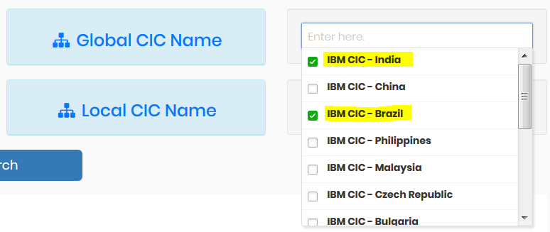

Again, press the “Search”.

The result shows all the services area offered by the selected IBM GTS CICs.

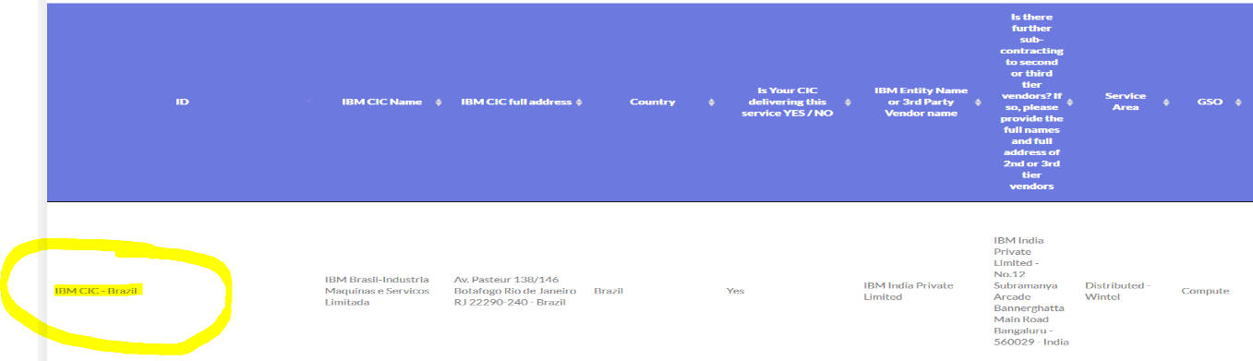

Export capabilities are as described above.

There is also a limited amount of data behind Local CICs and Local Services.

Please notice that currently local CICs are referring to Italy, France and Turkey only. ~~Other Market can avoid querying the local CICs~~

**Phase 2: Extract and Analyze data**

As described in the early point A), you can extract a specific data set or the whole data.

As consequence, you can refine the query choosing the Customer name, offering tools, data centers, services areas and IBM CICs alltogether.

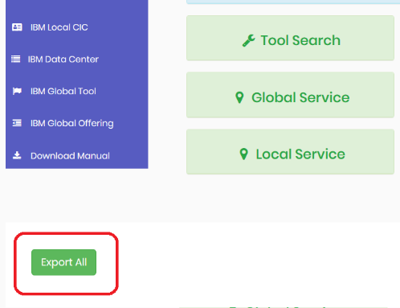When this (suggested) approach is followed, the tool proposes the “Export All” green button so that you can extract all data in one unique excel file.

Opening the excel file, it shows different tabs, one for each query output like this



The data that VIT presents to you are raw data. Sometimes the same vendor is duplicated for several reasons (e.g. there are multiple POs, or the same vendor is engaged for several offerings/services) then some manual work is needed to identify unique vendors avoiding duplicates.

As a consequence, it is required to analyze each sheet containing the data you have extracted from VIT and checks if the services supplied by the vendor shall apply to your account like:

1. consider the GSAR descriptions and/or the customer(s) which the specific service is supplied. When shared services are provided, the services should apply to “all specific customers”, so you need to check if you fall in such cases;
2. to identify unique vendors and the full address (if IBM) or the country (if Third Party vendors)
3. fill the DPA exhibit – vendor list

Following are suggested some tips how to simplify the data analysis

1. **Data Center worksheet**

In this sheet you can find data regarding vendors that may provide shared services (across all customers) or to be customer dedicate. You can identify the vendor scope looking into the column “E – Identify Customer” (see below picture for reference).

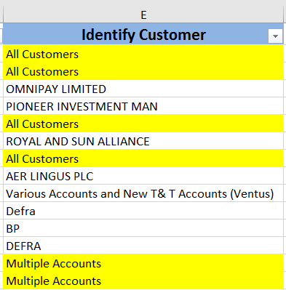If the customer name you are looking for is not there, you just need to choose the vendors that are supporting “All Customer” or “Multiple Accounts” (in yellow)

1. **IBM CICS**

The name of the IBM CICs listed in the column “B – IBM CIC Name” can be duplicated several time, based on the services area you selected. In this case, you may need to report just the IBM CIC name one time only.

Please notice that it is important to check the column “G” if further sub-contractors are engaged by the IBM CIC (see below picture row 6 and 7 – yellow cells). If yes, please consider including the vendors in your DPA exhibit.

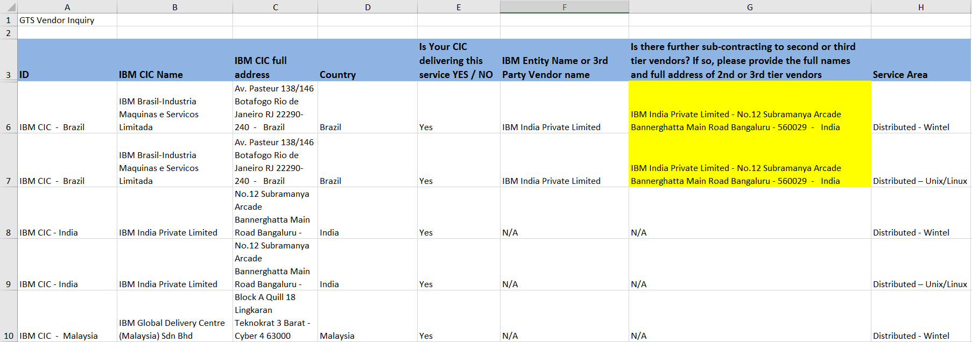

1. **Global Offering**

The global offering worksheet proposes the list of active level 30 and level 40 offering against this customer.

Potentially some of them are still open for financial reasons and, if so, you cannot take care about all of them. Please use Excel’s functions to select the subset offerings relevant for you (like the example in the below picture).

