Steps to load data into GTS Vendor Management Tool.

1. Goto Control panel →

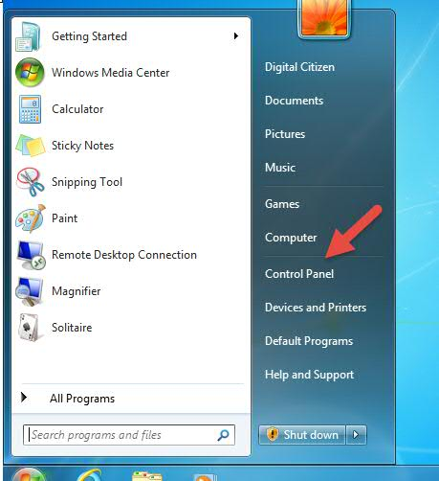

Incase you have a different windows OS running on your system you can check this :
https://www.digitalcitizen.life/8-ways-start-control-panel-windows-10

2. Select Region and Language .

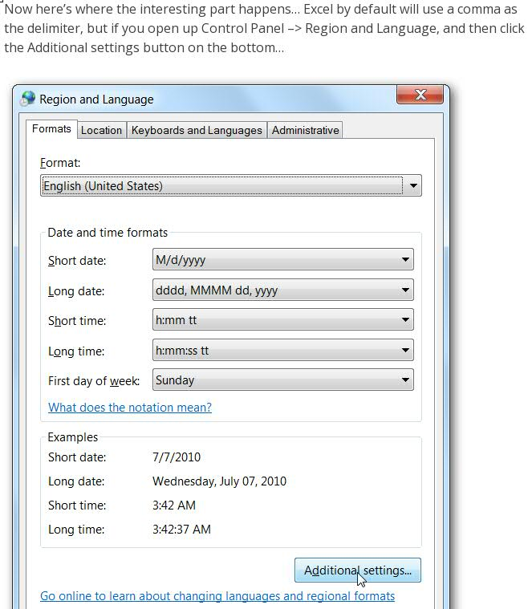

Incase you have a different version of windows running you can see this link :
http://home.bt.com/tech-gadgets/computing/how-to-fix-problems-with-language-settings-in-all-versions-of-windows-11363957260068

3. On Clicking the Additional settings change the below option .

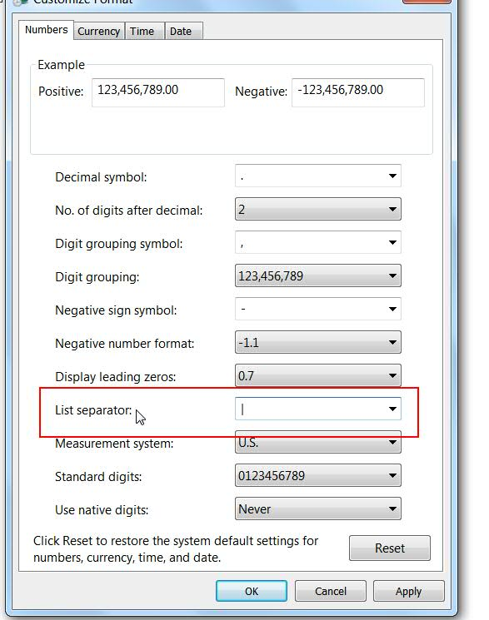

4 . Then click on apply and hence the settings will be saved .

Start the File Loading Process

1 . In order to load data please create separate excel sheets for each of the tabs in the master sheet .

2. Search for the character “ | ” in the sheet and replace with an empty space .( Use Replace all )

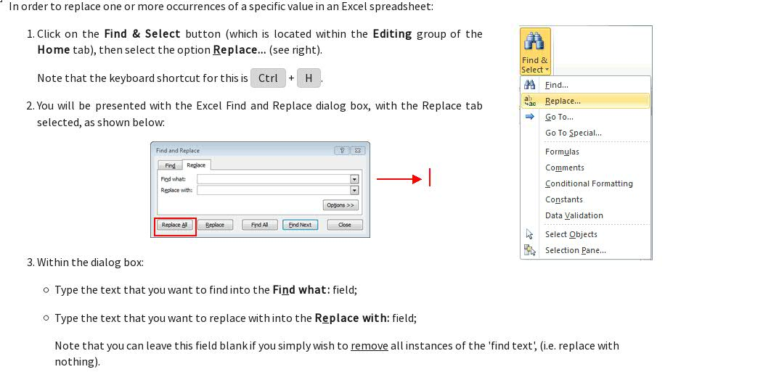

3. Please repeat the step 2 for the below character's as well .
- Double Quotes (“)
- Single Quotes (')

4. Since there are line breaks in the file, Use the below to remove line breaks . The Replace with field has a < space > . Please use Replace all to replace all entries.

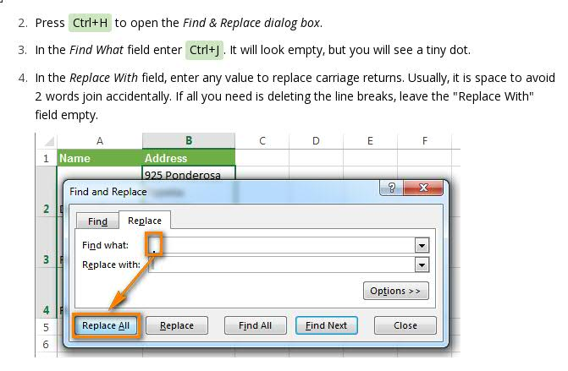

5. Please use the below steps to save the file . Click on File on the top left corner .

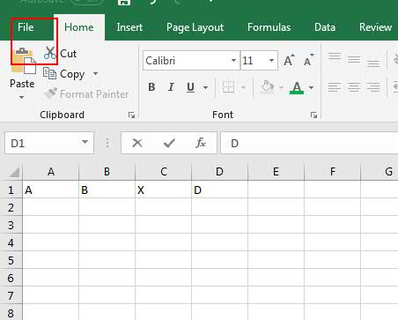

6. Then click on Save As

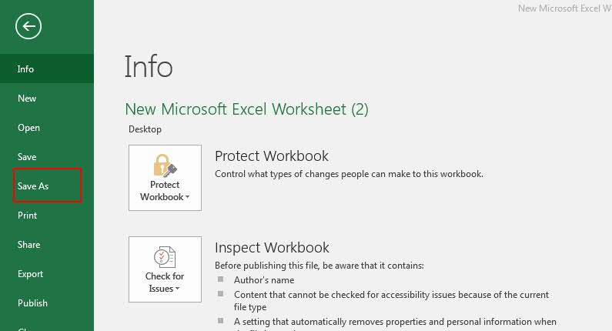

7. From the Dropdown select CSV(MS-DOS)(*.csv) and then click Save .

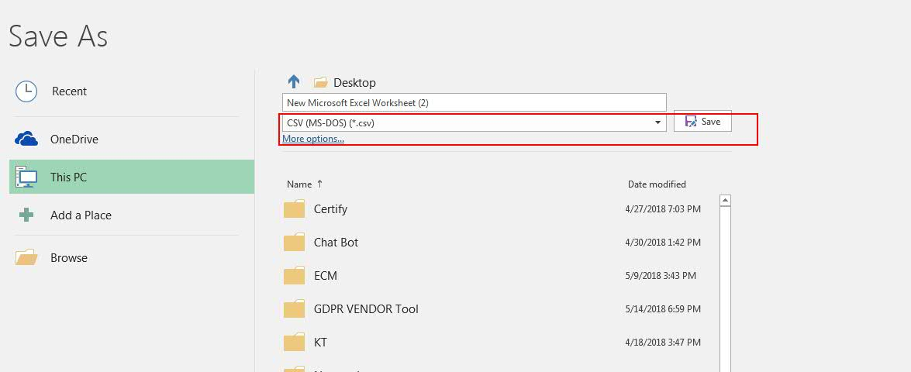

8 . Then the saved file is ready for loading .Use the saved file from the above steps to upload data for all the respective Geo's.

