**POJO Classes Manual generation and usage**

**Steps to generate POJO Classes.**

1.Call the ApI in Application.

2.Get the response in JSON string format

3.Install JSON Accelerator mac App. and Launch the app JSON Accelerator which is in applications .

link: <https://itunes.apple.com/in/app/json-accelerator/id511324989?mt=12>

4 copy paste the JSON format in JSON Accelerator app.

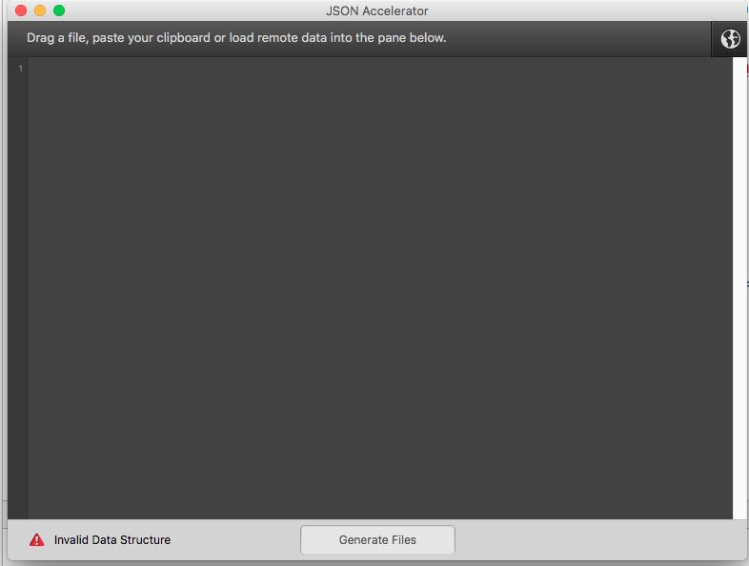

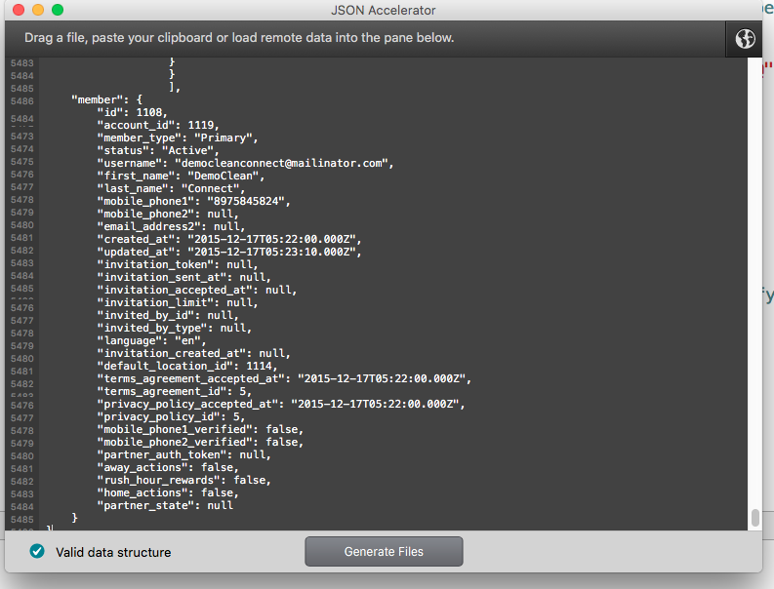

4.Set the Folder path to where has to generate the POJO classes

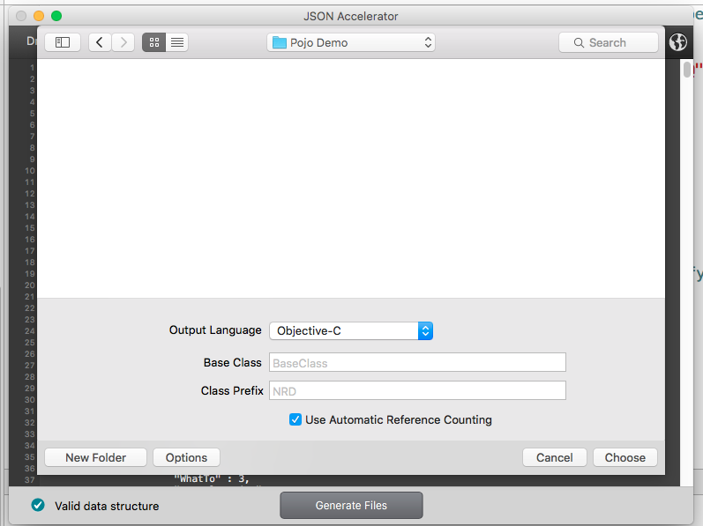

5.Make sure you selected for objective c language

6.Give the Name of Main base “class name” and also specify the Prefix identifier in input fields

7.Submit by chose the folder path to save,.

**Next steps**

1.Add the POJO generated classes to Project.

2.Call Respective Data filling by allocating the dictionary.

#import "DataModels.h"

self.arrMeasuremntsObjects = [[NSMutableArray alloc] init];

if ([resultData isKindOfClass:[NSArray class]]) {

NSLog(@"Responce data contains %lu objects ",(unsigned long)[resultData count]);

for (id data in resultData) {

MTMeasurements *objMesaurement = [[MTMeasurements alloc] initWithDictionary:data];

[self.arrMeasuremntsObjects addObject:objMesaurement];

}

NSLog(@"Coutnt Of Convenrted Objects %li",[self.arrMeasuremntsObjects count]);

}

See for example as below attached sample which contains

I suppose it will save some time and robust output with using POJO classes