*Wing Stop technical Guide*



Table of Contents

1 Franchise Admin 3

1.1 Customer Maintenance 3

1.1.1 Find Records 3

1.1.2 Reload Grid 4

1.1.3 Export to Excel 5

1.1.4 Search 5

1.1.5 Assigned and Unassigned 6

1.1.6 Add New 7

1.1.6.1 Royalty 8

1.1.6.2 Ad Fund 13

1.1.6.3 Loan 19

1.1.7 Edit 24

1.1.8 Delete 25

# Franchise Admin

## Customer Maintenance

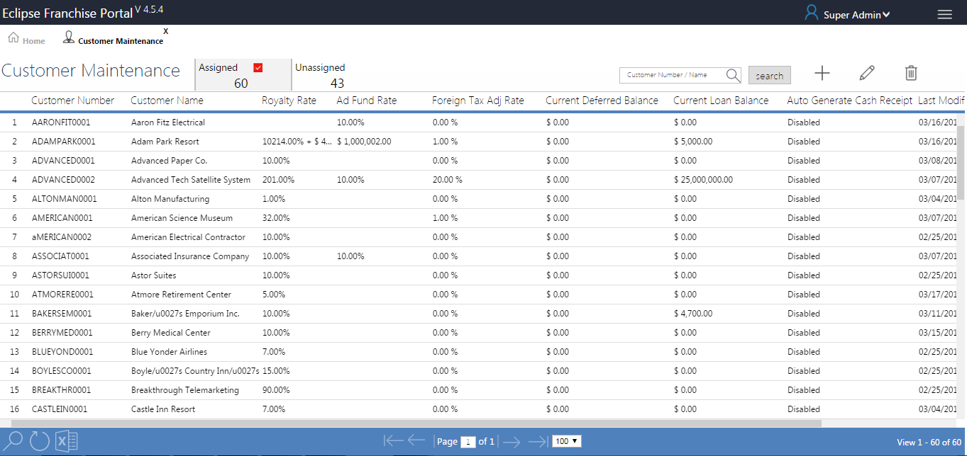

Grid SP - SP SP_EDP_CUSTOMER_MAINTENANCE__GRIDSEL (Module Menu Table)

Form - CustomerMaintenance.aspx

### Find Records

1. Click on find to search a required file with the available data.
2. Clicking on find the following text box pops up as shown below.
3. Enter the fields with the available data and click on find.
4. The searched file is displayed if found or else the page will be blank.

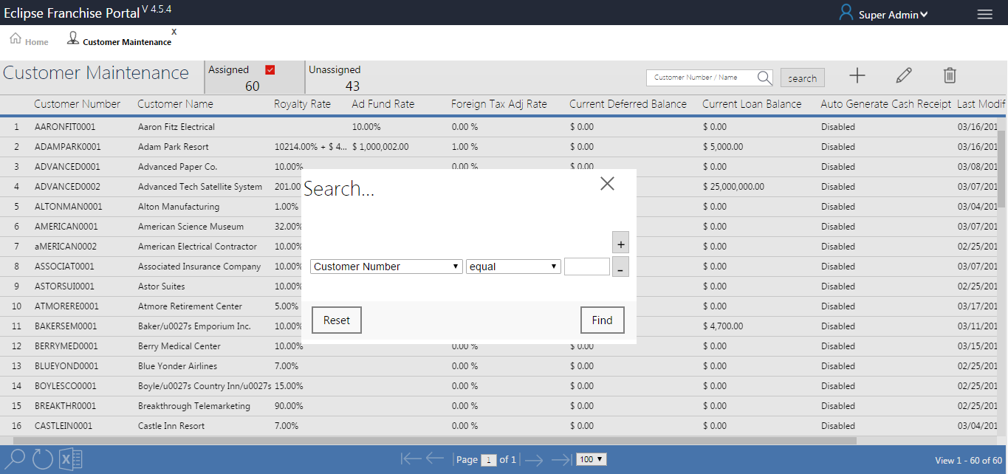

### Reload Grid

1. Click on Reload Grid button, Reloaded to whole grid.

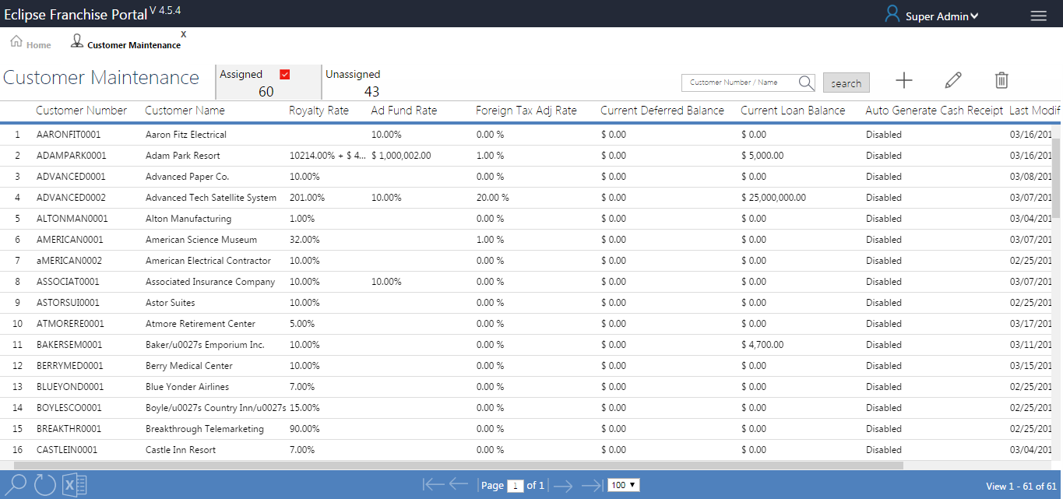

### Export to Excel

1. Click on Export to Excel button, generate to Excel sheet in left bottom of the page (SP_EDP_CUSTOMER_MAINTENANCE__GRIDSEL).

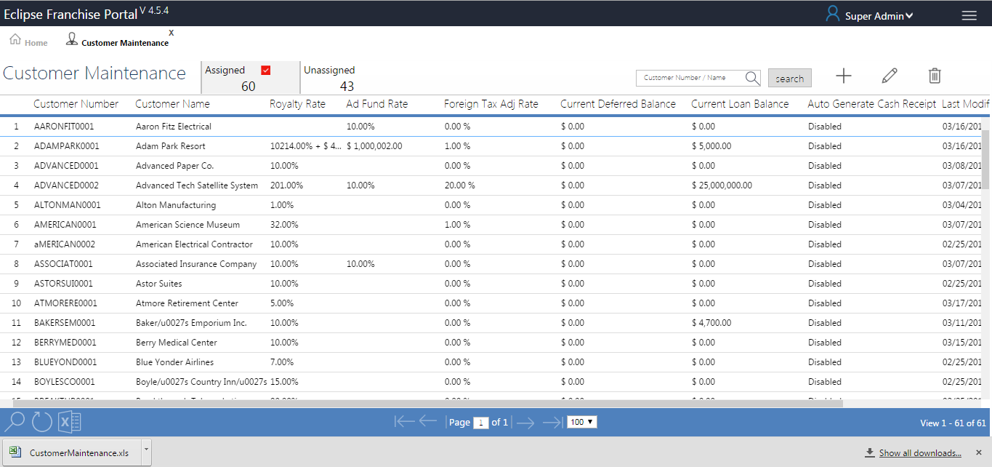

### Search

1. Enter the Customer Number/Name in the text box for filtration.
2. Click the Search button to filter the data shown below in grid.

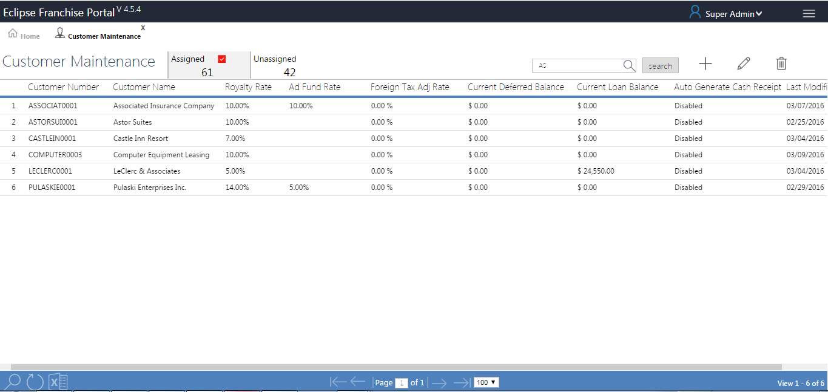

### Assigned and Unassigned

1. An assigned customer means we have a configuration for those customers in customer maintenance (SP_EFP_CustomerCount_DetailSel).

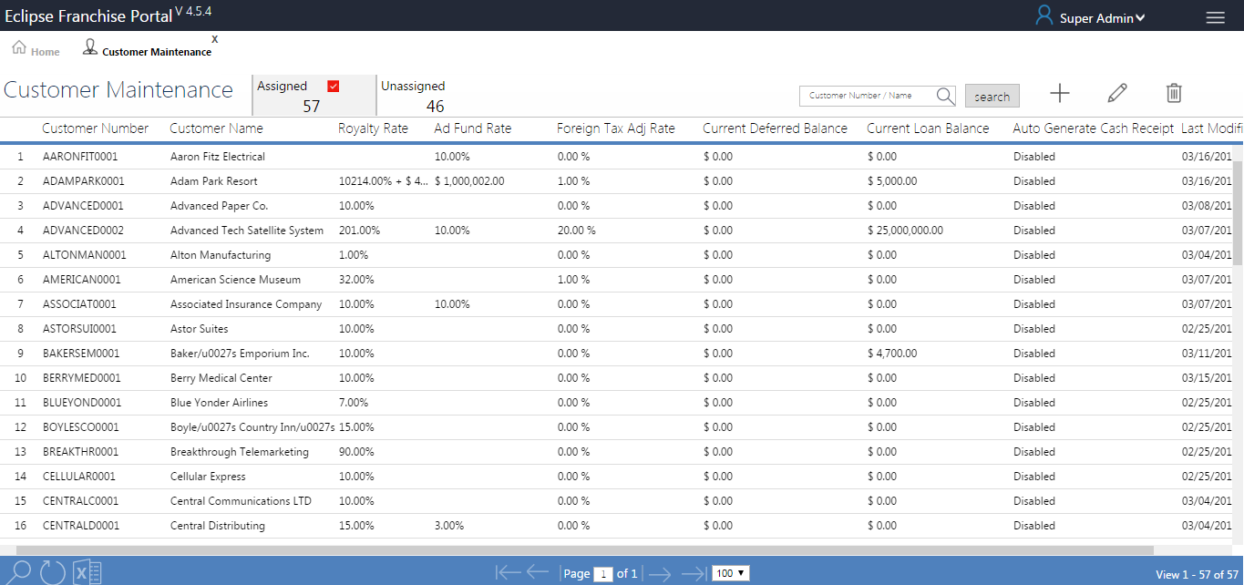

1. UN assigned customers do not have configuration in customer configuration (SP_EFP_CustomerCount_DetailSel).

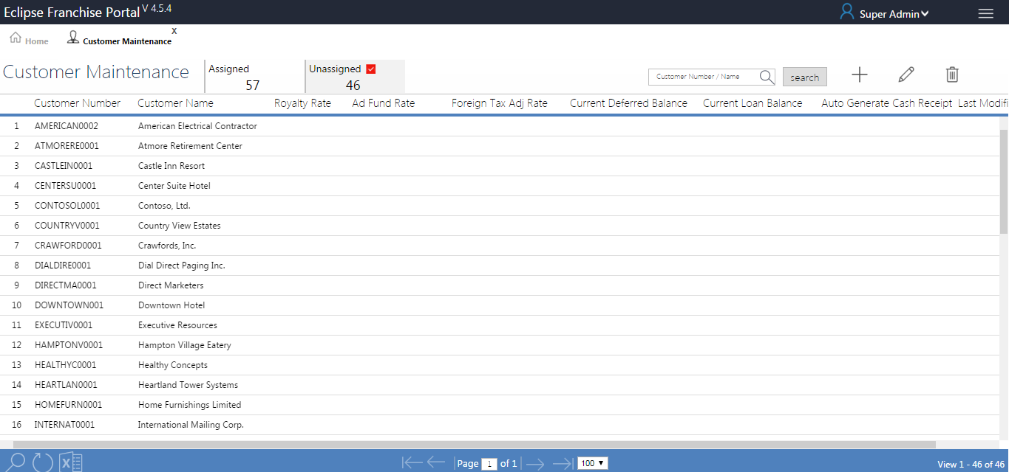

### Add New

1. Click on Add New button to view the Customer Maintenance Page.

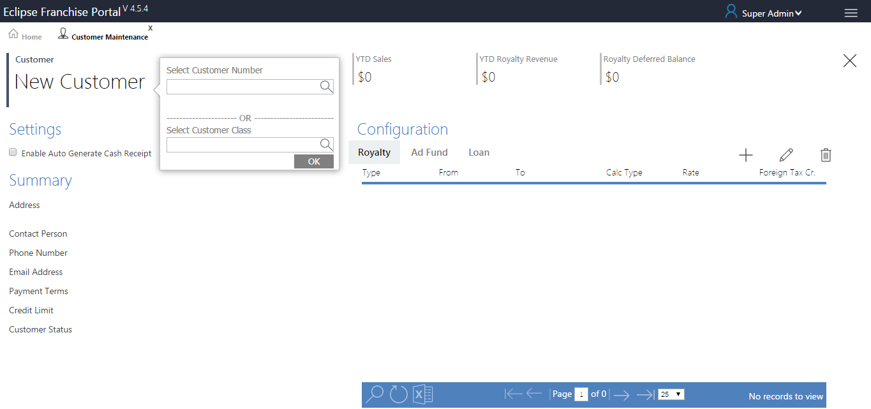

1. Select Customer Number or Class from the list (SP_CustNumberAutoComplete or SP_CustclassAutoComplete).
2. DefaultCompanyDB values stored in company based, the company will be get in System Setting page (dbo.EDPSystemSettings).
3. Customer Number generated based on matching data from the “GP table” dbo.RM00101 and Local table dbo.EDPFRACustomer.
4. Click ok to save Customer Number or Class in table (SP_EDP_CustMaintenance_JSON_INSUPD (dbo.EDPFRACustomer) ).
5. Based on the customer number selection the following fields will be used.
6. Total sales amount of customer is displayed in YTD Sales tile in the top, the value will be get from view table (vw_EDPFRASalesLine).
7. Settings option is used by check box to enable or disable (dbo.EDPFRACustomer).
8. Customer details displayed in Summary.

#### Royalty

1. YTD Royalty Revenue tile in the top, the value will be getting from view table (SP_YTDSalesSummary (vw_EDPFRARevenueHDR)).
2. Royalty Deferred Balance tile in the top, the value will be getting from view table (SP_YTDSalesSummary (dbo.EDPFRADeferHDR)).

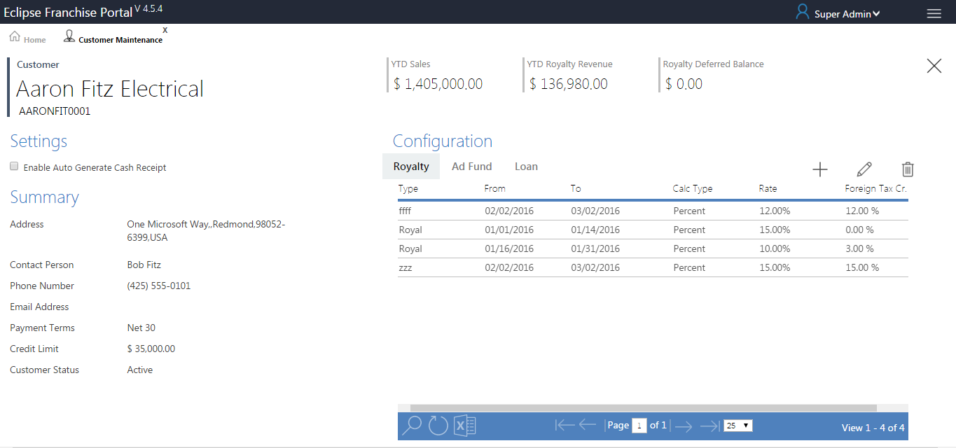

**Royalty Add New**

SAVE-SP - SP_EDP_CUSTOMER_MAINTENANCE_INSUPD

1. To Configuration Royalty, click add new button open royalty window.
2. Select Transaction type in drop down list (sp_RoyaltyCompanySelCombo (dbo.EDPFRARoyaltyConfig)).
3. Transaction type value based on fill Accounts Setup (Already inserted transaction type only displayed in transaction type dropdown list).
4. GP Company automatically filled in the text box based on transaction type value (SP_EDP_TranTypeDetailsel (EDPFRARoyaltyConfig)).
5. Chose Effective from Date after only show Account Setup window.
6. There are two Transactions type same Effective from and Effective to date will be try to user cannot save this table, alert message will be displayed.

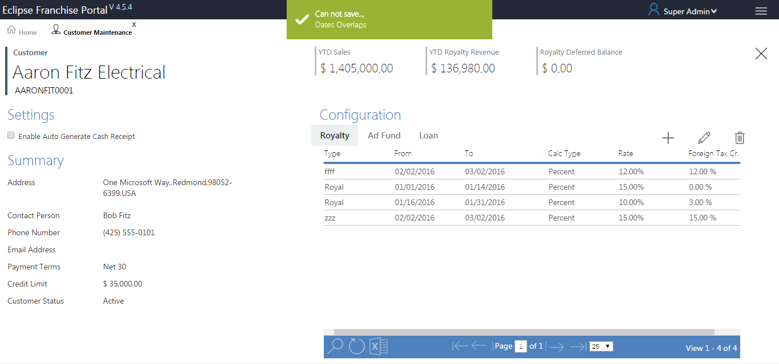

1. Select Calculation Type dropdown list after only enable Royalty Rate.
2. Transaction processed in GP, configuration alert message will be displayed.

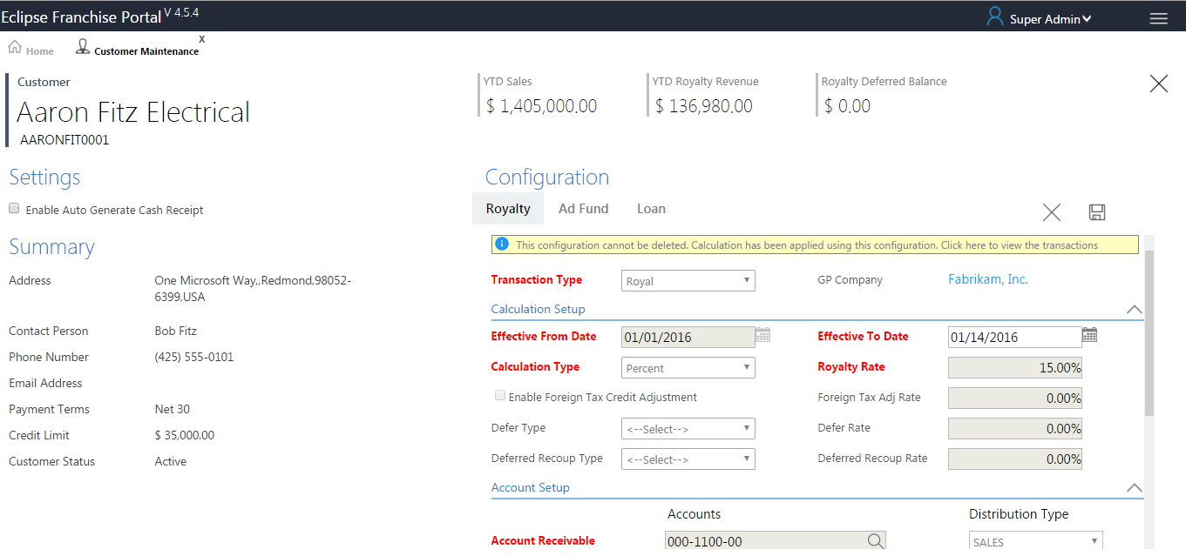

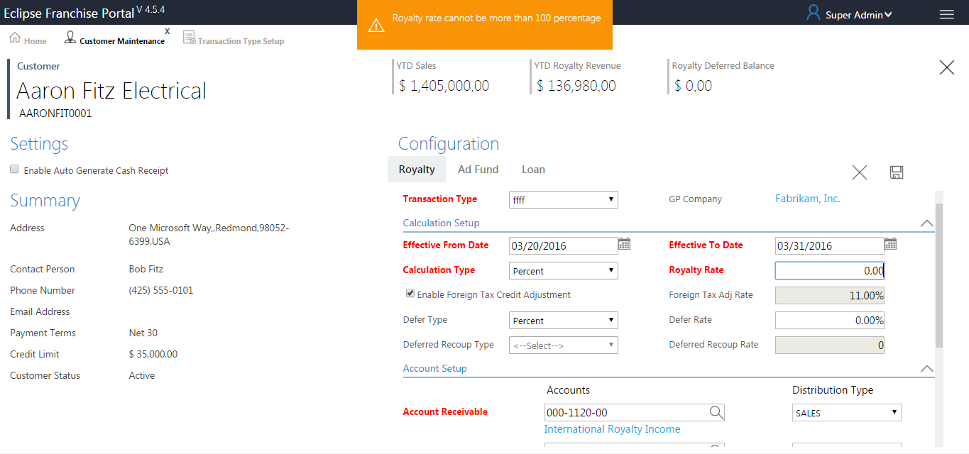

1. The above screen “Pop alert” present when we give more than 100% in Rate Field, this is applicable for all Rate Fields.
2. Mandatory fields mentioned by red colour.

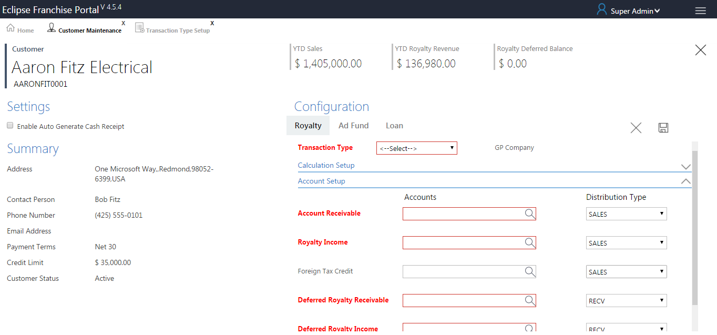

1. Foreign Tax Adj Rate enabled based on Foreign Tax Credit Adjustment Selection.
2. Defer Rate enabled based on Defer Type Selection.
3. Deferred Recoup Rate enabled based on   
   Deferred Recoup Type Selection.
4. For the customer once we selected the Defer Type then only the Rate Field section enabled but the Deferred Recoup Type fields are disabling.
5. All accounts fields generating based on (SP_DepitAccountAutoComplete (dbo.GL00100 and dbo.GL00105)), The values filled in base on companys (“para”).
6. All distribution Type fields generating based on (sp_GPDistributionTypesCombo (dbo. GPDistributionTypes)).
7. Click on save button Alert Message open as shown below (Configuration Created Successfully).

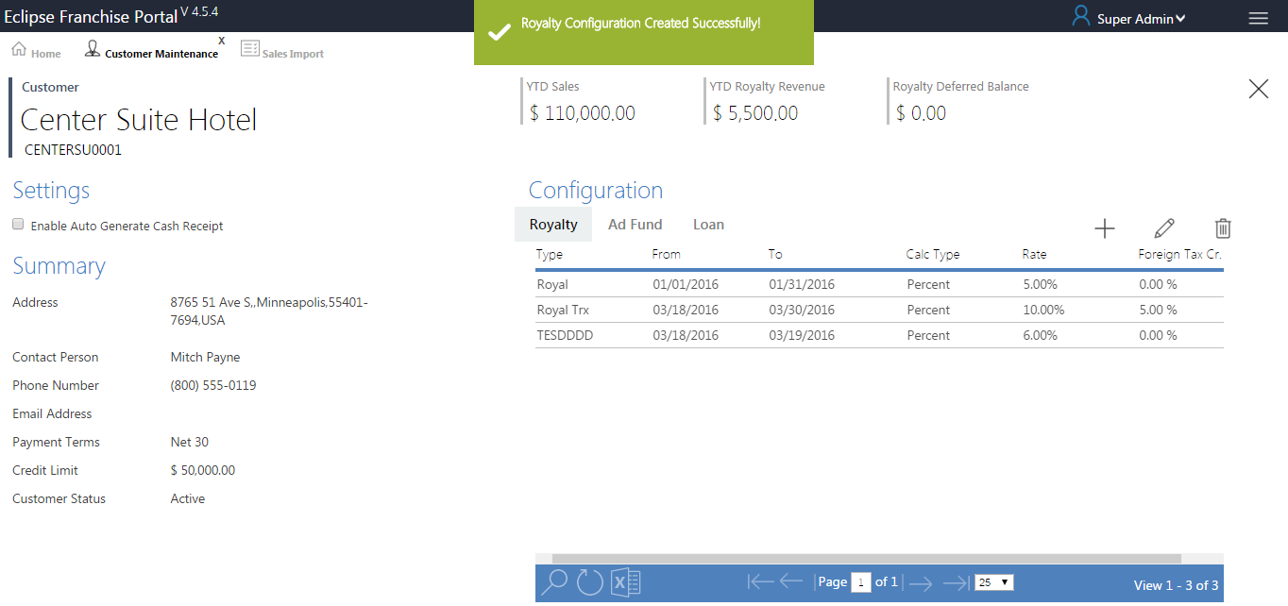

**Royalty Edit**

FILL-SP - SP_CMainRoyalty_DetailSel

SAVE-SP - SP_EDP_CUSTOMER_MAINTENANCE_INSUPD

1. Clicking on edit button or double click the grid row, Edit Window will be open up, make changes and click on save.
2. Change or Alter the values after click the save button, the values will be updated in Database.
3. Click on save button Alert Message open as shown below (Royalty Updated Successfully).

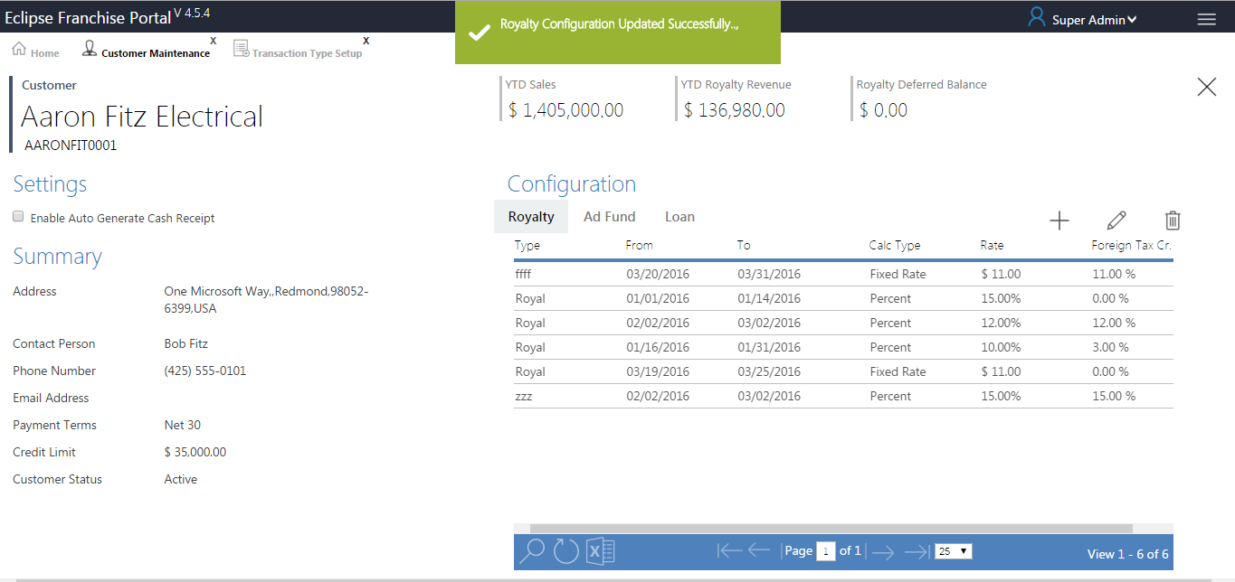

**Royalty Delete**

EDIT SP - SP_EDP_CUSTOMER_MAINTENANCE_INSUPD

1. Select a row and click delete, a pop up window is displayed.
2. Click on delete record, the record is deleted completely.

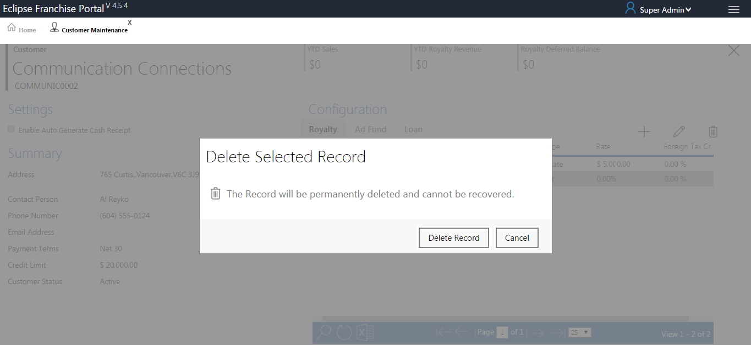

1. Clicking on save button Alert Message open as shown below (Customer Configuration deleted successfully).

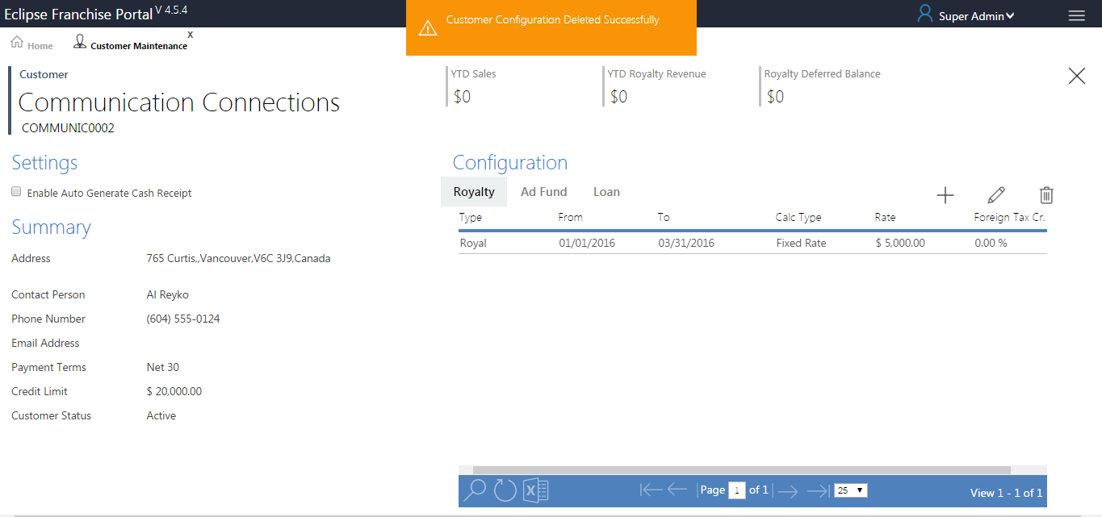

#### Ad Fund

1. YTD Ad Fund tile in the top, the value will be getting from view table (SP_YTDSalesSummary (vw_EDPFRARevenueHDR)).
2. Ad Fund Deferred Balance tile in the top, the value will be getting from view table (SP_YTDSalesSummary ([dbo].[EDPFRADeferHDR])).

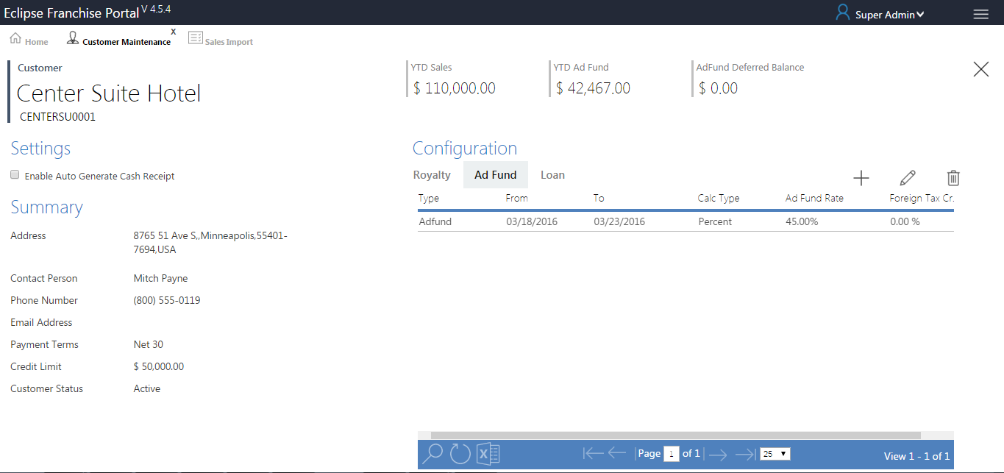

**Ad Fund Add New**

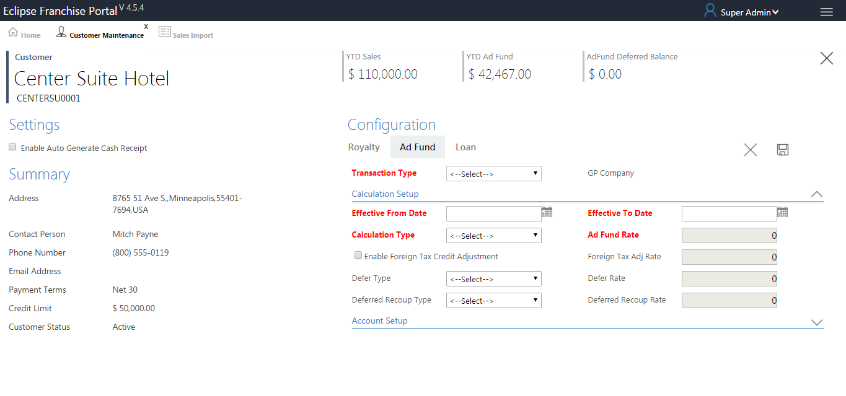

SAVE-SP - SP_EDP_CUSTOMER_MAINTENANCE_AD_INSUPD

1. Configuration Ad Fund, click add new button open Ad Fund window.
2. Select Transaction type in drop down list (sp_RoyaltyCompanySelCombo (dbo.EDPFRARoyaltyConfig)).
3. Transaction type value based on fill Accounts Setup fields (Already inserted transaction type only displayed in transaction type dropdown list).
4. GP Company automatically filled in the text box based on transaction type value (SP_EDP_TranTypeDetailsel (EDPFRARoyaltyConfig)).
5. Chose Effective from Date after only show Account Setup window.
6. There are two Transactions type same Effective from and Effective to date will be try to user cannot save this table, alert message will be displayed.

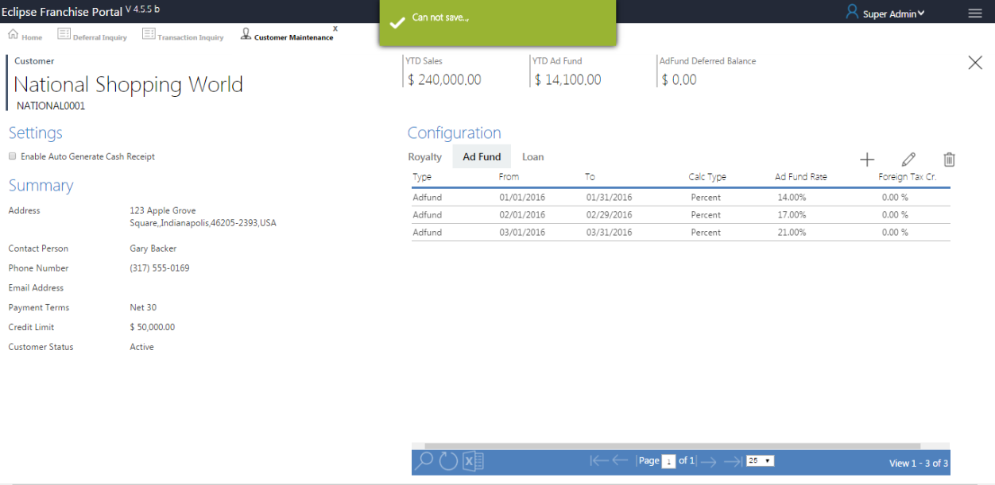

1. Select Calculation Type dropdown list after only enable Royalty Rate.
2. Transaction processed in GP, configuration alert message will be displayed.

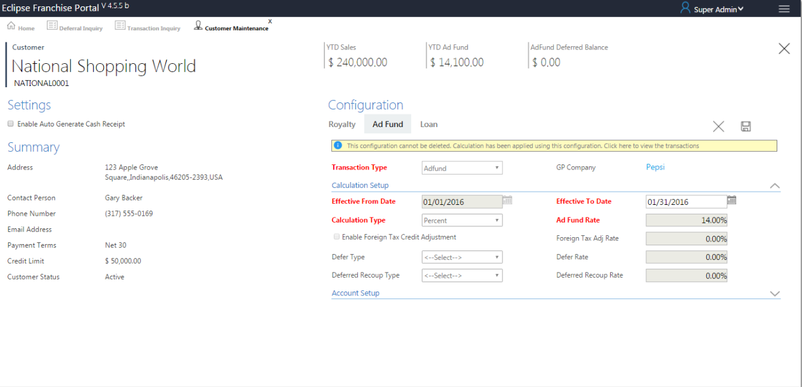



1. The above screen “Pop alert” present when we give more than 100% in Rate Field, this is applicable for all Rate Fields.
2. Mandatory fields mentioned by red colour.



1. Foreign Tax Adj Rate enabled based on Foreign Tax Credit Adjustment Selection.
2. Defer Rate enabled based on Defer Type Selection.
3. Deferred Recoup Rate enabled based on   
   Deferred Recoup Type Selection.
4. For the customer once we selected the Defer Type then only the Rate Field section enabled but the Deferred Recoup Type fields are disabling.
5. All accounts fields generating based on (SP_DepitAccountAutoComplete (dbo.GL00100 and dbo.GL00105)), The values filled in base on companys (“para”).
6. All distribution Type fields generating based on (sp_GPDistributionTypesCombo (dbo. GPDistributionTypes)).
7. Click on save button Alert Message open as shown below (Configuration Created Successfully).

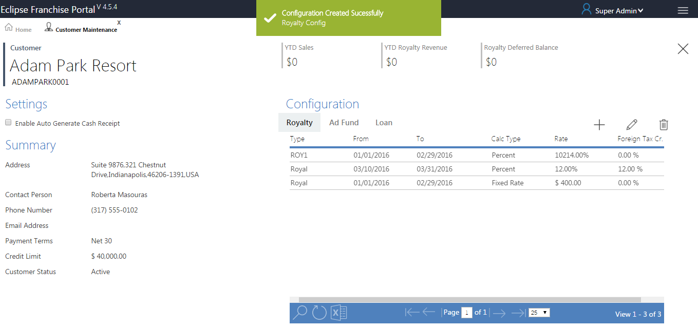

**Ad Fund Edit**

FILL-SP - SP_CMainAdRevenue_DetailSel

SAVE-SP - SP_EDP_CUSTOMER_MAINTENANCE_AD_INSUPD

1. Clicking on edit button or double click the grid row, Edit page will be open up, make changes and click on save.
2. Change or Alter the values after click the save button, the values will be updated in Database.

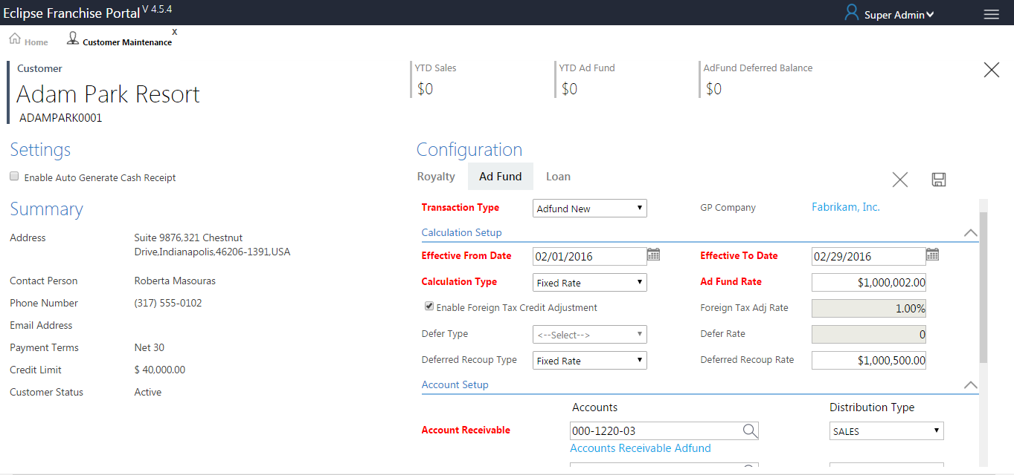

1. Clicking on save button Alert Message open as shown below (AD Fund Updated Successfully).

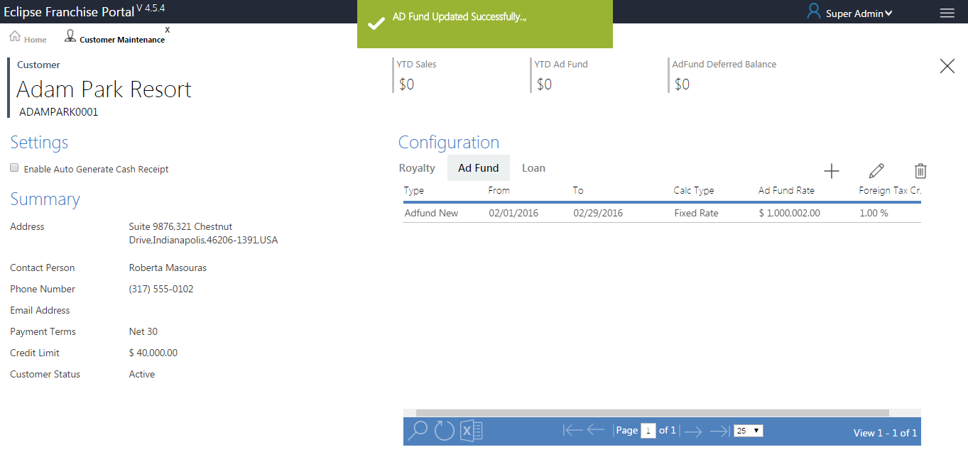

**Ad Fund Delete**

DELETE SP - SP_EDP_CUSTOMER_MAINTENANCE_AD_INSUPD

1. Select a row and click delete, a pop up window is displayed.
2. Click on delete record, the record is deleted completely.

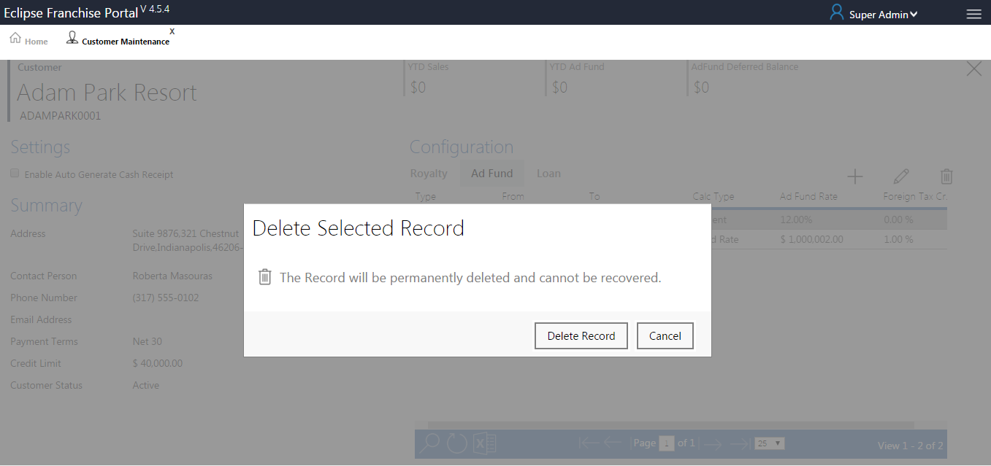

1. Click on save button Alert Message open as shown below (Customer Configuration deleted successfully).

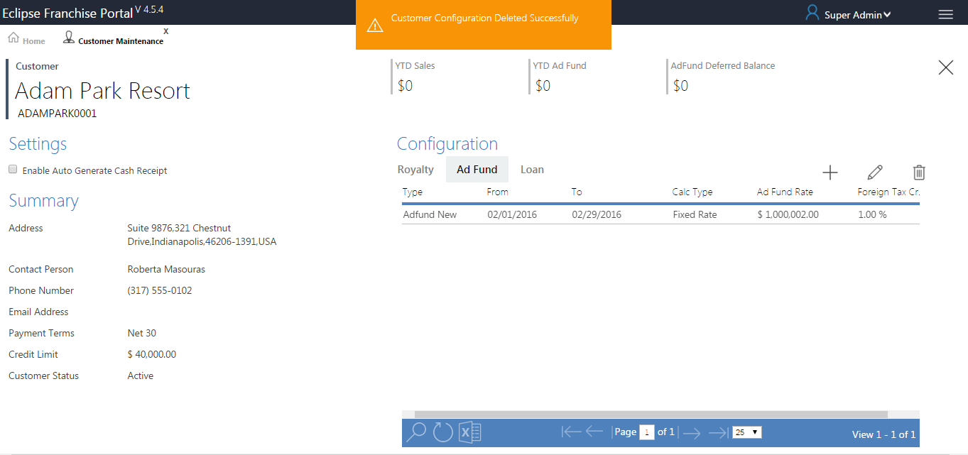

#### Loan

1. Current Loan Balance tile in the top, the value will be getting from view table (SP_YTDSalesSummary ([dbo].EDPFRALoanHDR)).

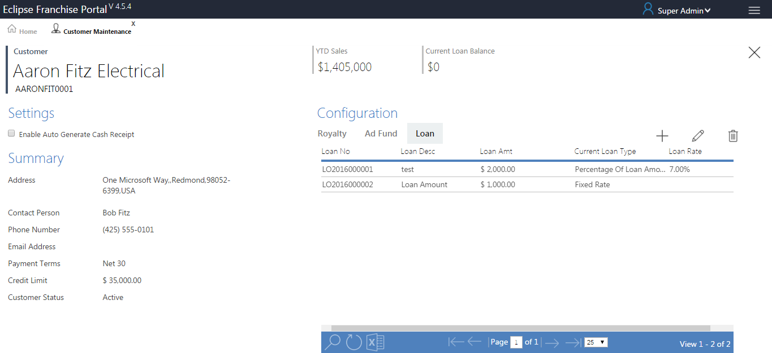

**Loan Add New**

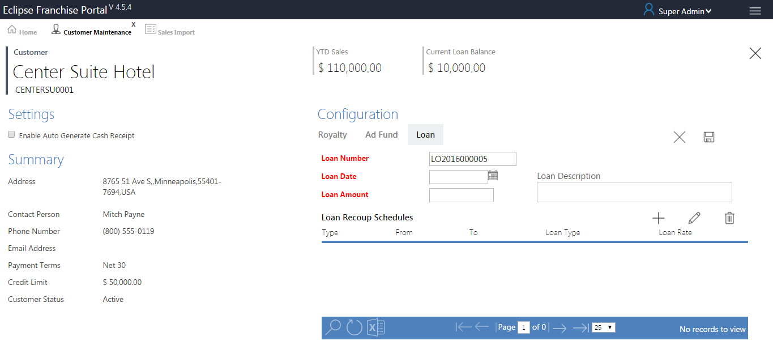

1. Loan Number generates automatically loan number text box (SP_EDP_GENERATE_LOANNUMBER (dbo.EDPFRALoanHDR)).
2. Select date from Loan date field.
3. Enter the amount value Loan Amount field.
4. Enter Description in Loan Description field.

**Loan Recoup Schedules**

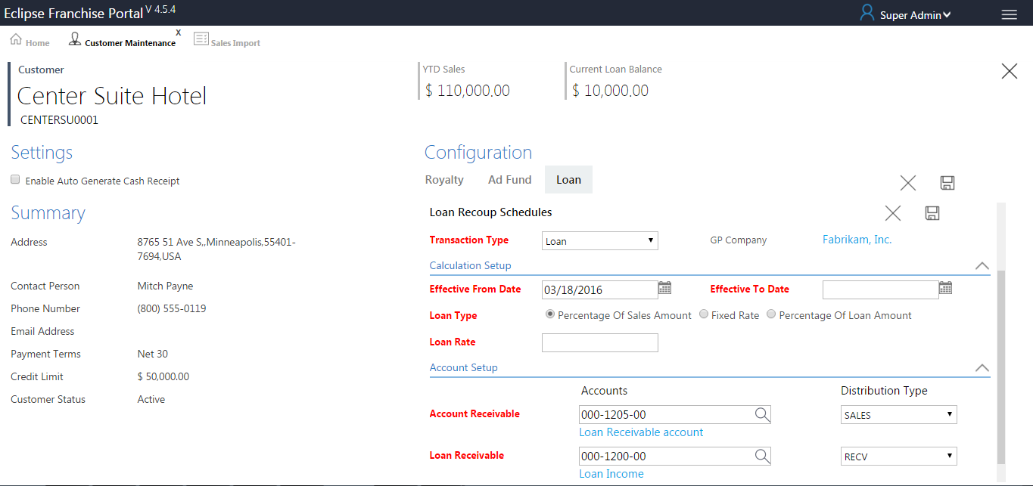

1. Select Transaction type in drop down list (sp_LoanRevenueCompanySelCombo (dbo.EDPFRARoyaltyConfig)).
2. Transaction type value based on fill Accounts Setup fields (Already inserted transaction type Loan “Category=3” only displayed in transaction type dropdown list).
3. GP Company automatically filled in the text box based on transaction type value (SP_EDP_TranTypeDetailsel (EDPFRARoyaltyConfig)).
4. Transaction processed in GP, configuration alert message will be displayed.
5. Chose Effective from Date after only show Account Setup window.
6. There are two Transactions type same Effective from and Effective to date will be try to user cannot save this table, alert message will be displayed.

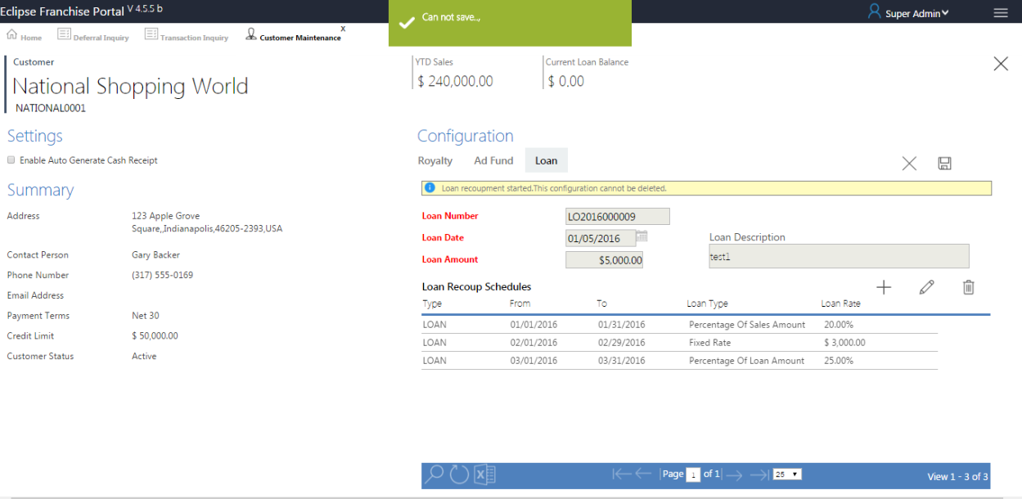

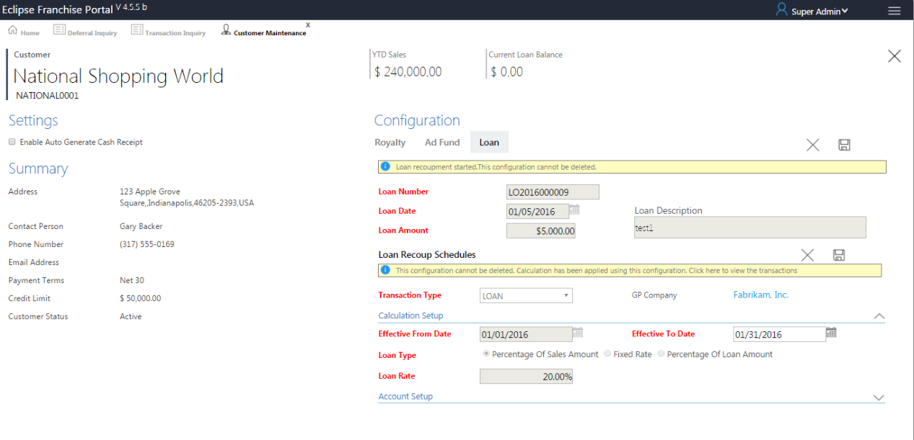

1. Transaction processed in GP, configuration alert message will be displayed.
2. Select Loan Type dropdown list after only enable Loan Rate.
3. All accounts fields generating based on (SP_DepitAccountAutoComplete (dbo.GL00100 and dbo.GL00105)), The values filled in base on companys (“para”).
4. All distribution Type fields generating based on (sp_GPDistributionTypesCombo (dbo. GPDistributionTypes)).

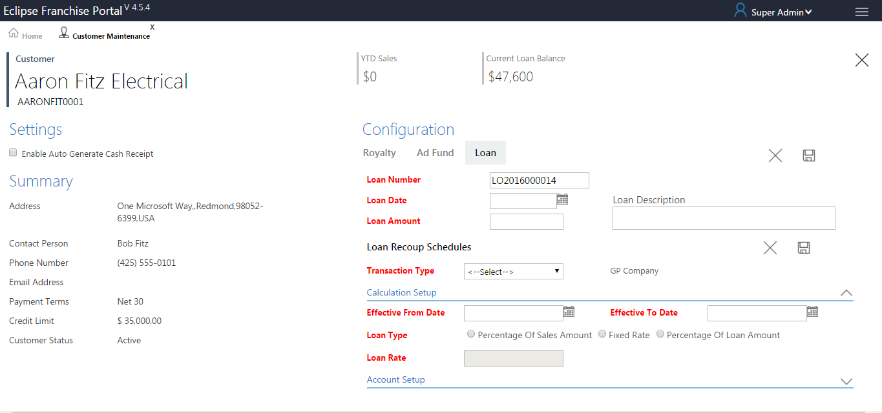

**Loan Edit**

FILL-SP - SP_LoanHDR_DetailSel

SAVE-SP - SP_EDP_CUSTOMER_MAINTENANCE_LOAN_HDR_INSUPD

1. Clicking on edit button or double click the grid row, Edit page will be open up, make changes and click on save.
2. Change or Alter the values after click the save button, the values will be updated in Database.

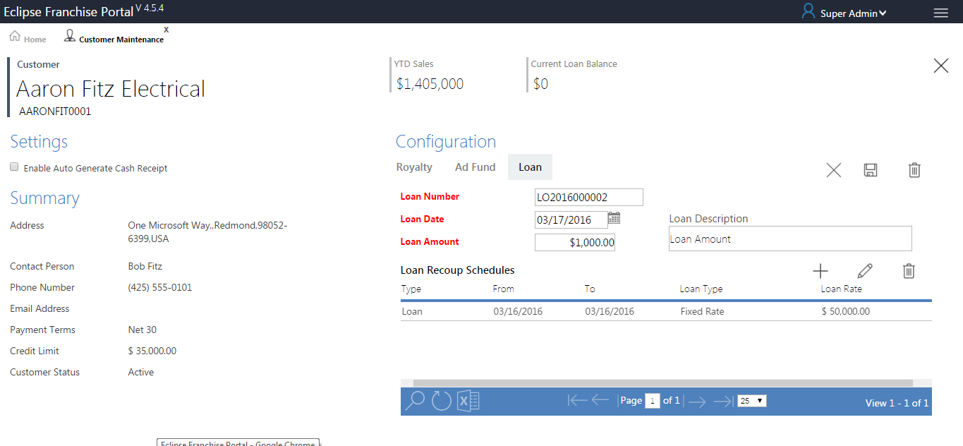

**Loan Delete**

DELETE SP - SP_EDP_CUSTOMER_MAINTENANCE_LOAN_HDR_INSUPD

1. Select a row and click delete, a pop up window is displayed.
2. Click on delete record, the record is deleted completely.

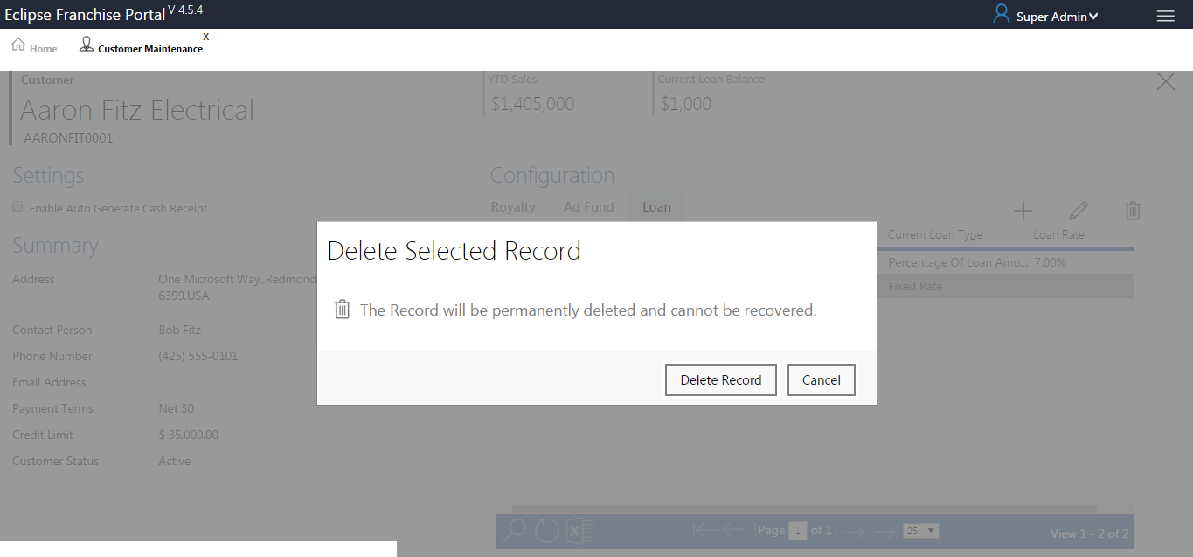

1. Clicking on save button Alert Message open as shown below (Customer Configuration deleted successfully).

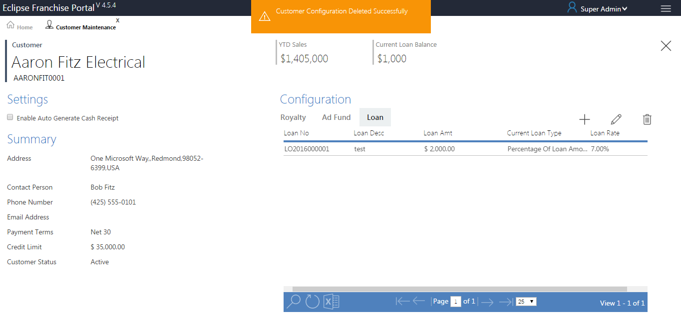

### Edit

EDIT SP -SP_EDP_CUST_MAINTENANCE_INSUPD

1. Clicking on edit button or double click the grid row, Edit page will be open up, make changes and click on save.
2. Change or Alter the values after click the save button, the values will be updated in Database.

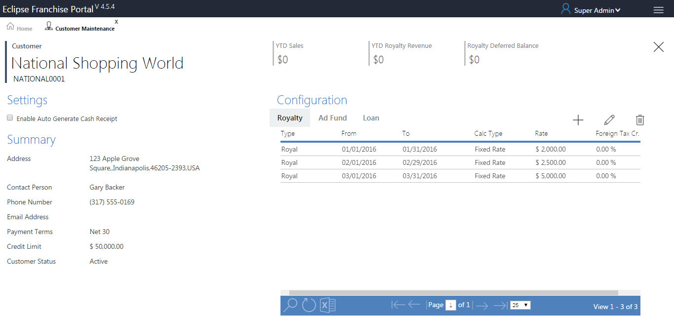

### Delete

DELETE SP - SP_EDP_CUST_MAINTENANCE_INSUPD

1. Select a row and click delete, a pop up window is displayed.
2. Click on delete record, the record is deleted completely.

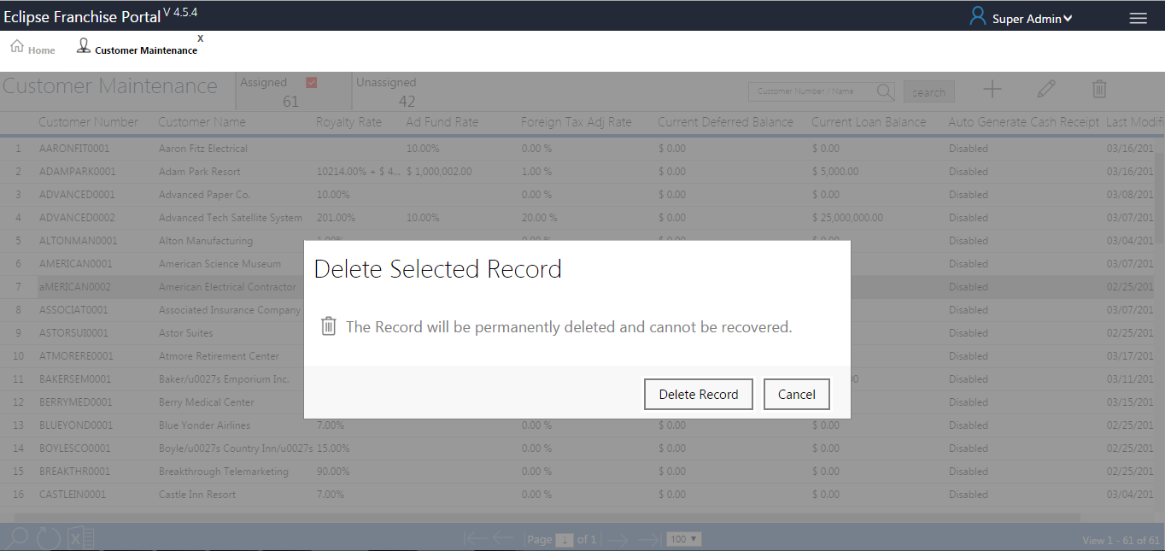

1. Clicking on save button Alert Message open as shown below (Customer deleted successfully).

