Wing Stop User Guide



Table of Contents
1 Franchise Admin 3
1.1 Trans Type 3
1.1.1 Find Records 3
1.1.2 Reload Grid 4
1.1.3 Export to Excel 4
1.1.4 Add New 5
1.1.5 Edit 7
1.1.6 Delete 8

Franchise Admin

Trans Type

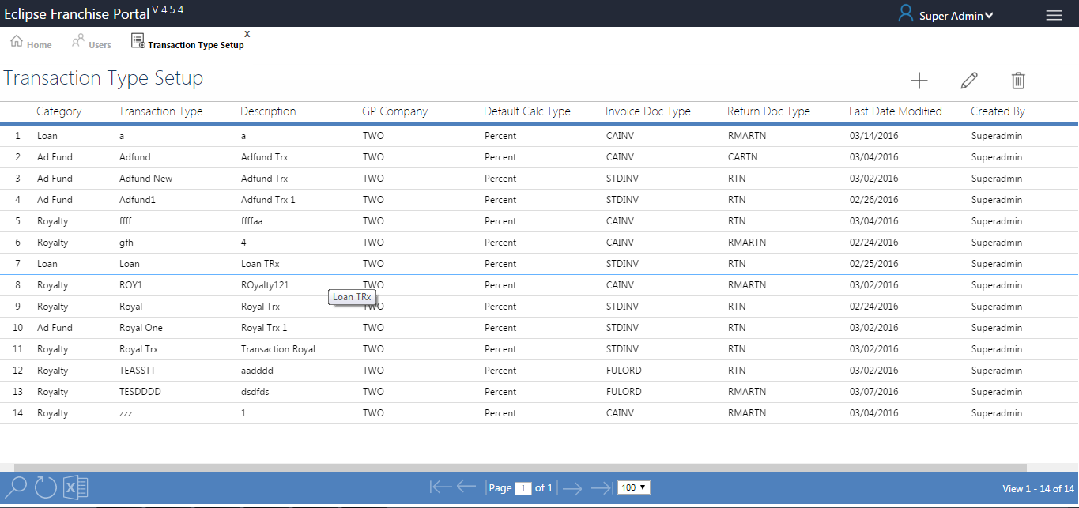
Grid SP - SP_EDP_TransactionTypeSetup_GRID (Module Menu Table)
Form - TransactionTypeSetup.aspx

Find Records
- Click on find to search a required file with the available data.
- Clicking on find the following text box pops up as shown below.
- Enter the fields with the available data and click on find.
- The searched file is displayed if found or else the page will be blank.
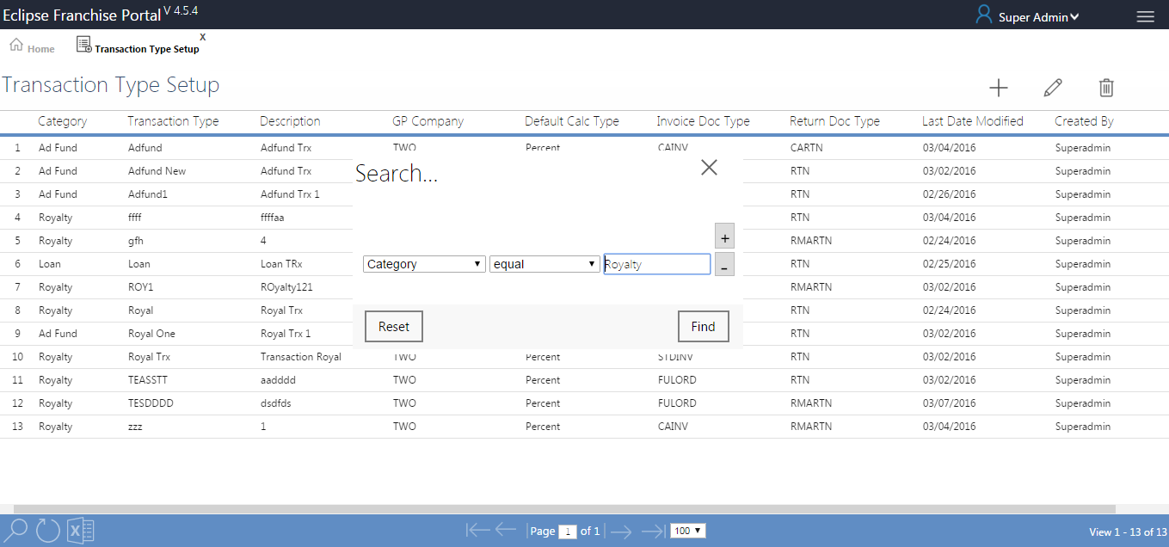

Reload Grid
- Click on Reload Grid button, Reloaded to whole grid.
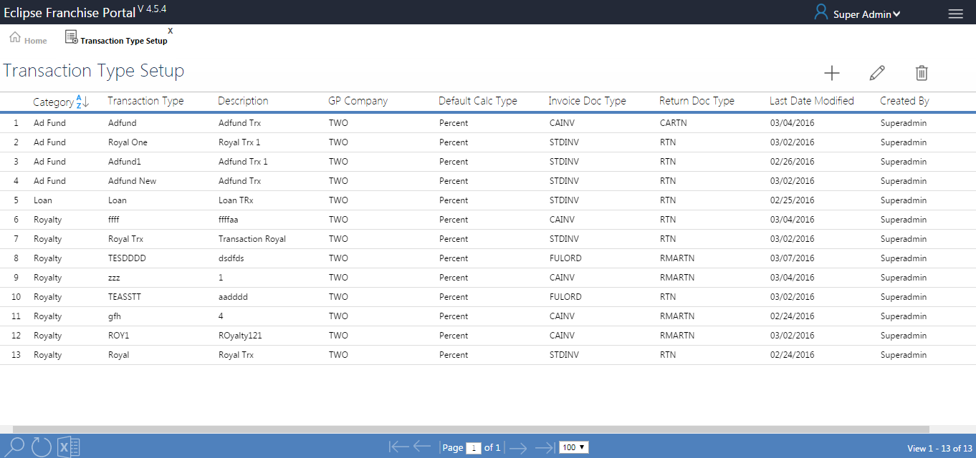

Export to Excel
- Click on Export to Excel button, generate to Excel sheet in left bottom of the page (SP_EDP_TransactionTypeSetup_GRID).
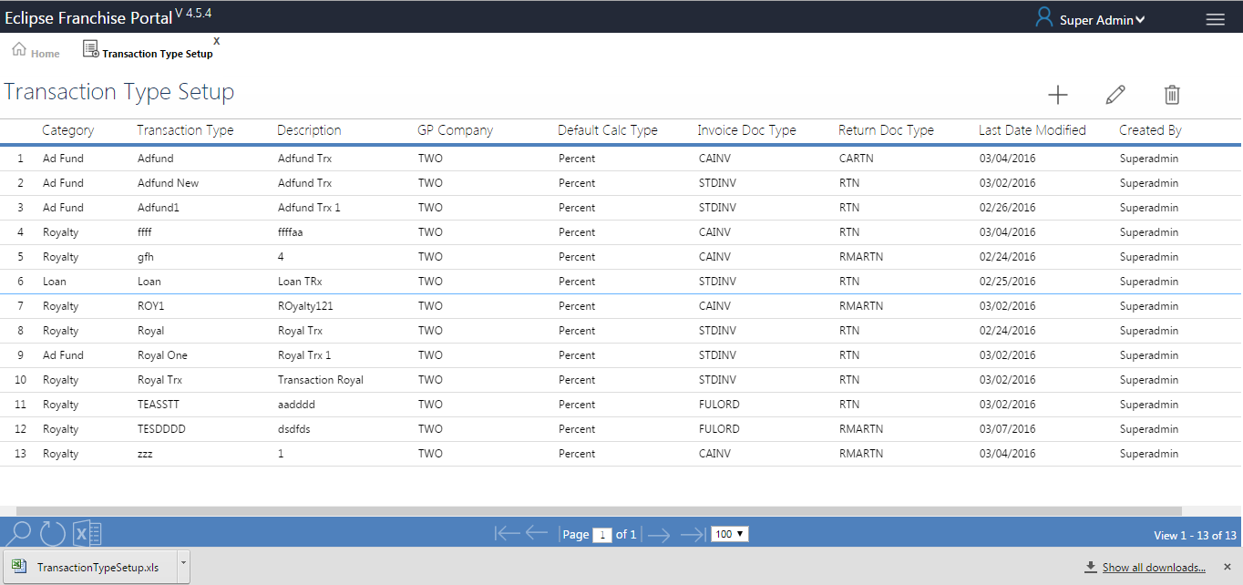

Add New

- Click on Add New button to view the Transaction Type Page.
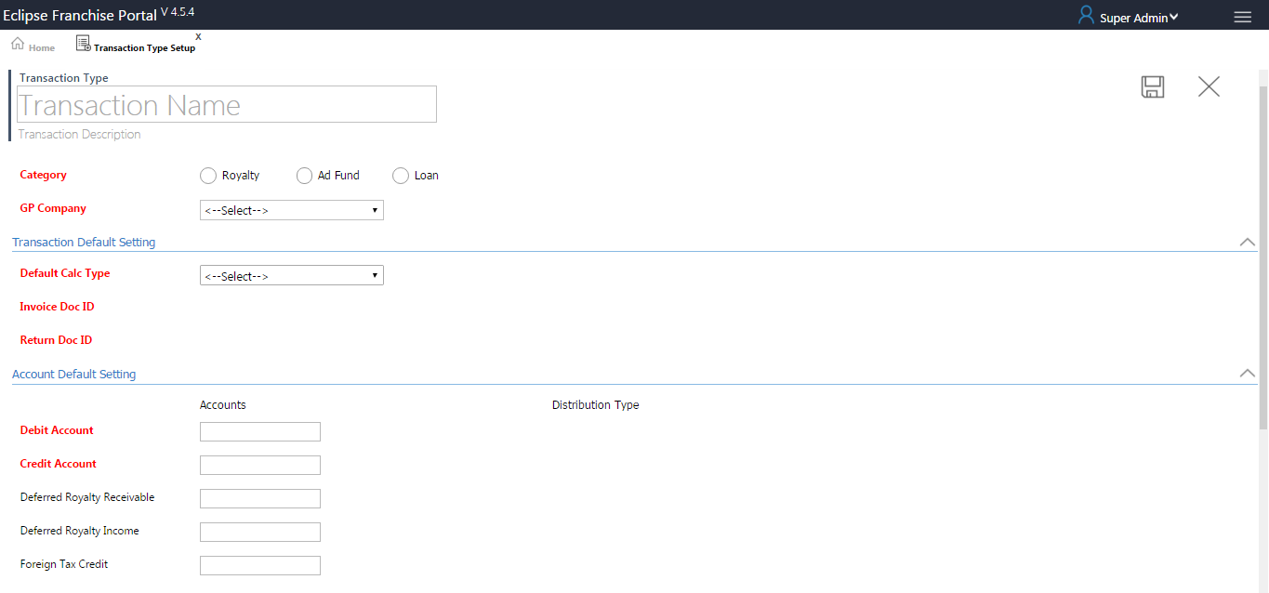
- Fill the all fields (Mandatory fields are highlighted in red colour font)
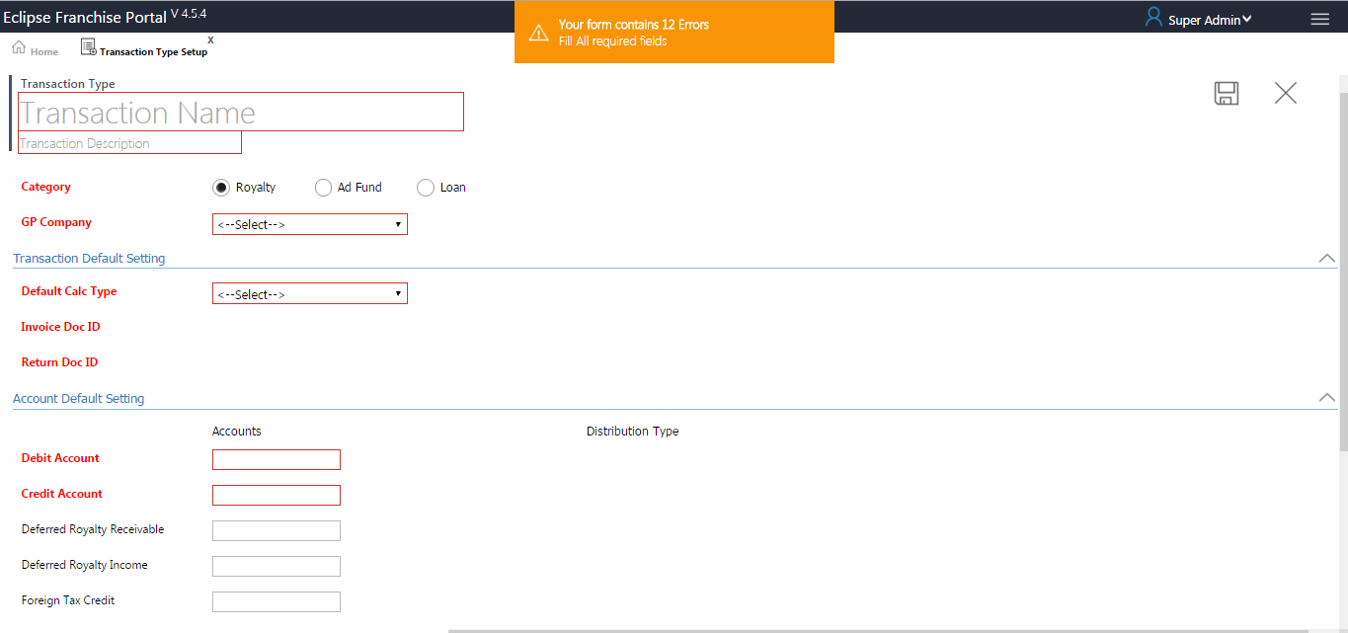
- Enter transaction name and transaction description.
- Select category in radio button.
- Select GP Company from the dropdown list in this field “CMPNYNAM” based on Synonyms (sp_CompanySelCombo(synSY01500)).
- Based on the company selection the following fields are loaded
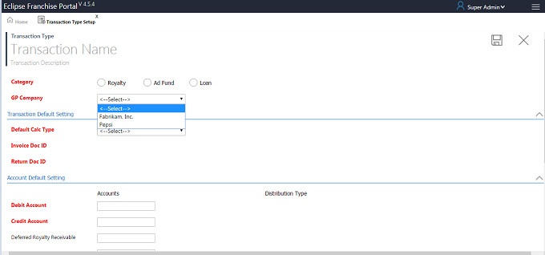
- Transaction Default Setting
- Default Calc Type based on Percent and Fixed Rate, It will be declared in default to transaction type page (% and $).
- Invoice Doc ID generating based on Field “SOPTYPE=3”, linked server and company DB defined System Setting (SP_EDP_DOCTYPE_Invoice_COMBO (dbo.SOP40200)).
- Return Doc ID generating based on “SOPTYPE=4”, linked server and company DB defined in System Settings (SP_EDP_DOCTYPE_RETURN_COMBO(dbo.SOP40200)).
- Account Default Setting
- All accounts fields generating based on “ACTIVE=1” matching data from “GP tables” ..GL00100 (ACTNUMST account value field) and ..GL00105 (ACTDESCR Distribution value field) (SP_DepitAccountAutoComplete(dbo.GL00100 and dbo.GL00105)).
- All distribution Type fields generating based on “Type” in this fiels (sp_GPDistributionTypesCombo(dbo.GPDistributionTypes)).

- GP Items Mapping
- Gp Items Mapping, All fields are generating by based on this fields “ITEMNMBR,ITEMDESC” using GP table ..IV00101 (SP_EDP_Item_COMBO(dbo.IV00101)).
- Clicking on save button Alert Message open as shown below (Transaction Type Created).
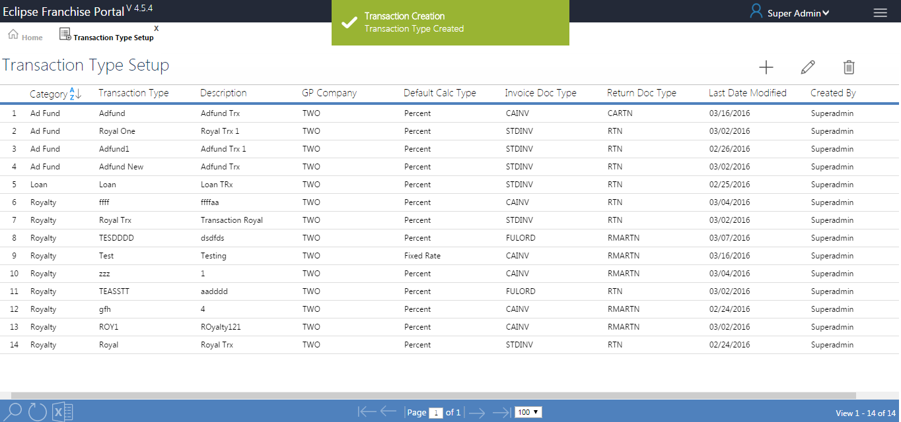

Edit
FILL-SP - SP_EDP_TRANSACTION_DETAILSEL
SAVE-SP - SP_EDP_TRANSACTION_JSON_INSUPD
- Clicking on edit button or double click the grid row, Edit page will be open up, make changes and click on save.
- Change or Alter the values after click the save button, the values will be updated in Database.
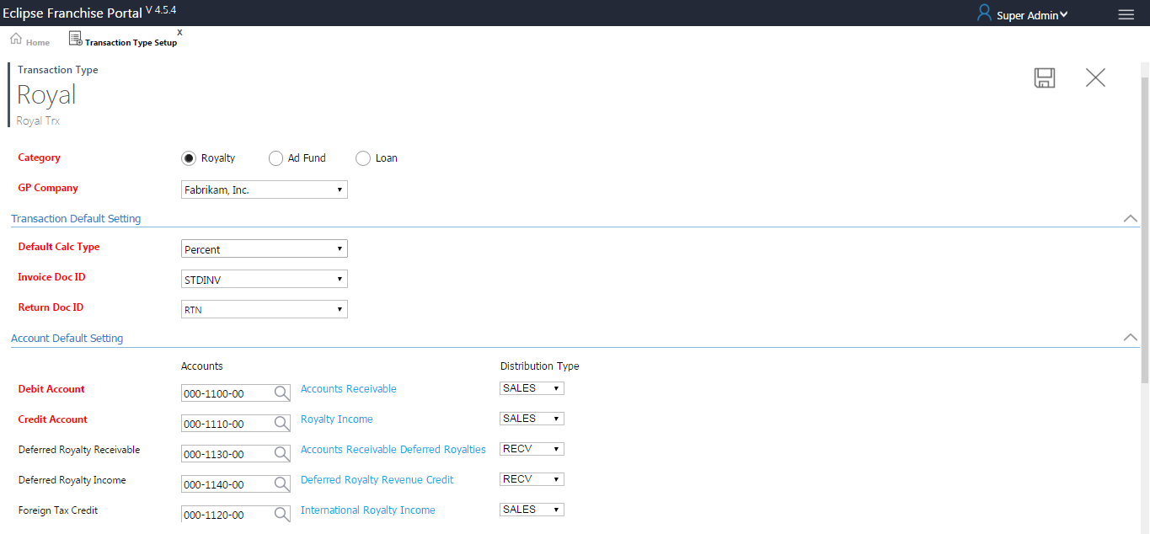
- Clicking on save button Alert Message open as shown below (Transaction Updated).
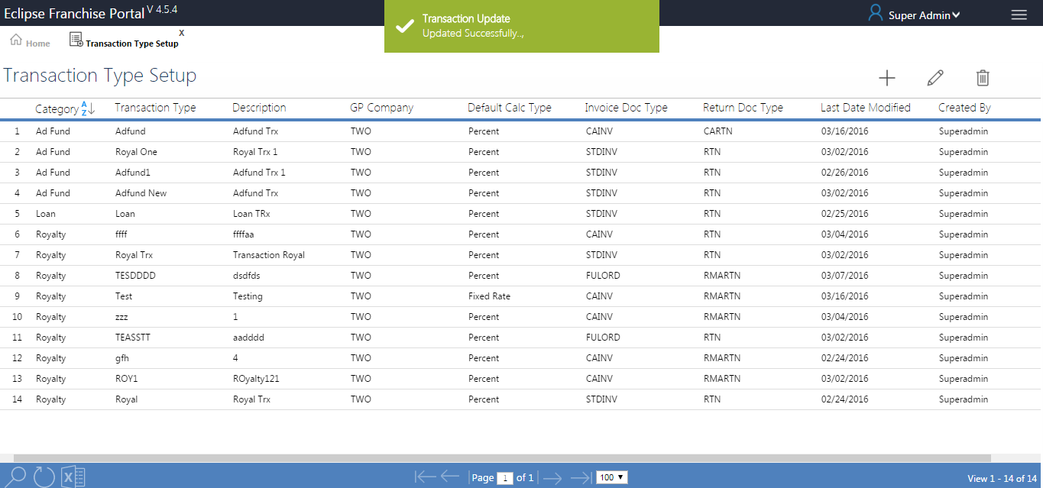

Delete
DELETE-SP - SP_EDP_TRANSACTION_JSON_INSUPD
- Select a row and click delete, a pop up window is displayed.
- Click on delete record, the record is deleted completely.

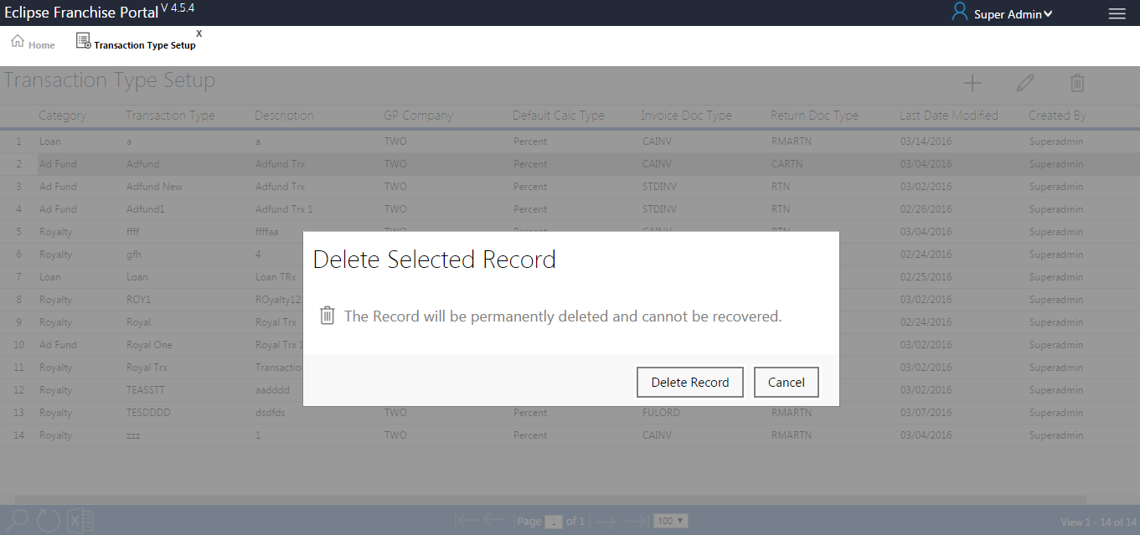
- Clicking on save button Alert Message open as shown below (Transaction Setup deleted successfully).
