HIMAL-CUAS
High-Altitude Intelligent Modular Counter-UAS System
Idea Report — Smart India Hackathon 2026, Problem Statement SIH26050
High Altitude Performance Optimization and Robust Design of Anti-Drone System · Theme: Robotics and Drone · Category: Hardware
Team PLUTO · Team ID: 161855 · College: Dr. Ambedkar Institute of Technology
Table of Contents
Abstract 3
Idea Overview 3
Problem Statement (Pain Points) 4
1. Extreme Cold and Battery Loss 4
2. Low Pressure and Reduced Cooling 4
3. Dust, Snow and Icing 5
4. Wind, Vibration and Thermal Cycling 5
5. Limited Power and Remote Access 5
6. Hidden Degradation and No Early Warning 5
Existing Solutions and Research Gap 5
Proposed Solution 6
System Structure 7
1. Detection Subsystem 9
2. Pan-Tilt Tracking Mount 9
3. Response Interface (Sound Cannon) 9
4. Protective Enclosure 9
5. Thermal Control 9
6. Power System 9
7. Health Monitoring Layer 9
8. Operator Console 9
Technical Approach 10
1. Detection, Tracking and Response 10
2. Enclosure and Thermal Management 11
3. Solar-Battery Power System 13
4. Health Monitoring and Predictive Maintenance 15
Working Mechanism 18
Dashboard and Monitoring System 19
Technology Stack and Implementation Plan 21
1. Technology Stack 21
2. Prototype Scope 22
3. Implementation Roadmap 22
4. Demonstration Scenario 22
Feasibility and Viability 23
1. Feasibility Analysis 23
2. Risks and Mitigation 23
3. Validation Plan 23
Estimated Prototype Budget 24
Impact, Sustainability and Market Opportunity 25
Limitations and Future Scope 25
Conclusion 26
References 26

List of Figures
Figure 1: System architecture of HIMAL-CUAS: high-altitude environment and solar power feed detection, protection, thermal and stabilisation subsystems, all supervised by the health-monitoring layer and reported through the PRAAN operator dashboard. 7
Figure 2: Mechanical concept of the node: rotating antenna head, sound cannon on the mast and processor base (from the team's own concept drawing). 8
Figure 3: Layered enclosure cross-section, outside to inside: outer shell, anti-icing coating, reflective foil, aerogel insulation, dry-nitrogen cavity, heater film, heat-spreader plate and the electronics plate, with the internal processor block shown separately. 12
Figure 4: Health-monitoring architecture: Guardian MCU (Tier 0, layers L0–L1) and Analyst computer (Tier 1, layers L2–L5), both supervised by the independent watchdog chain W1–W4. 16
Figure 5: PRAAN operator console in nominal state: mode, capability gauges, BIT strip, detection scope, telemetry, trends, survival margin and event log. 20
Figure 6: PRAAN console after an injected radome-icing fault: capability gauges drop, BIT lights change, the survival margin shifts and an actionable alert is logged. 21

Abstract
HIMAL-CUAS is a modular counter-drone sensing and tracking node built to keep working at 4,000 m and above, where extreme cold, thin air, wind, snow, dust, icing, thermal cycling and the absence of grid power degrade sensors, electronics and batteries. The node fuses passive radio-frequency (RF) detection with radar, tracks targets with a wind-compensated pan-tilt mount, and offers a directional acoustic “sound cannon” as a response interface that is only simulated in the prototype. Its survivability comes from four co-designed subsystems: a layered aerogel, dry-nitrogen and heated-radome enclosure; zonal active heating with independent hardware interlocks; a solar-plus-battery power chain with MPPT charging, storm mode and load shedding; and a model-based predictive health-monitoring layer that compares live behaviour with physical expectations and warns before parts fail. An operator dashboard turns this into four capability scores, actionable alerts and simulated response commands. This report presents the architecture, design equations, risk analysis, validation plan and an indicative prototype budget for problem statement SIH26050. The design is a proposal; no field measurements are claimed.

Idea Overview
HIMAL-CUAS is designed as a smart, self-protecting drone-watch node placed at a remote high-altitude post. Instead of assuming a warm, grid-powered, easily serviced site, it treats survival in the mountains as part of the design, so that detection and tracking stay reliable when conventional systems lose accuracy or availability.
The system combines five main technologies:
- RF and radar based multi-sensor drone detection with wind-compensated pan-tilt tracking
- Dry-nitrogen aerogel enclosure with zonal active heating and heated radome
- Solar-battery power management with MPPT, storm mode and load shedding
- Predictive health monitoring that names failing parts and forecasts remaining life
- Operator dashboard with a simulated, operator-gated sound-cannon response
In operation, the node listens passively for drone control links, confirms and locates targets with radar, points its antenna head at them and reports confidence and bearing on the dashboard. In the background it keeps every zone warm, manages its solar-battery budget and continuously compares its own behaviour with physical models, so an iced radome, a leaking seal or a weakening battery is flagged early instead of being found after the node has gone blind. The response step is shown only as a simulated command.
Problem statement SIH26050 is judged on the template items and evaluation criteria listed in the SIH 2026 guidelines [1]. Table 1 shows where each is answered in this report.
Table 1: Mapping of this report to the SIH 2026 idea template and evaluation criteria
Template item / criterion | Where addressed
Proposed solution, innovation and uniqueness | Proposed Solution; Technical Approach
Technical approach (technology, method, flow charts) | System Structure; Technical Approach; Working Mechanism; Technology Stack; Figures 1–6
Feasibility and viability, risks and strategies | Feasibility and Viability
Impact and benefits | Impact, Sustainability and Market Opportunity
Research and references | Existing Solutions and Research Gap; References
Novelty and complexity | Proposed Solution; Technical Approach
Clarity and detail in the prescribed format | Tables 1–12; Figures 1–6
Feasibility and practicability | Technology Stack and Implementation Plan; Feasibility and Viability; Estimated Prototype Budget
Sustainability and scale of impact | Solar-Battery Power System; Impact, Sustainability and Market Opportunity
User experience | Dashboard and Monitoring System
Potential for future work | Limitations and Future Scope

Problem Statement (Pain Points)
Problem statement SIH26050, “High Altitude Performance Optimization and Robust Design of Anti-Drone System”, asks for an anti-drone system that keeps reliable detection, tracking and operational availability at high altitude [1]. Low-cost commercial drones are used for reconnaissance and cross-border trafficking, and indigenous counter-drone systems such as DRDO's D4 are being deployed at border outposts, airbases and communication hubs [2]. Most of these systems are engineered around detection and neutralisation performance; far less attention is paid to whether the node itself stays healthy at 4,000 m or more. The main pain points are:

1. Extreme Cold and Battery Loss
At −40 °C lithium-ion capacity and power fall sharply, and charging below freezing can permanently damage cells [3]. Lubricants thicken, cables stiffen and electronics drift out of their safe temperature ranges.

2. Low Pressure and Reduced Cooling
At about 4,300 m ambient pressure is roughly 60% of sea-level pressure, so air carries away less heat and heat-dissipating parts run hotter than expected even in freezing air. Sealed enclosures also see large pressure differences between the inside and the outside.

3. Dust, Snow and Icing
Snow, dust and ice block the radar radome, antennas and the acoustic horn and let moisture in. These failures are silent: an iced radome looks exactly like an empty sky.

4. Wind, Vibration and Thermal Cycling
Wind shakes the mount and degrades pointing during tracking, while daily freeze-thaw cycles fatigue solder joints and connectors and make cables stiff.

5. Limited Power and Remote Access
Forward posts are off-grid, diesel generators break down frequently, and passes into Ladakh are snowed in for at least four months, with air access limited by weather [4]. A failed part may not be repaired until the road reopens.

6. Hidden Degradation and No Early Warning
Typical monitoring raises an alarm only after a limit is crossed. Nothing tells the operator that insulation is degrading, a seal is leaking or a battery is ageing until the node has already failed. These challenges lead to lost detection, mission-ending failures at remote sites, costly and risky maintenance trips and no accountability for system health.

Existing Solutions and Research Gap
- Counter-UAS sensing. Practical systems detect, track, identify and respond, and pair radar with RF or electro-optical sensors because no single modality covers every case; false alarms from birds and clutter cause alarm fatigue [5]. The fielded D4 system combines radar, RF detectors and EO/IR sensors and uses jamming and a laser-based kill mechanism [2]. Machine-learning detection is surveyed in [6], and rotor micro-Doppler is a well-known radar cue for separating drones from birds [7].
- Non-RF response. Experiments show that intentional sound tuned to the resonance of MEMS gyroscopes can destabilise multirotor drones [8], which motivates a directional acoustic effector as an alternative to RF jamming. Its effect depends on the drone and conditions and is not evaluated here.
- Environmental robustness. Himalayan automatic weather stations rely on solar panels and batteries yet still need regular maintenance visits, and maintenance costs outweigh purchase cost [9]. Cold can leave batteries dead [10], and aerogel offers conductivity on the order of 0.015 W/(m·K), far below conventional insulation [11].
- Built-in test and prognostics. Military electronics use power-up, continuous and initiated built-in test to detect faults and isolate them to a replaceable unit [12], [13]; telecom towers monitor battery, generator and shelter conditions remotely [14]; prognostics estimates remaining life from degradation trends [15], [16], and model-based fault detection uses residuals between measurement and model [17].
Table 2 summarises the gap: existing practice targets detection performance, reports state only after a limit is crossed, or assumes a serviceable site. We found no published design that co-designs sensing, thermal protection, power autonomy and predictive health for a high-altitude counter-drone node, and this is the gap HIMAL-CUAS addresses.
Table 2: Positioning against existing practice
Practice | Health approach | Limitation at altitude
Military BIT/BITE | Power-up, continuous and initiated self-test; isolation to a replaceable unit | Reports present state; no wear-out forecast
Telecom tower monitoring | Battery, generator and shelter alarms | Threshold based; assumes a serviceable site
Himalayan weather stations | Low-power logging; periodic visits | Maintenance cost dominates; limited self-diagnosis
HIMAL-CUAS (proposed) | Model-based residuals, remaining-life forecast, capability scores | Needs a commissioning baseline; not yet field-validated

Proposed Solution
HIMAL-CUAS solves these problems with a modular sensing and tracking node that is protected as carefully as it is instrumented. A rotating head carries the RF and radar antennas and is steered by a wind-compensated pan-tilt mount. A sealed, aerogel-insulated, nitrogen-filled enclosure with four independently heated zones protects the electronics, a solar-plus-battery chain powers everything off-grid, and a health-monitoring layer supervises the whole node. An operator dashboard shows target tracks, capability scores and alerts, and a directional sound cannon appears as a simulated, operator-gated response.

Objectives
- Detect and track small drones with two independent sensors (RF and radar).
- Keep all electronics inside their safe operating envelope at −40 °C ambient.
- Run autonomously off-grid on solar power and degrade gracefully in storms.
- Hold pointing accuracy under wind and vibration.
- Detect degradation early, name the failing part and forecast remaining life so scarce site visits are planned, not reactive.
- Provide a clear operator interface and a safe prototype in which any neutralisation is simulated.

What Makes HIMAL-CUAS Different
The contribution is not drone detection alone; it is keeping detection, tracking and sensing reliable when conventional systems lose accuracy or availability at altitude.
- Weather-tolerant sensing. RF and radar are chosen over optical or laser sensing because they degrade less in fog, snow and dust.
- Co-designed protection. Thermal protection, power and monitoring share one model: an estimate of insulation conductance drives heater control, endurance forecasts and maintenance alerts together.
- Predict, do not just alarm. The health layer reports capability and remaining life instead of raw alarms.
- Supervised monitor. The monitoring software is itself watched by an independent hardware watchdog chain, and reset states are safe by wiring.
- Safe, modular demonstration. Sensing head, thermal module, gimbal and power module are swappable units, and no jamming or acoustic firing is ever performed.

System Structure
The HIMAL-CUAS system includes the following main components:
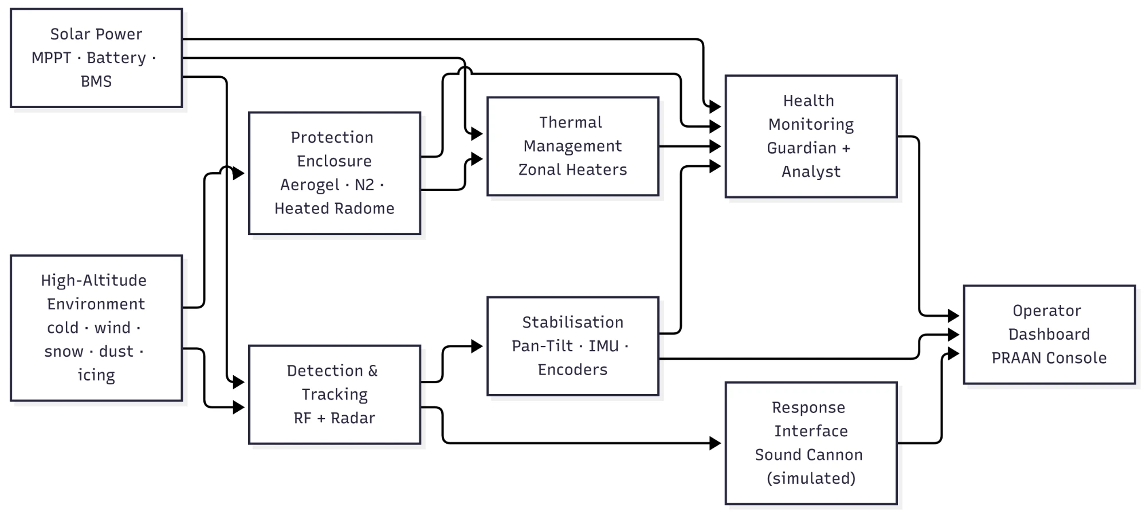
Figure 1: System architecture of HIMAL-CUAS: high-altitude environment and solar power feed detection, protection, thermal and stabilisation subsystems, all supervised by the health-monitoring layer and reported through the PRAAN operator dashboard.
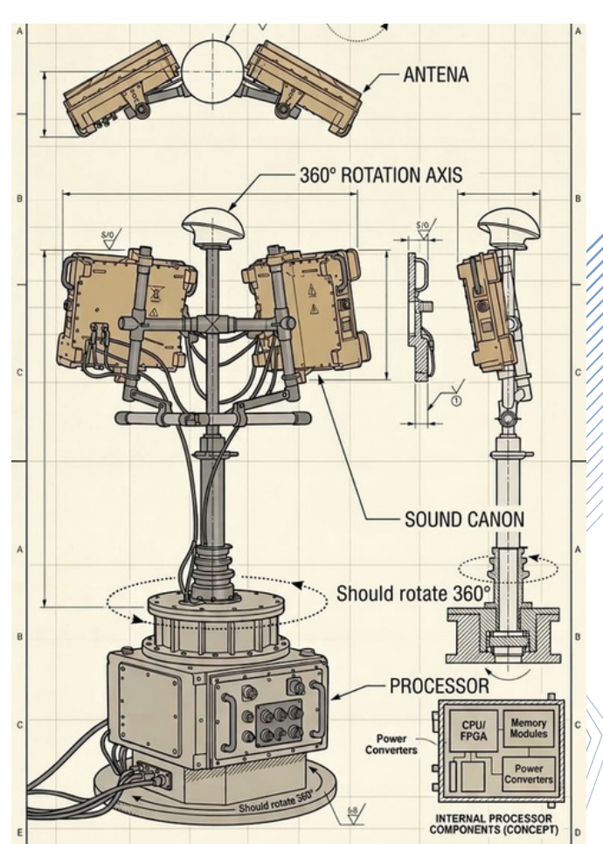
Figure 2: Mechanical concept of the node: rotating antenna head, sound cannon on the mast and processor base (from the team's own concept drawing).

1. Detection Subsystem
Purpose: finds and locates possible drones using two independent sensors.
- SDR/RF receiver with directional antenna (passive)
- Radar module (mmWave or X-band; simulated target source in the prototype)
- Edge computer running fusion, tracking and classification

2. Pan-Tilt Tracking Mount
Purpose: points the antenna head at the target and holds it steady in wind.
- Two-axis pan-tilt with absolute encoders, IMU and motor drivers
- Stiff mast, vibration isolators and low-force silicone cabling

3. Response Interface (Sound Cannon)
Purpose: a directional acoustic effector on the mast that is aimed by the same rotation axis. In the prototype it is a simulated, operator-gated command and is never fired.

4. Protective Enclosure
Purpose: shields electronics from cold, moisture, snow, dust and radiative heat loss.
- Weatherproof shell, hydrophobic coating, reflective foil, aerogel blanket
- Sealed dry-nitrogen cavity, gaskets and a heated radome

5. Thermal Control
Purpose: keeps every zone inside its safe temperature range.
- Four heater zones (battery, compute/SDR, radome/aperture, gimbal/motor) with PWM drivers
- Temperature sensors, heat-spreader plate and series relay interlocks

6. Power System
Purpose: provides autonomous off-grid power.
- Steeply tilted solar array, MPPT controller, heated insulated battery bank with BMS
- Fused DC-DC distribution and storm-mode load shedding

7. Health Monitoring Layer
Purpose: detects degradation, names the failing part, forecasts remaining life and triggers safe modes.
- Guardian microcontroller (real-time safety) and Analyst computer (analytics)
- Temperature, pressure, humidity, current, voltage, vibration and heartbeat data

8. Operator Console
Purpose: gives the operator awareness and control.
- Target track display, capability gauges, alert log and simulated response output

Technical Approach
This section gives the engineering behind each subsystem. All numbers are design estimates to be confirmed during prototype testing.

1. Detection, Tracking and Response

Passive RF Detection
A software-defined radio (SDR) passively listens for the control, telemetry and video links of commercial drones, which commonly use the 2.4 GHz and 5.8 GHz ISM bands and sub-GHz links near 433, 868 or 915 MHz. Detection combines wideband energy detection against a constant-false-alarm threshold with signature features such as hop pattern, burst timing and occupied bandwidth. The receiver noise floor for bandwidth B and noise figure NF is
N = −174 + 10 log₁₀(B) + NF [dBm] (1)
and its drift is also used as an RF-chain health indicator. Bearing is found by rotating a directional antenna and locating the amplitude peak. RF detection cannot see a drone that flies autonomously without emitting, which is why radar is required.

Radar
A compact mmWave FMCW radar, or an X-band pulse-Doppler radar where approvals allow, gives range, bearing and radial velocity of any object regardless of emissions. The maximum detection range follows the radar equation
R_{max} = [ P_{t} G² λ² σ / ( (4π)³ P_{min} ) ]^{1/4} (2)
where P_{t} is transmit power, G antenna gain, λ wavelength, σ target radar cross-section (on the order of 0.01–0.1 m² for small drones) and P_{min} the minimum detectable power. Range scales with the fourth root, so antenna gain and clutter processing matter more than raw power. Rotor micro-Doppler helps separate drones from birds [7]. Table 3 compares the two sensors; an optical or laser sensor was rejected as the primary sensor because it is short-ranged and degraded by exactly the fog, snow and dust this problem statement targets.
Table 3: RF detection versus radar
Attribute | RF detection | Radar
Principle | Passive; hears the control and video link | Active; echo from the airframe
Needs target emission | Yes | No
Measures | Bearing and signal signature | Range, bearing and velocity
Weather effects | Antenna icing | Radome icing, precipitation clutter
Power | Low (2–5 W for the SDR) | Higher; duty-cycled in storm mode
Main weakness | RF-silent drones | Small cross-section, bird clutter

Fusion and Tracking Flow
The operating flow is: the RF detector observes drone-link activity; the radar, or a simulated radar source in the prototype, supplies range and bearing; the pan-tilt head is cued to the estimated bearing; fusion software associates the RF and radar reports by gating on bearing and range, maintains a Kalman-filter track and classifies drone versus non-drone; and the dashboard shows confidence, bearing and status. With independent evidence, a simple combined confidence is
c = 1 − (1 − c_{RF}) (1 − c_{rad}) (3)
where c_{RF} and c_{rad} are the per-sensor confidences; this rule is a starting point to be calibrated on recorded data.

Wind-Compensated Pan-Tilt Tracking
Wind and vibration at altitude corrupt pointing. Each axis uses a cascaded loop: an outer position loop closed on the absolute encoder, an inner rate loop closed on the IMU gyroscope, and a feed-forward term from estimated wind disturbance. The controller is a PID law
u(t) = K_{p} e(t) + K_{i} ∫ e(τ) dτ + K_{d} de/dt (4)
with anti-windup and temperature-scheduled friction compensation, because bearing grease stiffens in the cold. A stiff mast, vibration isolators and silicone cables with low-force routing reduce disturbance torque. Motor current, encoder and IMU signals are reused by the health layer.

Response Interface: Sound Cannon
The sound cannon is a directional acoustic effector on the mast, aimed by the same rotation axis. Free-field sound pressure level falls about 6 dB per doubling of distance, so it is a short-range, last-layer option whose use must be coordinated with the operator and competent authority. In the prototype the effector is not fired: the response is a simulated dashboard command behind a two-step arm-and-confirm gate. High sound pressure is a hearing hazard and any RF jamming needs statutory authorisation, so neither is operated outside an authorised setting.

2. Enclosure and Thermal Management

Layered Enclosure
The enclosure (Figure 3, Table 4) protects electronics from cold, moisture, snow, dust and radiative heat loss. Its shell and gaskets target an IP65/66-style rating [18]. Because air is thin, heat is moved by conduction through a heat-spreader plate rather than by airflow.
Table 4: Enclosure layers, outside to inside
No. | Layer | Function
1 | Weatherproof shell (Al alloy or FRP) | Low-temperature toughness and structure
2 | Hydrophobic anti-icing coating | Reduces snow, water and ice adhesion
3 | Low-emissivity reflective foil | Reduces radiative heat loss
4 | Aerogel blanket | Primary low-conductivity insulation
5 | Sealed dry-nitrogen cavity | Prevents condensation and internal icing
6 | Heating film / PTC | Active zonal heating
7 | Aluminium or copper heat-spreader plate | Spreads heat and avoids hot spots
8 | Electronics plate with sensors | Mounts compute, RF and sensing modules

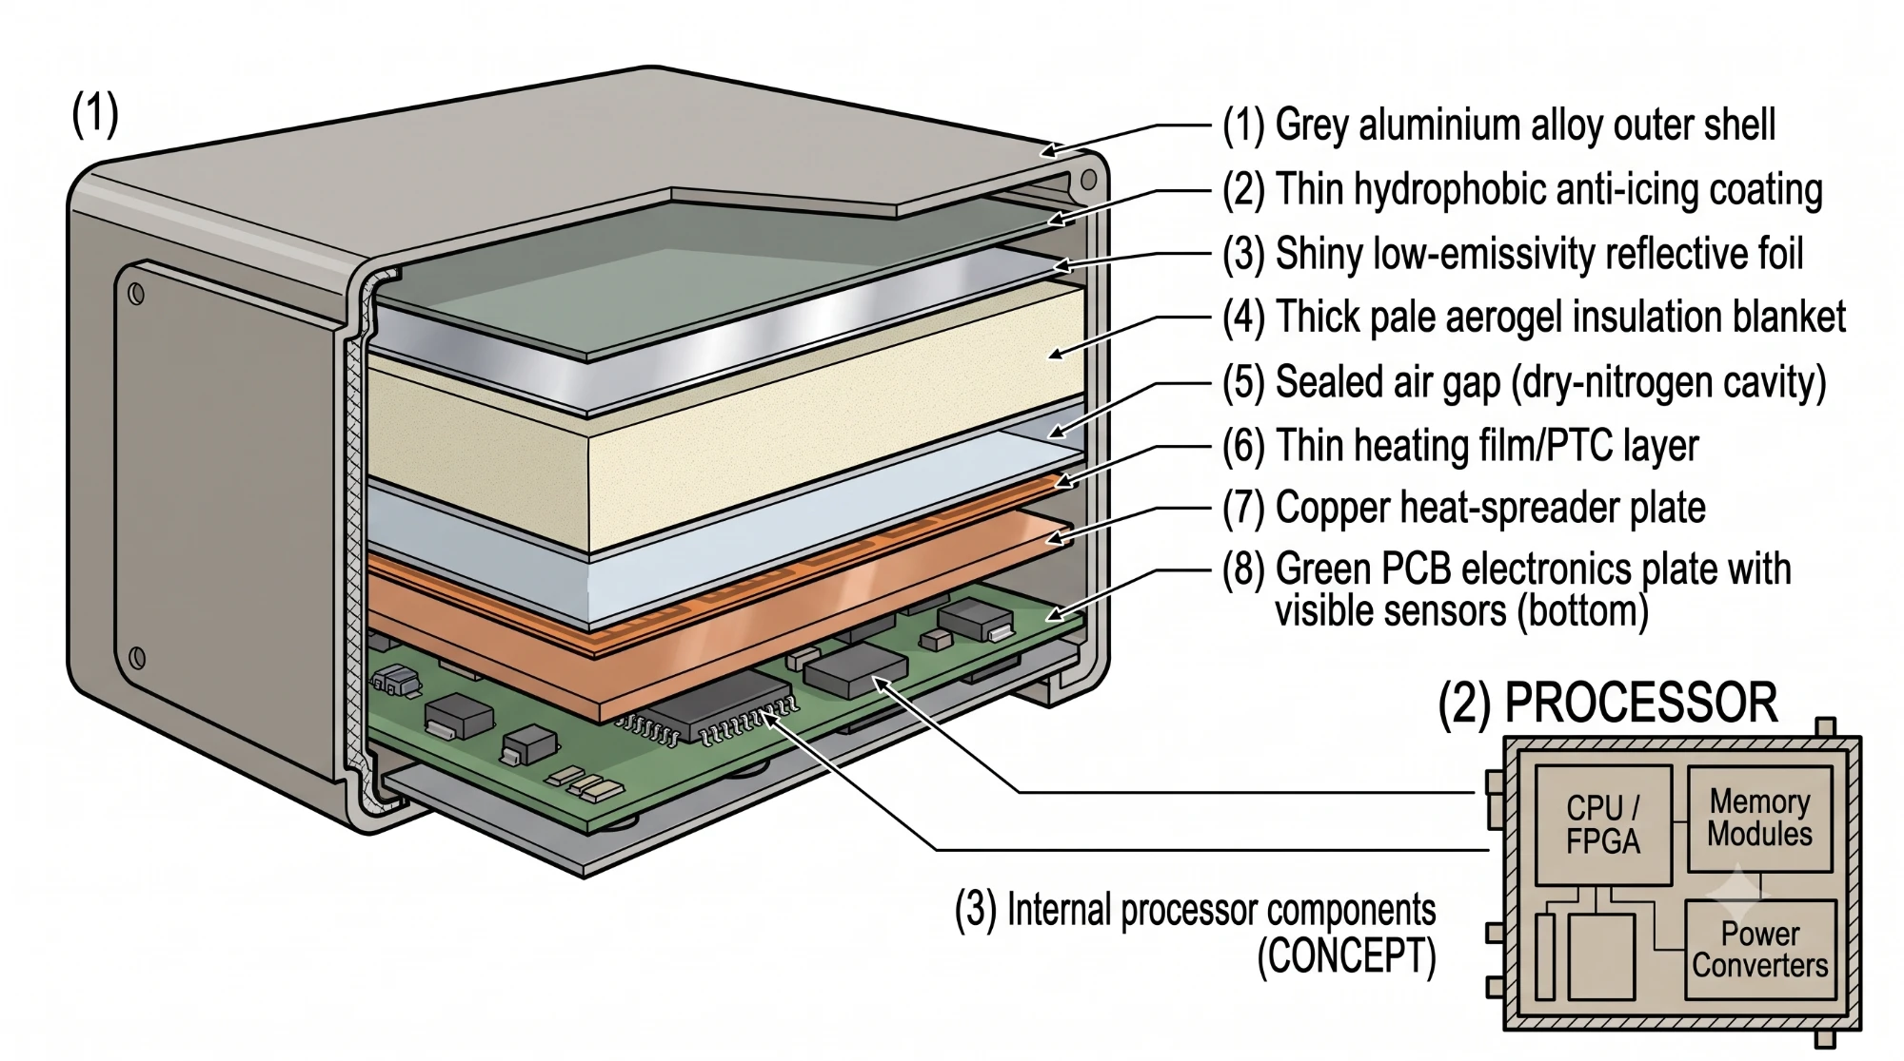
Figure 3: Layered enclosure cross-section, outside to inside: outer shell, anti-icing coating, reflective foil, aerogel insulation, dry-nitrogen cavity, heater film, heat-spreader plate and the electronics plate, with the internal processor block shown separately.

Thermal Model and Sizing
With internal temperature T_{in}, ambient T_{out}, heater power P_{h}, electronics dissipation P_{e}, thermal capacitance C_{th} and overall conductance UA, the enclosure obeys
C_{th} dT_{in}/dt = P_{h} + P_{e} − UA (T_{in} − T_{out}) (5)
At steady state the coldest survivable ambient for a set-point T_{set} and maximum heater power P_{h,max} is
T_{out,min} = T_{set} − ( P_{h,max} + P_{e} ) / UA (6)
For a slab of conductivity k, area A and thickness d,
UA_{ins} = kA / d (7)
As an illustration, a 0.3 m cube (A ≈ 0.54 m²) with 10 mm aerogel (k ≈ 0.015 W/(m·K)) gives UA_{ins} ≈ 0.8 W/K, so holding 15 °C at −40 °C costs about 45 W of combined heater and electronics power, consistent with the 15–40 W average heater budget below; doubling the thickness roughly halves the loss. Wind adds convective loss, so effective conductance is treated as UA₀ + k_{w}√v. These values are design estimates to be measured in the cold test.

Zonal Heating
One heater would overheat some parts while freezing others, so four zones (Table 5) are controlled independently. A zone heater switches on below its lower threshold and reduces or switches off at its upper threshold; if a zone exceeds a safety limit or its sensor is faulty, heater output is shut down and an alert is raised. Every zone has a series relay interlock commanded by the safety microcontroller so a shorted driver cannot leave a heater latched on. The battery is never charged below about 0 °C to avoid lithium plating [3].
Table 5: Zonal heating strategy
Zone | Target range | Reason
Battery | 10–20 °C | Capacity and safe charge and discharge
Compute and SDR | 0–35 °C | Reliable processor and RF operation
Radome / antenna and effector aperture | Above icing and condensation threshold | Keeps RF and radar apertures and the sound-cannon horn clear
Gimbal / motor | Above low-temperature mechanical limit | Limits bearing stiffness and motor stress

Sealed Nitrogen Cavity, Radome and Cabling
A dry-nitrogen cavity keeps moisture and frost out. Because sealing at sea level would leave the cavity about 40 kPa above ambient at altitude, it is purged and filled on site to a small overpressure. The radome and sound-cannon horn are heated, and the radome heater is pre-energised when its temperature nears the dew point so ice never forms. Thermal cycling fatigues solder and connectors, so the design uses strain relief, conformal coating, silicone cables that stay flexible in the cold, and thermal-cycle testing.

3. Solar-Battery Power System

Architecture
The power path is solar array → MPPT charge controller → heated, insulated battery bank with BMS → fused DC-DC distribution → compute, sensors, radar, gimbal, communications and heaters. Panels are mounted at a steep tilt so snow slides off, an MPPT controller maximises harvest as sunlight and temperature change [19], and the battery sits in a dedicated insulated, heated compartment. Fuses, reverse-polarity protection, over-current protection and regulated DC-DC outputs protect the loads.

Load Budget
Table 6 gives the initial load budget taken from the concept note, with the camera load replaced by the radar. All values are estimates to be replaced by measurement.
Table 6: Initial power budget (design estimate)
Load | Typical | Notes
Edge compute | 8–12 W | Raspberry Pi or Jetson class
SDR / RF receiver | 2–5 W | Passive RF sensing
Radar and pan-tilt | 6–12 W | Radar duty-cycled; varies with slewing
Health and environment sensors | 2–3 W | Temperature, pressure, humidity, V/I, IMU
Communications | 3–8 W | Wi-Fi, LoRa or cellular
Thermal-control electronics | 1–2 W | MCU, drivers, interfaces
Zonal heaters | 15–40 W average | Largest uncertainty; depends on weather and insulation
Conversion and wiring losses | 3–5 W | MPPT and DC-DC
Average / peak | ≈ 60 W / 100–120 W | Initial design value; replace by measurement

Energy Sizing
At 60 W average the daily energy is 1.44 kWh; with a 25% design margin m this becomes
E_{d} = P_{avg} × 24 h × (1 + m) (8)
which for 60 W and m = 0.25 gives 60 × 24 × 1.25 = 1.8 kWh per day. Two days of no-sun autonomy therefore need about 3.6 kWh of usable storage (about 4.5 kWh nominal at 80% usable depth of discharge, an assumption). For H_{ps} peak-sun hours and system efficiency η, the array power is
P_{arr} = E_{d} / ( η H_{ps} ) = 1.8 kWh / (0.75 × 4 h) ≈ 600 W (9)
which matches the 500–700 W conceptual estimate; the bench prototype uses a 100–200 W panel or a solar-emulation supply for a shorter demonstration.

Storm Mode and Load Shedding
During low solar input the node enters storm mode: scan duty and compute load are reduced and power is preserved for critical sensing and heating (Table 8). The fixed shedding order is logging verbosity, radar scan rate, gimbal scan duty, radar transmit power, communications cadence, radar entirely (RF-only fallback), non-battery heater zones to survival set-points, and finally RF receiver duty cycling. The battery heater is shed last because a frozen battery cannot be recovered whereas everything else returns at sunrise.

4. Health Monitoring and Predictive Maintenance

Concept and Architecture
A fixed alarm limit cannot work when “normal” itself moves with weather: a heater legitimately draws more on a colder night. The health layer therefore computes a residual, the difference between measured behaviour and a model prediction, so weather cancels and only wear remains. Two tiers (Figure 4) share the work: a Guardian microcontroller (ESP32-S3 or STM32) runs hard real-time safety, thermal control and the watchdog, and an Analyst computer (Raspberry Pi 5 [20]) runs residuals, detection, diagnosis, prognosis and the dashboard.
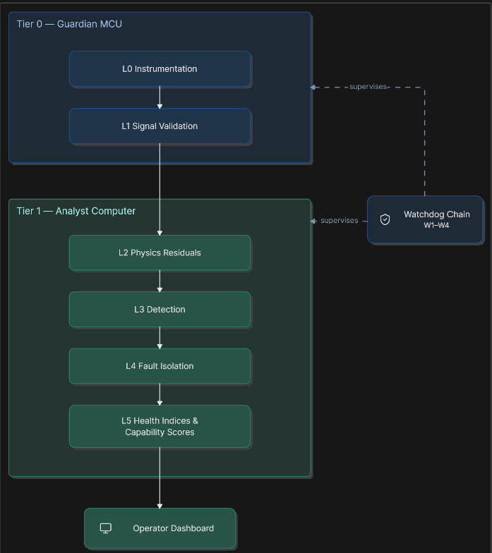
Figure 4: Health-monitoring architecture: Guardian MCU (Tier 0, layers L0–L1) and Analyst computer (Tier 1, layers L2–L5), both supervised by the independent watchdog chain W1–W4.

Failure-Mode-Driven Instrumentation
Sensors are chosen from a failure-mode, effects and criticality analysis [21] rather than from a parts list. Fifty-five failure modes were enumerated in six groups: thermal and enclosure (10), power (13), mechanical (9), sensing chain (10), compute (7) and the monitor itself (6). Each is mapped to the quantity that reveals it [16]. Twenty-eight modes need no added hardware because they use software telemetry or sensors the mission already carries (IMU, encoders, motor current); 25 are covered by a 16-line sensor set of about ₹12,000 (temperature, pressure, humidity, current and voltage, BMS, PV reference); two (feedline water ingress and antenna icing) need a directional coupler. Together this covers 53 of 55 modes (96%), including every catastrophic mode. Occurrence ratings are left out until field data exist.

Signal Validation
A residual from a bad sensor gives a confident, wrong diagnosis, so every channel first passes five checks: range, rate of change, stuck-at (variance), bus errors, and redundancy against a partner sensor or a physical cross-check. If a channel fails, dependent indices become unknown, not healthy, and a distinct “blind” alert is raised.

Physics Residuals
Eleven estimators (Table 7) turn raw data into wear indicators. Three examples: the sealed cavity is a fixed volume of gas, so the ratio
Λ = p_{cav} / T_{cav} (T in K) (10)
stays constant while sealed and falls when nitrogen leaks, an earlier indicator than humidity in a properly dried cavity. Battery ageing is separated from cold by dividing internal resistance, measured on heater-switching current steps, by its temperature-dependent reference,
ρ = R_{int} / R_{ref}(T), R_{int} = −ΔV / ΔI (11)
and the solar performance ratio, with irradiance G, module temperature T_{m} and coefficient γ ≈ −0.0035/K, separates snow from soiling:
PR = P_{dc} / [ (G/1000) P_{stc} ( 1 + γ (T_{m} − 25) ) ] (12)
Table 7: Physics residual estimators
ID | Quantity monitored | Faults revealed
R1 | Enclosure conductance UA | Insulation or seal degradation
R2 | Cavity ratio Λ | Nitrogen leak, seal breach
R3 | Heater resistance, film-to-zone resistance | Open, short, latched driver, delamination
R4 | Battery ρ, capacity, cell imbalance | Ageing, weak cell, plating risk
R5 | Solar performance ratio | Snow, soiling, string fault, MPPT
R6 | Gimbal friction map versus angle | Cold stiffness, wear, cable snag
R7 | Vibration band energies | Loose mount, bearing defect
R8 | Radome level and horn impedance | Radome icing, blocked horn
R9 | RF noise floor and calibration tone | LNA fault, interference
R10 | Rail wiring resistance | Connector fatigue
R11 | Pipeline heartbeat and latency | Service hang, throttling

Detection and Fault Isolation
Each residual is given the cheapest detector that fits its failure mode: hard limits for hazards, a cumulative sum for slow wear [22], residual thresholds, and a Mahalanobis novelty score learned from the node's first week of nominal data. The one-sided CUSUM
S_{t} = max( 0, S_{t−1} + ( r_{t} − μ₀ ) − k ), alarm if S_{t} > h (13)
accumulates small persistent deviations, so a 2% drift is found in days instead of waiting for a 20% excursion. Every alarm needs a dwell time, a hysteresis band and a re-arm delay to prevent alarm fatigue. Fault-signature matrices then name the cause; for example, 100% commanded duty with near-zero heater current means an open element, whereas zero duty with current flowing means a latched driver and the series relay is opened. A dependency graph folds cascades into one root cause with its consequences.

Health Indices and Capability Scores
Per-item health indices roll up as
HI_{sub} = (1 − α) Σ w_{i} HI_{i} + α min_{i} HI_{i}, α = 0.5 (14)
so one dead component among many cannot be averaged away. Indices are composed into four capability scores: Detect (RF and radar chains, compute; range in km), Track (gimbal, encoder, vibration; slew rate and pointing error), Endure (battery, solar, heater demand; hours to reserve) and Protect (cavity, dew-point and thermal margins; coldest survivable ambient). The headline is the minimum of the four, with bands 80–100 normal, 60–79 caution, 40–59 degraded and below 40 safe mode.

Prognostics
Prediction runs on four timescales: seconds (hardware-enforced protection), hours (a 48 h energy and thermal survival forecast every 15 min), days to weeks (degradation trends) and seasons (cumulative thermal-cycle damage as a relative index). Remaining useful life uses a robust Theil–Sen slope β on the CUSUM-confirmed segment [23]:
RUL = ( f_{lim} − f_{now} ) / β (15)
always reported with a confidence interval and suppressed when the slope is not significant. The survival forecast rolls the energy balance forward,
E(t+Δt) = E(t) + η P_{sol}(t) Δt − ( P_{base} + P_{heat}(t) ) Δt (16)
with P_{heat} = clip( UA_{eff} (T_{set} − T_{out}), 0, P_{h,max} ). Insulation degradation therefore raises predicted heater demand and shortens predicted endurance, so one estimator drives both maintenance alerts and an earlier storm mode.

Working Mechanism
During operation the node follows this sequence:
- Start-up self-test. Built-in test checks the RF chain, radar, effector interface, gimbal, thermal, power and compute, and records commissioning baselines.
- Thermal hold. Zonal heaters bring every zone to its set-point; the Guardian keeps them there and enforces safety limits.
- Passive listening. The SDR watches the RF bands for drone-link activity while the head scans.
- Radar cue. Radar supplies range, bearing and velocity of contacts; the pan-tilt head is cued to the bearing.
- Fusion and tracking. RF and radar reports are associated, tracked and classified; confidence is shown on the dashboard.
- Health supervision. In parallel, residuals and capability scores are updated and alerts raised with evidence, action and part needed.
- Mode control. If capability falls or power runs low, the node moves through the modes in Table 8, shedding load in the published order.
- Simulated response. If the operator arms and confirms, a simulated sound-cannon command is displayed; nothing is fired.

Operating Modes and Fail-Safe Behaviour
Table 8: Operating modes and shed power budgets
Mode | Entry | Power | Behaviour
NORMAL | All capabilities ≥ 80 | 60 W | Full RF + radar scan; all zones at set-point
WATCH | Any capability 60–79 | 60 W | Elevated logging, faster residuals
DEGRADED | Any capability 40–59 | 44 W | Half inference rate, 50% scan duty, reduced slew
STORM | Endurance < 12 h, wind > 25 m/s or forecast deficit | 19 W | RF-only, radar at 10% duty, gimbal parked into wind
SAFE | Any capability < 40 or critical alert | 8 W | Sensing off; battery heater, Guardian and beacon only
SURVIVAL | Battery below reserve | 5 W | Battery heater and Guardian only

Power figures are shed budgets against the 60 W average, not measurements. Modes exit at thresholds 8–10 points above entry with a minimum dwell so the node does not chatter. Four independent watchdogs guard the monitor itself: thread watchdogs (5 s), systemd (30 s), the Guardian power-cycling the Analyst over a load switch after 60 s without heartbeat, and an external TPL5010 that resets the Guardian after 8 s. Reset states are safe by wiring: heater gates pulled low, relays normally open, gimbal drivers disabled. After three power-cycles in an hour the node latches SAFE and waits for a human instead of draining the battery.

Dashboard and Monitoring System
The operator console, named PRAAN (Sanskrit for vital breath), is designed to be scanned, not read. It surfaces the summary first and encodes state in form as well as number so faults are visible at a glance (Figure 5 and Figure 6).
The console shows:
- Mode indicator and four capability gauges with needle, tick marks and a marked critical zone
- Built-in-test strip: a pass, warn or fail light with timestamp for each subsystem (RF chain, radar, radome, effector, gimbal, thermal, power, compute)
- Detection scope with range rings, degree ticks and a track symbol, plus track bearing, range and confidence
- Cold-weather survival margin: the coldest survivable ambient against the −40 °C requirement
- Degradation trend charts and a log-formatted event list
Every alert carries its evidence, confidence, predicted time to impact, recommended action and the part needed, so a maintenance trip arrives with the right spare. Severity classes are info, advisory, caution, warning, critical and blind. Since backhaul at remote posts may be a low-rate LoRa link, only compact status frames are sent upstream while full data stay on the local Analyst. A “demonstration controls” panel injects simulated faults (radome icing, heater open circuit) so reviewers can watch detection, diagnosis and mode escalation live; the console is clearly marked as simulated data.
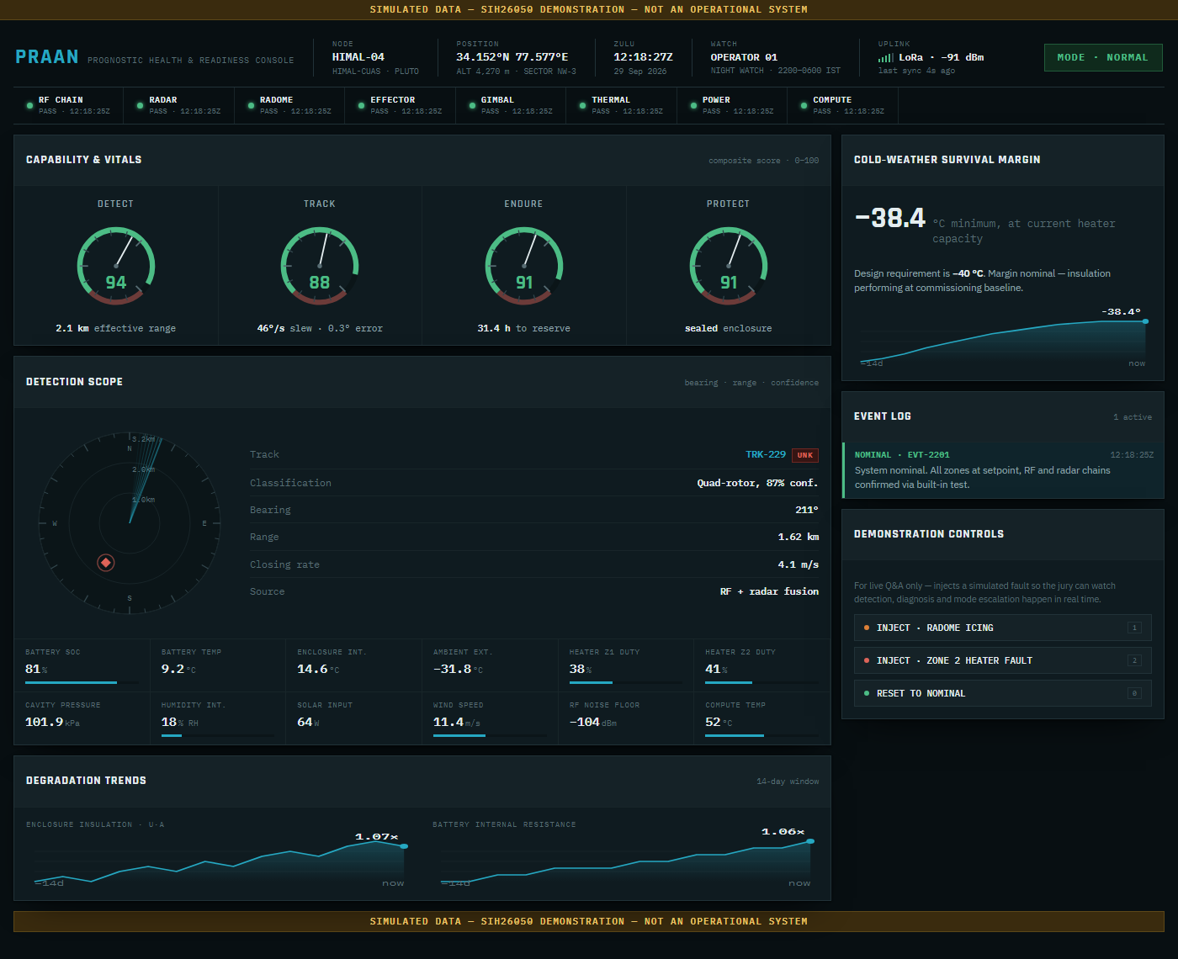
Figure 5: PRAAN operator console in nominal state: mode, capability gauges, BIT strip, detection scope, telemetry, trends, survival margin and event log.
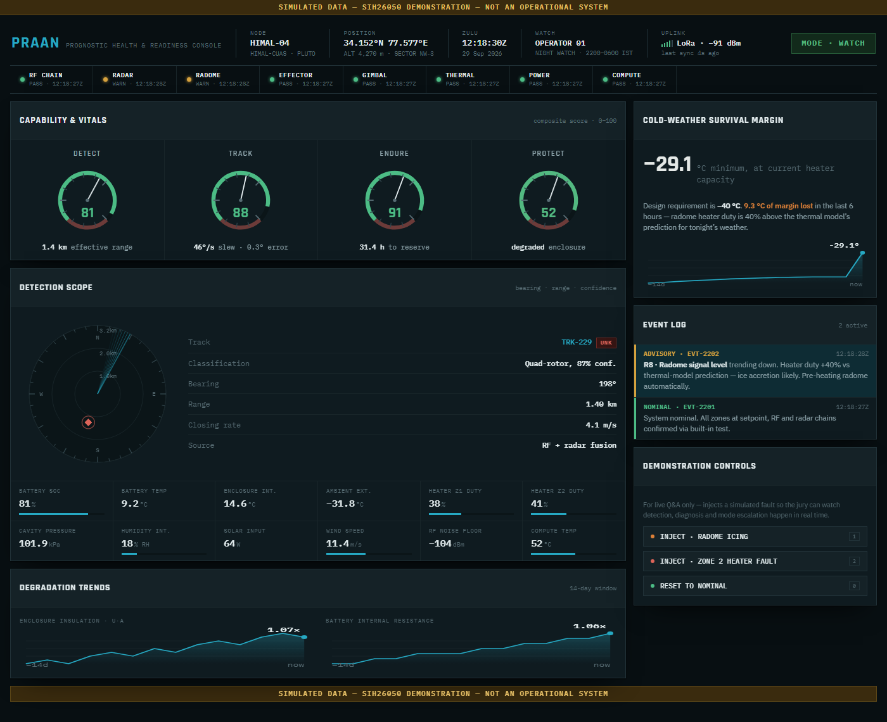
Figure 6: PRAAN console after an injected radome-icing fault: capability gauges drop, BIT lights change, the survival margin shifts and an actionable alert is logged.

Technology Stack and Implementation Plan

1. Technology Stack
Table 9: Proposed technology stack
Layer | Choice
RF sensing | SDR (RTL-SDR or HackRF class for the prototype) with SoapySDR / GNU Radio processing
Radar | mmWave FMCW module (TI IWR6843 class) with vendor SDK; simulated target list as fallback
Edge compute | Raspberry Pi 5, 4 GB [20]; Jetson Orin Nano if heavier inference is needed [24]
Safety MCU | ESP32-S3 or STM32G474 running an RTOS: thermal PID, interlocks, telemetry frame
Motion | Servo or BLDC with FOC driver, AS5048A magnetic encoders, ICM-42688-P IMU, Hall homing
Sensing | BMP390 [25], SHT45 [26], DS18B20 / NTC, INA226 / INA3221
Power | MPPT controller, 4S Li-ion or 12 V LiFePO₄ pack, UART smart BMS, DC-DC rails
Software | Python (NumPy / SciPy) analytics, MQTT messaging, time-series store, web dashboard, 100× replay harness

2. Prototype Scope
The minimum viable prototype is intentionally small and safe:
- SDR-based RF detection, or a safe simulated detection input
- A radar module or a simulated radar source
- A servo or BLDC pan-tilt unit with encoders and IMU
- An aerogel-insulated mini enclosure with a sealed nitrogen cavity and PTC / film heaters
- An ESP32 or STM32 for acquisition, thermal control and health logic, and a Raspberry Pi for analytics and the dashboard
- Temperature, humidity, pressure, voltage / current and vibration sensors
- A battery with BMS, DC-DC regulation and a small solar panel or solar-emulation supply
- A fan or vibration motor for wind disturbance and an ice-box or freezer for the cold test
- The sound cannon shown only as a simulated command

3. Implementation Roadmap
Work proceeds in seven phases: (1) Guardian firmware and instrumentation; (2) enclosure and zonal heater control; (3) signal validation and residual estimators; (4) RF and radar detection with pan-tilt tracking; (5) power chain and storm mode; (6) operator console and fault-injection rig; (7) cold-chamber validation and replacement of estimated numbers by measurements.

4. Demonstration Scenario
- Start the unit at a low external temperature (ice box) and show the zonal heaters holding the set-points.
- Introduce a test RF beacon or a simulated radar target and show detection, fusion and pan-tilt tracking.
- Introduce a fan or vibration disturbance and show IMU / encoder correction.
- Create faults: disconnect a sensor, open the insulation vent screw, open a heater relay, reduce solar input or lower battery charge.
- Show the capability-score changes, alerts with actions, and automatic degraded, storm or safe mode.
- Show only a simulated response command; transmit no jamming signal and fire no effector.

Feasibility and Viability

1. Feasibility Analysis
- Technical. Every module is commercially available, and the estimators use standard algebra, filters and robust regression that run on a single-board computer.
- Schedule. The roadmap orders the work so that a bench demonstration is possible before any optional item.
- Cost. The bench prototype is small (see Estimated Prototype Budget).
- Regulatory and safety. The prototype receives RF passively, uses simulated radar or approved modules, and never fires the effector or jams; any real deployment needs the relevant Indian spectrum, safety and defence approvals.

2. Risks and Mitigation
Table 10: Risk register
Challenge | Impact | Mitigation
Extreme cold | Battery and electronics lose performance | Aerogel, zonal heating, low-temperature-rated parts
Low pressure | Weak convection; seal stress | Conductive spreader, site-purged N₂ cavity, pressure monitoring
Dust, snow, icing | Aperture blockage, ingress | IP65/66-style seals, hydrophobic surface, heated radome and horn
Wind and vibration | Pointing error | Stiff mount, isolators, IMU + encoder, PID
Thermal cycling | Solder and connector fatigue | Strain relief, conformal coating, cycle testing
Cold cable stiffness | Gimbal disturbance | Silicone cables, low-force routing
Battery degradation | Short runtime, shutdown | Heated bay, BMS, SOC and resistance monitoring, reserve mode
Hardware sourcing and approvals | Radar or effector delayed | Simulated inputs; approved modules; early quotations
Monitor failure | Blind or unsafe node | Watchdog chain, safe-by-wiring defaults

3. Validation Plan
Slow degradation cannot be waited for, so faults are created on demand and physical injection is preferred over software flags. Table 11 lists the tests; the outcomes are design targets to be verified, not results. Replayed telemetry used for trend figures must be labelled simulated.
Table 11: Validation tests (targets to be verified)
Test | Method | Target outcome
Cold soak | Ice box or freezer, then chamber | Zones stay inside their target ranges
RF detection | Known 2.4 GHz beacon at set bearings | Detection and bearing error recorded
Tracking in wind | Fan disturbance on the pan-tilt | Error lower than the uncompensated case
Insulation loss | Open the enclosure vent screw | Conductance rise flagged; survival margin falls
Heater fault | Relay opens one zone | Isolated with a named cause in seconds
Power autonomy | Bench supply as sun; cover the panel | Storm mode enters before the deficit
Radome and horn | Mist and freeze the radome; tape the horn | Signal-level or impedance shift and heater recovery seen
Monitor hang | Stop the analytics service | Guardian power-cycles it; heating uninterrupted

Estimated Prototype Budget
Table 12 lists the bench prototype. The health-monitoring row bundles the 16-line sensor set summarised in the Health Monitoring subsection (itemised in the companion health-layer bill of materials); the Raspberry Pi, battery, panel and aerogel prices come from the design notes, and rows marked ≈ are indicative Indian retail estimates to be confirmed by quotation. The sound cannon and, unless budget allows, the radar are simulated, so they add no cost here.
Table 12: Estimated prototype budget
Component | Cost (INR) | Functionality
Raspberry Pi 5 with cooler and NVMe | ₹9,500 | Analyst: fusion, tracking, analytics and dashboard
SDR receiver with antenna | ≈ ₹4,500 | Passive RF detection of drone control links
Servo / BLDC pan-tilt mount | ≈ ₹2,500 | Two-axis pointing of the antenna head
Health-monitoring sensors, Set T1 (16 lines, incl. ESP32-S3 Guardian and BMS) | ₹11,990 | Temperature, pressure, humidity, current/voltage, watchdog, fault-injection rig
Aerogel blanket, 10 mm | ₹2,500 | Primary thermal insulation of the test enclosure
Dry-nitrogen purge kit | ≈ ₹1,500 | Sealed nitrogen cavity fill and leak test
Heater films / PTC pads and MOSFET drivers (4 zones) | ₹2,400 | Zonal active heating with PWM and relay interlocks
Mini test enclosure, gasket and cable glands | ≈ ₹2,500 | Sealed housing for the cold-test rig
Battery pack (4S Li-ion or LiFePO₄) | ₹4,500 | Heated energy storage
100 W solar panel with MPPT controller | ₹5,500 | Off-grid charging; solar-emulation supply as alternative
DC-DC converters and fuses | ≈ ₹1,500 | Regulated, protected power rails
LoRa / Wi-Fi communication modules | ≈ ₹1,500 | Backhaul of compact status frames
Cold-test cooler box and vibration motor | ≈ ₹1,250 | Cold soak and mechanical disturbance injection
Wiring, connectors, mounts and assembly | ≈ ₹3,000 | Integration into a working unit
Radar module (mmWave evaluation kit) — optional | not included | Replaces the simulated radar source if budget allows
Total Estimated Cost: | ≈ ₹54,640 | Excludes the optional radar module and any real effector

Impact, Sustainability and Market Opportunity
Operational impact. The node gives continuous surveillance at remote, off-grid mountain posts and reduces manual monitoring. Predictive alerts with parts lists let scarce visits, which may be impossible for months, be planned instead of reactive, raising availability where failure is costly.
Environmental resilience. Aerogel insulation, zonal heating and sealed nitrogen cavities shield hardware from cold, icing and moisture, extend equipment life and cut long-term replacement cost.
Sustainability. Solar-plus-battery autonomy reduces dependence on diesel generators and their logistics [4]; better insulation lowers heater energy; and modular, replaceable units let a failed module be swapped instead of scrapping the node.
User experience. Operators see capability, not raw data: four scores, an actionable alert list and a single mode indicator, with training limited to reading those cues.
The thermal, power and health design also has strong potential in:
- Border posts and forward bases at high altitude
- Telecom towers and remote energy infrastructure [14]
- Weather stations and high-altitude research stations [9]
- Critical infrastructure that needs unattended, self-diagnosing sensing
Nodes are modular and can be tiled along a border, with an optional fleet tier for cross-node analytics.

Limitations and Future Scope
This is a proposal-stage design. No field or chamber measurements are claimed; power and conductance values are estimates until the first cold-chamber run. Radar and effector sourcing and approvals are open items, drone classification accuracy depends on recorded data, and acoustic-effector performance varies with target and conditions. Health thresholds are baselined at commissioning, and failure occurrence rates are unknown until field data exist.
Possible future improvements include:
- Cold-chamber and field trials, replacing every estimated number by a measured one
- Learned baselines, such as a small autoencoder running beside the deterministic detectors
- Fleet analytics across nodes and multi-node triangulation
- A directional coupler for feedline and antenna health
- Authorised effector integration under proper approvals
- A fuel-cell or hybrid storage option for long-duration autonomy

Conclusion
HIMAL-CUAS treats high-altitude counter-drone operation as a survivability problem as well as a detection problem. It fuses RF and radar sensing with wind-compensated tracking and an operator-gated, simulated response, and protects them with an aerogel–nitrogen enclosure, zonal heating, a solar-battery chain with storm mode and a predictive health layer that names failing parts and forecasts remaining life. The modular design, risk register, validation plan and low-cost prototype path make it feasible to build and test, and the sustainability and scalability arguments support wider use in remote infrastructure. With further development and field testing, HIMAL-CUAS has the potential to evolve from a college prototype into a deployable high-altitude sensing product.

References
[1] "SIH 2026 guidelines," Innovation Cell, Ministry of Education / AICTE. [Online]. Available: https://www.sih.gov.in/letters/SIH2026-Guidelines-College-SPOC.pdf
[2] "DRDO's D4 counter-drone system set to safeguard urban India from rogue UAV threats," Indian Defence Research Wing (IDRW). [Online]. Available: https://idrw.org/drdos-d4-counter-drone-system-set-to-safeguard-urban-india-from-rogue-uav-threats/
[3] Y. Ji, Y. Zhang, and C.-Y. Wang, "Li-ion cell operation at low temperatures," J. Electrochem. Soc., vol. 160, no. 4, pp. A636–A649, 2013.
[4] "Lighting up Ladakh's frontlines," Daily Excelsior. [Online]. Available: https://www.dailyexcelsior.com/lighting-up-ladakhs-frontlines/
[5] "Counter-UAS systems explained: A complete guide to drone defense," Kontek Industries. [Online]. Available: https://blog.kontekindustries.com/counter-uas-systems-explained
[6] B. Taha and A. Shoufan, "Machine learning-based drone detection and classification: State-of-the-art in research," IEEE Access, vol. 7, pp. 138669–138682, 2019.
[7] V. C. Chen, F. Li, S.-S. Ho, and H. Wechsler, "Micro-Doppler effect in radar: Phenomenon, model, and simulation study," IEEE Trans. Aerosp. Electron. Syst., vol. 42, no. 1, pp. 2–21, Jan. 2006.
[8] Y. Son et al., "Rocking drones with intentional sound noise on gyroscopic sensors," in Proc. 24th USENIX Security Symp., Washington, DC, USA, Aug. 2015, pp. 881–896.
[9] "Setting up and managing automatic weather stations for remote sites monitoring: From Niger to Nepal," Springer Nature Link (book chapter). [Online]. Available: https://link.springer.com/chapter/10.1007/978-3-319-59096-7_2
[10] "Peak power: World's highest-altitude weather stations powered by lead batteries," Consortium for Battery Innovation. [Online]. Available: https://batteryinnovation.org/peak-power-worlds-highest-altitude-weather-stations-powered-by-lead-batteries/
[11] E. Cuce, P. M. Cuce, C. J. Wood, and S. B. Riffat, "Toward aerogel based thermal superinsulation in buildings: A comprehensive review," Renew. Sustain. Energy Rev., vol. 34, pp. 273–299, 2014.
[12] "Built-in test equipment (BITE)," SKYbrary Aviation Safety. [Online]. Available: https://skybrary.aero/articles/built-test-equipment-bite
[13] "Built-in-test equipment," JIDA Paper P-1600, Defense Technical Information Center, ADA107842. [Online]. Available: https://apps.dtic.mil/sti/tr/pdf/ADA107842.pdf
[14] "Remote monitoring system for telecom towers," DPS Telecom. [Online]. Available: https://www.dpstele.com/network-monitoring/tower/remote-monitoring-system-telecom-tower.php
[15] M. Pecht, Prognostics and Health Management of Electronics. Hoboken, NJ, USA: Wiley, 2008.
[16] S. Cheng, M. H. Azarian, and M. G. Pecht, "Sensor systems for prognostics and health management," Sensors, vol. 10, no. 6, pp. 5774–5797, 2010.
[17] R. Isermann, "Model-based fault-detection and diagnosis: Status and applications," Annu. Rev. Control, vol. 29, no. 1, pp. 71–85, 2005.
[18] Degrees of Protection Provided by Enclosures (IP Code), IEC 60529, International Electrotechnical Commission, 2013.
[19] T. Esram and P. L. Chapman, "Comparison of photovoltaic array maximum power point tracking techniques," IEEE Trans. Energy Convers., vol. 22, no. 2, pp. 439–449, Jun. 2007.
[20] Raspberry Pi Ltd., "Raspberry Pi 5." [Online]. Available: https://www.raspberrypi.com
[21] Procedures for Performing a Failure Mode, Effects and Criticality Analysis, MIL-STD-1629A, U.S. Department of Defense, Nov. 1980.
[22] E. S. Page, "Continuous inspection schemes," Biometrika, vol. 41, nos. 1–2, pp. 100–115, 1954.
[23] P. K. Sen, "Estimates of the regression coefficient based on Kendall's tau," J. Amer. Statist. Assoc., vol. 63, no. 324, pp. 1379–1389, 1968.
[24] NVIDIA Corp., "Jetson embedded computing platform." [Online]. Available: https://developer.nvidia.com/jetson
[25] Bosch Sensortec, "BMP390 digital pressure sensor." [Online]. Available: https://www.bosch-sensortec.com
[26] Sensirion AG, "SHT4x humidity and temperature sensors." [Online]. Available: https://www.sensirion.com

